**NAME:ROHAN NYATI**

**SAP ID:500075940**

**ROLL NO. : R177219148**

**BATCH-5(AI&ML)**

**Lab-3**

**1: Solver selection**

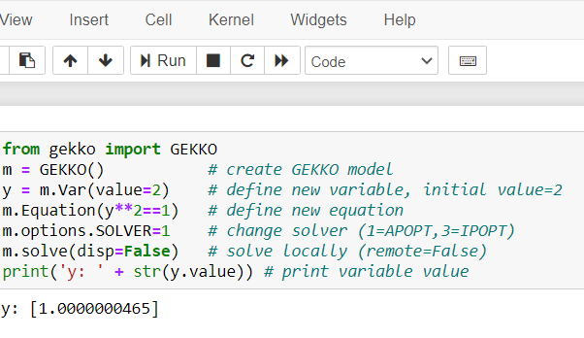

## 2: Solve Linear Equations

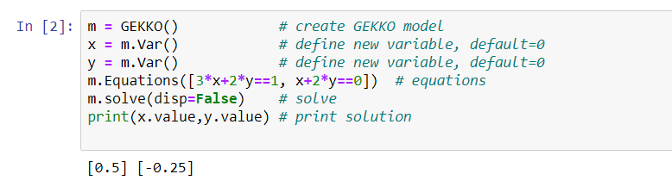

## 3: Solve Nonlinear Equations

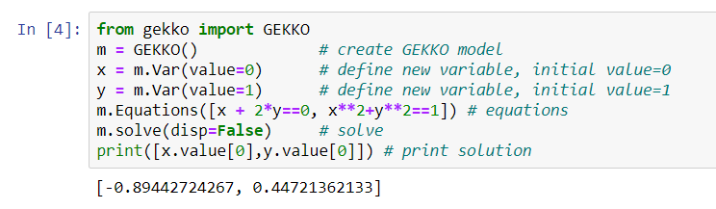

**4: Interpolation with Cubic Spline**

**In [2]:**

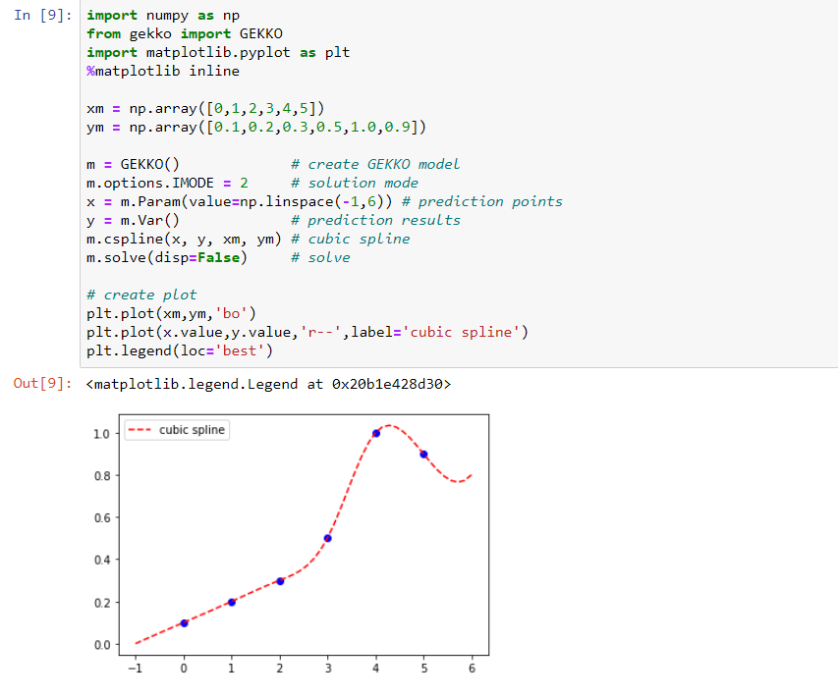

**5: Linear and Polynomial Regression**

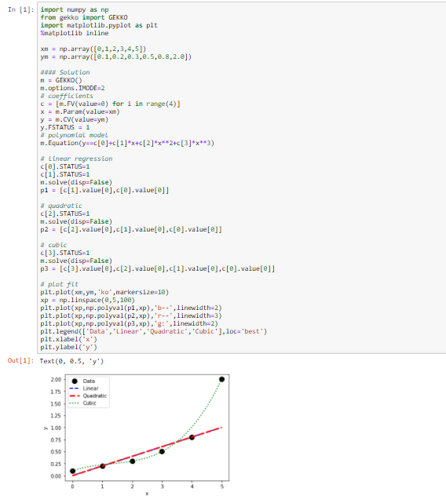

**6: Nonlinear Regression**

