**NAME:ROHAN NYATI**

**SAP ID:500075940**

**ROLL NO. : R177219148**

**BATCH-5(AI&ML)**

**Lab-4**

**Linear Search**

def linear_Search(list1, n, key):

# Searching list1 sequentially

for i in range(0, n):

if (list1[i] == key):

return i

return -1

list1 = [10 ,30, 50, 40, 70, 90]

key = 40

n = len(list1)

res = linear_Search(list1, n, key)

if(res == -1):

print("Element not found")

else:

print("Element found at index: ", res)

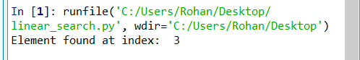

**Binary Search**

def binary_search(list1, n):

low = 0

high = len(list1) - 1

mid = 0

while low <= high:

# for get integer result

mid = (high + low) // 2

# Check if n is present at mid

if list1[mid] < n:

low = mid + 1

# If n is greater, compare to the right of mid

elif list1[mid] > n:

high = mid - 1

# If n is smaller, compared to the left of mid

else:

return mid

# element was not present in the list, return -1

return -1

# Initial list1

list1 = [1, 3, 4, 13, 45, 55, 200]

n = 55

# Function call

result = binary_search(list1, n)

if result != -1:

print("Element is present at index", str(result))

else:

print("Element is not present in list1")

