ROHAN NYATI

500075940

R177219148

BATCH-5 (AI&ML)

EXPERIMENT-2

Q.1 Consider any given case study and identify different entities and relationships among them.

A relationship between two entities signifies that the two entities are associated with each other somehow. For example, a student might enroll in a course. The entity Student is therefore related to Course, and a relationship is presented as a connector connecting between them.

Example Uml Diagram Shown depicting different entities and relationships

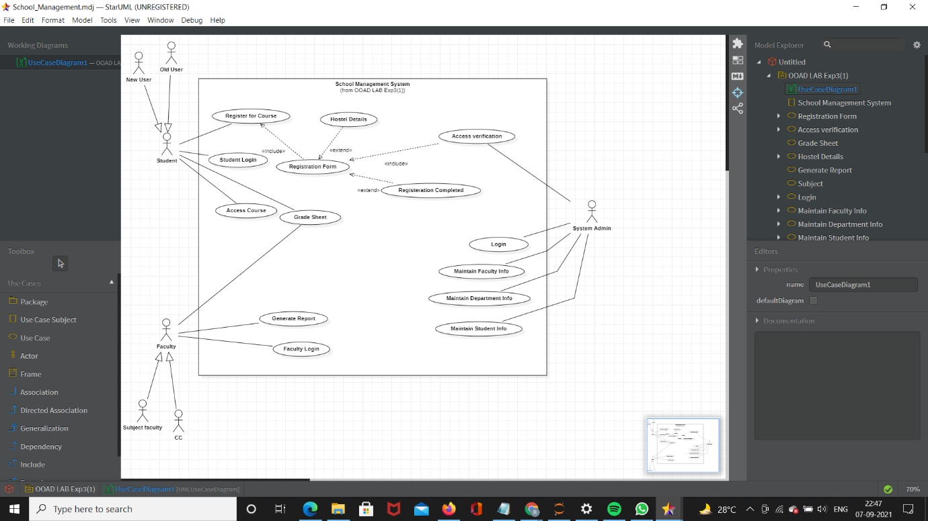

Q.2 Provide the examples of generalization, aggregation and realization .

**Generalization**

Generalization uses a “is-a” relationship from a specialization to the generalization class. Common structure and behaviour are used from the specialization to the generalized class. At a very broader level you can understand this as inheritance. Why I take the term inheritance is, you can relate this term very well. Generalization is also called a “Is-a” relationship.



*Example:* Consider there exists a class named Person. A student is a person. A faculty is a person. Therefore here the relationship between student and person, similarly faculty and person is generalization.

## Aggregation

Aggregation is a special case of association. A directional association between objects. When an object ‘has-a’ another object, then you have got an aggregation between them. Direction between them specified which object contains the other object. Aggregation is also called a “Has-a” relationship.



***Example:*** A Library contains students and books. Relationship between library and student is aggregation. A student can exist without a library and therefore it is aggregation.

**Realization**

Realization is a relationship between the blueprint class and the object containing its respective implementation level details. This object is said to realize the blueprint class. In other words, you can understand this as the relationship between the interface and the implementing class.



*Example:* A particular model of a car ‘Nano’ that implements the blueprint of a car realizes the abstraction.