**Rohan Nyati**

**500075940**

**R177219148**

**B-5 AI&ML SEM-5**

**Experiment-4**

**Experiment No: 04 Class Diagram and Object Diagram**

A) Draw the class diagram for the following:

A school has a principal, many students, and many teachers. Each of these persons has a name, birthdate, and may borrow and return books. Teachers and the principal are both paid a salary; the principal evaluates the teachers. A school board supervises multiple schools and can hire and fire the principal for each school. A school has many playgrounds and rooms. A playground has many swings. Each room has many chairs and doors. Rooms include restrooms, classrooms, and the cafeteria. Each classroom has many computers and desks. Each desk has many rulers.

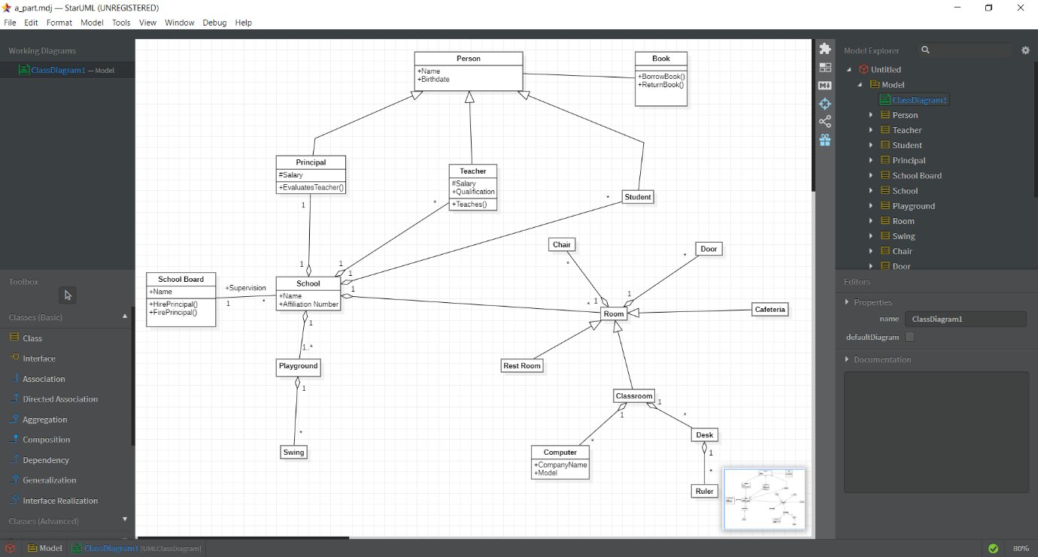

B) Draw class Diagram for a Hockey League:

Draw a UML class diagram representing the following elements from the problem domain for a Hockey League. A Hockey League is made up of at least 4 hockey teams. Each hockey team is composed of 6-12 players and 1 player is the captain of the team. A team has a name and registration number. Player has a name, a number and a position. Hockey teams play games against each other. Each game has a score card and a location. Each team also has a coach. A coach has a number of certificates and experience letter. A coach can provide coaching to multiple teams. Coaches and players are people having name and address. A league also has registration number and teams dynamically participate in the league. Draw a class diagram for this informedation with appropriate relationships and multiplicities.

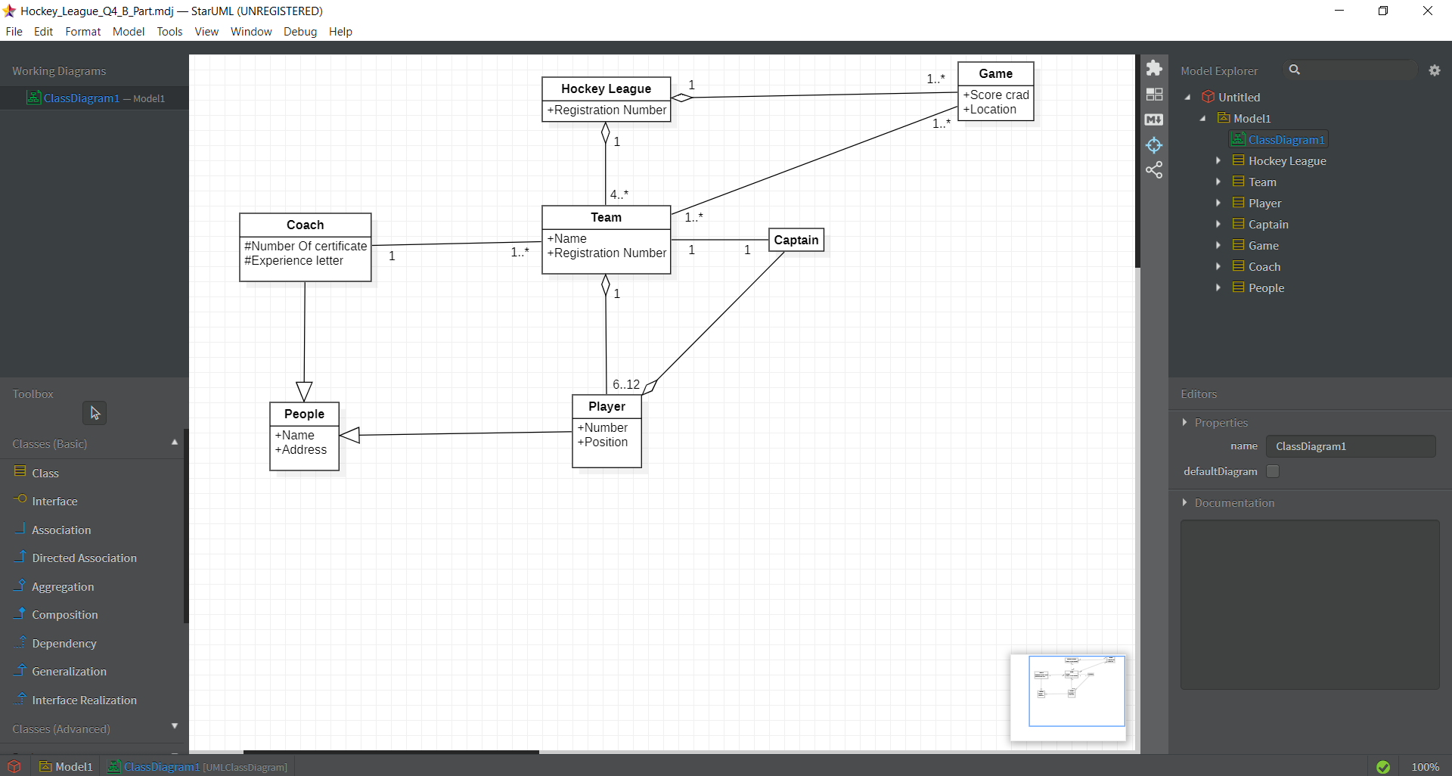

C) Design a class diagram and any two **object diagrams** for each statement:

1. A faculty takes many subjects in a school.

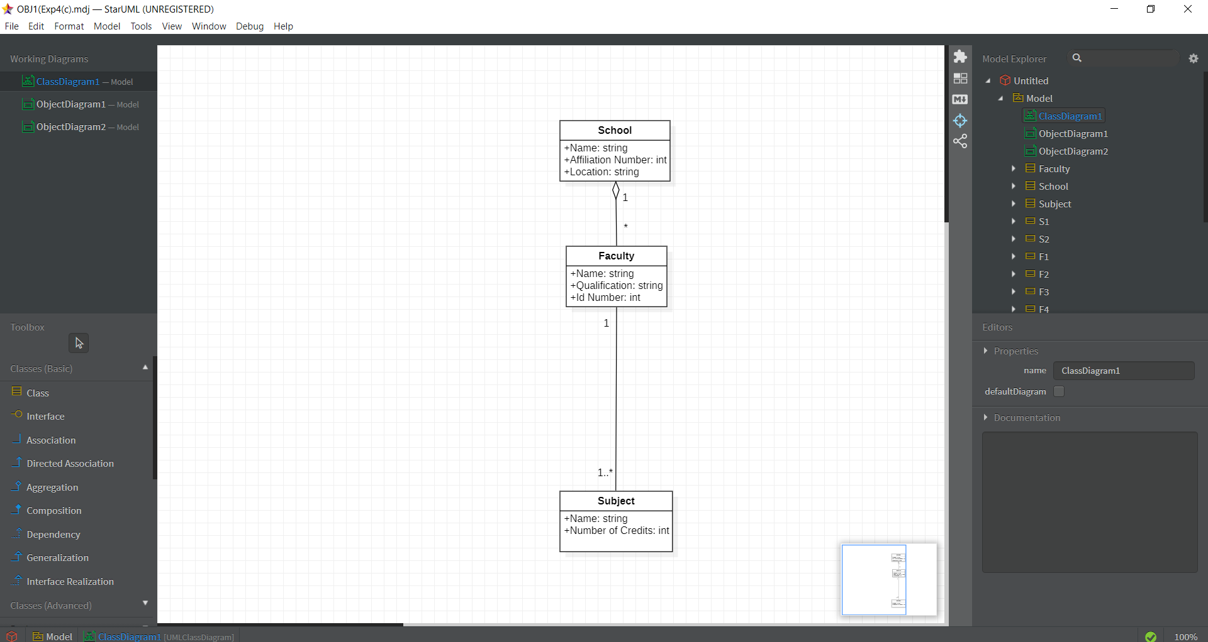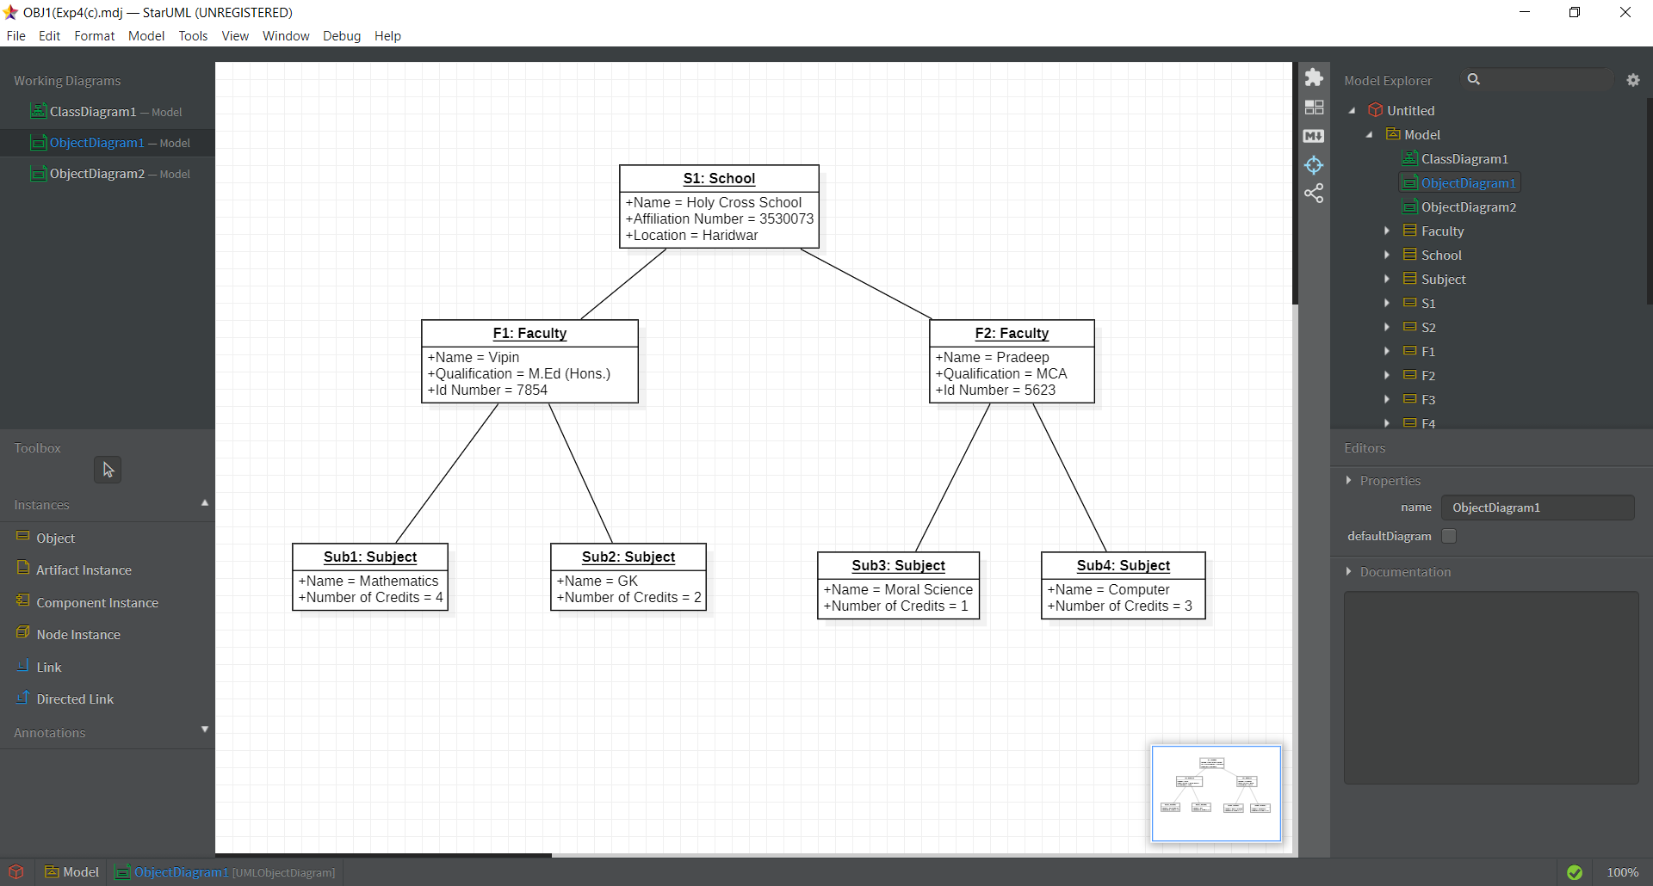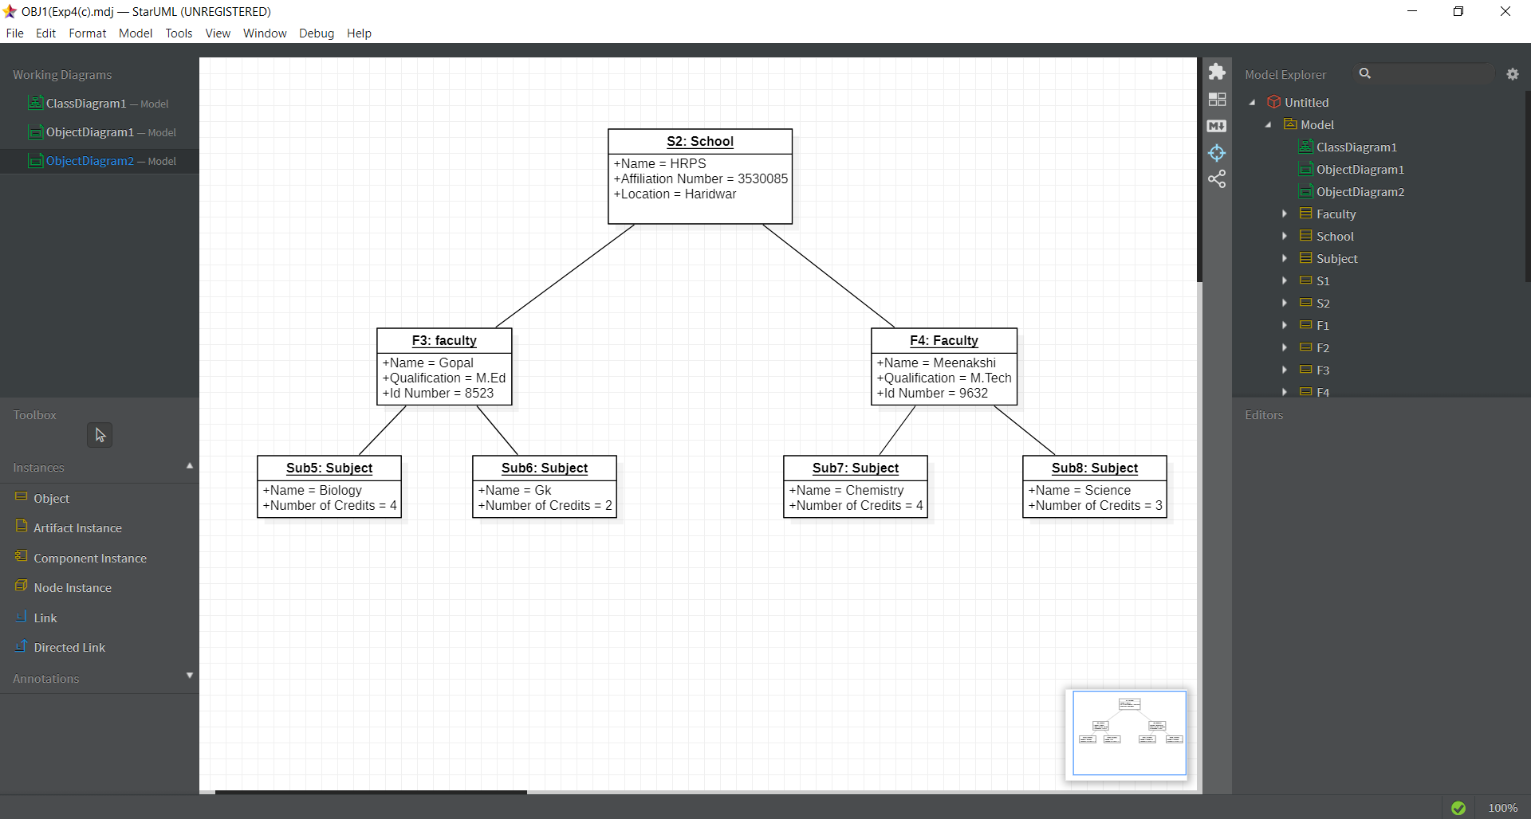

1. Athlete may represent country in various sports events.

