**Rohan Nyati**

**500075940**

**R177219148**

**B-5 AI&ML SEM-5**

**Experiment-5**

**Experiment No: 05 Activity and Swimlane Diagram**

**a) Design detailed Activity diagram of Hospital Management System for the following**:

1. System helps in registering information about patients and handles patient’s query.
2. A unique ID is generated for each patient after registration for maintains medical history of patient.
3. System also monitors the doctor appointments, when the ID is generated the patient receives the appointment time and number from the receptionist and accordingly visits the doctor.
4. This system also deals with testing appointments as and when ID is generated the patient receives the appointment time and number and accordingly undergoes the test.
5. It also deals with bed allotments to various patients by checking their ID. It also undergoes various operations by diagnosing the patients.
6. The system identifies whether the person is a doctor or staff and handles various activities such as draw salary and gives salary, also it adds doctor/staff information into database.
7. This system is responsible for handling various other activities like deleting, editing doctor/staff information into the database.
8. As per doctor diagnoses the patient, gives treatment and gives suggestions to patients and prescribe laboratory tests and medicines.
9. This system also takes care of medical equipment, doctor visit, vitals recording, patient case sheet, diet ordering, blood requisition, transfer information and discharge information, maintenance of wards, inter and intra wards transfers also it generates patient’s discharge summary which includes patients health at the time of discharge, medical history, various diagnosis and drug prescriptions, history of patients illness and course in hospital.
10. Patient can pay bill through credit card, cash or cheque whose information is maintained by this system.

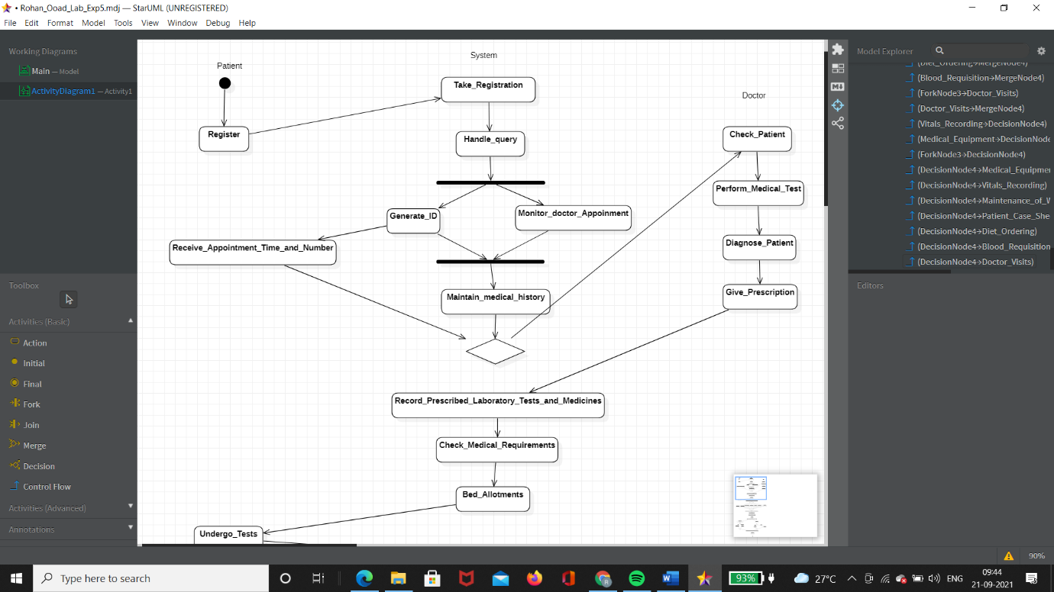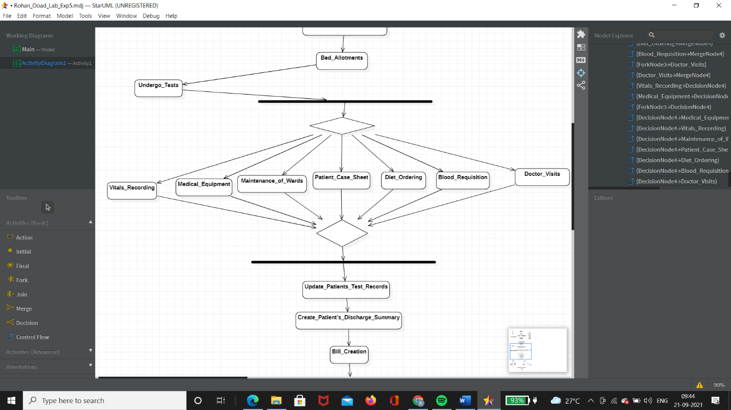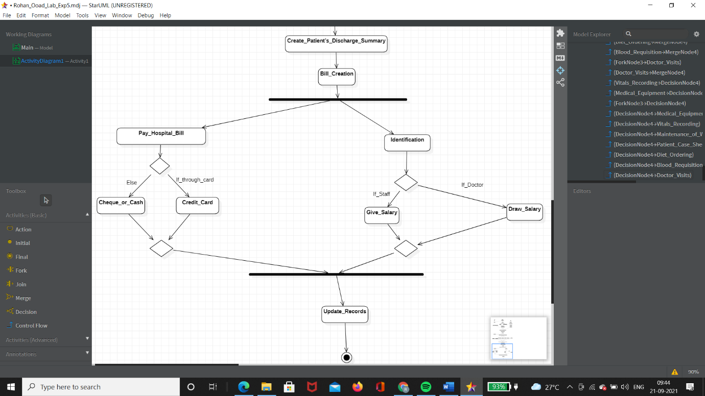

**b) Design Swimlane diagram for booking an “online movie ticket”.**

