**Rohan Nyati**

**500075940**

**R177219148**

**B-5 AI&ML SEM-5**

**Assignment-3**

Draw Use Case Diagram for following:

a) An organization wants to develop the system based on following Requirements:

1. Students have to register first through fill up the registration form.

2. Faculty can prepare the grade sheet of concern subjects.

3. Student and faculty can see the result of each student.

4. Faculty can generate the report about registered students.

5. System can verify the students Registration Details First.

6. Student may have to fill up the hostel details during registration process

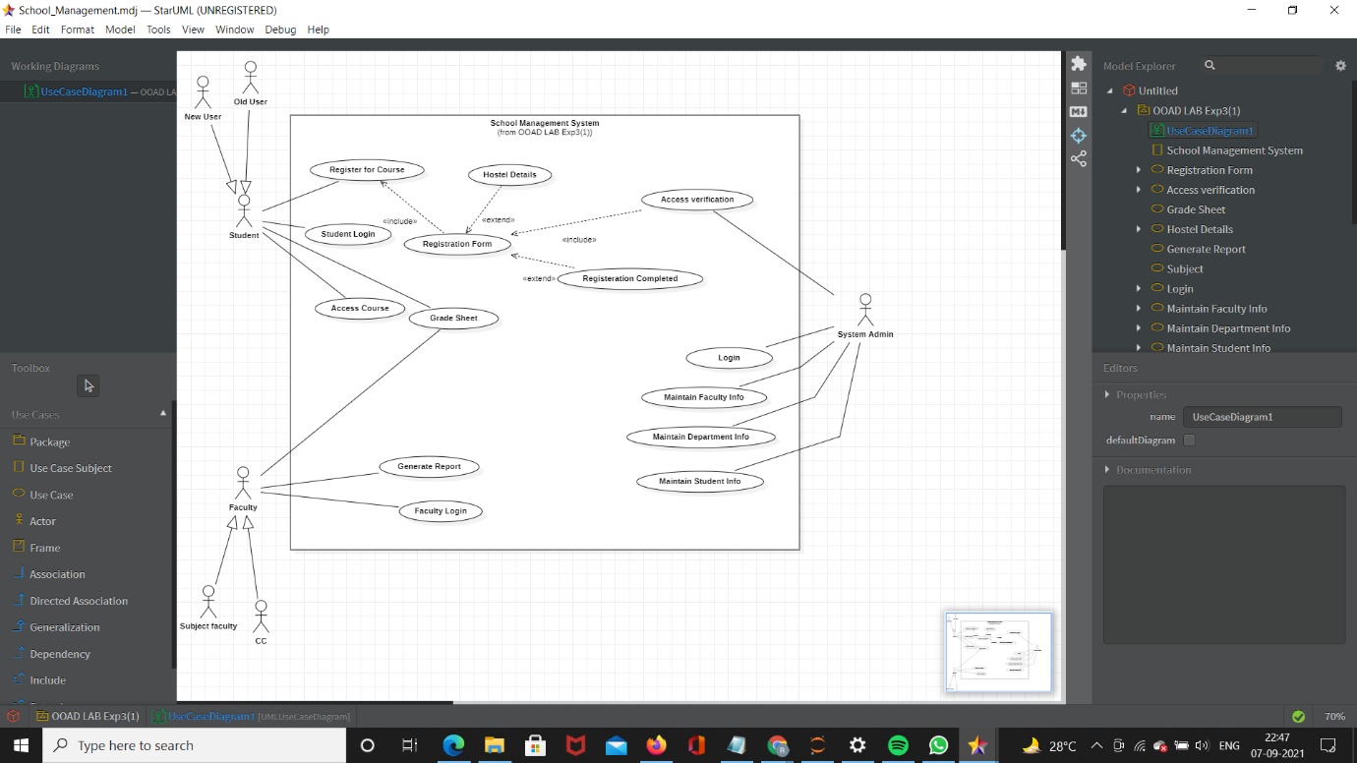

**b)** Consider a bookstore in a shopping mall. The customer selects the books from racks to purchase. The customer brings selected books to cashier. The cashier scans each item with checkout system to prepare an order. The cashier requests to customer for payment. The customer gives credit card to cashier. The verifier and checkout system scans the card. The verifier accepts the card and payment is accepted. Customer signs the credit card slip. The purchased books are handed over to customer.

