**Rohan Nyati**

**500075940**

**R177219148**

**B-5 AI&ML SEM-5**

**Assignment-8**

**STATE DIAGRAMS**

1. **Printer**

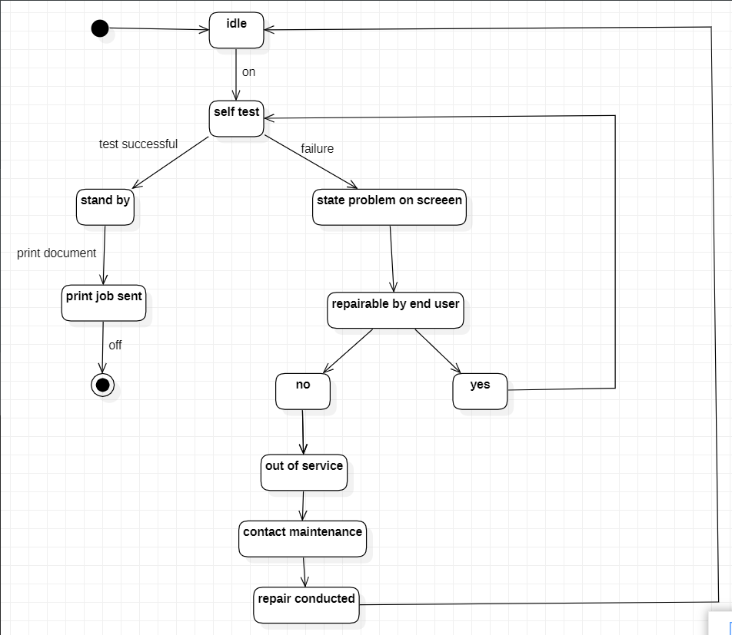

1. **ATM**

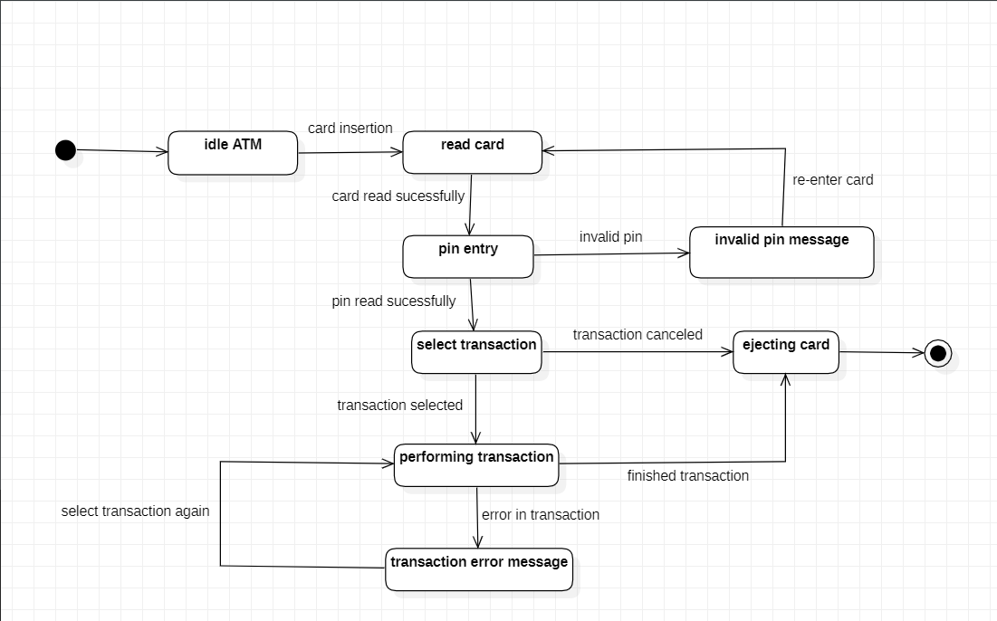

1. **Telephone**

