**Rohan Nyati**

**500075940**

**R177219148**

**B-5 AI&ML SEM-5**

**Assignment-1**

**Q.1** Instructions: Use any UML Tool to design given UML diagrams and submit raw files(e.g., abc.mdj ) along with a word/pdf file containing all solutions.

Design Use case and a Class diagram for given scenarios:

Online Tour Booking System

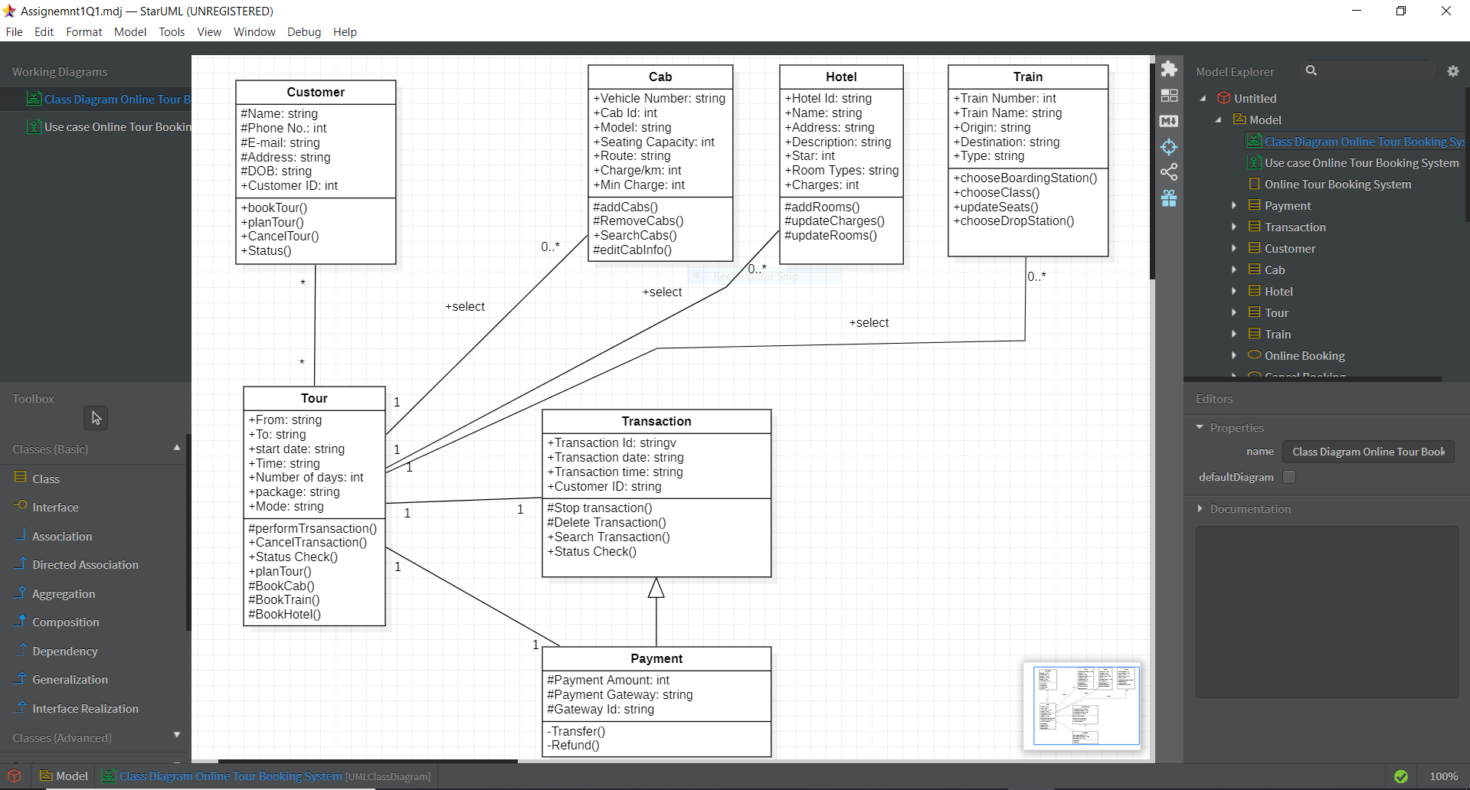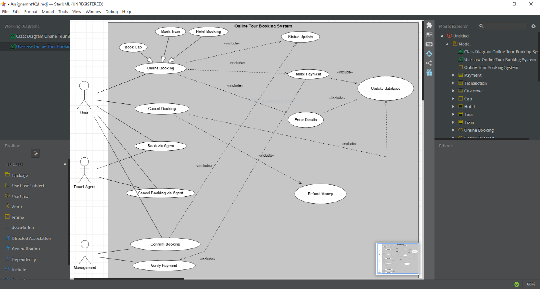

**Q.2** Instructions: Use any UML Tool to design given UML diagrams and submit raw files(e.g., abc.mdj ) along with a word/pdf file containing all solutions.

Design Use case and a Class diagram for given scenarios:

System for managing and conducting International Games Event

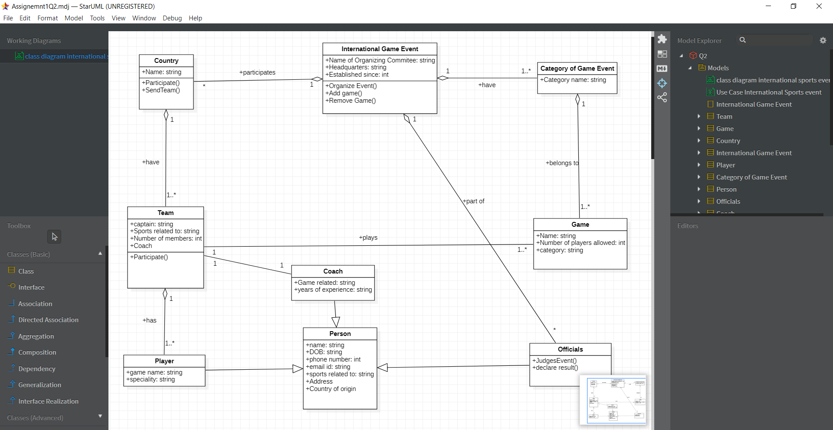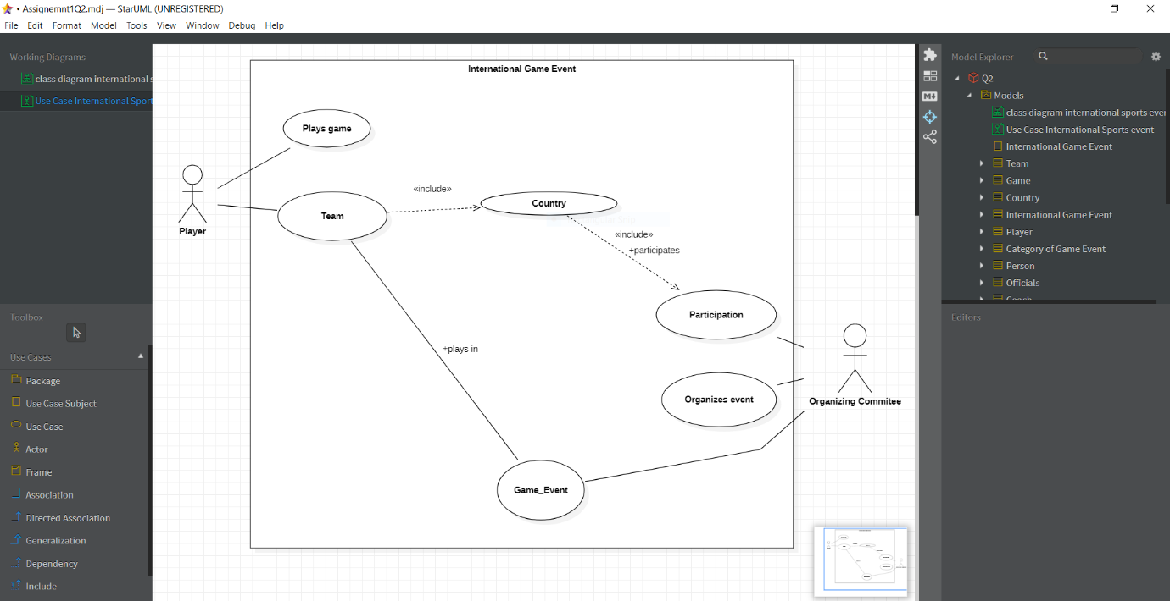

**Q.3** Instructions: Use any UML Tool to design given UML diagrams and submit raw files(e.g., abc.mdj ) along with a word/pdf file containing all solutions.

Design a Class diagram for given scenarios:

Order management system for online shopping store.

