

Pattern

&

Anomaly

D

etection

Lab

Experiment

10

Submitted By: Submitted To:

Dhruv Singhal

D

r.

Gopal Phartiyal

500075346

Asst. Professor

R177219074

SOCS

AIML B3

UPES



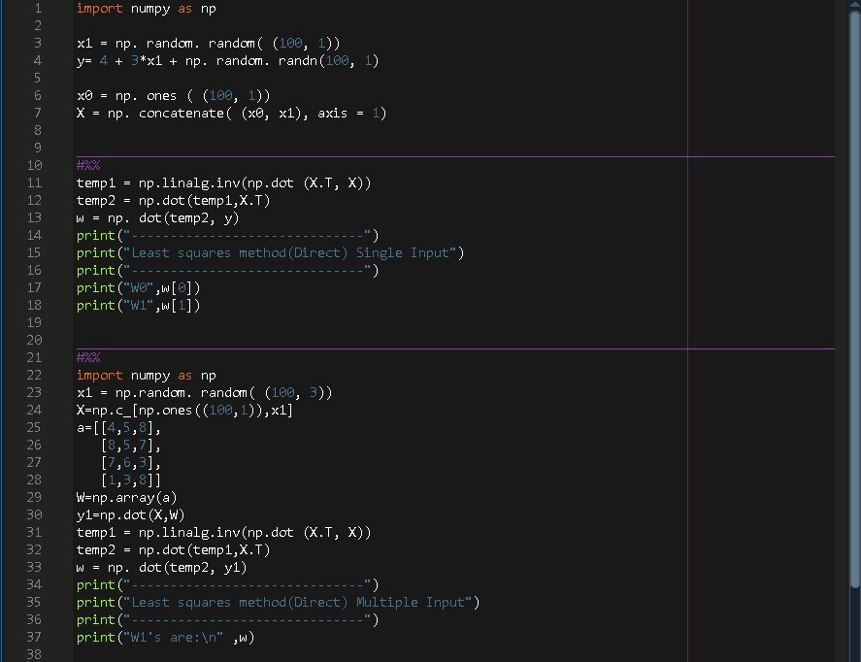CODE:

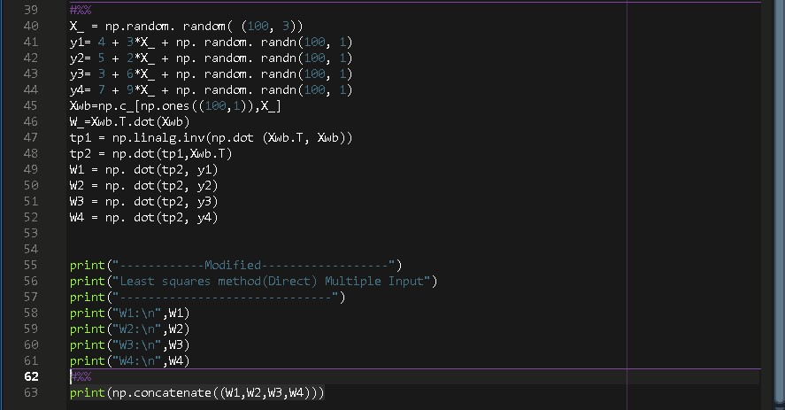

OUTPUT:

