Pattern and Anomaly Detection Lab

Experiment -1

# Installing Anaconda and Setup up Environment



Submitted By: Submitted To:

Dhruv Singhal Dr. Gopal Phartiyal

R177219074 Professor

500075346 SOCS

AIML B3 UPES Anaconda & Spyder Installation for windows

1. Click on the link below to open the download page

https://www.anaconda.com/download/#windows

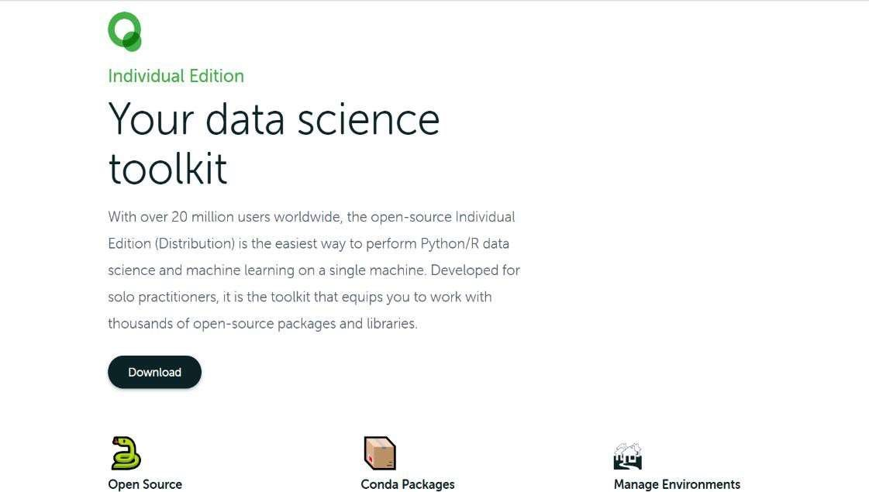

1. Click on the Download button and check for the compatibility of your system. Then, it will start downloading.

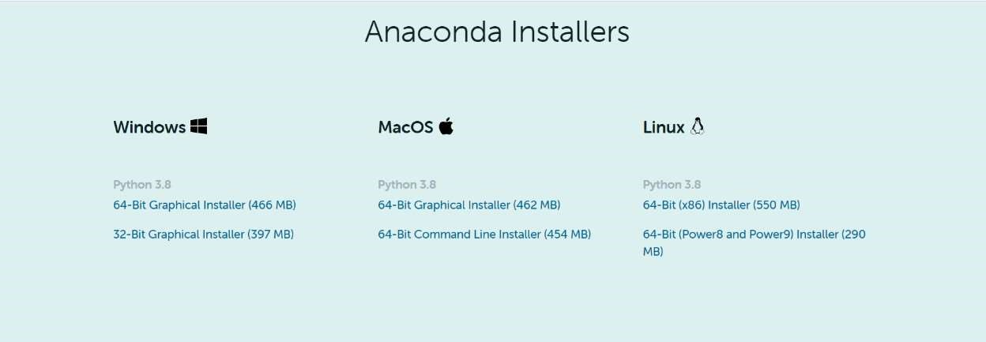

1. Double click the installer to launch.
2. Click on Next.

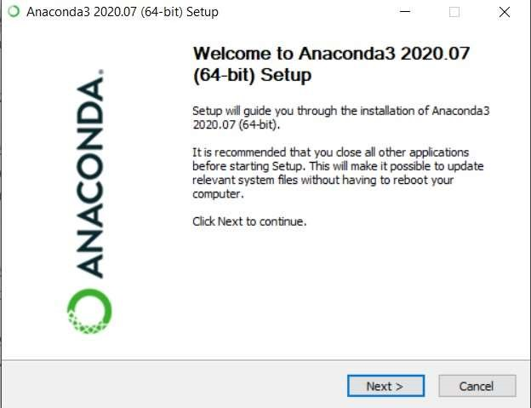

1. Read the license agreement and click on “I Agree”.

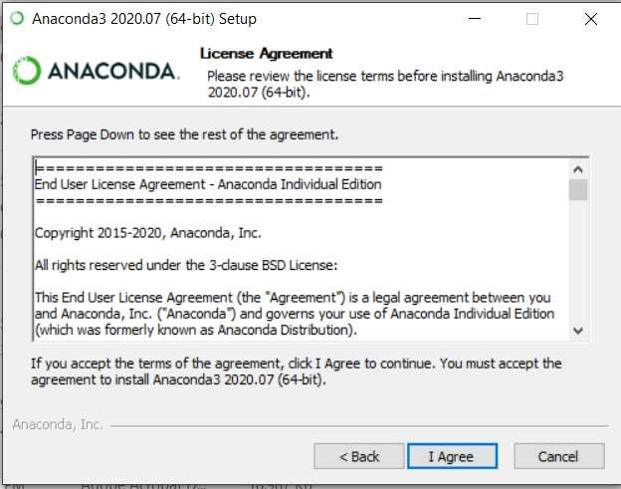

1. Select installation type “Just Me” unless you’re installing it for all users (which require Windows Administrator privileges) and click on Next.

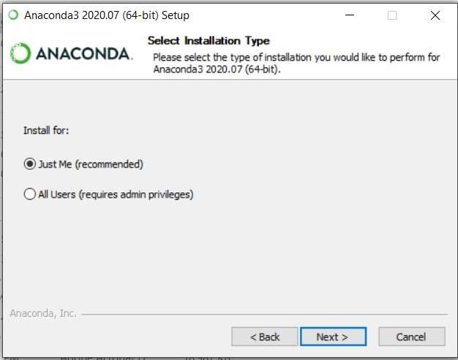

1. Select a destination folder to install Anaconda and click the Next button.

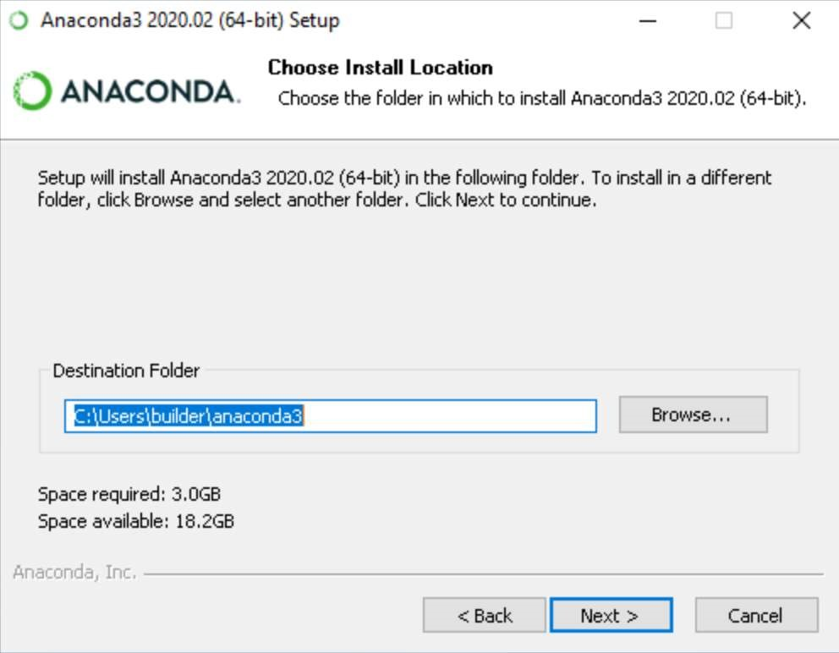

1. Choose whether to add Anaconda to your PATH environment variable. We recommend NOT adding Anaconda to the PATH environment variable, since this can interfere with other softwares. Instead, use Anaconda software by opening

Anaconda Navigator or the Anaconda Prompt from the Start Menu

Choose whether to register Anaconda as your default Python. Unless you plan to install and run multiple versions of Anaconda or multiple versions of Python, accept the default version and leave this box checked.

1. Click the Install button.

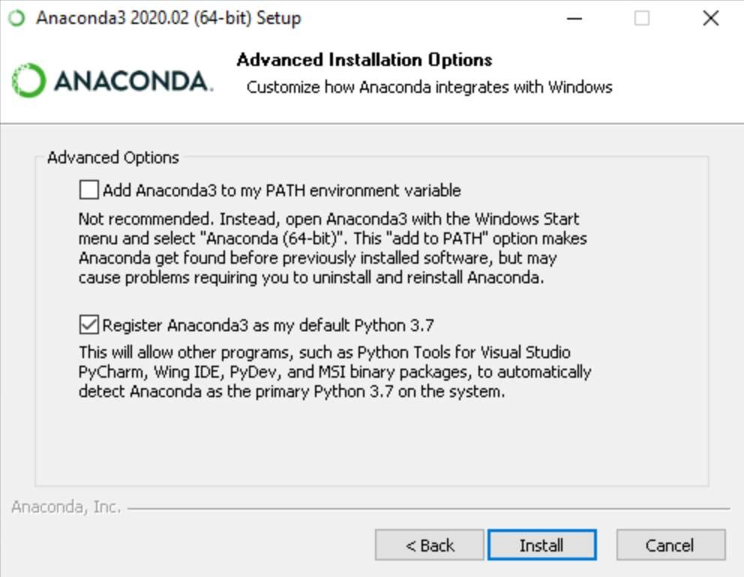

If you want to watch the packages Anaconda is installing, click on Show Details.

1. Click on the Next button.

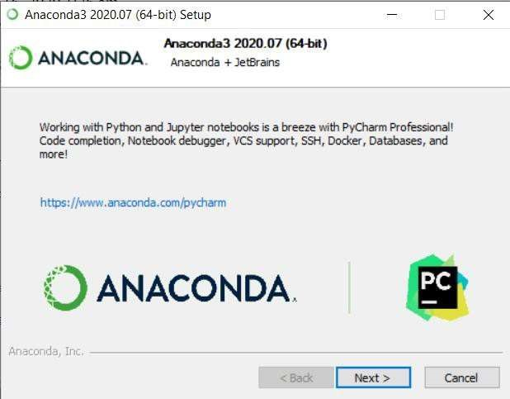

1. And then click the Finish button.

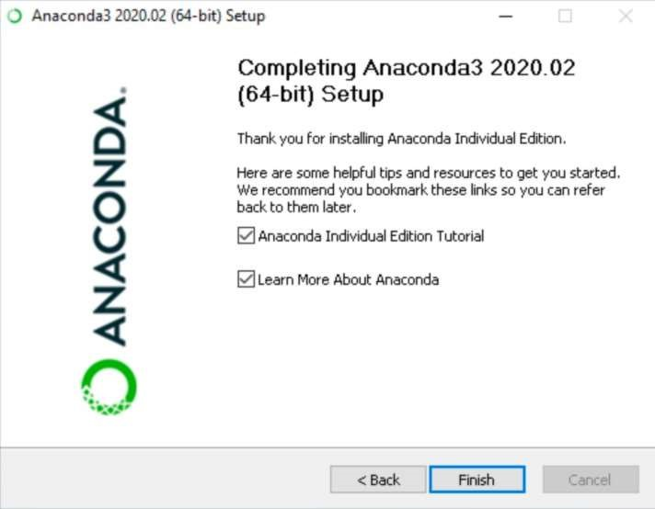

1. After a successful installation you will see the “Thanks for installing Anaconda” dialog box.

13.Open Anaconda navigator.

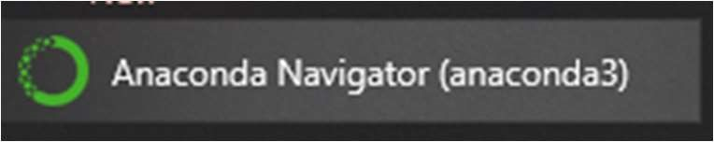

14. This screen will pop up.

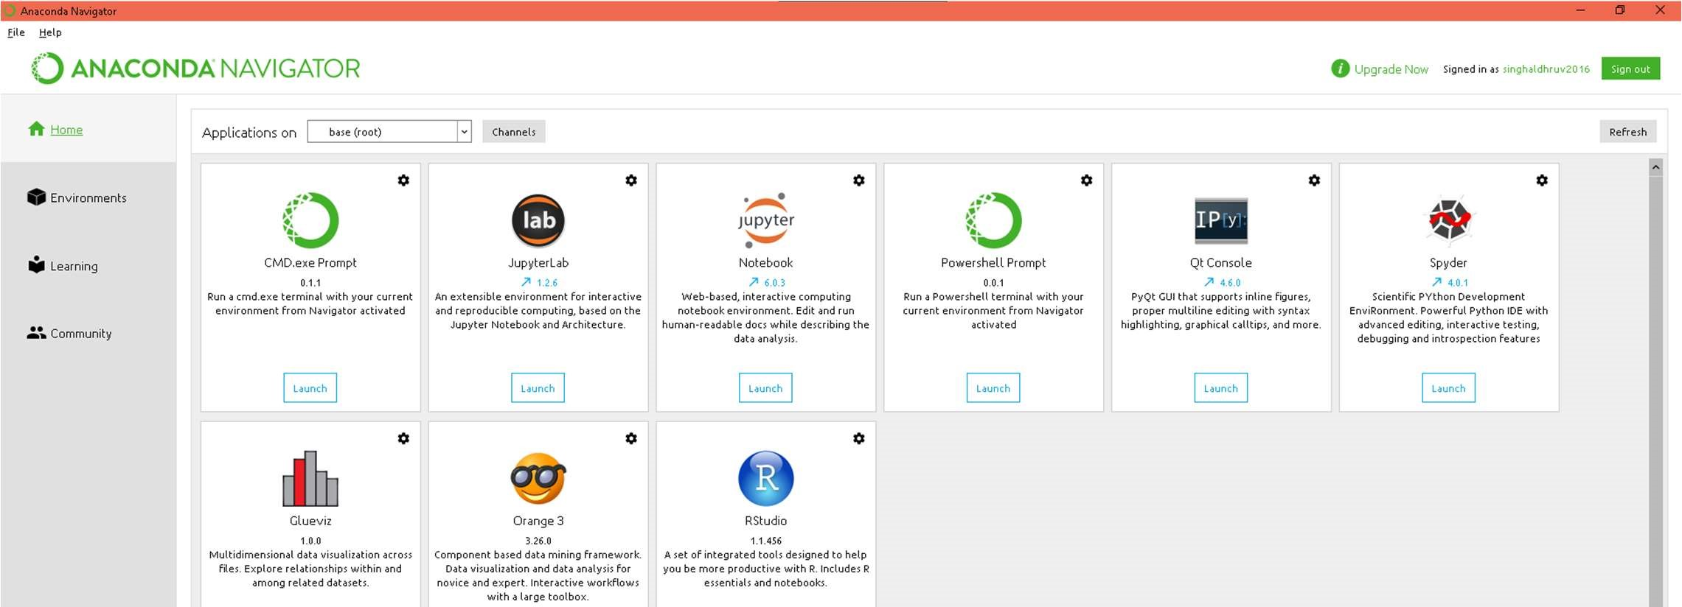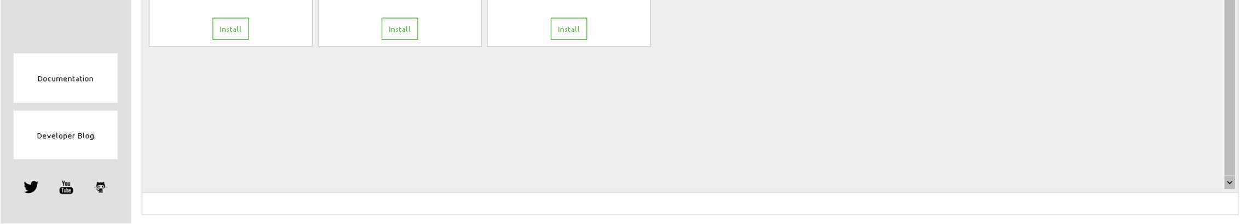

15.Go to “Environments “ from Left Side panel.

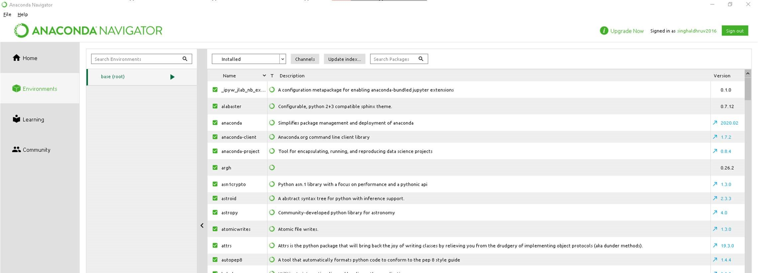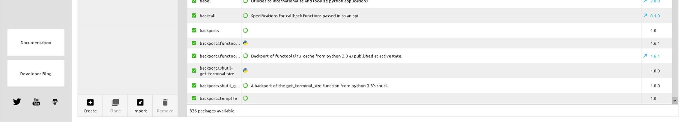

1. From Bottom Left click “Create” and choose version and name of the environment.

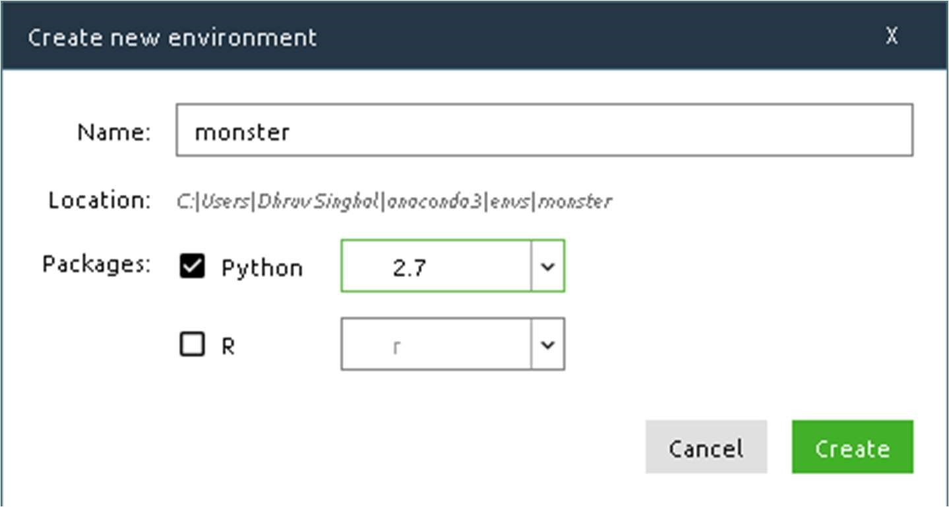

1. Create environment.

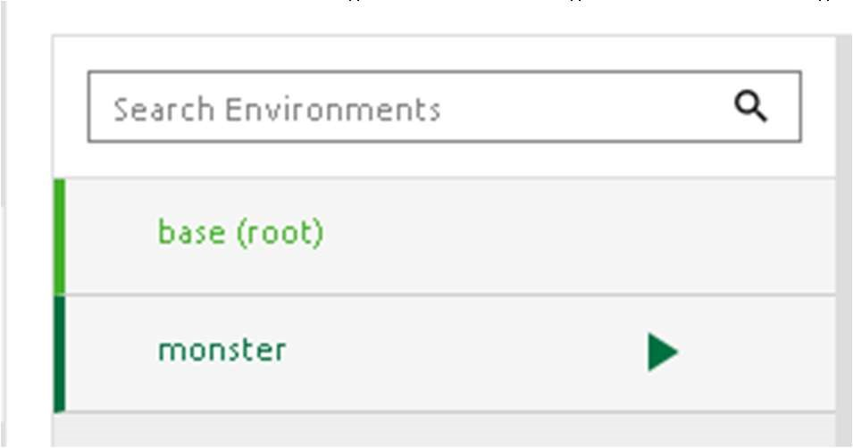

1. Activate Environment from Anaconda Prompt and Launch Spyder(After installing From Anaconda Navigator)

Spyder:

Spyder, the Scientific Python Development Environment, is a free integrated development environment (IDE) that is included with Anaconda.

It includes:

* + Editing
  + Interactive testing
  + Debugging
  + Introspection features

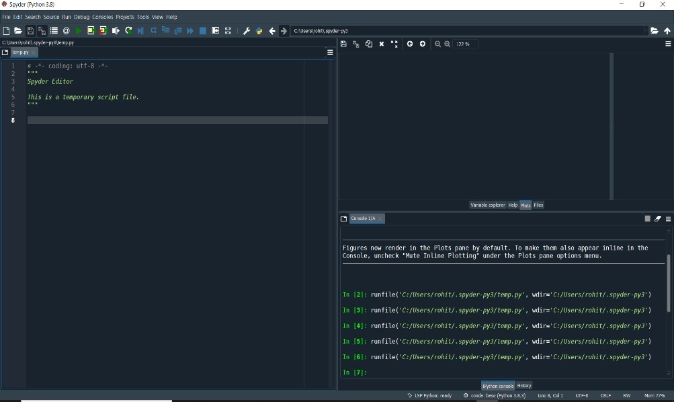

Editor

Console

Variable

/help /file

/plot space

Steps for Spyder setup and run a test code:

1. In Window search box, type Spyder and press Enter. 2. Spyder IDE opened and you can see a total of 3 area:

* + 1. Editor
    2. Console
    3. Variable/help/file/plot space

* + 1. Let’s write a test code in the Editor and run the code by clicking on Run button.

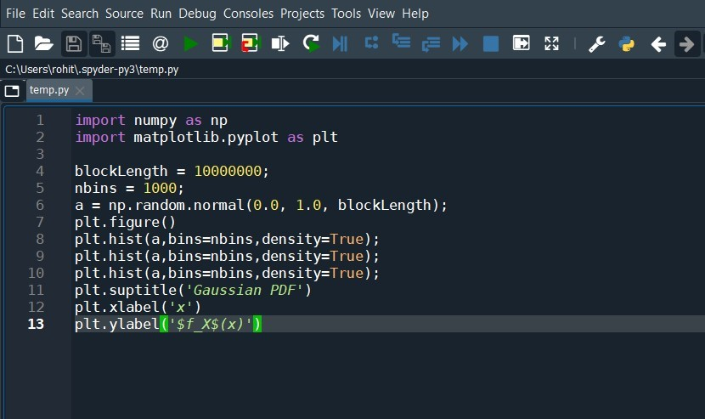

* + 1. You can see the variable, plot, files on right side of IDE by clicking appropriate tabs as highlighted with Red color below.

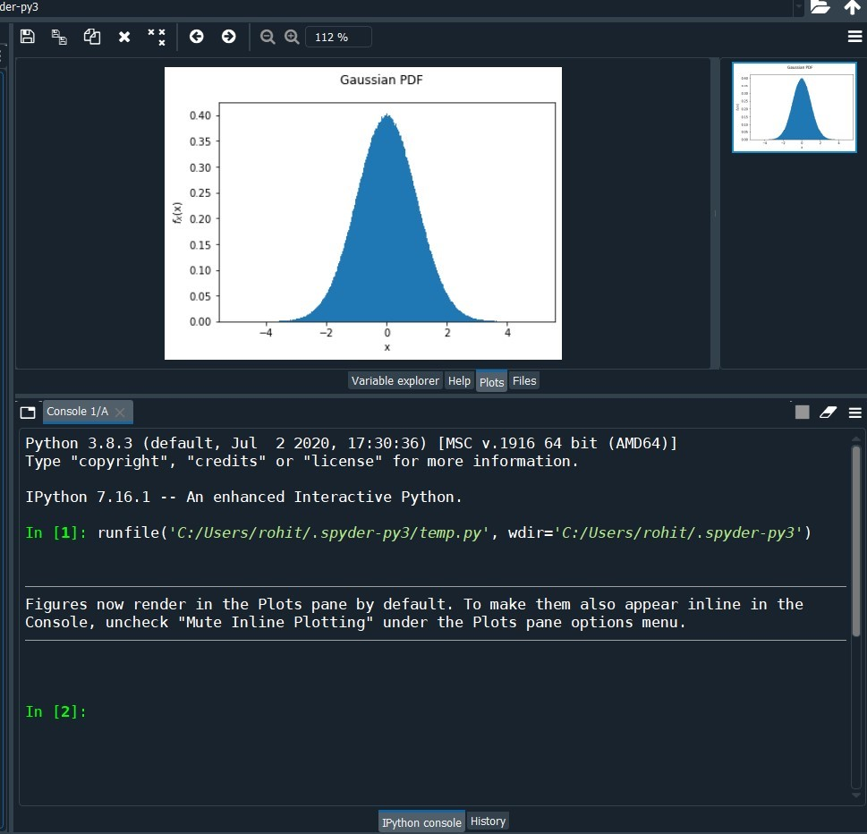

* + 1. As a whole Spyder screen looks like as below.

