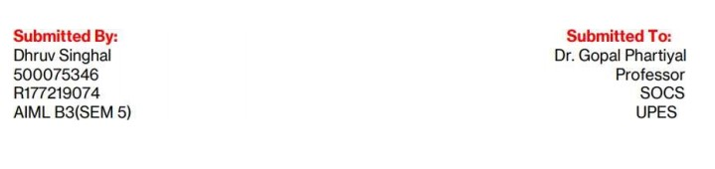Pattern & Anomaly Detection Lab

Experiment: 4

AIM:

To perform Logistic Regression

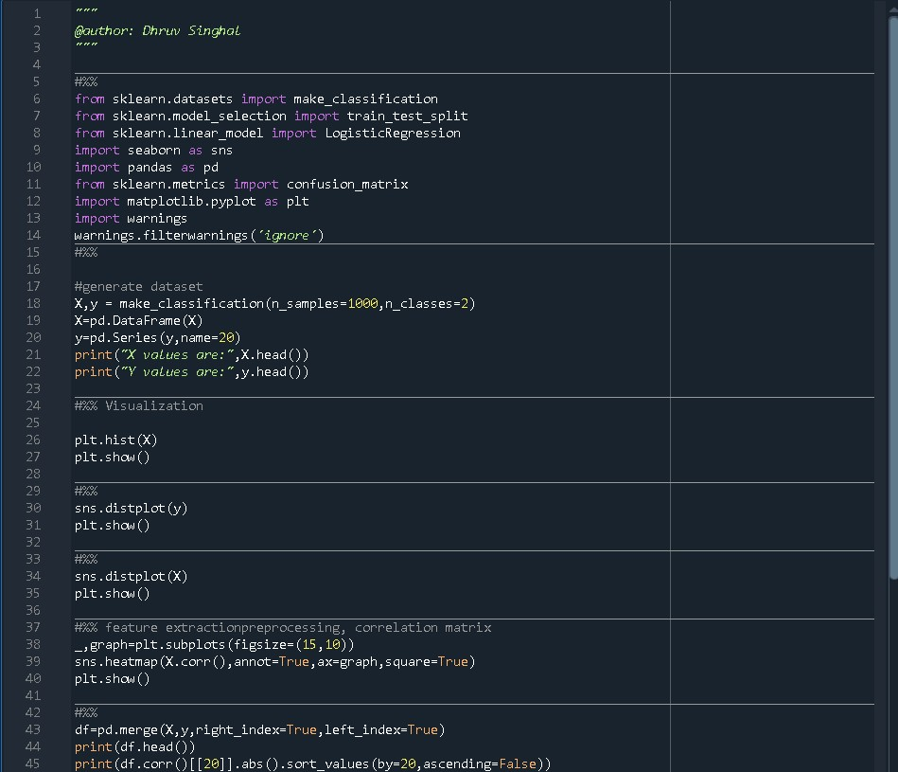**CODE:**

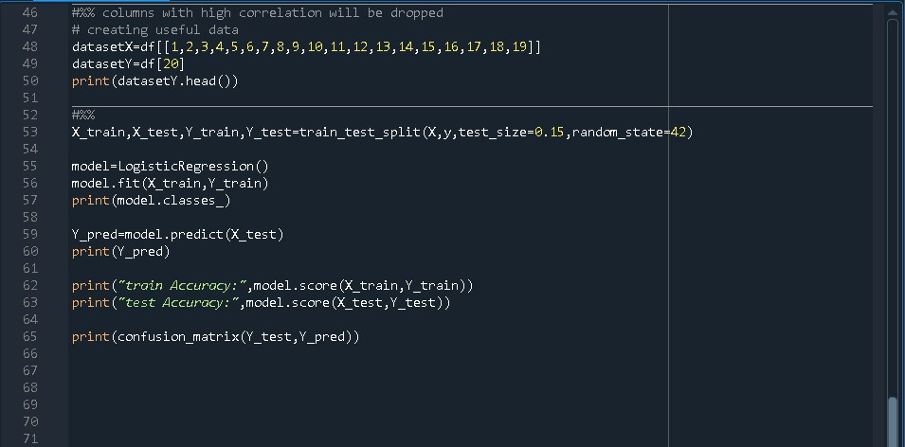

**OUTPUT:**



