

Pattern

&

Anomaly

Detection

Lab

Experiment 8

Nested Cross Validation with Hyperparameter

T

uning

Submitted By: Submitted To:

Dhruv Singhal

D

r.

Gopal

Phartiyal

500075346

Asst. Professor

R177219074

SOCS

AIML B3

UPES



**Hyperparameter**

**Tuning and Nested Cross validation on**

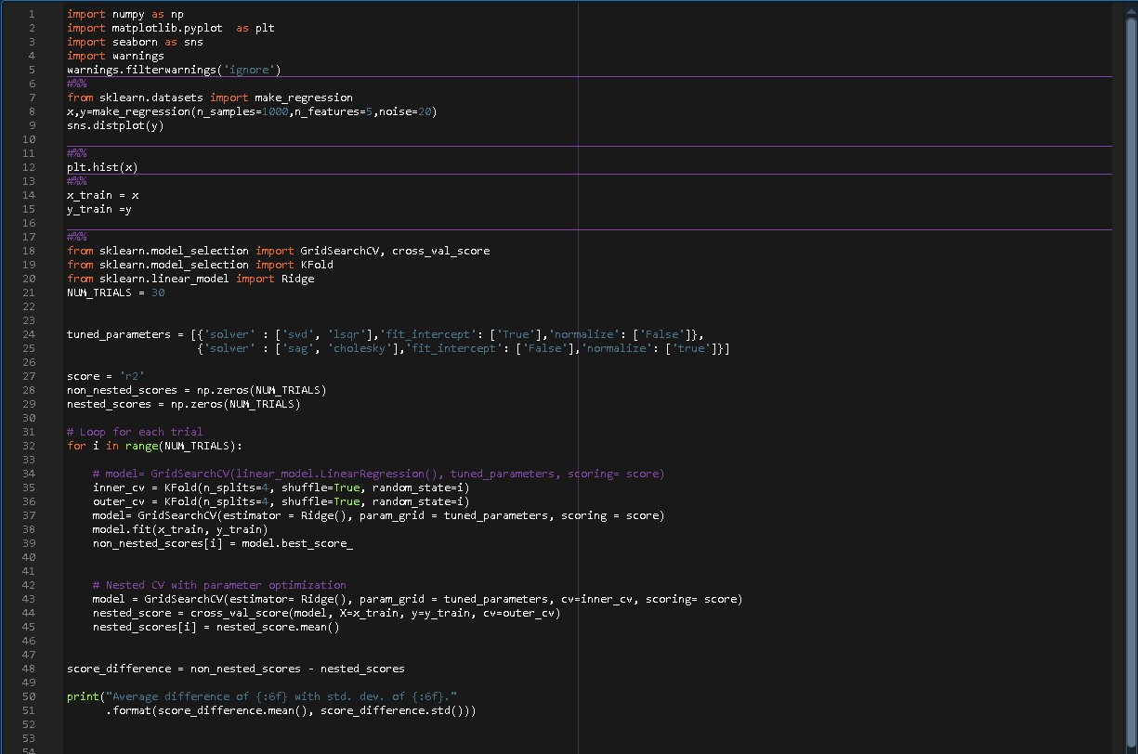**Linear Regression**

**CODE:**

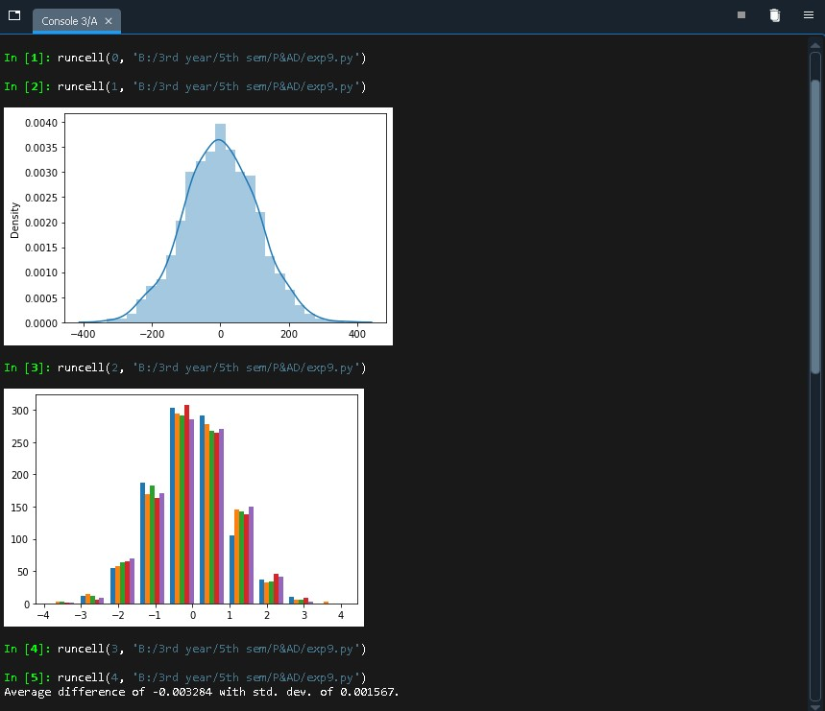OUTPUT:

**Hyperparameter**

**Tuning and Nested Cross validation on**

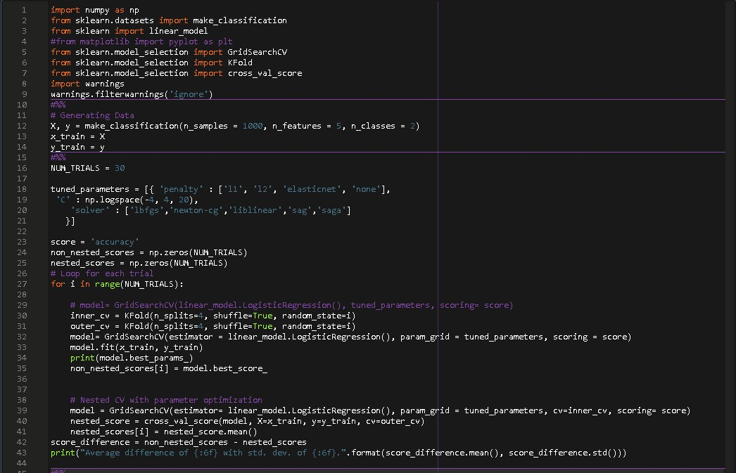**Logistic Regression**

**CODE:**

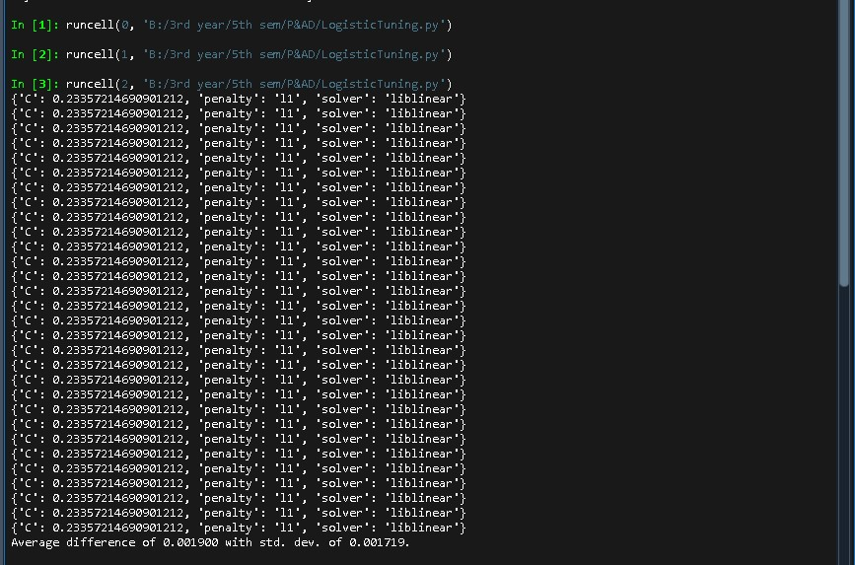OUTPUT:

**Hyperparameter**

**Tuning and Nested Cross validation on**

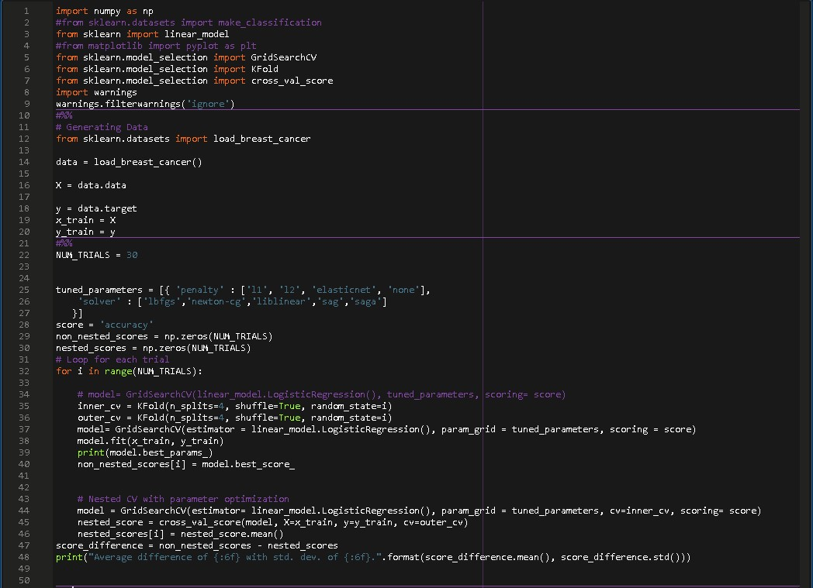**Logistic Regression**

**(Breast Cancer Dataset)**

**CODE:**

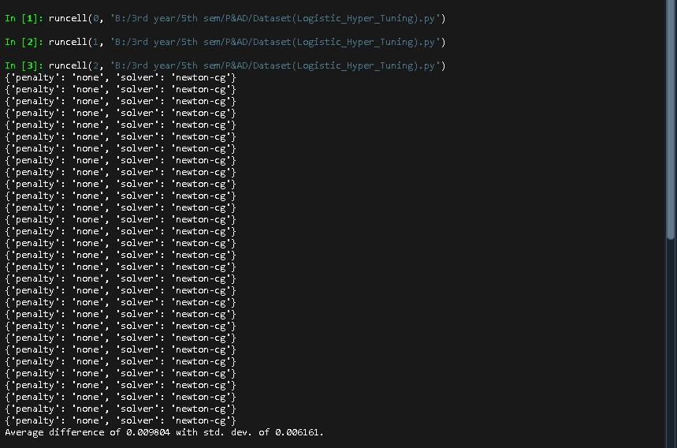OUTPUT: