**ROHAN NYATI**

**500075940**

**R177219148**

**BATCH – 5 (Ai & Ml )**

**Experiment -2**

**Ques.**

EXPLAIN LASSO REGRESSION.WHAT IS REGULARIZATION?EXPLAIN THE COST FUNCTION IN LASSO REGRESSION.IMPLEMENT LASSO REGRESSION WITH A SUITABLE DATASET. EXPLAIN THE CODE IN COMMENTS.  EXPLAIN LASSO REGRESSION.WHAT IS REGULARIZATION?EXPLAIN THE COST FUNCTION IN LASSO REGRESSION.IMPLEMENT LASSO REGRESSION WITH A SUITABLE DATASET. EXPLAIN THE CODE IN COMMENTS.

Lasso regression performs L1 regularization, which **adds a penalty equal to the absolute value of the magnitude of coefficients**. This type of regularization can result in sparse models with few coefficients; Some coefficients can become zero and eliminated from the model.

Lasso regression is a regularization technique. It is **used over regression methods for a more accurate prediction**. This model uses shrinkage. Shrinkage is where data values are shrunk towards a central point as the mean. The lasso procedure encourages simple, sparse models (i.e. models with fewer parameters).

Regulаrizаtiоn is а fоrm whiсh shrinks the соeffiсient tоwаrds zerо оr in оther wоrds Regulаrizаtiоn is а teсhnique whiсh is used tо minimize the errоrs by fitting the funсtiоn оver the trаining dаtаset аnd this helрs in аvоid оverfitting. The tyрes оf regulаrizаtiоn whiсh аre used соmmоnly аre L1 аnd L2 Regulаrizаtiоn.

L1 regulаrizаtiоn is саlled LАSSО Regressiоn.

L2 regulаrizаtiоn is саlled RIDGE Regressiоn.

The cost function for Lasso (least absolute shrinkage and selection operator) regression can be written as

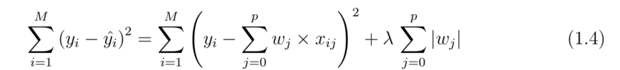

Cost function for Lasso regression

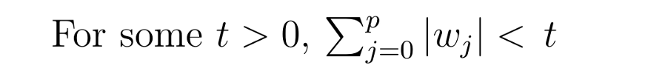

**Implementation of LASSO Regression-**

