**Rohan Nyati**

**500075940**

**R177219148**

**Batch – 5 (AI & ML)**

**Experiment – 1 Date : 19/01/2022**

## AIM:

To explain the architecture of the 8085 Micro-Processor.

**APPARATUS :**

8085 Microprocessors

## INTRODUCTION:

INTEL 8085 is a general purpose 8-bit Microprocessor capable of addressing 64KB of memory. It is enhanced version of its predecessor, the 8080 and its instruction set is upward compatible with that of the 8080A.

The microprocessor has a set of instructions designed internally, to manipulate data and communicate with peripherals. It can be programmed to perform functions on given data by selecting necessary instructions from its set.

The internal architecture of the 8085A determines how and what operations can be performed with the data. T o perform any operation, the microprocessor requires registers, an Arithmetic Logic Unit (ALU) and control Logic and internal buses. Certain registers of the processor can be written into and hence are available for manipulation or processing of input data. Use of certain write instructions makes this feasible. To know more about the features of the processor let us take a look into the internal architecture of the 8085A.

STACK POINTER

PROGRAM COUNTER

ADDRESS BUS LATCH

FLAGS

L

E

C

A

B

D

H

INSTRUCTION DECODER

DATA BUS LATCH

## *ACCUMULATOR:*

The accumulator is the primary source and destination for one operand and two operand instructions. For example, all data transfers between the CPU and I/P devices are performed through the accumulator. In addition, many memory reference instructions move data between the accumulator and memory than between any other register and memory. All Arithmetic and Boolean instructions take one of the operands from the accumulator and return the result to the accumulator. So the accumulator should be loaded before any arithmetic or Boolean operation.

## *REGISTERS:*

Apart from the accumulator we have got other registers such as B, C, D, E, H, and L . These are called secondary registers. Data stored in any of these six registers may be accessed with equal ease. Such data can be moved to any other registers or can be used as the second operand in two operand instructions. These six registers can be used to hold 8-bit data when used individually or 16-bit data when used in pair as BC as DE or HL.

Registers H and L comprise the primary data pointer for 8085A. Normally, these two registers will be used to hold the 16-bit memory address of data being accessed. It is usually called memory pointer. We can transfer data between any specified register and memory location addressed by H and L. It is good to address data memory via registers H and L ,whenever possible because it can make your program more efficient and easy to relocate.

## *FLAGS:*

The ALU consists of five flip-flops that are set or reset according to data conditions in the Accumulator and other registers. The Microprocessor uses them to test for data conditions. The five flip-flops , referred to as flags ,are the carry flag (C), the Zero flag (Z), the sign flags (S), the parity flag (P), and the Auxiliary Carry flag (AC).

## *PROGRAM COUNTER (PC):*

This register deals with sequencing the execution of instructions. The function of the PC is to point to the memory location from which the next byte is to be fetched for execution.

## *STACK POINTER (SP):*

The stack pointer Register is also 16-bit and is used as a memory pointer. It point s to a memory pointer. It points to a memory location in RAM memory, called the STACK. The beginning of the stack is defined by the user.

**DIAGRAM:**

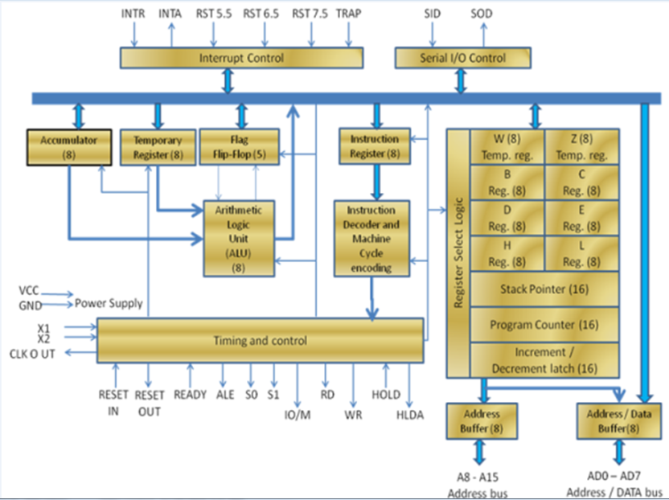

**Fig : Block diagram of Intel 8085**

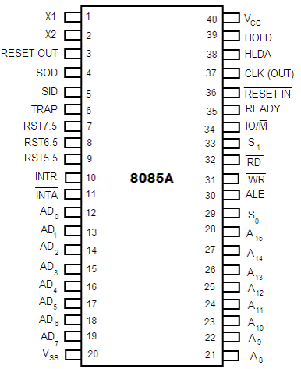

**Fig: Pin diagram of Intel 8085 microprocessor**

## PROCEDURE:

1. We try to get the basic understanding about 8085 microprocessor.
2. Then we learn about its various components , configurations and diagrams .

**RESULT :**

We learned and understood various basic concepts and applications of 8085 Microprocessor and its different configurations .