**ROHAN NYATI**

**500075940**

**R177219148**

**BATCH – 5 (Ai & Ml )**

**Experiment -1**

**Q1) Implement the following things on PyTorch:-(Python)**

1. **Explore the tools with different options like**
   * **installation**
   * **tensor creation deletion**
   * **tensor manipulation**

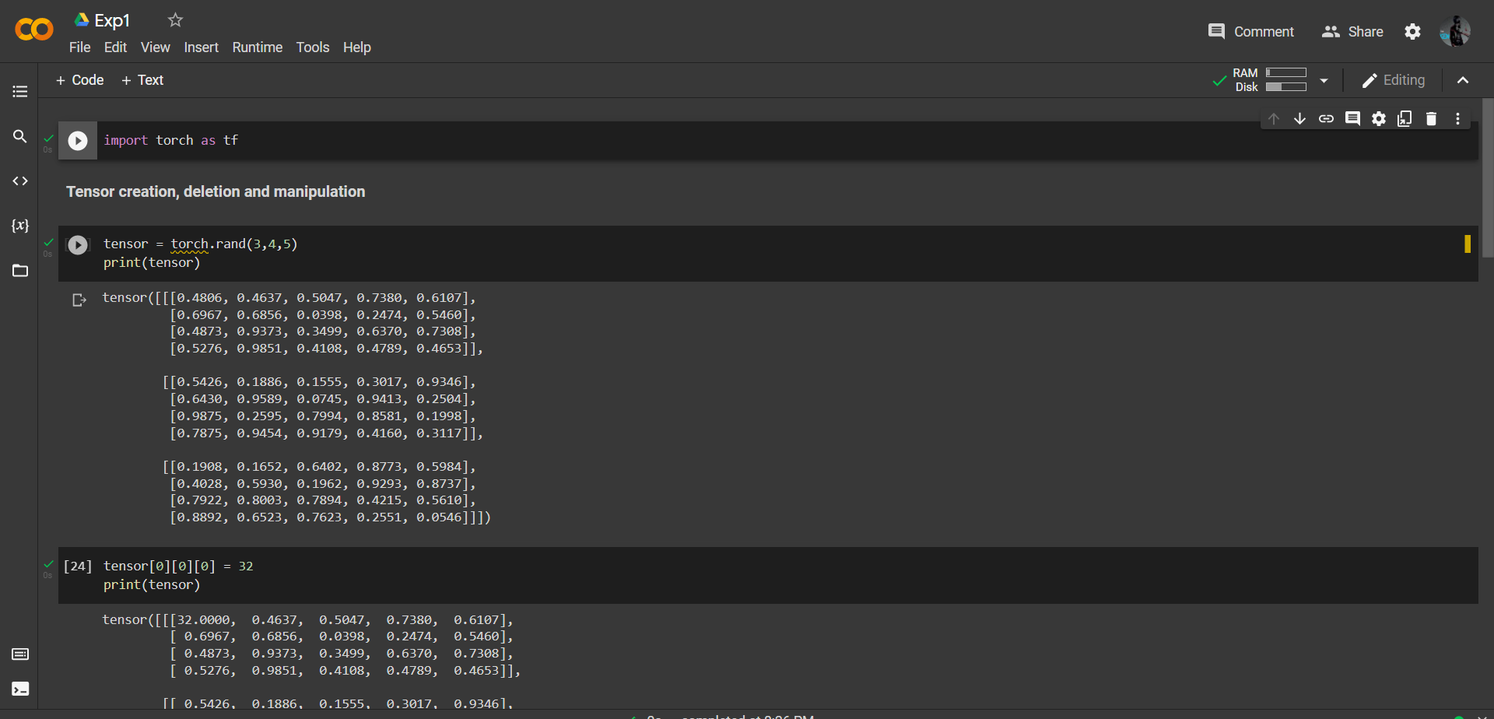

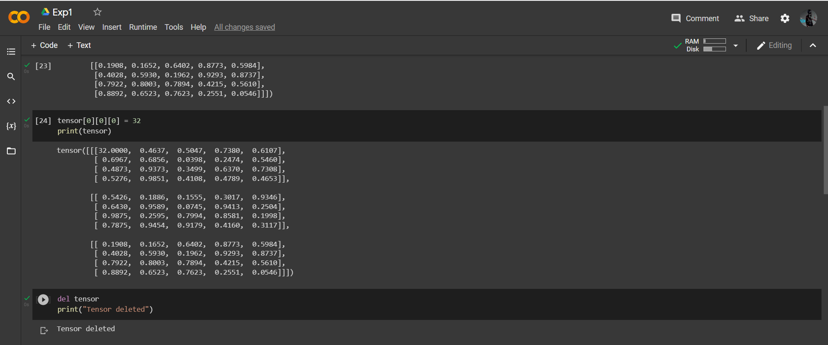

**2) Write a Program for Matrix Addition**

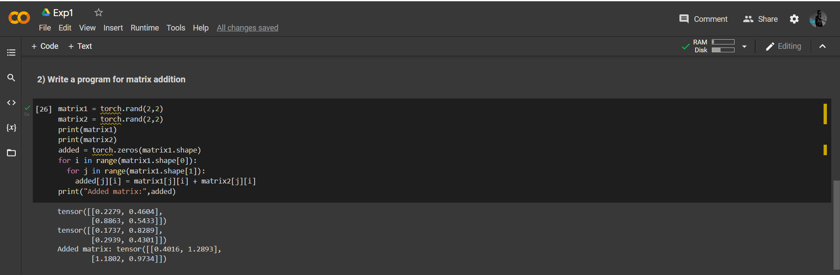

**3) Write a Program for Matrix Multiplication**

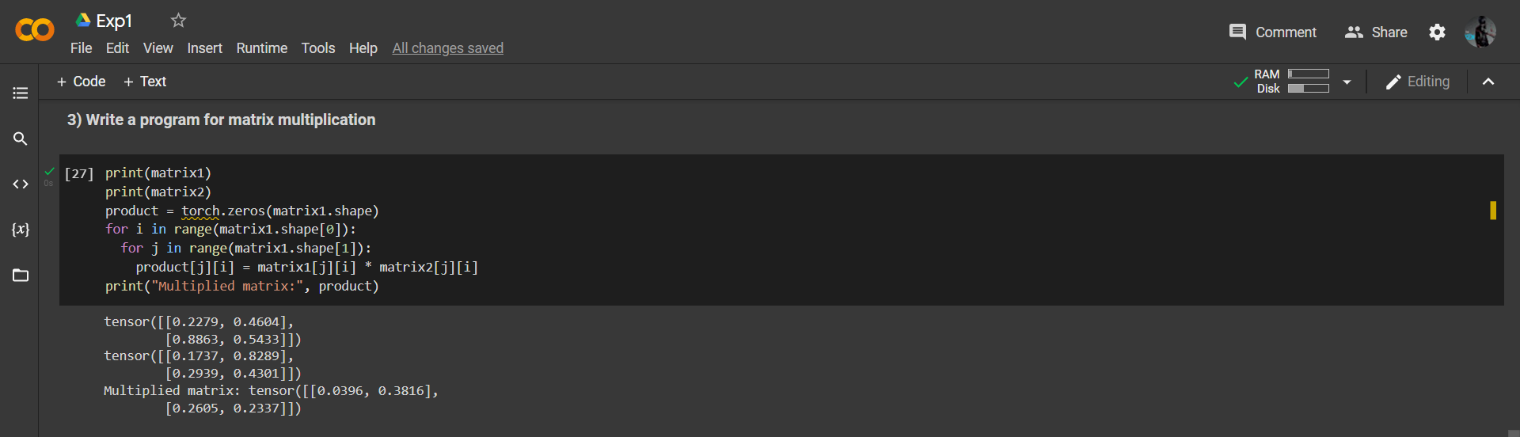

**4) Write a Program for Matrix Transpose**

