System Design Diagrams
Real-Time Network Intrusion Detection System (NIDS) using Packet Inspection and Web-Based Alerting
Rohan Pandey | Roll No. 2501720100117 | Section 2D | Guide: Mr. Vikas
3.1 Data Flow Diagram, Level 0 (Context Diagram)
The context diagram shows the whole system as a single process. Packets enter the system from the network hosts, which can be normal users or an attacker. The administrator opens the dashboard to start monitoring and receives live packet counts and attack alerts from the system.
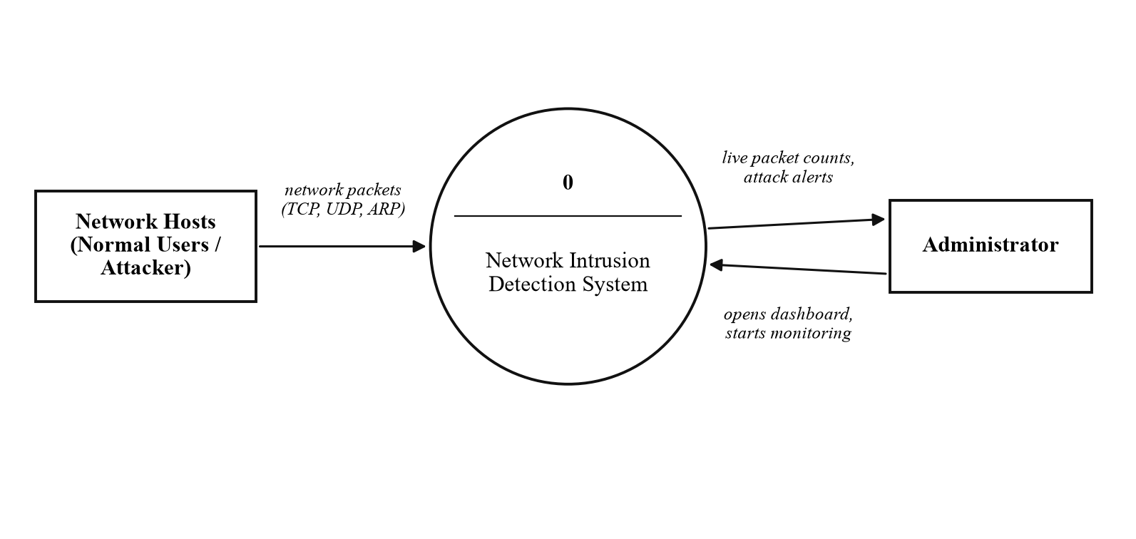
Fig. 3.1: Level 0 DFD of the Network Intrusion Detection System
3.2 Data Flow Diagram, Level 1
The level 1 diagram breaks the system into five processes. Process 1.0 captures packets from the network card with Scapy. Process 2.0 counts TCP, UDP and ARP packets and sends the counts every second. Process 3.0 checks each packet against the detection rules and keeps recent SYN packets in the SYN History store (D1). Process 4.0 is the Node.js server, which receives counts and alerts over HTTP POST and saves every alert in the alert log (D2). Process 5.0 is the web dashboard, which receives the data through Socket.IO and shows it to the administrator. In the current phase the port scan rule is implemented inside process 3.0; the SYN flood and ARP spoofing rules will be added to the same process in the next phase.
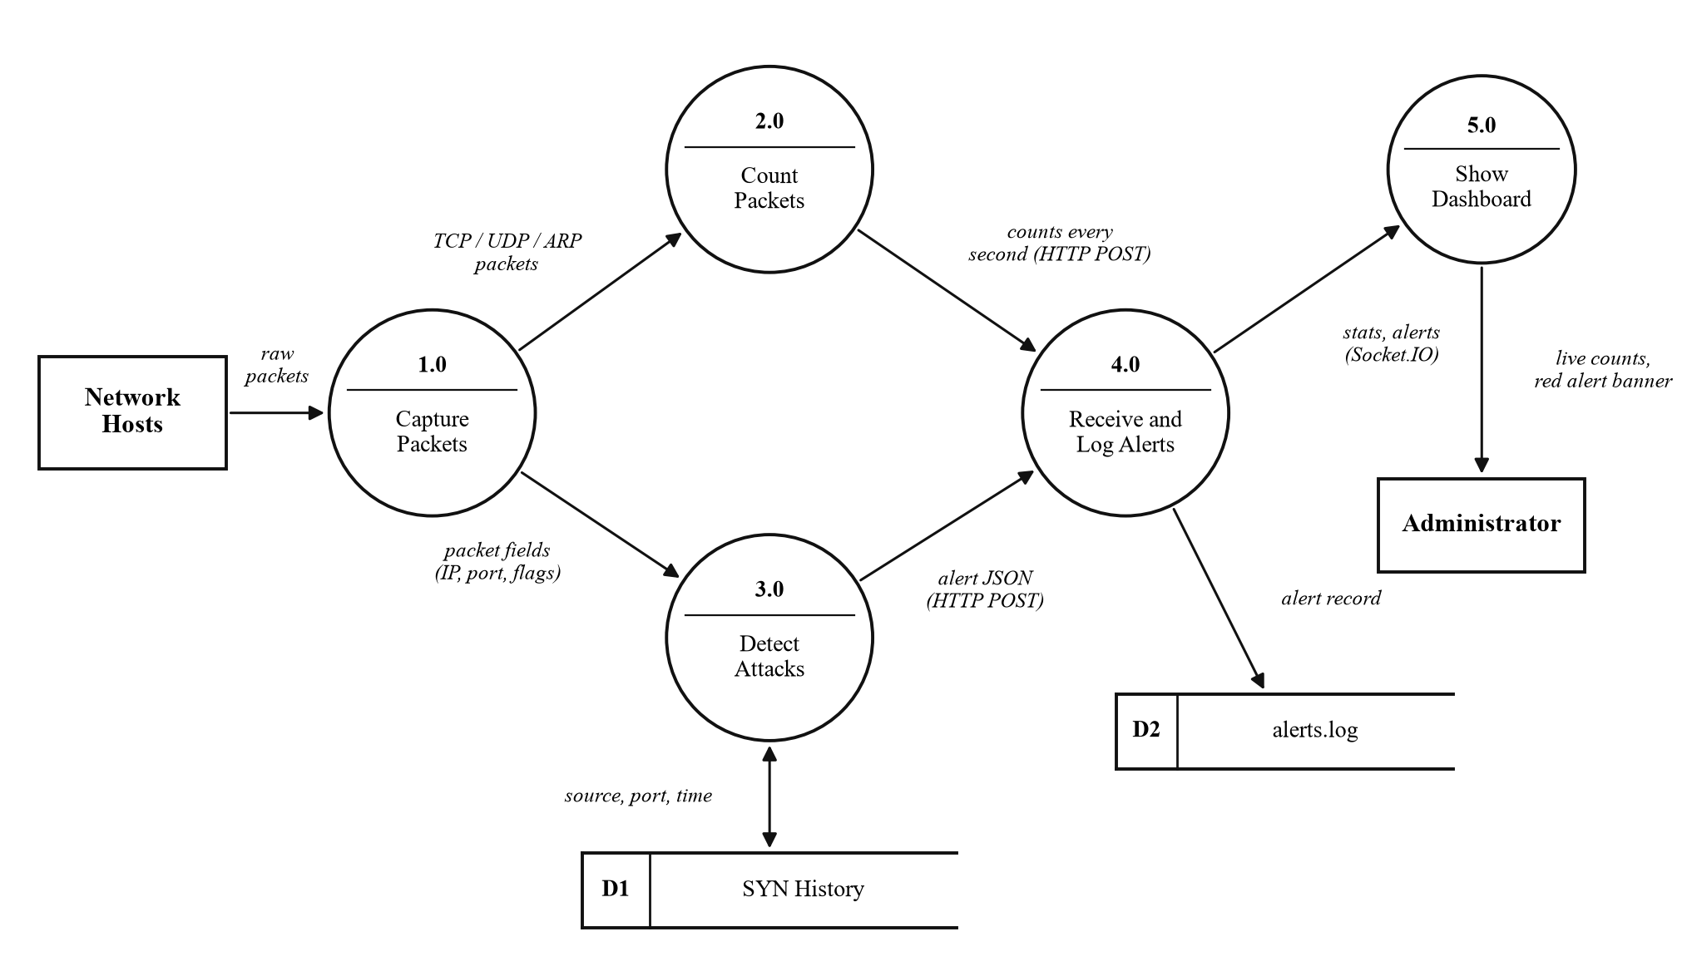
Fig. 3.2: Level 1 DFD showing the processes, data stores and data flows
3.3 Use Case Diagram
The administrator starts monitoring, watches live packet counts and real-time alerts, checks the alert log and can change the detection thresholds. The attacker is an external actor. The attack traffic triggers the detection use case, which notifies the administrator through the real-time alerts screen.
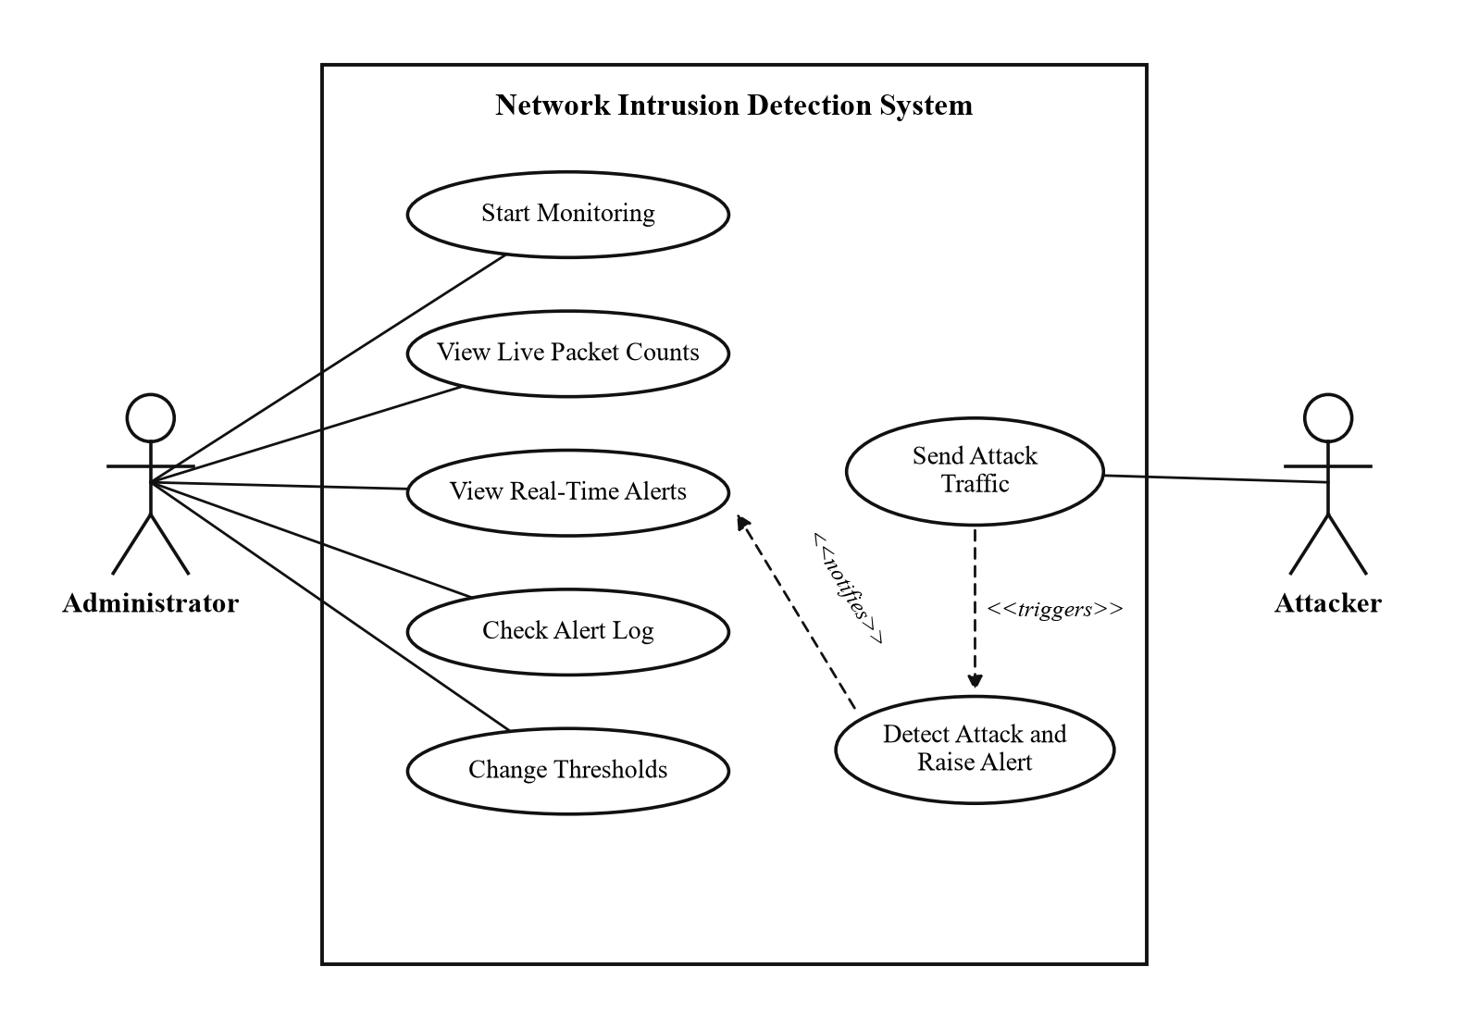
Fig. 3.3: Use case diagram of the system
3.4 Flowchart of Packet Processing and Port Scan Detection
The flowchart shows what the sensor does for every captured packet. The packet is counted, and if it is a TCP SYN packet, its destination port and time are saved under its source IP address. Entries older than five seconds are removed. If one source has tried more than fifteen different ports in that time, and no alert was raised for it in the last thirty seconds, an alert is sent to the dashboard. Once every second the counts are sent and reset to zero.
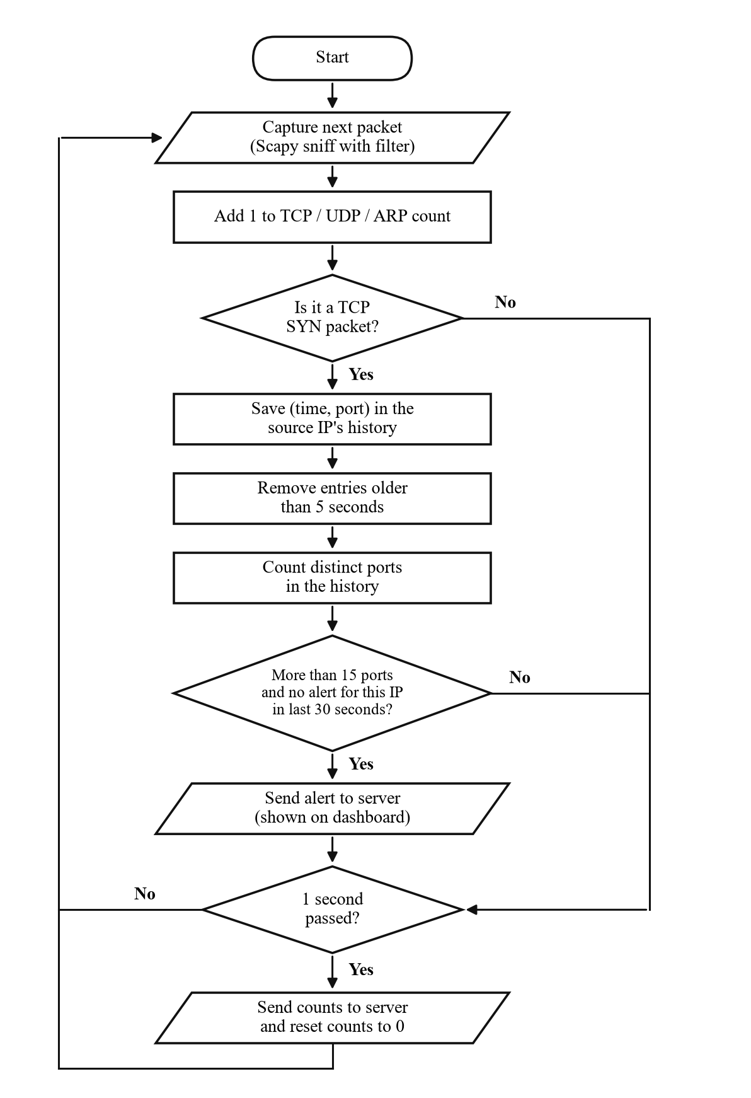
Fig. 3.4: Flowchart of packet processing and port scan detection

