1. In the below elements which of them are values or an expression? eg:- values can be integer or string and expressions will be mathematical operators.

*

'hello'

-87.8

-

/

6

Ans : Mathematical Operators are +, /, -, *

Expressions are ‘hello’, -87.8, 6

2. What is the difference between string and variable?

Ans : A string is used to contain information within double quotes and a variable is a name given to that string. For example : rohan = “My first name” where rohan is the variable and “My first name” is the information stored as a string

3. Describe three different data types.

Ans : Int : 45

Float : 4.5

Complex : 4+5i

4. What is an expression made up of? What do all expressions do?

Ans : Expressions are combinations of values, operators, variables and calls to functions. Expressions need to be evaluated. Python will interpret these and display the results.

Eg: 4*5-10 is an expression

5. This assignment statements, like spam = 10. What is the difference between an expression and a statement?

Ans : 40-20+10 is an expression

Rohan = “My first Name” is a statement

6. After running the following code, what does the variable bacon contain?

bacon = 22

bacon + 1

Ans : bacon = 22

Bacon + 1

Print(bacon)

22

bacon=22

bacon = bacon + 1

print(bacon)

23

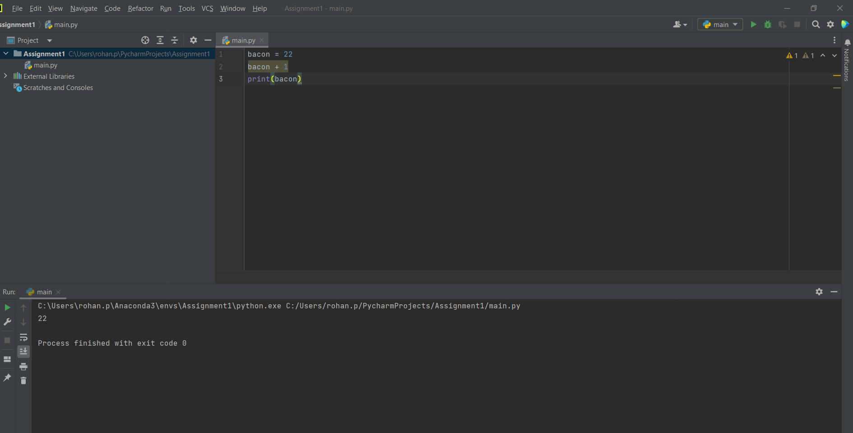

7. What should the values of the following two terms be?

'spam' + 'spamspam'

'spam' * 3

Ans : The first statement is a string concatenation and the second statement is a string multiplication

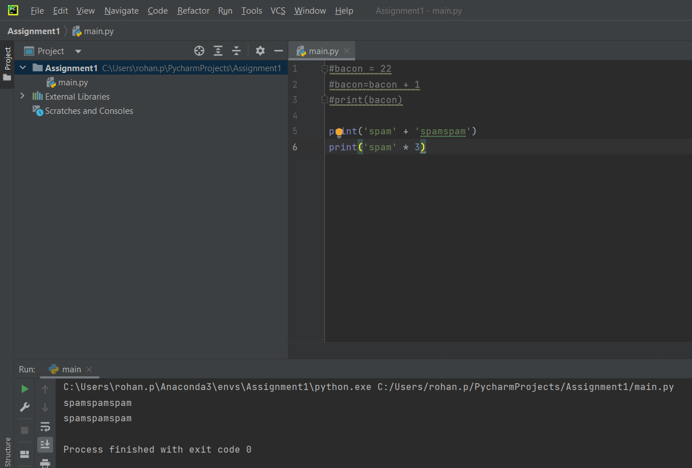

8. Why is eggs a valid variable name while 100 is invalid?

Ans : In python variable names cannot begin with a number.

1. A variable name must start with a letter or an underscore character.
2. A variable name cannot start with a digit.
3. A variable name can only contain alpha-numeric characters and underscores ( a-z, A-Z , 0-9 , and _ )
4. Variable names are case-sensitive (rohan, Rohan and ROHAN are three different variables)

9. What three functions can be used to get the integer, floating-point number, or string version of a value?

Ans : int(), float(), str()

10. Why does this expression cause an error? How can you fix it?

'I have eaten ' + 99 + ' burritos.'

Ans : Can only concatenate str (not "int") to str. We can rectify the same by converting it to a str and then concatenating.

