1.What are the two values of the Boolean data type? How do you write them?

Ans : True and False are the two types of Boolean data types.

2. What are the three different types of Boolean operators?

Ans : AND, OR and NOT are the three types of Boolean operators.

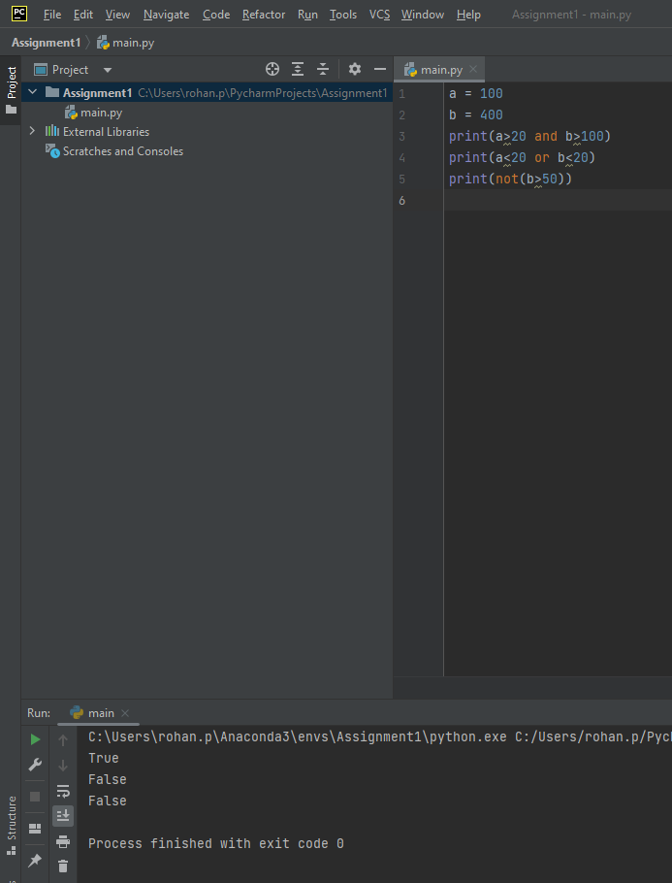

3. Make a list of each Boolean operator's truth tables (i.e. every possible combination of Boolean values for the operator and what it evaluate ).

**Truth Table for AND operator**

True and True = True

True and False = False

False and True = False

False and False = False

**Truth Table for OR operator**

True and True = True

True and False = True

False and True = True

False and False = False

**Truth Table for NOT operator**

Not operator inverts the True to false and vice versa**.**

4. What are the values of the following expressions?

Ans :

(5 > 4) and (3 == 5) # False

not (5 > 4) # False

(5 > 4) or (3 == 5) # True

not ((5 > 4) or (3 == 5)) # False

(True and True) and (True == False) # False

(not False) or (not True) # True

5. What are the six comparison operators?

Ans : >, <, !=, ==, <=, >=

6. How do you tell the difference between the equal to and assignment operators?Describe a condition and when you would use one.

Ans = “==” Is the equal to operator that compares two values and evaluates to a Boolean, while “=” is that assignment operator that stores a value in a variable.

7. Identify the three blocks in this code:

spam = 0

if spam == 10:

print('eggs')

if spam > 5:

print('bacon')

else:

print('ham')

print('spam')

print('spam')

Ans = There are 2 “if” blocks and one “else” block

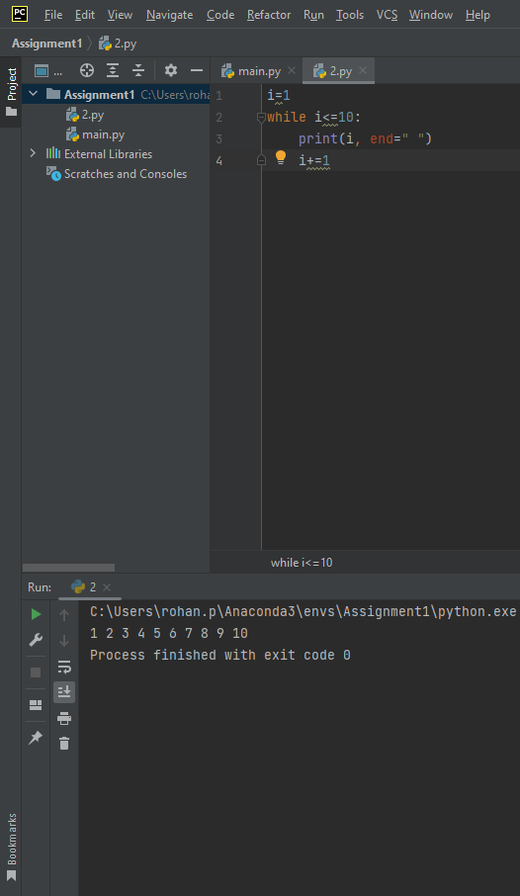

8. Write code that prints Hello if 1 is stored in spam, prints Howdy if 2 is stored in spam, and prints Greetings! if anything else is stored in spam.

9.If your programme is stuck in an endless loop, what keys you’ll press?

Ans : Ctrl-c to stop a program stuck in an infinite loop.

10. How can you tell the difference between break and continue?

Ans : The break statement will move the execution outside the loop if break condtion is satisfied. Whereas the continue statement will move the execution to the start of the loop.

11. In a for loop, what is the difference between range(10), range(0, 10), and range(0, 10, 1)?

Ans : The Differences are as follows:

1. The ***range(10)*** call range from 0 to 9 (but not include 10)
2. The ***range (0,10)*** explicitly tells the loop to start at 0
3. The ***range(0,10,1)*** explicitly tells the loop to increase the variable by 1 on each iteration

12. Write a short program that prints the numbers 1 to 10 using a for loop. Then write an equivalent program that prints the numbers 1 to 10 using a while loop.

Ans = Using For Loop

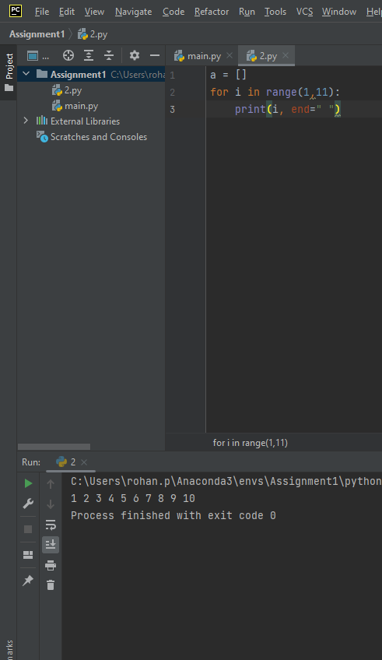

13. If you had a function named bacon() inside a module named spam, how would you call it after importing spam?

Ans = spam.bacon