1. What exactly is []?

Ans = An empty list is represented this way [].

2. In a list of values stored in a variable called spam, how would you assign the value 'hello' as the third value? (Assume [2, 4, 6, 8, 10] are in spam.)

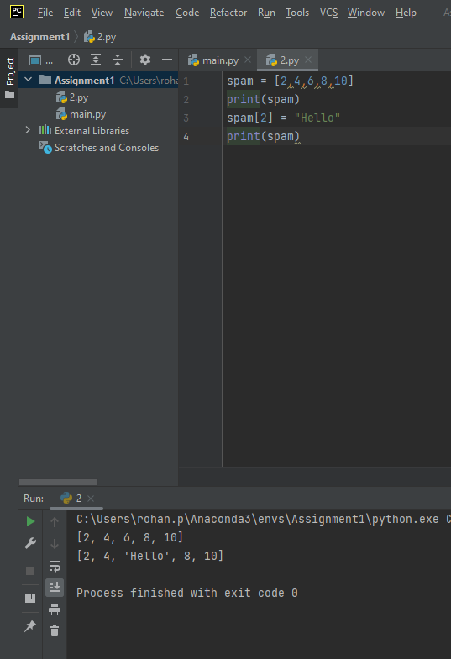

Let's pretend the spam includes the list ['a', 'b', 'c', 'd'] for the next three queries.

3. What is the value of spam[int(int('3' \* 2) / 11)]?

4. What is the value of spam[-1]?

5. What is the value of spam[:2]?

Let's pretend bacon has the list [3.14, 'cat,' 11, 'cat,' True] for the next three questions.

6. What is the value of bacon.index('cat')?

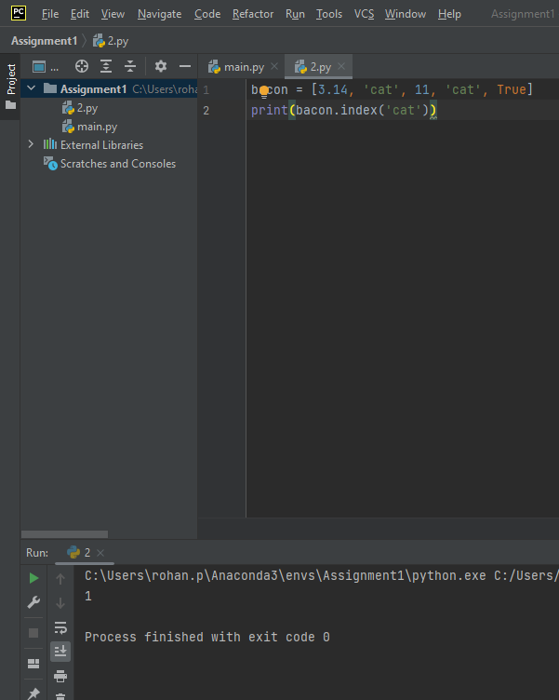

7. How does bacon.append(99) change the look of the list value in bacon?

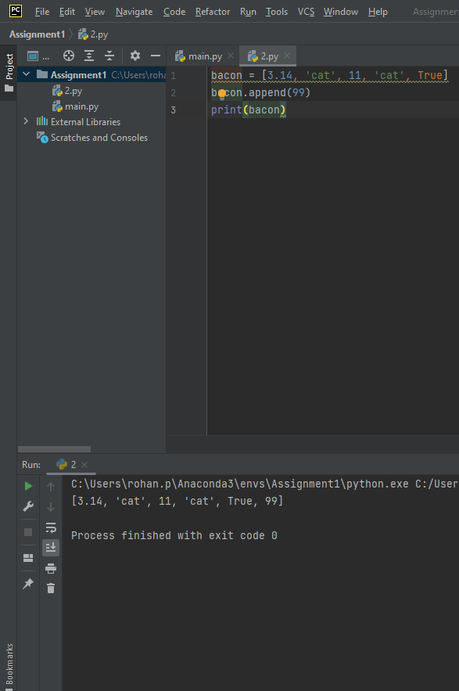

8. How does bacon.remove('cat') change the look of the list in bacon?

9. What are the list concatenation and list replication operators?

Ans = ‘+’ symbol is used to concatenate and ‘\*’ is used for replication.

10. What is difference between the list methods append() and insert()?

Ans = append () function adds an item at the end of your mentioned list.

insert() function takes two arguments i.e in which index you want to insert the variable thereby you can insert the value anywhere inside your list.

Difference between append () and insert() is in append it adds to the end of the list whereas in insert it can add in between your list

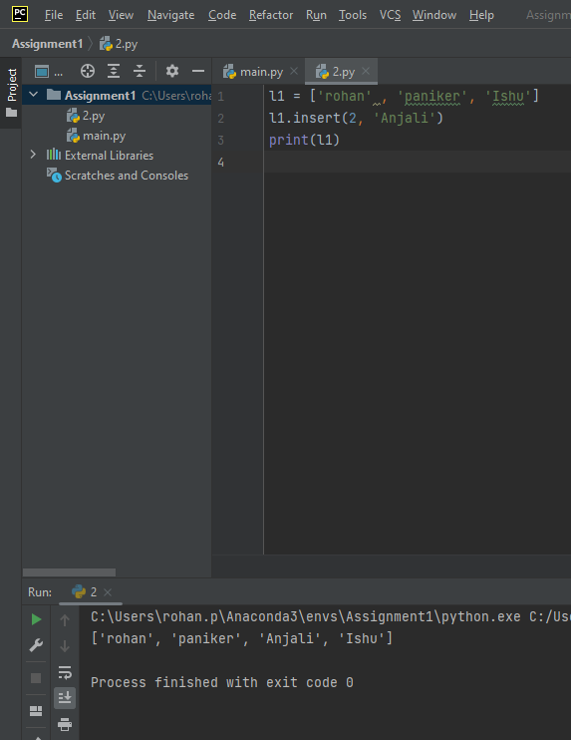

11. What are the two methods for removing items from a list?

Ans = The remove() method removes the first matching element (which is passed as an argument) from the list. The pop() method removes an element at a given index, and will also return the removed item.

12. Describe how list values and string values are identical.

Ans = I do not know what this means

13. What's the difference between tuples and lists?

Ans =  Lists are Mutable, Indexable and Sliceable. they can have values added, removed, or changed. Tuples are Immutable but Indexable and Sliceable, the tuple values cannot be changed at all. Also, tuples are represented using parentheses, (), while lists use the square brackets, [].

14. How do you type a tuple value that only contains the integer 42?

Ans = A comma to be added at the end to identify between an integer and a tuple.

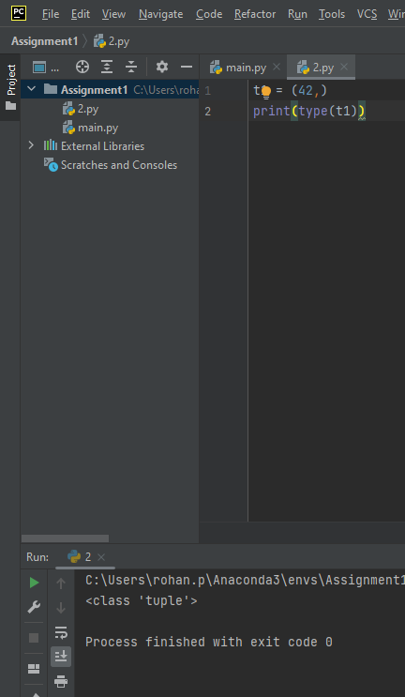

15. How do you get a list value's tuple form? How do you get a tuple value's list form?

Ans =  The tuple() and list() functions, respectively are used to convert a list to tuple and vice versa

16. Variables that "contain" list values are not necessarily lists themselves. Instead, what do they contain?

Ans = They are references to a list

17. How do you distinguish between copy.copy() and copy.deepcopy()?

Ans = I don’t understand what is copy.deepcopy()