1. What does an empty dictionary's code look like?

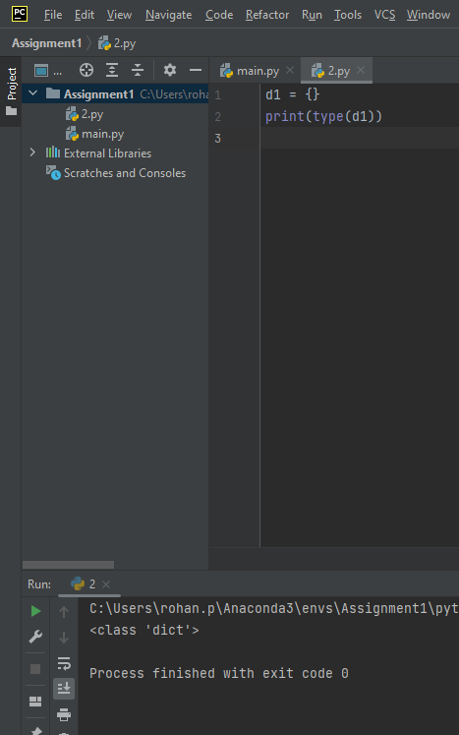

2. What is the value of a dictionary value with the key 'foo' and the value 42?

3. What is the most significant distinction between a dictionary and a list?

Ans = Dictionaries are represented by {} where as listed are represented by []

4. What happens if you try to access spam['foo'] if spam is {'bar': 100}?

5. If a dictionary is stored in spam, what is the difference between the expressions 'cat' in spam and 'cat' in spam.keys()?

Ans = There is no difference . The operator checks whether a value exists as a key in the dictionary or not

6. If a dictionary is stored in spam, what is the difference between the expressions 'cat' in spam and 'cat' in spam.values()?

Ans = 'cat' in spam checks whether there is a 'cat' key in the dictionary, while 'cat' in spam.values() checks whether there is a value 'cat' for one of the keys in spam.

7. What is a shortcut for the following code?

if 'color' not in spam:

spam['color'] = 'black'

Ans = I m not able to understand this question.

8. How do you "pretty print" dictionary values using which module and function?

Ans = pprint() is used to pretty print with dictionary values.