1. What are escape characters, and how do you use them?

Ans = \' Single Quote

\\ Backslash

\n New Line

\r Carriage Return

\t Tab

\b Backspace

2. What do the escape characters n and t stand for?

Ans = “\n” for New Line and “\t” for space between the words

3. What is the way to include backslash characters in a string?

Ans = \\ Backslash

4. The string "Howl's Moving Castle" is a correct value. Why isn't the single quote character in the word Howl's not escaped a problem?

Ans = The reason is because we are using to encapsulate the entire string in double quotes hence it doesn’t affect the single quote character. If we used a single quotes to encompass the entire string then it will give an error.

5. How do you write a string of newlines if you don't want to use the n character?

Ans = a = ‘’’How are you Rohan

I m good’’’

print(a)

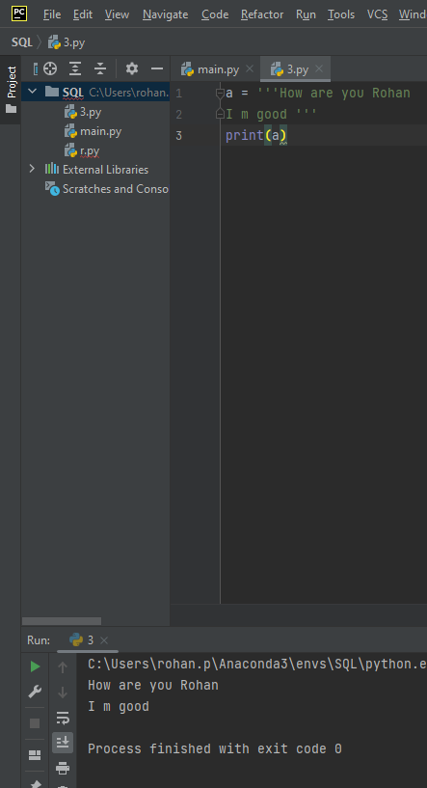

6. What are the values of the given expressions?

'Hello, world!'[1] = e

'Hello, world!'[0:5] = Hello

'Hello, world!'[:5] = Hello

'Hello, world!'[3:] = lo, world!

7. What are the values of the following expressions?

'Hello'.upper() = HELLO

'Hello'.upper().isupper() = True

'Hello'.upper().lower() = hello

8. What are the values of the following expressions?

'Remember, remember, the fifth of July.'.split() = ['Remember,', 'remember,', 'the', 'fifth', 'of', 'July.']

'-'.join('There can only one.'.split()) = There-can-only-one.

9. What are the methods for right-justifying, left-justifying, and centering a string?

Ans = rjust() is used for right justifying, ljust() is used for left justifying and center() is used for centering.

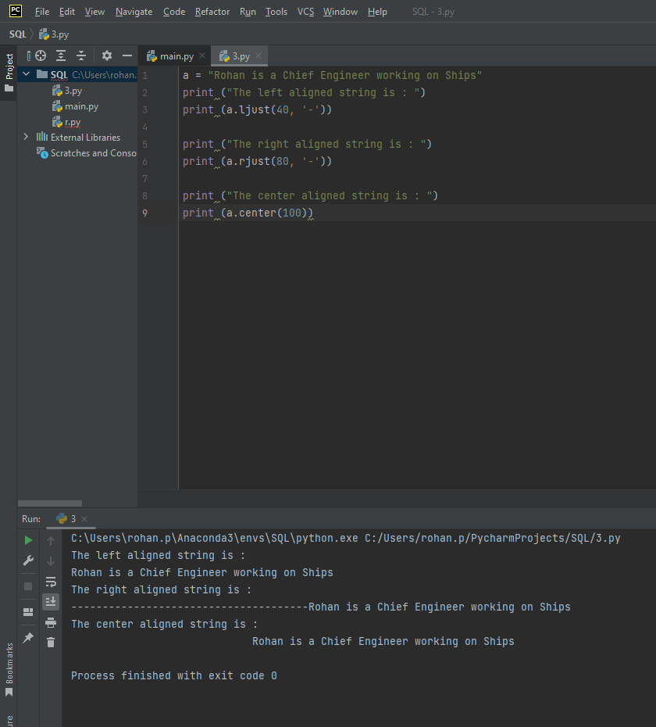

10. What is the best way to remove whitespace characters from the start or end?

Ans = lstrip() for left strip and rstrip() for right strip and strip() with no arguments will remove any whitespaces by default.

