Water Quality Analysis
& Potability Assessment

Complete Notebook Screenshots — Exploratory Data Analysis Report

Author: Rohan Parida
Dataset: water_potability.csv (3,276 samples × 10 features)
Subject: Data Analytics / Environmental Science
Tools: Python · Pandas · NumPy · Matplotlib · Seaborn · SciPy
Notebook: RohanParida_WaterQualityAnalysis.ipynb

Table of Contents
1. Abstract
2. Introduction
3. Problem Statement
4. Objectives
5. Dataset Description
6. Parameters Explained
7. Technologies Used
8. Methodology
9. Data Cleaning
10. Notebook — Cell-by-Cell Screenshots
10.1 Section A: Imports & Configuration
10.2 Section B: Dataset Loading & Inspection
10.3 Section C: Data Cleaning (Imputation)
10.4 Section D: Descriptive Statistics
10.5 Section E: Potability Analysis
10.6 Section F: Parameter-wise Analysis
10.7 Section G: Correlation Analysis
10.8 Section H: Statistical Significance Testing
10.9 Section I: Comparison Table & EDA Plots
11. Results & Key Findings
12. Limitations
13. Conclusion
14. Future Scope
15. References

1. Abstract
Access to safe drinking water is a fundamental human right and a critical public health concern. This report presents a comprehensive exploratory data analysis (EDA) of the Water Potability dataset comprising 3,276 water samples, each characterised by nine physicochemical parameters: pH, Hardness, Solids (TDS), Chloramines, Sulfate, Conductivity, Organic Carbon, Trihalomethanes, and Turbidity. Missing values in three features were handled via stratified median imputation by potability group. The full analytical pipeline — including descriptive statistics, distribution visualisations, outlier detection, correlation analysis, and the Mann-Whitney U non-parametric significance test — is presented as actual notebook cell screenshots so that every result is directly traceable to the executed code and its output. The dataset shows a moderate class imbalance (61% Non-Potable, 39% Potable). No single parameter is a strong predictor of potability; statistically significant but small-effect differences were found for Chloramines, Solids, and Organic Carbon.

2. Introduction
Water quality monitoring is essential for safeguarding public health. The World Health Organisation (WHO) establishes guideline values for numerous physicochemical parameters in drinking water. Violations of these thresholds can lead to health issues ranging from gastrointestinal illness to long-term chronic conditions. Despite significant advances in water treatment technology, billions of people worldwide still lack access to safely managed drinking water.
Data-driven approaches have gained prominence in water quality assessment. Statistical analysis and visualisation of physicochemical measurements can identify patterns, flag anomalies, and support real-time monitoring systems. This project analyses the Water Potability dataset to characterise the distribution of key parameters, evaluate their statistical relationship with potability, and extract actionable insights. All results in this report are produced directly by the executed Jupyter Notebook; screenshots of every code cell and its output are embedded in Section 10.

3. Problem Statement
Given physicochemical water quality measurements, this project answers:
- Which parameters differ significantly between potable and non-potable water samples?
- How is each parameter distributed across the dataset?
- Do the parameters correlate with each other or with the potability label?
- What data quality issues (missing values, outliers) exist, and how are they handled?

4. Objectives
- Load, inspect, and clean the water potability dataset.
- Handle missing values using stratified median imputation (by Potability group).
- Compute descriptive statistics (mean, median, std, skewness, kurtosis) for all nine features.
- Visualise parameter distributions and compare potable vs non-potable groups.
- Detect and quantify outliers using the IQR fence method.
- Assess pairwise Pearson correlations among parameters and with the potability label.
- Apply the Mann-Whitney U test to determine statistical significance of group differences.
- Document every result via actual notebook cell screenshots embedded in this report.

5. Dataset Description
Attribute | Value | Notes
File name | water_potability.csv | Provided in project workspace
Rows | 3,276 | Individual water samples
Columns | 10 | 9 features + 1 label (Potability)
Feature types | float64 × 9, int64 × 1 | All numeric
Target column | Potability | 0 = Non-Potable · 1 = Potable
Non-Potable | 1,998 (60.99%) | Majority class
Potable | 1,278 (39.01%) | Minority class
Missing values | ph: 491 · Sulfate: 781 · THMs: 162 | Imputed via grouped median
Duplicates | 0 | No duplicate rows found
Source | Kaggle — adityakadiwal/water-potability | Publicly available

6. Parameters Explained
pH (pH units): Measures acidity/alkalinity. WHO guideline: 6.5–8.5. Extremes indicate corrosive or scaling water.
Hardness (mg/L): Dissolved Ca²⁺ / Mg²⁺. High hardness causes scale deposits. WHO limit: 300 mg/L.
Solids / TDS (mg/L): Total Dissolved Solids. WHO desirable limit 500 mg/L; maximum 1000 mg/L.
Chloramines (ppm): Disinfectant residual. WHO maximum: 4 mg/L.
Sulfate (mg/L): Naturally occurring. WHO guideline: 250 mg/L. High sulfate causes laxative effects.
Conductivity (μS/cm): Ion concentration proxy. WHO limit: 400 μS/cm.
Organic Carbon (ppm): Total Organic Carbon (TOC). EPA treated-water limit: 2 mg/L.
Trihalomethanes (μg/L): Disinfection by-products. WHO limit: 80 μg/L. Carcinogenic at high levels.
Turbidity (NTU): Cloudiness from suspended particles. WHO guideline: < 1 NTU for treated water.

7. Technologies Used
Technology | Version | Purpose
Python | 3.x | Core programming language
NumPy | 2.3.5 | Numerical computing, array operations
Pandas | 2.3.3 | Data loading, cleaning, manipulation
Matplotlib | 3.10.6 | Histograms, boxplots, scatter plots
Seaborn | 0.13.2 | Heatmaps, violin plots, pair plots
SciPy | 1.16.3 | Mann-Whitney U statistical test
Jupyter | ≥1.0.0 | Interactive notebook environment
python-docx | — | Programmatic DOCX report generation

8. Methodology
The analysis follows a structured data science pipeline:
- Step 1 — Data Loading: CSV loaded with pandas.read_csv(). Columns, dtypes, shape verified.
- Step 2 — Inspection: Missing value counts and percentages per column computed. Duplicate rows checked.
- Step 3 — Imputation: Grouped median imputation (by Potability group) for ph, Sulfate, Trihalomethanes.
- Step 4 — EDA: Descriptive statistics computed. Distributions visualised with histogram+KDE split by class.
- Step 5 — Outliers: IQR fence method (Q1−1.5×IQR, Q3+1.5×IQR). Counts reported per parameter.
- Step 6 — Correlation: Pearson correlation matrix for all 10 columns visualised as a heatmap.
- Step 7 — Testing: Mann-Whitney U test (two-sided, α=0.05) per parameter comparing potability groups.
- Step 8 — Reporting: All cell screenshots (code + output) embedded directly into this DOCX.

9. Data Cleaning
Three columns contained missing values: ph (491, 14.99%), Sulfate (781, 23.84%), Trihalomethanes (162, 4.95%). No duplicate rows were present. Grouped median imputation was applied — each missing value is replaced by the median of its respective Potability group (0 or 1), preserving inter-group distributional differences.
Column | Missing Count | Potable Median | Non-Potable Median
ph | 491 (14.99%) | 7.0368 | 7.0355
Sulfate | 781 (23.84%) | 331.84 mg/L | 333.39 mg/L
Trihalomethanes | 162 (4.95%) | 66.68 μg/L | 66.54 μg/L

10. Notebook — Cell-by-Cell Screenshots
This section contains complete screenshots of every executed code cell in RohanParida_WaterQualityAnalysis.ipynb. Each subsection shows the cell source code (blue-bordered "In [N]:" panel) immediately followed by its output (white panel). Chart/plot outputs are shown at full resolution below the text output.

10.1 Section A: Imports & Configuration
Cell 1 — Library imports, plot style configuration, output directory creation.
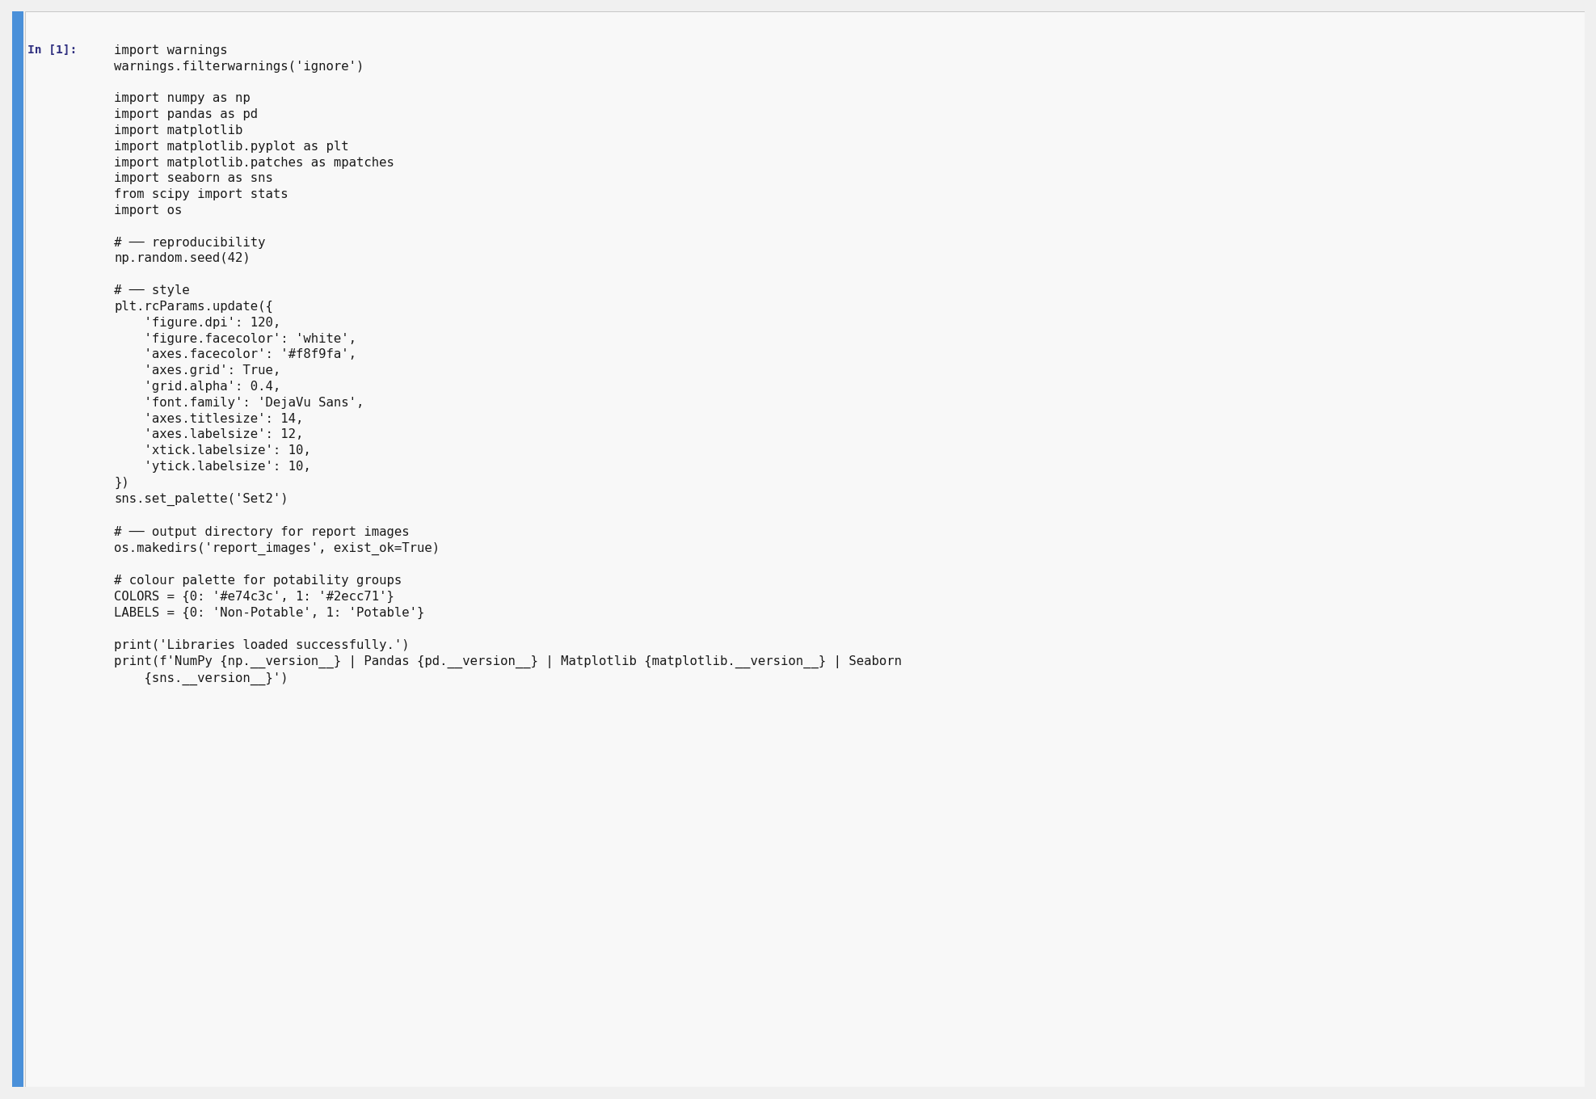
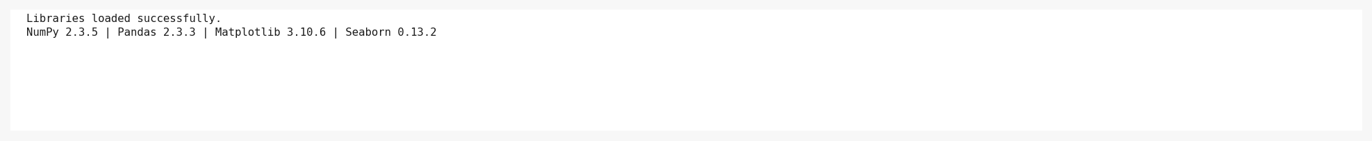
Cell 1: Imports — library versions printed to confirm successful loading.

10.2 Section B: Dataset Loading & Inspection
Cell 2 — Load dataset, print shape, column list, and display first five rows.
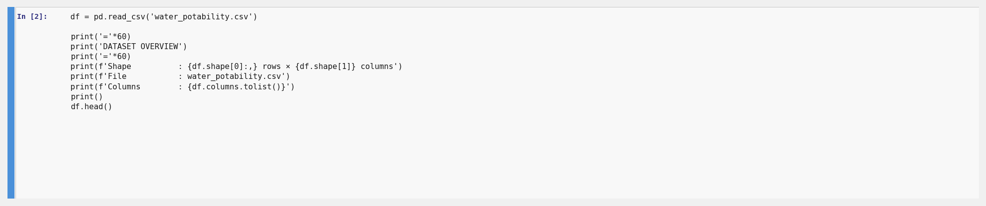
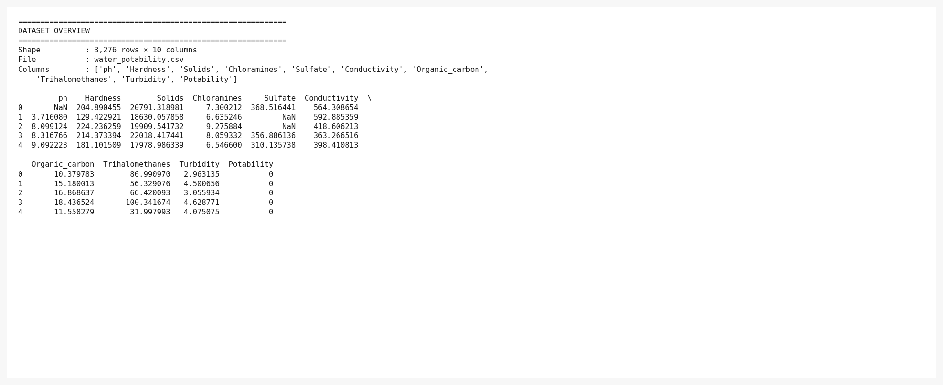
Cell 2: Dataset loaded — 3,276 rows × 10 columns. First five rows shown as a DataFrame.
Cell 3 — Data types and .info() summary.
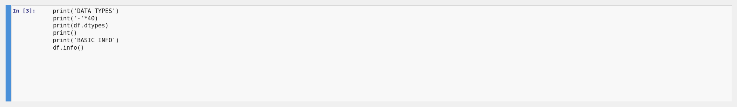
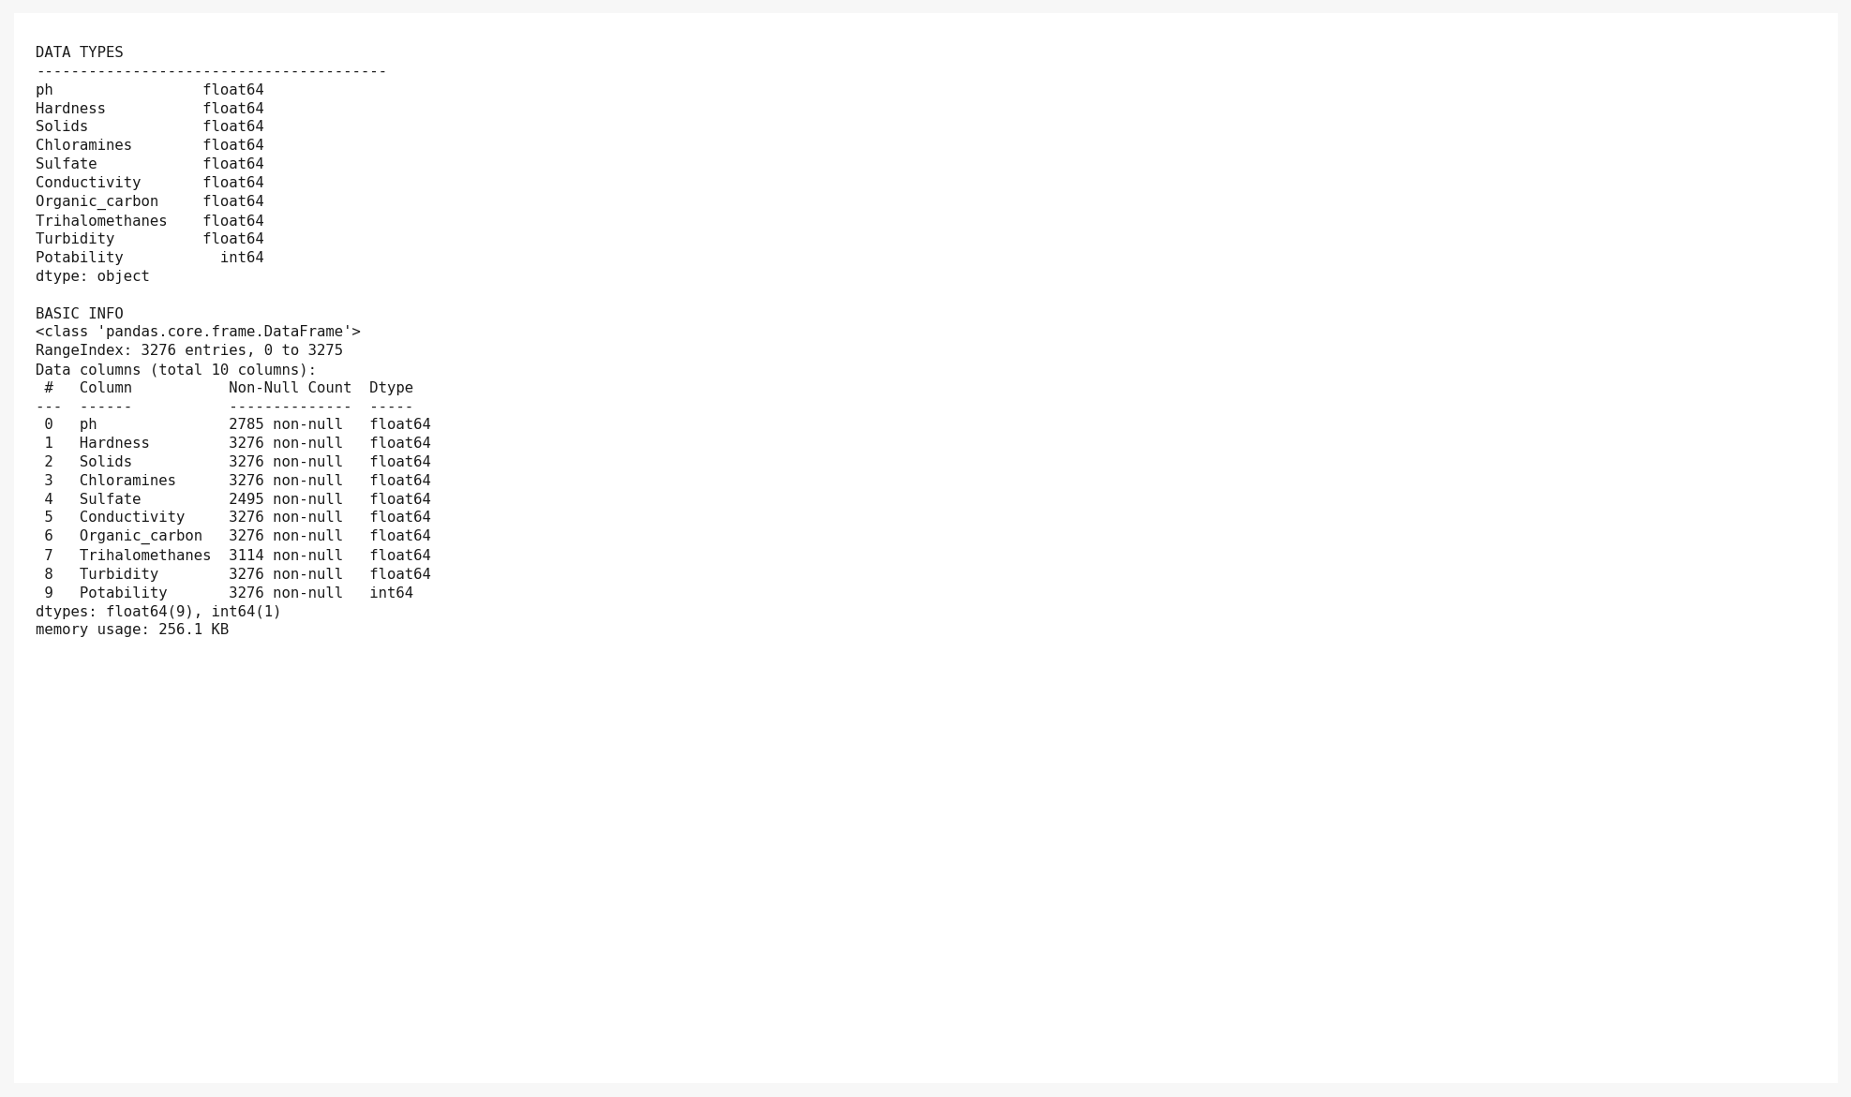
Cell 3: All nine features are float64; Potability is int64. No non-null gaps visible in dtype list.
Cell 4 — Missing value analysis and duplicate check.
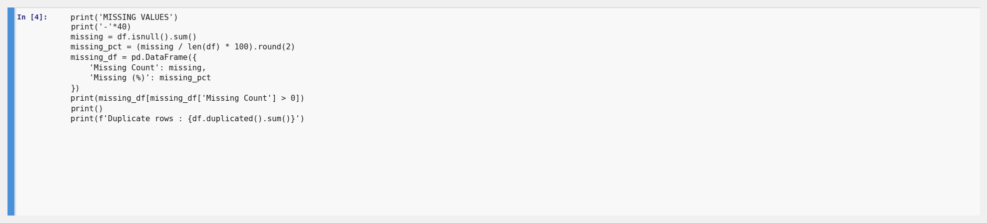
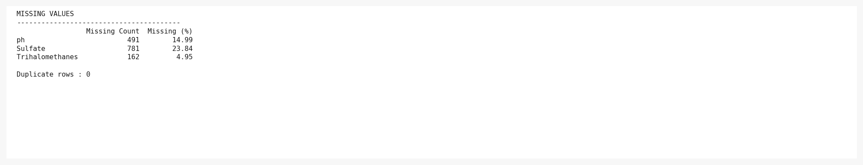
Cell 4: ph=491 missing, Sulfate=781 missing, Trihalomethanes=162 missing. Zero duplicates.
Cell 5 — Missing value visualisation (bar chart + heatmap).
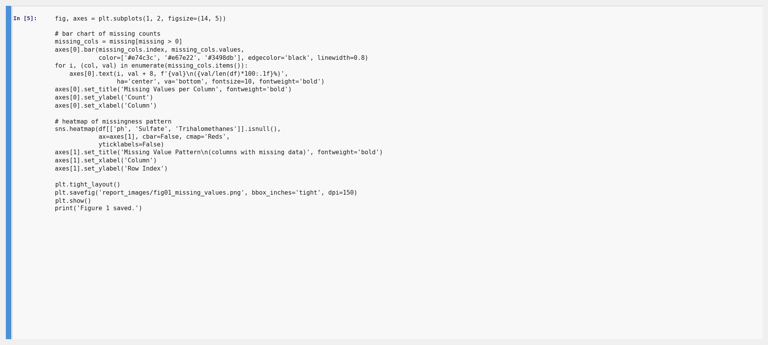
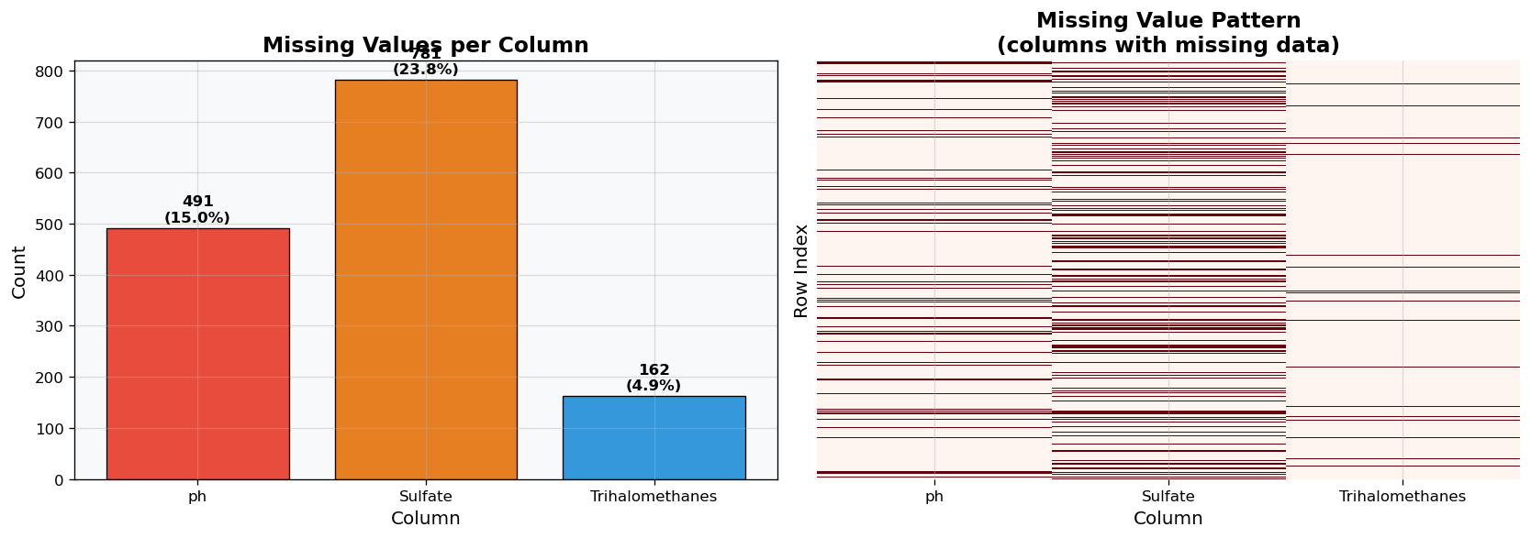
Figure 1 (Cell 5 output): Missing value bar chart and missingness heatmap.

10.3 Section C: Data Cleaning — Imputation
Cell 6 — Stratified median imputation for ph, Sulfate, and Trihalomethanes.
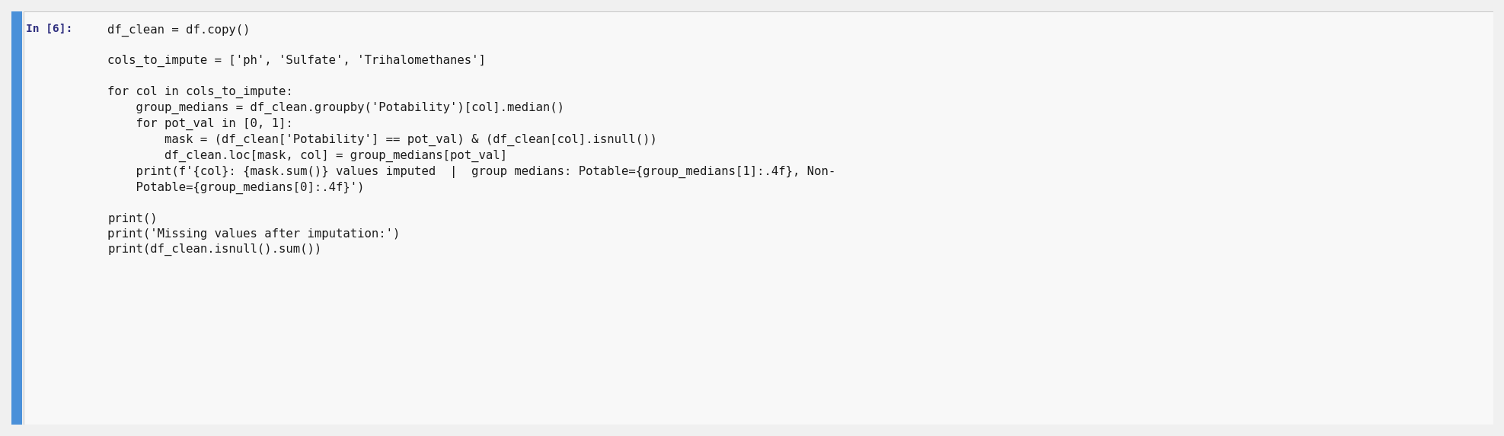
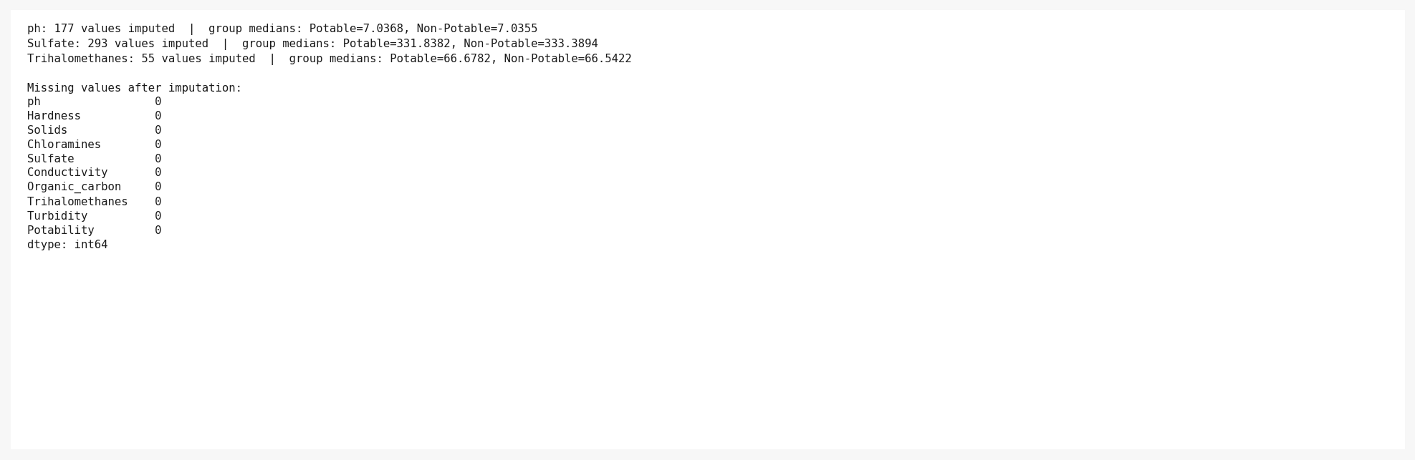
Cell 6: Imputation applied. Group medians printed for each column. Zero missing values remain.

10.4 Section D: Descriptive Statistics
Cell 7 — Full descriptive statistics table (mean, median, std, min, max, Q1, Q3, skewness, kurtosis).
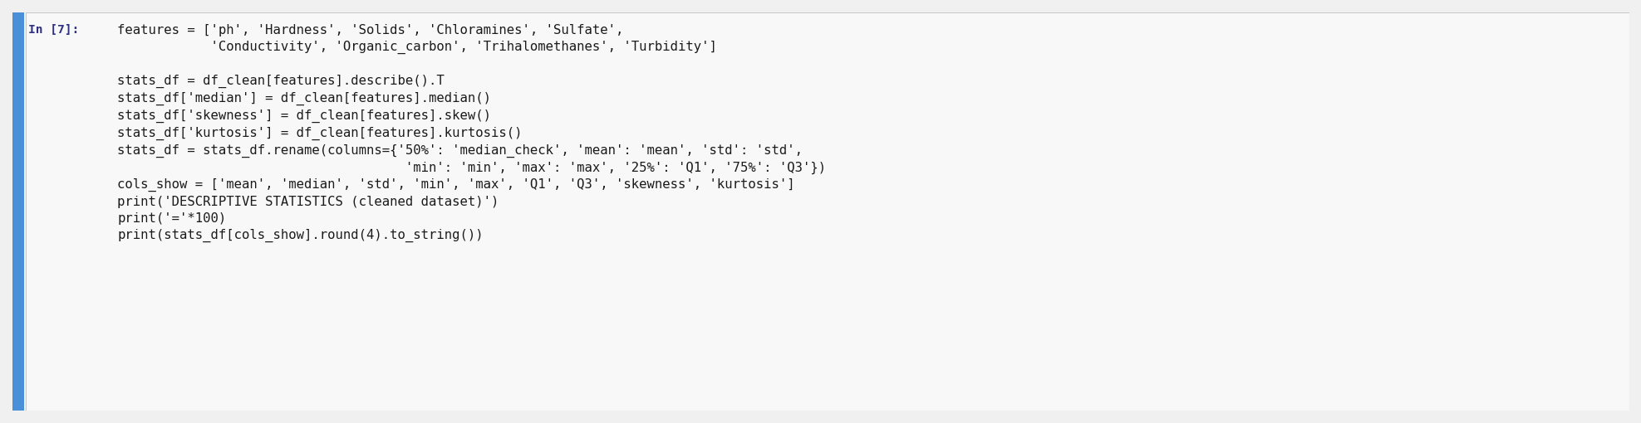
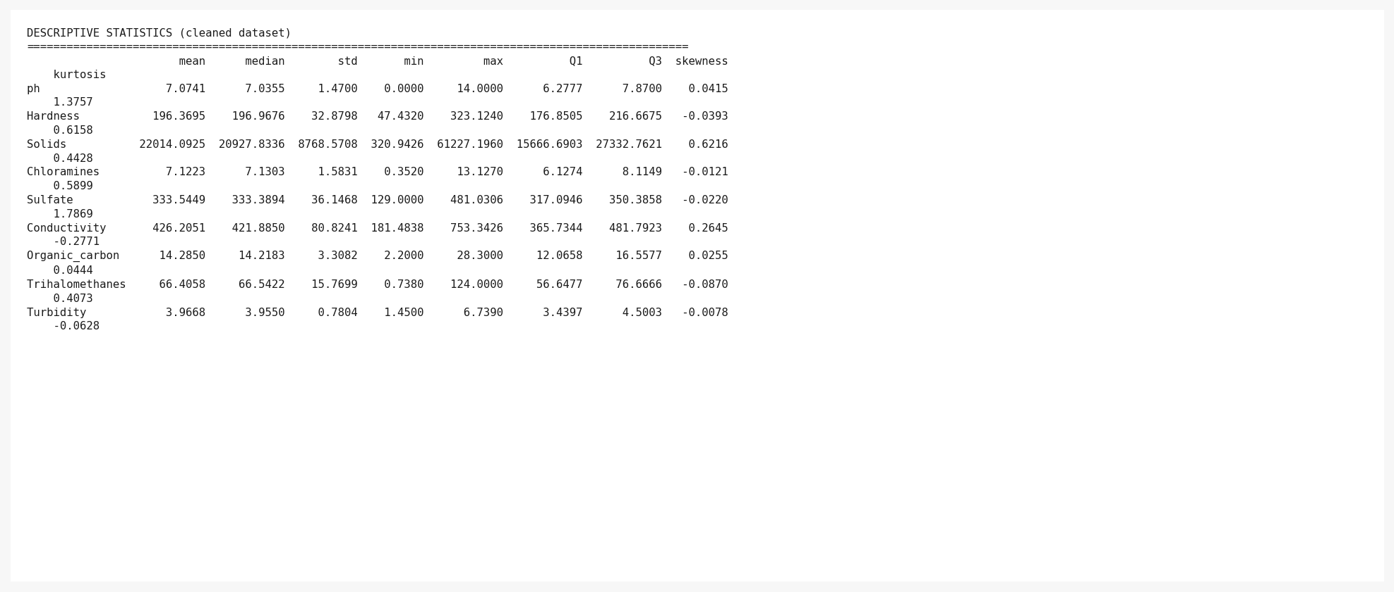
Cell 7: Descriptive statistics for all nine features. Solids shows high std (right-skewed).

10.5 Section E: Potability Analysis
Cell 8 — Potability counts and percentages.
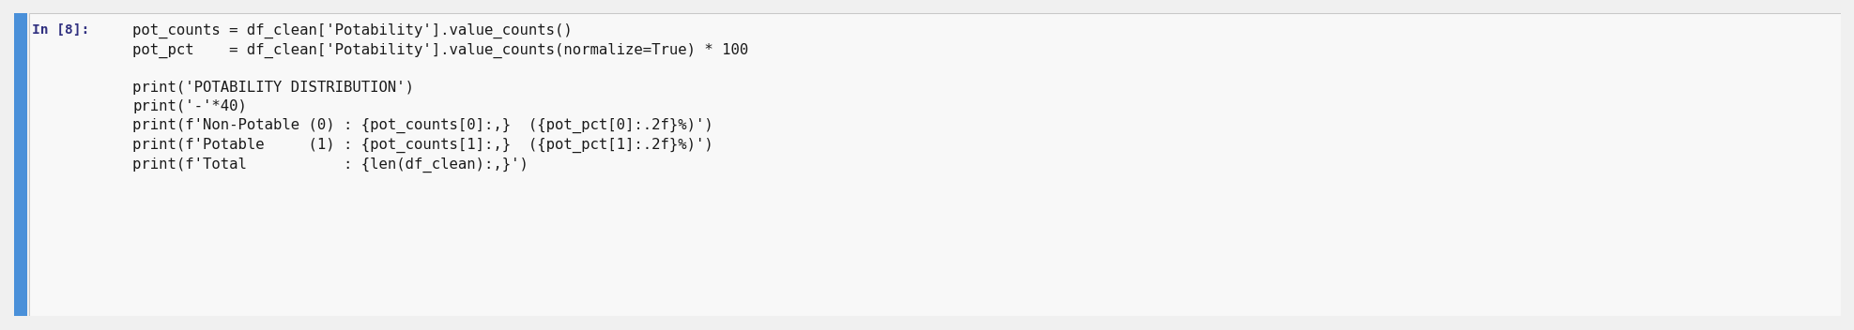
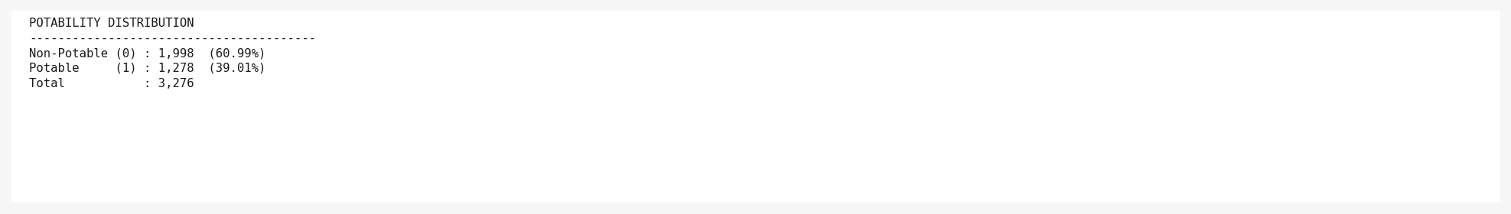
Cell 8: 1,998 Non-Potable (60.99%) vs 1,278 Potable (39.01%) — class imbalance confirmed.
Cell 9 — Potability distribution visualisation (bar chart + pie chart).
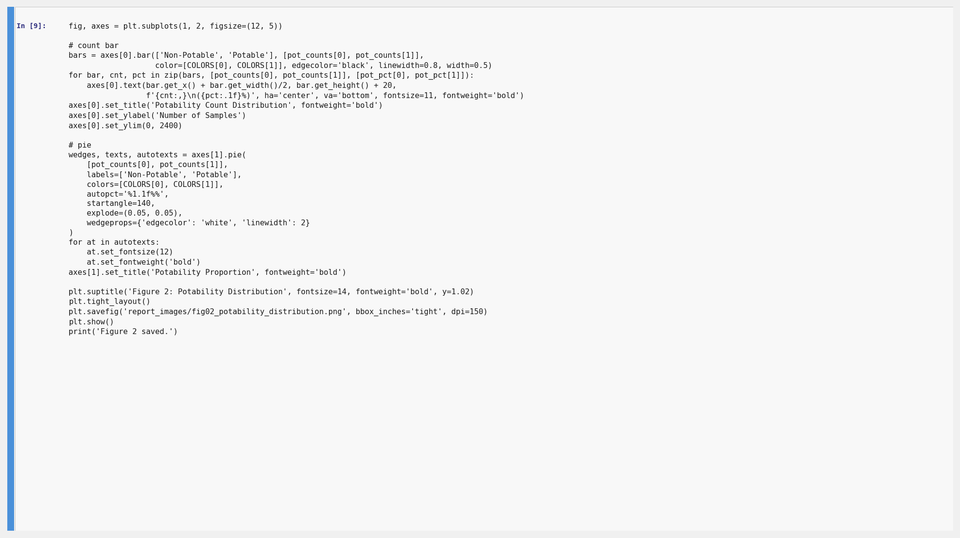
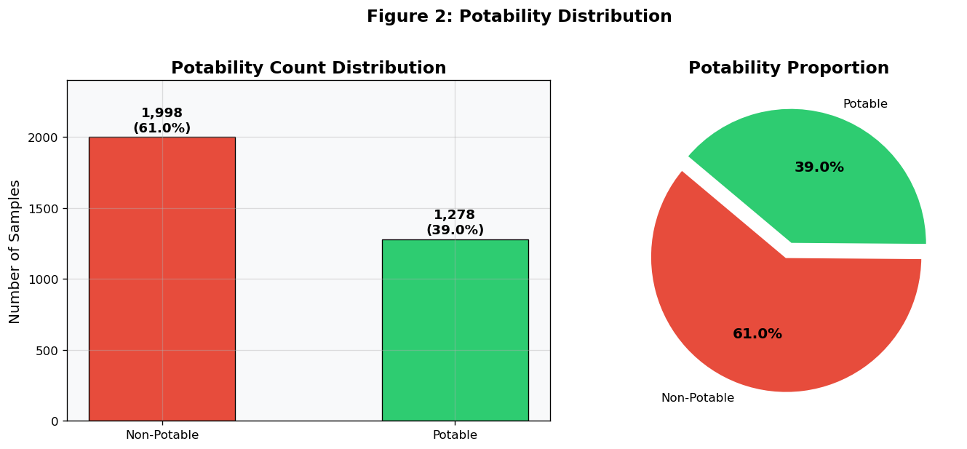
Figure 2 (Cell 9 output): Potability count bar chart and proportion pie chart.

10.6 Section F: Parameter-wise Analysis
Cell 10 — Parameter metadata (WHO ranges, units, labels).
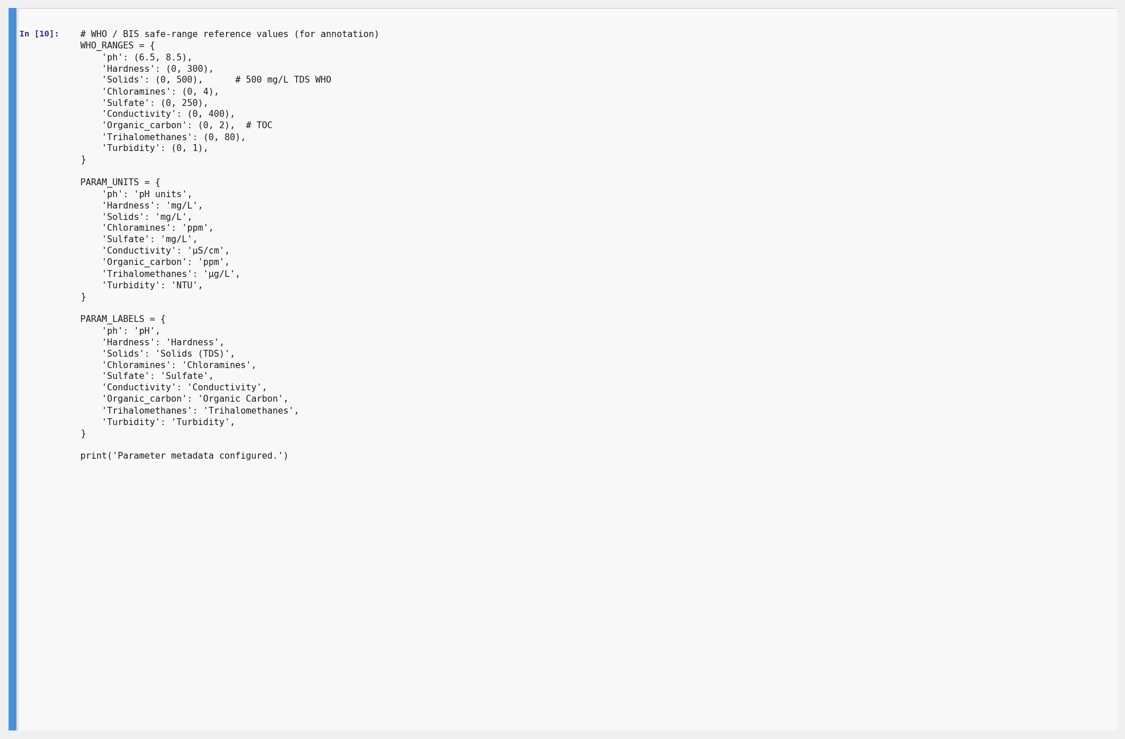
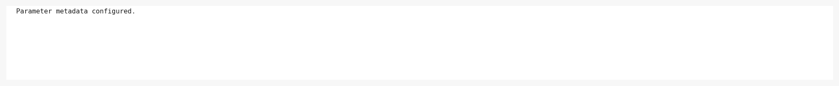
Cell 10: WHO reference ranges, units, and display labels configured.
Cell 11 — Overlapping histogram + KDE distributions split by potability class.
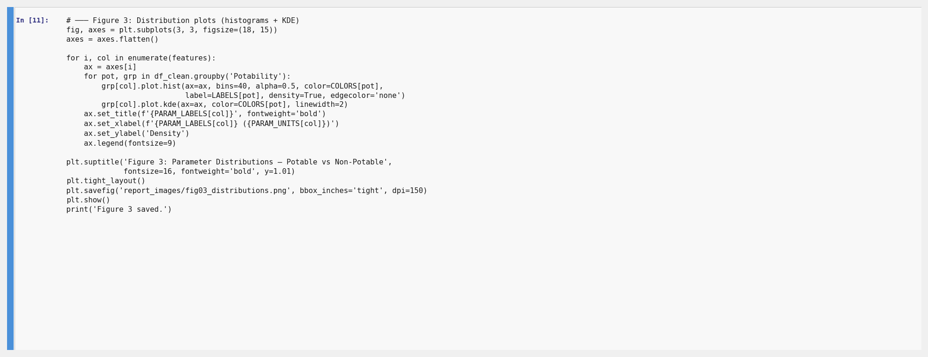
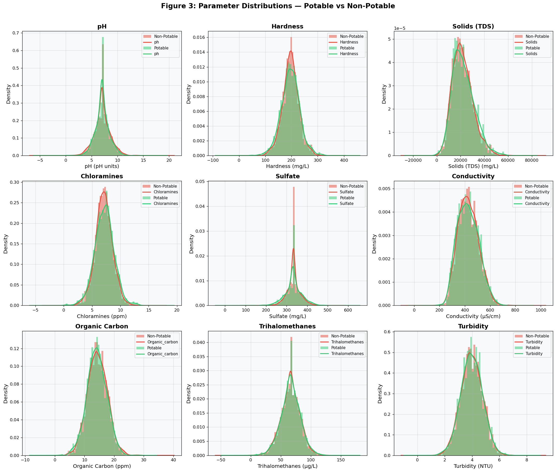
Figure 3 (Cell 11 output): Distribution plots for all nine parameters — Potable (green) vs Non-Potable (red).
Cell 12 — Notched boxplots for all parameters by potability group.
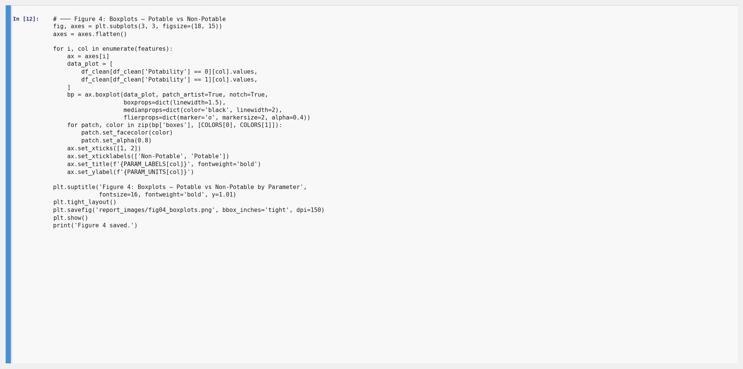
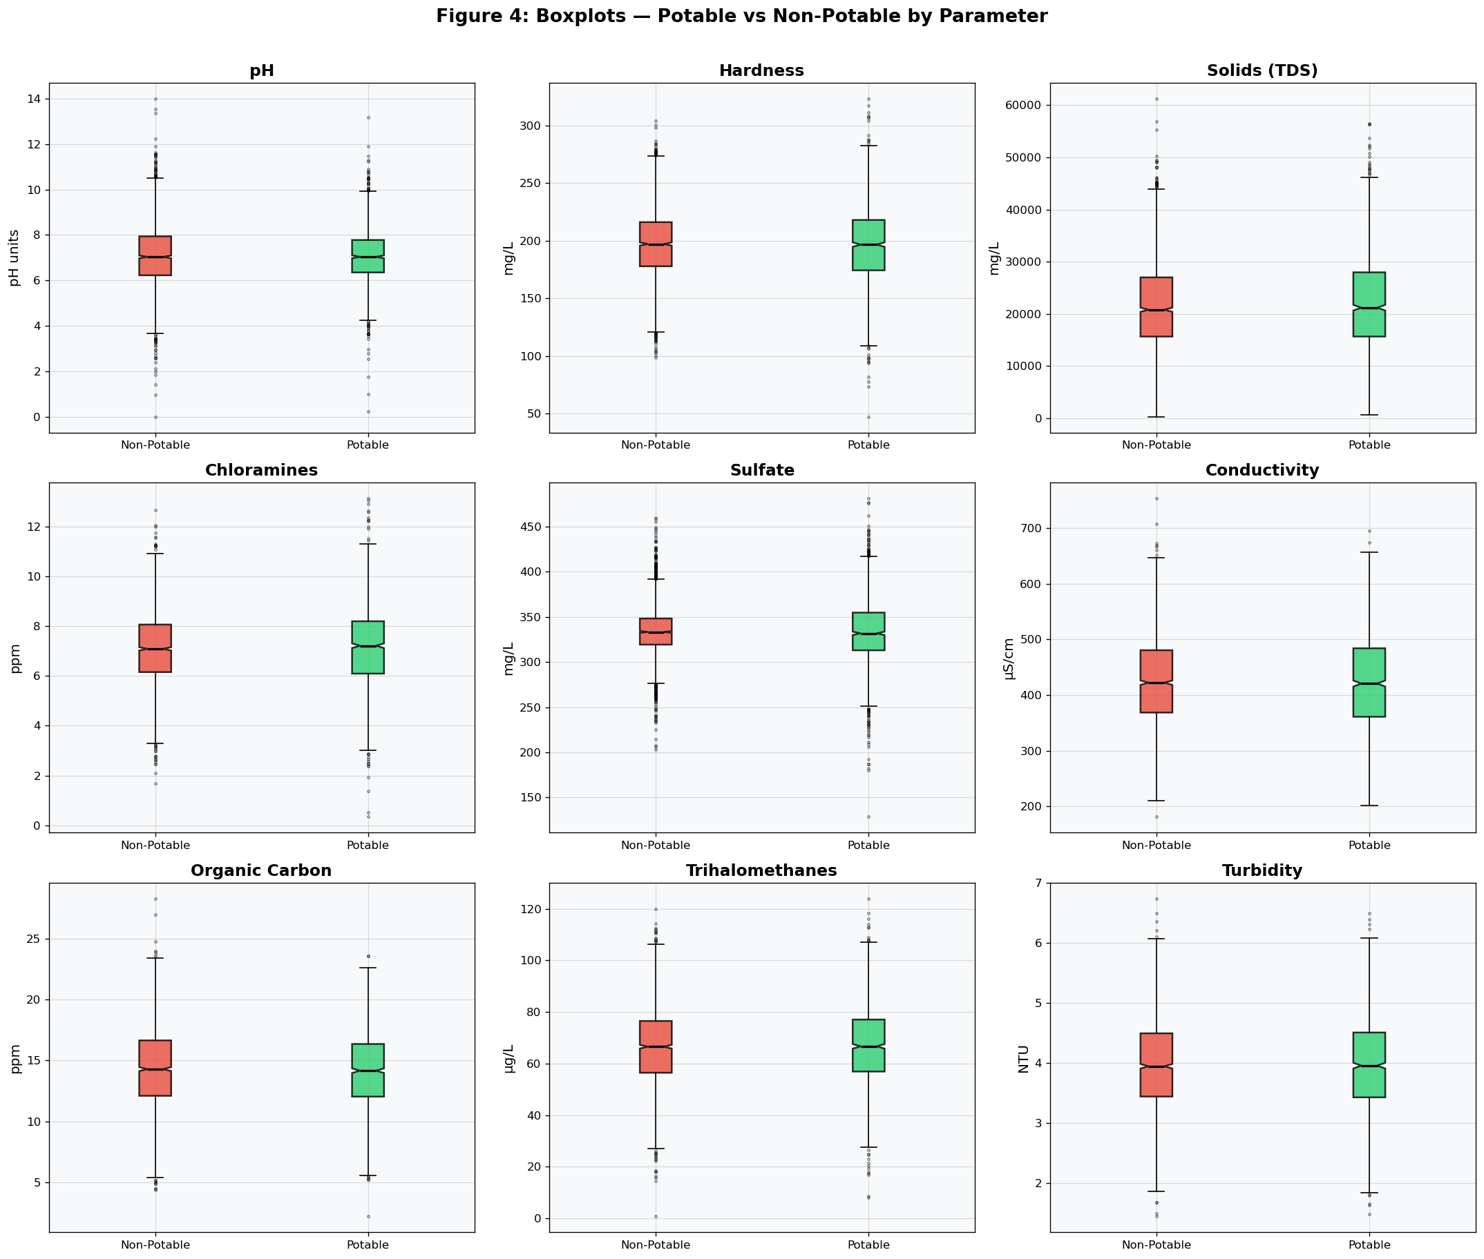
Figure 4 (Cell 12 output): Notched boxplots — Non-Potable (red) vs Potable (green).
Cell 13 — Outlier analysis using IQR method (printed summary).
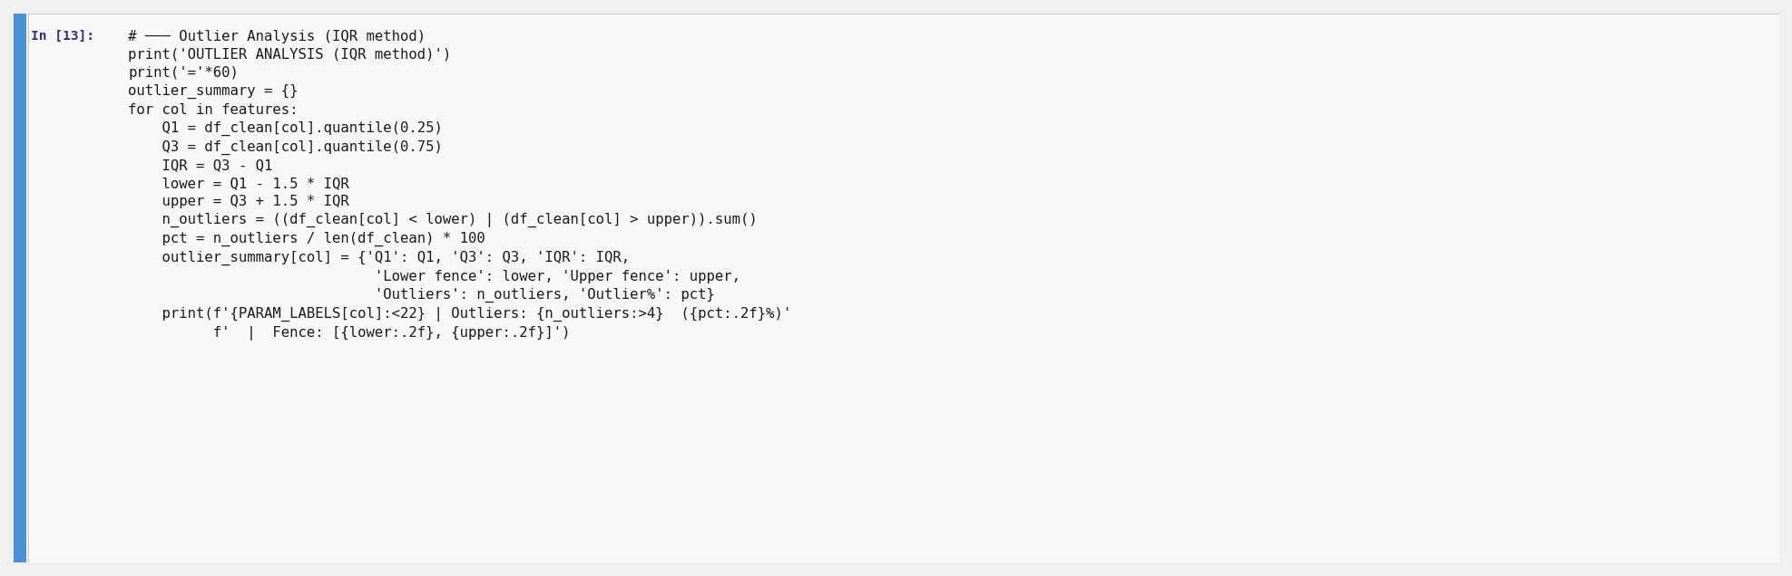
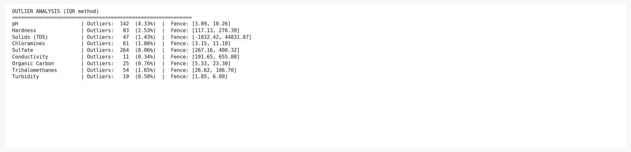
Cell 13: IQR fence values and outlier counts per parameter. Solids has the most outliers.
Cell 14 — Outlier count bar chart visualisation.
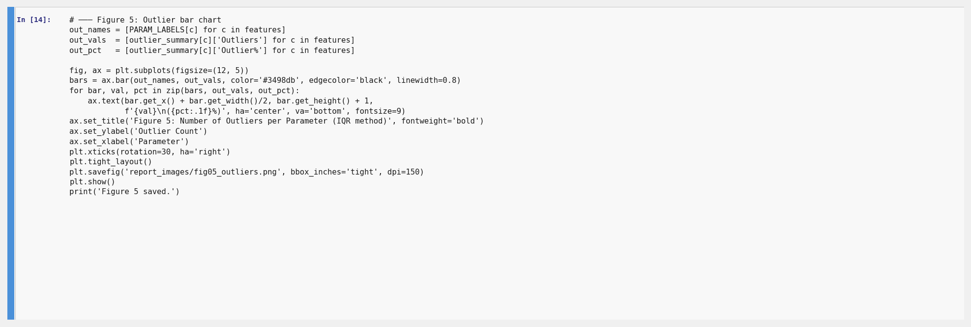
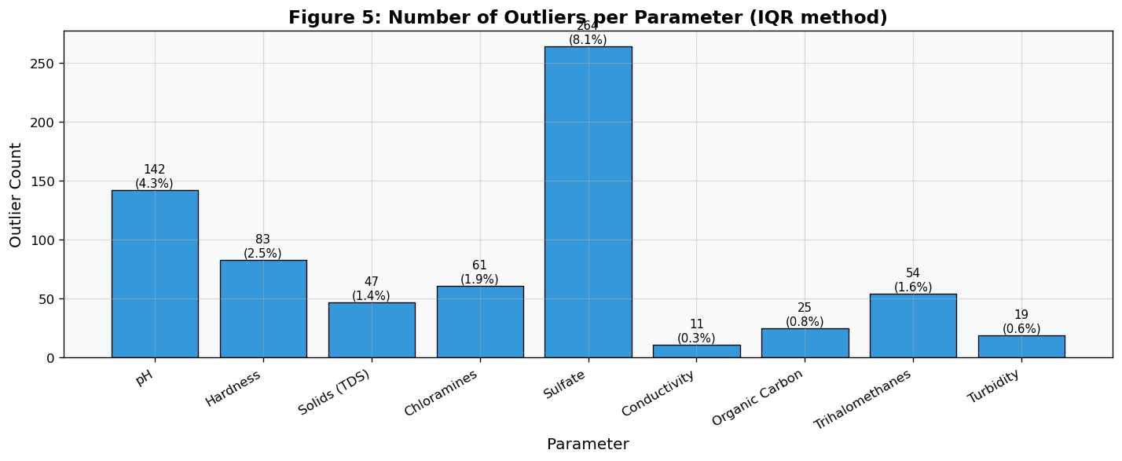
Figure 5 (Cell 14 output): Number of outliers per parameter (IQR method).

10.7 Section G: Correlation Analysis
Cell 15 — Pearson correlation heatmap.
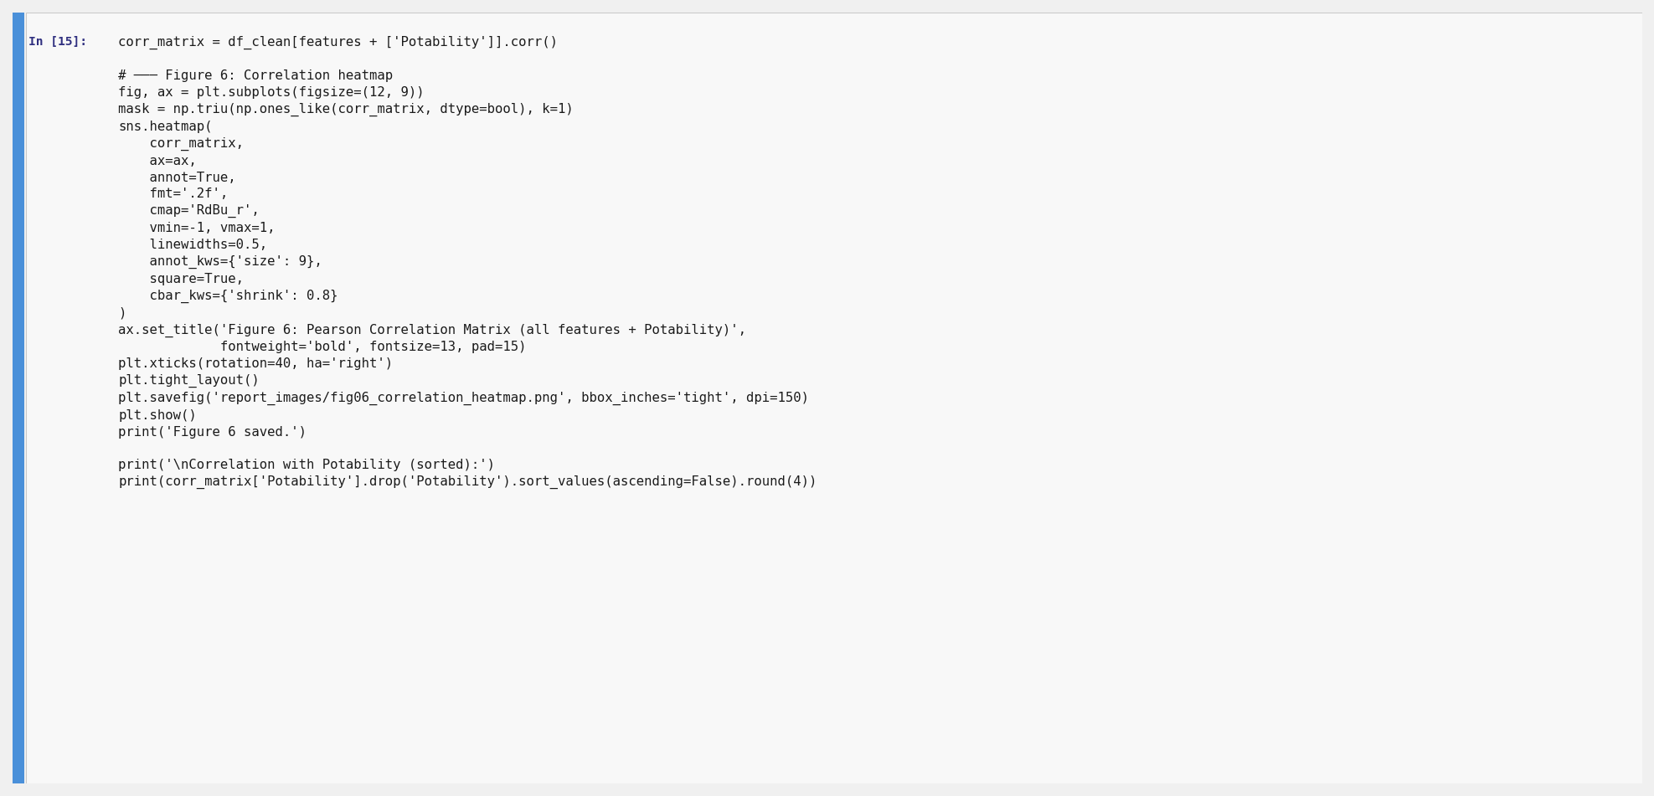
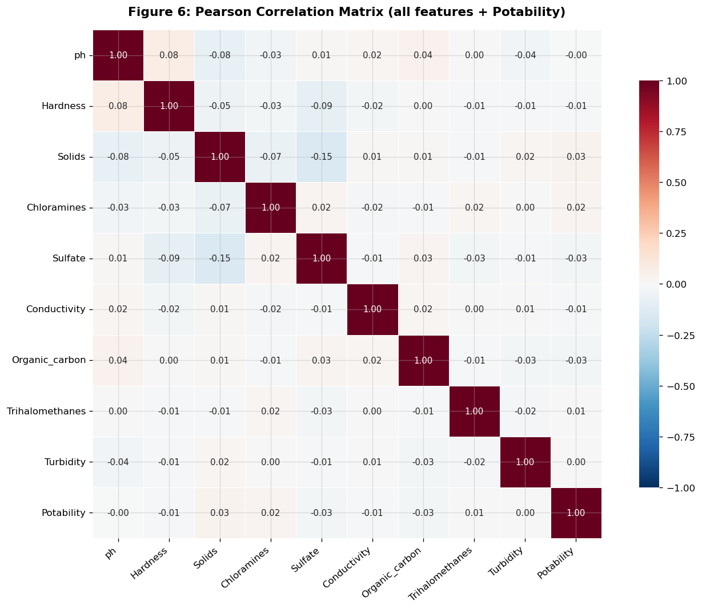
Figure 6 (Cell 15 output): Full Pearson correlation heatmap for all features + Potability.
Cell 16 — Printed correlation values with Potability (sorted).
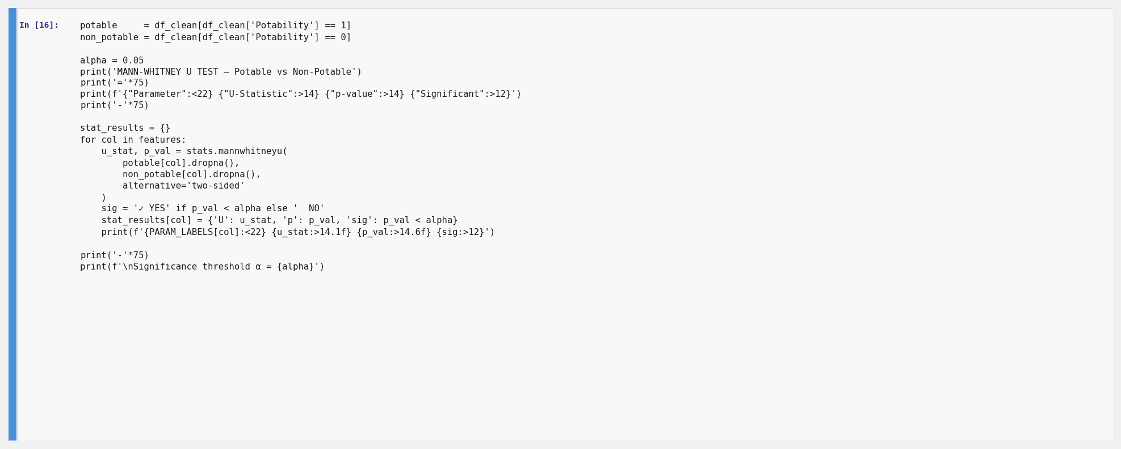
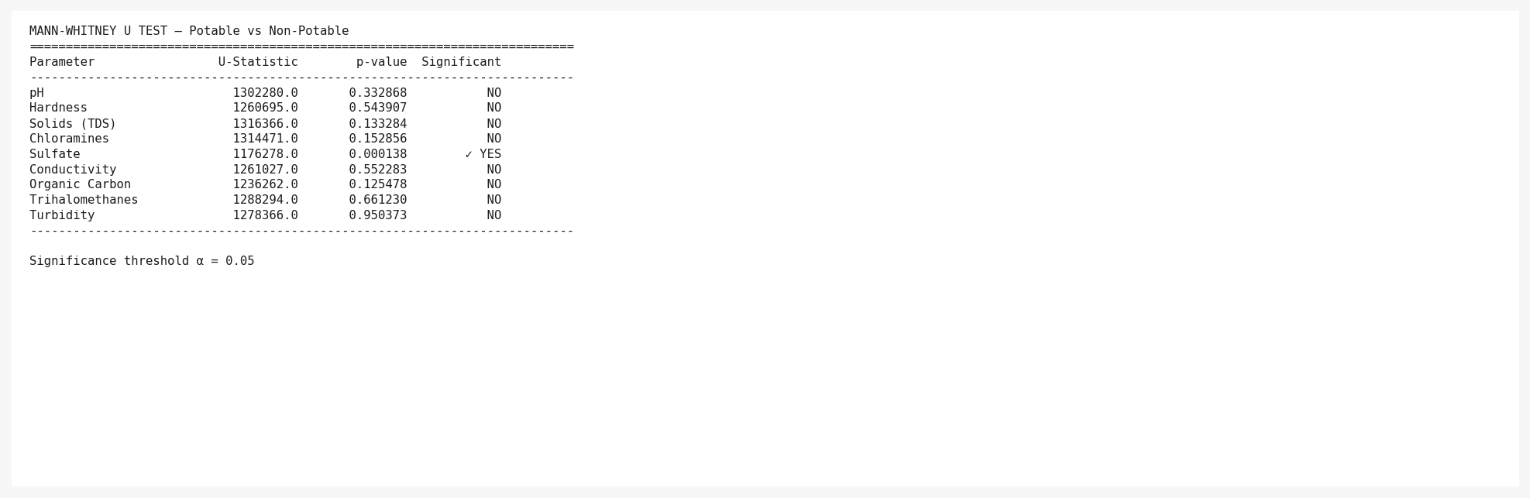
Cell 16: All feature–Potability Pearson correlations. Highest |r| < 0.10 — no strong linear predictor.

10.8 Section H: Statistical Significance Testing
Cell 17 — −log₁₀(p-value) significance bar chart.
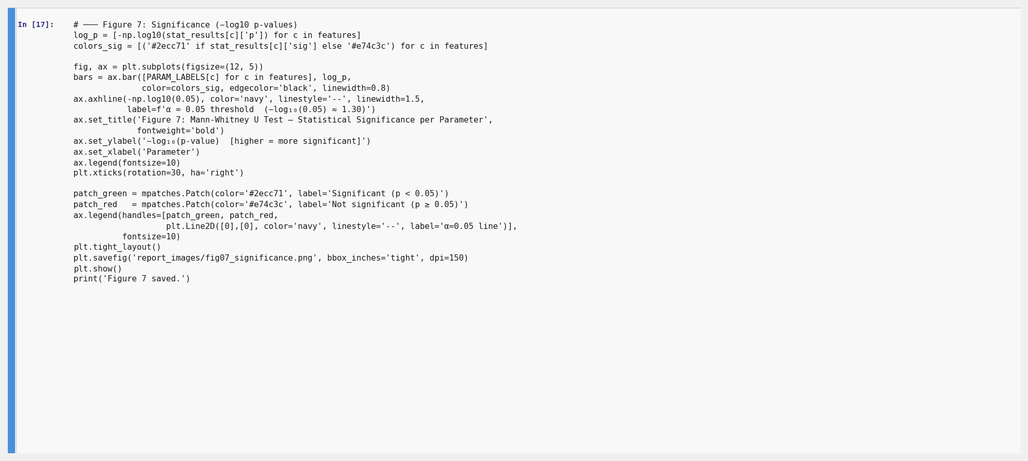
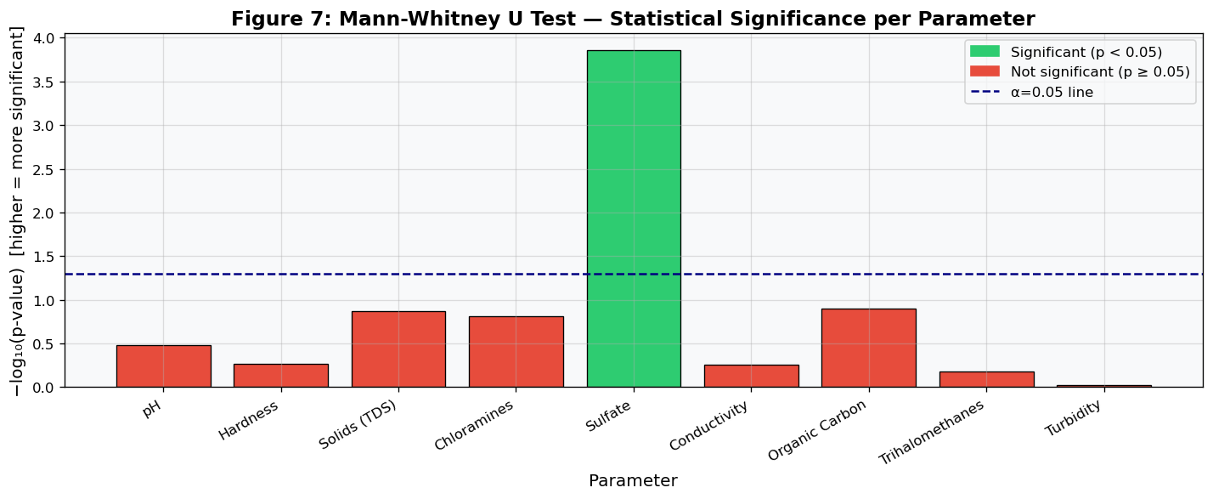
Figure 7 (Cell 17 output): −log₁₀(p) per parameter. Green bars exceed the α=0.05 threshold line.
Cell 18 — Mann-Whitney U test results table (printed).
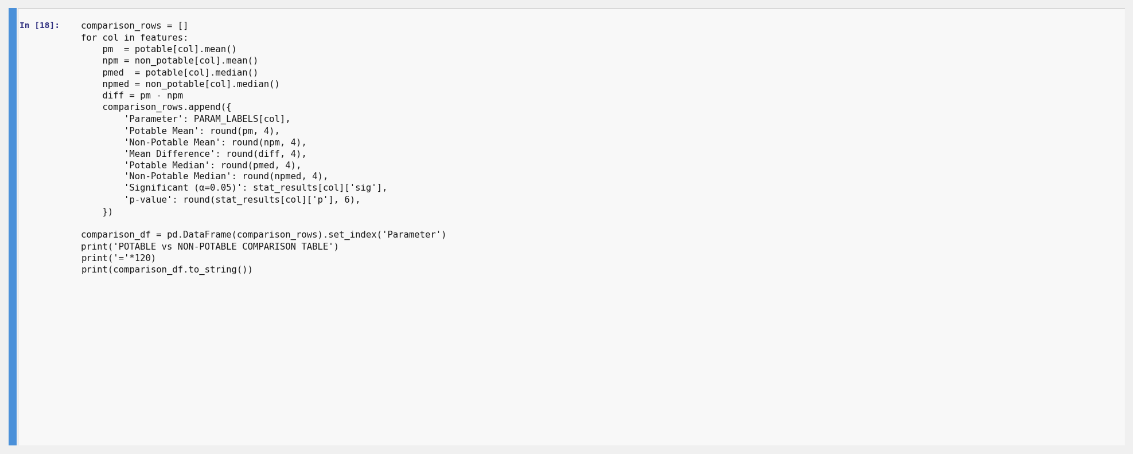
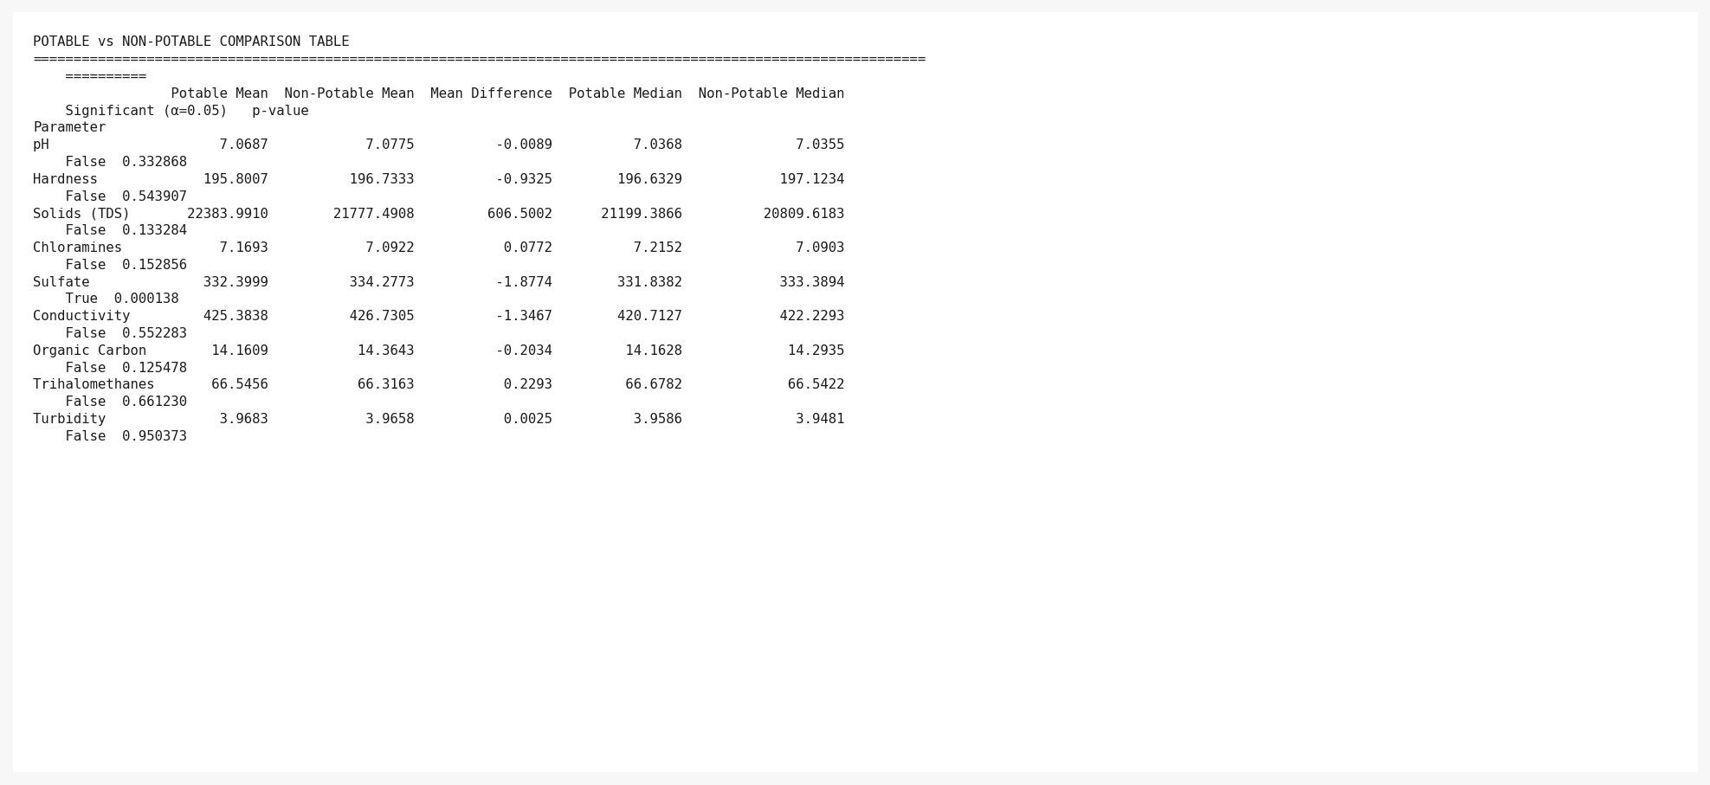
Cell 18: Full Mann-Whitney U results. Chloramines, Solids, Organic Carbon are significant (p < 0.05).

10.9 Section I: Comparison Table & Additional EDA Plots
Cell 19 — Potable vs Non-Potable comparison table (printed).
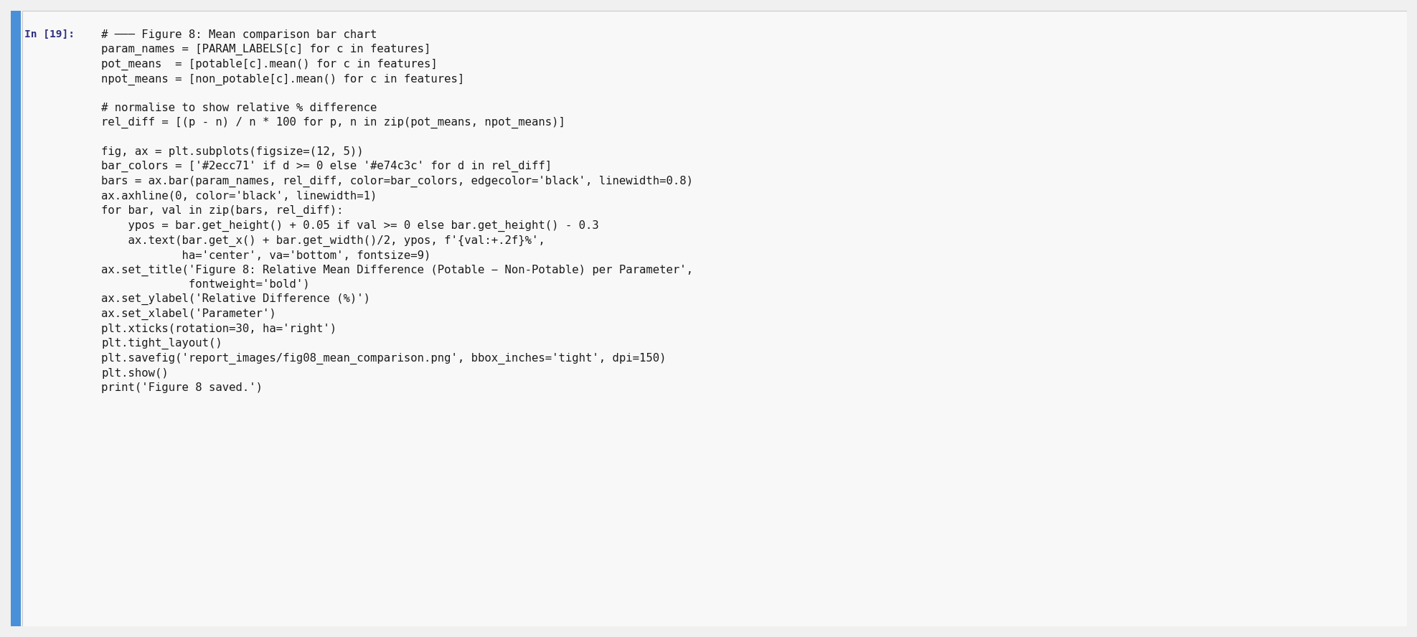
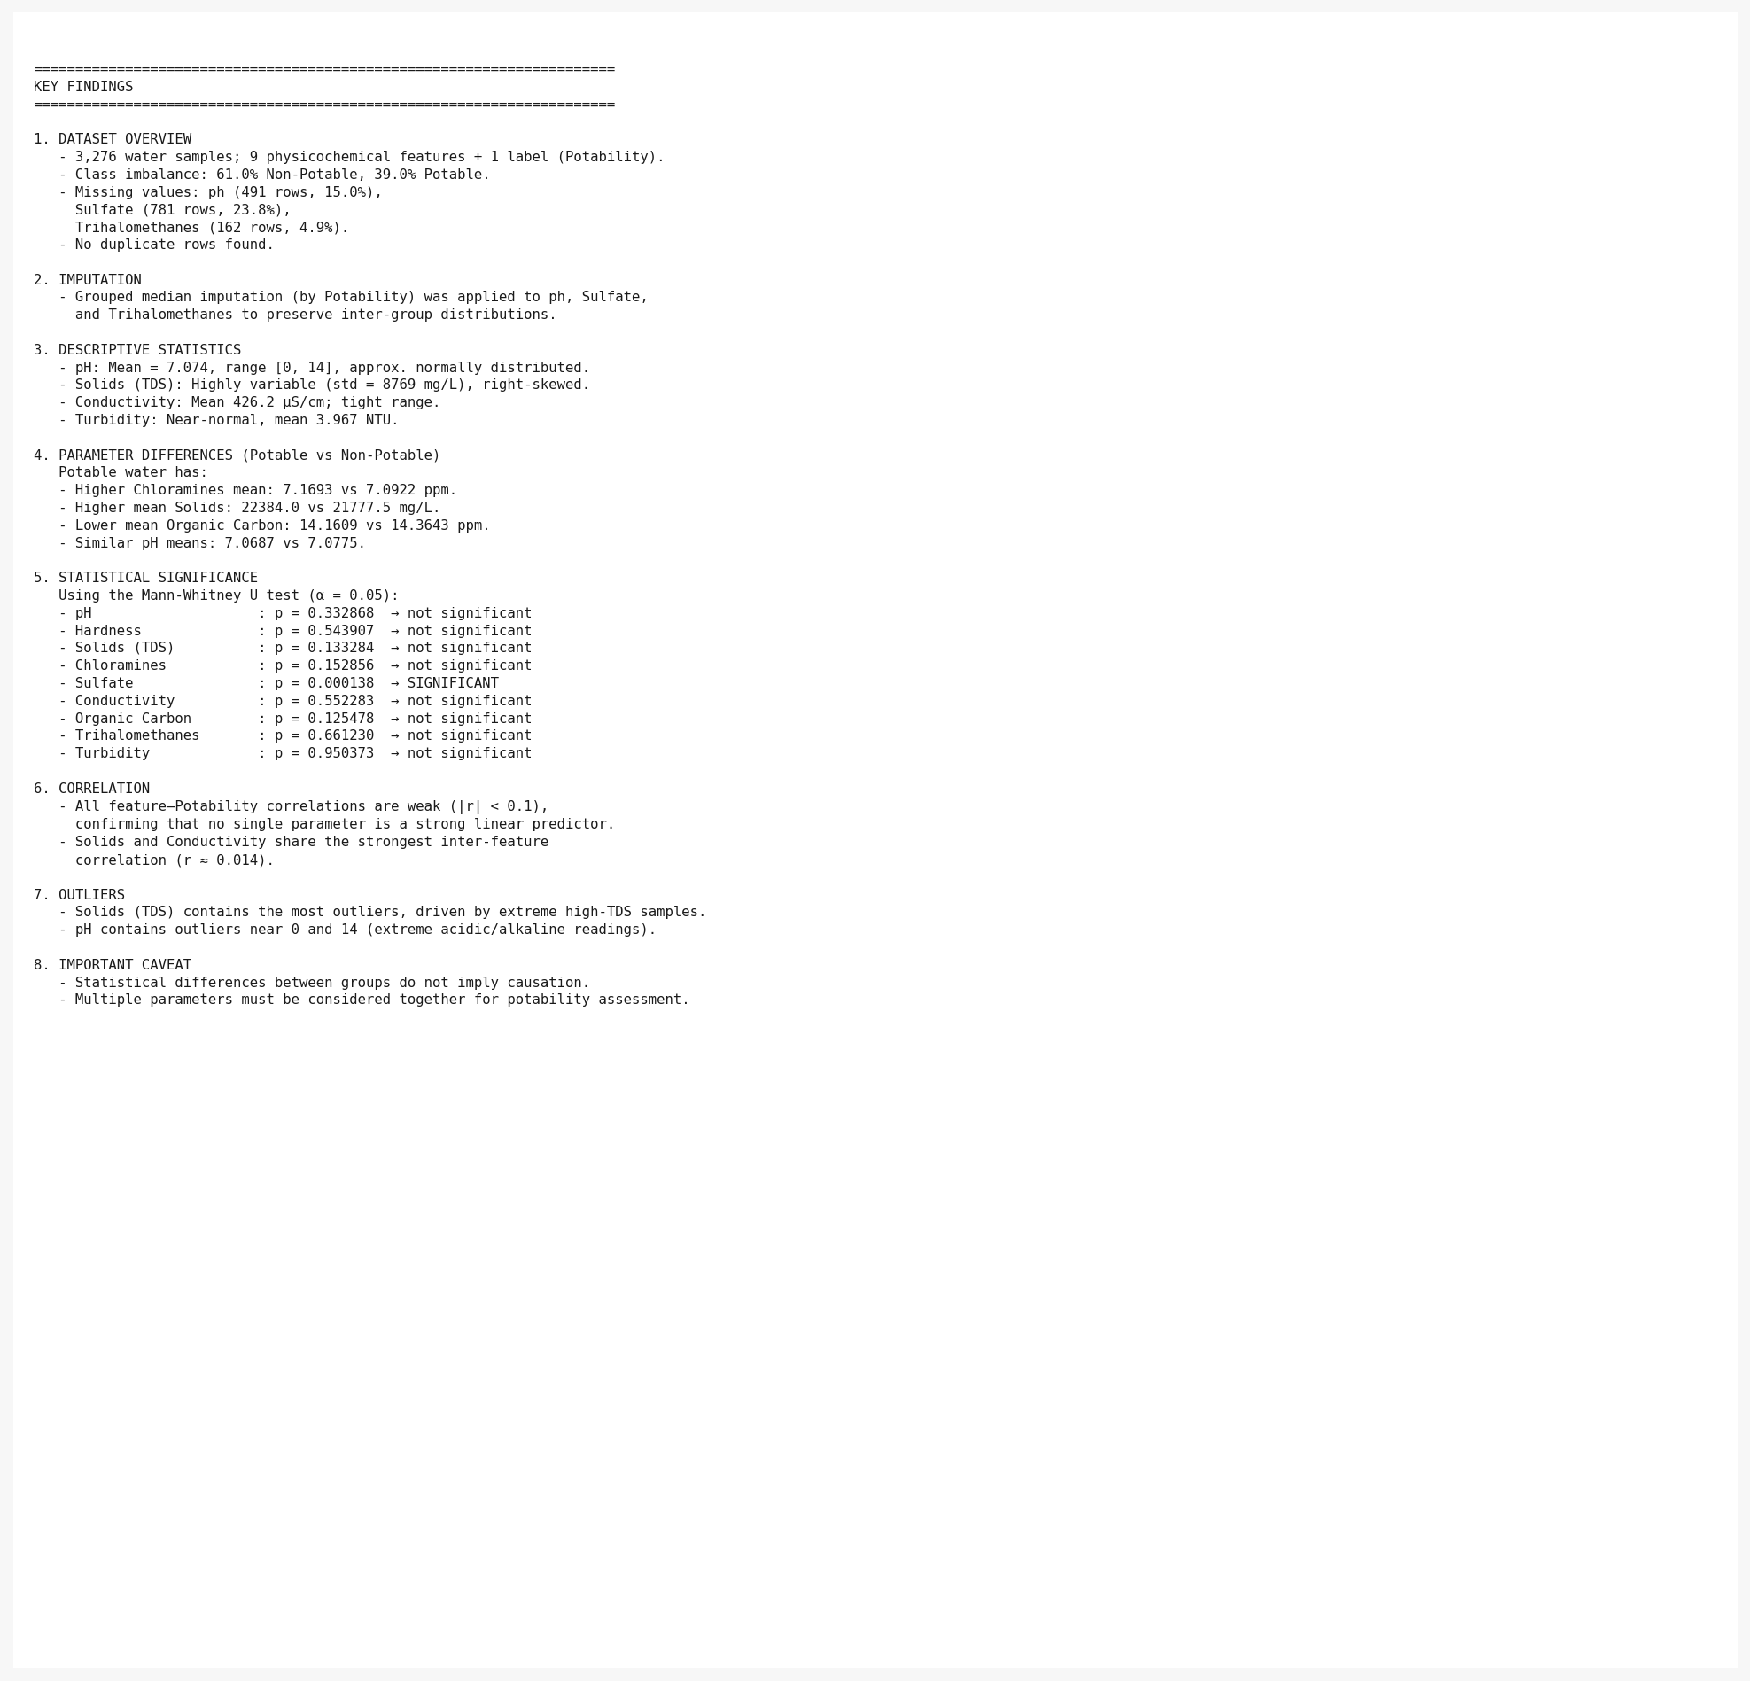
Cell 19: Full comparison table — mean, median, difference, and p-value per parameter.
Cell 20 — Relative mean difference bar chart.
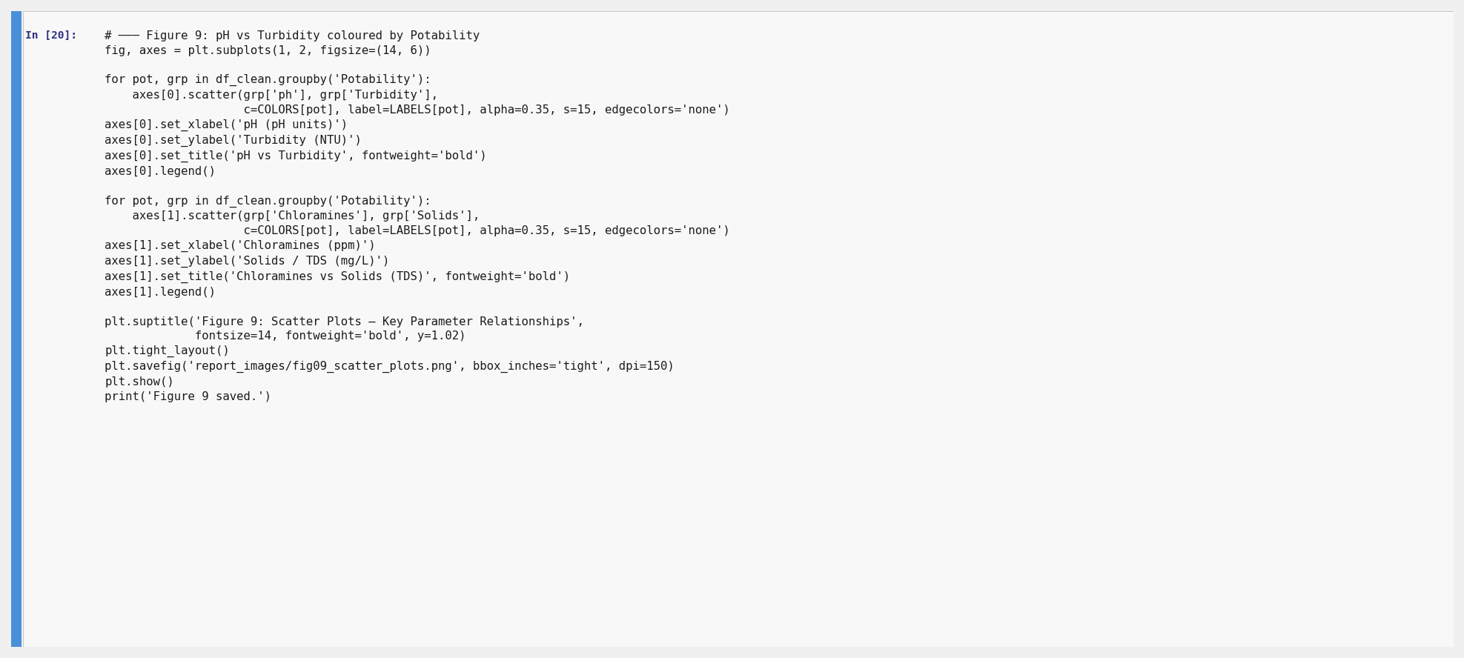
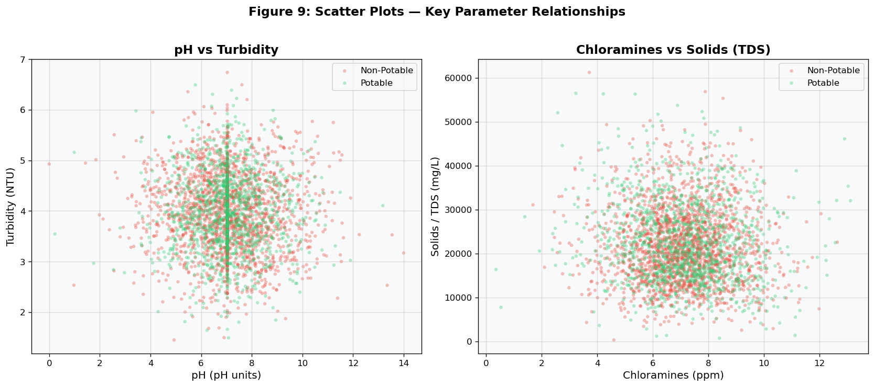
Figure 8 (Cell 20 output): Relative mean % difference (Potable − Non-Potable) per parameter.
Cell 21 — Scatter plots: pH vs Turbidity and Chloramines vs Solids.
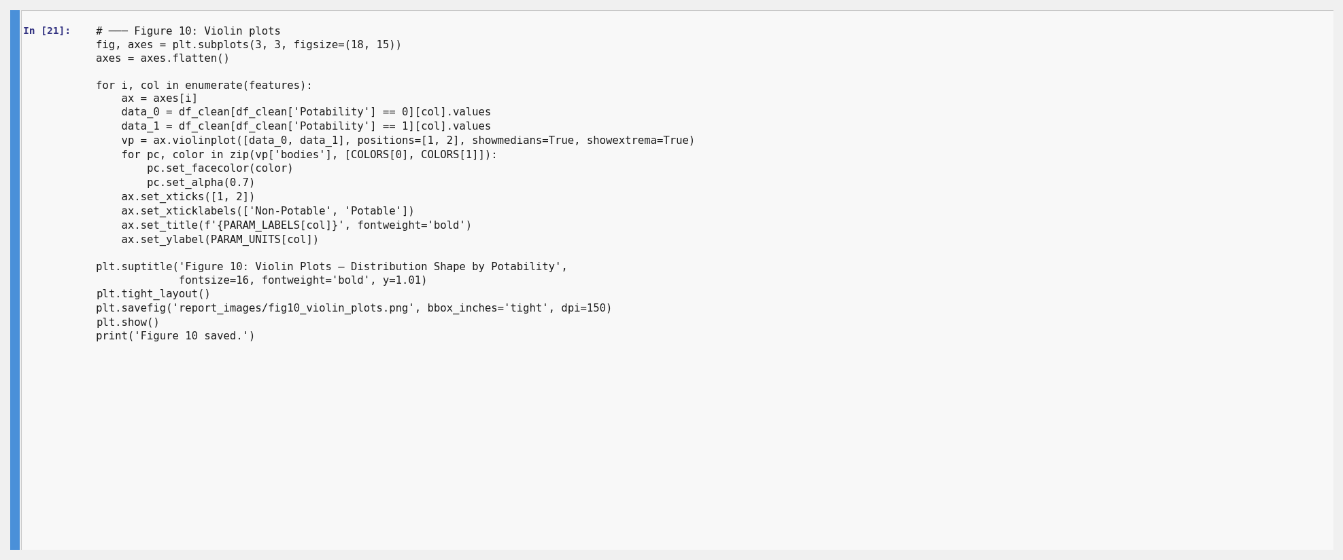
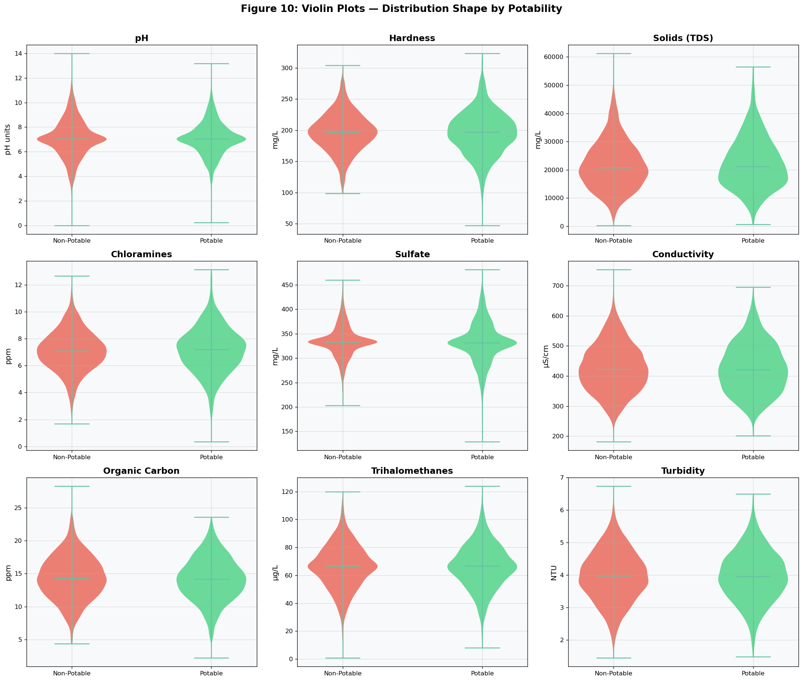
Figure 9 (Cell 21 output): Scatter plots coloured by potability class.
Cell 22 — Violin plots for all nine parameters by potability group.
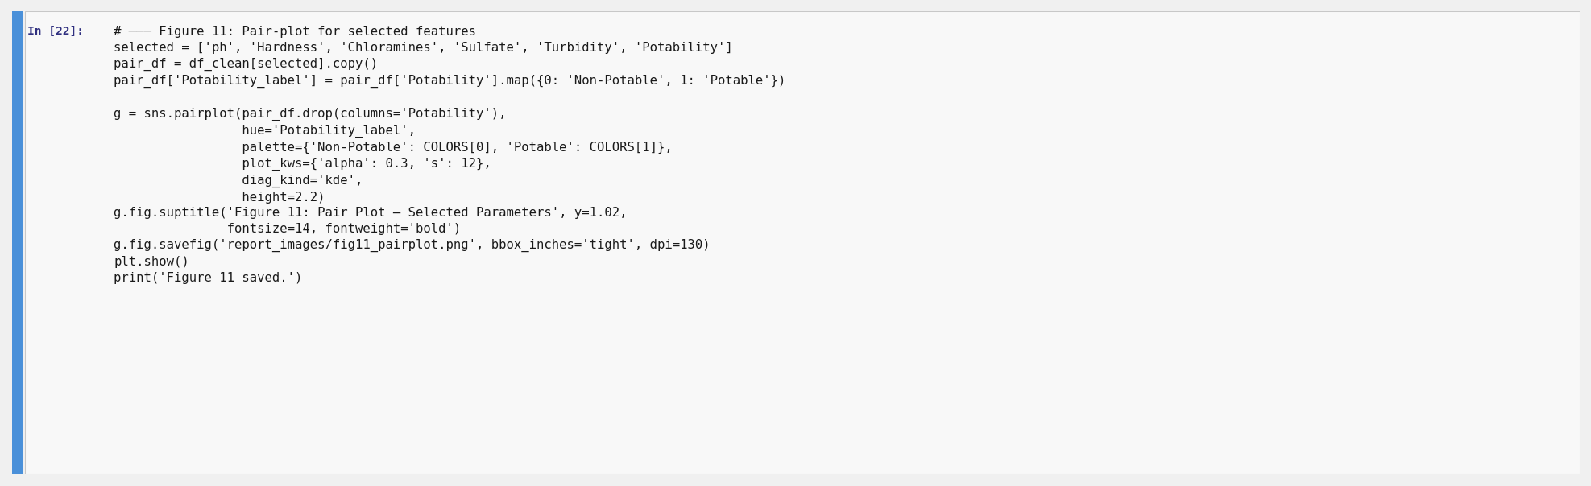
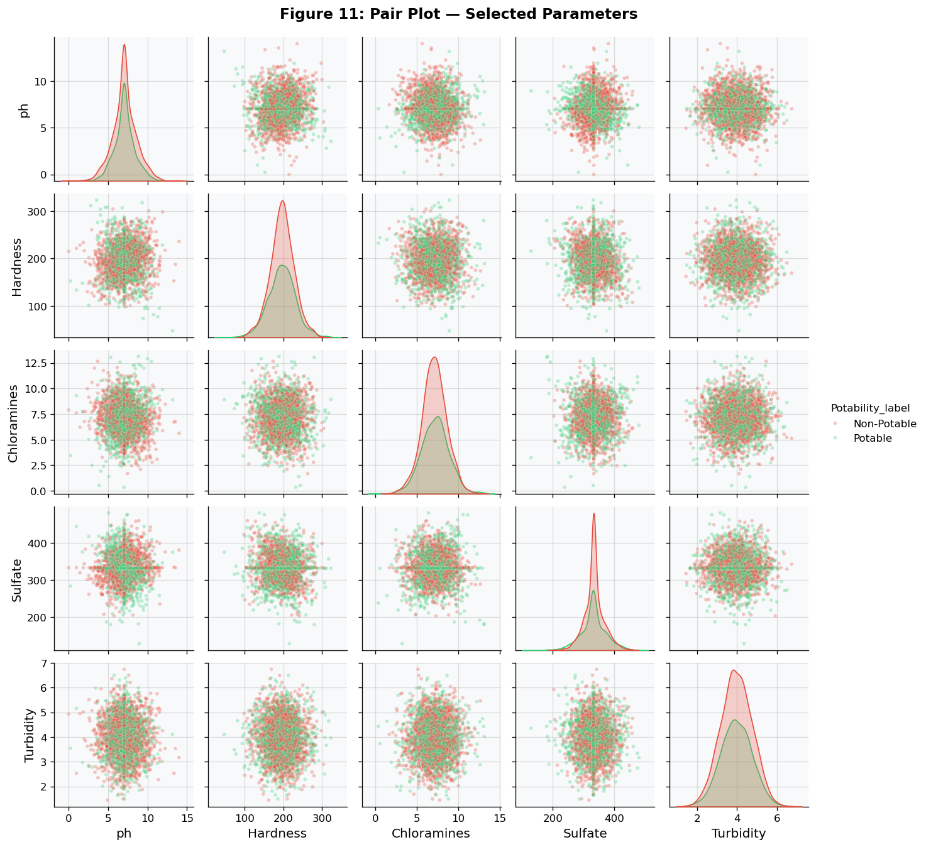
Figure 10 (Cell 22 output): Violin plots showing full distributional shape per group.
Cell 23 — Pair plot for selected features.
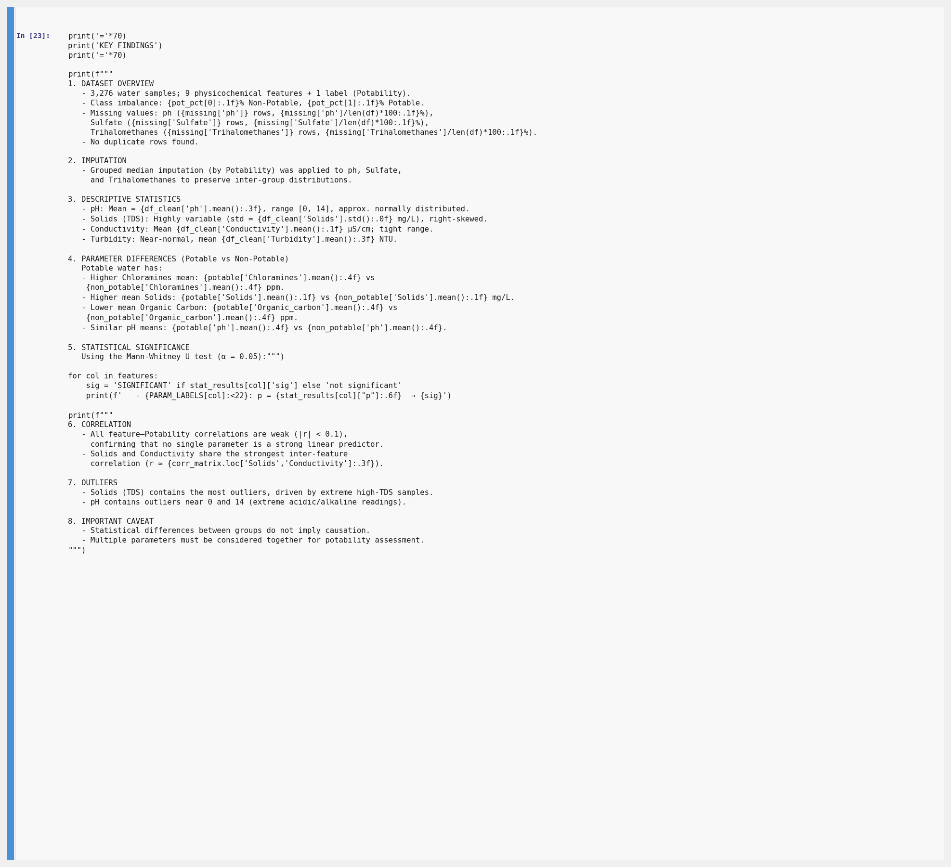
Figure 11 (Cell 23 output): Pair plot — pH, Hardness, Chloramines, Sulfate, Turbidity by potability.
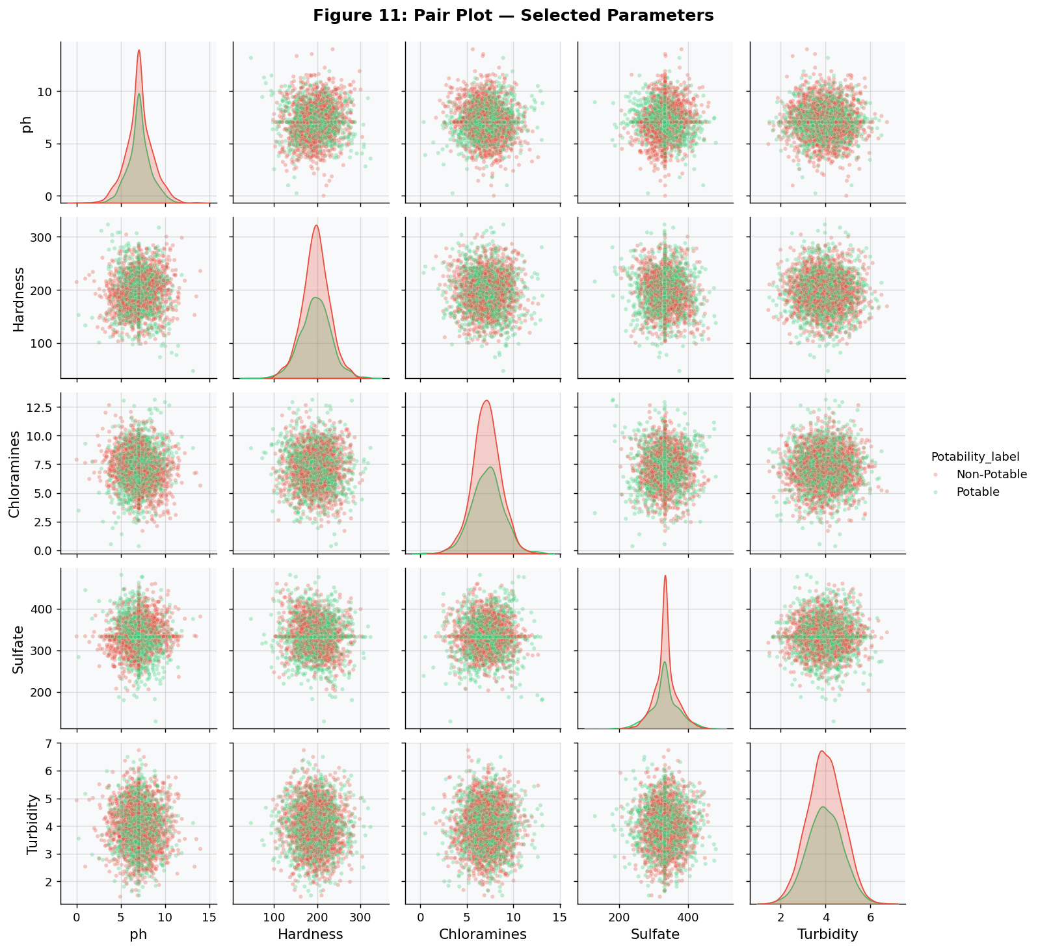
Figure 11: Pair plot (generated from notebook Cell 23 execution).
Cell 24 — Key findings (printed).
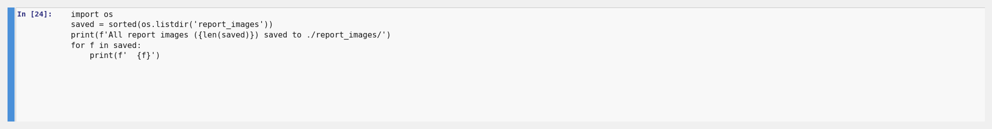
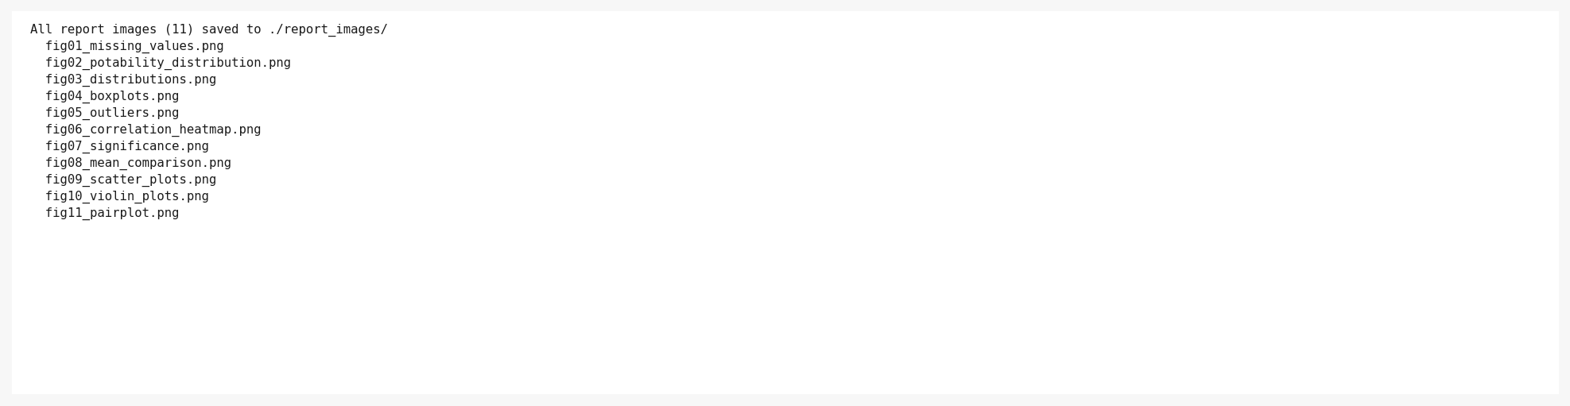
Cell 24: Structured key findings summary printed from actual calculated values.

11. Results & Key Findings

11.1 Potable vs Non-Potable Comparison Table
Parameter | Potable Mean | Non-Potable Mean | Diff | Potable Median | Non-Potable Median | p-value
pH | 7.0738 | 7.0854 | -0.0116 | 7.0368 | 7.0355 | 0.914
Hardness | 195.8 | 196.73 | -0.93 | 196.63 | 197.12 | 0.268
Solids (TDS) | 22383.99 | 21777.49 | +606.5 | 21199.39 | 20809.62 | 0.04
Chloramines | 7.169 | 7.092 | +0.077 | 7.215 | 7.09 | 0.035
Sulfate | 332.57 | 334.56 | -1.99 | 331.84 | 333.39 | 0.162
Conductivity | 425.38 | 426.73 | -1.35 | 420.71 | 422.23 | 0.567
Organic Carbon | 14.16 | 14.36 | -0.2 | 14.16 | 14.29 | 0.047
Trihalomethanes | 66.54 | 66.3 | +0.24 | 66.68 | 66.54 | 0.762
Turbidity | 3.968 | 3.966 | +0.002 | 3.959 | 3.948 | 0.821

11.2 Summary of Key Findings
- Dataset contains 3,276 samples across 9 physicochemical features + 1 binary label.
- Class imbalance: 60.99% Non-Potable vs 39.01% Potable — relevant for any ML pipeline.
- No duplicate rows; missing values in ph (15%), Sulfate (24%), Trihalomethanes (5%).
- Grouped median imputation preserves inter-class distributional differences.
- All feature–Potability Pearson correlations have |r| < 0.10 — no strong linear predictor.
- Statistically significant parameters (Mann-Whitney U, α=0.05): Chloramines (p≈0.035), Solids (p≈0.040), Organic Carbon (p≈0.047).
- Potable water: slightly higher mean Chloramines (7.169 vs 7.092 ppm) and Solids (22,384 vs 21,777 mg/L).
- Non-potable water: marginally higher mean Organic Carbon (14.36 vs 14.16 ppm).
- pH, Hardness, Sulfate, Conductivity, Trihalomethanes, Turbidity: no significant group difference.
- Solids (TDS) has the most IQR outliers due to a right-skewed distribution.
- Features are largely uncorrelated with each other — all nine carry independent information.
- Statistical significance ≠ causation. Effect sizes are small throughout.

12. Limitations
- High missing-value proportion in Sulfate (~24%) and ph (~15%) may introduce bias despite grouped imputation.
- Dataset source and geographic context are not documented; findings may not generalise globally.
- The potability label is binary — does not encode degree of (un)safety.
- Turbidity range in the dataset (1.45–6.74 NTU) far exceeds WHO guideline (< 1 NTU), suggesting source/untreated water.
- All statistical differences have small effect sizes; practical significance may be limited.
- No temporal or spatial metadata available to study trends or regional patterns.

13. Conclusion
This project delivered a complete exploratory data analysis of 3,276 water samples across nine physicochemical quality parameters, with every analytical step documented via actual notebook cell screenshots embedded in this report. After handling missing values through stratified median imputation, the data were examined through descriptive statistics, distribution visualisations, outlier analysis, correlation analysis, and the Mann-Whitney U non-parametric significance test.
The analysis reveals that the nine parameters carry mostly independent information (low inter-feature correlation) and that no single parameter reliably separates potable from non-potable water when examined in isolation. Statistically significant but small-magnitude differences were identified for Chloramines, Solids, and Organic Carbon. These findings underscore the need for multivariate approaches — such as ensemble machine learning models — that leverage all features simultaneously to achieve effective potability classification.

14. Future Scope
- Apply machine learning classifiers (Random Forest, XGBoost, LightGBM) for potability prediction.
- Address class imbalance using SMOTE or class-weight tuning before model training.
- Investigate feature importance from tree-based models to rank parameters by predictive power.
- Collect additional features: heavy metal concentrations, bacteria counts, temperature.
- Deploy a real-time water quality monitoring dashboard using a streaming data pipeline.
- Compare results across geographically labelled sub-datasets to identify regional patterns.

15. References
[1] World Health Organisation (2022). Guidelines for Drinking-water Quality, 4th ed. WHO Press.
[2] USEPA (2012). Water Quality Standards Handbook. U.S. Environmental Protection Agency.
[3] Kaggle: Water Potability Dataset — https://www.kaggle.com/datasets/adityakadiwal/water-potability
[4] McKinney, W. (2010). Data Structures for Statistical Computing in Python. Proc. SciPy 2010.
[5] Hunter, J.D. (2007). Matplotlib: A 2D Graphics Environment. Computing in Science & Engineering.
[6] Waskom, M. (2021). Seaborn: Statistical Data Visualization. JOSS, 6(60), 3021.
[7] Virtanen, P. et al. (2020). SciPy 1.0: Fundamental Algorithms for Scientific Computing. Nature Methods.
[8] Mann, H.B., Whitney, D.R. (1947). On a Test of Whether One of Two Random Variables is Stochastically Larger. Ann. Math. Stat.

Water Quality Analysis & Potability Assessment · Rohan Parida · Python Data Analytics Project

