2. Implement the 8 Puzzle Breadth First Search Algorithm.

from queue import Queue

def print_board(board):

for row in board:

print(" ".join(map(str, row)))

def is_goal_state(board, goal):

return board == goal

def get_blank_position(board):

for i in range(3):

for j in range(3):

if board[i][j] == 0:

return i, j

def generate_successors(board):

successors = []

blank_i, blank_j = get_blank_position(board)

moves = [(0, 1), (1, 0), (0, -1), (-1, 0)] # right, down, left, up

for move_i, move_j in moves:

new_i, new_j = blank_i + move_i, blank_j + move_j

if 0 <= new_i < 3 and 0 <= new_j < 3:

successor = [row.copy() for row in board]

successor[blank_i][blank_j], successor[new_i][new_j] = successor[new_i][new_j], successor[blank_i][blank_j]

successors.append(successor)

return successors

def breadth_first_search(initial_state, goal_state):

visited = set()

queue = Queue()

queue.put((initial_state, []))

while not queue.empty():

current_state, path = queue.get()

visited.add(tuple(map(tuple, current_state)))

if is_goal_state(current_state, goal_state):

return path

for successor in generate_successors(current_state):

if tuple(map(tuple, successor)) not in visited:

queue.put((successor, path + [successor]))

return None

# Example:

initial_state = [

[1, 2, 3],

[0, 4, 6],

[7, 5, 8]

]

goal_state = [

[1, 2, 3],

[4, 5, 6],

[7, 8, 0]

]

solution = breadth_first_search(initial_state, goal_state)

if solution:

print("Solution found:")

for step, state in enumerate(solution):

print(f"Step {step + 1}:")

print_board(state)

print()

else:

print("No solution found.")

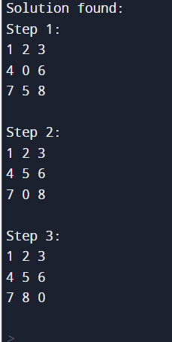

Q. Explore the working of Tic Tac Toe using Min max strategy.

**function** minimax(board, depth, isMaximizingPlayer):  
  
 **if** current board state is a terminal state :  
 **return** value of the board  
   
 **if** isMaximizingPlayer :  
 bestVal = -INFINITY   
 **for each** move in board :  
 value = minimax(board, depth+1, false)  
 bestVal = max( bestVal, value)   
 **return** bestVal  
  
 **else** :  
 bestVal = +INFINITY   
 **for each** move in board :  
 value = minimax(board, depth+1, true)  
 bestVal = min( bestVal, value)   
 **return** bestVal