CYBER SAATHI
Senior Citizen Cyber Safety & Scam Reporting Portal
System Architecture & Technical Design Document
College: PVG's College of Engineering and Technology, Nashik
Department: Department of Information Technology | Savitribai Phule Pune University (SPPU)
Project Team: Rohan Bhopale (Team Leader), Swayam Adik, Sakshi Badgujar, Yash Bhamare
Repository: https://github.com/rohanpbhopale05-ops/cyber-saathi

1. High-Resolution System Architecture Diagram

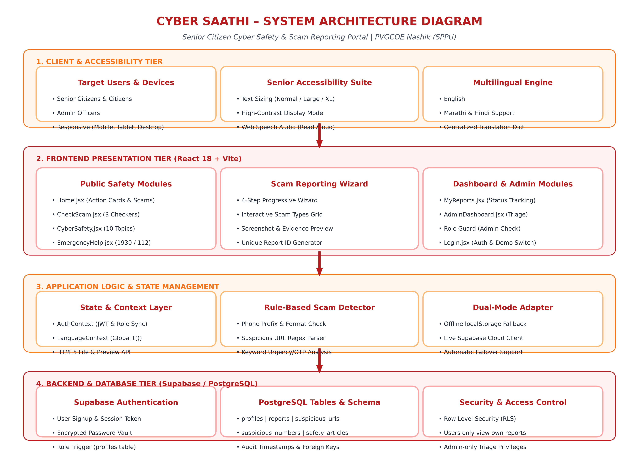
Figure 1.1: End-to-End 4-Tier Architecture Diagram for Cyber Saathi Portal

2. Native Word Architecture Diagram (Editable Layout)
This diagram is constructed directly using native Microsoft Word table blocks so that you can easily edit text, resize blocks, or copy them into your final project seminar report.
TIER 1: USER & ACCESSIBILITY LAYER (Clients & Inputs)
Target Users & Devices  • Senior Citizens & General Public  • Cyber Safety Admins / Police  • Responsive Web (Mobile, Tablet, PC) | Senior Accessibility Suite  • Normal / Large / Extra-Large Text  • High Contrast Display Mode  • Web Speech API (Read Aloud) | Multilingual Localization  • English Interface  • मराठी (Marathi Localization)  • हिंदी (Hindi Localization)
▼ HTTP(S) / User Actions / Voice Output ▼
TIER 2: FRONTEND PRESENTATION LAYER (React 18 + Vite)
Public Information Modules  • Home.jsx (Action Cards & Scams)  • CheckScam.jsx (Phone/URL/Msg)  • CyberSafety.jsx (10 Safety Tips)  • EmergencyHelp.jsx (1930 / 112) | Scam Reporting Wizard  • Step 1: Select Scam Category  • Step 2: Specific Incident Data  • Step 3: Evidence/Screenshot Upload  • Step 4: Submission & CS-ID Generation | Dashboard & Authentication  • MyReports.jsx (Report Tracking)  • AdminDashboard.jsx (Triage Console)  • Login.jsx (Auth & Signup)  • Role-Based Access Control
▼ React Context State / Client Engine ▼
TIER 3: CLIENT APPLICATION LOGIC & UTILITIES
Context Providers  • AuthContext.jsx (Session & Roles)  • LanguageContext.jsx (i18n)  • SpeechSynthesis Web Audio API | Rule-Based Detector  • Regex pattern parser for URLs  • Suspicious phone prefix detector  • Message urgency & OTP analyzer | Failover Storage Adapter  • Supabase Cloud API Client  • LocalStorage Offline Buffer  • Real File API & Image Previewer
▼ Secure HTTPS API / JWT Authentication / PostgreSQL ▼
TIER 4: BACKEND & DATABASE STORAGE (Supabase Cloud Tier)
Supabase Auth & Roles  • Email/Password Signup & Login  • Role Assignment ('user' / 'admin')  • Trigger: on_auth_user_created | PostgreSQL Database  • profiles (user profile & role)  • reports (complaints & evidence)  • suspicious_numbers & urls | Security & Row-Level Rules  • RLS Policy: Users view own reports  • Admin-only status modification  • Immutable Audit timestamps

3. Detailed Tier Breakdown for Project Report

Tier 1: Client & Accessibility Layer
• Accessibility Controls: Provides font scaling ('Normal', 'Large', 'Extra Large') and a high-contrast mode specifically tailored for elderly users with impaired vision.
• Web Speech Synthesis: Features an interactive 'READ ALOUD' audio button allowing senior citizens to listen to safety guidelines spoken aloud.
• Multilingual Dictionary: Implements centralized localization dictionary supporting English, Marathi, and Hindi dynamically.

Tier 2: Frontend Presentation Layer (React 18 & Vite)
• Scam Reporting Wizard: Breaks down crime reporting into 4 gentle steps: Scam Selection, Specific Details, Real Evidence/Screenshot Attachment with thumbnail preview, and Confirmation.
• Real-Time Scam Checker: Provides an intuitive 3-tab scanner for Phone numbers, URLs, and Message text.
• Emergency Hotline Hub: Features prominent, high-contrast one-tap dial buttons for National Cyber Crime Helpline (1930) and Police Emergency (112).
• Role-Guarded Dashboards: Provides regular users with a personal 'My Reports' tracking timeline, and administrators with an authorized triage portal.

Tier 3: Application Logic & State Adapter
• Rule-Based Detection Engine: Employs rule-based regex patterns for detecting OTP urgency, KYC suspension threats, and suspicious domain patterns.
• Failover Dual-Mode Architecture: Allows the application to run smoothly in offline/demo mode via localStorage while automatically syncing with Supabase when configured.

Tier 4: Backend Database & Security Layer (Supabase PostgreSQL)
• Authentication & Security: Secured via Supabase Auth (JWT tokens) with automated trigger profiles.
• Row Level Security (RLS): Strict database-level policies prevent unauthorized cross-tenant data access, ensuring senior citizens' private reports are strictly private.

