***Arrays:-***

* *If we want to represent huge no of values we can use array for storing data into it.*
* *Arrays are fixed in size , with default capacity which we provide*
* *Arrays can hold only homogenous type of data. (Same type of data).*
* *An array can be defined as indexed collection of fixed no of homogenous data elements.*
* *We can represent huge no of values by using single variable, so that readability of the code gets improved.*
* *Arrays concept is not based on standard data structure for arrays therefore, inbuilt method support is not available thus we need to write every coding requirement explicitly.*
* *To use arrays which should know the size of arrays in advance which may not be possible always.*

***Array Declaration:-***

* *1-D Array*

1. *int[] x,(Recommended) b) int []x, c) int x[];*

*(a) is recommended because name is clearly separated from the type.*

*We cannot specify the size of array at the time of declaration itself if done we will get compile time error*

* *2-D Array*

1. *int[][] x, b) int [][]x c) int x[][] d) int[] []x e) int[] x[] f) int []x[]*

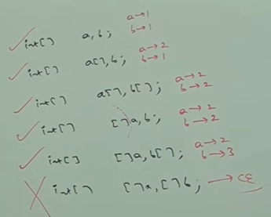

***\*\*\* If we want to declare dimension before variable, this facility is available / applicable for 1st variable only and if we forcefully try to declare it before 2nd dimension then it will give CompileError.***

* *3-D Array --- Valid declarations*

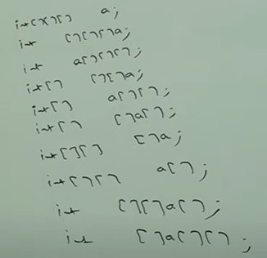

***Array Creation(1-dimensional):-*** *“ new “ operator -is used.*

*\*If few are creating array using new keyword that means every array in java is an Object.*

*\* new 🡪 dynamic memory allocator (allocates memory during runtime)*

*1) int[] a= new int[10];*

*\* For every Array type , corresponding classes are available in java , but these are limited and are part of java language and are not available at programmer level.*

*🡪[I 🡪Integer Array , [D 🡪Double Array, [[I , [[D 🡪2-D array , [Z 🡪 Boolean Array*

Note:- int[] x=new int[10] 🡪 Valid

int [] x=new int[0] 🡪 Valid

int [] x=new int[-3] 🡪 Code will be compiled but while executing it will throw

NegativeArraySizeException (Runtime Error)

The maximum allowed array size in java is 2,14,74,83,647 which is the maximum value of int data type. Even in the first case we may get Runtime exception, if sufficient hep memory is not available.

*Data Type allowed for array size🡪 byte, short, char ,int*

***Array Creation(2-dimensional):-***

*In java 2-D array not implemented by using Matrix representation style, Sun microsystems people followed* ***Array of Arrays approach*** *for multidimensional array creation.*

*The main advantage of this approach is , memory utilization will be improved.*

*Example:- int [][] x = new int[2][];*

*x[0]=new int[2];*

*x[1]=new int [3];*

Note:- int[] x =new int[6];

x[6]=70 🡪Runtime Exception 🡪ArrayIndexOutOfBoundsException

x[-6]=80🡪Runtime Exception🡪ArrayIndexOutOfBoundsException

x[2.5]=90🡪Compile Error🡪Possible loss of precision ,found double requires int

***( .length is final variable available only for Arrays to calculate length of an Array )***

***( .length() is method available for Strings used to calculate length of String & String objects)***

***Anonymous Arrays:-***

*Instant arrays created for one time use and no further use without name/nameless arrays are called as Anonymous Arrays. While creating anonymous arrays we cannot specify size as we directly pass the values. Mostly passed as parameters to methods.*

*Sum(new int[]{10,20,30,40});*

*public static void Sum(int[] x) { ----- method body ----- }*

|  |  |
| --- | --- |
| *Array Type* | *Allowed Array Types* |
| *Primitive data Type* | *Any type which can be impilictly promoted / casted to declared type. Automatic casting* |
| *Object type Array* | *Either declared type or its child class Objects* |
| *Abstract class Type Array* | *Its child class objects are allowed.* |
| *Interface type Array* | *Its implementation class objects are allowed.* |

*Note:-*

1. *Char element can be promoted to int type(ASCII) but char array[] cannot be promoted to int type. But if forcefully trying to do then throws* ***Compile Error🡪Incompatible Types.***

*Char [] ch={a,b,c,d,e};*

*int[] c=ch* 🡪 *Invalid throws* ***Compile Error***🡪***Incompatible Types.***

1. *Int[] x ={1,2,3,4,5};*

*Int[] y=x; 🡪 Valid*

***Storing of Arrays:-***

*Char 🡪 int ---------------------Valid*

*Char[] 🡪 int[]-----------------Invalid*

*Int 🡪 double-------------------Valid*

*Int[] 🡪 double[]---------------Invalid*

*Float 🡪int----------------------Invalid*

*Float[] 🡪 int[]----------------Invalid*

*String 🡪Object--------------Valid*

*String[] 🡪 Object[]--------Valid*