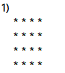

**public** **void** pattern1() {

**for** (**int** i = 0; i < 4; i++) {

**for** (**int** j = 0; j < 4; j++)

System.***out***.print("*");

System.***out***.print("\n");

}

}

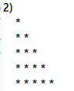

**public** **void** pattern2() {

**for** (**int** i = 0; i < 4; i++) {

**for** (**int** j = 0; j <= i; j++) {

System.***out***.print("* ");

}

System.***out***.print("\n");

}

}

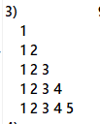

**public** **void** pattern3() {

**for** (**int** i = 1; i <= 5; i++) {

**for** (**int** j = 1; j <= i; j++) {

System.***out***.print(j + " ");

}

System.***out***.print("\n");

}

}

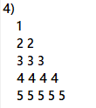

**public** **void** pattern4() {

**for** (**int** i = 1; i <= 5; i++) {

**for** (**int** j = 1; j <= i; j++)

System.***out***.print(i + " ");

System.***out***.print("\n");

}

}

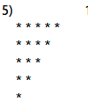

**public** **void** pattern5() {

**for** (**int** i = 1; i <= 5; i++) {

**for** (**int** j = 5; j >= i; j--)

System.***out***.print("* ");

System.***out***.print("\n");

}

}

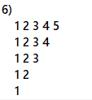

**public** **void** pattern6() {

**for** (**int** i = 5; i >= 1; i--) {

**for** (**int** j = 1; j <= i; j++)

System.***out***.print(j + " ");

System.***out***.print("\n");

}

}

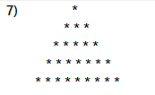

**public** **void** pattern7() {

**int** n = 5;

**for** (**int** i = 0; i < n; i++) {

**for** (**int** j = 0; j < n - i - 1; j++) {

System.***out***.print(" ");

}

**for** (**int** j = 0; j < 2 * i + 1; j++) {

System.***out***.print("*");

}

**for** (**int** j = 0; j < n - i - 1; j++) {

System.***out***.print(" ");

}

System.***out***.print("\n");

}

}

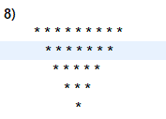

**public** **void** pattern8() {

**int** n = 5;

**for** (**int** i = 0; i < n; i++) {

**for** (**int** j = 0; j < i; j++) {

System.***out***.print(" ");

}

**for** (**int** j = 0; j < 2 * n - (2 * i + 1); j++) {

System.***out***.print("*");

}

**for** (**int** j = 0; j < i; j++) {

System.***out***.print(" ");

}

System.***out***.print("\n");

}

}

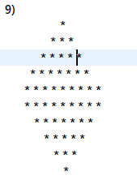

**public** **void** pattern9() {

**int** n = 5;

**for** (**int** i = 0; i < n; i++) {

**for** (**int** j = 0; j < n - i - 1; j++) {

System.***out***.print(" ");

}

**for** (**int** j = 0; j < 2 * i + 1; j++) {

System.***out***.print("*");

}

**for** (**int** j = 0; j < n - i - 1; j++) {

System.***out***.print(" ");

}

System.***out***.print("\n");

}

**for** (**int** i = 0; i < n; i++) {

**for** (**int** j = 0; j < i; j++) {

System.***out***.print(" ");

}

**for** (**int** j = 0; j < 2 * n - (2 * i + 1); j++) {

System.***out***.print("*");

}

**for** (**int** j = 0; j < i; j++) {

System.***out***.print(" ");

}

System.***out***.print("\n");

}

}

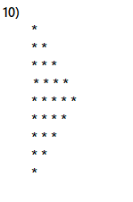

**public** **void** pattern10() {

**int** n=5;

**for**(**int** i=1;i<=2*n-1;i++) {

**int** stars=i;

**if**(i>n)

stars=2*n-i;

**for**(**int** j=1;j<=stars;j++) {

System.***out***.print("*");

}

System.***out***.print("\n");

}

}

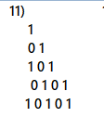

**public** **void** pattern11() {

**int** start=1;

**int** n=5;

**for**(**int** i=0;i<n;i++) {

**if**(i%2==0)

start=1;

**else**

start=0;

**for**(**int** j=0;j<=i;j++) {

System.***out***.print(start);

start=1-start;

}

System.***out***.print("\n");

}

}

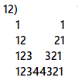

**public** **void** pattern12() {

**int** n=5;

**int** space=2*(n-1);

**for**(**int** i=1;i<=n;i++) {

**for**(**int** j=1;j<=i;j++) {

System.***out***.print(j);

}

**for**(**int** j=1;j<=space;j++) {

System.***out***.print(" ");

}

**for**(**int** j=i;j>=1;j--) {

System.***out***.print(j);

}

System.***out***.print("\n");

space -=2;

}

}

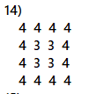

**public** **void** pattern14() {

**int** n=5;

**for**(**int** row=1;row<=n;row++){

**for**(**int** col=1;col<=n;col++) {

**int** atEveryIndex=n-Math.*min*(Math.*min*(row-1,col-1),Math.*min*(n-row,n-col));

System.***out***.print(atEveryIndex+" ");

}

System.***out***.println();

}

}

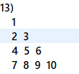

**public** **void** pattern13() {

**int** num=1;

**for**(**int** i=1;i<=4;i++) {

**for**(**int** j=1;j<=i;j++) {

System.***out***.print(num+" ");

num++;

}

System.***out***.println();

}

}

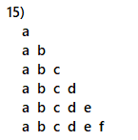

**public** **void** pattern15(){

**for**(**char** i='a';i<='f';i++) {

**for**(**char** j='a';j<=i;j++) {

System.***out***.print(j+" ");

}

System.***out***.println();

}

}

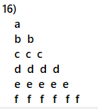

**public** **void** pattern16() {

**for**(**char** i='a';i<='f';i++) {

**for**(**char** j='a';j<=i;j++) {

System.***out***.print(i+" ");

}

System.***out***.println();

}

}

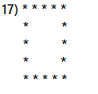

**public** **void** pattern17() {

**int** num=8;

**for** (**int** i = 1; i <= num; i++) {

**for** (**int** j = 1; j <= num; j++) {

**if** (i == 1 || i == num || j == 1 || j == num) {

System.***out***.print("* ");

} **else** {

System.***out***.print(" ");

}

}

System.***out***.println();

}

}

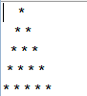

**public** **void** pattern18() {

**int** num=5;

**for** (**int** i = 1; i <= num; i++) {

**for** (**int** j = 1; j <= num - i; j++) {

System.***out***.print(" ");

}

**for** (**int** k = 1; k <= i; k++) {

System.***out***.print("* ");

}

System.***out***.println();

}

}

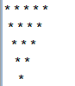

**public** **void** pattern19() {

**int** num=5;

**for** (**int** i = num-1; i >= 1; i--) {

**for** (**int** j = 1; j <= num - i; j++) {

System.***out***.print(" ");

}

**for** (**int** k = 1; k <= i; k++) {

System.***out***.print("* ");

}

System.***out***.println();

}

}

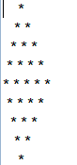

**public** **void** pattern20() {

**int** num=5;

**for** (**int** i = 1; i <= num; i++) {

**for** (**int** j = 1; j <= num - i; j++) {

System.***out***.print(" ");

}

**for** (**int** k = 1; k <= i; k++) {

System.***out***.print("* ");

}

System.***out***.println();

}

**for** (**int** i = num-1; i >= 1; i--) {

**for** (**int** j = 1; j <= num - i; j++) {

System.***out***.print(" ");

}

**for** (**int** k = 1; k <= i; k++) {

System.***out***.print("* ");

}

System.***out***.println();

}

}