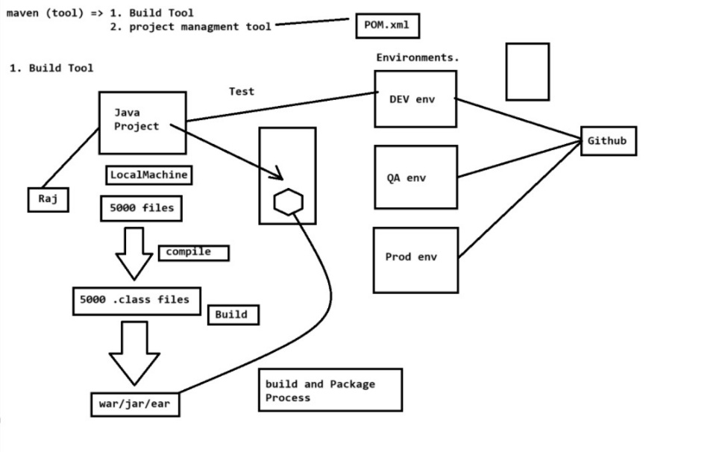

* **Maven :-**
* Maven is a build & project management tool.
* Maven is a Apache foundation product.
* Maven is agent less.
* Maven is written in java language.
* **Build & package process-**
* When you deploy a project we need to compile all of our java files. After compilation .class file will created.
* **Eg-** if there is 5K java files after compilation 5K .class file will created
* **Packaging-**
* Conversion of multiple .class file into single file (war/jar) it is called as packaging process.
* To perform build & package process maven provides you some commands/goals –

1. **Clean-** by using clean command we can delete previous jar/war files
2. **Install-** it is use to download dependencies/ jars required for our project.
3. **Compile-** it is use to compile java files present inside our project.
4. **Test-** it is use to perform unit test cases in our project.
5. **Package-** it is the combination of compile, test & install command. It is used to package project.

**Note :-** War/jar files will be created inside target folder.

* **Project Mangaement Tool-**

Maven has 1 file called as POM.xml (Project Object Model) it contains all the dependencies required for our project.

* **IQ. What is POM.xml ?**
* It contains metadata related to our project.
* **Eg-** name of our project, version, dependencies, plugins, packaging types, etc.
* **IQ.What do mean by Project dependencies-**
* Dependencies are nothing but collections of multiple jars.

**Eg-**

* hibernate core dependencies which consist all of our hibernate related jars.
* When you add any dependencies inside POM.xml maven automatically downloads jar related to that dependencies. & maven stores this jars in maven dependencies library.
* **Maven will download this jars from-**

1. Local repository (m2 home)

2. Remote repository (company recommended)

3. Centralized repository (mvn repository)

Maven will first check dependency inside local repository if it is not found it will check in remote repository.

* **Maven scopes -**

Scopes control when & how dependencies are available in different environments. Like compilation, testing, runtime.

* **Different maven scopes-**

**1. Compile scope-** it is the default maven scope available in all environments. Like compile time, testing, runtime

**2. Provided-** dependencies with this scope are needed at compile time but expected at runtime. They are not included in jar/war files.

**3. Runtime scope-** dependencies is needed at runtime.

**4. Test-** dependencies with this scope are only use for testing.

By using this scopes we can increase application performance