MSCD640
Lab 1

Name: Rohan Purohit

Date: 9/17/2015 I redid the lab after getting access as Late Submission was Accepted

-----------------------------------------------------------------------------------

The purpose of this lab is to become familiar with the following types of basic DBA tasks:
- Connecting to your database as SYS
- Starting/stopping database
- Toggling archivelog mode
- Viewing information in the data dictionary regarding your database
- Managing tablespaces and datafiles
- Managing control files and online redo logs

Read Chapters 1 through 5 in the book before starting on this lab.

These labs focus on how to perform DBA tasks from the SQL*Plus command prompt. These labs do not show how to perform tasks from Enterprise Manager. I prefer that students learn basic DBA tasks from SQL*Plus for the following reasons:
- Not all environments have Enterprise Manager installed, therefore you’ll need to know how to perform basic DBA tasks from the SQL command prompt.
- Performing the tasks manually from SQL gives you a better understanding of the underlying SQL used to accomplish DBA tasks.
- If you can perform DBA tasks from SQL, then you’ll have no problems understanding how to perform the same tasks in Enterprise Manager.

To get an “A” grade on this lab:
- Answer all questions.
- Provide output of steps that require you to perform a task. The output can be a spool file, cut and paste from the screen to a word document, screen shots. I need to see something to verify that you ran the labs. I’m expecting you to turn in a word document that contains each question and also the corresponding answers to questions asked and output from SQL statements. The easiest method for working labs is to copy each lab result from a spool file OR from the screen and paste the results directly under the lab exercise command. For example, lab exercise 1 a) asks you to issue the following OS command at the server command prompt:

Echo $ORACLE_SID

On the server issue your command. When the command has returned, copy and paste BOTH your issued command AND the command response. It helps if you set your response in the word document to a smaller font and different color than the lab exercises. You can also reset the orientation for the word document to landscape instead of portrait as there are times lab output does not fit well in a portrait orientation. So, if I change font sizing and output color, your answer should look something like this:

Echo $ORACLE_SID

[mscd640@ora05 ~]$ echo $ORACLE_SID
mscd640cdb

- Longer code required for labs can be found on the ORA05 database server under /home/mscd640/MSCD640_Scripts. If a script file is required to complete a lab exercise it will be noted in the exercise itself. Some exercises will require the student to type in a defined code snippet found in the lab exercise. If cutting and pasting code from the Lab document to a SQL session on the database server be sure to review pasted code for possible conversions of single quote marks (‘) to periods (.). If an undesired symbol conversion happens the student will need to correct the code prior to submitting the statement again. If, when submitting code, an SP error is returned, this indicates a syntax error typically due to a missing semi-colon, single-quote mark, or misspelled object name, identifier, variable, or clause.

-----------------------------------------------------------------------------------
Lab 1, Part 1: Understanding Your Database Environment
Read Chapters 1-3 in the book.
-----------------------------------------------------------------------------------
- Logon to the Regis Database Server using the Putty application on the Regis Citrix Receiver website. Read the first section in the help document “How to login to your pluggable database.doc” before attempting login. Do not connect to your pluggable database yet. From the operating system prompt, issue the following commands:

- verify that the proper OS variables have been set.
See pages 25-29 in the book.

echo $ORACLE_SID
echo $ORACLE_HOME
echo $LD_LIBRARY_PATH
echo $HOME

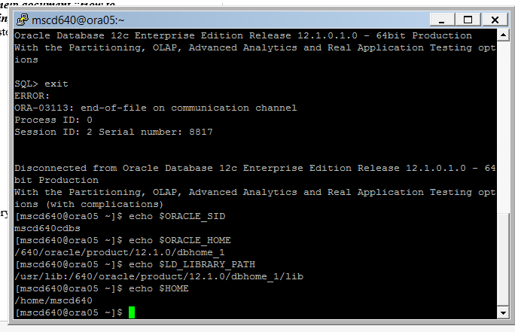

Note: $HOME defines the user mscd640 home directory on the database server.

- How much free disk space does the server have?

df –h
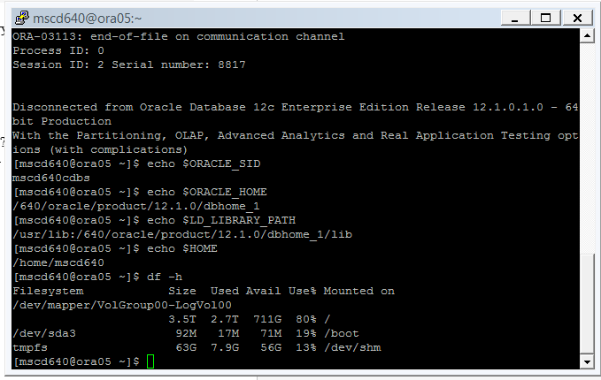

- What directory are you currently sitting in on the server? (you should be sitting at the default home directory for the the mscd640 user, i.e. /home/mscd640)

pwd
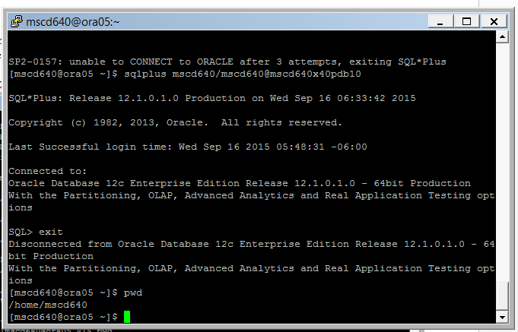

- Create a student directory to hold output files created during labs using the SPOOL command.
Replace bwaddoups with your first and, optionally, middle initial, and last name.
Ex: mkdir /home/mscd640/bwaddoups
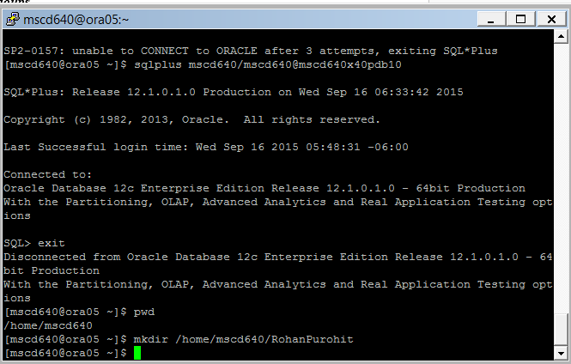

- Change directories so you are sitting in your student directory under $HOME.

Replace bwaddoups with the name of your sub-directory created in d) above.
Ex: cd $HOME/bwaddoups

You will want to cd to your home directory each time you logon to the database server to work on labs. DO NOT alter the default user .bash_profile file settings as everyone in our class uses the same username for logon, i.e. mscd640. The default user profile file is called automatically when first logging onto the server. Altering this file will cause a multitude of issues for all mscd640 students when working labs.
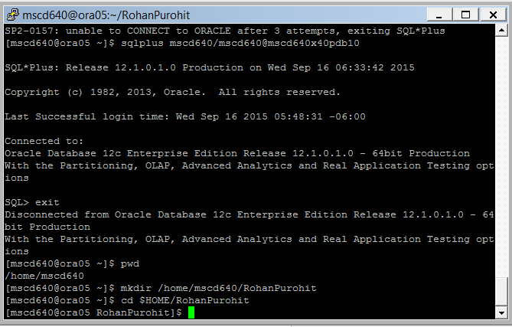
-----------------------------------------------------------------------------------
2. What are the differences between the Oracle database SYSDBA and SYSOPER privileges?
See page 128 in the book.

The SYS schema is the super user of the database, owns all dictionary objects and is used for tasks such as creating a database, starting or stopping an instance, backup and recovery and adding or moving data files. These types of tasks usually require the SYSDBA or SYSOPER roles. SYSDBA system privilege is for fully empowered database administrators the highest system privilege in oracle But SYSOPER system privilege is limited than SYSDBA. SYSOPER system privilege allows a user to perform basic operational tasks, but without the ability to look at user data.
-----------------------------------------------------------------------------------
3. Explain OS authentication and how that allows you to connect to the database as SYS without providing a password.
See page 133-134 in the book.
OS authentication means that if you can successfully log into a server then its possible to establish a connection to a local database without providing a username and password details. In other words, you can associate database privileges with an OS account or an associated OS group or both. After logging into the database server, users created with the IDENTIFIED EXTERNALLY clause can connect to the database without having to specify a username or password. This type of authentication can have some interesting advantages, for example users with this type of authentication don’t have to maintain a database username and password, scripts that log into the database don’t have to use hard coded passwords if executed by OS authenticated users. Finally another database user cant hack into user by trying to guess connection string. The only way to login into an OS authenticated user is from OS. When using OS authentication, Oracle prefixes the value contained in OS_AUTHENT_PREFIX database initialization parameter to the OS user connecting to the database. The default value for this parameter is OPS$.

-----------------------------------------------------------------------------------
4. From the server command line, logon as SYS to the ROOT container for our classroom PDB’s.

- Ex: [mscd640@ora05 ~]$ sqlplus / as sysdba

Executed command and logged into sql plus.

- Query the V$PDBS view to determine the current status of your PDB.

Ex: select name,open_mode from v$pdbs;

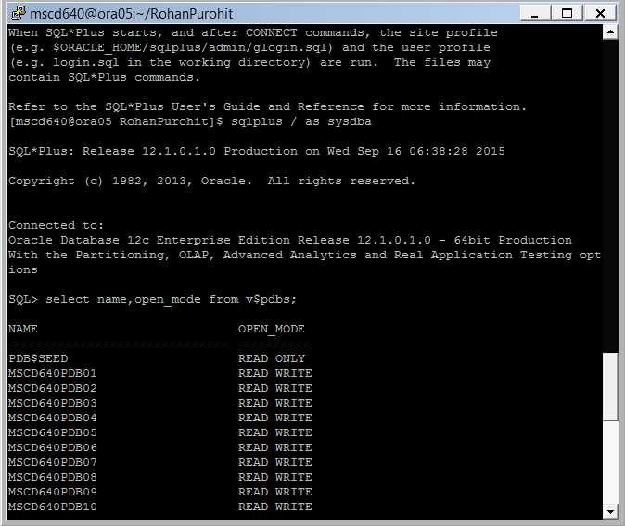

- Scroll through the list displayed and find your assigned PDB. Note the open_mode.
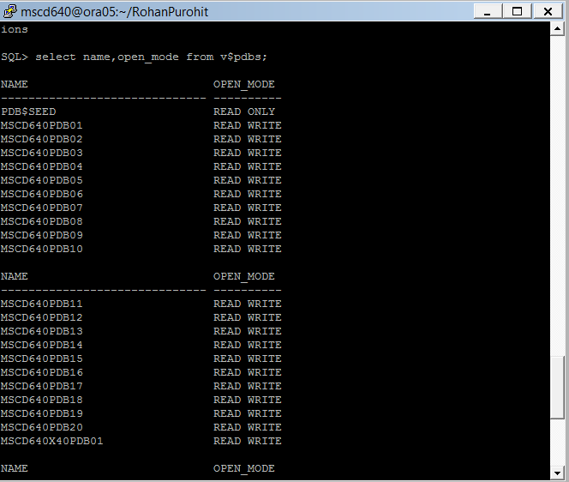

- When the 12c ROOT container database is opened all pluggable databases are opened, by default, into a MOUNT state, and remain in that state until they are opened from the container database. When a pluggable database is “closed” it is placed into the MOUNT state, not fully closed.

All student assigned PDB’s should initially be in a “MOUNTED” mode. Your PDB will need to be opened before working labs by performing the following tasks.

NOTE: If your student PDB is in an OPEN mode skip to e) below, otherwise continue with the steps below.

    - At the sql prompt type display the current container you connected to when logging onto the database. This should be the root container.

Ex: SQL> show con_name <no semi-colon required>

The following should be displayed:

SQL> show con_name

CON_NAME
------------------------------
CDB$ROOT

    - Show the container id number assigned to CDB$ROOT.

Ex: SQL> show con_id <no semi-colon required>

The following should be displayed:

SQL> show con_id

CON_ID
------------------------------
1

    - From your current SQL session set the container to your assigned PDB:

Replace xx in the example with your assigned pdb number.
Ex: SQL> alter session set container = msc640xpdbxx;
Session altered.

    - At the sql prompt type display the container name for your PDB. Note the name for future reference.

Ex: SQL> show con_name <no semi-colon required>

Display the container id number assigned to your PDB.

Ex: SQL> show con_id <no semi-colon required>

    - Issue an ALTER PLUGGABLE DATABASE command to open the pdb.

Ex: alter pluggable database open;

    - Query the V$PDBS view contained in the view. There should only be one record present for your PDB.

Ex: SQL> select con_id,
name,
open_mode,
open_time
from v$pdbs;
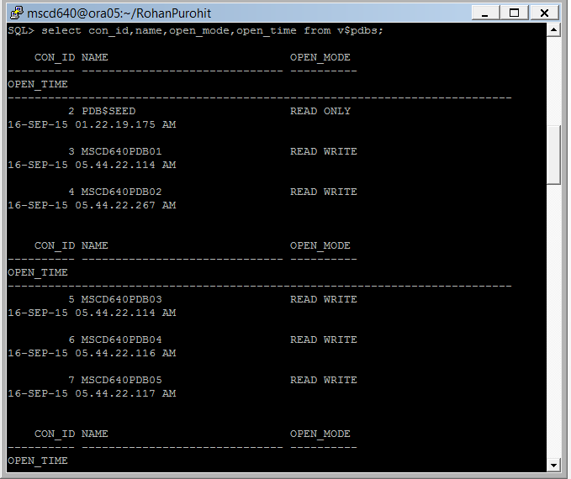

    - Go to exercise 5.

- PERFORM THIS STEP ONLY IF YOUR PDB IS INITIALLY IN AN OPEN MODE!

If your PDB is listed in an OPEN mode proceed with the following to close it.

Ex: SQL> show con_name <no semi-colon required>

The following should be displayed:

SQL> show con_name

CON_NAME
------------------------------
CDB$ROOT

    - Show the container id number assigned to CDB$ROOT.

Ex: SQL> show con_id <no semi-colon required>

The following should be displayed:

SQL> show con_id

CON_ID
------------------------------
1

    - From your current SQL session set the container to your assigned PDB:

Replace xx in the example with your assigned pdb number.
Ex: SQL> alter session set container = msc640xpdbxx;
Session altered.

    - At the sql prompt type display the container name for your PDB. Note the name for future reference.

Ex: SQL> show con_name <no semi-colon required>

Display the container id number assigned to your PDB.

Ex: SQL> show con_id <no semi-colon required>

    - Issue a ALTER PLUGGABLE DATABASE command to close your PDB.

Ex: SQL> alter pluggable database close;

    - Exit SQLPlus.

SQL> exit;

    - Return to step (d) above and work through learning how to open your pluggable database.

5. Logon to your pluggable database if not already logged on.
See pages 41-46 in the book.

- Logon to your assigned pluggable database using your default username.

Replace the example username/password and pdb# with your assigned user, password, and db.
Ex: [mscd640@ora05 ~]$ sqlplus adminxx/adminxx@msc640xpdbxx

- From the sql prompt show the user logged on.
Ex: SQL> show user;
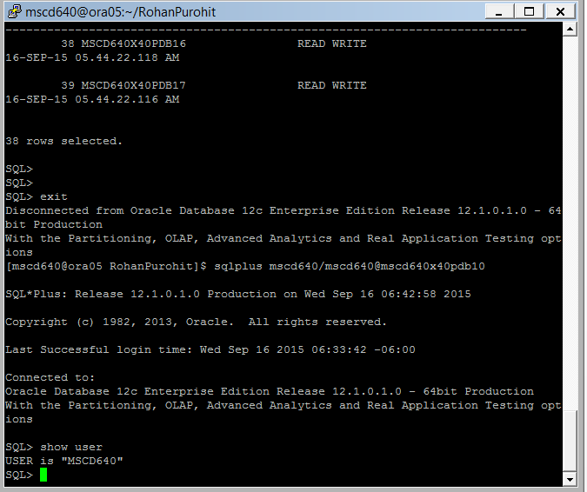

- Show the name of the 12c database:
Ex: SQL> select name from v$database;
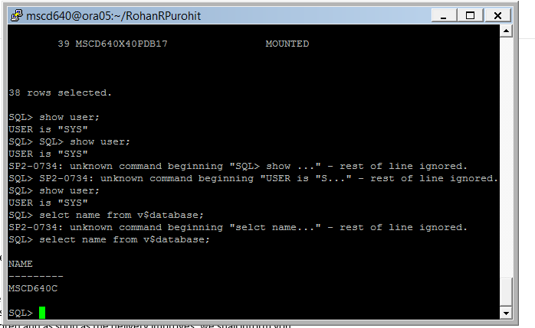

- Show the name of the ROOT container instance:
Ex: SQL> select instance_name from v$instance;
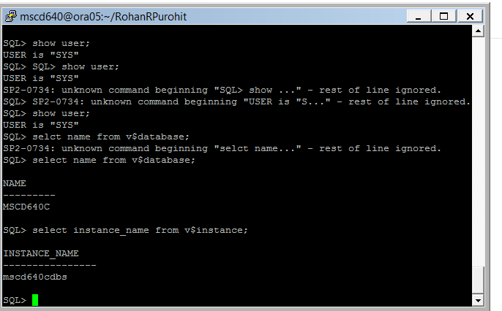

- Show the name and open status of your pluggable database:

Ex: SQL> select con_id, name,open_mode from v$pdbs;

- What is the difference between the values displayed in (c), (d), and (e) above?
It shows different values for the 12 c database, container database and open pdb.,
- What does the variable “CON_ID” represent in V$PDBS?
Connection ID.
---------------------------------------------------------------------------------------------------------

For the rest of the labs, it is assumed that you now know how to open and close your database. Always verify your Pluggable database is in an OPEN state before starting to run your sql scripts AND that you are sitting in YOUR PDB unless performing work required from the ROOT container.

- What version of Oracle are you using? Are you using the Enterprise Edition or the Standard Edition? Issue the following sql statements on your pluggable database to display this information:

- From SQLPlus display the container database you are currently sitting in. You should be sitting in your pluggable MSC640xpdbxx database:

SQL> show con_name

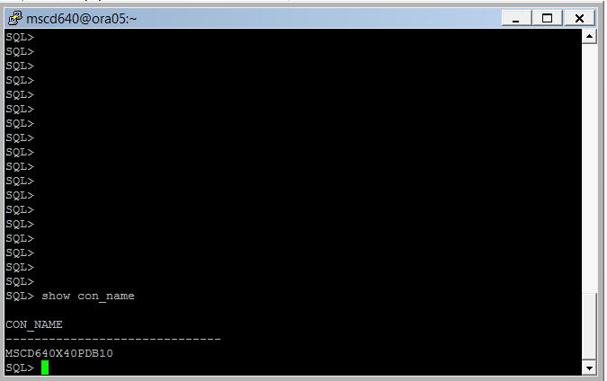
- Display the database version:

Format the output for readability.
SQL> set linesize 200
SQL> set pagesize 100

SQL> select * from v$version;
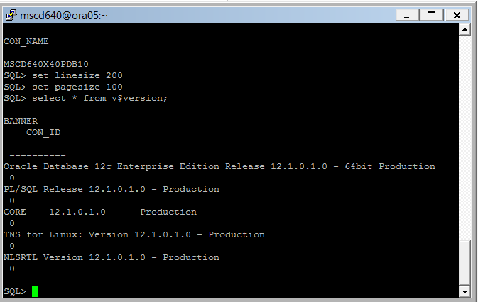

- What is the characterset for your database;

Format the output for readability:

SQL> set linesize 80
SQL> select * from cdb_properties where description like 'Character%';
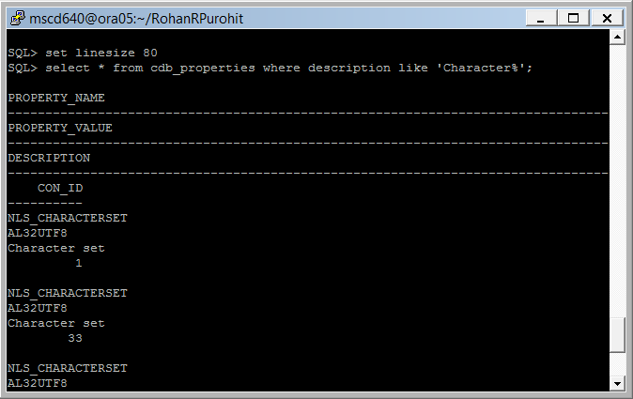

- How many database properties are set for your PDB?
SQL> select count(*) from cdb_properties;
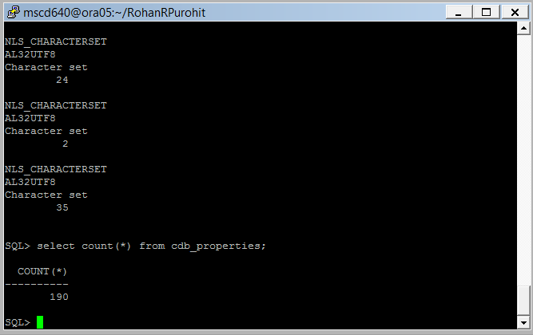
-----------------------------------------------------------------------------------
8. What database features are enabled in your PDB database? If running from SQL*Plus, you may want to enable some formatting so that the output fits on your screen:

SQL> set lines 132
SQL> col name form a40
SQL> col version form a15

SELECT name ,version ,first_usage_date
FROM cdb_feature_usage_statistics;
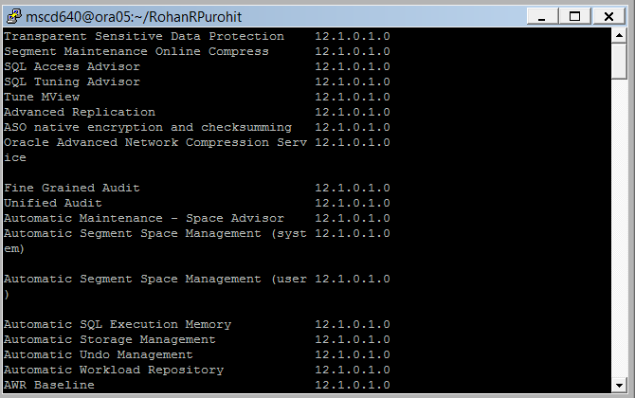
-----------------------------------------------------------------------------------
9. What type of initialization file does your database use? Is it an spfile or an init.ora file?
See page 30 in the book.
The database server has the SPfile initialization file. Local machines have Pfile or INIT.ora files for initialization.

Reset output format for readability;
SQL> set linesize 80
SQL> show parameter spfile

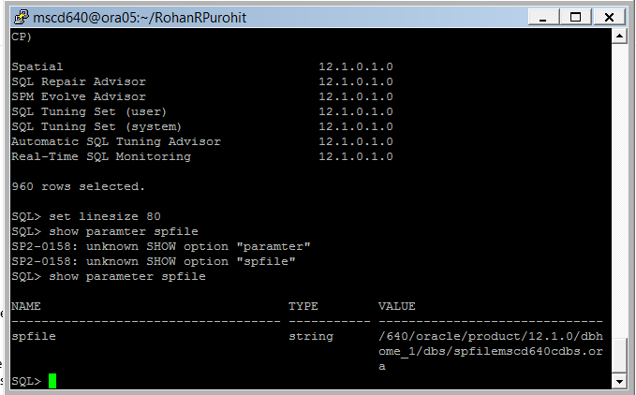

What are the advantages/disadvantages of using an spfile versus and init.ora file?
Since SPfile is on server it does not have to be loaded into memory many times. Since INIT file is on local it can be edited with parameter values to reflect local changes.
-----------------------------------------------------------------------------------

10. What is the default permanent tablespace for your database?
See page 34-35 in the book.

SELECT *
FROM cdb_properties
WHERE property_name = 'DEFAULT_PERMANENT_TABLESPACE';
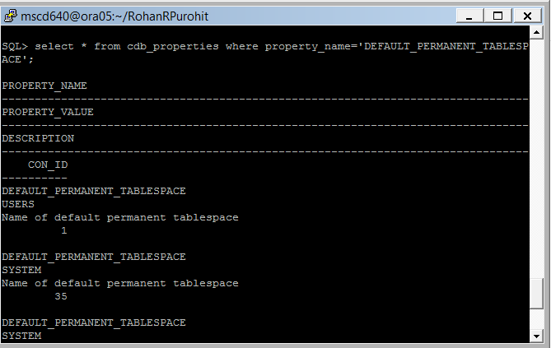

-----------------------------------------------------------------------------------
11. What is the default temporary tablespace for your database?

SELECT *
FROM cdb_properties
WHERE property_name = 'DEFAULT_TEMP_TABLESPACE';
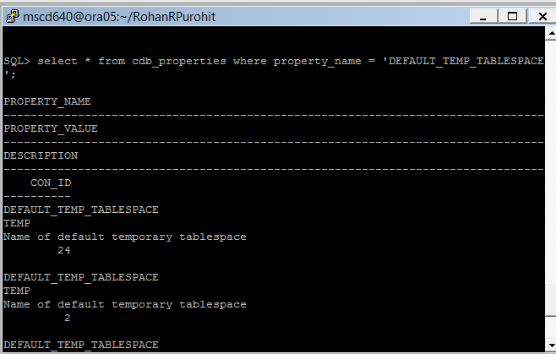
-----------------------------------------------------------------------------------
12. Are you using automatic undo management for your UNDO tablespace? (YES or NO).
Yes.
select name, value
from v$parameter
where name in ('undo_management','undo_tablespace');

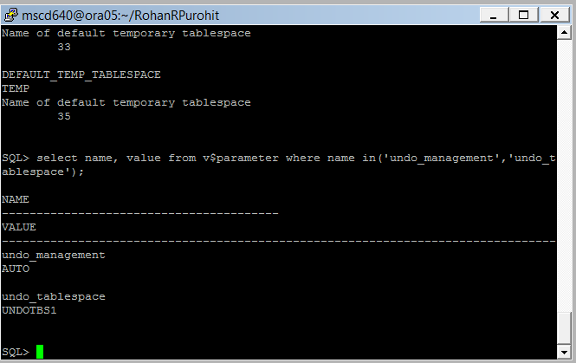
-----------------------------------------------------------------------------------
13. Does your database use a password file?
See page 40 in the book.
Yes, the database uses password files.

SQL> select * from v$pwfile_users;

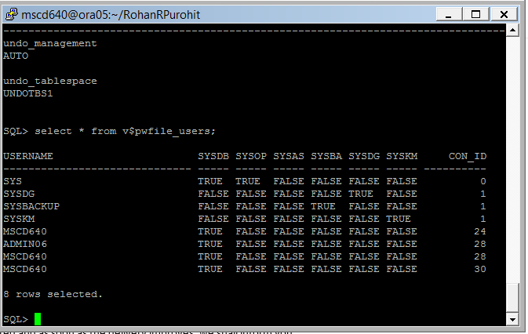

What is the advantage of using a password file?
If you want to assign non sys users sys privileges or you want to remotely connect to your database via oracle net with sys privileges. Or use an oracle feature or utility that requires a password file it can be used.
-----------------------------------------------------------------------------------

14. As a percentage, how much free space in your PDB tablespaces? To gather this information you will need to be logged on as SYSDBA to the ROOT container. You will then need to alter your session to your PDB container. This is required as your admin user does not have privileges to see some of the SYSDBA views.

- From the SQL Prompt logon to your ROOT as SYSDBA:

Ex: SQL> connect / as sysdba;

- Display the container name to verify your location as CDB$ROOT:
Ex: show con_name <no semi-colon required>
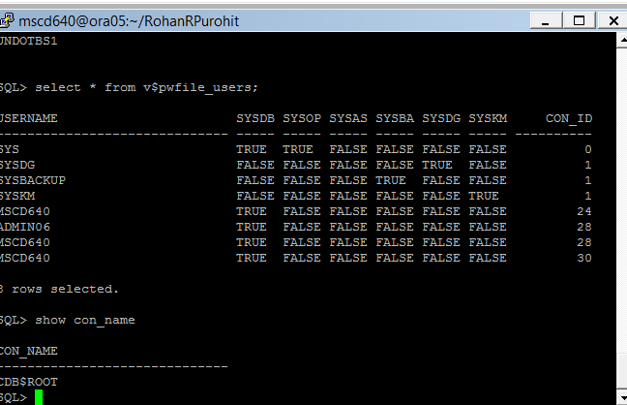
Replace the xx in the pdb# with your assigned and pdb number.
- Alter your session to set the container to your PDB container:
Ex: SQL> alter session set container = mscd640xpdbxx
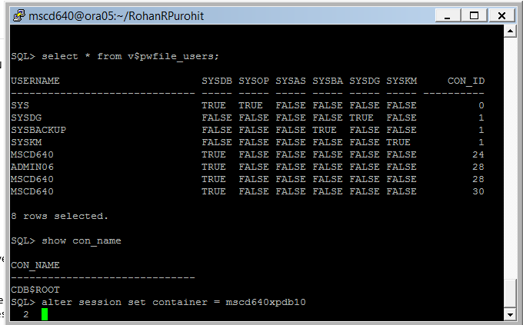
- From the ROOT container call the following query from the MSCD_Scripts directory. The script will display the percentage of Free Space in your PDB Tablespaces.

Ex: SQL> @$HOME/MSCD640_Scripts/LAB1_Ex14.sql

Cut and paste the script and script output in your lab exercise results.

CDB$ROOT
SQL> alter session set container = mscd640xpdb10
2
SQL> @$HOME/MSCD640_Scripts/LAB1_Ex14.sql
SQL> COL pct_free FORMAT 999
SQL> SET linesize 200
SQL> SELECT (f.bytes/a.bytes)*100 pct_free,'% free',a.tablespace_name
2 FROM
3 (SELECT NVL(SUM(bytes),0) bytes, x.tablespace_name
4 FROM cdb_free_space y, cdb_tablespaces x
5 WHERE x.tablespace_name = y.tablespace_name(+)
6 AND x.contents != 'TEMPORARY' AND x.status != 'READ ONLY'
7 AND x.tablespace_name NOT LIKE 'UNDO%'
8 GROUP BY x.tablespace_name) f,
9 (SELECT SUM(bytes) bytes, tablespace_name
10 FROM CDB_data_files
11 GROUP BY tablespace_name) a
12 WHERE a.tablespace_name = f.tablespace_name
13 ORDER BY 1;

PCT_FREE '%FREE TABLESPACE_NAME
-------- ------ ------------------------------
8 % free SYSTEM
24 % free SYSAUX
39 % free INV_BIG_DATA
184 % free USERS

SQL> SET linesize 80
SQL> SET ECHO OFF
SQL>
-----------------------------------------------------------------------------------

15. Where are the container (CDB) database files located? (datafiles, online redo logs, and control files)? You will run a script that will output the information requested as a report to the database server in your student home directory.

- If not sitting in your student home directory on the database server, exit from SQLPlus and issue the following command to change directory to your new student directory created at the beginning of the lab.

cd $HOME/your student home directory

- Logon to SQLPlus to the ROOT container.

Ex: [mscd640@ora05] sqlplus / as sysdba
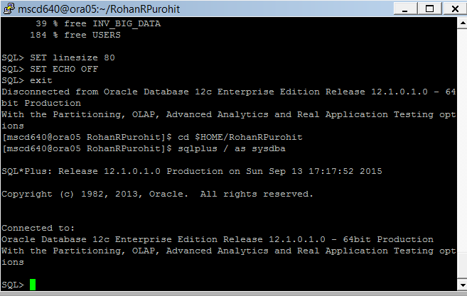
- Display the container name to verify your location:
Ex: show con_name <no semi-colon required>
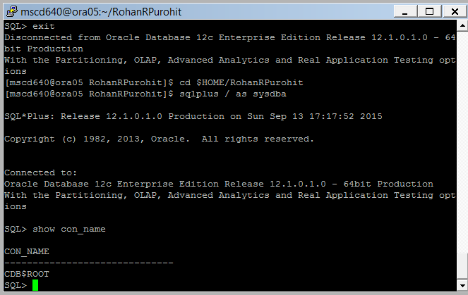
Replace the xx in the pdb# with your assigned and pdb number.
- Alter your session to set the container to your PDB container:

Ex: SQL> alter session set container = mscd640xpdbxx
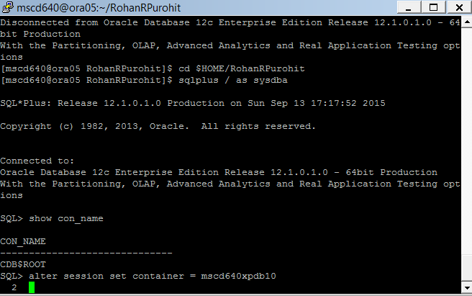
- Call the following script from your SQL session. An output file will be created in your student directory.

Ex: SQL> @MSCD_Scripts/LAB1_Ex15.sql
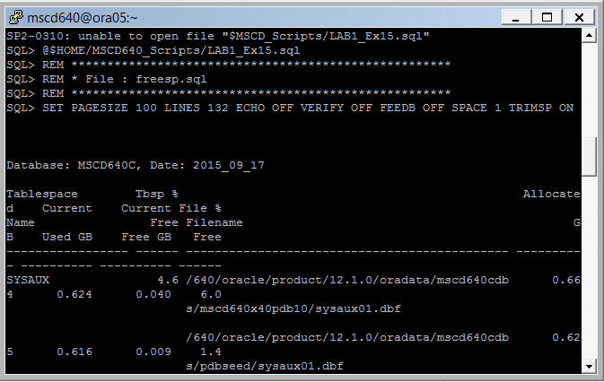

- Exit SQLPlus

- From the OS command line, type the following command to view your directory contents. You should see the file created from the script above.

[mscd640@ora05]$ ls –ltr

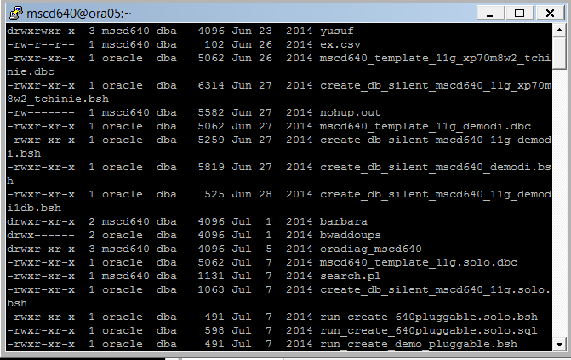

- From the OS command line issue the more statement to view and copy and paste the file output to this lab exercise. When viewing output using “more” press the enter button to scroll through the output displayed.

-----------------------------------------------------------------------------------

16. In Oracle Database 12c, what is the optimal way to manage the memory that Oracle uses? What new memory management parameters were introduced in Oracle Database 11g?
See page 31 in the book.
Oracle recommends that you use SPfile as it’s a binary server parameter file. For 11g and higher set memory_target and memory_max_target initialization parameters. For 10g set the sga_target and sga_target_max initialization parameters. For 10g, set pga_aggregate_target and workarea_size policy. Starting with 10g use the automatic undo feature. This is set using undo_management and undo_tablespace parameters. Set open_cursors to a higher value than the default.

al
- Logon to SQLPlus to the ROOT container.

Ex: [mscd640@ora05] sqlplus / as sysdba

- Display the container name to verify your location:
Ex: show con_name <no semi-colon required>

Replace the xx in the pdb# with your assigned and pdb number.
- Alter your session to set the container to your PDB container:

Ex: SQL> alter session set container = mscd640xpdbxx

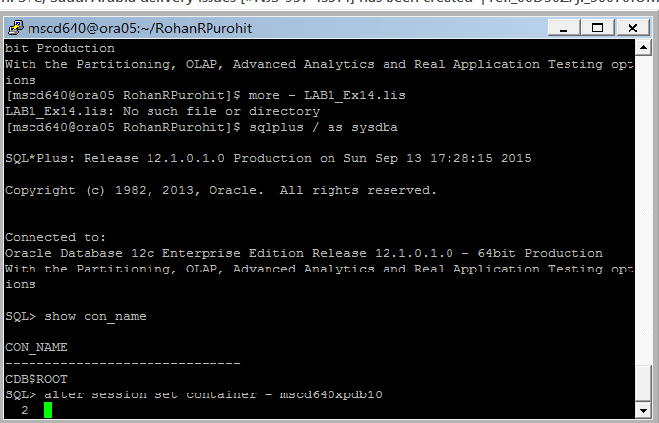
- SQL> show parameter memory;
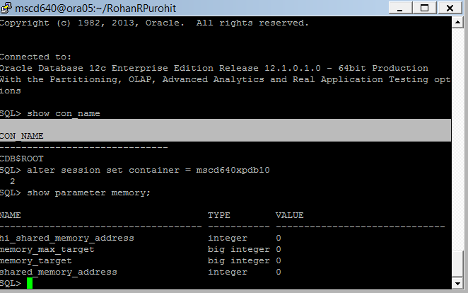
- Is your database configured to use the latest Oracle Database 12g memory management parameters?
Yes.
- Are the memory management parameters modifiable with the “ALTER SYSTEM” SQL statement? YES or NO?
Yes.
From SQL call the following script to display the memory management parameters:
Ex: SQL> @$HOME/MSCD640_Scripts/LAB1_Ex16.sql
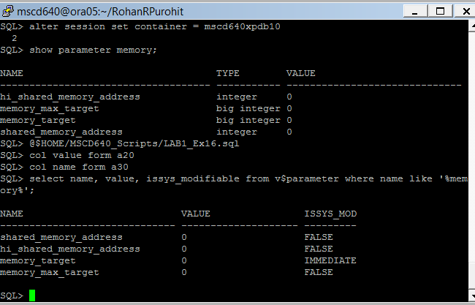
- Exit SQLPlus
-----------------------------------------------------------------------------------

17. One area of difference between non-multitenant and multitenant databases is the use of archivelog mode. Pluggable databases cannot be independently placed into archivelog outside of the container database as they do not have independent log files, i.e. the container database owns the redo log files, which can be archived (however, pluggable databases can be recovered possibly through performing a resetlog). This next query will return the status of archivelog mode for the container database, which includes all pluggable databases.

- Logon to SQLPlus to the ROOT container.

Ex: [mscd640@ora05] sqlplus / as sysdba

- Display the container name to verify your location:
Ex: show con_name <no semi-colon required>

- SQL> select log_mode from v$database;
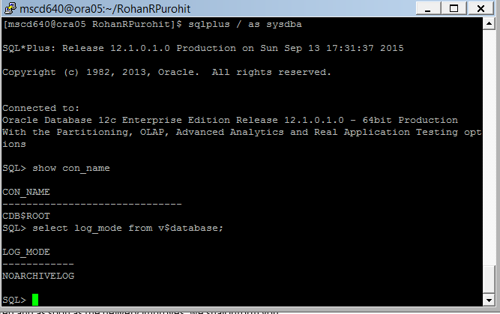
- How many log file groups does the container database have?

Ex: Select max(group#) from v$logfile;
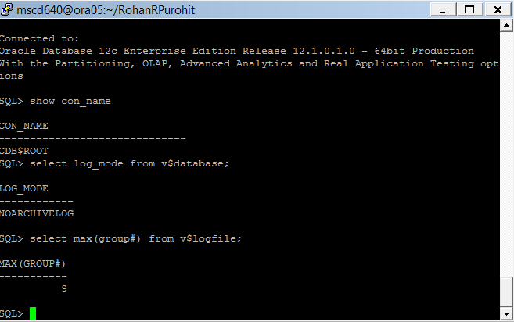
- How many log file members per group?
Different for different groups, one is two one is three.
- select group#, member from v$logfile;
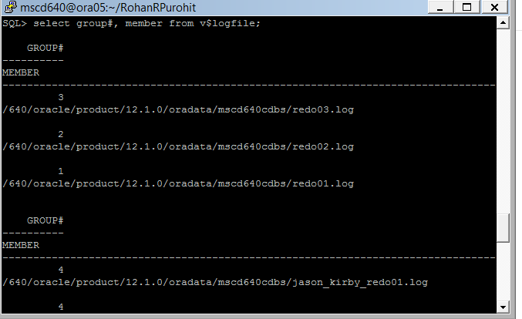
Switch the logfiles a few times:

- SQL> alter system switch logfile;

- SQL> alter system switch logfile;

- SQL> alter system switch logfile;
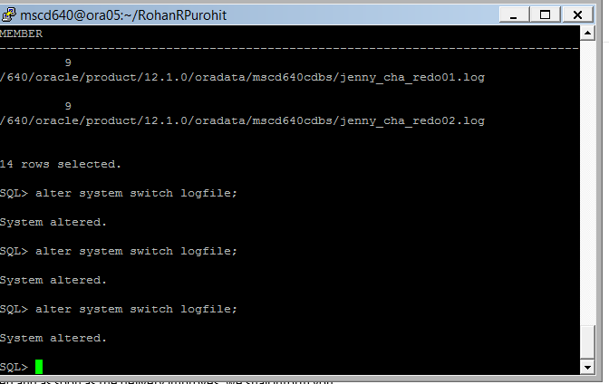

18. How often have your online redo logs switched since yesterday? Call the following query to display query the CDB redo log file switches.

Ex: SQL> @$HOME/MSCD640_Scripts/LAB1_Ex18.sql
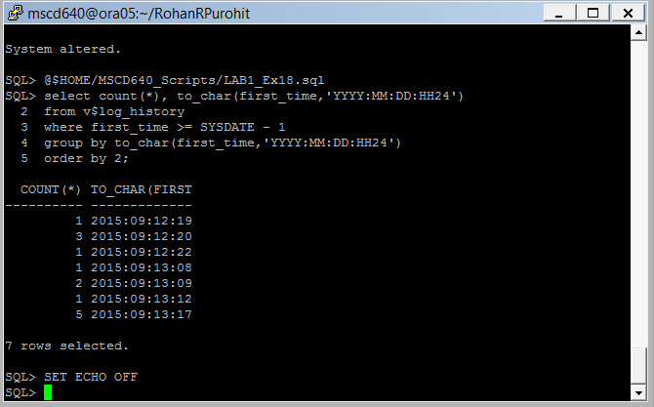
-----------------------------------------------------------------------------------

19. Issue the following SQL statement to display the alert log location for your database. The database alert log will always be a sub directory within the $ORACLE_BASE location.

- Ex: SQL> show parameter background_dump_dest
cd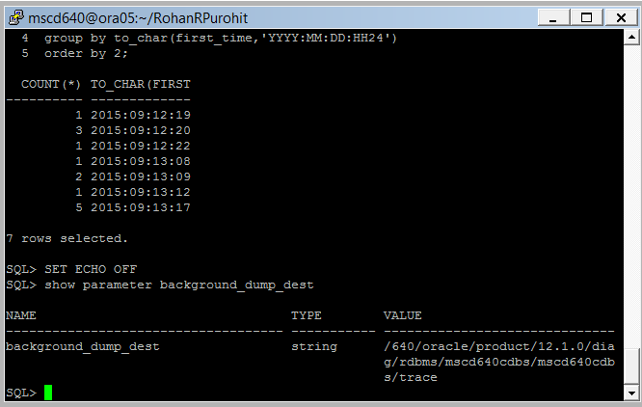
- Exit SQLPlus.

- What is the actual name of your alert log? To find the name exit out of SQLPlus and cd to the directory identified in (a) above. NOTE: The directory name stored in the background_dump_dest may be incorrect. Use the following to verify the location.

- From the OS command line change directory to location specified in the background_dump_dest initialization parameter.

Ex: [mscd640@ora05] cd /640/oracle/product/11.2.0/diag/rdbms/mscd640cdb/mscd640cdb/trace
- Issue to following OS command to display all files in the alert log directory ending in .log. The alert log file will start with

Ex: ls –ltr *.log
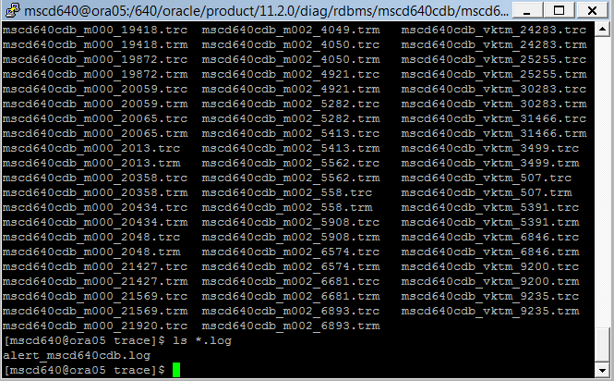

- What is the name of the alert log?
alert_mscd640cdb.log
- Issue the following OS command to display the last 10 lines of the alert log file.

Ex: [mscd640@ora05 ]Tail -10 < name of your alert.log file>

- What do the last 10 lines of the alert.log show?
The last 10 lines of the alert log show any alerts for the database.

- What is the alert log used for?
The alert log is a chronological log of messages and errors, and includes the following items:
- All internal errors (ORA-600), block corruption errors (ORA-1578), and deadlock errors (ORA-60) that occur
- Administrative operations, such as CREATE, ALTER, and DROP statements and STARTUP, SHUTDOWN, and ARCHIVELOG statements
- Messages and errors relating to the functions of shared server and dispatcher processes
- Errors occurring during the automatic refresh of a materialized view
- The values of all initialization parameters that had nondefault values at the time the database and instance start
Oracle Database uses the alert log to record these operations as an alternative to displaying the information on an operator's console (although some systems also display information on the console). If an operation is successful, a "completed" message is written in the alert log, along with a timestamp.

-----------------------------------------------------------------------------------
20. Is your database using a Fast Recovery Area (FRA)?

- From the OS command line, logon to SQLPlus to the ROOT container as SYSDBA:

[mscd640@ora05] sqlplus / as sysdba

- What value is set for the parameter db_recovery?

SQL> show parameter db_recovery
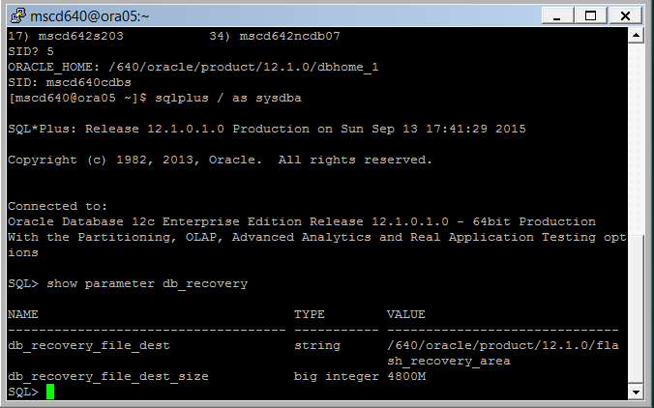
- What is the Fast Recovery Area used for?
FRA (flash or fast recovery area) is a storage area (directory on disk or ASM diskgroup) that contains redo logs, control file, archived logs, backup pieces and copies, flashback logs and, in 11g, foreign archived logs.
-----------------------------------------------------------------------------------

21. Customize your SQL prompt.
See pages 58-59 in the book.

SQL> SET SQLPROMPT '&_USER.@&_CONNECT_IDENTIFIER.> '

What does your SQL prompt now show?
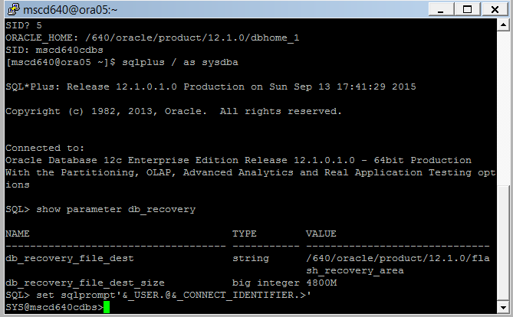
-----------------------------------------------------------------------------------

22. Run the following script to display the top resource consuming SQL statements in your database.
See page 71 in the book.

SQL> @$HOME/MSCD640_Scripts/LAB1_Ex22.sql

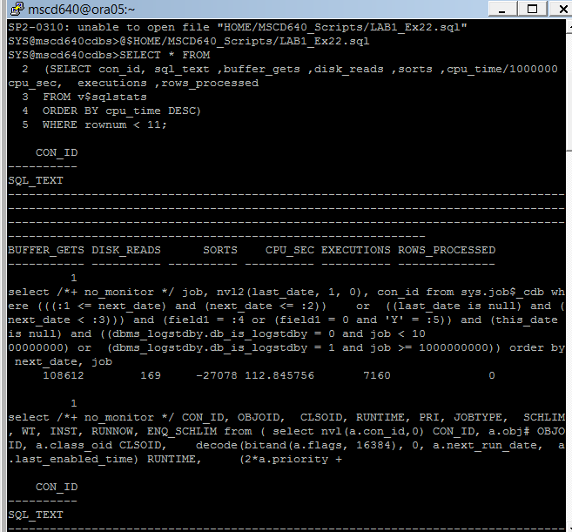
-----------------------------------------------------------------------------------
23. What users exist in your PDB database?
See pages 74 in the book.

- From SQLPlus connect to your PDB database container:

Replace the xx in the pdb# with your assigned and pdb number.
Ex: SQL> alter session set container = mscd640xpdxx

- Display the current container name. It should be your PDB name.
Ex: SQL> show con_name

- Call the following script from SQLPlus to display the usernames located in your PDB.
Ex: SQL> @$HOME/MSCD_Scripts/LAB1_Ex23.sql
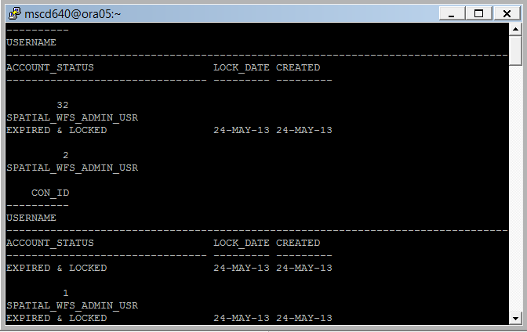--------------------------------------------------------------------------------------
24. What DBA users exist in your PDB database?
See pages 74 in the book.

- Call the following script from SQLPlus to display the DBA Users in your PDB.
Ex: SQL> @HOME/MSCD_Scripts/LAB1_Ex24.sql
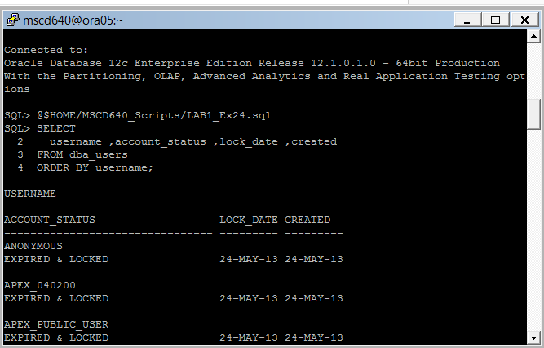

- Exit SQLPlus
-----------------------------------------------------------------------------------
Lab 1, Part 2: Tablespaces and Datafiles
Read Chapter 4 in the book.

Tablespaces in Multitenant databases can be defined at both the root (CDB) level, and at the pluggable (PDB) level as long as the PDB user has been granted the required privileges. The below exercise is written with the assumption the PDB ADMIN user cannot create tablespaces.

25. List your PDB tablespaces, data files, and temp files.

- From the OS Command connect to the ROOT container as SYSDBA.
Ex: [mscd640@ora05] sqlplus / as sysdba

- From SQLPlus connect to your PDB database container:

Replace the xx in the pdb# with your assigned and pdb number.
Ex: SQL> alter session set container = mscd640xpdxx

- Select tablespace_name, con_id from cdb_tablespaces;
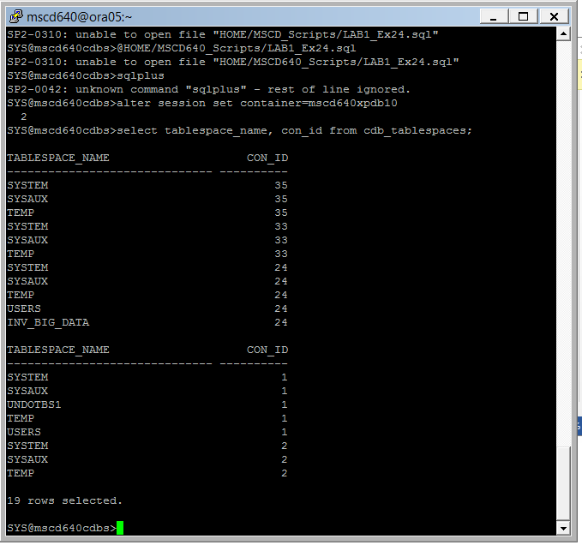
- Select file_name, con_id from cdb_data_files;
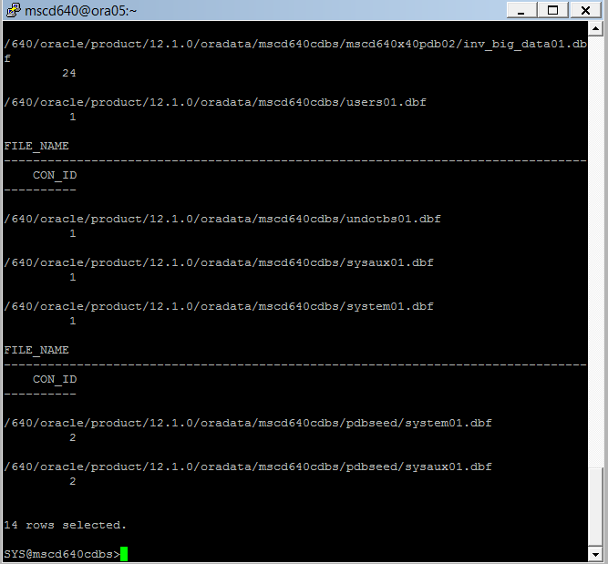
- Select file_name, con_id from cdb_temp_files;
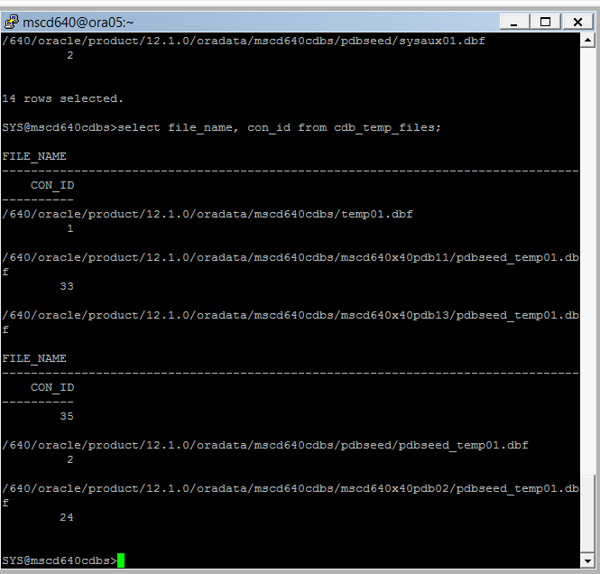
- Exit SQLPlus

-----------------------------------------------------------------------------------------------------------

26. Create a new PDB tablespace with a datafile located in the same directory as other datafiles in your database (see PDB data file directory output from #25 above). You’ll have to modify this script.

- Before creating your new tablespace and datafile validate your session container id (con_id) and container name (con_name) session settings:

From the sql prompt issue the following statements:

SQL> show con_id

SQL> show con_name
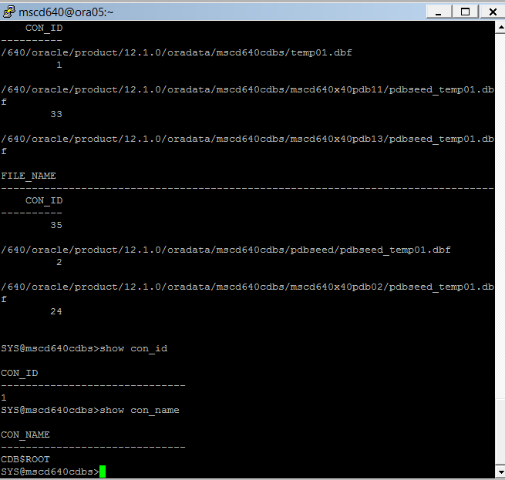
The con_id and con_name should equal the values for your assigned PDB. If not, exit SQL and log back on as SYSDBA and set the container to PDB container as detailed in exercise 25 parts (a) and (b).

Create a new tablespace using the datafile directory discovered in exercise 26.

- Create a default tablespace USERS that will be used as the default tablespace for all new user created objects, unless otherwise directed in labs.

Ex: SQL> create tablespace users
datafile 'PDB datafile directory/user01.dbf'
size 30M;
Users tablepsace already existed so I created a test2 tablespace instead.
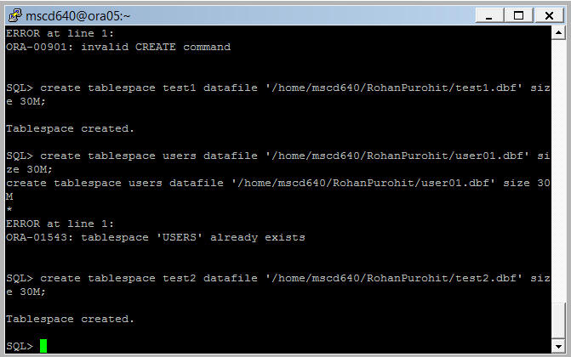
- Create another new tablespace for app_data.

Ex: SQL> create tablespace app_data
datafile 'PDB datafile directory/app_data01.dbf'
size 10M;
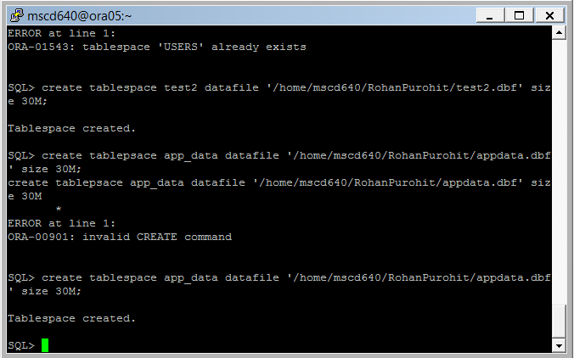
If you get this error:

ORA-01119: error in creating database file '/u01/oracle/product/11.2.0/oradata/D79219/app_data01.dbf'
ORA-27040: file create error, unable to create file

That most likely means that the directory path you’ve entered does not exist on the database server. You need to ensure that you use the same directory path as other datafiles in your database (select file_name from cdb_data_file;).

After successfully creating the tablespace, verify that the tablespace was created by running this script:

SQL> select tablespace_name, extent_management, segment_space_management from cdb_tablespaces;
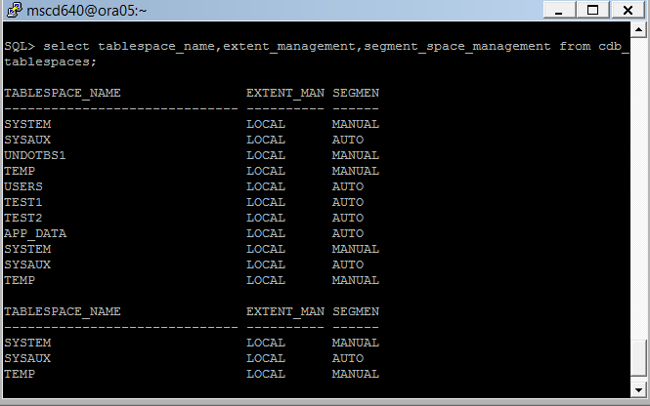

What are the advantages of using a locally managed tablespace?
Locally managed tablespace allow you to set the size of the datafile to allocate space for your data.The main benefits of locally managed tablespaces include:
- Marginally faster performance: Because there is less data dictionary contention, throughput can be faster.
- Faster tablespace space management activities: Since space management activities are done in the tablespace blocks, we see less space management contention (ST locks). Uniform extent management is enforced and tablespace fragmentation can be reduced.

What are the advantages of using automatic segment space management?

Automatic segment space management (ASSM, or bitmap freelists) is a simpler and more efficient way of managing space within a segment. It completely eliminates any need to specify and tune the pctused, freelists, and freelist groups storage parameters for schema objects created in the tablespace. If any of these attributes are specified, they are ignored.
-----------------------------------------------------------------------------------
27. Rename the tablespace you created in the prior step.
See page 82 in the book.

SQL> alter tablespace app_data rename to test_data;
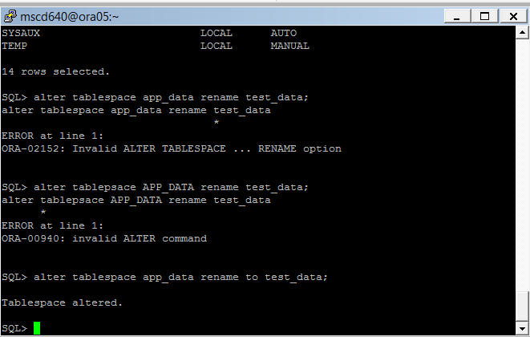
Verify: I could not replicate this step as I am unable to login to my PDB.

SQL> select tablespace_name, extent_management, segment_space_management from cdb_tablespaces;
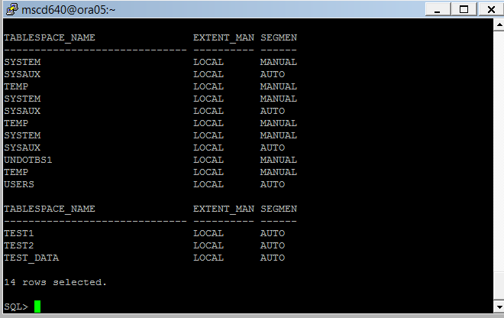
-----------------------------------------------------------------------------------
28. Alter the tablespace to read only mode:
See pages 84-85 in the book.

SQL> alter tablespace test_data read only;
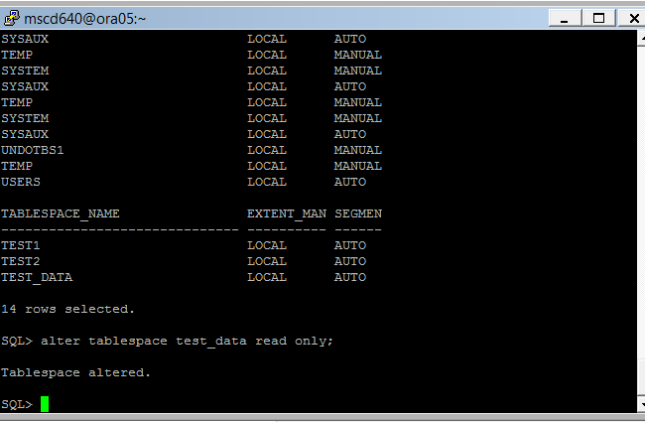
Commit your tablespace change:

SQL> commit;
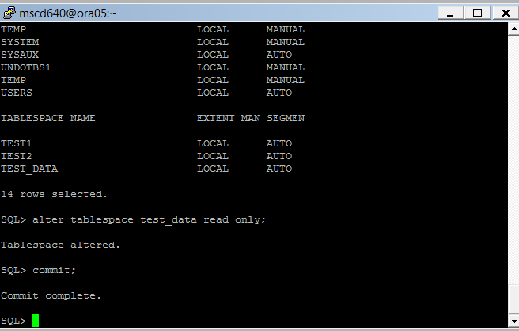
Try to create a table in the read only tablespace:

SQL> create table test1 (test_id number) tablespace test_data;
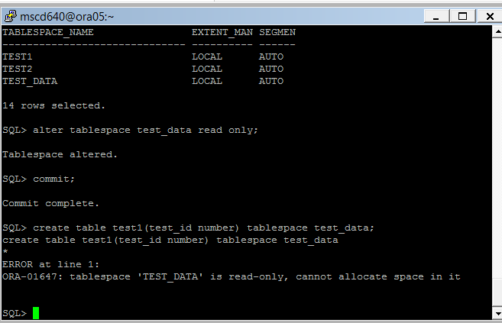
What happened? Test_data is read only so cannot create space in it.

-----------------------------------------------------------------------------------
29. Alter the tablespace back to read write.

SQL> alter tablespace test_data read write;
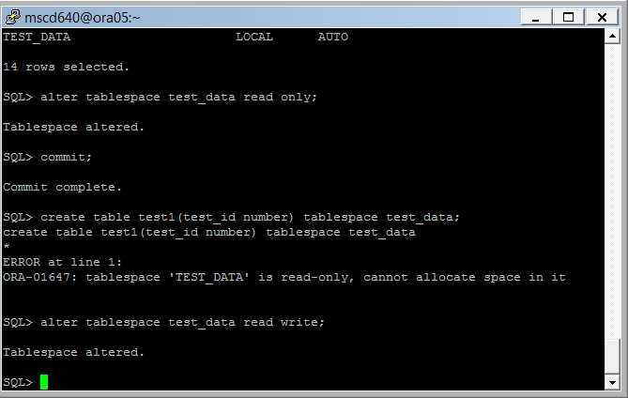
Try to create a table in that tablespace:

SQL> create table test1 (test_id number) tablespace test_data;
SQL> desc test1;
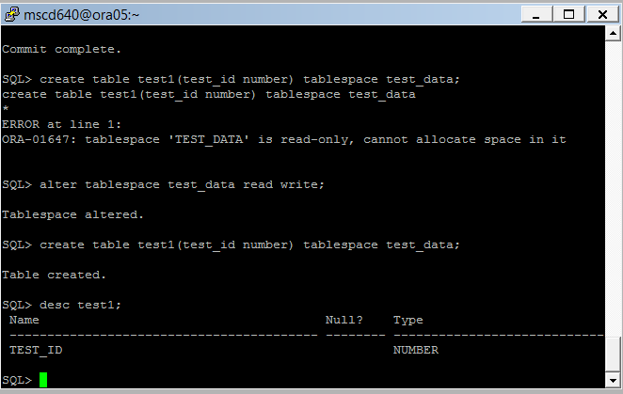
-----------------------------------------------------------------------------------
30. Alter the size of the TEST_DATA tablespace by modifying the size of its datafile. Be sure to reference the correct directory path for your PDB as specified in exercise #26.
See pages 90-91 in the book.

- SQL> alter database datafile ‘directory path and datafile name’ resize 20m;
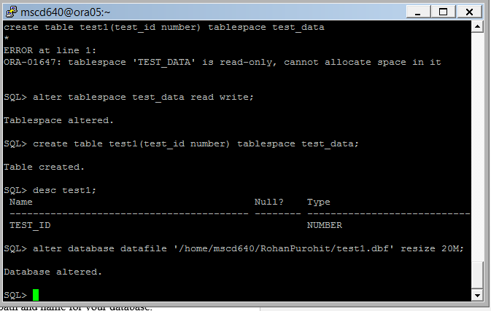
- Verify the size has changed:

SQL> select file_name, bytes from cdb_data_files;
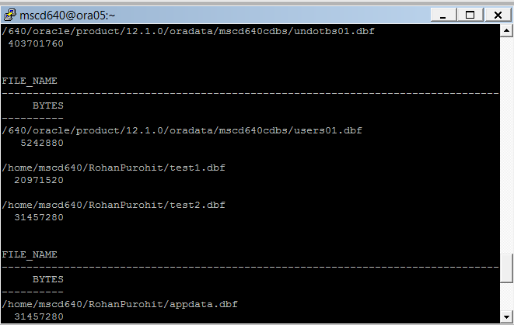
-----------------------------------------------------------------------------------
32. Add a datafile named app_data02.dbf to the TEST_DATA tablespace.
See pages 90-91 in the book.

- SQL> alter tablespace test_data add ‘your datafile path and name’ size 10m;

You will need to provide the correct datafile path and name for your database.

For example:

SQL> alter tablespace test_data add datafile '/u01/oracle/product/11.2.0/oradata/D79219/app_data02.dbf' size 10m;

- Verify the file was added:

SQL> select name, bytes from cdb_data_files;

If you receive an error similar to this:
I was unable to test this out as my PDB login does not work and does not allow me to create a tablespace to later edit and play around with.

ORA-01119: error in creating database file '/u01/oracle/product/11.2.0/oradata/D79219/app_data02.dbf'
ORA-27040: file create error, unable to create file

That means the directory path you’ve entered does not exist in your database.

-----------------------------------------------------------------------------------

33. Drop the tablespace that you added.
See page 84-86 in the book.

SQL> drop tablespace test_data including contents and datafiles;
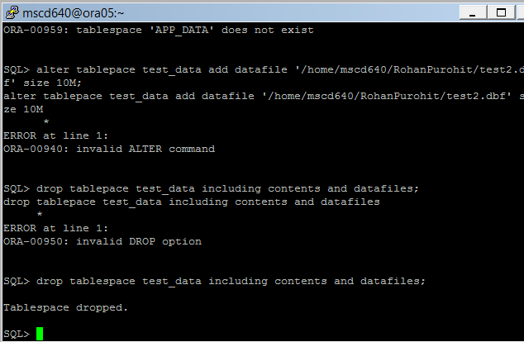
-----------------------------------------------------------------------------------
34.
- Create a bigfile tablespace. Be sure to reference the correct directory path for your PDB as specified in #26 above.
See page 87 in the book.

create bigfile tablespace inv_big_data
datafile 'your database directory path/inv_big_data01.dbf'
size 10m
extent management local
uniform size 128k
segment space management auto;
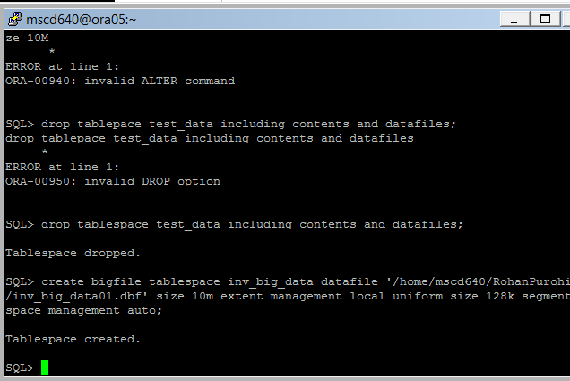
- Verify that a bigfile tablespace was created:

SQL> select tablespace_name, bigfile from cdb_tablespaces;
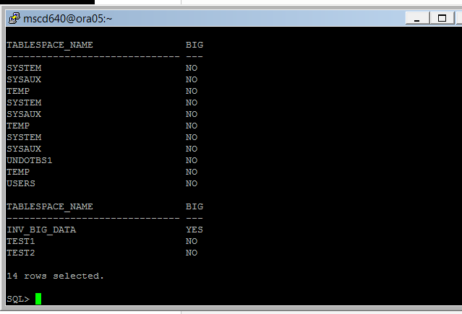
- Exit SQLPlus

- What are the pros/cons to a bigfile tablespace?

From a performance standpoint and management standpoint bigfile tablespaces are better but you should be careful about the space you might need and if that may compromise your performance goals.
-----------------------------------------------------------------------------------
Lab 1, Part 3: Managing Control Files and Online Redo Logs
Read Chapter 5 in the book.
-----------------------------------------------------------------------------------
35. From the OS Command connect to the ROOT container as SYSDBA.
- Ex: [mscd640@ora05] sqlplus / as sysdba

- From SQLPlus connect to your PDB database container as SYSDBA:

Replace the xx in the pdb# with your assigned and pdb number.
Ex: SQL> alter session set container = mscd640xpdxx

- Where are CDB controlfiles and what are they named?
Control files are created when the database is created. The control file is a small binary file that contains database name, names of data files and their locations, names of online redo log files, current online redo log sequence number, checkpoint information and names and locations of RMAN backup files if they are used. Every database must have atleast one control file. It can be named O12C.
See page 102 in the book.

SQL> select name from v$controlfile;
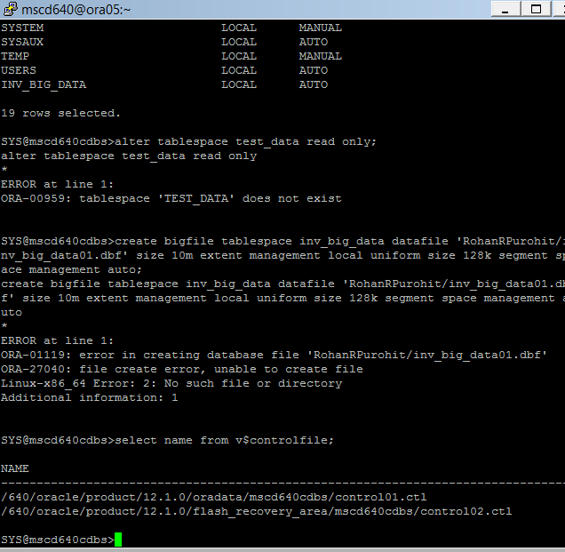
-----------------------------------------------------------------------------------
36. What is the control_files parameter set to?

SQL> show parameter control_files;
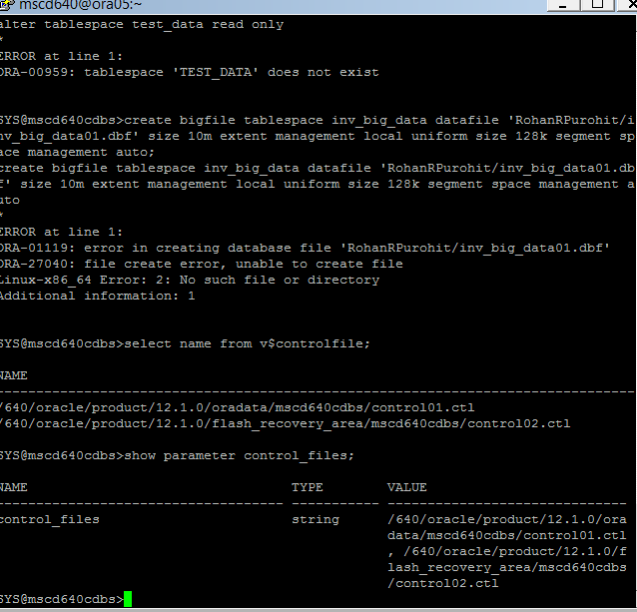
- Is there a separate controlfile for your pluggable database? Why or why not?
I don’t think there is a separate control file for the database since the main database is just one core unit that has the main control file and other spawns are just partitions of the main database.
----------------------------------------------------------------------------------------------
37. How many online redo log groups are in your database?

- From SQLPlus call the following script file to display the online redo groups in your database.
SQL> @$HOME/MSCD640/Scripts/LAB1_Ex37.sql

- How many groups are there?
There are more than five groups. Close to 12 groups. 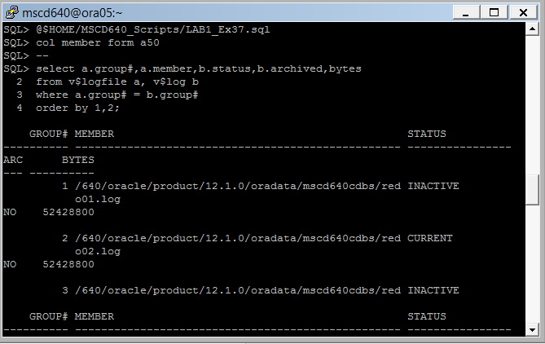How many members are in each group?
There are two to three redo log files in each group
- What size are the online redo log file members?
They are files which go through a round robin algorithm to write transaction data into for backup purposes.
-----------------------------------------------------------------------------------

38. Add an online redo log group to your CDB database using the next available group number based on your output from exercise #37. Create two members in the group. Make sure you use the same size as the current online redo logs. Define the directory path and filename in the following format:

/640/oracle/product/12.1.0/oradata/msc640cdb/student_name_redo01.log

- Create the new log group and redo log files editing the group number to the next available group number using the directory path name found in exercise 37 :

(replace the 4 in the example with the next available redo log group number)

SQL> alter database add logfile group 4 ('<directory path/filename>') SIZE 52428800;
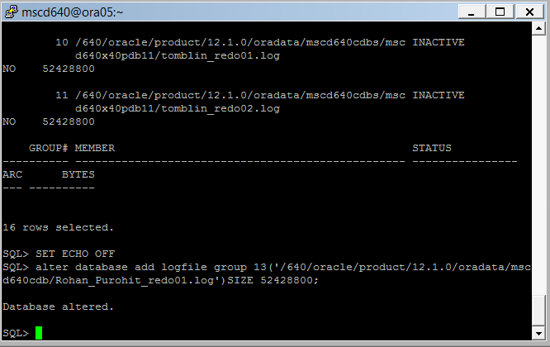
-----------------------------------------------------------------------------------
39. Add additional logfile(s).

- Add an additional logfile member to the new group you added in exercise #38. Change the group number in the below example to the new group number created in #38 above.

alter database add logfile member '<directory path/filename>'
to group 4;

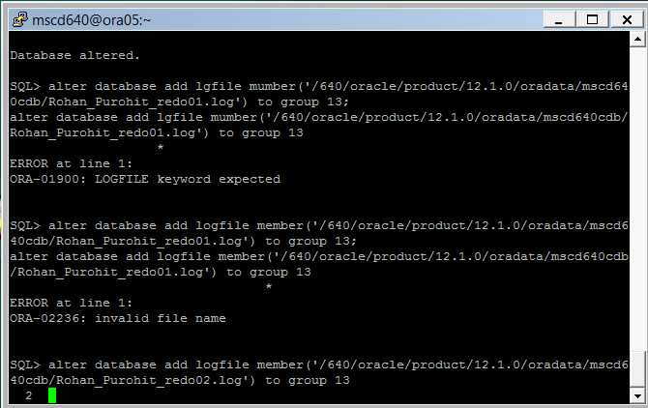

- Verify that the new group has two members:

col member form a50
--
select a.group#,a.member,b.status,b.archived,bytes
from v$logfile a, v$log b
where a.group# = b.group#
order by 1,2;
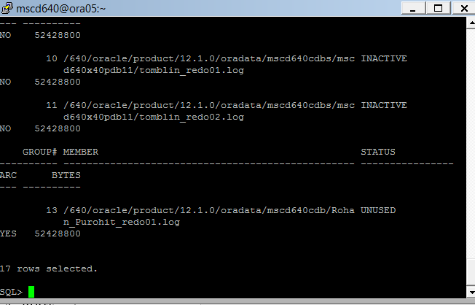

- What is the advantage to having two members in one online redo log group?
You have more than one member so you can alternate between the two files and continuously write transactional data to backup.

40. Close your pluggable database. You will need to be sitting in the ROOT container as SYSDBA.

- From the sql prompt show the user logged on.

Ex: SQL> show user;
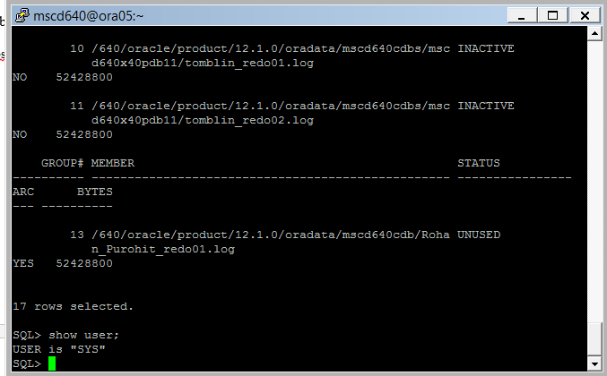

- Show the name and open status for just your pluggable database:

Ex: SQL> select con_id, name,open_mode from v$pdbs;

- Close YOUR pluggable database.

- Connect to the container database as sysdba:

Ex: SQL> conn / as sysdba
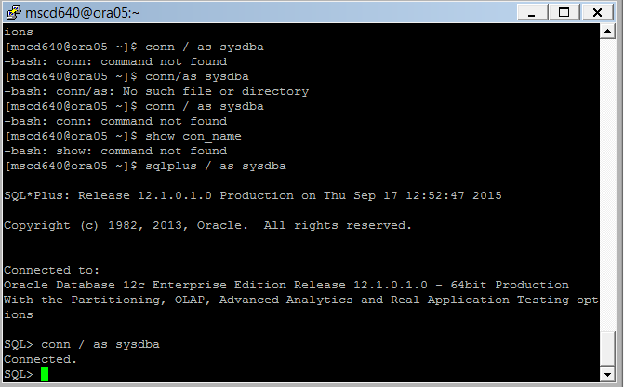

- Show the name of the container database you are sitting in. You should be returned the value of CDB$ROOT:
I am at CDB$ROOT .
Ex: SQL> show con_name

- Now you can close the pluggable database

(replace the “xx” in the example below with YOUR pluggable database name):

Ex: SQL> alter pluggable database msc640xpdbxx close immediate;
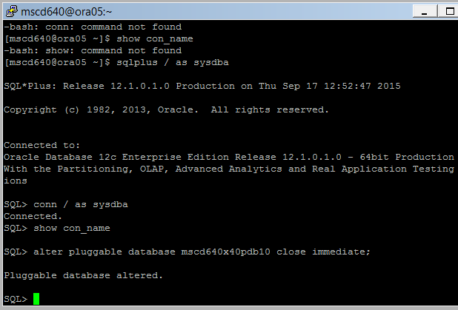
- Show the name and open status for just your pluggable database. Your database open status should be defined as ‘MOUNT’ after issuing the close immediate clause in f) above.

Enter your pluggable database name in CAPS
Ex:
SQL> select con_id, name,open_mode
from v$pdbs
where name = ‘your pluggable database name’;
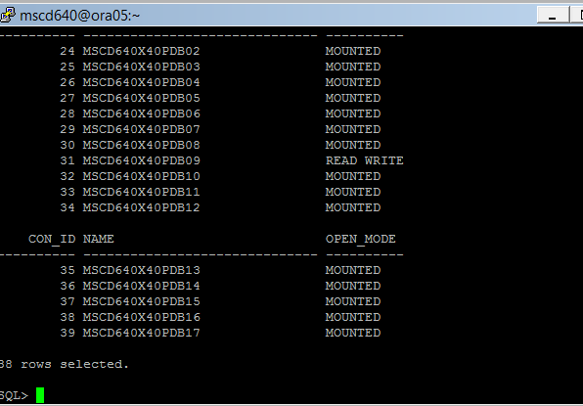
End of Lab1.

