Individual Submission for S1

Mockup of Dashboard of a personal finance tracker to give a clear overview of someone’s finances

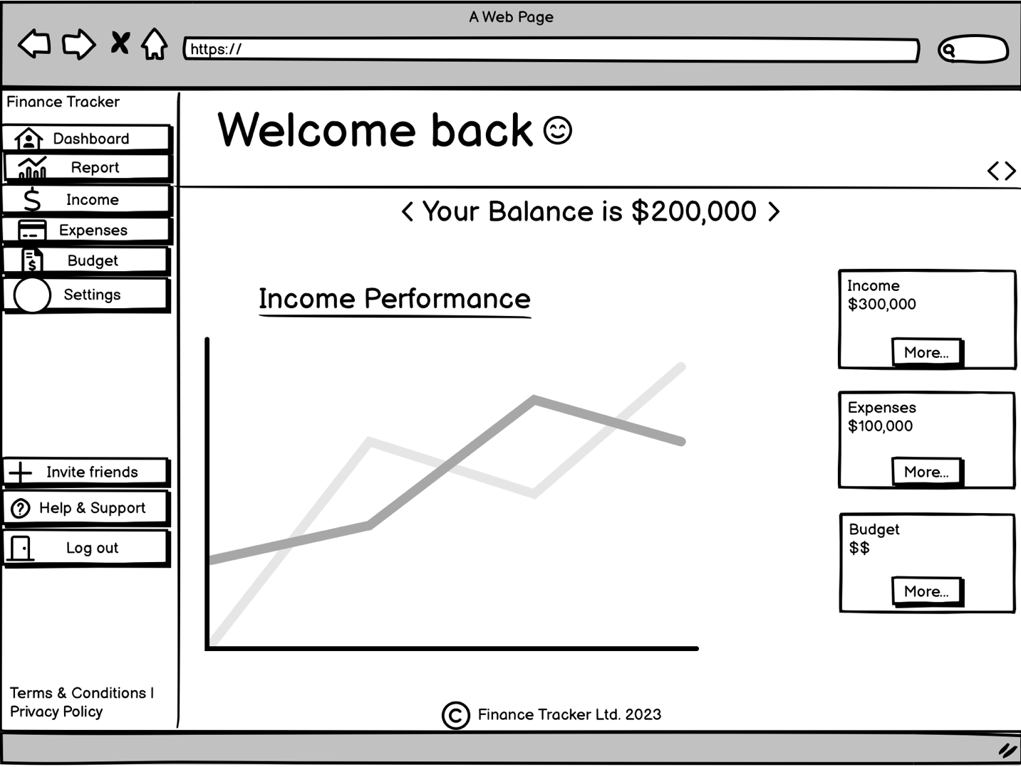

The persona represents Nadia who is an actress and wants to get a comprehensive understanding of their current financial situation.

**Goals**



**Nadia Shanaa**

*“Empowering my financial future, one smart decision at a time”*

Age: 27 Family Status: Single

Pet: Dog Location: Madrid, Spain

Acessibility: None Education: Graduate

Occupation: Actress Personality: Social and Outgoing

**BIO**

Nadia, a 27-year old working professional is always on the go.

Between her work schedule and social life, she struggles to

keep track of her finances. She’s looking for a solution that is

user-friendly and accessible from anywhere, so she can stay organized and manage her finances on the go.

* To get a clear overview on the dashboard
* User-friendly and easy to use from the jump
* Create and stick to a budget

**Frustrations**

* Financial improprieties
* Complex applications including the dashboard
* Inadequate budgeting tools

**Motivations**

Incentive :

Growth :

Power :

**Favorite app**