IoT in Smart Agriculture:
Applications in Smart Irrigation and Crop Monitoring
Rohan N | Vivekananda College of Engineering and Technology | CodeAlpha
Abstract
Agriculture is an important source of livelihood, but farmers face challenges related to changing weather conditions, resource management, monitoring, and maintenance. Internet of Things (IoT) technology can support agriculture by connecting sensors, controllers, communication networks, and monitoring systems. IoT-based Smart Agriculture can collect information such as soil moisture, temperature, humidity, and water level and make it available to farmers through a dashboard or other connected system. Based on sensor readings, the system can provide alerts or control agricultural devices such as water pumps. This paper discusses the applications, working, benefits, challenges, and future scope of IoT in Smart Agriculture.
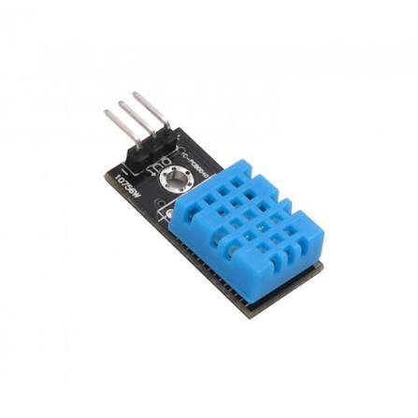
Keywords: IoT, Smart Agriculture, Smart Irrigation, Crop Monitoring, Sensors, ESP8266, Automation
1. Introduction
Agriculture plays an important role in human life and provides employment and food resources. However, farmers may face difficulties in monitoring field conditions and managing limited resources. Smallholder farmers may also have limited access to technology and agricultural information. IoT provides an approach in which sensors and devices can collect field information and communicate it through the internet. An IoT-based agricultural system can connect sensors and actuators to cloud services, allowing agricultural conditions to be monitored and managed more efficiently [1][2].
2. IoT in Smart Agriculture
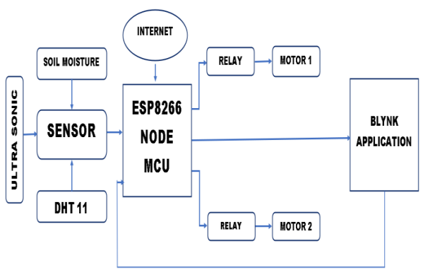
IoT in Smart Agriculture uses connected sensors and devices to observe agricultural conditions and support decisions. Sensors can measure soil moisture, temperature, humidity, and water level. A microcontroller receives the sensor readings and can send the information through a communication network to a cloud platform or monitoring dashboard. The farmer can then observe the collected information and respond to changes in field conditions.
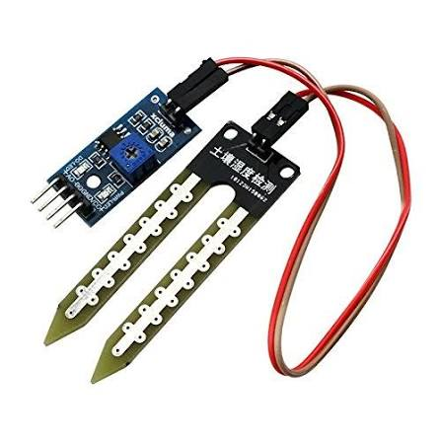
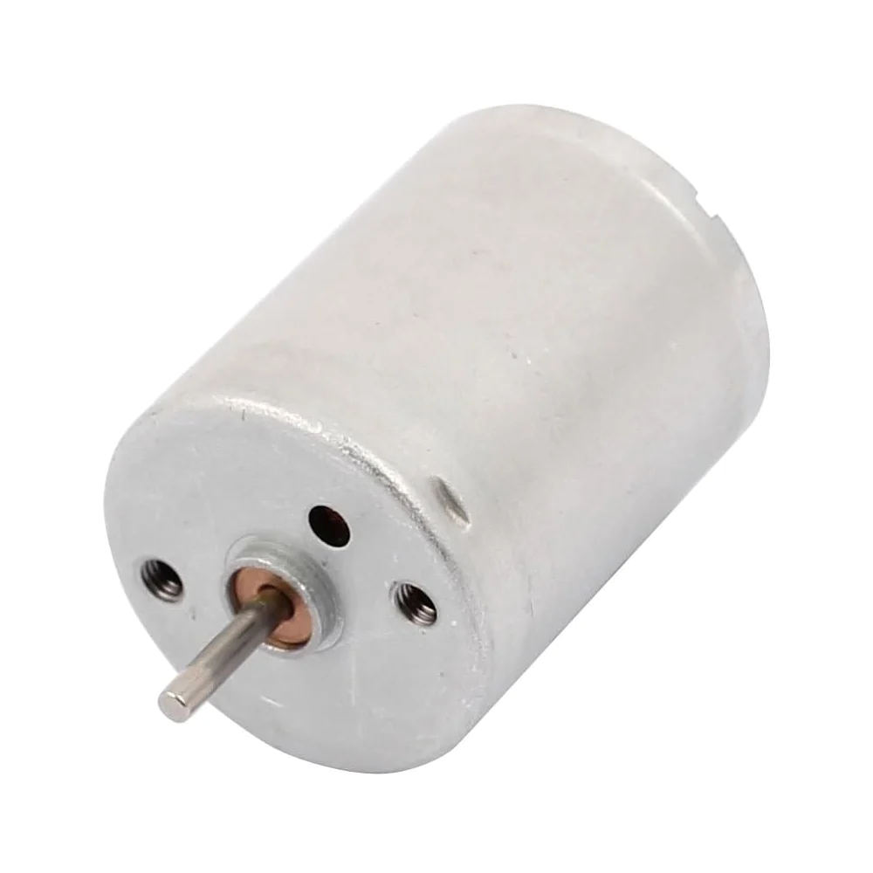
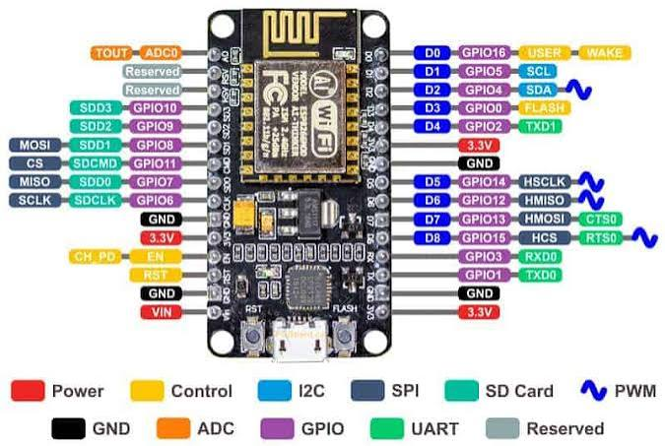

The main components discussed in the referenced Smart Agriculture system include a soil-moisture sensor, DHT11 temperature and humidity sensor, ultrasonic sensor, relay, motor, and ESP8266 NodeMCU [2]. The soil-moisture sensor measures moisture present in the soil. The DHT11 is used for temperature and humidity measurement. An ultrasonic sensor can measure distance and can be used to monitor water levels in tanks or reservoirs. A relay allows a microcontroller to control higher-power devices, while a motor can operate a water pump. The ESP8266 NodeMCU provides Wi-Fi connectivity and can send sensor information to a cloud server or monitoring dashboard [2].

3. Applications of IoT in Smart Agriculture
3.1 Smart Irrigation
Smart irrigation uses soil-moisture information to determine when irrigation is required. When the soil becomes too dry, the system can provide an alert or operate a water pump through a relay and motor. This can reduce unnecessary watering and reduce the need for continuous manual operation.
3.2 Crop and Environmental Monitoring
IoT sensors can continuously monitor environmental conditions such as temperature, humidity, and soil moisture. The collected information helps farmers understand changing field conditions and take appropriate action. Continuous monitoring also allows abnormal conditions to be identified earlier.
3.3 Water-Level Monitoring
Ultrasonic sensors can measure the distance between the sensor and the water surface. This information can be used to monitor the water level in tanks and reservoirs and can support irrigation-related operations.
3.4 Remote Monitoring
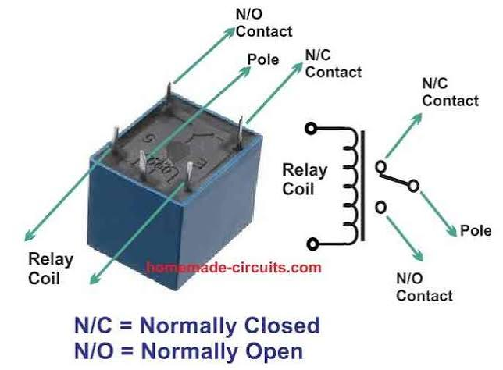
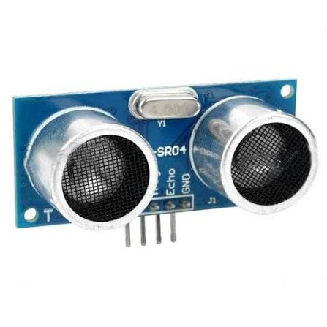
Because IoT devices can transmit sensor data through the internet, agricultural information can be viewed remotely through a connected dashboard or system. This reduces the need for farmers to be physically present at the field for every observation.
4. Working of an IoT-Based Smart Agriculture System

An IoT-based Smart Agriculture system first collects information using sensors installed in the agricultural environment. The sensor readings are received by a microcontroller or IoT device. The device processes the readings and communicates them through the internet. The data can be stored and displayed on a cloud platform or monitoring dashboard. When a measured value reaches a predefined condition, the system can generate an alert or activate an agricultural device. For example, low soil moisture can trigger irrigation. The basic working flow is:
Sensors → Microcontroller → Internet/IoT Network → Cloud/Database → Data Analysis → Farmer/Automated Action.
5. Benefits
IoT-based agriculture provides continuous monitoring of soil and environmental conditions and can support faster decision-making. Smart irrigation can help avoid unnecessary water usage by supplying water according to soil conditions. Remote monitoring can reduce manual effort, while automated control can improve the operation of devices such as pumps. Overall, IoT can support resource management, monitoring, and automation in agricultural activities.
6. Challenges and Limitations
IoT implementation can involve the cost of sensors, controllers, communication devices, and other equipment. Reliable internet connectivity may also be difficult in some rural agricultural areas. Sensors require maintenance and calibration to provide dependable measurements, and environmental conditions such as dust, rain, and temperature can affect electronic devices. Data security is another concern because agricultural information is transmitted through networks and therefore requires appropriate protection [1].
7. Future Scope
Future Smart Agriculture systems can combine IoT with Artificial Intelligence (AI), Machine Learning (ML), drones, satellite imagery, and advanced sensors. AI can analyze large amounts of agricultural data and identify patterns that may be difficult to detect manually. Future systems may provide improved prediction of crop conditions, irrigation requirements, diseases, and agricultural risks. Drones and satellite imagery can provide information over large areas, while IoT sensors can provide detailed field-level information. The integration of IoT and AI can therefore support more intelligent decision-making and greater automation [1].
8. Conclusion
IoT provides a connected approach for monitoring and managing agricultural conditions. By combining sensors, microcontrollers, communication networks, cloud platforms, and automated devices, Smart Agriculture systems can collect useful field information and support timely decisions. Applications such as smart irrigation, crop and environmental monitoring, water-level monitoring, and remote monitoring demonstrate how IoT can be applied in agriculture. At the same time, cost, connectivity, maintenance, environmental conditions, and data security remain important challenges. Continued development of IoT, AI, sensors, and connected technologies can support increasingly intelligent and automated agricultural systems.

9. References
[1]
Design and Implementation of Internet of Things (IoT) Platform Targeted for Smallholder Farmers: From Nepal Perspective. Published in Agriculture, 2023, Volume 13, Issue 10, Article 1900.
[2]
A Research Paper on Smart Agriculture System Using IoT. Published in International Research Journal of Engineering and Technology (IRJET), 2022, Volume 09, Issue 06.

