Name: Rohan Raygade

PHP Basics

CODE 1

<**html**>  
<**head**>  
 <**title**>My First Program</**title**>  
</**head**>  
<**body**>  
**<?php  
echo "<h3>"**.**"This is my first program"**.**"</h3>"**;  
**echo "<h5>"**.**"I am trying to print a string in the browser window"**.**"</h5>"**;  
**?>**</**body**>  
</**html**>

Output:

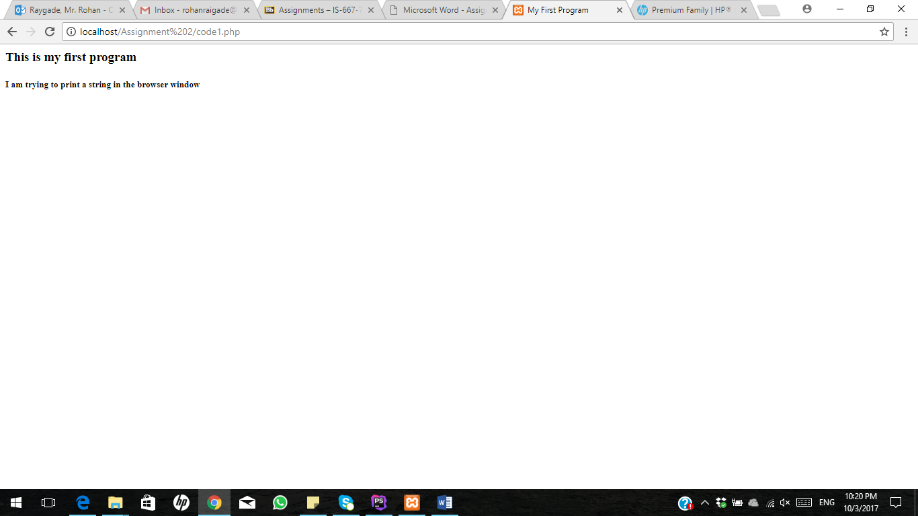

CODE 2:

<**html**>  
<**head**>  
 <**title**>My Second Program: Variable Assignment</**title**>  
</**head**>  
<**body**>  
**<?php**$string1 = **'First String assigned to a variable called $String1'**;  
$string2 = **'Second String assigned to a variable called $String2'**;  
**echo "<h1>"**.$string1.**"</h1>"**;  
**echo "<h2>"**.$string2.**"</h2>"**;  
**?>**</**body**>  
</**html**>

Output:

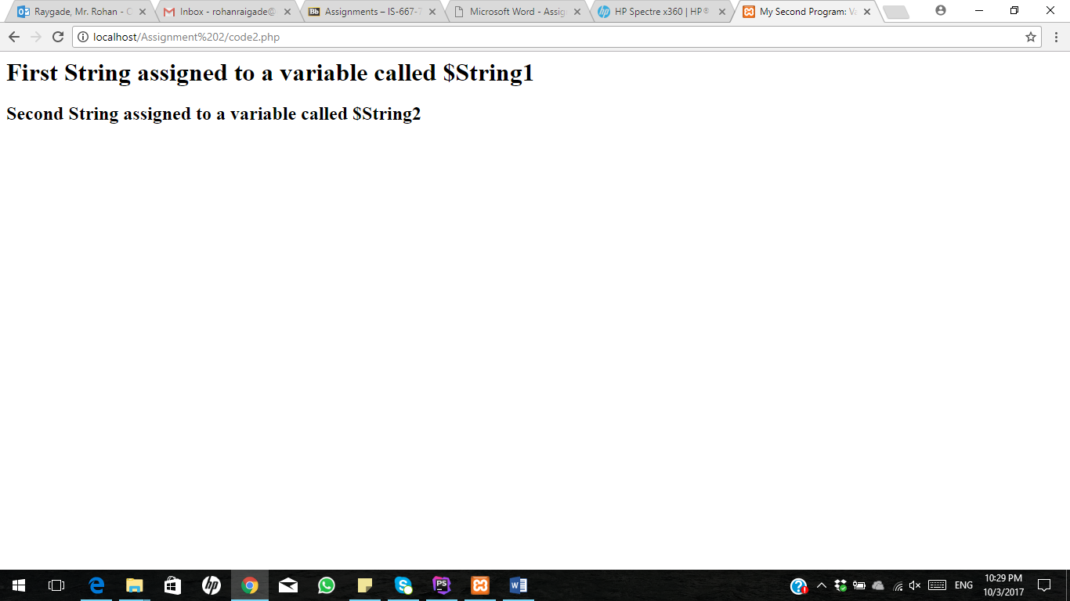

CODE 3:

<**html**>  
<**head**>  
 <**title**>Different Operators Demo</**title**>  
</**head**>  
<**body**>  
**<?php**$number1 = **'5'**;  
$number2 = **'10'**;  
**echo "<h3>I am demonstrating different arithmetic functions</h3>"**;  
**echo "Addition : "**. ($number1 + $number2) .**"<br><br>"**;  
**echo "Subtraction : "**. ($number1 - $number2) .**"<br><br>"**;  
**echo "Division : "**. ($number1 / $number2) .**"<br><br>"**;  
**echo "Multiplication : "** .($number1 * $number2) .**"<br><br>"**;  
**?>**</**body**>  
</**html**>

OUTPUT:

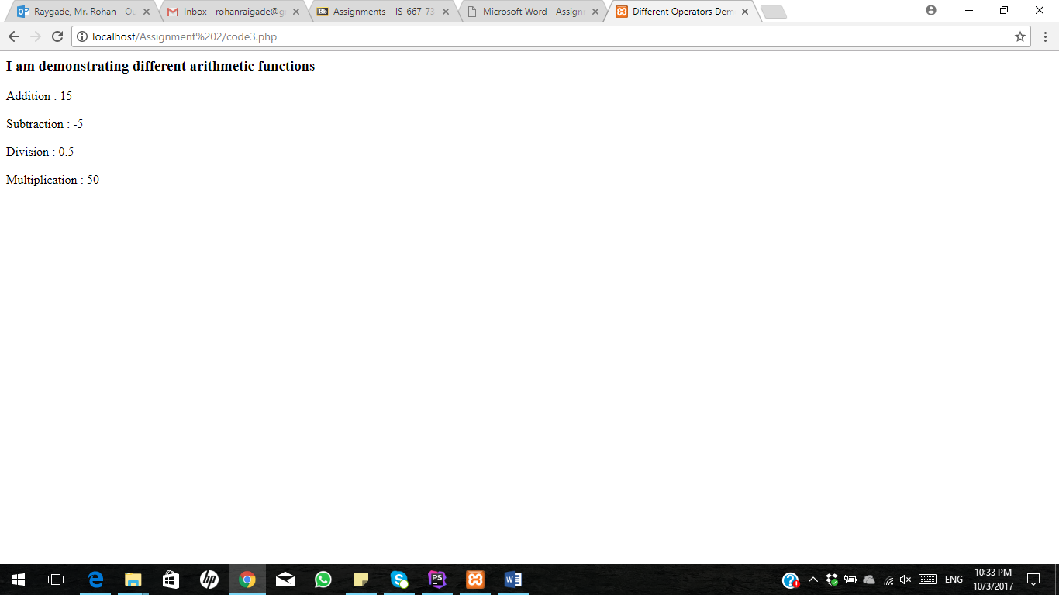

CODE 4:

<**html**>  
<**head**>  
 <**title**>Different Operators Demo</**title**>  
</**head**>  
<**body**>  
**<?php**$number1 = **'5'**;  
$number2 = **'10'**;  
$number3 = **'15'**;  
$number4 = **'20'**;  
$number5 = **'30'**;  
  
**echo "<h3>I am demonstrating different arithmetic functions</h3>"**;  
**echo "Addition : "**. ($number1 + $number2) .**"<br><br>"**;  
**echo "Subtraction : "**. ($number1 - $number2) .**"<br><br>"**;  
**echo "Division : "**. ($number1 / $number2) .**"<br><br>"**;  
**echo "Multiplication : "** .($number1 * $number2) .**"<br><br>"**;  
**echo "Addition : "**. ($number1 + $number2 + $number3 + $number4).**"<br><br>"**;  
**echo "Division : "**. ($number4 / $number1) .**"<br><br>"**;  
**echo "Subtraction : "**. ($number4 - $number3) .**"<br><br>"**;  
**?>**</**body**>  
</**html**>

OUTPUT:

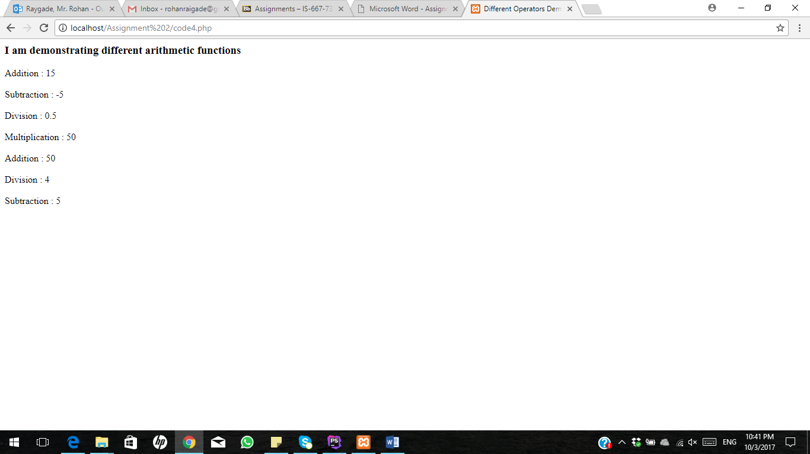

CODE 5:

<**html**>  
<**head**>  
 <**title**>Different Operators Demo</**title**>  
</**head**>  
<**body**>  
**<?php**$d = **'U00123'**;  
$dd=0;  
++$d;  
**for**($r=0;$r<20;$r++)  
{  
 **echo** $d .++$dd.**"<br>"**;  
}  
**?>**</**body**>  
</**html**>

OUTPUT:

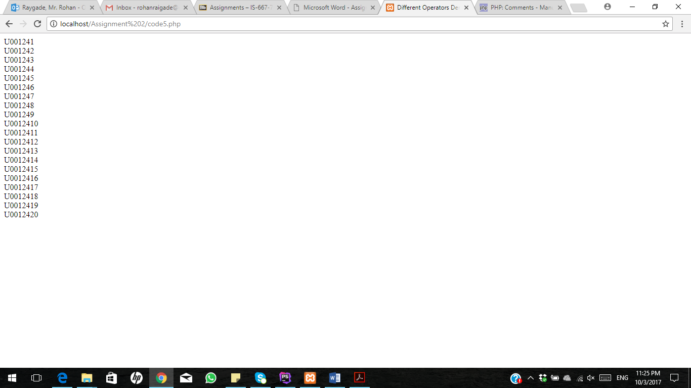

CODE 6:

<**html**>  
<**head**>  
 <**title**>Code 6 </**title**>  
</**head**>  
<**body**>  
**<?php  
echo "<h3>Code 6 </h3>"**;  
$original = **array**( **'1'**,**'2'**,**'3'**,**'4'**,**'5'**,**'6'**,**'7'**,**'8'**,**'9'** );  
**echo 'Original array : '**.**"<br><br>"**;  
**foreach** ($original **as** $a)  
{**echo "**$a **"**;}  
**echo "<br><br>"**;  
$inserted = **'$'**;  
**for** ($x=2; $x<10; $x=$x+3)  
{  
*array_splice*($original, $x, 0, $inserted);  
}  
**echo " After inserting '$' the array is : "**. **"<br><br>"**;  
**foreach** ($original **as** $a)  
{**echo "**$a **"**;}  
**echo "<br><br>"  
?>**</**body**>  
</**html**>

OUTPUT:

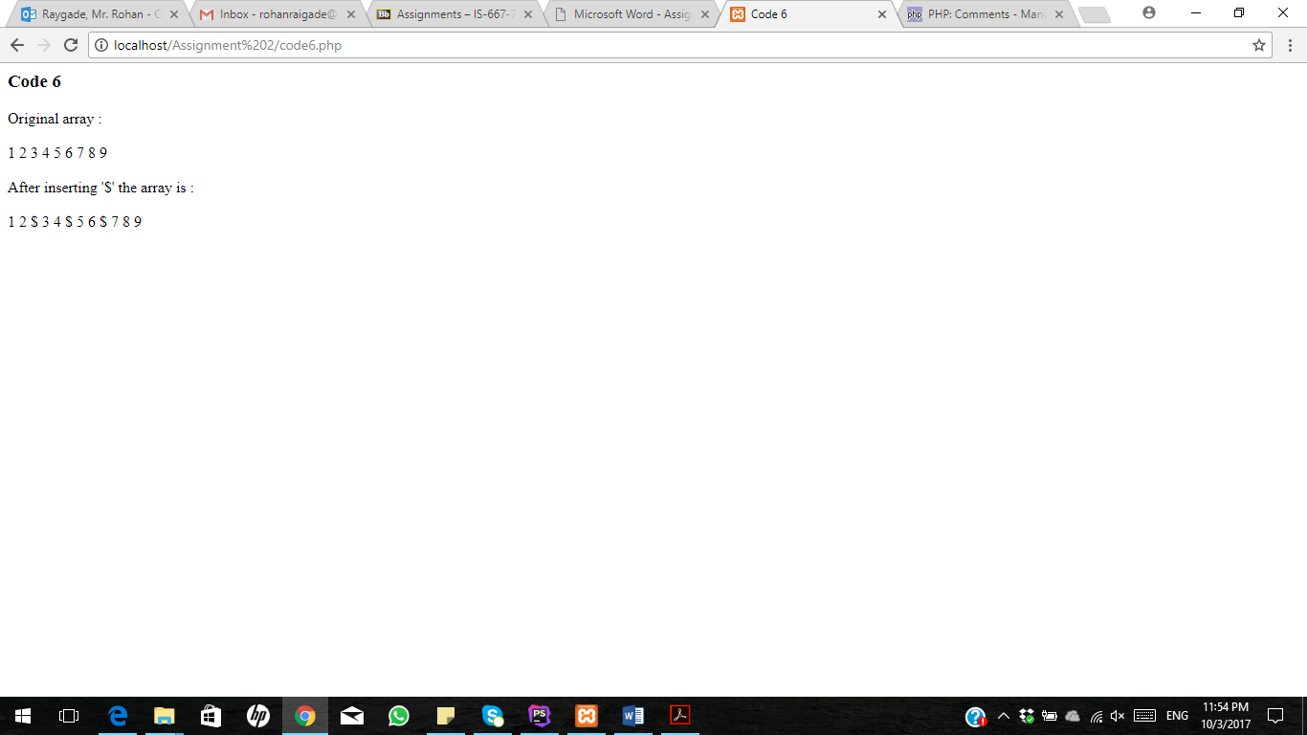

CODE 7:

<**html**>  
<**head**>  
<**title**> Code 7 </**title**>  
</**head**>  
<**body**>  
**<?php  
echo "<h3>Code 7 </h3>"**;  
$color = **array**(**'white'**, **'green'**, **'red'**, **'blue'**, **'black'**);  
**echo "The memory of that scene for me is like a frame of film forever frozen at that moment:the** $color[2] **carpet, the** $color[1] **lawn, the** $color[0] **house, the leaden sky.   
The new president and his first lady. - Richard M. Nixon"**.**"<br><br>"**;  
**?>**</**body**>  
</**html**>

OUTPUT:

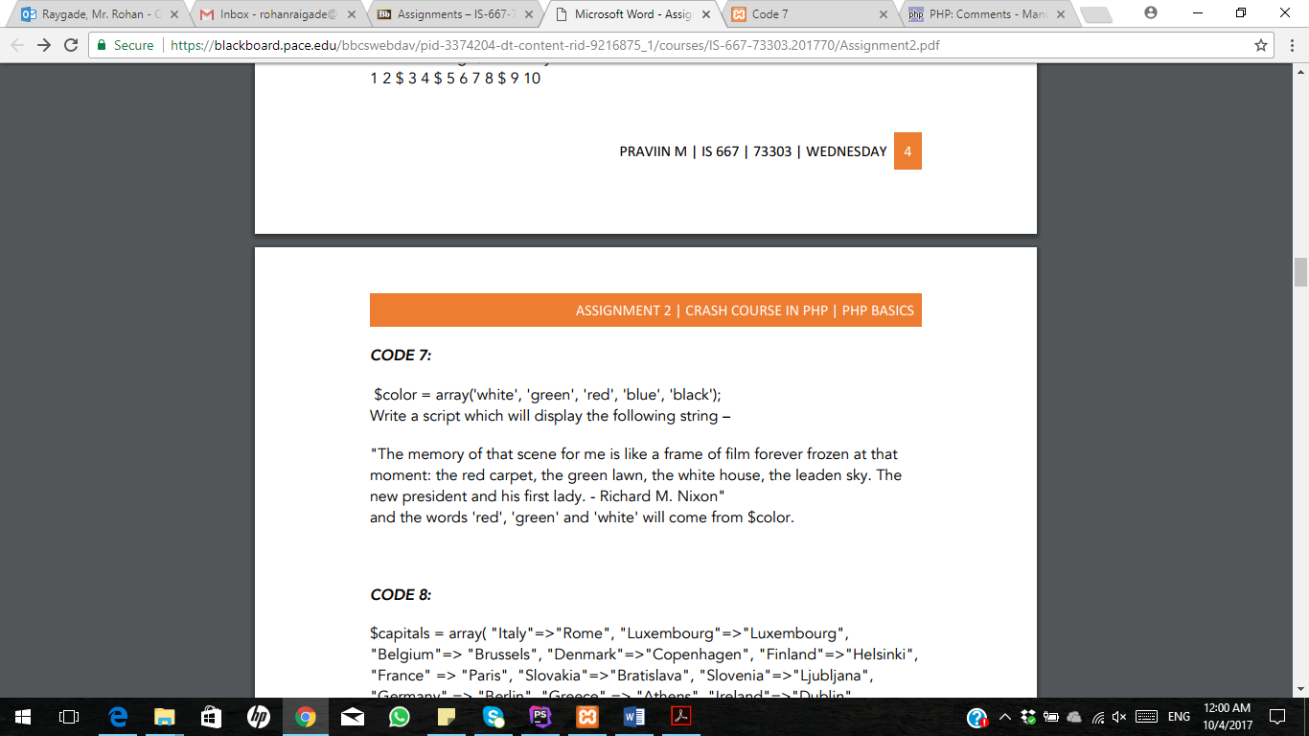

CODE 8:

</**head**>  
<**body**>  
**<?php  
echo "<h3>Code 8 </h3>"**;  
$capitals = **array**( **"Italy"**=>**"Rome"**, **"Luxembourg"**=>**"Luxembourg"**, **"Belgium"**=> **"Brussels"**, **"Denmark"**=>**"Copenhagen"**,  
 **"Finland"**=>**"Helsinki"**, **"France"** => **"Paris"**, **"Slovakia"**=>**"Bratislava"**, **"Slovenia"**=>**"Ljubljana"**,  
 **"Germany"** => **"Berlin"**, **"Greece"** => **"Athens"**, **"Ireland"**=>**"Dublin"**, **"Netherlands"**=>**"Amsterdam"**,  
 **"Portugal"**=>**"Lisbon"**, **"Spain"**=>**"Madrid"**, **"Sweden"**=>**"Stockholm"**, **"United Kingdom"**=>**"London"**,  
 **"Cyprus"**=>**"Nicosia"**, **"Lithuania"**=>**"Vilnius"**, **"Czech Republic"**=>**"Prague"**, **"Estonia"**=>**"Tallin"**,  
 **"Hungary"**=>**"Budapest"**, **"Latvia"**=>**"Riga"**, **"Malta"**=>**"Valetta"**, **"Austria"** => **"Vienna"**, **"Poland"**=>**"Warsaw"**) ;  
 *asort*($capitals);  
**foreach** ($capitals **as** $country => $capitals)  
{  
 **echo "The capital of** $country **is** $capitals**"**.**"<br>"**;  
}  
**"<br><br>"**;  
**?>**</**body**>  
</**html**>

OUTPUT:

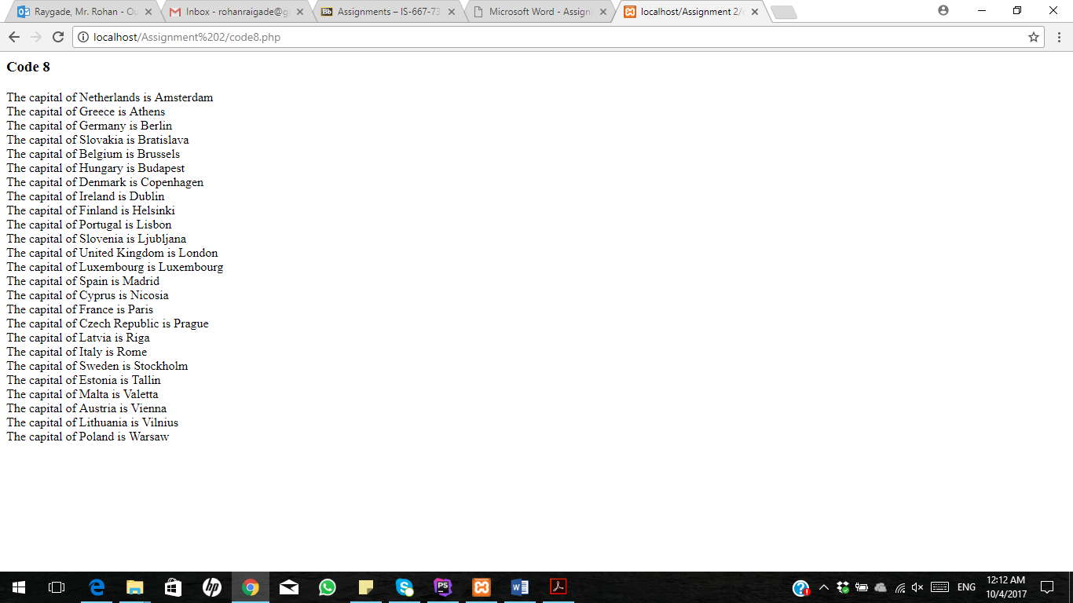

CODE 9:

<**html**>  
<**head**>  
 <**title**> Code 9 </**title**>  
</**head**>  
<**body**>  
**<?php  
echo "<h3>Code 9 </h3>"**;  
$a=*range*(14,86);  
*shuffle*($a);  
**for** ($b=0; $b< 10; $b++)  
{  
**echo** $a[$b].**' '**;  
}  
**"<br><br>"**;  
**?>**</**body**>  
</**html**>

OUTPUT:

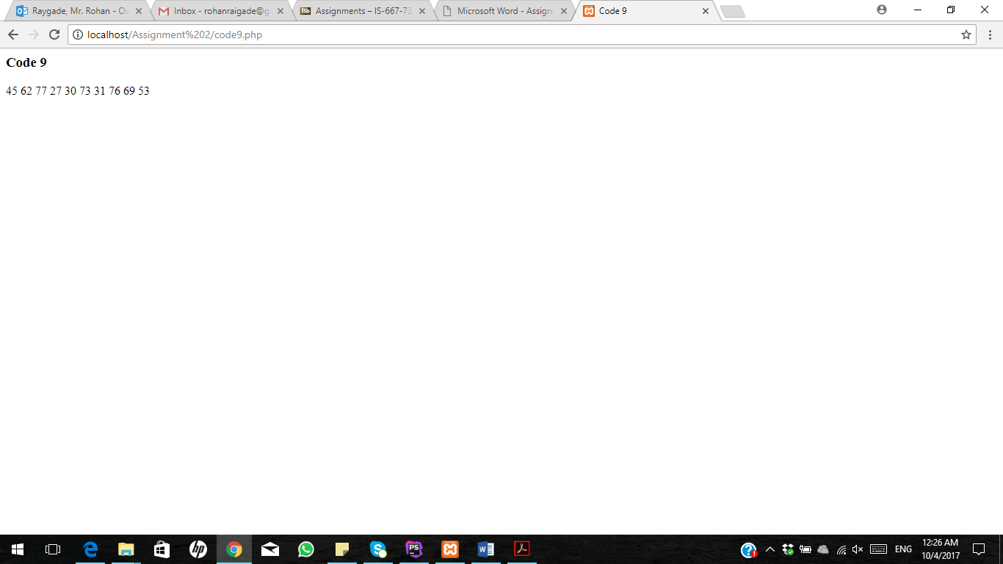

CODE 10:

<**html**>  
<**head**>  
 <**title**> Code 10 </**title**>  
</**head**>  
<**body**>  
**<?php  
echo "<h1>Code 10 </h1>"**;  
**for**($x=1; $x<=10; $x++)  
{  
**if**($x< 10)  
{  
 **echo "**$x**-"**;  
}  
 **else** {  
 **echo "**$x**"**;  
 }  
}**"<br>"**;  
**?>**</**body**>  
</**html**>

OUTPUT:

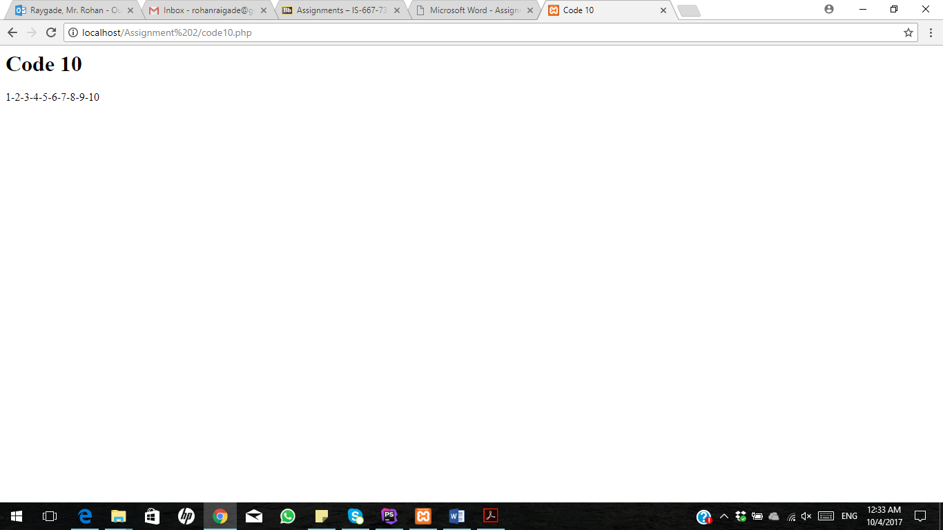

CODE 11:

<**html**>  
<**head**>  
 <**title**> Code 11 </**title**>  
</**head**>  
<**body**>  
**<?php  
echo "<h3>Code 11 </h3>"**;  
$sum = 0;  
**for**($x=1; $x<=30; $x++)  
{  
 $sum +=$x;  
}  
**echo "The sum of the numbers is** $sum**"**.**"\n"**;  
**?>**</**body**>  
</**html**>

OUTPUT: 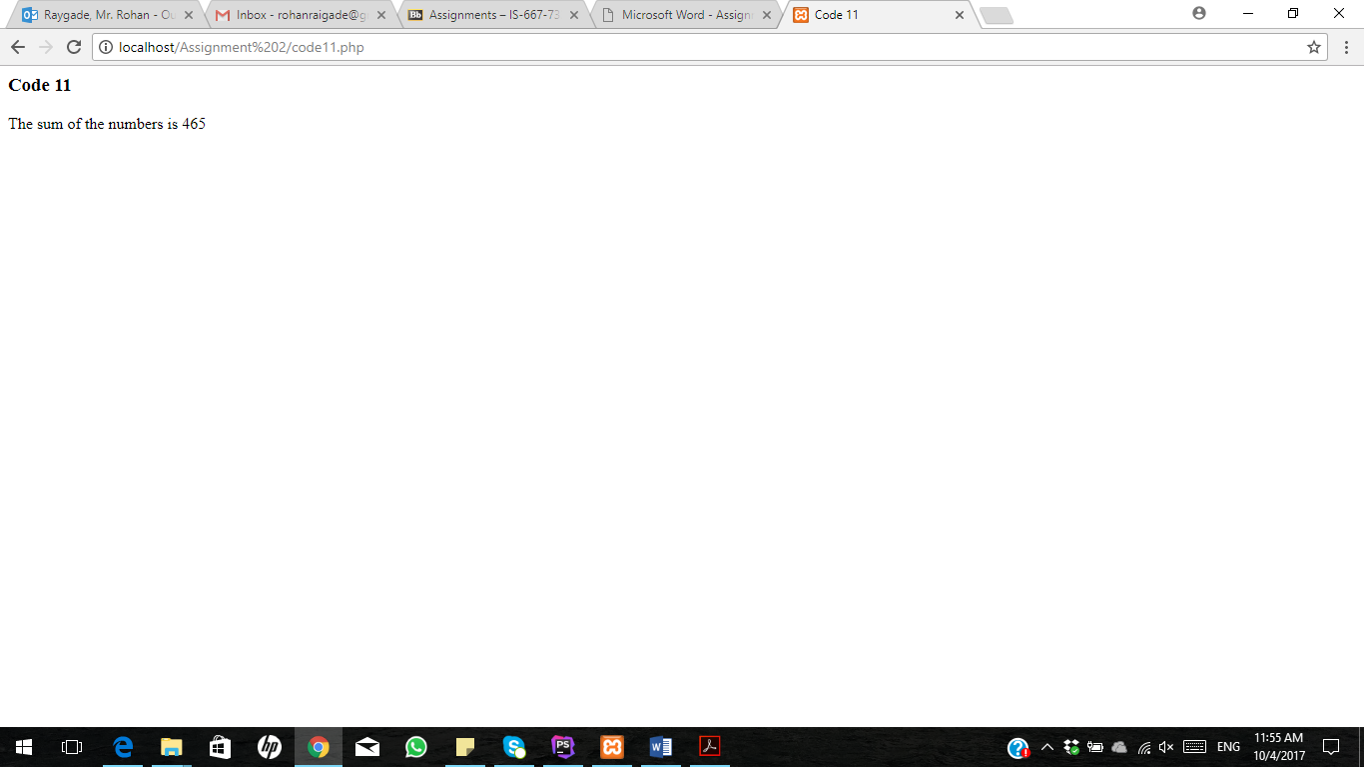

CODE 12:

<**html**>  
<**head**>  
 <**title**> Code 12 </**title**>  
</**head**>  
<**body**>  
  
**<?php  
echo "<h3>Code 12 </h3>"**;  
**echo "Associative array : Ascending order sort by value "**.**"<br>"**;  
$array2=**array**(**"Jane Smith"**=>**"31"**,**"Jacob Smith"**=>**"41"**,**"William Smith"**=>**"39"**,**"Frodo Baggins"**=>**"40"**);

*asort*($array2);  
**foreach**($array2 **as** $x=>$x_value)  
{**echo "Age of "**.$x.**" is : "**.$x_value.**"<br>"**;}  
**"<br><br>"**;  
  
**echo "Associative array : Ascending order sort by Key "**.**"<br>"**;  
$array3=**array**(**"Jane Smith"**=>**"31"**,**"Jacob Smith"**=>**"41"**,**"William Smith"**=>**"39"**,**"Frodo Baggins"**=>**"40"**);

*ksort*($array3);  
**foreach**($array3 **as** $y=>$y_value)  
{**echo "Age of "**.$y.**" is : "**.$y_value.**"<br>"**;}  
**"<br><br>"**;  
  
**echo "Associative array : Descending order sorting by Value "**.**"<br>"**;  
$age=**array**(**"Jane Smith"**=>**"31"**,**"Jacob Smith"**=>**"41"**,**"William Smith"**=>**"39"**,**"Frodo Baggins"**=>**"40"**);  
*arsort*($age);  
**foreach**($age **as** $z=>$z_value)  
{**echo "Age of "**.$z.**" is : "**.$z_value.**"<br>"**;}  
**"<br><br>"**;  
  
**echo "Associative array : Descending order sorting by Key "**.**"<br>"**;  
$array4=**array**(**"Jane Smith"**=>**"31"**,**"Jacob Smith"**=>**"41"**,**"William Smith"**=>**"39"**,**"Frodo Baggins"**=>**"40"**);

*krsort*($array4);  
**foreach**($array4 **as** $a=>$a_value)  
{**echo "Age of "**.$a.**" is : "**.$a_value.**"<br>"**;}  
**"<br><br>"**;  
**?>**</**body**>  
</**html**>

OUTPUT:

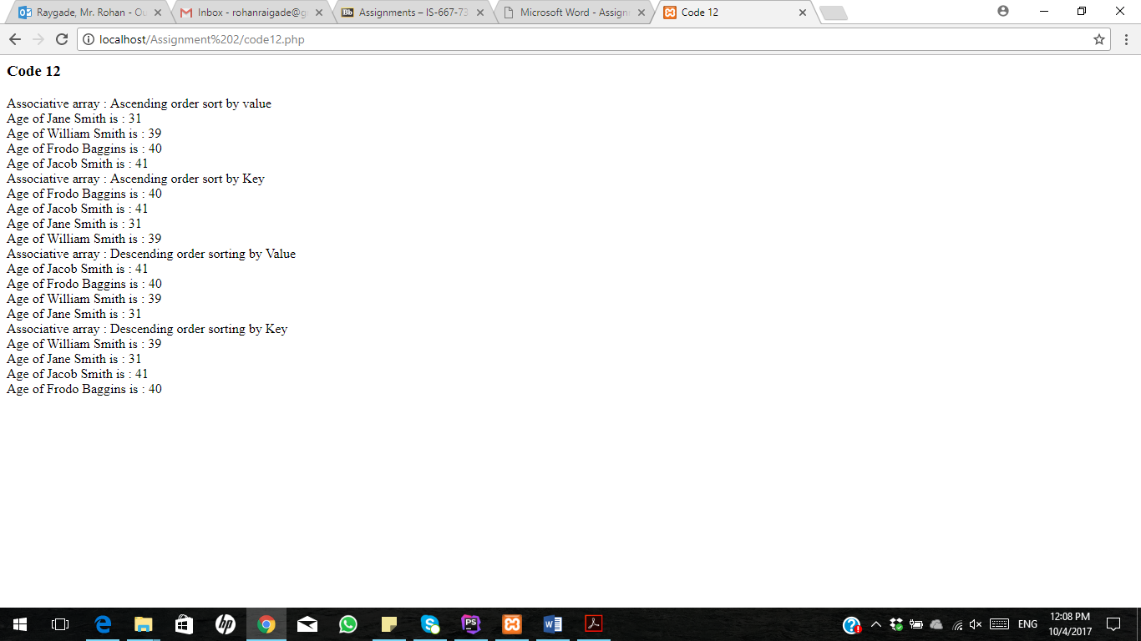

CODE 13:

<**html**>  
<**head**>  
 <**title**> Code 13 </**title**>  
</**head**>  
<**body**>  
**<?php  
echo "<h3>Code 13 </h3>"**;  
**for**($a=1;$a<=5;$a++)  
{  
 **for** ($b=1;$b<=$a;$b++)  
 {  
 **echo "*"**;  
 **if**($a< $b)  
 {  
 **echo " "**;  
 }  
 }  
 **echo"<br>"**;  
}  
**"<br><br>"**;  
**?>**</**body**>  
</**html**>

OUTPUT:

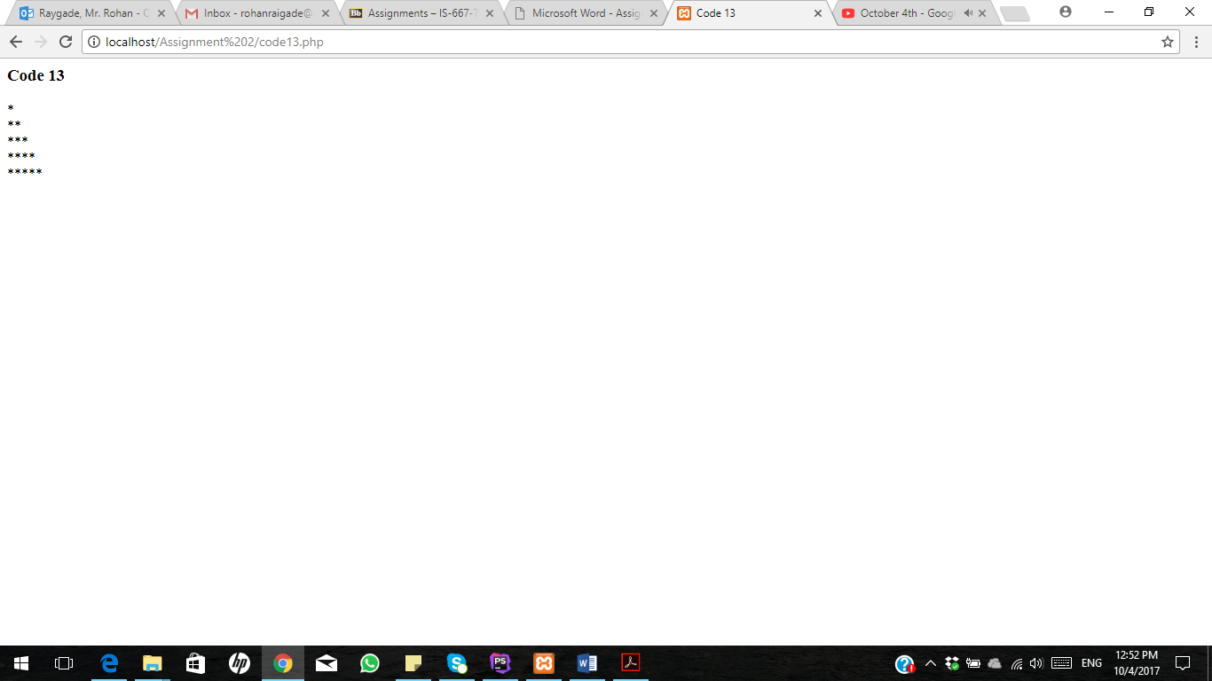

CODE 14:

<**html**>  
<**head**>  
 <**title**> Code 14 </**title**>  
</**head**>  
<**body**>  
**<?php  
for**($x=150;$x<=500;$x++)  
{  
 **if**($x%6==0)  
 **echo** $x.**','**;  
}  
**"<br>"**;  
**?>**</**body**>  
</**html**>

OUTPUT:

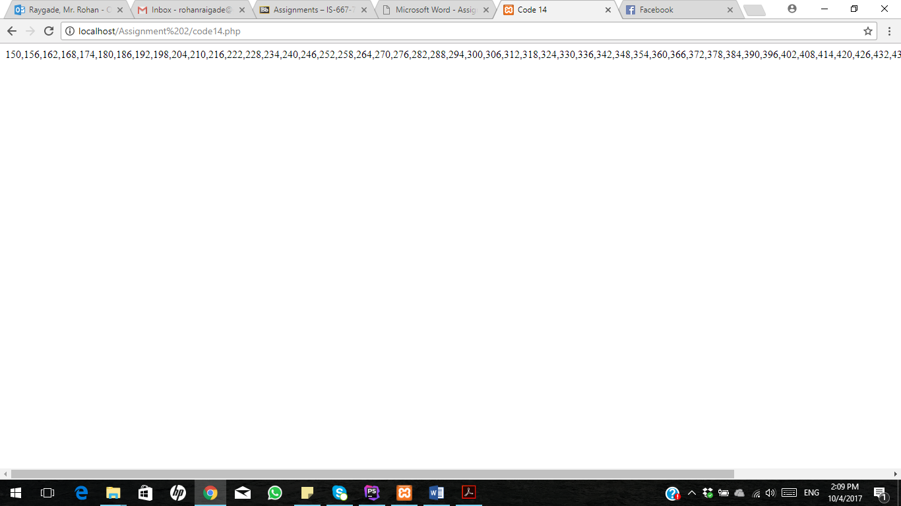

CODE 15:

<html>  
<head>  
 <title> Code 15 </title>  
</head>  
<body>  
<?php  
$dt = "2017-09-24";  
echo 'First day : '. date("Y-m-01", strtotime($dt)).' - Last day : '. date("Y-m-t", strtotime($dt));  
"<br>";  
?>  
</body>  
</html>

OUTPUT:

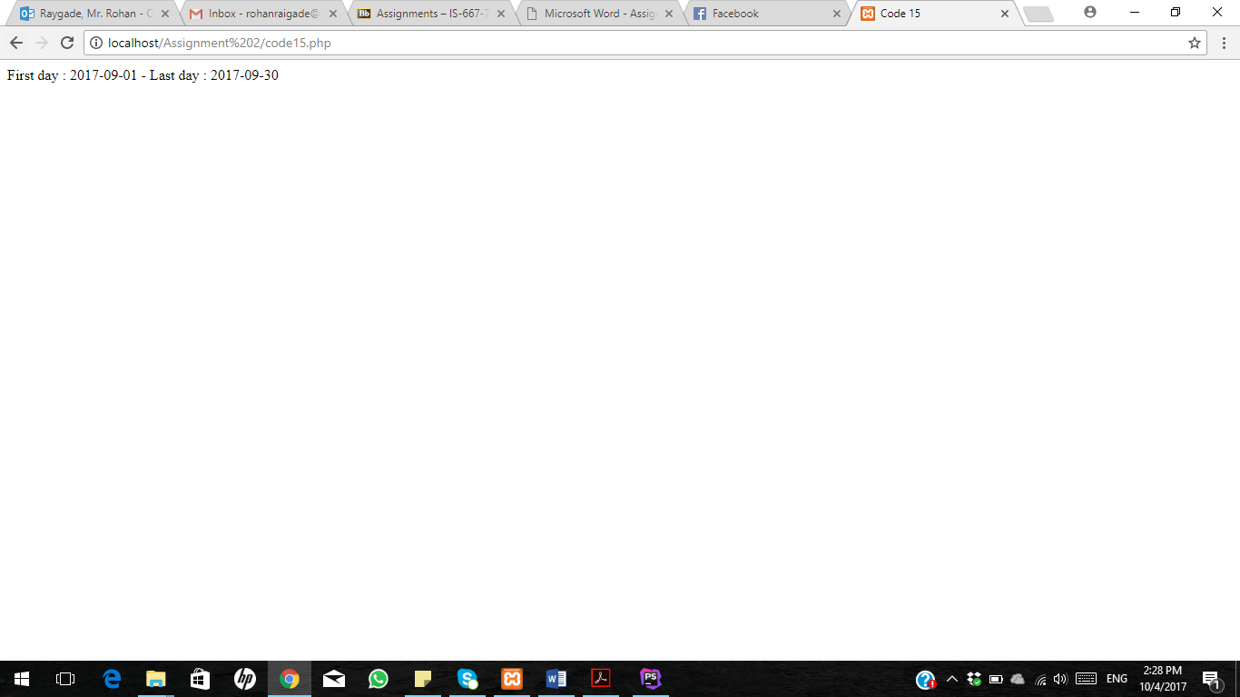

CODE 16:

<**html**>  
<**head**>  
</**head**>  
<**body**>  
<**h1**>Code 16 </**h1**>  
<**p**>© **<?php echo** *date*(**'Y'**); **?>** Rohan Raygade</**p**>  
</**body**>  
</**html**>

OUTPUT:

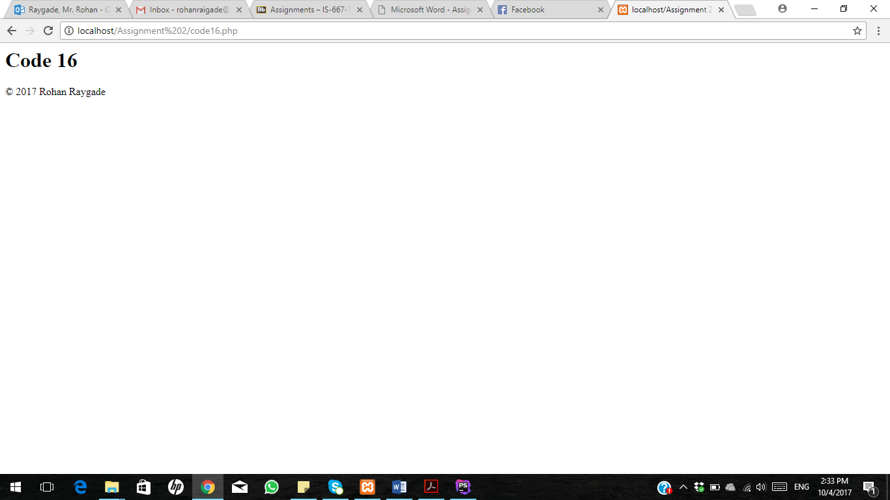

CODE 17:

<**html**>  
<**head**>  
 <**title**> Code 17 </**title**>  
</**head**>  
<**body**>  
**<?php  
echo** *date*(**"Y/m/d"**). **"\n"**.**"<br>"**;  
**echo** *date*(**"y.m.d"**). **"\n"**.**"<br>"**;  
**echo** *date*(**"d-m-y"**).**"\n"**.**"<br>"**;  
**?>**</**body**>  
</**html**>

OUTPUT:

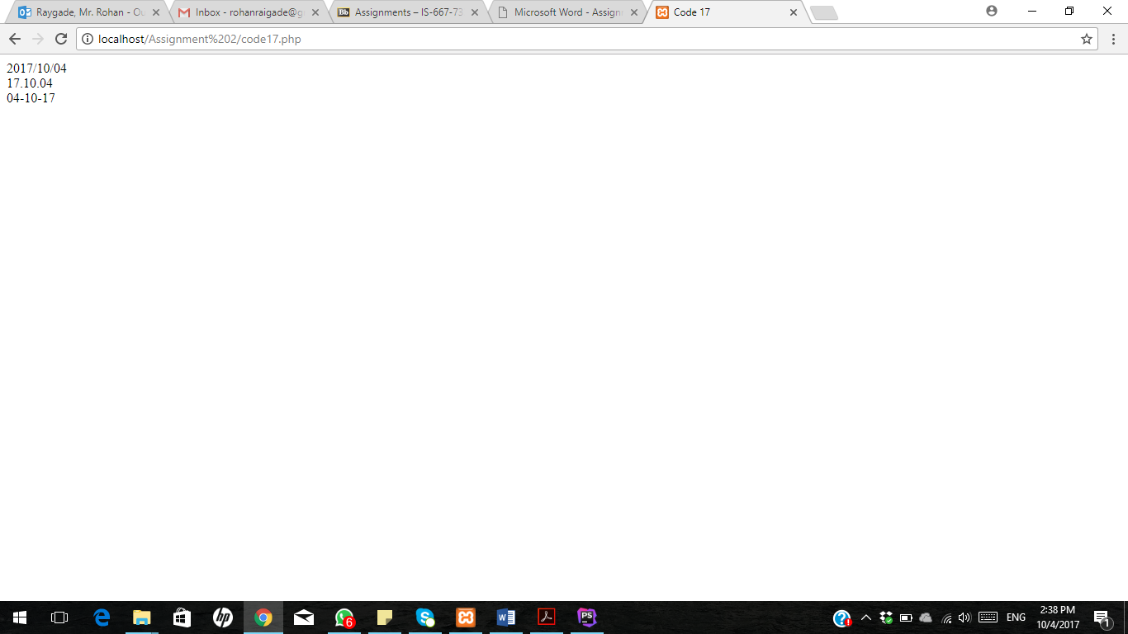

CODE 18:

<**html**>  
<**head**>  
 <**title**> Code 18 </**title**>  
</**head**>  
<**body**>  
<**table width="270px" cellspacing="0px" cellpadding="0px" border="1px"**>  
 **<?php  
 echo "<h3>Code 18 </h3>"**;  
 **for**($row=1;$row<=8;$row++)  
 {  
 **echo "<tr>"**;  
 **for**($col=1;$col<=8;$col++)  
 {  
 $total=$row+$col;  
 **if**($total%2==0)  
 {  
 **echo "<td height=30px width=30px bgcolor=#FFFFFF></td>"**;  
 }  
 **else** {  
 **echo "<td height=30px width=30px bgcolor=#000000></td>"**;  
 }  
 }  
 **echo "</tr>"**;  
 }  
 **"<br><br>"**;  
 **?>**</**table**>  
</**body**>  
</**html**>

OUTPUT:

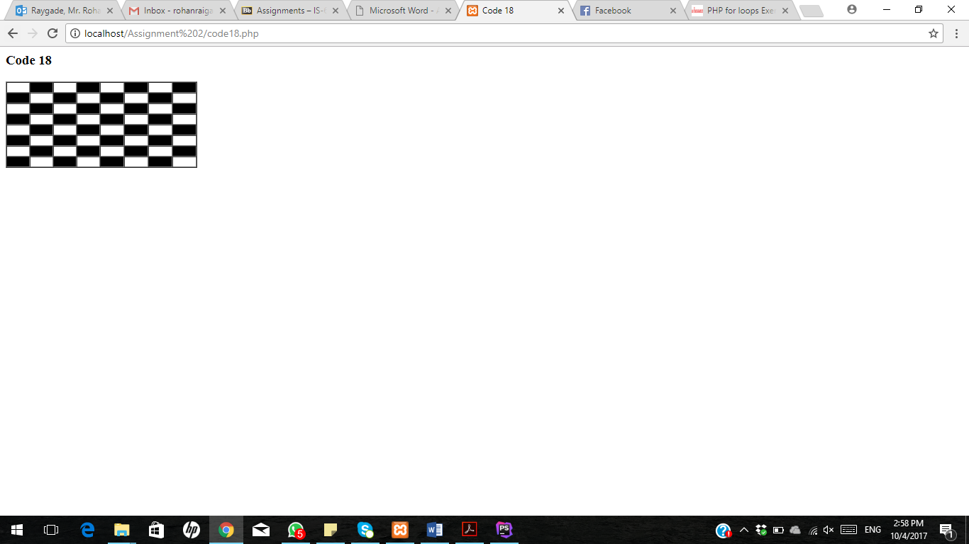

CODE 19:

<**html**>  
<**head**>  
</**head**>  
<**body**>  
**<?php  
echo "<h4>Code 19 </h4>"**;  
*var_dump*(*checkdate*(2017,-25,30));  
**?>**</**body**>  
</**html**>

OUTPUT:

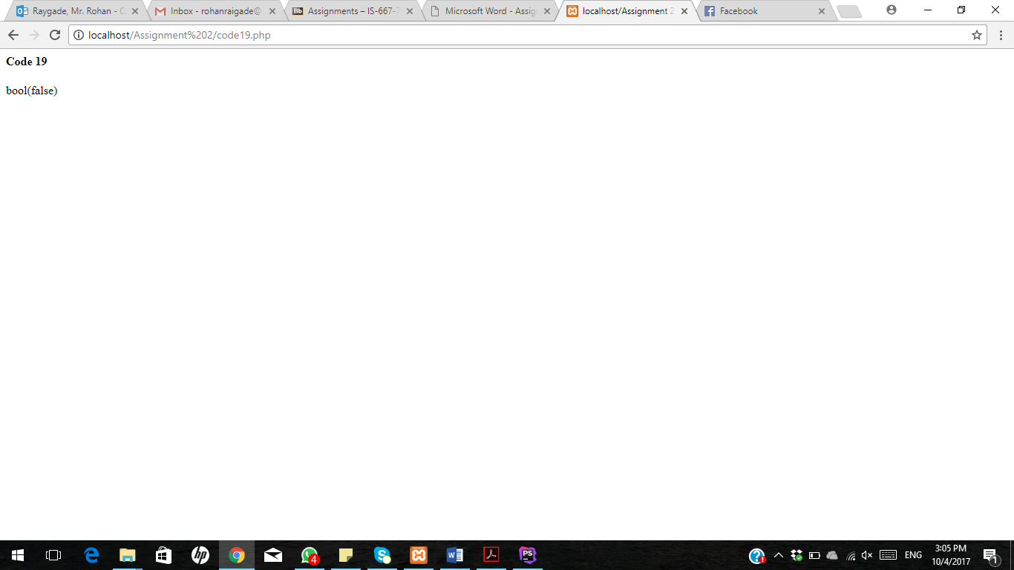

CODE 20:

<**html**>  
<**head**>  
</**head**>  
<**body**>  
**<?php  
echo "<h2>Code 20 </h2>"**;  
**function** roundout ($value, $places=0)  
{  
**if** ($places < 0) { $places = 0; }  
$a= *pow*(10, $places);  
**return** ($value >= 0 ? *ceil*($value * $a):*floor*($value * $a)) / $a;  
}  
**echo** roundout (78.78001, 2).**"\n"**.**"<br>"**;  
**echo** roundout (8.131001, 2).**"\n"**.**"<br>"**;  
**echo** roundout (0.586001, 4).**"\n"**.**"<br>"**;  
**echo** roundout (-.125481, 3).**"\n"**.**"<br>"**;  
**echo** roundout (-.125481);  
**?>**</**body**>  
</**html**>

OUTPUT:

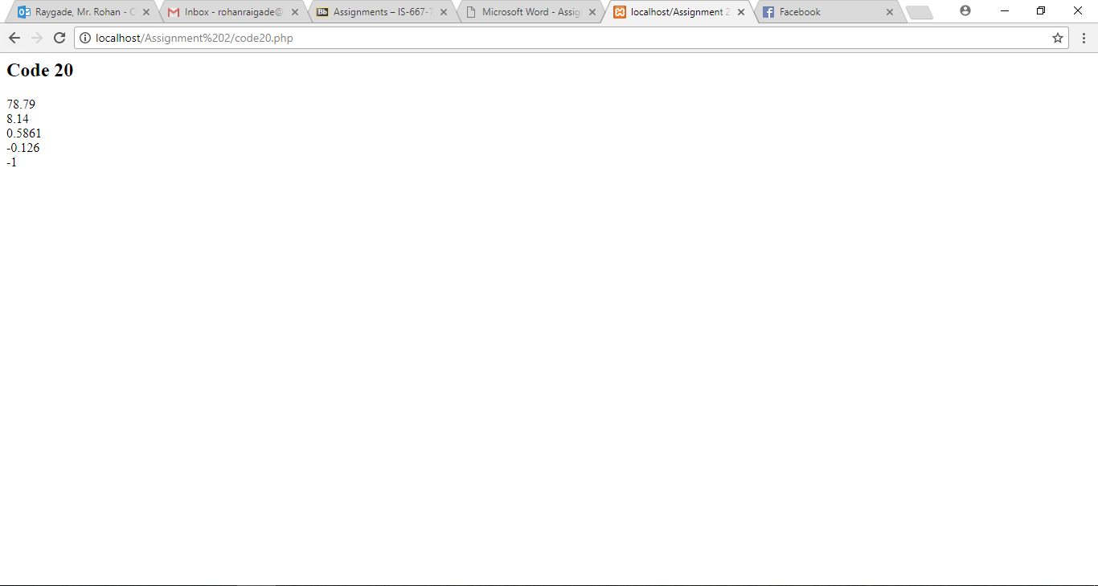

CODE 21:

<**html**>  
<**head**>  
</**head**>  
<**body**>  
**<?php  
echo "<h2>Code 21 </h2>"**;  
$path = **'www.example.com/public_html/index.php'**;  
$file_name = *substr*(*strrchr*($path, **"/"**), 1);  
**echo** $file_name.**"\n"**; *// "index.php"***?>**</**body**>  
</**html**>

OUTPUT:

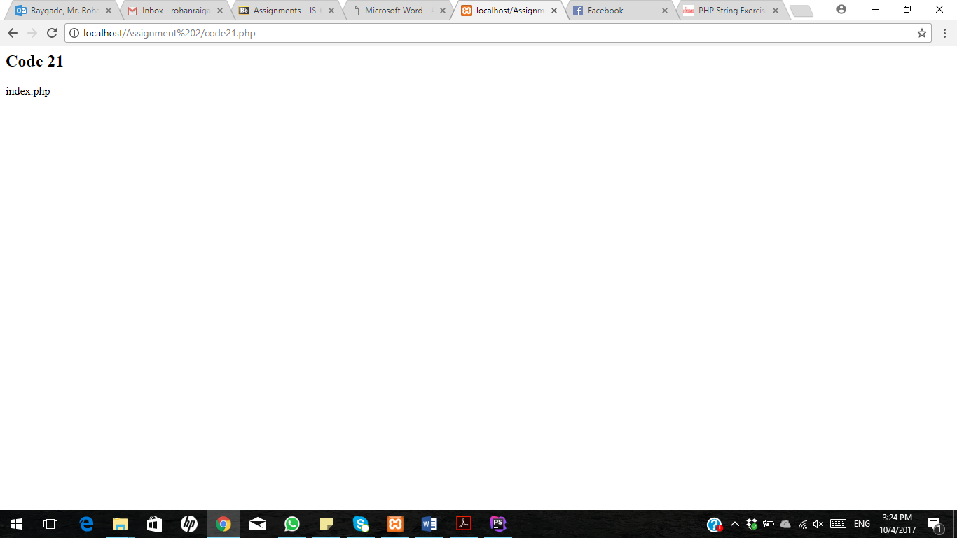

CODE 22:

<**html**>  
<**head**>  
</**head**>  
<**body**>  
**<?php  
function** randompassword_generate($chars)  
{  
 $data = **'1234567890ABCDEFGHIJKLMNOPQRSTUVWXYZabcefghijklmnopqrstuvwxyz'**;  
 **return** *substr*(*str_shuffle*($data), 0, $chars);  
}  
 **echo** randompassword_generate(10).**"\n"**;  
**?>**</**body**>  
</**html**>

OUTPUT:

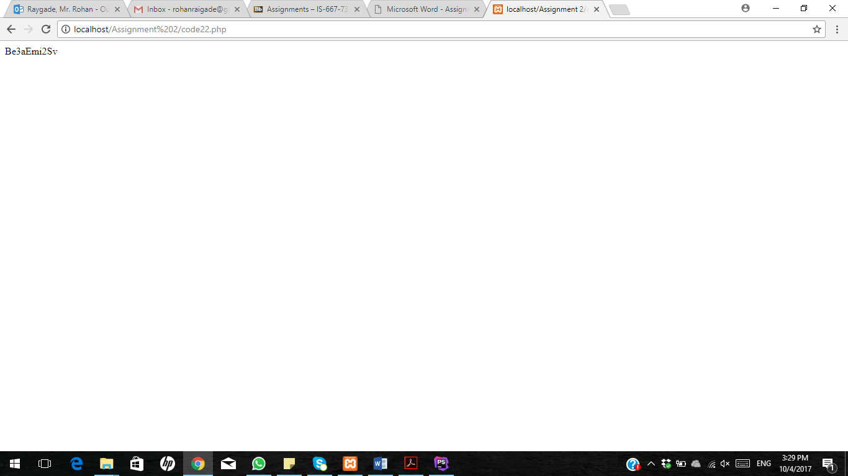

CODE 23:

<**html**>  
<**head**>  
<**title**> Code 23 </**title**>  
</**head**>  
<**body**>  
**<?php  
echo "<h2>Code 23 </h2>"**;  
$my_url = **'http://www.example.com/5478631'**;  
**echo** *substr*($my_url, *strrpos*($my_url, **'/'** )+1).**"\n"**.**"<br><br>"**;  
**?>**</**body**>  
</**html**>

OUTPUT:

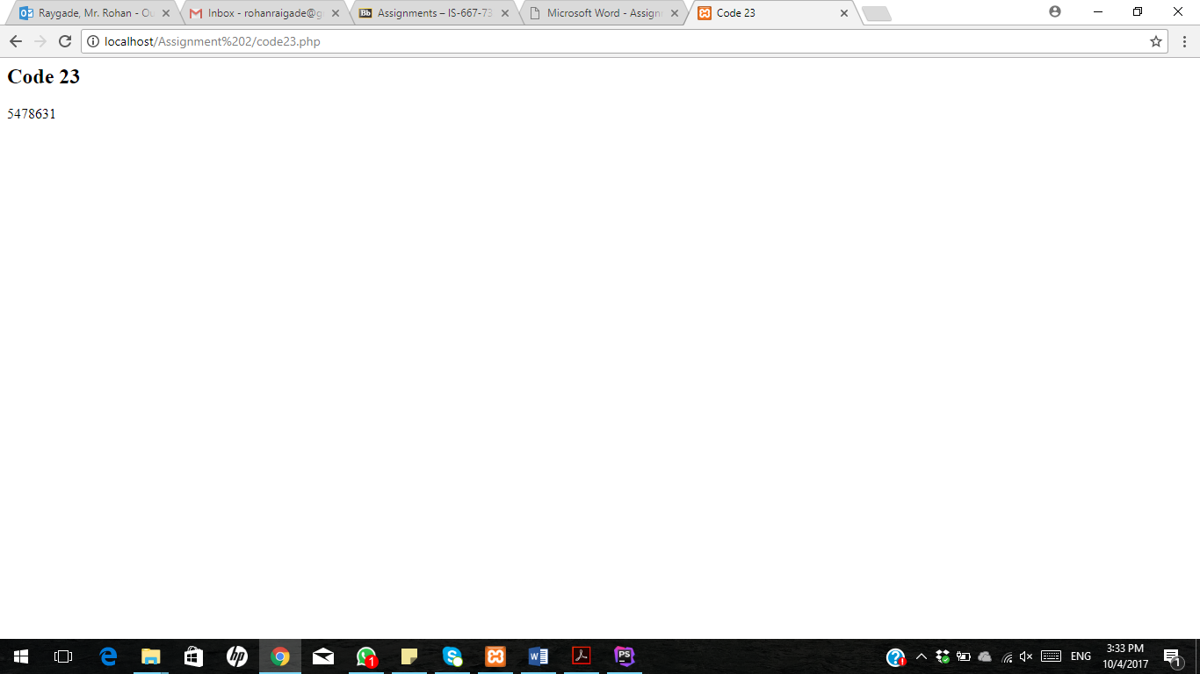

CODE 24:

<**html**>  
<**head**>  
</**head**>  
<**body**>  
**<?php  
echo "<h2>Code 24 </h2>"**;  
**for** ($x = *ord*(**'a'**); $x <= *ord*(**'z'**); $x++)  
**echo** *chr*($x);  
**echo "\n"**.**"<br><br>"**;  
**?>**</**body**>  
</**html**>

OUTPUT:

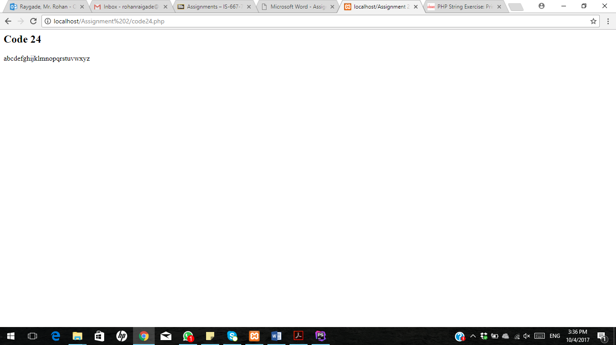

CODE 25:

<**html**>  
<**head**>  
 <**title**> Code 25 </**title**>  
</**head**>  
<**body**>  
**<?php  
echo "<h2>Code 25 </h2>"**;  
$n=5;  
**for**($a=1; $a<=$n; $a++)  
{  
 **for**($b=1; $b<=$a; $b++)  
 {  
 **echo ' * '**;  
 }  
 **echo "<br>"**;  
}  
**for**($a=$n; $a>=1; $a--)  
{  
 **for**($b=1; $b<=$a; $b++)  
 {  
 **echo ' * '**;  
 }  
 **echo "<br>"**;  
}  
**?>**</**body**>  
</**html**>

OUTPUT:

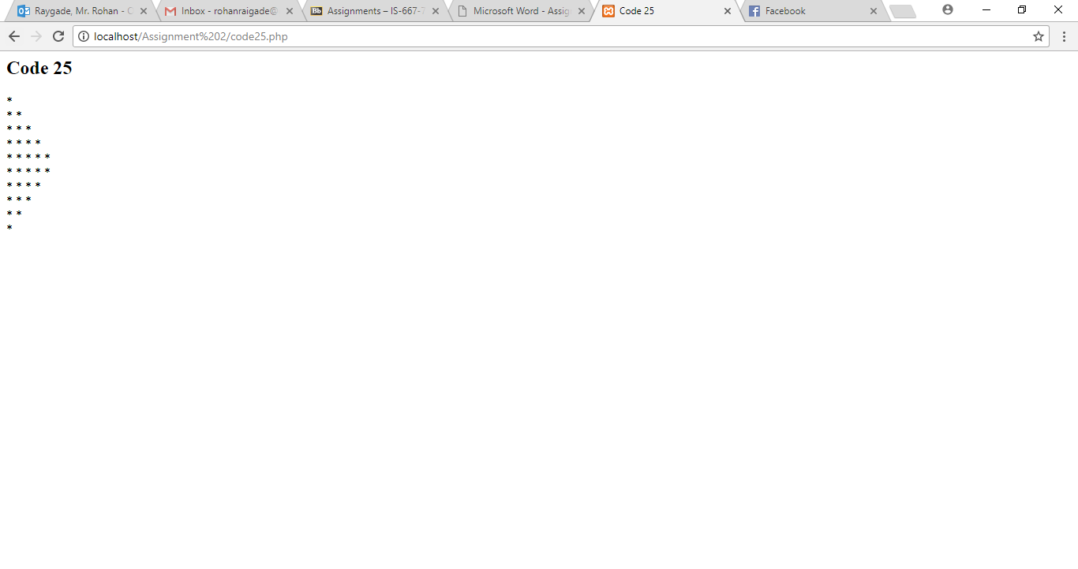

CODE 26:

<**html**>  
<**head**>  
</**head**>  
<**body**>  
**<?php  
echo "<h2>Code 26 </h2>"**;  
**echo "All Uppercase Letters"**.**"<br>"**;  
**print**(*strtoupper*(**"hi! i am rohan raygade"**)).**"<br><br>"**;  
**echo "All Lowercase Letters"**.**"<br>"**;  
**print**(*strtolower*(**"HI! I AM ROHAN RAYGADE"**)).**"<br><br>"**;  
**echo "First Character Uppercase"**.**"<br>"**;  
**print**(*ucfirst*(**"hi! i am rohan raygade"**)).**"<br><br>"**;  
**echo "String's first Character Uppercase"**.**"<br>"**;  
**print**(*ucwords*(**"hi! i am rohan raygade"**)).**"<br><br>"**;  
**?>**</**body**>  
</**html**>

OUTPUT:

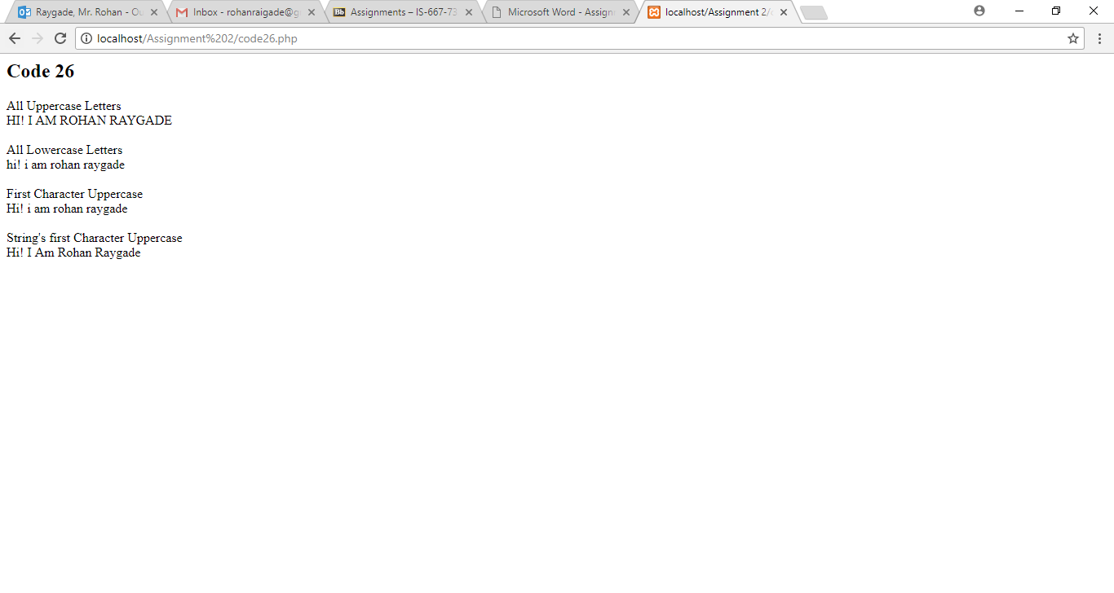

CODE 27:

<**html**>  
<**head**>  
</**head**>  
<**body**>  
**<?php  
echo "<h2>Code 27 </h2>"**;  
**for** ($i=1; $i<=9; $i++)  
{  
 **echo "pqr"**.**" "**;  
}  
**echo "<br><br>"**;  
  
**for** ($i=1; $i<=9; $i++)  
{  
 **echo "asdf"**.**" "**;  
}  
**echo "<br><br>"**;  
**for** ($i=1; $i<=15; $i++)  
{  
 **echo** $i.**" "**;  
}  
**echo "<br><br>"**;  
**for** ($i=1, $x= **'A'**; $i<=6,$x <= **'F'** ; $i++,$x++)  
 **echo** $i.**". Block "**. $x.**"<br>"**;  
**?>**</**body**>  
</**html**>

OUTPUT:

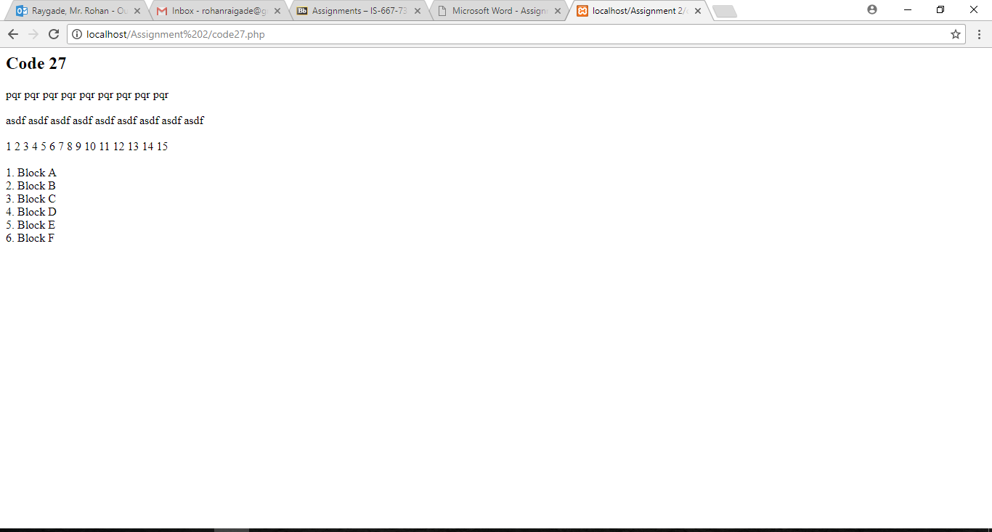

CODE 28:

<**html**>  
<**head**>  
</**head**>  
<**body**>  
**<?php  
echo "<h3>Code 28 </h3>"**;  
**for** ($count = 1; $count < 20; $count++){  
 $squared = $count * $count;  
 **print**(**"**$count **\*** $count **=** $squared **\n"**);  
 **echo "<br><br>"**;  
}  
**?>**</**body**>  
</**html**>

OUTPUT:

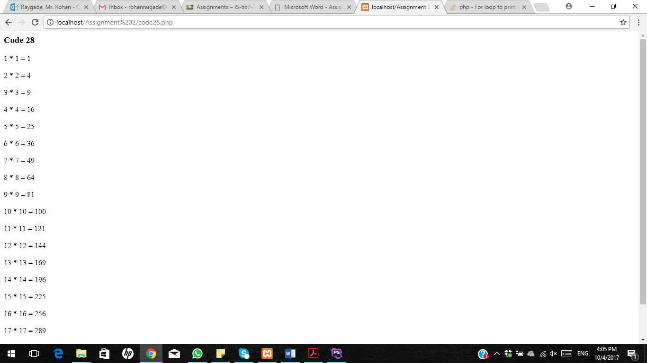

CODE 29:

<**html**>  
<**head**>  
</**head**>  
<**body**>  
**<?php  
echo "<h3>Code 29 </h3>"**;  
**echo "<table align=\"left\" border=\"1\" cellpadding=\"2\" cellspacing=\"2\">"**;  
**for**($i=1;$i<=7;$i++)  
{  
 **echo "<tr>"**;  
 **for** ($j=1;$j<=7;$j++)  
 {  
 **echo "<td>"**.$i*$j.**"</td>"**;  
 }  
 **echo "</tr>"**;  
}  
**echo "</table>"**;  
**echo "<br><br>"**;  
**?>**<**br**><**br**>  
</**body**>  
</**html**>

OUTPUT:

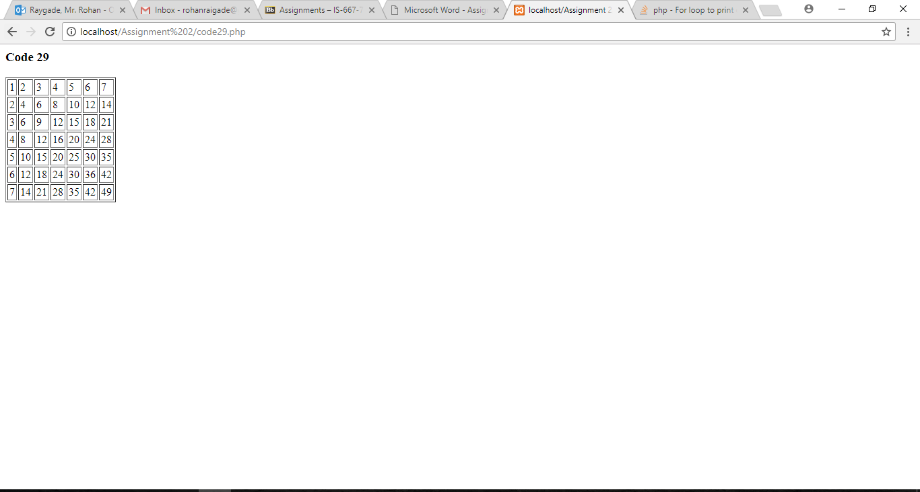

CODE 30:

<**html**>  
<**head**>  
</**head**>  
<**body**>  
**<?php  
echo "<h3>Code 30 </h3>"**;  
$n = 4;  
$x = 1;  
**for**($a=1;$a<=$n-1;$a++)  
{  
 $x*=($a+1);  
}  
**echo "The factorial of** $n **=** $x**"**.**"<br><br>"**;  
**?>**</**body**>  
</**html**>

OUTPUT:

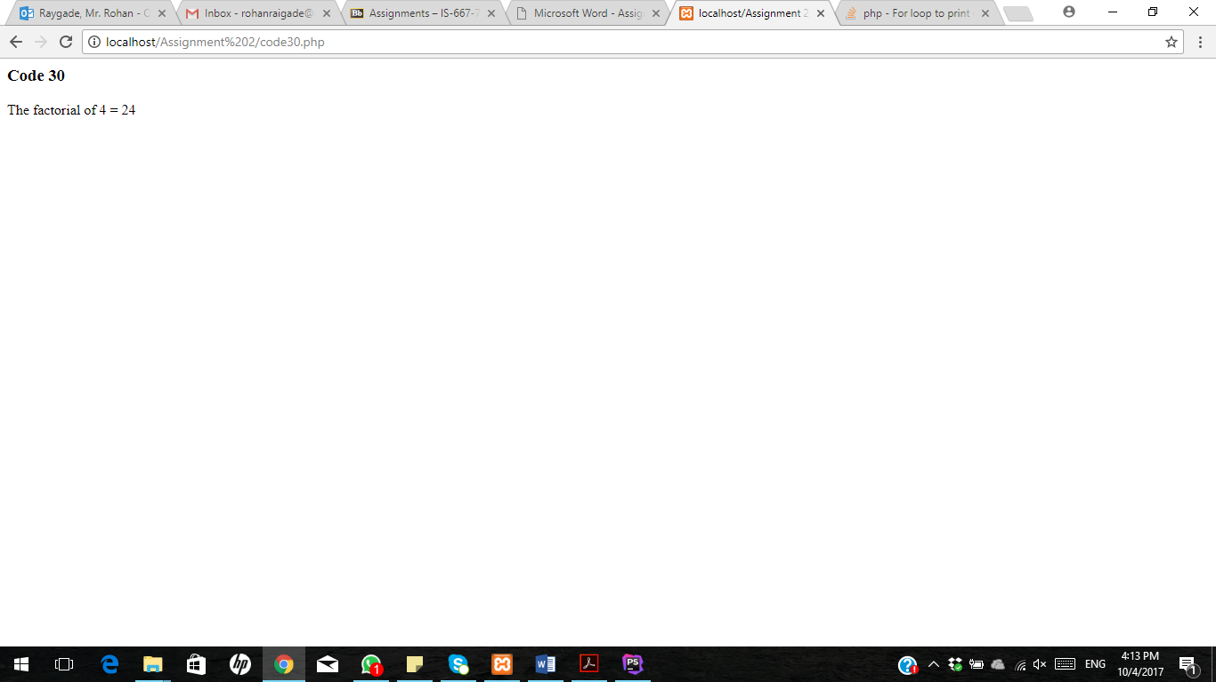

CODE 31:

<**html**>  
<**head**>  
</**head**>  
<**body**>  
**<?php  
echo "<h2>Code 31 </h2>"**;  
**echo "<table align=\"left\" border=\"1\" cellpadding=\"2\" cellspacing=\"2\">"**;  
**for** ($row=1; $row <= 10; $row++) {  
 **echo "<tr> \n"**;  
 **for** ($col=1; $col <= 10; $col++) {  
 $p = $col * $row;  
 **echo "<td>**$p**</td> \n"**;  
 }  
 **echo "</tr>"**;  
}  
**echo "</table>"**;  
**?>**</**body**>  
</**html**>

OUTPUT:

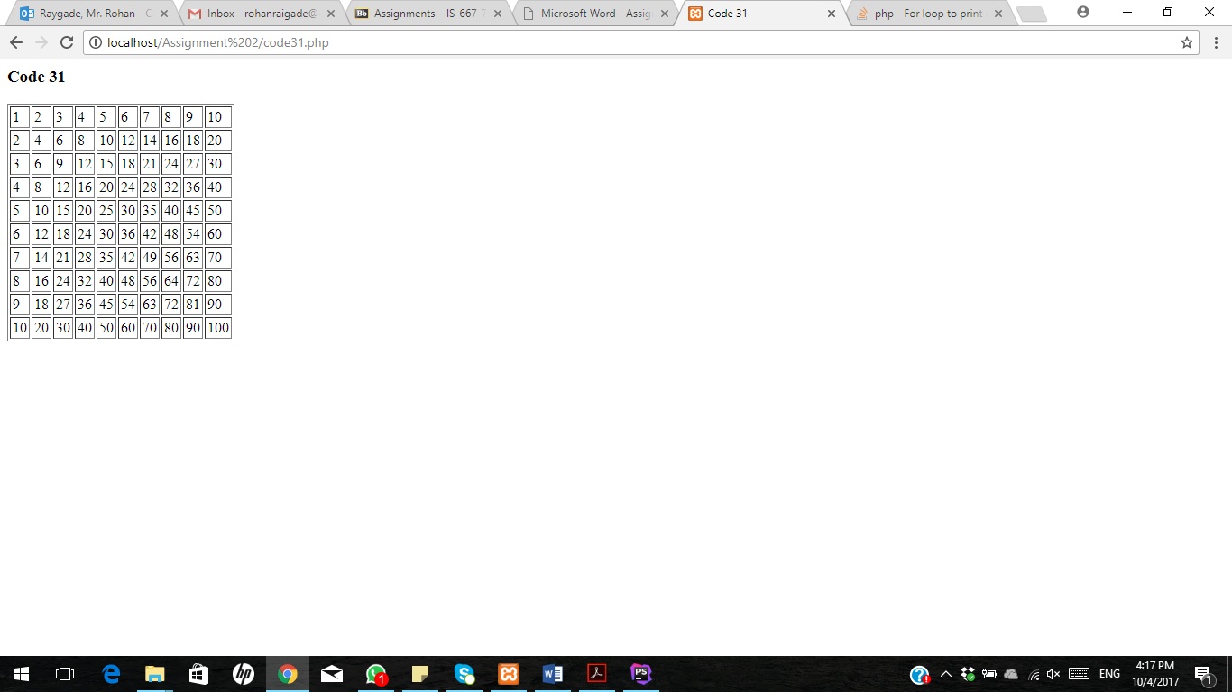

CODE 32:

<**HTML**>  
<**HEAD**>  
 <**TITLE**><**center**>Assignment 1 - My First Web Page</**center**></**TITLE**>  
 <**style**>  
 **table**, **th**, **td** {  
 **border**: 1**px solid black**;  
 **border-collapse**: **collapse**;  
 }  
 **th**, **td** {  
 **padding**: 5**px**;  
 **text-align**: **left**;  
 }  
 </**style**>  
</**HEAD**>  
  
<**BODY**>  
<**H1**><**center**>My First Web Page</**center**></**H1**>  
<**H2**><**center**>My Name is Rohan Raygade</**center**></**H2**>  
<**H3**><**center**><**a href=" https://www.linkedin.com/in/rohanraygade"**</**center**> https://www.linkedin.com/in/rohanraygade </**a**></**H3**>  
<**center**><**img src="rohan1.jpg" alt="error" height="100" width="100"**></**center**>  
<**P**> <**ul**> <**li**> Hello,Myself Rohan Raygade pursing MS in Computer Science from Pace University.</**li**>  
 <**li**> I have completed Undergrad Studies back in India at University of Pune. I also have experience working with Tieto (MNC from Finland) as a Software Engineer for Web Development. I have hands on  
 experiance in asp.net, C#, MSSQL, Java. Here from this class i am expecting to learn and enhace my skill in front end development and Database design  
 with relation to Web Development. </**li**></**ul**>  
  
  
<**div style="width**:35% ; **float**: **left"**>  
 <**H3**><**left**>GET Method</**left**></**H3**>  
 <**form name="index" action="get.php" method="get"**>  
 First name:<**br**>  
 <**input type="text" name="firstname"**><**br**>  
 Last name:<**br**>  
 <**input type="text" name="lastname"**><**br**>  
 Address:<**br**>  
 <**input type="text" name="address"**><**br**>  
 Date:<**br**>  
 <**input type="date" name="date"**><**br**>  
  
 <**input type="radio" name="gender" value="male" checked**> Male<**br**>  
 <**input type="radio" name="gender" value="female"**> Female<**br**>  
 <**input type="radio" name="gender" value="other"**> Other<**br**>  
  
  
 Highest Education:<**br**>  
 <**input type="checkbox" name="education" value="MS" checked**> MS<**br**>  
 <**input type="checkbox" name="education" value="BS"** > BS<**br**>  
 <**input type="checkbox" name="education" value="BA"** > BA<**br**>  
 <**input type="submit" value="Submit"**>  
  
 </**form**>  
</**div**>  
  
  
<**div style="width**:65% ; **float**: **right"**>  
 <**H3**><**left**>POST Method</**left**></**H3**>  
 <**form name="index" action="post.php" method="post"**>  
 First name:<**br**>  
 <**input type="text" name="firstname"**><**br**>  
 Last name:<**br**>  
 <**input type="text" name="lastname"**><**br**>  
 Address:<**br**>  
 <**input type="text" name="address"**><**br**>  
 Date:<**br**>  
 <**input type="date" name="date"**><**br**>  
  
 <**input type="radio" name="gender" value="male" checked**> Male<**br**>  
 <**input type="radio" name="gender" value="female"**> Female<**br**>  
 <**input type="radio" name="gender" value="other"**> Other<**br**>  
  
  
 Highest Education:<**br**>  
 <**input type="checkbox" name="education" value="MS" checked**> MS<**br**>  
 <**input type="checkbox" name="education" value="BS"** > BS<**br**>  
 <**input type="checkbox" name="education" value="BA"** > BA<**br**>  
 <**input type="submit" value="Submit"**>  
  
 </**form**>  
</**div**>  
</**centre**>  
  
  
  
</**BODY**>  
</**HTML**>

OUTPUT 1:

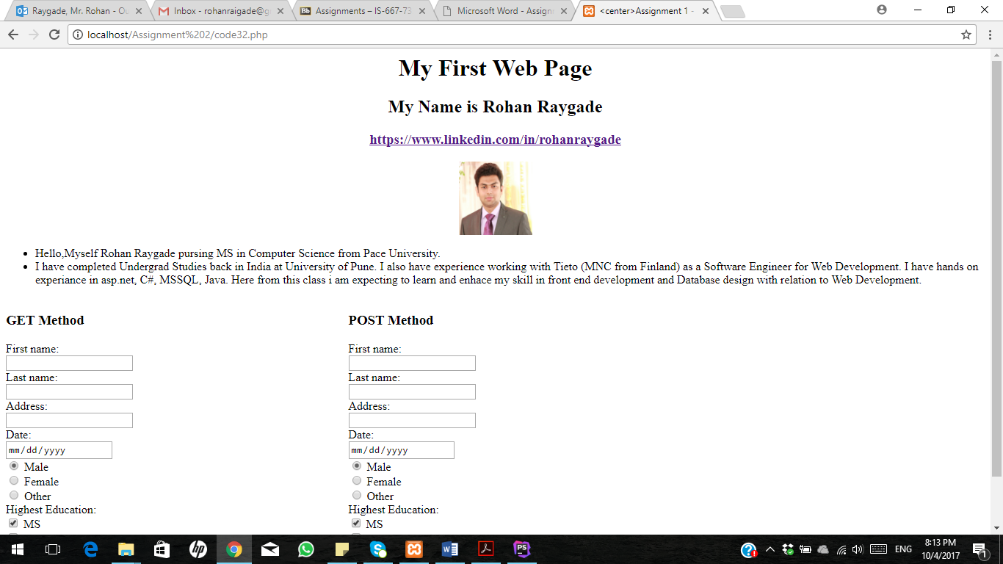

OUTPUT 2:

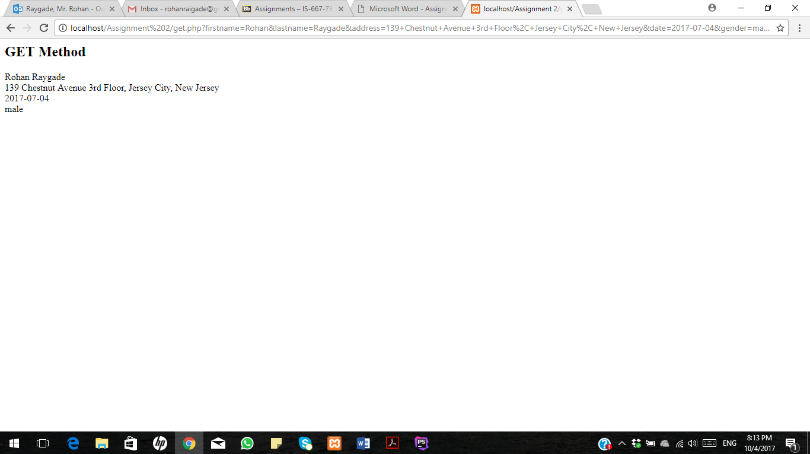

OUTPUT 3:

