# DAA-Hands-on-

Implement:

insertion sort: DAA Hands On 2/insertionSort.py

selection sort: DAA Hands On 2/selectionSort.py

bubble sort: DAA Hands On 2/bubbleSort.py

In the discussion:

Post a link to your GitHub repository(s) with the source code.

Argue selection sort correctness. Solution: DAA Hands On 2/Correctnessofselectionsort.pdf

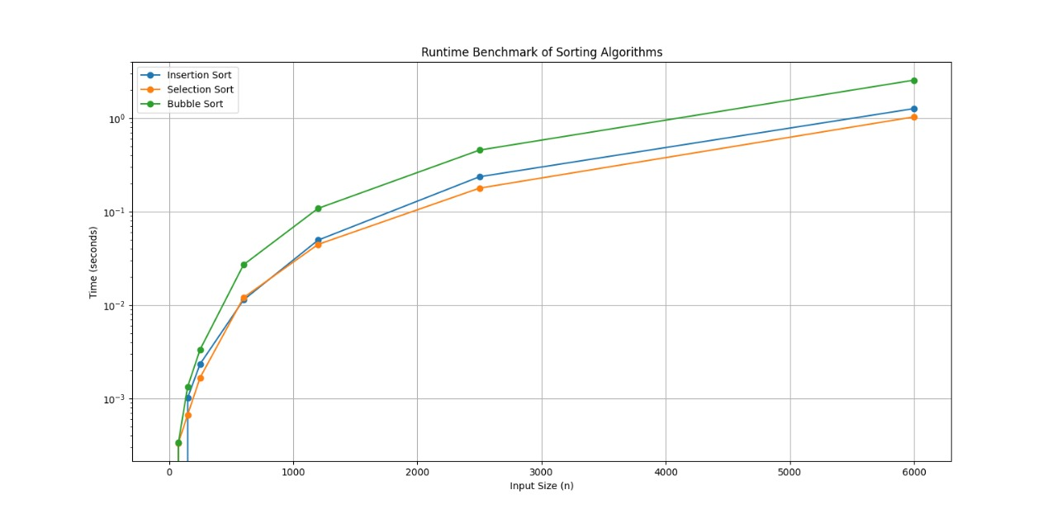

Benchmark the runtime of each algorithm. Your benchmarks should include information about your computer (RAM, CPU etc.) and be run with various input sizes; from small (array of size 5,10,20) up to large arrays (where your computer is struggling). I should see a plot of time vs input size n. Feel free to use benchmarking software.