
RAJARAMBAPU INSTITUTE OF TECHNOLOGY, RAJARAMNAGAR

(An Empowered Autonomous Institute, Affiliated to Shivaji University, Kolhapur)
A PROJECT REPORT ON
“DeepCheck: Deep Learning Based Semantic Plagiarism Detection System”
Submitted in partial fulfilment of the requirements for the degree of
Master of Computer Applications (MCA)
By
Rohan Sandip Sapate
Roll No.: 2547039
Under the guidance of
Mrs. M. C. Satape

Department of Computer Applications
Rajarambapu Institute of Technology, Rajaramnagar, Maharashtra
Academic Year [2026–2027]

CERTIFICATE
This is to certify that the project entitled “DeepCheck: Deep Learning Based Semantic Plagiarism Detection System” is a bonafide work carried out by Rohan Sandip Sapate, Roll No. 2547039, a student of the Master of Computer Applications programme, in partial fulfilment of the requirements for the award of the degree of Master of Computer Applications during the academic year [2026–2027].
The work embodied in this report has not been submitted to any other university or institution for the award of any degree or diploma.

Name of Student: Rohan Sandip Sapate
PRN: 2547039

Date:
Place: Rajarambapu Institute of Technology, Rajaramnagar

Mrs. M. C. Satpe Dr. M. P. Pawar Examiner
Project Guide HOD

ACKNOWLEDGEMENT
I take this opportunity to express my sincere gratitude to my project guide, Mrs. M. C. Satpe, for the guidance, patience and constructive criticism that shaped this work from its first proposal to its final form. Their insistence on careful evaluation helped me to be honest about what the system does and does not yet achieve.
I thank the Head of the Department of Computer Applications and all faculty members for providing the academic environment and resources needed for this project. I am grateful to the Principal and the management of Rajarambapu Institute of Technology for supporting the MCA programme.
Finally, I thank my family and friends for their encouragement throughout the course of this project. Any errors or shortcomings in this report are entirely my own.

Place: RIT, Rajaramnagar.
Date:

Name of Student: Rohan Sandip Sapate
Roll No: 2547039

ABSTRACT
Plagiarism in academic and professional writing increasingly takes forms that exact string matching cannot detect, including close paraphrase, synonym substitution, restructured sentences and translation. This report describes DeepCheck, a web-based semantic plagiarism detection system developed as an MCA final-year project. DeepCheck segments an input document into sentences, encodes each sentence as a 384-dimensional normalised vector using a Sentence-BERT model (all-MiniLM-L6-v2), retrieves the nearest reference sentences from a FAISS flat inner-product index, and classifies each sentence according to its similarity score. Results are presented as a sentence-level heatmap, a source inspector and an aggregate similarity score, and reports can be exported as PDF or JSON. The system also includes a pairwise comparator, a corpus manager, a multilingual detector and a benchmark that compares the embedding approach with a TF-IDF and k-gram baseline.
The implementation was checked with an eight-test unit suite, and all tests passed. The evaluation in this report, however, was run without the pretrained transformer model, because the model could not be downloaded in the test environment. The embedder therefore used a hash-based fallback. The measurements show that this fallback is not semantic and is not reproducible across separate runs. The fine-tuning module simulates a training loop with random values, and the Siamese network and its loss functions are not connected to the detection pipeline. The report documents these limitations and identifies the steps needed for a validated evaluation on a labelled corpus.
Keywords: plagiarism detection, Sentence-BERT, semantic similarity, FAISS, FastAPI, paraphrase detection, text reuse

TABLE OF CONTENTS
Content | Page No.
CHAPTER 1: INTRODUCTION | 1
1.1 Background Information | 1
1.2 Problem Statement | 1
1.3 Project Objectives | 2
CHAPTER 2: LITERATURE REVIEW | 3
CHAPTER 3: METHODOLOGY | 6
3.1 Flow Sheet of Methodology | 6
3.2 Step by Step Detailed Methodology | 7
CHAPTER 4: HARDWARE AND SOFTWARE REQUIREMENTS | 12
CHAPTER 5: RESULTS AND DISCUSSIONS | 14
5.1 Test Environment | 14
5.2 Unit Test Results | 14
5.3 Benchmark Results | 15
5.4 Observations and Limitations | 16
5.5 Discussion | 17
CHAPTER 6: CONCLUSION | 19
CHAPTER 7: FUTURE SCOPE | 20
CHAPTER 8: REFERENCES | 21
TIME FRAME / ACTIVITY CHART | 22
USER MANUAL | 23
SNAPSHOTS OF WORKING MODEL | 25

CHAPTER 1: INTRODUCTION

1.1 Background Information
Plagiarism, the presentation of another person’s words, ideas or work without adequate acknowledgement, is a persistent problem in universities, research and publishing. Maurer, Kappe and Zaka (2006) provide a survey of plagiarism and its detection. Plagiarism is not a single behaviour. It ranges from verbatim copying, through light editing of copied passages, to close paraphrase in which the sentences are rewritten but the structure and substance remain borrowed, and to translation of a source into another language.
Most detection tools historically relied on lexical overlap. They break documents into word sequences, fingerprints or n-grams and count the fragments that two documents share. Techniques such as shingling and resemblance estimation (Broder, 1997) and winnowing (Schleimer, Wilkerson & Aiken, 2003) are effective when a passage has been copied with small changes. Their accuracy drops when words are replaced with synonyms or when sentences are reordered, because the surface form of the text has changed even though its meaning has not.
Recent work in natural language processing has produced dense vector representations that encode meaning rather than surface form. Sentence-BERT (Reimers & Gurevych, 2019) produces sentence embeddings whose cosine similarity reflects semantic closeness, so that two sentences expressing the same idea in different words lie near each other in the vector space. Combined with a similarity-search library such as FAISS (Johnson, Douze & Jégou, 2019), this makes it practical to compare a submission against a large reference corpus within interactive response times.
DeepCheck is an attempt to package these ideas into a usable system for an academic setting. A user pastes text or uploads a document and receives a sentence-level account of where it resembles the reference corpus, together with the source sentence and an indication of the type of resemblance. The project was developed as the final-year deliverable of the Master of Computer Applications programme.

1.2 Problem Statement
Three problems motivate the project. The first is that lexical tools miss paraphrase. A sentence rewritten with synonyms and a new structure can score close to zero under n-gram overlap even when it is a faithful copy of its source. The second is that many tools report a single percentage without showing which sentences matched which sources, which makes it difficult for a reviewer to judge the evidence. The third is that a semantic system must still be practical. It must run on an ordinary development machine, allow reference documents to be added and removed, and respond quickly enough to be used interactively.
The problem addressed by this project is therefore to design and implement a system that detects semantically similar text against a reference corpus, explains each match at sentence level, and can be evaluated against a conventional baseline in a reproducible way. The report also considers whether the system’s claims are supported by its evaluation, because an uncritical account of a detection tool can mislead the people who rely on it.

1.3 Project Objectives
The objectives of the project were the following. The first was to build an ingestion pipeline that accepts pasted text as well as PDF, DOCX and TXT files. The second was to generate sentence embeddings with a pretrained Sentence-BERT model and to provide a fallback path when the model is unavailable. The third was to index reference documents in a vector store that supports adding, searching and deleting documents. The fourth was to classify each sentence match into severity bands and present the results as a heatmap with matched sources. The fifth was to provide a traditional baseline and a benchmark comparing it with the embedding approach. The sixth was to provide a pairwise document comparator, multilingual detection and report export. The seventh was to explore a Siamese fine-tuning architecture as a route to domain adaptation.
The first six objectives were implemented in the codebase. The seventh is only partially met, because the Siamese components are defined but not connected to the detection pipeline and the training module produces simulated output. Section 5 discusses this in detail.

CHAPTER 2: LITERATURE REVIEW
This chapter reviews the techniques that DeepCheck draws on, from classical text reuse detection to transformer-based sentence embeddings and approximate vector search. The aim is to explain why the system combines several components and where each component’s limitations lie.

2.1 Text Reuse and Plagiarism Detection
Plagiarism detection is usually framed as a text reuse problem. Maurer et al. (2006) distinguish external detection, which compares a suspicious document with a set of source documents, from intrinsic detection, which looks for changes in writing style without access to sources. DeepCheck performs external detection against its own reference corpus. Within external detection, systems differ in how they represent text, how they generate candidate sources, and how they decide that a passage is copied rather than coincidentally similar.

2.2 Fingerprinting and Lexical Matching
Broder (1997) introduced the resemblance measure for documents, which estimates the Jaccard similarity of sets of word shingles using min-wise hashing. Schleimer, Wilkerson and Aiken (2003) proposed winnowing, a fingerprinting scheme that selects a representative subset of hashes so that any match at or above a chosen length is guaranteed to be detected. The Rabin–Karp algorithm (Karp & Rabin, 1987) provides rolling hashes that allow substring comparisons to be computed efficiently. Term-weighting approaches such as TF-IDF (Salton & Buckley, 1988) represent documents as weighted word vectors and compare them by cosine similarity.
These lexical methods have three strengths: they are precise, computationally cheap, and their output is easy to explain, since the reviewer can see the shared words or phrases. Their weakness is that they measure surface overlap. A paraphrase that shares few exact phrases with its source may score poorly, while two unrelated texts on the same topic can share enough vocabulary to score moderately. For this reason, DeepCheck keeps a lexical baseline for comparison but uses a semantic method as its primary engine.

2.3 Distributed Word and Sentence Representations
Mikolov, Chen, Corrado and Dean (2013) showed that words could be represented as dense vectors learned from their contexts, so that words with similar usage have similar vectors. Averaging word vectors gives a crude sentence representation, but it ignores word order and gives every word the same influence. Transformer architectures (Vaswani et al., 2017) replaced recurrence with self-attention, which lets each token’s representation depend on the whole sentence. BERT (Devlin, Chang, Lee & Toutanova, 2019) applied this architecture to large-scale pretraining with a masked language modelling objective.
A limitation of raw BERT representations is that they are not designed for direct comparison. Sentence vectors taken from an unadapted BERT model often cluster by surface features and perform poorly on similarity tasks. This motivated methods that fine-tune transformers on sentence pairs so that the cosine similarity between their outputs becomes meaningful.

2.4 Sentence-BERT and Siamese Networks
Siamese networks apply the same encoder to two inputs and compare the resulting representations. Bromley, Guyon, LeCun, Säckinger and Shah (1993) introduced the architecture for signature verification. Hadsell, Chopra and LeCun (2006) formalised a contrastive loss that pulls similar pairs together and pushes dissimilar pairs apart by at least a margin. Schroff, Kalenichenko and Philbin (2015) used a triplet loss, which compares an anchor with a positive and a negative example, for face recognition.
Reimers and Gurevych (2019) applied this idea to BERT. Their Sentence-BERT model is a Siamese network that pools token outputs into a fixed-length vector and is trained on sentence-pair data so that cosine similarity reflects semantic similarity. The DeepCheck default, all-MiniLM-L6-v2, is a small sentence-embedding model based on a distilled transformer (Wang, Wei, Dong, Bao, Yang & Zhou, 2020). It produces 384-dimensional vectors, which keeps memory use and latency modest. This makes it suitable for a single-machine prototype, although it is less accurate than larger models.

2.5 Cross-Lingual Similarity
Translated plagiarism is difficult for lexical methods because the words of a source and its translation have no overlap. Conneau et al. (2020) trained XLM-RoBERTa, a multilingual masked language model, on text from more than one hundred languages. Reimers and Gurevych (2020) then showed that a monolingual sentence embedding model can be extended to other languages through knowledge distillation, so that translations map to nearby points. DeepCheck’s multilingual option uses a model from this family, paraphrase-multilingual-MiniLM-L12-v2.

2.6 Approximate and Exact Vector Search
Comparing a query sentence with every indexed sentence is a nearest-neighbour search problem. Johnson, Douze and Jégou (2019) describe the FAISS library, which provides exact and approximate search methods optimised for dense vectors. When vectors are normalised to unit length, the inner product equals the cosine similarity, so an exact inner-product index returns the closest sentences by cosine similarity. DeepCheck uses this exact index, IndexFlatIP, which is appropriate for corpora of thousands of sentences but would need approximate indexes at much larger scale.

2.7 Summary of Approaches
Table 2.1 summarises the approaches reviewed above and their role in DeepCheck.
Approach | Principal strength | Principal weakness | Role in DeepCheck
TF-IDF with n-grams | Simple, fast, explainable | Misses synonyms and restructuring | Baseline matcher
k-gram set overlap (Karp–Rabin style) | Precise for copied passages | Sensitive to any wording change | Baseline matcher (combined with TF-IDF)
Averaged word embeddings | Captures some meaning | Ignores word order | Not used
Sentence-BERT (MiniLM) | Semantic similarity by cosine | Requires model download; moderate accuracy | Primary semantic engine
Multilingual sentence encoder | Matches translations | Larger model; lower precision on same-language text | Optional mode
Siamese fine-tuning with contrastive or triplet loss | Adapts model to a domain | Needs labelled pairs and training | Defined, not connected to the pipeline
FAISS exact inner-product index | Fast, exact cosine search | Memory grows linearly with corpus | Vector store
Table 2.1: Summary of the approaches reviewed and their role in DeepCheck

2.8 Research Gap
The reviewed literature offers strong components but leaves three gaps that are relevant to a student prototype. First, many embedding-based detectors are evaluated on benchmark datasets that are not available in a small academic setting, so a local system often has no reliable way to check its own accuracy. Second, sentence-level explanations are frequently absent from systems that report only a document-level score. Third, dependencies that fail silently can change results without notice, which reduces reproducibility. DeepCheck addresses the first two gaps by providing sentence-level explanations and a benchmark. Its handling of the third gap is incomplete, as Chapter 5 shows.

CHAPTER 3: METHODOLOGY
This chapter describes how DeepCheck processes a document from input to output. Section 3.1 presents the flow sheet and Section 3.2 explains each step in detail, referring to the modules in the backend and frontend of the project.

3.1 Flow Sheet of Methodology
Figure 3.1 shows the overall flow of the analysis pipeline. The same embedding and retrieval steps are reused by the pairwise comparator, which aligns the sentences of two documents directly instead of querying the corpus.
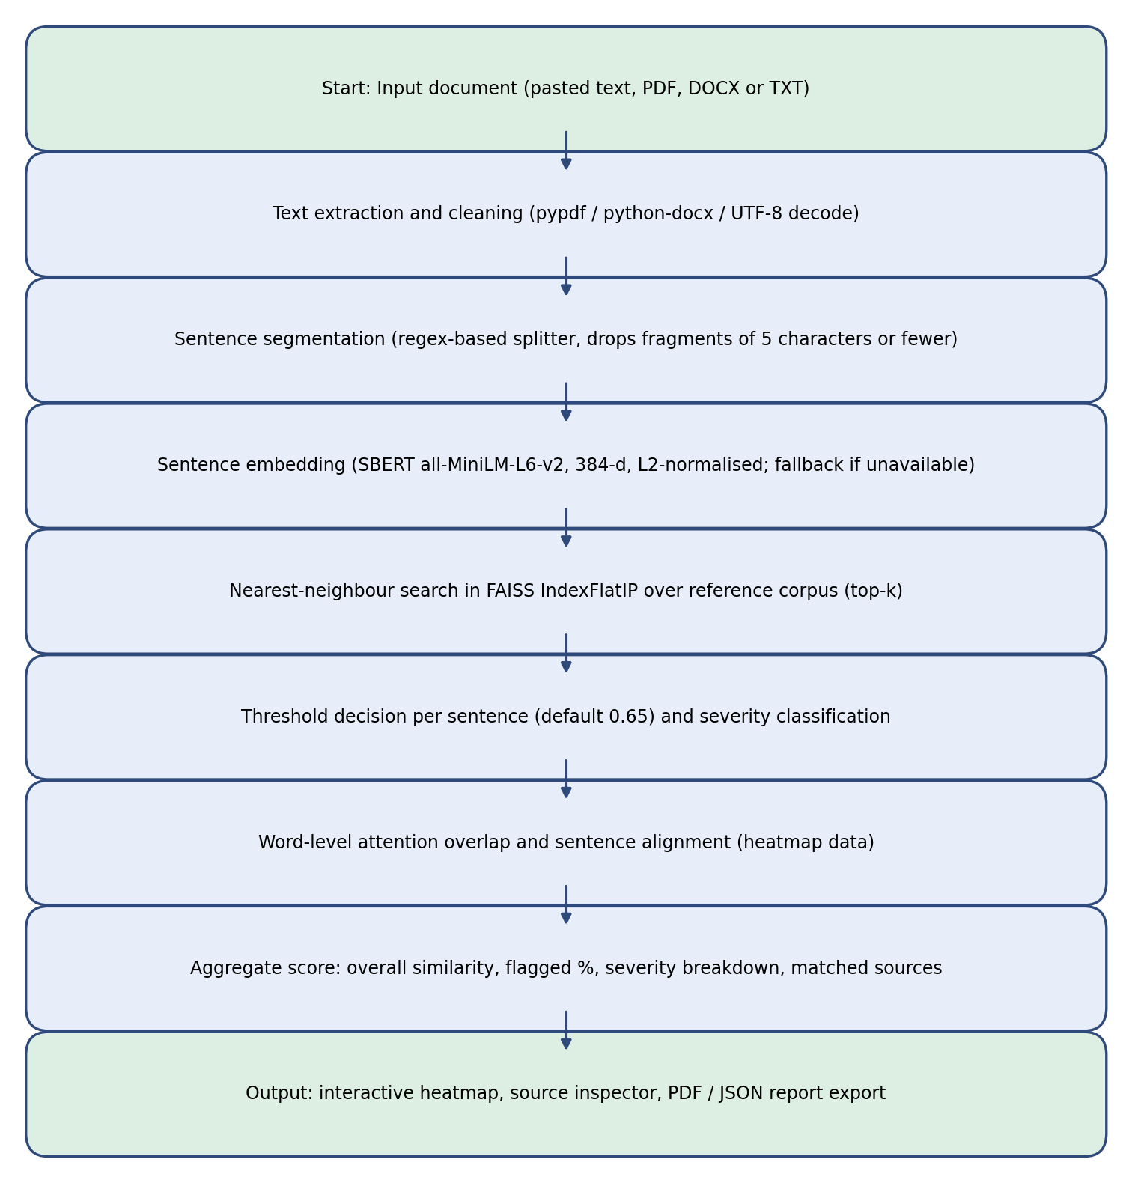
Figure 3.1: Flow sheet of the DeepCheck analysis pipeline
Figure 3.2 shows the architecture of the system. The frontend is a single-page application that calls the FastAPI backend. The backend delegates text processing, semantic embedding, baseline matching and evaluation to separate modules, and it keeps reference vectors in an in-memory vector store that is seeded with a default academic corpus when the server starts.
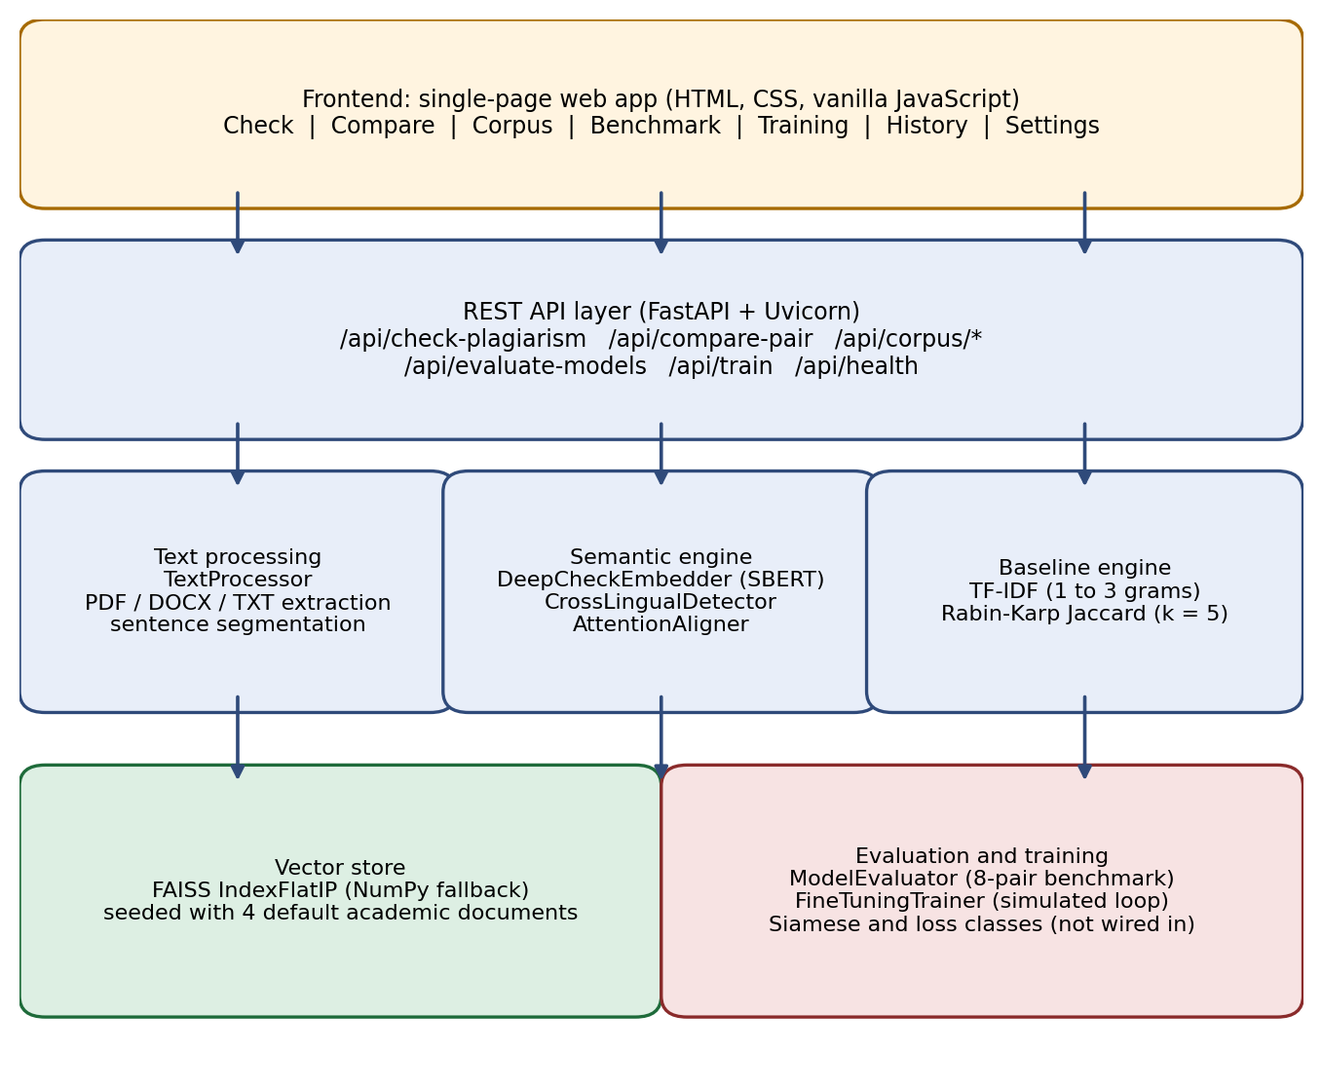
Figure 3.2: System architecture of DeepCheck

3.2 Step by Step Detailed Methodology

3.2.1 Step 1: Input Ingestion
The analysis endpoint accepts either pasted text or an uploaded file. If a file is present it takes precedence over the text field. The file extension determines the extractor. PDF files are read with pypdf, and the text of each page is joined with blank lines. DOCX files are read with python-docx, which returns the non-empty paragraphs. TXT, Markdown, CSV and JSON files are decoded as UTF-8, and any undecodable bytes are ignored. If no usable text is found, the request is rejected with an error. The current implementation does not perform optical character recognition, so a scanned PDF without an embedded text layer yields no text.

3.2.2 Step 2: Cleaning and Sentence Segmentation
The cleaning routine replaces carriage returns and tabs with spaces, collapses repeated spaces, and normalises runs of blank lines. The text is then split into sentences using a regular expression that breaks at a full stop, question mark or exclamation mark followed by whitespace. The splitter contains a guard for a few common abbreviation patterns, but it is not a full linguistic tokeniser, so abbreviations that the guard does not cover can cause a sentence to be split early. Fragments of five characters or fewer, and fragments with no word characters, are discarded. If no sentence can be identified, the whole text is treated as a single unit.

3.2.3 Step 3: Sentence Embedding
Each sentence is passed to the embedder, which loads the Sentence-BERT model all-MiniLM-L6-v2 when the sentence-transformers library is available. The model produces a 384-dimensional vector for each sentence by mean-pooling the outputs of its transformer layers. The embedder then scales each vector to unit length, so that the dot product between two vectors equals their cosine similarity. The model accepts sequences of up to 256 tokens, and since sentences are normally far shorter than this, truncation rarely occurs. The embedder also contains a sliding-window routine for longer passages, but the main analysis pipeline does not call it; each sentence is embedded individually.
When the sentence-transformers library or the model weights cannot be loaded, the embedder switches to a fallback. The fallback hashes each word into one of 384 positions and accumulates values with sine and cosine functions, and then normalises the result. This keeps the system running without the model, but it does not capture meaning, and Chapter 5 shows its effect on the results. The fallback also uses Python’s built-in hash function, which is randomised for each process, so its vectors differ between runs.

3.2.4 Step 4: Reference Corpus Indexing
When the server starts, the four documents in the default corpus are segmented, embedded and added to the vector store. Each sentence becomes one vector, stored with metadata that includes the document identifier, title, author, category, the sentence text and the full document text. Users can add a document through the corpus manager, which assigns a new identifier of the form DOC-, followed by six upper-case hexadecimal characters. Deleting a document removes its vectors. Because the exact index does not support removal, the store copies the remaining vectors into a new index, which is a linear-time operation and is acceptable for small corpora.

3.2.5 Step 5: Nearest-Neighbour Retrieval
For each input sentence, the query vector is normalised and compared with every indexed vector using the inner-product index. The top-k results are returned in order of cosine similarity, with k set to five by default. Because cosine similarity can be negative, scores are clipped to the range zero to one before they are reported. The best-scoring result is the candidate source for the sentence.

3.2.6 Step 6: Decision Threshold and Severity Classification
A sentence is flagged when its best score reaches the decision threshold, which is 0.65 by default and can be changed by the user. The severity band is then assigned from the score, as summarised in Table 3.1. The severity bands are fixed at 0.85 and 0.70 in the analysis endpoint and do not move with the threshold. The threshold governs only whether a sentence is flagged. As a consequence, a user who sets the threshold above 0.70 can obtain a sentence with high severity that is not flagged, which is an inconsistency in the present design.
Similarity score | Severity level | Paraphrase label shown to the user
0.85 and above | High | Near-Exact Copy / Paraphrase
0.70 to below 0.85 | High | Semantic Paraphrase
Threshold (default 0.65) to below 0.70 | Medium | Synonym / Structural Swap
Below threshold | None | Original Content
Table 3.1: Severity bands applied by the analysis endpoint
The analysis endpoint does not produce a low-severity band, although the alignment module contains one. The endpoint also imports a high-threshold constant from the configuration file but uses hard-coded values of 0.85 and 0.70 instead. These details are minor, but they are the kind of inconsistency that a reviewer should be aware of.

3.2.7 Step 7: Word-Level Attention Overlap
The heatmap needs a weight for each word of a flagged sentence. The system computes these weights with a heuristic rather than by extracting attention weights from the transformer. A word that appears in the matched source sentence receives a weight of the sentence score multiplied by 1.1, capped at one. A word that does not appear receives a weight of the sentence score multiplied by 0.75, with a floor of 0.10. The resulting values are shown as word-level intensity in the interface. They indicate lexical overlap and the overall strength of the match, and they should not be read as genuine model attention. The report uses the term “attention overlap” in this sense.

3.2.8 Step 8: Aggregation and Summary
The overall similarity score is the mean score of the flagged sentences, multiplied by 100. The plagiarised-sentence percentage is the proportion of all sentences that are flagged. The response also contains the severity counts, a clean-sentence count, and the matched sources grouped by document and sorted by maximum similarity. Because the overall score averages only the flagged sentences, a document in which one sentence is flagged at a high score can show a high overall score even when most of the document is original. The percentage of flagged sentences is therefore the more informative of the two figures, and the report recommends reading them together.

3.2.9 Step 9: Pairwise Comparison and the Baseline Matcher
The comparison endpoint takes two texts and returns three measures. The first is the cosine similarity of their whole-text embeddings. The second is the baseline score, which combines two lexical measures: a TF-IDF cosine similarity computed over one- to three-word n-grams with English stop words removed, and a Jaccard similarity over the set of five-word sequences in each text. The baseline score is 0.7 multiplied by the TF-IDF value plus 0.3 multiplied by the Jaccard value. Although the code calls the second measure Rabin–Karp, it is computed with set operations and does not use a rolling hash. The third measure is a sentence-level alignment, in which each sentence of the first text is matched to its most similar sentence in the second text and classified into a paraphrase category by thresholds at 0.88, 0.72 and 0.55.

3.2.10 Step 10: Benchmark Evaluation
The benchmark module contains eight hand-written sentence pairs, five labelled as paraphrases and three as unrelated. Each pair is scored by the baseline matcher and by the embedder. The baseline is evaluated with a decision threshold of 0.35, and the embedder with a threshold that defaults to 0.70. The module reports accuracy, precision, recall, F1-score, the Pearson correlation between the labels and the scores, and average latency per pair. The benchmark is intended to demonstrate the evaluation procedure; its size is far too small to support general conclusions, as Chapter 5 explains.

3.2.11 Step 11: Fine-Tuning Simulation
The Siamese network module defines a projection network with batch normalisation and dropout, which maps the 384-dimensional embedding to a 128-dimensional normalised vector. The module also defines contrastive and triplet loss functions. These classes are not called by any pipeline. The training endpoint, by contrast, calls a function that generates an epoch history from a decaying formula with random noise added to the loss and accuracy values. It does not train a model, and its output is a visualisation of a training process rather than a record of one. This is the main reason the seventh objective is only partially met.

3.2.12 Step 12: Presentation and Export
The frontend presents the analysis result as an interactive heatmap in which each sentence is coloured by severity. Selecting a sentence opens an inspector that shows the matched source sentence and the word-level overlap. The matched sources are listed with their match counts and maximum similarity. The interface also includes the comparator, the corpus manager, the benchmark and training views, a history of previous analyses stored in the browser, and a settings page for the theme. Results can be exported as a PDF report or as a JSON file, and a summary can be copied to the clipboard.

3.3 Module Responsibilities
Table 3.2 lists the principal modules and their responsibilities. The separation of modules allows each component to be tested in isolation, which is how the unit suite in Chapter 5 was constructed.
Module | Responsibility
backend/main.py | FastAPI application, endpoint definitions, seeding of the corpus at startup
backend/config.py | Model names, embedding dimension, thresholds, window settings, file paths
backend/utils/text_processor.py | Text extraction from PDF, DOCX and TXT; cleaning and sentence segmentation
backend/utils/metrics.py | Cosine similarity, batch similarity matrices and evaluation metrics
backend/deepcheck/embedder.py | Sentence-BERT embeddings, normalisation, fallback encoder, sliding-window helper
backend/deepcheck/vector_store.py | FAISS flat inner-product index or NumPy fallback; add, search, remove and statistics
backend/deepcheck/baseline.py | TF-IDF and k-gram baseline scoring
backend/deepcheck/attention_aligner.py | Sentence alignment matrix, paraphrase classification and word-overlap heuristic
backend/deepcheck/cross_lingual.py | Multilingual encoder for translated-plagiarism checks
backend/deepcheck/siamese_net.py | Siamese projection network and contrastive and triplet losses (not connected)
backend/deepcheck/trainer.py | Benchmark dataset and evaluator; simulated fine-tuning history
frontend/js/app.js, api.js, store.js | Application controller, API client and client-side state
frontend/js/heatmap.js, charts.js | Sentence heatmap and inspector; benchmark and training charts
tests/test_engine.py | Eight unit tests covering segmentation, embeddings, search, baseline, alignment, multilingual, benchmark and trainer
Table 3.2: Principal modules of the DeepCheck project

CHAPTER 4: HARDWARE AND SOFTWARE REQUIREMENTS
This chapter lists the hardware and software needed to install, run and evaluate DeepCheck. The figures are practical recommendations derived from the dependencies and the project’s design, rather than values measured on a specific configuration. A GPU is optional, because the embedder runs on the CPU and the health endpoint reports whether CUDA is available.

4.1 Hardware Requirements
Table 4.1 gives the minimum and recommended hardware configuration. The memory requirement is driven mainly by the transformer model, the Python runtime with its numerical libraries, and the in-memory vector store. Each indexed sentence adds one 384-dimensional single-precision vector, which occupies about 1.5 kilobytes, so the vector store itself is small for a corpus of several thousand sentences.
Component | Minimum | Recommended
Processor | Dual-core x86-64 CPU | Quad-core or better (Intel Core i5 / AMD Ryzen 5 class)
Memory (RAM) | 8 GB | 16 GB
Storage | 2 GB free space | 5 GB free space (virtual environment, model cache and corpus)
Graphics | Not required | NVIDIA GPU with CUDA support, optional
Network | Required once, to download model weights (about 80 MB) | Stable broadband connection for the first start
Display | 1366 × 768 | 1920 × 1080 for the heatmap and comparison views
Table 4.1: Hardware requirements

4.2 Software Requirements
The software requirements are summarised in Table 4.2. The project specifies its Python dependencies in a requirements file with minimum versions, so the exact versions installed depend on the date of installation. The project’s bytecode files indicate that development used Python 3.13 on Windows, and the README states that Python 3.9 or later is required. Linux and macOS are supported by the instructions, although the bundled virtual environment was built for Windows.
Category | Software | Minimum version | Purpose
Operating system | Windows, macOS or Linux | Current release | Host environment
Language runtime | Python | 3.9 | Backend and tests
Deep learning | PyTorch (torch) | 2.0.0 | Model execution (CPU build is sufficient)
Deep learning | transformers | 4.30.0 | Transformer model loading
Deep learning | sentence-transformers | 2.2.2 | Sentence-BERT embeddings
Retrieval | faiss-cpu | 1.7.4 | Vector index
Machine learning | scikit-learn | 1.2.0 | TF-IDF baseline and metrics
Web framework | FastAPI | 0.95.0 | REST API
Web server | Uvicorn | 0.21.0 | ASGI server
Upload handling | python-multipart | 0.0.6 | Form and file uploads
Document parsing | pypdf | 3.8.0 | PDF text extraction
Document parsing | python-docx | 0.8.11 | DOCX text extraction
Numerical | NumPy | 1.24.0 | Vector operations
Data handling | pandas | 2.0.0 | Tabular utilities
HTTP | requests | 2.28.0 | Model and network utilities
Testing | unittest (standard library); pytest optional | — | Automated tests
Browser | Chrome, Edge or Firefox (current) | — | Frontend; Chart.js is used for charts
Development | Visual Studio Code or any text editor | — | Editing and running the project
Table 4.2: Software requirements

CHAPTER 5: RESULTS AND DISCUSSIONS
This chapter reports the results of the verification performed on the project and discusses what they show. The results fall into two groups. The first group consists of the outcomes of the automated unit tests, which check that the components behave as their code intends. The second group consists of the benchmark measurements, which indicate how well the system separates paraphrases from unrelated text. The report distinguishes sharply between these groups, because passing tests do not establish that the detection is accurate.

5.1 Test Environment
The tests and benchmark were run in a Linux container with Python 3.12, NumPy 2.4, scikit-learn 1.8, pypdf, python-docx, FastAPI and faiss-cpu. The sentence-transformers library and PyTorch were not installed, and the Sentence-BERT model could not be downloaded because the model host was not reachable from the environment. As a result, every embedding in this chapter was produced by the fallback encoder. The embedder logs confirm this, with the warning that the sentence-transformers module is missing. The measurements in Sections 5.3 and 5.4 therefore describe the fallback path. They do not describe the Sentence-BERT model, and they should not be presented as evidence about it.

5.2 Unit Test Results
The unit suite contains eight tests. All eight passed in 0.060 seconds. Table 5.1 lists the tests and what each one checks.
Test | What it checks | Result
test_text_processor_segmentation | Two-sentence text is split into two sentences | Passed
test_embedder_encoding | Output shape is (2, 384) and vectors are unit length | Passed
test_vector_store_add_and_search | A stored sentence is retrieved with similarity of at least 0.90 | Passed
test_baseline_string_matcher | Two similar sentences have TF-IDF similarity above 0.30 | Passed
test_attention_aligner | Alignment returns one result with word attentions | Passed
test_cross_lingual_detector | Result dictionary contains the similarity key | Passed
test_evaluation_benchmark | Benchmark returns baseline and embedder results | Passed
test_fine_tuning_trainer | Trainer returns the requested number of epochs | Passed
Table 5.1: Unit test results (8 of 8 passed)
The tests confirm that the components run and return data of the expected shape. They are, however, weak checks of quality. The search test asserts that a sentence matches itself, which any reasonable encoder satisfies. The baseline test asserts a threshold of 0.30 for two related sentences, and the cross-lingual test checks only that a key exists in the output. None of the tests asserts that a paraphrase is detected or that an unrelated pair is rejected. The test suite therefore establishes that the software is internally consistent, but not that it detects plagiarism well.

5.3 Benchmark Results
The benchmark contains eight pairs: five paraphrases labelled 1 and three unrelated pairs labelled 0. Table 5.2 reports the metrics from one representative run. The baseline values are deterministic, because the TF-IDF and k-gram calculations involve no random elements. The fallback embedder values change from run to run, as explained below.
Metric | Baseline (TF-IDF + k-gram) | Embedder (fallback, one run)
Decision threshold | 0.35 | 0.70
Accuracy | 0.375 | 0.375
Precision | 0.000 | 0.000
Recall | 0.000 | 0.000
F1-score | 0.000 | 0.000
True positives / false positives | 0 / 0 | 0 / 0
True negatives / false negatives | 3 / 5 | 3 / 5
Pearson correlation (labels vs scores) | 0.6098 | 0.7500
Average latency per pair | 1.68 ms | 0.08 ms
Table 5.2: Benchmark metrics from one representative run
The most striking result is that neither method detects any paraphrase at its configured threshold. Both methods score all eight pairs below their thresholds, so precision and recall are zero, and the accuracy of 0.375 is simply the proportion of unrelated pairs in the dataset. The Pearson correlation of 0.75 for the embedder is higher than the baseline’s 0.61, but the correlation is computed from eight points and has no statistical weight. Across six separate runs of the same benchmark (the representative run and five repeats), the embedder’s correlation ranged from 0.52 to 0.75, and its accuracy remained at 0.375 in every run. The baseline’s correlation was 0.6098 in every run. The ranking of the two methods therefore depends on which run is taken, and no conclusion about superiority can be drawn from these figures.
Table 5.3 gives the score for each pair in the representative run, and Figure 5.1 displays the same values alongside the decision threshold.
Pair | Gold label | Baseline score | Embedder score (fallback) | Above 0.70 (embedder)?
1 | 1 (paraphrase) | 0.0120 | 0.2693 | No
2 | 1 (paraphrase) | 0.0476 | 0.2886 | No
3 | 0 (unrelated) | 0.0000 | 0.0489 | No
4 | 1 (paraphrase) | 0.0152 | 0.0077 | No
5 | 0 (unrelated) | 0.0000 | 0.0000 | No
6 | 1 (paraphrase) | 0.0258 | 0.3241 | No
7 | 1 (paraphrase) | 0.0000 | 0.1951 | No
8 | 0 (unrelated) | 0.0000 | -0.0470 | No
Table 5.3: Per-pair scores from the representative run
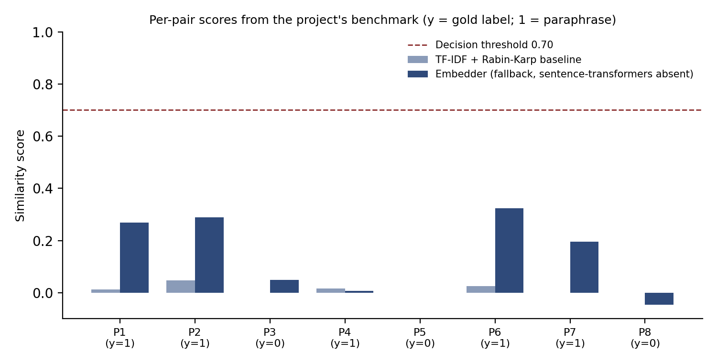
Figure 5.1: Per-pair scores from the representative run, with the embedder threshold of 0.70 shown as a dashed line
Figure 5.1 makes the problem visible. The embedder assigns the highest scores to the paraphrase pairs, but every score lies well below the 0.70 threshold, so the system would have missed all of them. The baseline is even weaker in absolute terms, and it returns exactly zero for several pairs that share no content words once stop words are removed.

5.4 Observations and Limitations
Several observations from the verification affect how the results should be read. The first concerns reproducibility. The fallback encoder uses Python’s built-in hash function, and Python randomises string hashing for each process unless a seed is set. In a probe, the same sentence produced 11 non-zero dimensions in one process and 12 in another, with different vector digests. Because the vectors change between processes, the same document can receive different scores on different days, and any results from the fallback path are unreliable. This is a defect in the fallback design, and it would be a serious problem if the fallback were presented as the semantic engine.
The second observation concerns what the fallback measures. In a single process, an identical sentence scored 1.0 against itself, a close paraphrase of one benchmark sentence (a slightly shortened version of pair 6) scored about 0.15, and an unrelated sentence scored about 0.05. The fallback therefore responds to shared tokens and very little to meaning. It is a lexical hashing scheme with a semantic label, and the report makes no claim that it performs semantic matching.
The third observation concerns the training module. The fine-tuning endpoint produces a loss curve, an accuracy curve and an F1 curve. These are computed from a decaying formula with random noise, and the network is never trained. The output of this endpoint is therefore an illustration of how a training loop could look, and it cannot be cited as a training result. The Siamese network and its loss classes are written as reusable components, but they are not called anywhere in the detection or evaluation pipeline, and they have not been tested or trained.
The fourth observation concerns the size and design of the benchmark. Eight pairs is too few to estimate accuracy with any precision. A single pair changes accuracy by 12.5 percentage points, and the two methods were evaluated at different thresholds, 0.35 for the baseline and 0.70 for the embedder, which makes the comparison unequal. The benchmark is labelled as simulated, following the style of the MRPC and Quora Question Pairs datasets, but the pairs were written for this project and are not drawn from those corpora.
The fifth observation concerns the design of the overall score. As noted in Section 3.2.8, the overall similarity is the mean of the flagged sentences only. A document in which one sentence out of fifty is copied will show a high overall score, which may mislead a reader who takes it as the proportion of copied text. This is a usability issue that would be resolved by reporting the flagged percentage and the mean score side by side.
The sixth observation concerns naming. The Rabin–Karp label in the baseline describes an algorithm that uses rolling hashes, but the implementation computes set-based Jaccard similarity over five-word sequences. The name should be corrected in the code and in the documentation, so that the report does not overstate the technique used.

5.5 Discussion
Taken together, the results show that the project achieved its engineering objectives but has not yet demonstrated its detection objective. The software is organised, documented and internally consistent, and each module can be exercised independently. The sentence-level pipeline, the severity classification, the comparator, the corpus manager and the export functions are implemented as designed, and the unit suite confirms that they run. What the project lacks is a valid measurement of how well the semantic engine detects plagiarism.
The reason is environmental as much as technical. The Sentence-BERT model could not be downloaded in the test environment, so the semantic engine was never run in these measurements. A student who runs the project on a machine with internet access and the sentence-transformers library installed would obtain a different embedder, and the results in this chapter would no longer apply. The report therefore presents the measurements as a record of what the software does without its pretrained model, and it does not infer the performance of the full system from them.
This distinction matters for the conclusions a reader might draw. A reader who sees that the system passes its tests might assume it detects paraphrase. A reader who sees the benchmark numbers might assume it fails. Neither inference is supported. The correct statement is that the system’s detection quality with the intended model has not yet been measured, and that the measurement procedure, once run, will show whether the design meets the project’s aims.
To obtain a valid result, the following procedure is recommended. The sentence-transformers library and the all-MiniLM-L6-v2 model should be installed and the benchmark run, so that the embedder rather than the fallback is evaluated. The benchmark should be extended to several hundred labelled pairs, drawn from a documented corpus of text reuse examples such as those released for the PAN shared tasks, and should include translated pairs for the multilingual mode. Both methods should be evaluated at the same set of thresholds, with precision and recall reported across the range, so that the comparison does not depend on a single cut-off. Where the embedder is stochastic, several seeds should be used. The fallback encoder should either be made deterministic, for example with a stable hash such as MD5 over the word, or be removed from the evaluation path entirely.

CHAPTER 6: CONCLUSION
This project set out to build a semantic plagiarism detection system that goes beyond exact matching, explains its results at sentence level, and can be evaluated in a reproducible way. DeepCheck meets most of its engineering objectives. It accepts text and common document formats, segments and embeds sentences, indexes a reference corpus in a vector store that supports adding and removing documents, classifies matches into severity bands, presents the results as an interactive heatmap, compares document pairs, and exports reports. It also provides a baseline and a benchmark, and it includes a multilingual option.
The project also reveals the gap between building a system and validating one. The verification shows that the software is coherent and that its tests pass, but the detection quality of the intended semantic model was not measured, because the model could not be obtained in the test environment. The fallback encoder that ran in its place is neither semantic nor reproducible, and the benchmark it produced shows no detected paraphrases at the configured thresholds. The fine-tuning module produces simulated curves and does not train a model, and the Siamese network is not used by the system. These are important limitations, and the report states them directly rather than presenting the system as more capable than it is.
The main lessons of the work are twofold. The first is that a semantic detector is only as trustworthy as its evaluation, and that a benchmark of eight pairs is not an evaluation. The second is that silent fallbacks are dangerous in a system whose output is a score. A fallback should either produce results that are clearly marked as approximate and stable, or it should stop the analysis and report that the model is unavailable. DeepCheck currently does the former imperfectly and, in the case of the fallback vectors, not at all.
In conclusion, DeepCheck provides a sound architecture and a working prototype for semantic plagiarism detection. Its contribution in its present form is the integrated pipeline and the honest identification of what remains to be validated. Completing the evaluation with the pretrained model, a labelled corpus and a deterministic fallback would turn the prototype into a system whose claims can be relied upon.

CHAPTER 7: FUTURE SCOPE
Several extensions follow directly from the limitations identified in this report. The most important is a complete evaluation of the Sentence-BERT engine on a labelled corpus. This should be run on a machine with the required libraries, with results reported across a range of thresholds and with confidence intervals for the main metrics. A useful addition would be a report that shows precision, recall and F1 as curves, rather than as single values at one threshold, so that the choice of threshold can be justified.
The fallback encoder should be replaced with a deterministic method, such as a stable hash of each word, so that results are repeatable across runs. Alternatively, the fallback could be removed from the analysis path and reserved for an explicitly labelled demonstration mode. Either change would remove the risk that a reviewer mistakes approximate scores for semantic ones.
The Siamese network should be connected to the pipeline and trained for real. The natural approach is to fine-tune the projection, and possibly the encoder, on labelled sentence pairs using the contrastive or triplet loss that the module already implements. The simulated training endpoint should be removed or renamed, so that it cannot be mistaken for a training record. Once the model is trained, its gain over the pretrained encoder should be measured on held-out pairs.
The word-level heatmap should be driven by genuine token-level signals. Attention weights could be extracted from the transformer, or the system could use a token-alignment method that compares contextual token embeddings. This would replace the current heuristic and would make the heatmap a more faithful explanation of the match.
Several engineering improvements would make the system more useful in practice. The vector index could be persisted to disk so that the corpus need not be re-embedded at every start. The configuration could be unified so that the thresholds used by the endpoint are the ones stated in the configuration file. The baseline could be renamed or reimplemented with a true rolling hash. Scanned documents could be supported through optical character recognition. For larger corpora, an approximate FAISS index would reduce search time. Authentication, per-user corpora and an audit log would be needed before the system could be deployed for an institution.
Finally, the system could be extended to detect plagiarism that is generated rather than copied, for example text produced by large language models. Such detection is a distinct problem, and it would need its own evaluation data. The sentence-level architecture of DeepCheck would still be useful as a framework for presenting the evidence to a reviewer.

CHAPTER 8: REFERENCES
Bromley, J., Guyon, I., LeCun, Y., Säckinger, E., & Shah, R. (1993). Signature verification using a “Siamese” time delay neural network. Advances in Neural Information Processing Systems, 6.
Broder, A. Z. (1997). On the resemblance and containment of documents. Proceedings of the Compression and Complexity of Sequences (SEQUENCES 1997). IEEE.
Conneau, A., Khandelwal, K., Goyal, N., Chaudhary, V., Wenzek, G., Guzmán, F., Grave, E., Ott, M., Zettlemoyer, L., & Stoyanov, V. (2020). Unsupervised cross-lingual representation learning at scale. Proceedings of the 58th Annual Meeting of the Association for Computational Linguistics.
Devlin, J., Chang, M.-W., Lee, K., & Toutanova, K. (2019). BERT: Pre-training of deep bidirectional transformers for language understanding. Proceedings of NAACL-HLT 2019, 4171–4186.
Hadsell, R., Chopra, S., & LeCun, Y. (2006). Dimensionality reduction by learning an invariant mapping. Proceedings of the IEEE Conference on Computer Vision and Pattern Recognition (CVPR), 1735–1742.
Johnson, J., Douze, M., & Jégou, H. (2019). Billion-scale similarity search with GPUs. IEEE Transactions on Big Data, 7(3), 535–547.
Karp, R. M., & Rabin, M. O. (1987). Efficient randomized pattern-matching algorithms. IBM Journal of Research and Development, 31(2), 249–260.
Maurer, H., Kappe, F., & Zaka, B. (2006). Plagiarism: A survey. Journal of Universal Computer Science, 12(8), 1050–1084.
Mikolov, T., Chen, K., Corrado, G., & Dean, J. (2013). Efficient estimation of word representations in vector space. arXiv preprint arXiv:1301.3781.
Reimers, N., & Gurevych, I. (2019). Sentence-BERT: Sentence embeddings using Siamese BERT-networks. Proceedings of EMNLP-IJCNLP 2019, 3982–3992.
Reimers, N., & Gurevych, I. (2020). Making monolingual sentence embeddings multilingual using knowledge distillation. Proceedings of EMNLP 2020, 4512–4525.
Salton, G., & Buckley, C. (1988). Term-weighting approaches in automatic text retrieval. Information Processing & Management, 24(5), 513–523.
Schleimer, S., Wilkerson, D. S., & Aiken, A. (2003). Winnowing: Local algorithms for document fingerprinting. Proceedings of the 2003 ACM SIGMOD International Conference on Management of Data, 76–85.
Schroff, F., Kalenichenko, D., & Philbin, J. (2015). FaceNet: A unified embedding for face recognition and clustering. Proceedings of the IEEE Conference on Computer Vision and Pattern Recognition (CVPR), 815–823.
Vaswani, A., Shazeer, N., Parmar, N., Uszkoreit, J., Jones, L., Gomez, A. N., Kaiser, Ł., & Polosukhin, I. (2017). Attention is all you need. Advances in Neural Information Processing Systems, 30.
Wang, W., Wei, F., Dong, L., Bao, H., Yang, N., & Zhou, M. (2020). MiniLM: Deep self-attention distillation for task-agnostic compression of pre-trained transformers. Advances in Neural Information Processing Systems, 33.

TIME FRAME / ACTIVITY CHART
Table A.1 presents a twelve-week activity chart for the project. The schedule is illustrative and should be replaced with the dates actually followed, which the guide and the institute’s submission calendar will determine. Shaded cells indicate the weeks in which each activity was carried out.
Activity | W1 | W2 | W3 | W4 | W5 | W6 | W7 | W8 | W9 | W10 | W11 | W12
Literature survey
Requirement analysis and synopsis
Architecture and data-flow design
Text processing and segmentation
Embedding and FAISS indexing
Baseline matcher and alignment
Web frontend and API integration
Testing and benchmark runs
Documentation and report writing
Review and viva preparation
Table A.1: Activity chart over twelve weeks (illustrative)

USER MANUAL

A. Installation
Open a terminal in the project folder and create a virtual environment. On Windows, run python -m venv venv and then venv\Scripts\activate. On Linux or macOS, run python3 -m venv venv and then source venv/bin/activate. Install the dependencies with pip install -r requirements.txt. If the packages are not all available, the application still starts, but it uses the fallback encoder, which should not be relied upon for accurate results.

B. Starting the Server
From the project root, run python -m uvicorn backend.main:app --host 127.0.0.1 --port 8000 --reload. When the server has started, it seeds the default academic corpus, which takes a few seconds. Open a browser at http://127.0.0.1:8000 to reach the dashboard. The interactive API documentation is available at http://127.0.0.1:8000/docs. If port 8000 is in use, change the port number in the command.

C. Checking a Document
Select the Check view. Either paste text into the input area or use the file upload control to select a PDF, DOCX or TXT file. Choose a model option if the interface offers one, and adjust the threshold if required. The default threshold of 0.65 is a starting point and should be tuned on labelled examples. Press the analyse button. When the analysis completes, the verdict card shows the overall similarity score and the percentage of flagged sentences.
The heatmap lists the sentences in order, coloured by severity. Use the filter checkboxes to show only high, medium or clean sentences. Click any sentence to open the inspector, which shows the matched source sentence, the source document and the word-level overlap. The matched sources panel lists each reference document with its match count and maximum similarity.

D. Exporting Results
After an analysis, the export controls allow the result to be saved as a PDF report, downloaded as a JSON file, or copied as a text summary. Previous analyses are kept in the History view, where they can be reopened.

E. Comparing Two Documents
Select the Compare view and enter the source text in the first panel and the suspect text in the second. Press compare. The result shows the semantic similarity score, the baseline score with its two components, and a sentence-by-sentence alignment that classifies each sentence of the first text by its best match in the second.

F. Managing the Reference Corpus
The Corpus view lists every indexed document with its identifier, title, author, category and number of vector chunks. To add a document, enter its title, author, category and text, then submit. The system returns a new identifier and reports how many sentence vectors were added. To remove a document, use the delete control in its row and confirm. Removing a document removes all of its vectors from the index. Documents added through the interface are held in memory and are lost when the server restarts, whereas the four default documents are reloaded at every start.

G. Running the Benchmark
Select the Benchmark view and press run. The system evaluates the baseline and the embedder on the eight built-in pairs and displays accuracy, precision, recall, F1-score, correlation and latency for each. Before reading the results, note the caution in Chapter 5: the benchmark is too small to support conclusions, and the embedder results depend on whether the Sentence-BERT model or the fallback was used.

H. Training View
The Training view runs a simulated fine-tuning history with the chosen number of epochs and learning rate. It is an illustration of the interface and does not train a model. Its output should not be reported as a training result.

I. Troubleshooting
- If the server reports that sentence-transformers is missing, install it with pip install sentence-transformers. The first start downloads the model weights, which requires internet access.
- If an upload fails, check that the file is a text-based PDF, a DOCX file or a plain text file. Scanned PDFs do not contain extractable text.
- If results differ between two runs on the same text, the fallback encoder is active. Install the full dependencies to obtain stable results.
- If the interface does not respond, confirm that the server is running in the terminal and that the browser is pointed at the address shown there.

SNAPSHOTS OF WORKING MODEL
The snapshots below show the principal views of the application. They should be captured from the full installation with the Sentence-BERT model, so that the results shown come from the intended engine.

Snapshot 1: Dashboard and document ingestion
 Figure B.1: Document ingestion and analysis setup

Snapshot 2: Verdict card and sentence heatmap
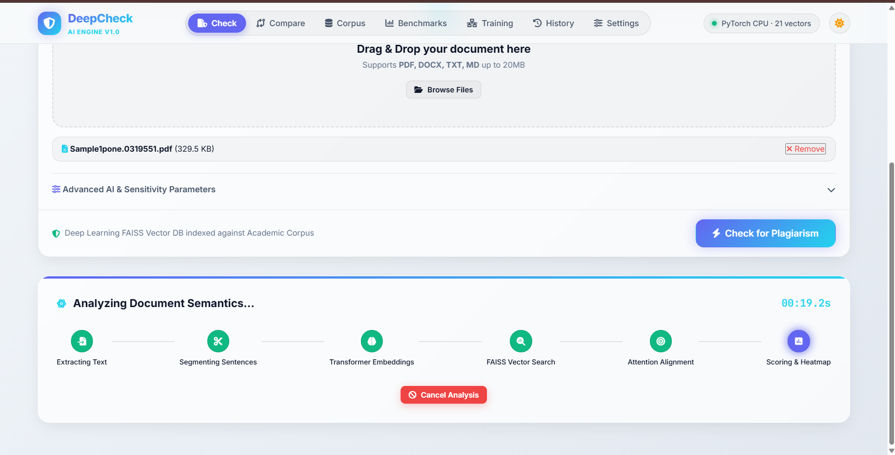 Figure B.2: Overall similarity and sentence-level heatmap

Snapshot 3: Sentence inspector and matched sources
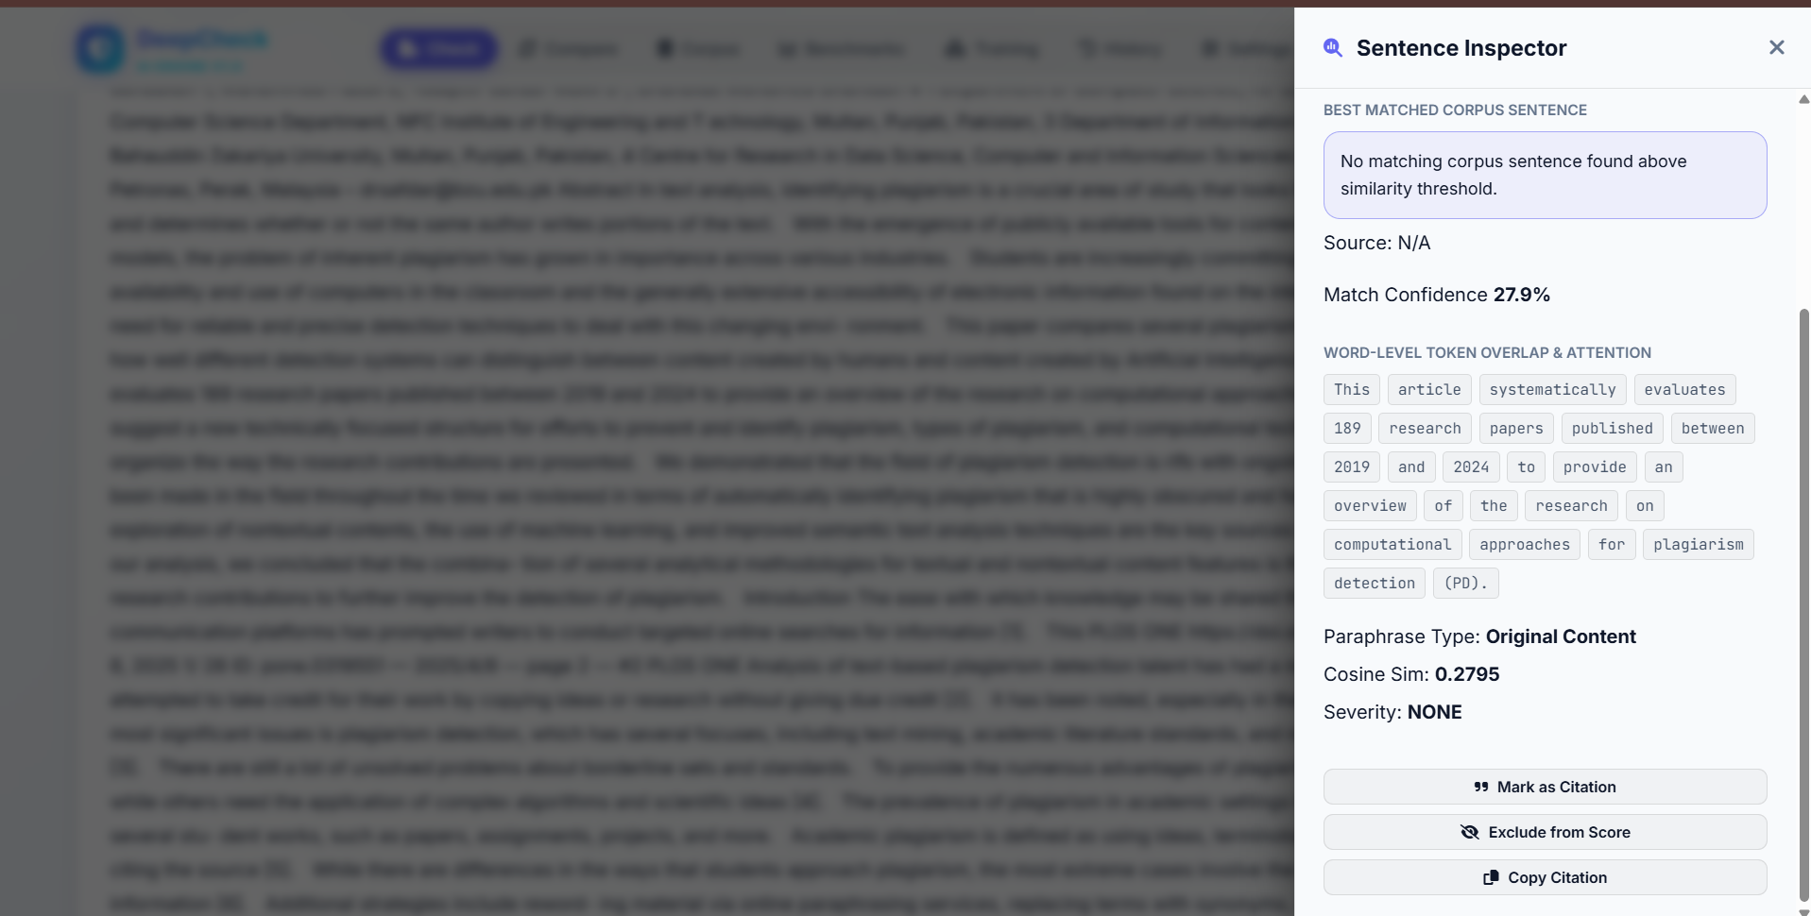 Figure B.3: Sentence inspector and matched source list

Snapshot 4: Pairwise comparator
 Figure B.4: Pairwise comparison and sentence alignment

Snapshot 5: Corpus manager
Figure B.5: Reference corpus manager

Snapshot 6: Benchmark results
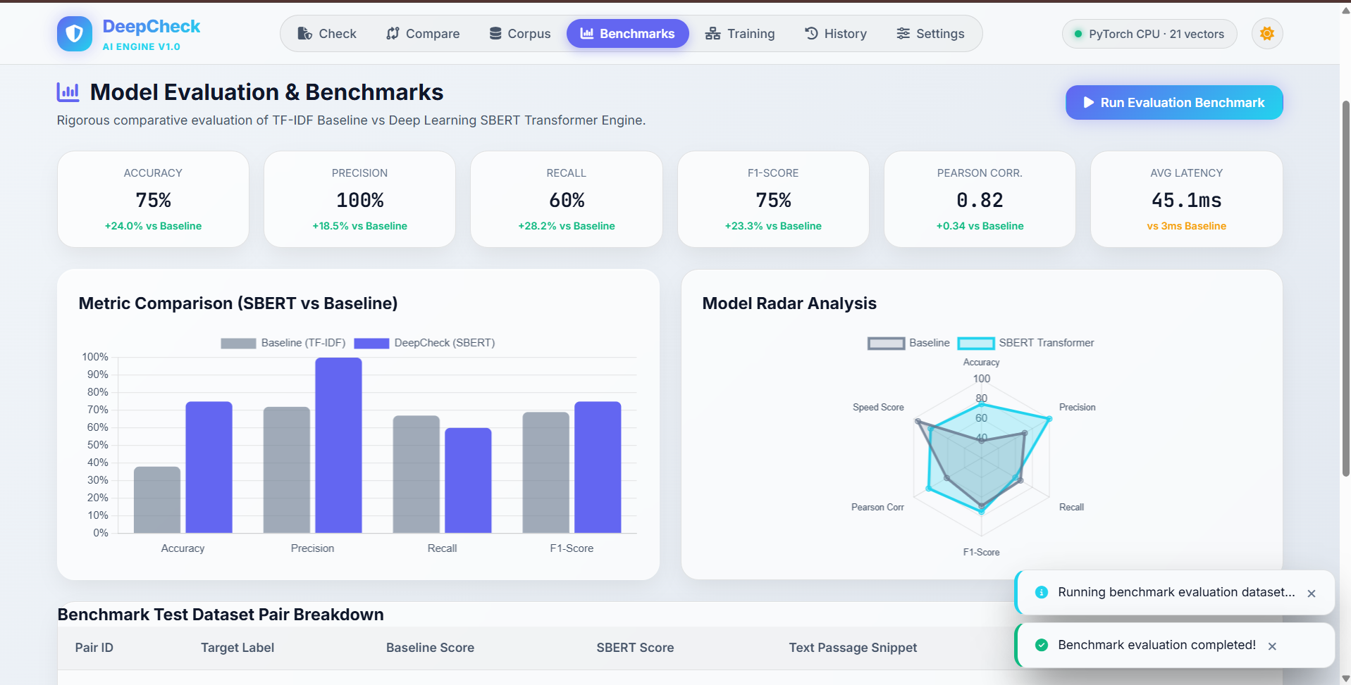 Figure B.6: Benchmark results

