Generating Sudoku Solutions with a Genetic Algorithm

Joseph Milne  
Missouri State University  
Springfield, MO  
milne189@live.missouristate.eduRohan Saha  
Missouri State University  
Springfield, MO  
Rohan2728@live.missouristate.eduRadeeb Bashir  
Missouri State University  
Springfield, MO  
Radeeb102@live.missouristate.edu

***Abstract***—Sudoku is one of the most popular puzzle games of all time. The goal is to solve the puzzle, a nine by nine grid with numbers ranging from one through nine so that each row, column, and three by three section has no repeating digits within the aforementioned range. There have been many methods and algorithms proposed and applied to efficiently solve many Sudoku puzzles. Genetic Algorithm (GA) is the algorithm that will be focused on for generating random solutions based on the rules for Sudoku.

***Keywords***—Genetic Algorithm, solving Sudoku puzzles, stochastic local search

**I. *Introduction***

Sudoku is a Japanese word based on the combination of two parts, su and doku. The first part, su, means number and the second part, doku, means single. As such, the meaning behind this is single number. In the past, it has also been referenced as Number Place which is a bit more straightforward in determining the objective from the name. The games’ nature is very logic based, as such, it is more commonly seen being used to help stimulate the brain in a wide variety of people.

The first Sudoku published in the United States of America was in a puzzle magazine back in 1979 [1]. Depending on the difficulty of the puzzle and its challenging but appealing problems, it has spread globally.

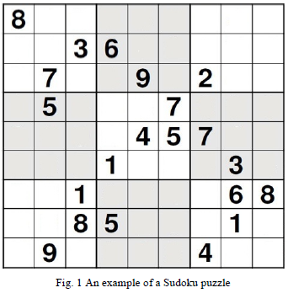

As demonstrated in Fig. 1, the entirety of the puzzle comes with some basis of understanding for the puzzle as some of the rows and columns are partially filled. The amount of numbers for basis already filled depends on the difficulty of the puzzle. For instance, a puzzle such as Fig. 1 would be more along the lines of an easy or medium puzzle based on the standard of most Sudoku puzzle publishers: Very Easy, Easy, Medium, Hard, Very Hard or also in the same representation, based on the amount of stars noted by the puzzle. Some other factors in the difficulty for the puzzle can include the diversity of numbers seen included ahead of time as well as the amount of each number included.

This paper seeks to randomly generate a solution for Sudoku based on the puzzle’s rules with a Genetic Algorithm (GA) to show people possible Sudoku puzzles which afterwards is up to their own discretion on how they use these generated solutions.

The rest of this paper will follow as: Section II the literature review. Section III as the proposed method of completing the task for this paper. Section IV, the results of the work for this paper. Finally, Section V, the conclusion of the work done on this paper and the future work.