CSC 525/625: Computer Graphics Fall 2017, MSU

**Project 1**

Programmers – Matt Revell and Rohan Saha

The purpose of this project is to demonstrate 2D object rendering capabilities of OpenGL. We came with a simple design as shown in Figure 1, the design consists of

1. Background
2. House
   1. Windows
   2. Doors
   3. House Number
3. Birds

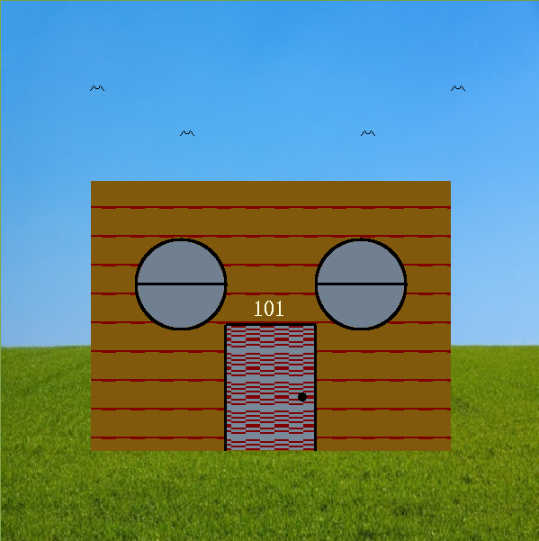

Figure 1. Project1 Design

1. **Background**

**The background image is a 600x600 RGB pixel map with multiple primary colors. The pixel data is stored in binary file called “background.bin” which is part of the project folder. The pixel map data is read and stored in global 3D array of GLUnsignedByte and the pixels are drawn using the OpenGL function “glDrawPixels” and the final background image is shown in figure 2.**

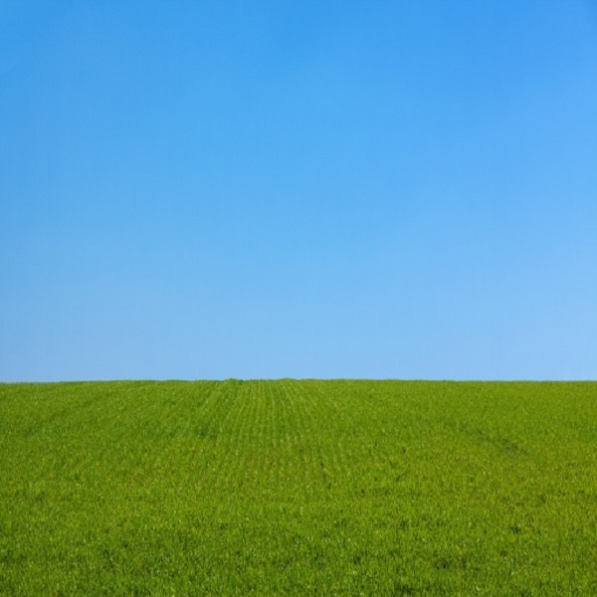

Figure 2. Background Image

1. **House**

**The house is drawn on top of the background image. The house is a polygon with custom pattern designed by us. The house is a composed of three components and they are**

* 1. **Windows**

**The window is circular in design, it has two components a frame and the glass. The frame is black in color and it is a hollow circle with point width of 5 as shown in Figure 3a. The glass is also a circle but it is filled with steel blue color as shown in Figure 3b. The middle line in the window is a line segment.**

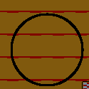

**Figure 3a. Window Frame**

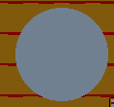

**Figure 3b Window glass**

* 1. **Door**

The door is also made of two components a door frame and the door surface.

The door frame is made using line segments as shown in Figure 4a and the door surface is a polygon filled with a custom frame as shown in Figure 4b

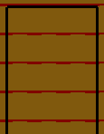

Figure 4a. Door Frame

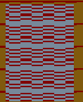

Figure 4b. Door Surface

* 1. **House Number**

**The house number is text designed “glutBitmapCharacter”.**

1. **Birds**

**The birds are custom bitmap of width 16 and height 7, and it is drawn using “glBitmap” as shown in Figure 5.**

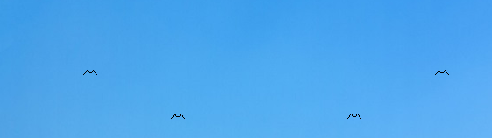

Figure 5. Birds