Course: MCA511-1 - Advanced Database Technologies

Lab Exercise – 8
Exercise: Demonstration of Import, Export, Dump, and Restore Operations in MongoDB
With respect to your chosen business domain, create a MongoDB database and design the required collection(s). Prepare the dataset in either JSON format or CSV format based on the requirements of your selected domain. Perform the following operations:
1. Import the prepared dataset into the appropriate MongoDB collection using the mongoimport utility.
2. Append Additional Records:Create a separate JSON or CSV file containing at least five additional records relevant to the selected business domain. Import the file into the existing collection to append the new records.
3. Verify the data in the collection by performing the following: a. Display the total number of documents in the collection. b. Display a sample document from the collection. c. Display the newly added records.
4. Export the documents from the collection into a JSON or CSV file using the mongoexport utility.
5. Create a complete backup of the MongoDB database using the mongodump utility.
6. Delete selected documents or drop the collection/database to demonstrate the need for data restoration.
7. Restore the backed up database using the mongorestore utility.
8. Verify that the database and collection have been restored successfully by displaying: a. The list of databases. b. The list of collections in the restored database. c. The total number of documents in the restored collection. d. A sample document from the restored collection.
9. Create an index on a relevant field in the collection based on the selected business domain. Execute a query that can benefit from the created index and verify the query execution using an appropriate MongoDB command.

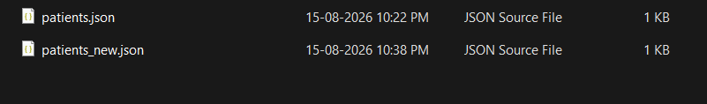
The patients.JSON file contains the initial patient records that are imported into the MongoDB database and the patients_new.JSON file contains additional patient records that are appended to the existing collection.
…………………………………………………………………………………..

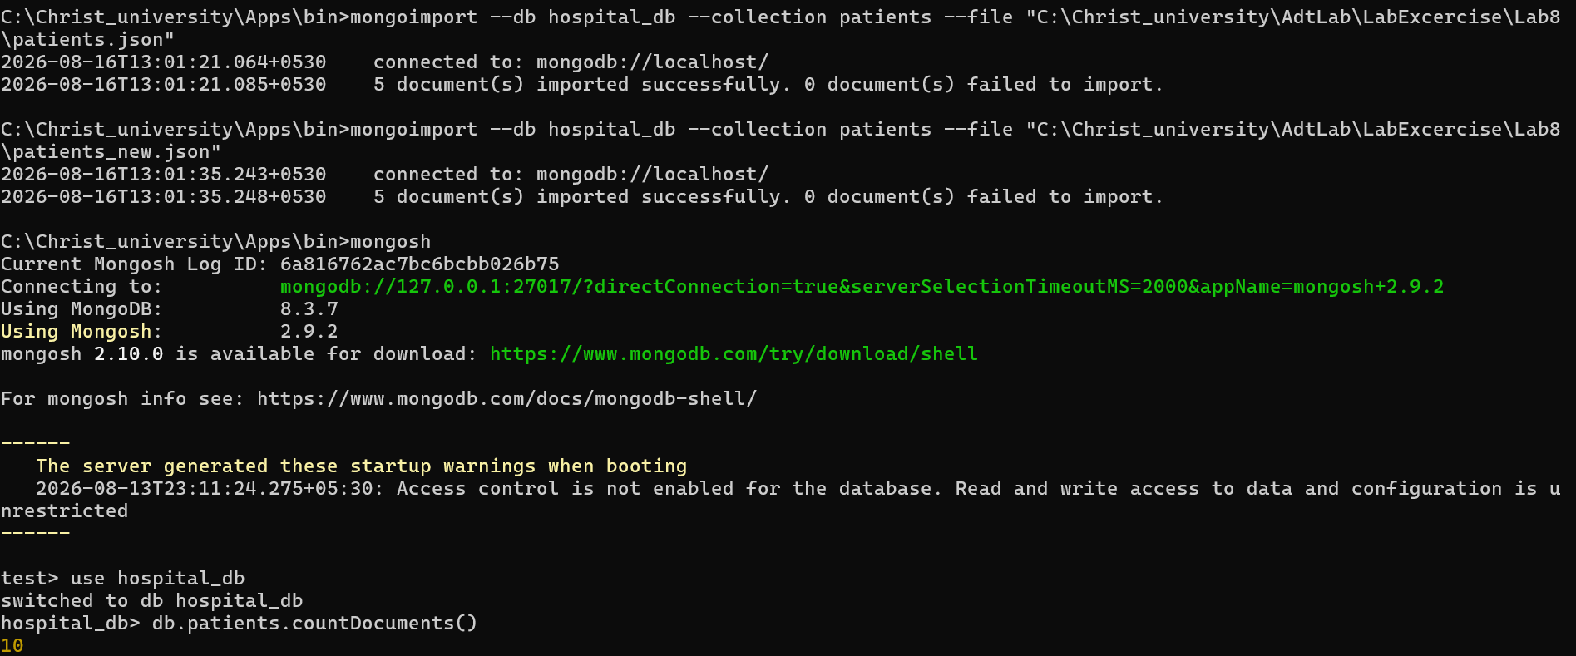

The mongoimport utility was used to import the initial patient dataset from the JSON file into the patients collection of the hospital_db database and Another JSON file containing additional patient records was imported into the same collection. MongoDB appended the new documents without replacing the existing data.
The countDocuments() command confirmed that the total number of patient records increased after importing the second dataset. The newly added documents were also verified using the find() command. 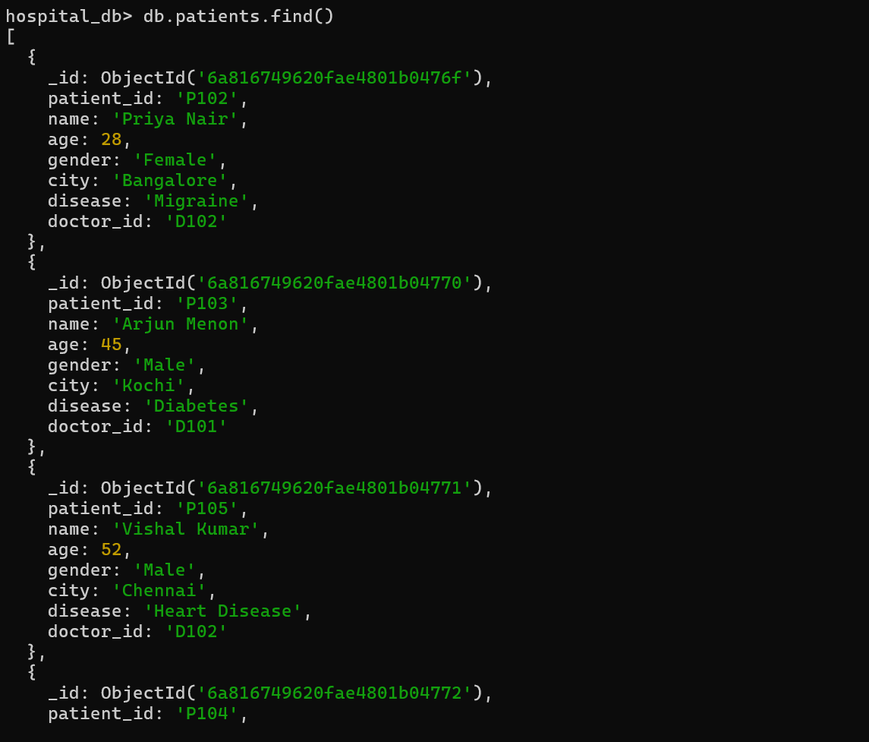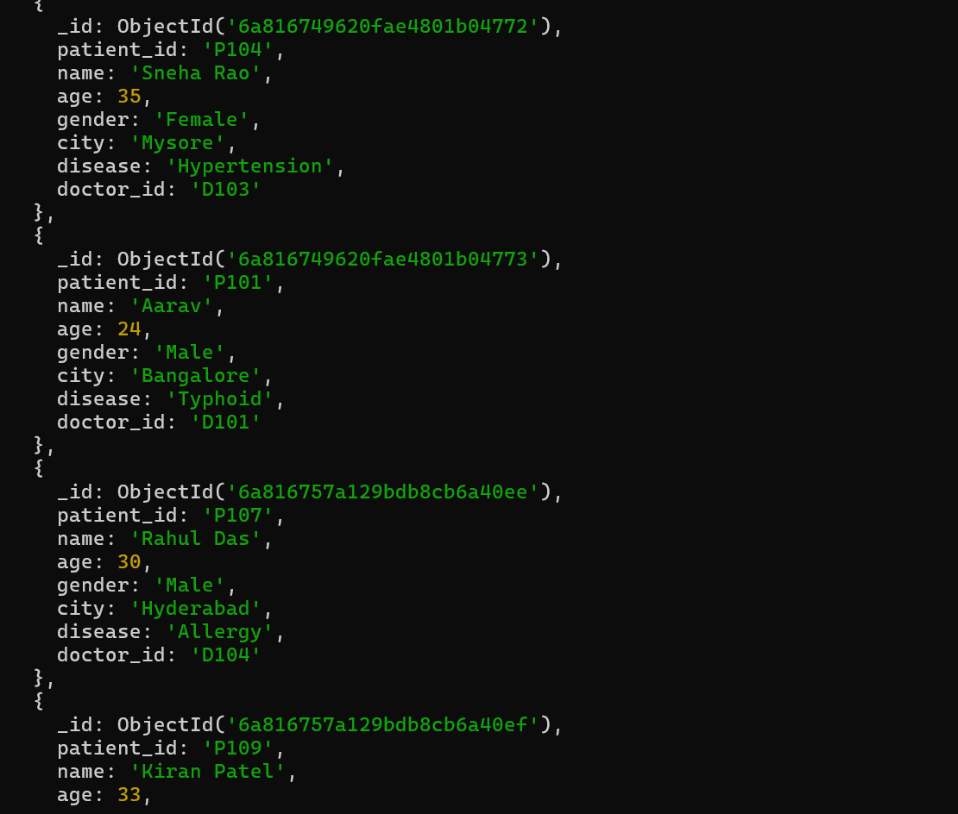
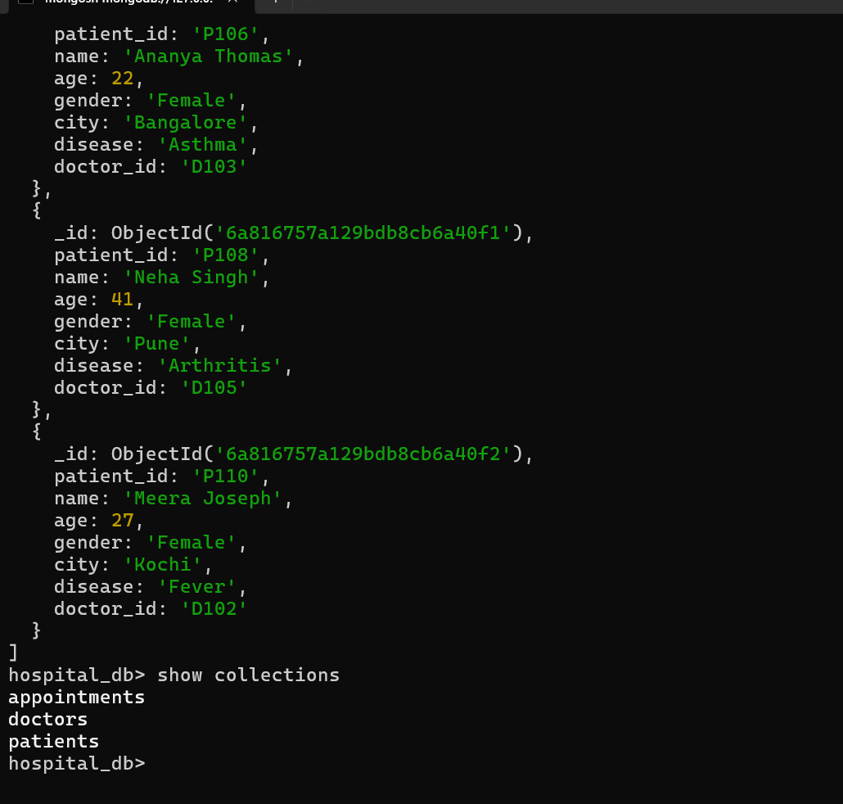
imported documents were verified using the find() command to ensure that all records were successfully inserted into the collection.
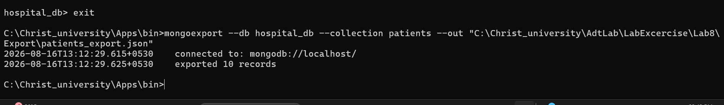
The mongoexport command exported the patients collection into a JSON file. This exported file can be used for data migration, sharing, or backup purposes.
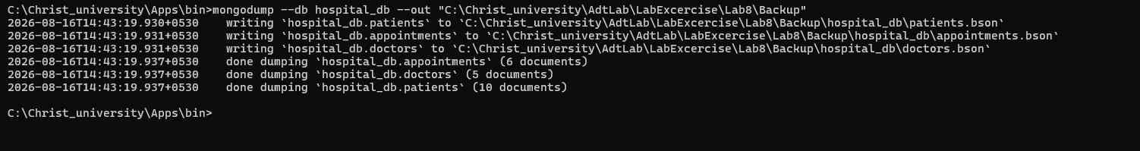
The mongodump command created a complete backup of the hospital_db database. BSON files for the patients, doctors, and appointments collections were generated and stored in the backup directory.
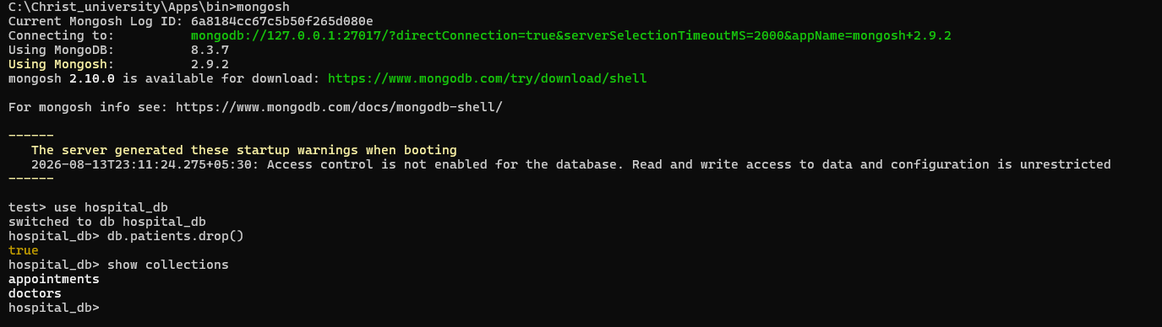
The patients collection was deleted using the drop() method. This step simulated accidental data loss before restoring the database.
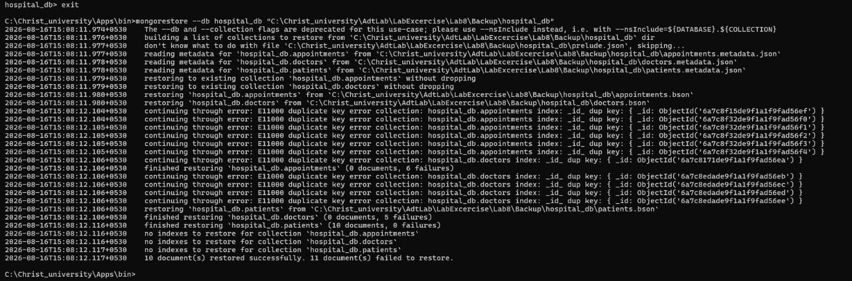
The mongorestore command restored the deleted patients collection from the backup created using mongodump, successfully recovering the database contents.
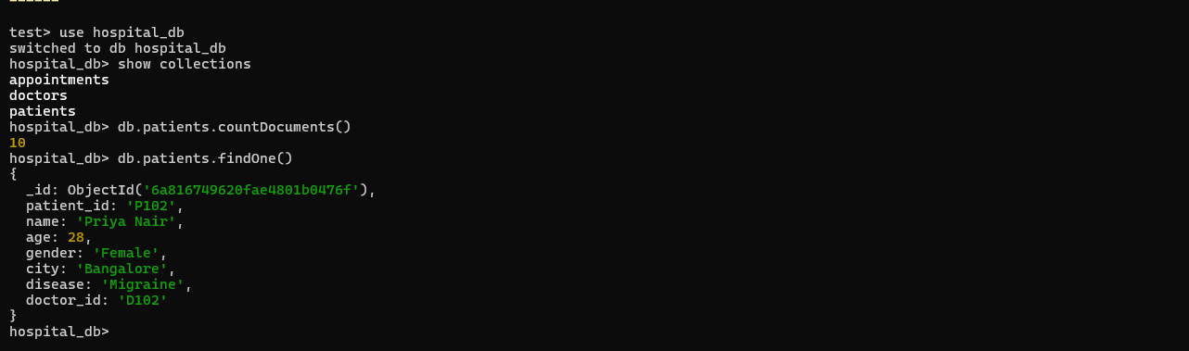
The restored collection was verified by checking the document count and displaying sample documents using MongoDB Shell commands.
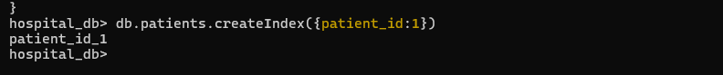
An index was created on the patient_id field using createIndex(). Indexes improve query performance by allowing MongoDB to locate matching documents more efficiently. 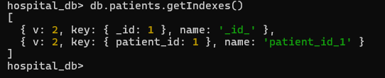
The getIndexes() command displayed all indexes available in the patients collection, confirming the successful creation of the new index.
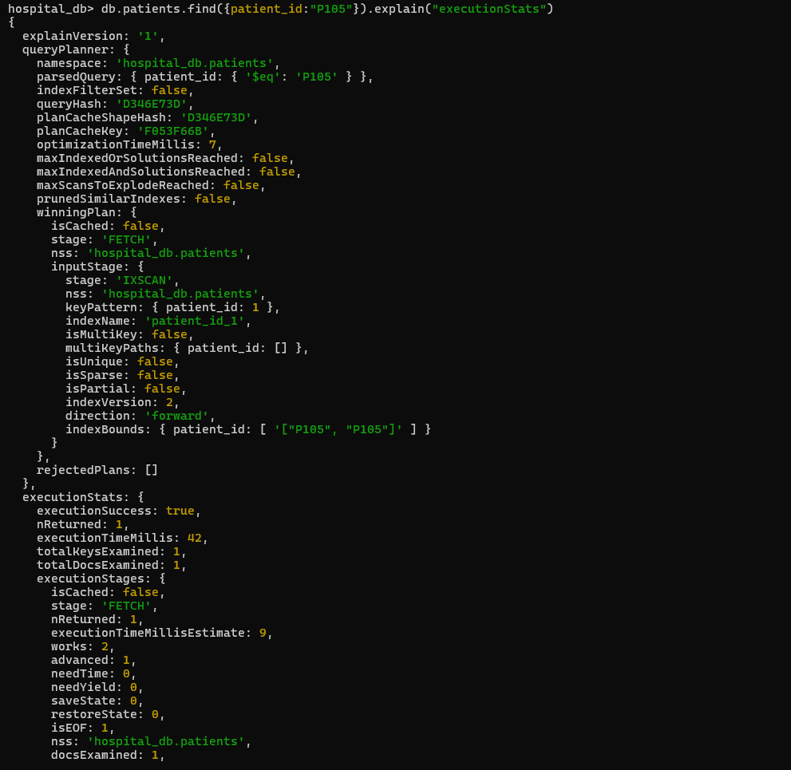
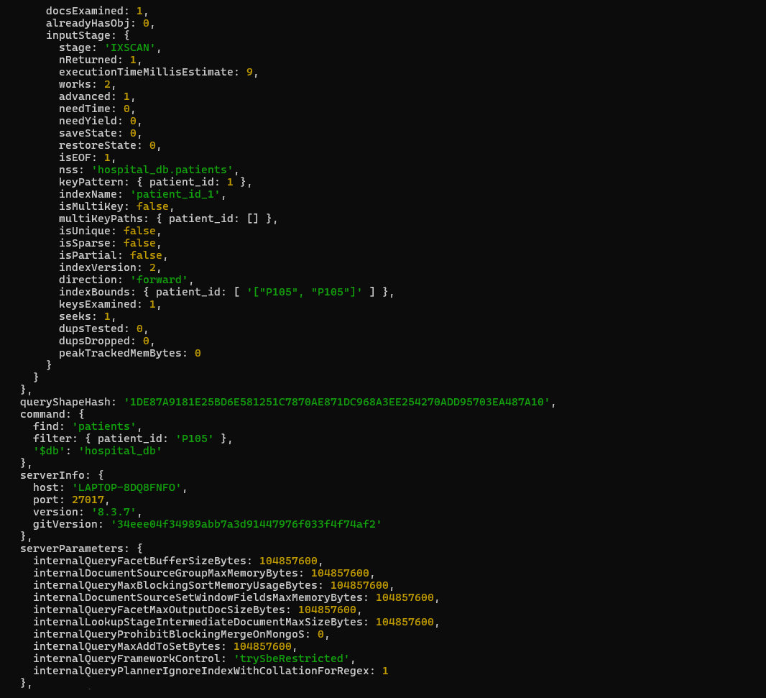
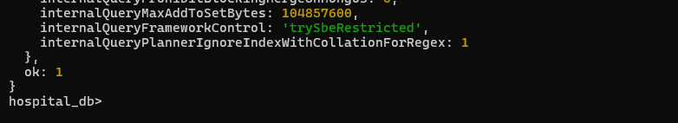
The explain("executionStats") method was used to analyze query execution. It demonstrated that MongoDB utilized the created index while searching for a patient record, resulting in more efficient query processing.
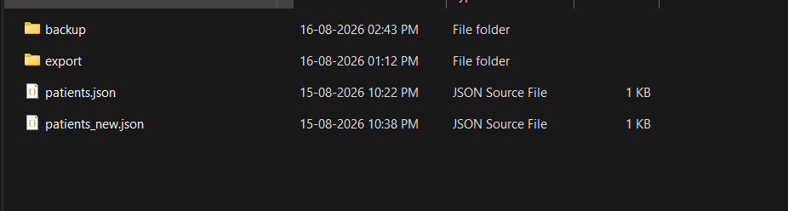
Two folders were created :-
Export :- to export the documents from the collection into a JSON file using the mongoexport.
Backup:- To Create a complete backup of the MongoDB database using the mongodump utility.
Conclusion
This laboratory exercise provided practical experience with MongoDB database administration tasks. Operations such as importing, exporting, backing up, restoring, and indexing data were successfully demonstrated. These techniques are essential for ensuring data reliability, efficient recovery, and improved query performance in real-world database systems.
Self Learning
During this exercise, I learned how MongoDB Database Tools work alongside MongoDB Shell to perform database management tasks. I also understood the importance of backups, restoration, data migration, and indexing in maintaining secure, reliable, and high-performance NoSQL databases.

