Course: MAI511-1 - Advanced Database Technologies

Exercise No: LAB Exercise – 7 RegNo.2648544
Exercise:
Demonstration of CRUD operations and Aggregate functions in MongoDB
With respect to your chosen business domain, create a MongoDB database and design
the required collections. Each collection should contain a minimum of 5 documents.
Perform the following operations:
1. Create Operations
• Use insertOne() and insertMany() to add documents to each collection.
2. Read Operations
• Use find(), findOne(), and appropriate filters to retrieve documents.
3. Apply logical operators:
• $and, $or, $not, $nor
4. Apply relational operators:
• $gt, $lt, $eq, $ne, $gte, $lte, $in, $nin
5. Update Operations
• Use updateOne() and updateMany() to modify fields or nested values in
the documents.
6. Delete Operations
• Use deleteOne() and deleteMany() to remove specific or multiple
documents.
7. Aggregation Operations
• Use aggregation functions and stages wherever applicable: $match,
$group, $sum, $avg, $count, $project, $sort, $unwind, $lookup, etc.

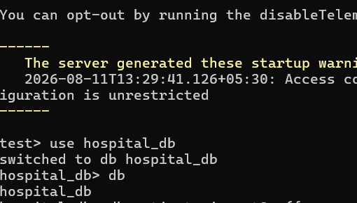
A new MongoDB database named hospital_db was created and selected using the use command. This database stores all collections related to the Hospital Management system.
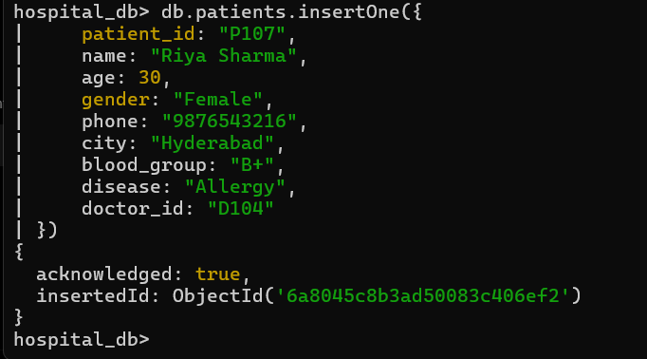

The insertOne() method was used to insert a single patient document into the patients collection. This demonstrates the Create operation by adding one record to the database.

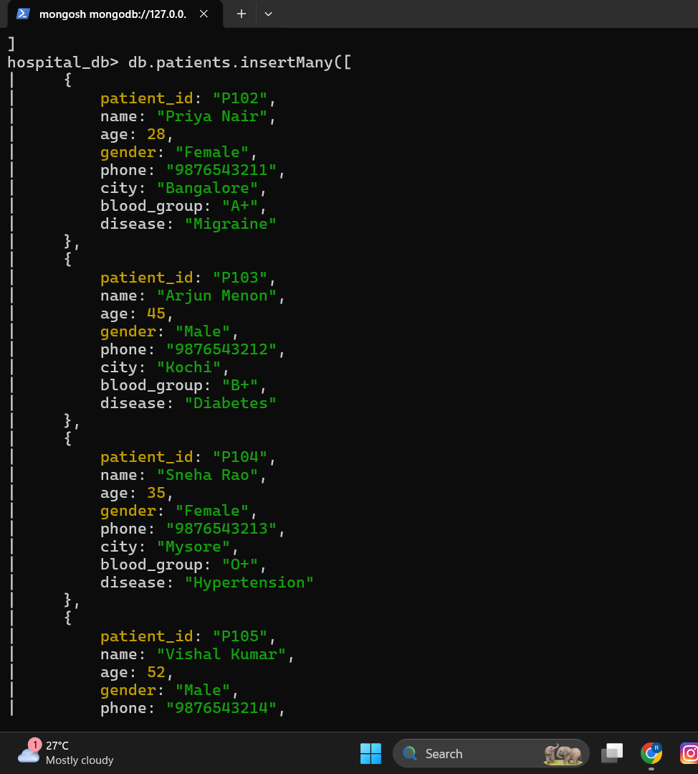
The insertMany() method was used to insert multiple patient documents at once. This allows efficient creation of several records in a single operation.
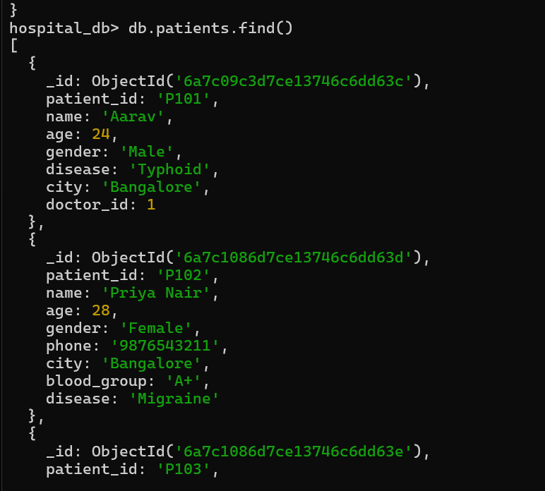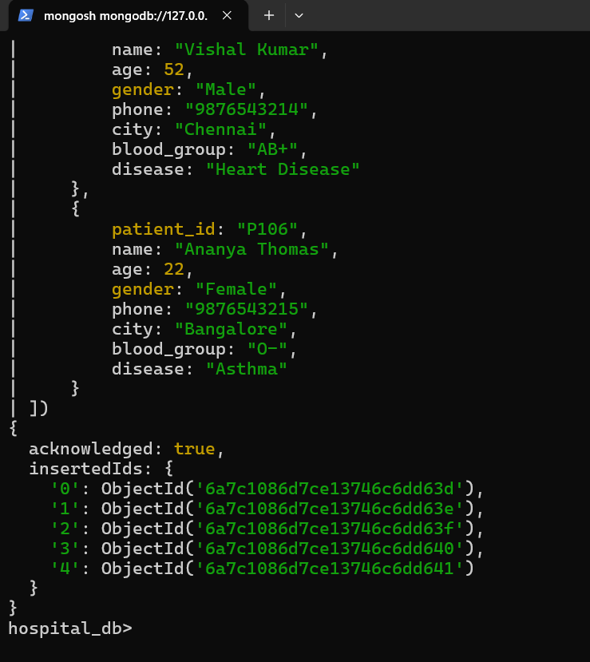
The find() method retrieves and displays all documents from the patients collection, allowing verification of the inserted data.

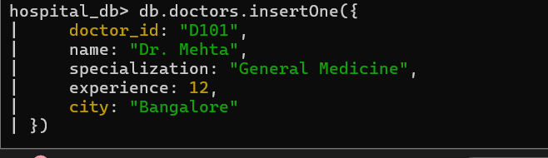

A new document was inserted into the doctors collection using insertOne(). This collection stores information about doctors associated with the hospital.
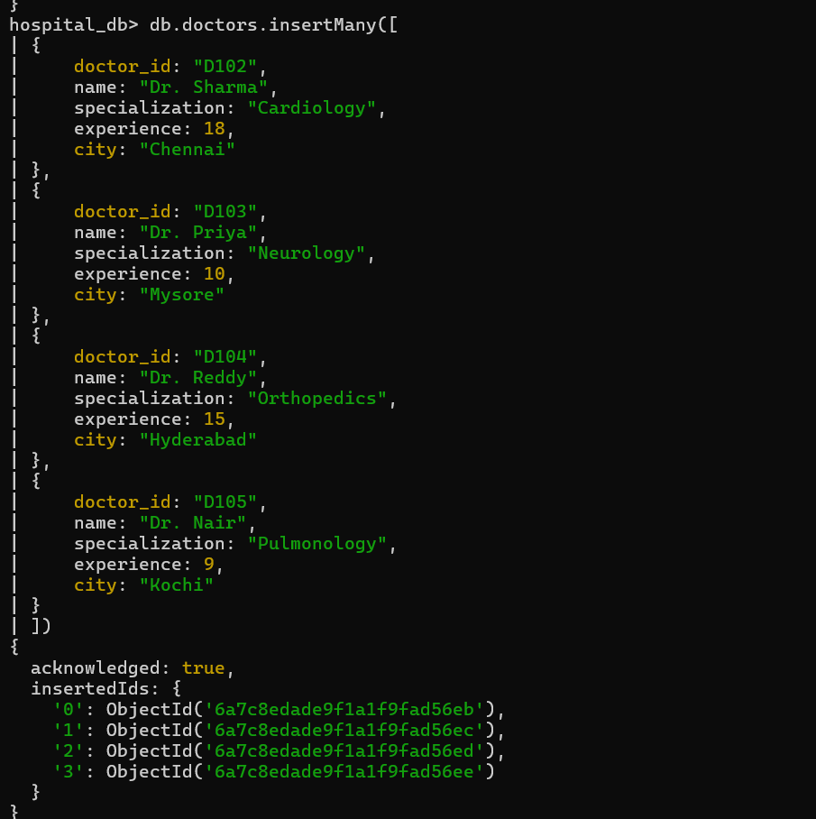
Multiple doctor documents were inserted using insertMany(), creating a complete collection for demonstrating CRUD and aggregation operations.
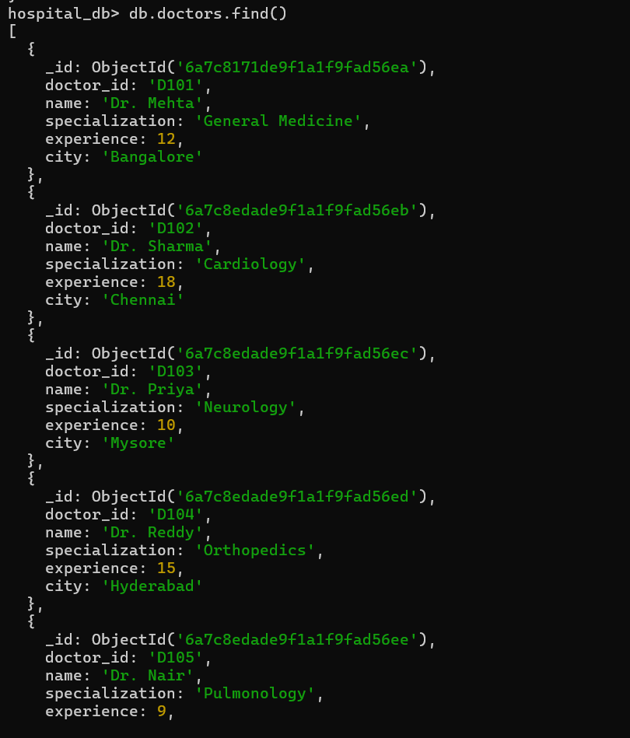
The find() command was used to display all doctor documents, confirming that the collection was successfully created.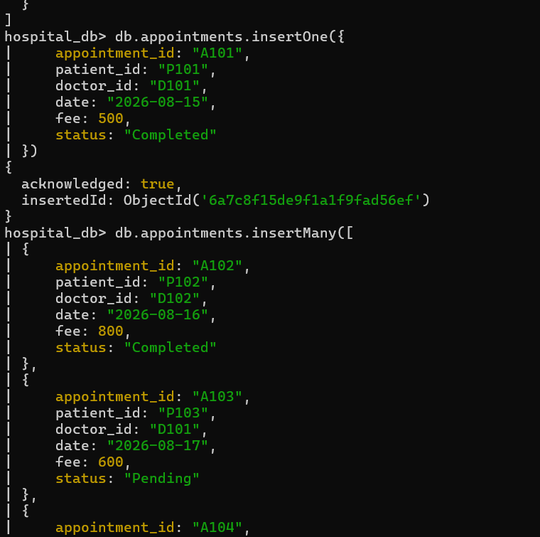
The appointments collection was created by inserting a single appointment document using insertOne(), representing the relationship between patients and doctors.
Then Multiple appointment records were inserted using insertMany() to simulate patient appointments in the Hospital Management System. 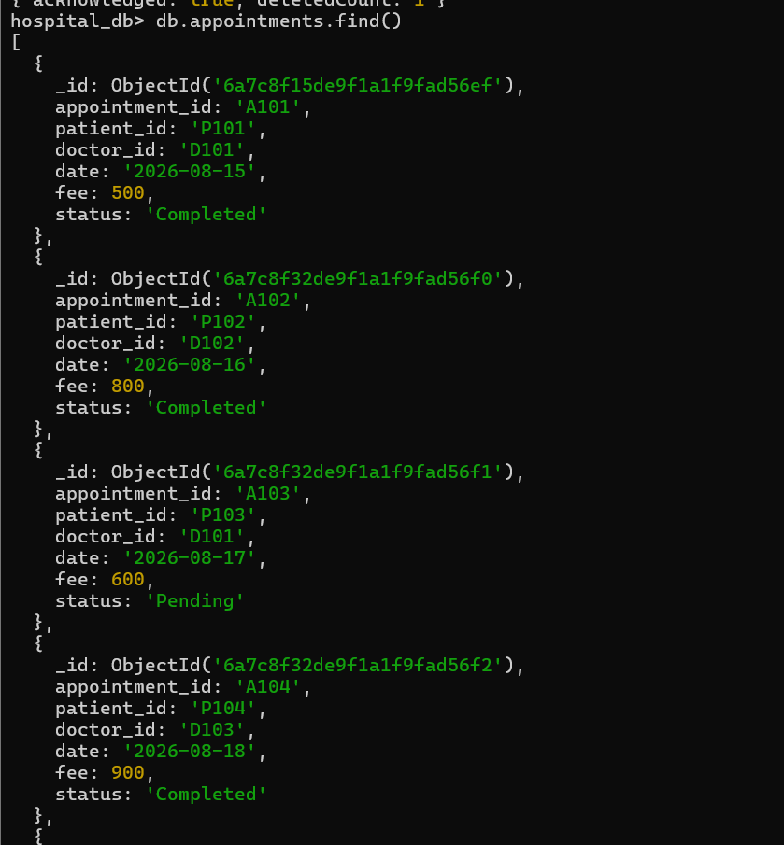 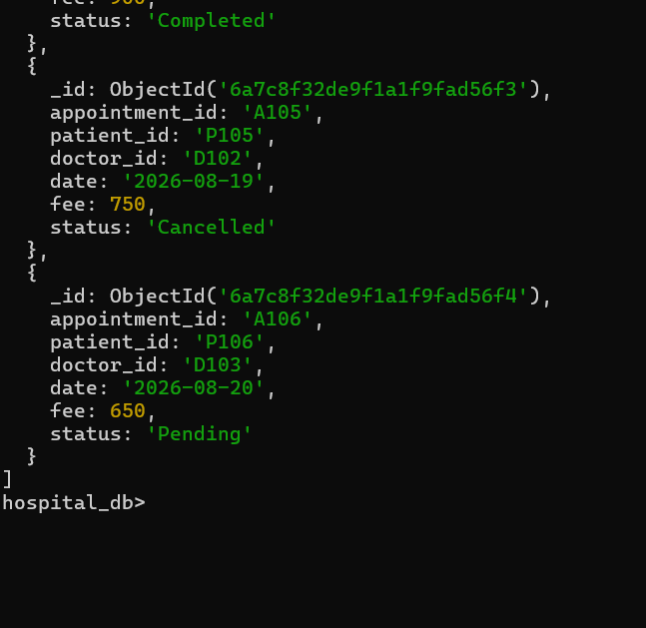
The find() method displays all appointment documents stored in the collection, verifying successful insertion.
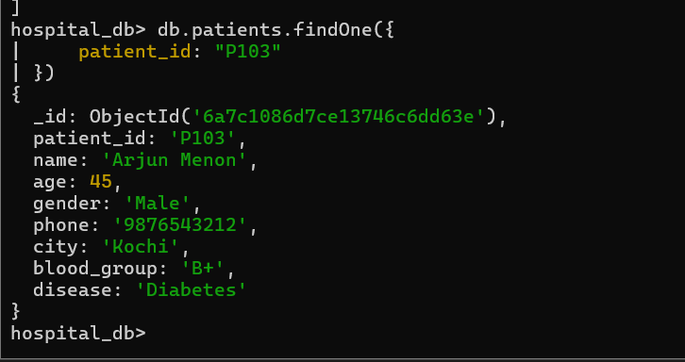
The findOne() method retrieves a single document that matches the specified condition. It is useful when only one matching record is required. 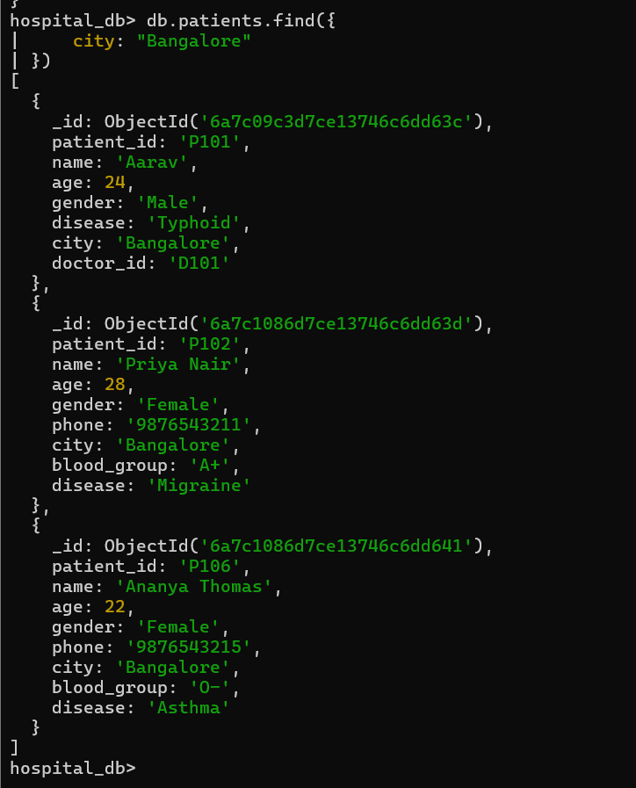
A filter condition was applied using find() to retrieve only the documents that satisfy the specified criteria, such as city or disease. In this case :- where city is bangalore. 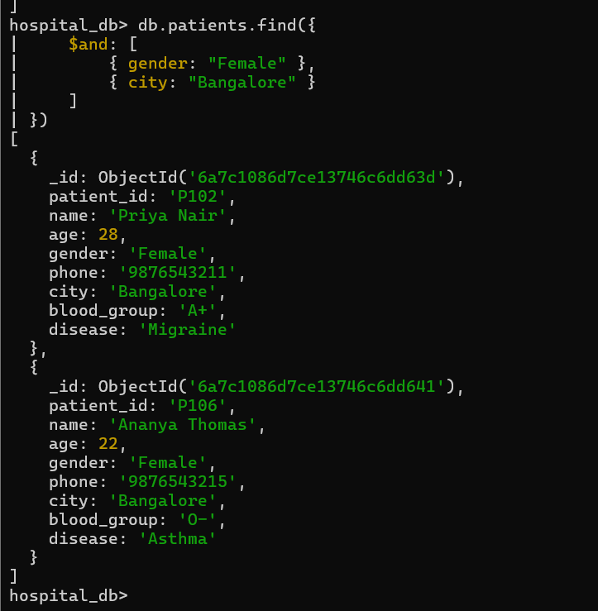
The $and operator retrieves documents that satisfy all specified conditions simultaneously.
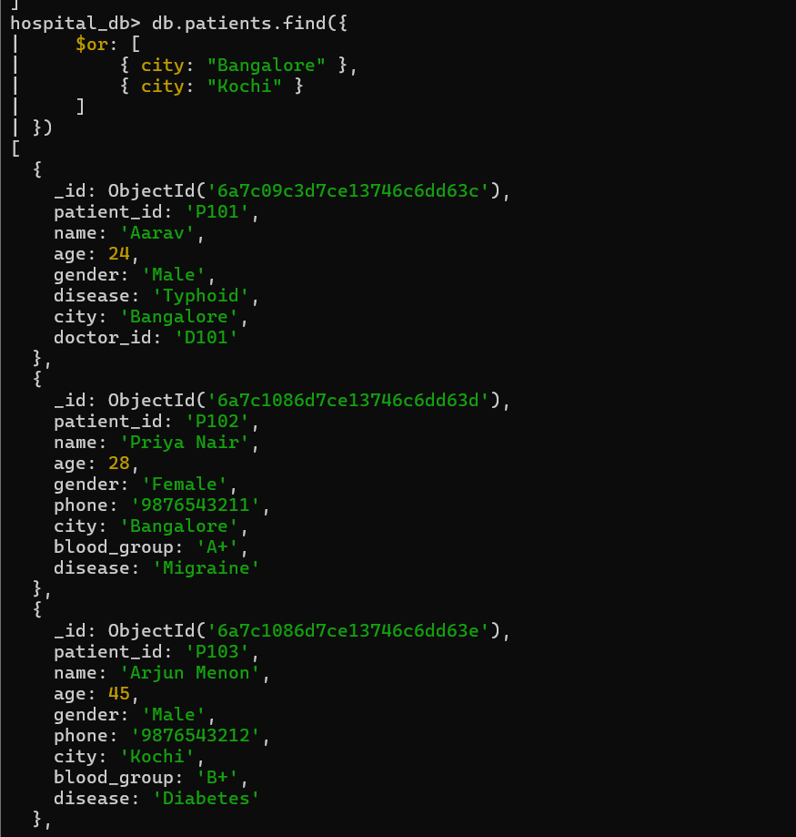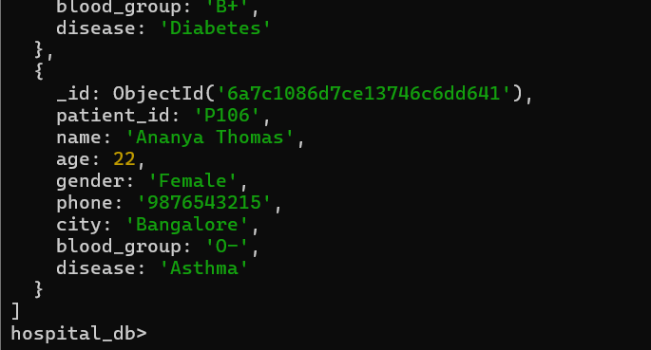
The $or operator retrieves documents that satisfy at least one of the given conditions.
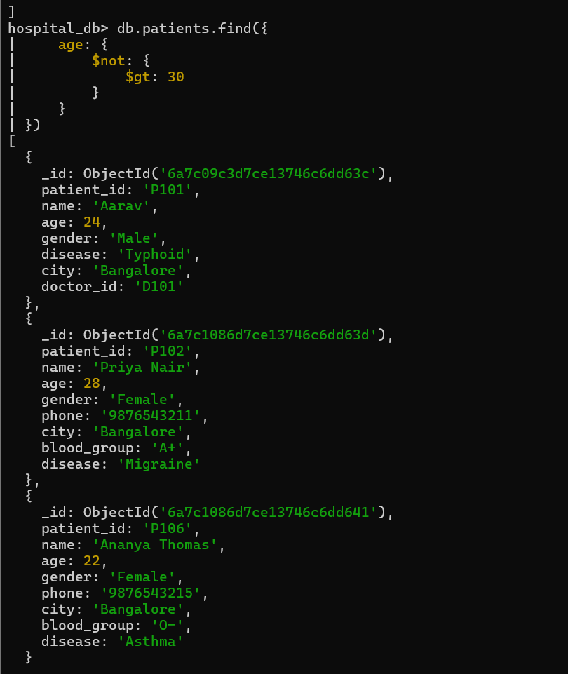
The $not operator returns documents that do not satisfy the specified condition.
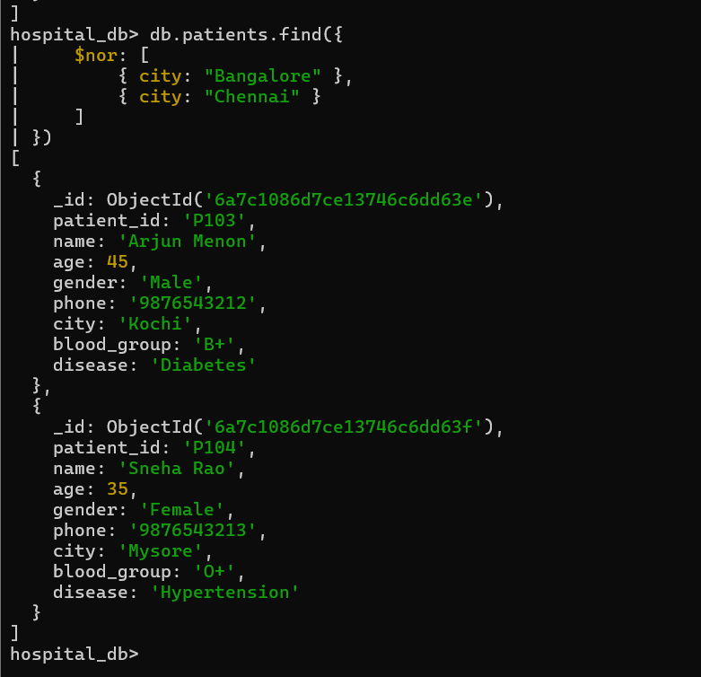
The $nor operator retrieves documents that do not satisfy any of the specified conditions.
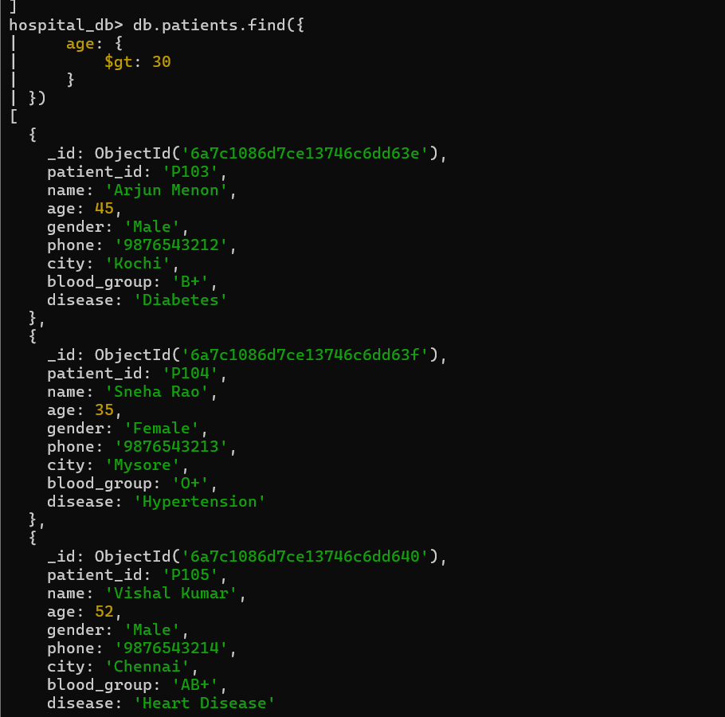
The $gt (greater than) operator retrieves all documents where the specified field value is greater than the given value. In this query, it displays patients whose age is greater than 30 years.
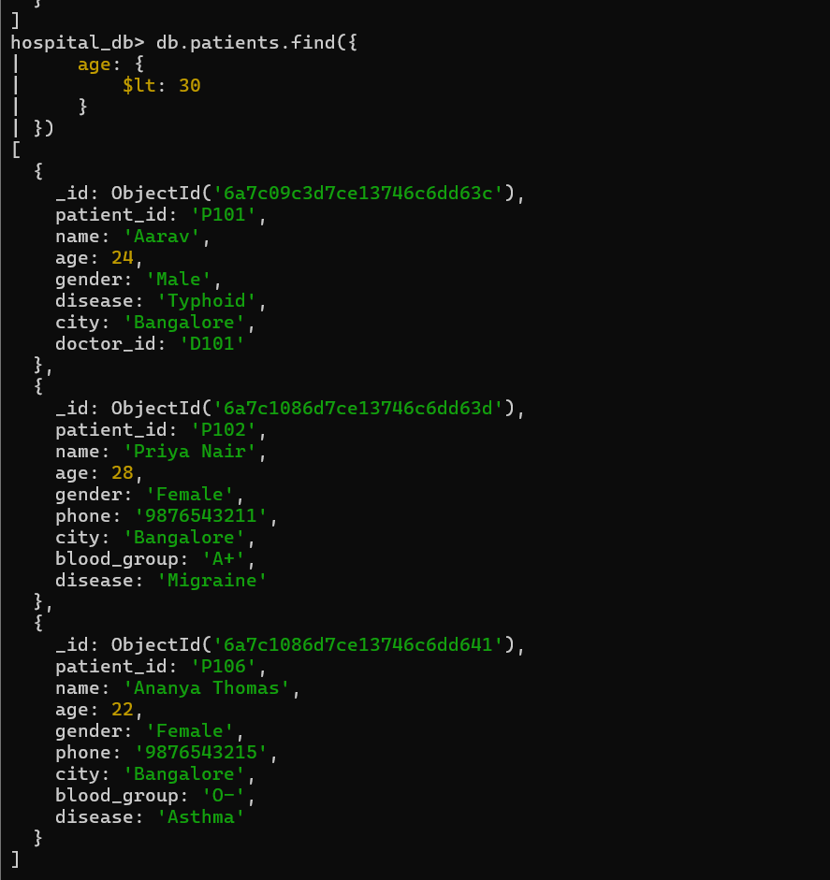
The $lt (less than) operator retrieves documents where the specified field value is less than the given value. Here, it displays patients whose age is below 30 years.
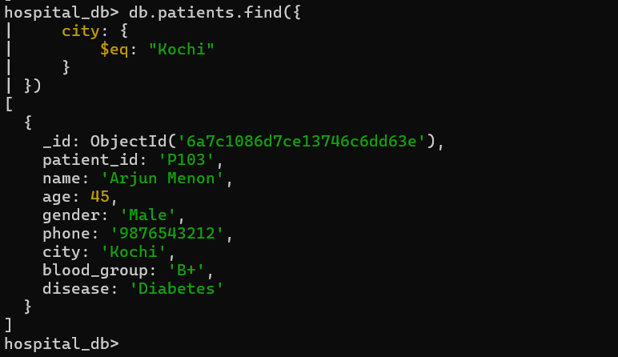
The $eq (equal to) operator retrieves documents where the specified field exactly matches the given value. In this query, it returns patients whose city is Kochi.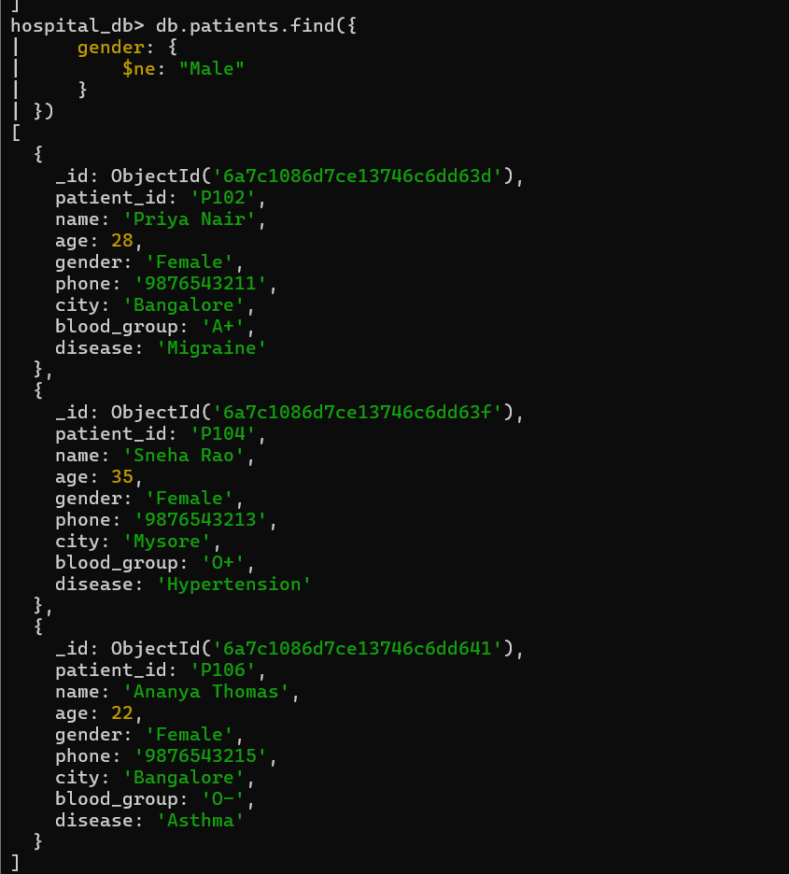
The $ne (not equal to) operator retrieves documents whose field value is different from the specified value. Here, it displays all patients whose gender is not Male.
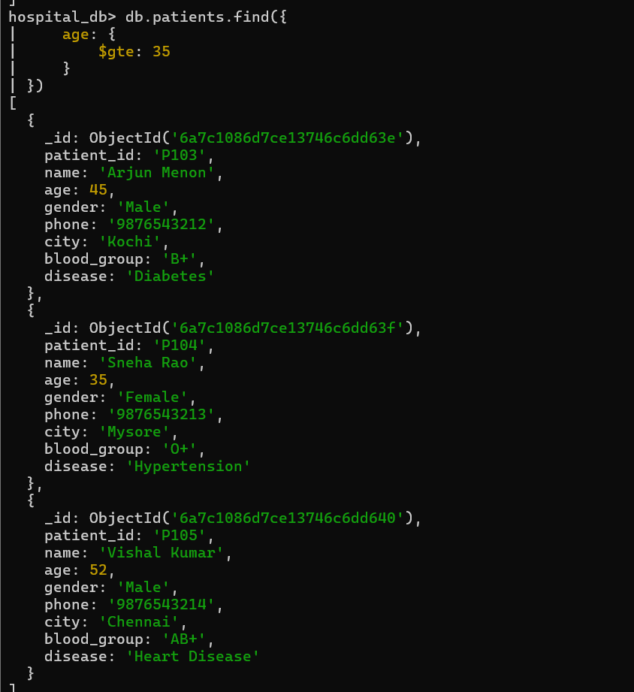
The $gte (greater than or equal to) operator retrieves documents where the field value is greater than or equal to the specified value. In this example, it returns patients aged 35 years and above.
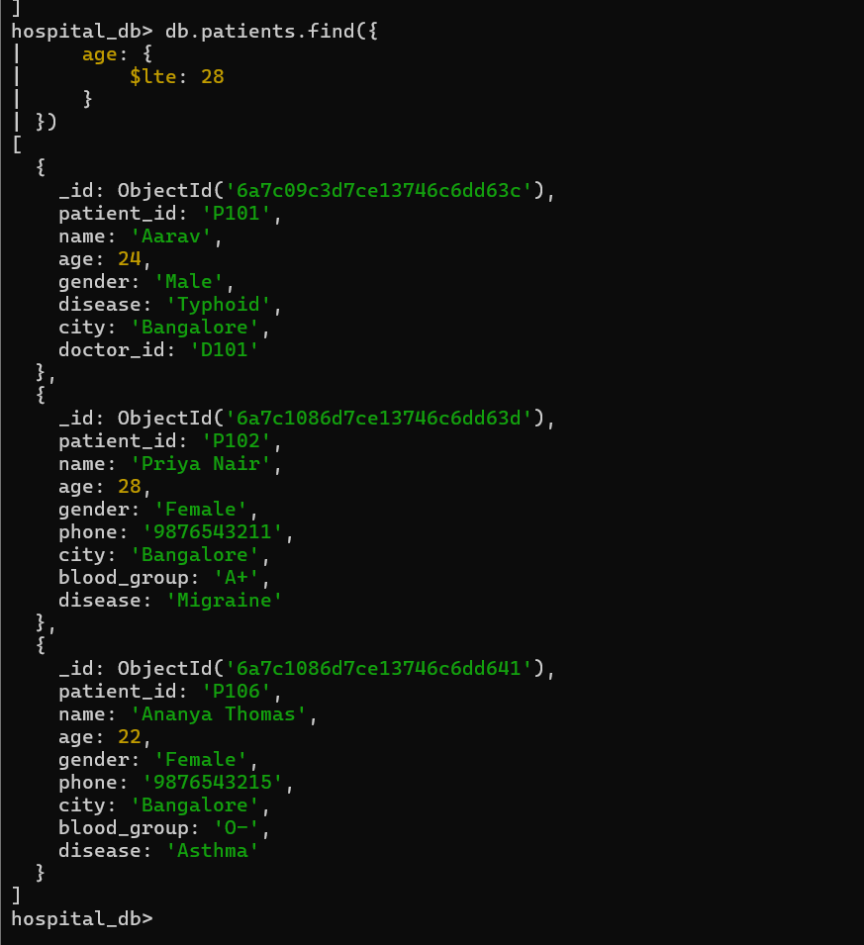
The $lte (less than or equal to) operator retrieves documents where the field value is less than or equal to the specified value. Here, it displays patients aged 28 years or below.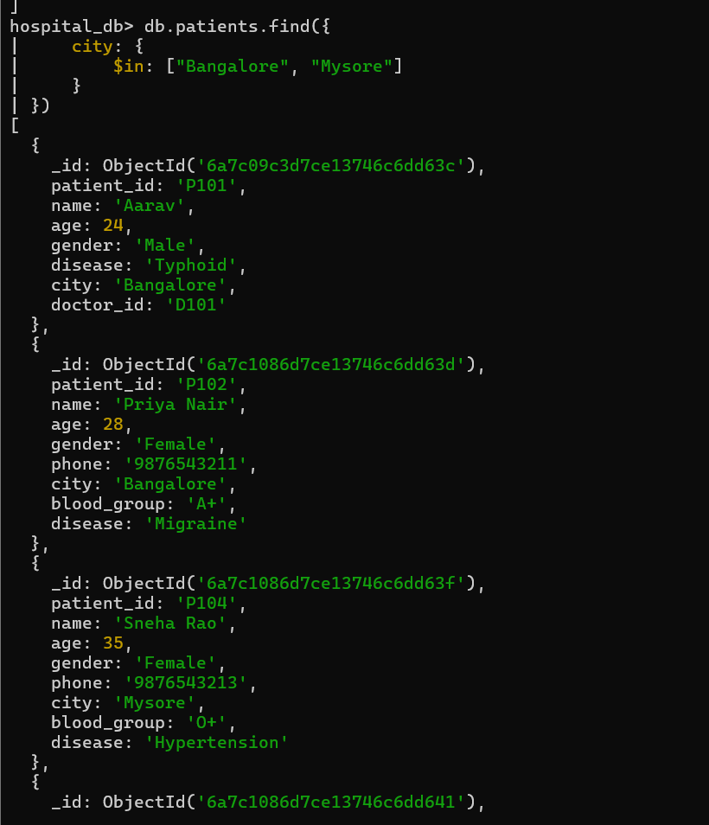 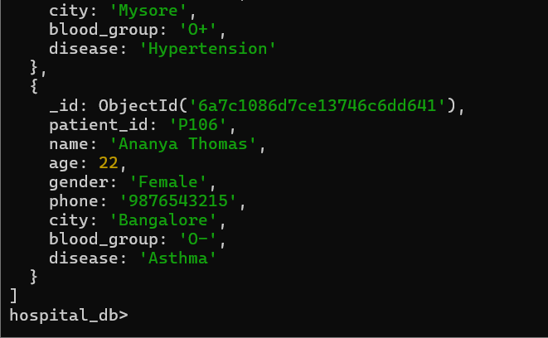
The $in operator retrieves documents whose field value matches any one of the values specified in the list. In this query, it displays patients who live in either Bangalore or Mysore.
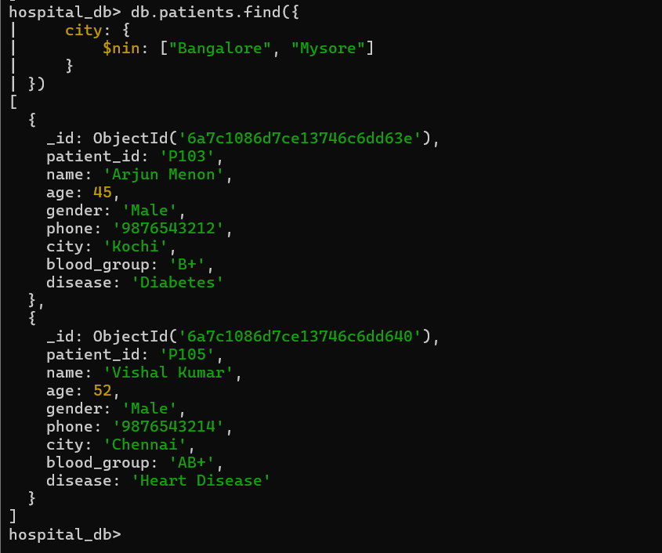
The $nin (not in) operator retrieves documents whose field value does not match any value in the specified list. Here, it displays patients who do not belong to Bangalore or Mysore.
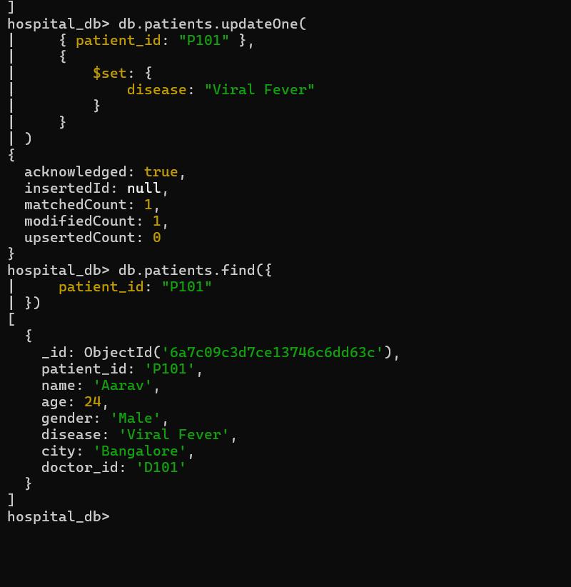
The updateOne() method modified a specific field in a single document, demonstrating how individual records can be updated.
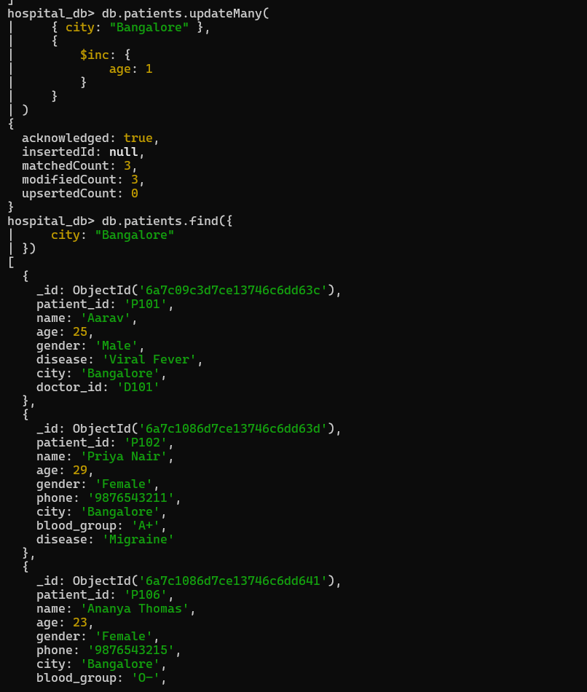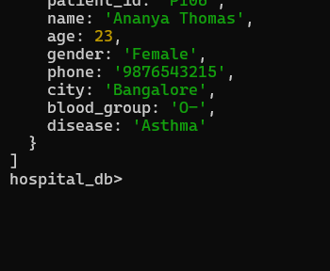
The updateMany() method updated multiple documents matching a specified condition in a single operation.
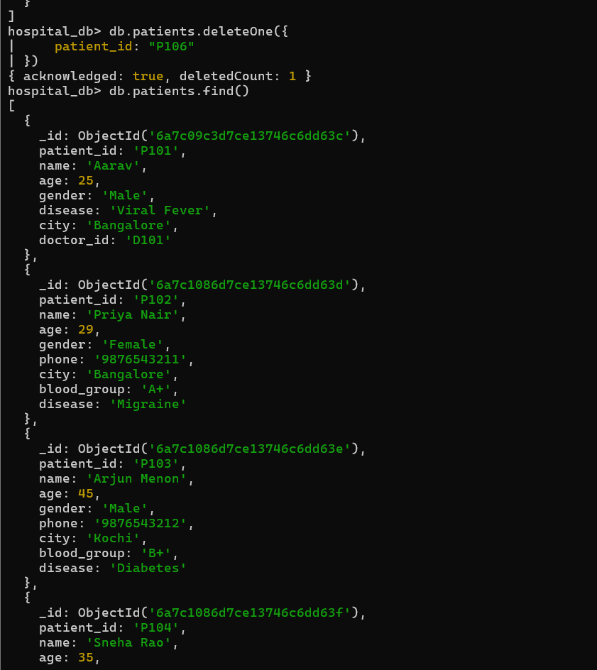 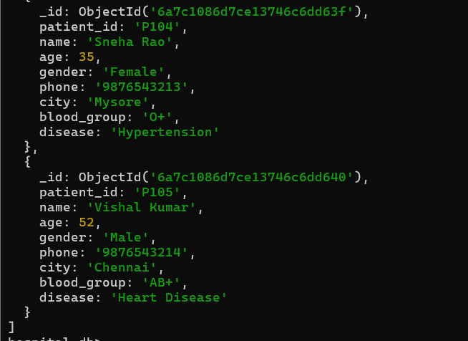 The deleteOne() method removed a single document from the collection based on the specified filter.
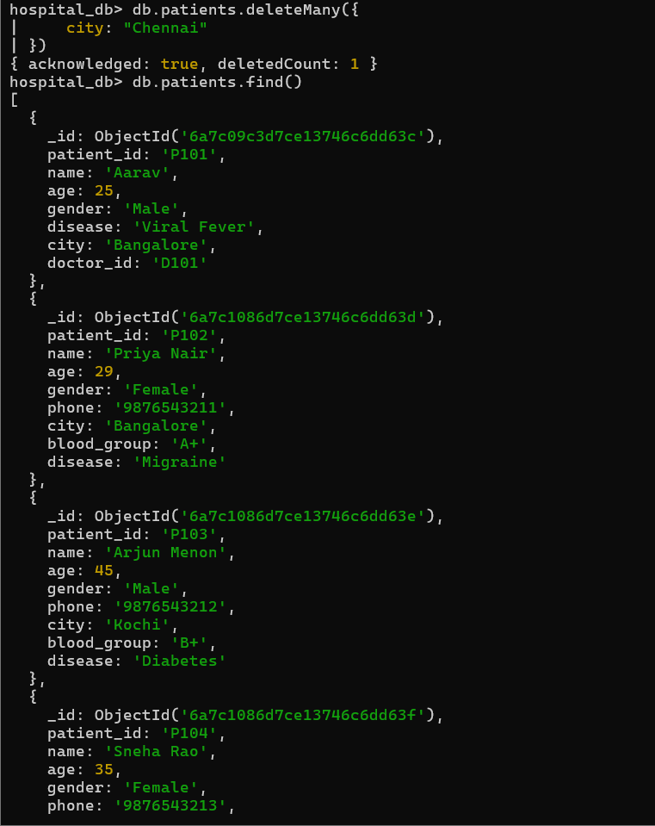
The deleteMany() method deleted all documents that matched the specified condition from the collection.
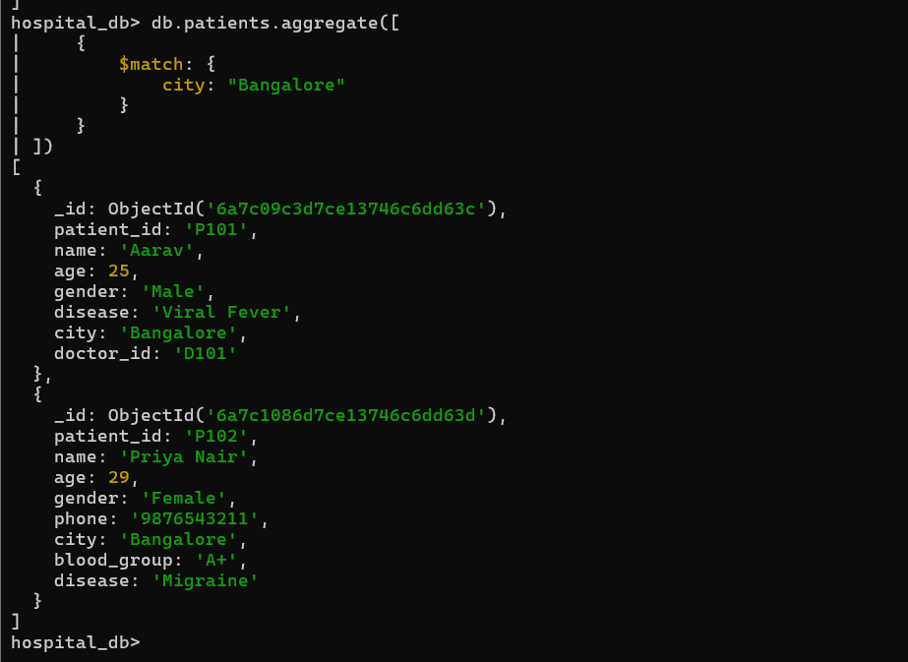 The $match stage filters documents before further processing, similar to the WHERE clause in SQL.
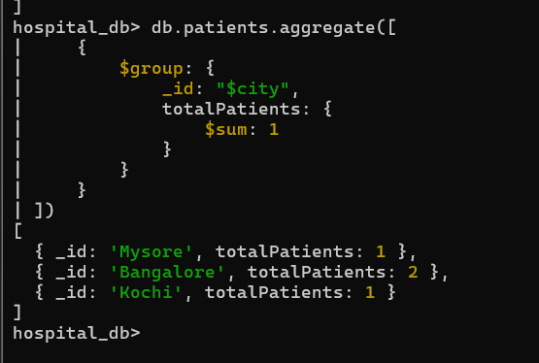
The $group stage groups documents based on a common field, while $sum calculates the total count or sum for each group.
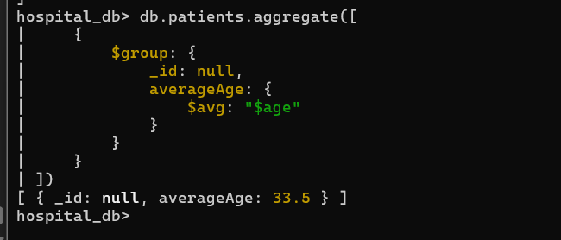
The $avg operator calculates the average value of a numeric field across the selected documents.
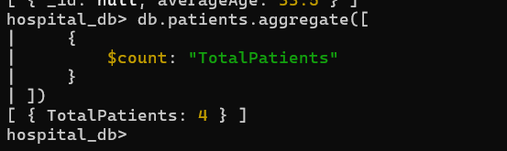 The $count stage counts the total number of documents that pass through the aggregation pipeline.
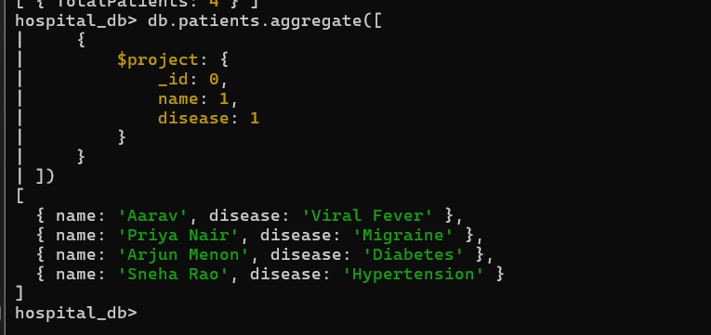
The $project stage displays only the required fields, helping customize the output by including or excluding specific attributes.
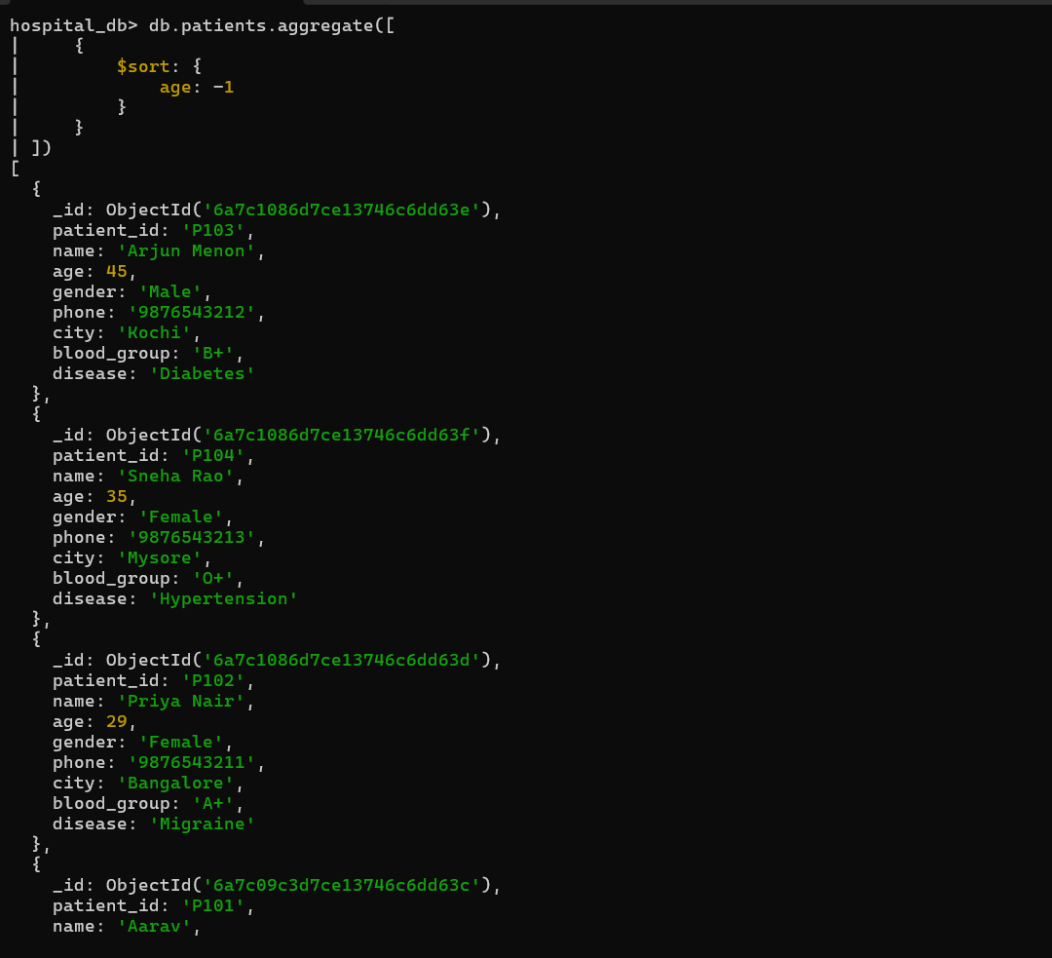 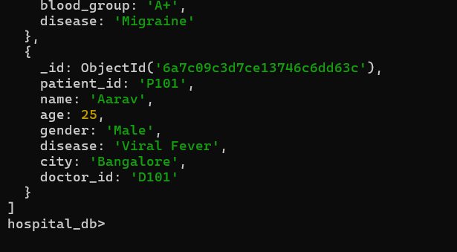 The $sort stage arranges documents in ascending or descending order based on a specified field.
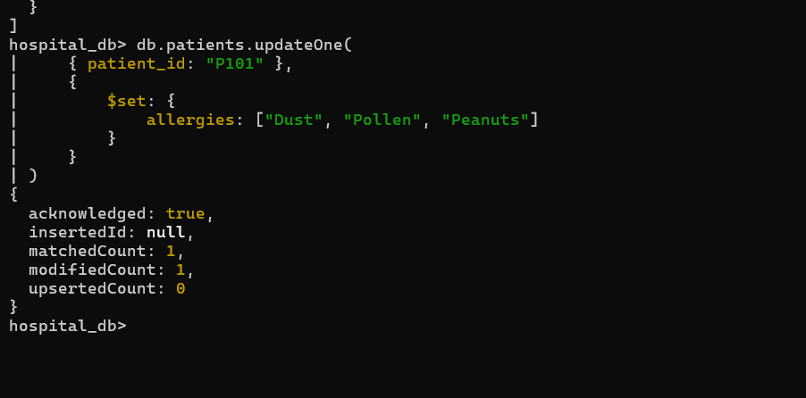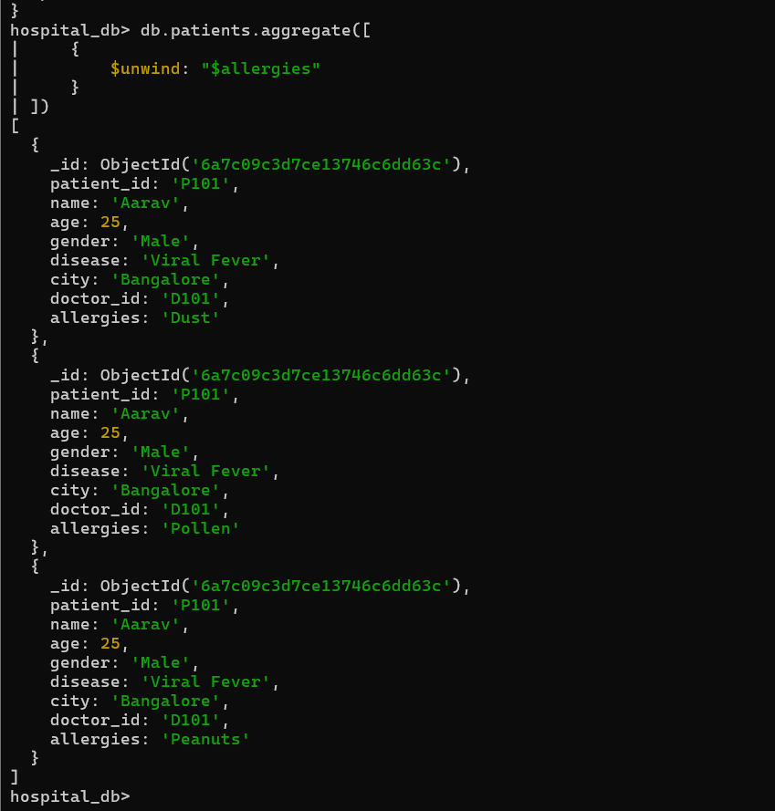
The $unwind stage separates each element of an array into an individual document, making array values easier to process.
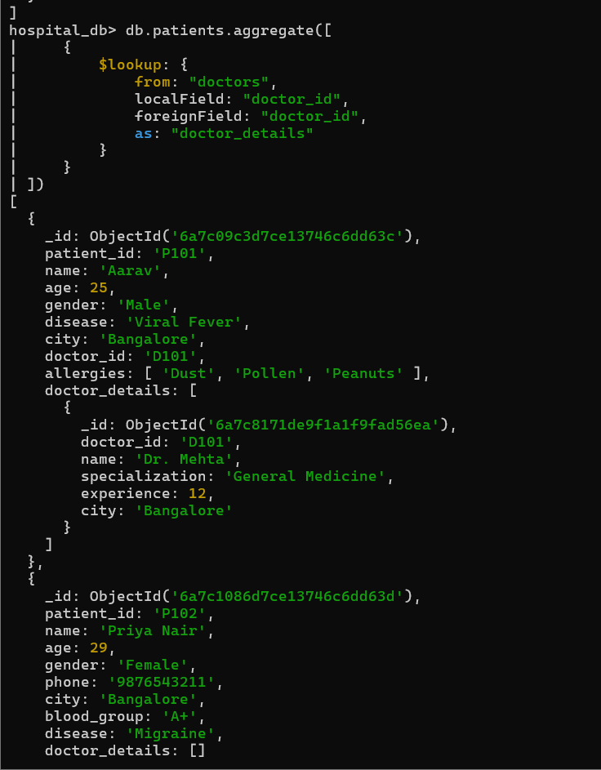
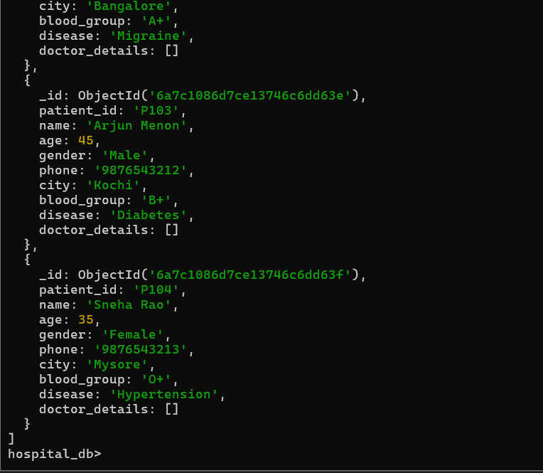 The $lookup stage performs a join between the patients and doctors collections using the doctor_id field, combining related information into a single result.

Conclusion
The CRUD operations and aggregation functions were successfully demonstrated using MongoDB in the Hospital Management System. The lab covered document insertion, retrieval, updating, deletion, logical and relational queries and advanced aggregation stages such as $match, $group, $project, $sort, $unwind and $lookup, providing practical understanding of NoSQL database operations.

Self-Learning
Through this lab, I learned how MongoDB stores data in collections and documents instead of tables and rows. I gained practical experience in performing CRUD operations, applying query operators, and using the aggregation framework to analyse and retrieve meaningful information from a NoSQL database.

