MAI511-1 - Advanced Database Technologies
Reg:no:-2648544
LAB Exercise – III Data Retrieval using JOINS, Subqueries and Correlated queries
- Write SQL statements to demonstrate the following JOIN operations on the tables created for your application domain. INNER, LEFT, RIGHT, and FULL OUTER JOINS. Specifications
- : a. The Operations should be performed on tables with logical sense and mention valid justification.
- b. What is the difference between each JOIN?
2. Demonstrate the usage of subqueries to implement the operations to be performed on the tables created for your application domain. Specifications:
a. At least 5 subqueries should be demonstrated.
b. All tables should be used in at least 1 Compound SQL Query to perform a specified operation.
c. The Operations should be performed on tables with logical sense and mention valid justification.

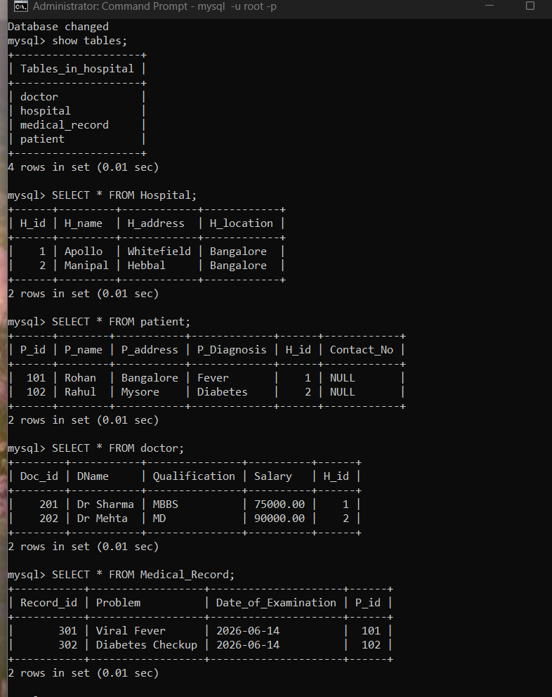

Displaying the existing database and tables in it ; also displaying the contents of each tables .

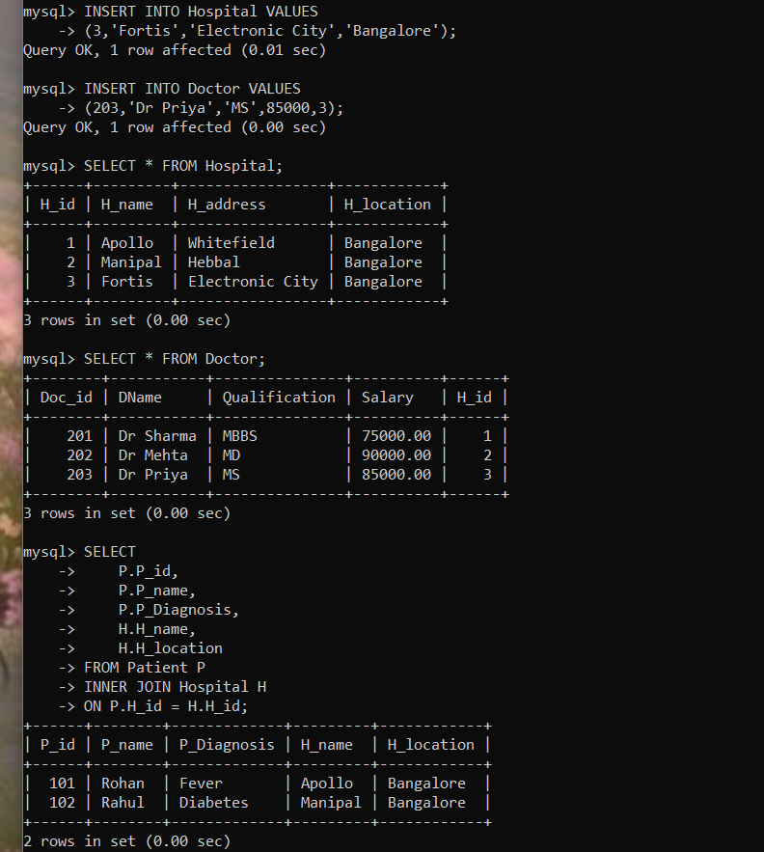
STEP : 1:- I modelled Fortis as a newly operational hospital that has recruited doctors but has not yet admitted any patients. This allows the JOIN operations to demonstrate meaningful differences instead of producing identical outputs.

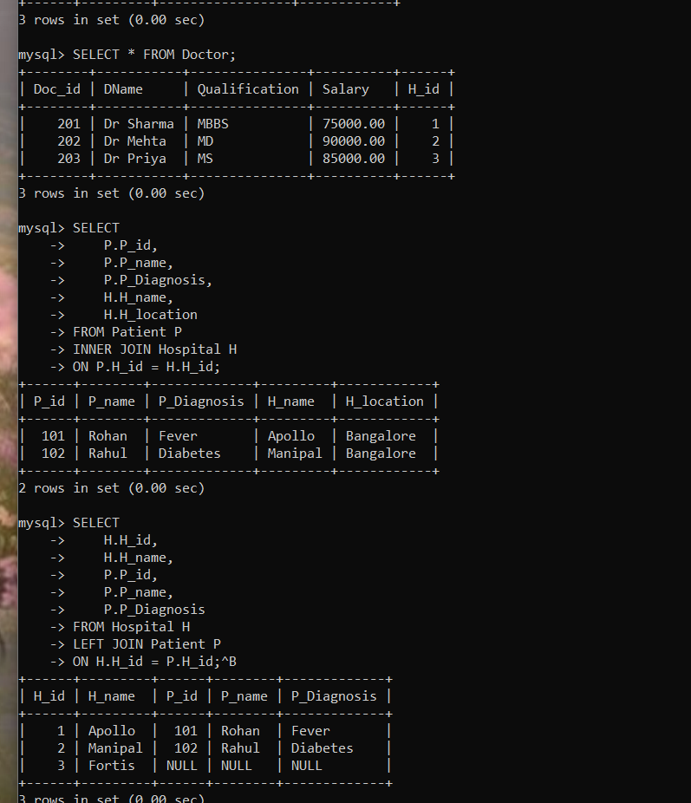
STEP 2 :- An inner join returns only the rows that have matching values in both tables.
Here:
- Every patient must have a matching hospital (Patient.H_id = Hospital.H_id).
- Hospitals without patients are not included.
This query is used to retrieve the details of patients along with the hospital where they are admitted. It is useful for hospital staff, receptionists, and administrators who need to know the admission details of patients. An inner join is appropriate because only patients having a valid hospital association should be displayed.

STEP 3:-
LEFT JOIN is used to display every hospital, including those that currently have no admitted patients. This helps hospital management identify hospitals that are operational but do not yet have patient records.

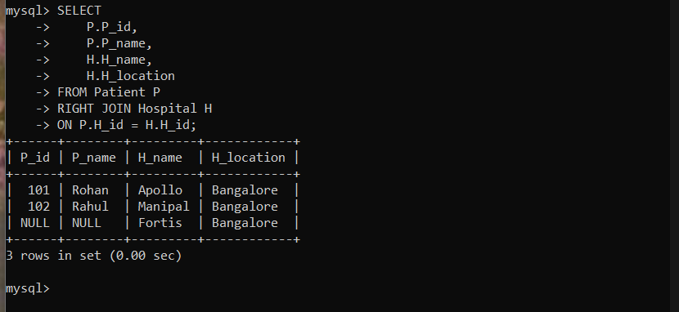

STEP 4 :- Right join displays all hospitals, even if they don't have any patients admitted.
This is a meaningful hospital-management query because administrators may want to know which hospitals currently have no patients.
Since we added Fortis, but no patient is admitted there, this query will demonstrate the RIGHT JOIN properly.

This query retrieves all hospitals along with the patients admitted to them. Since a RIGHT JOIN returns every row from the Hospital table, hospitals without admitted patients are also displayed. In this case, Fortis appears with NULL values for patient details because no patient has been admitted there yet.

RIGHT JOIN returns all rows from the right table (Hospital), even when there is no matching record in the Patient table. INNER JOIN would only return hospitals that currently have patients.
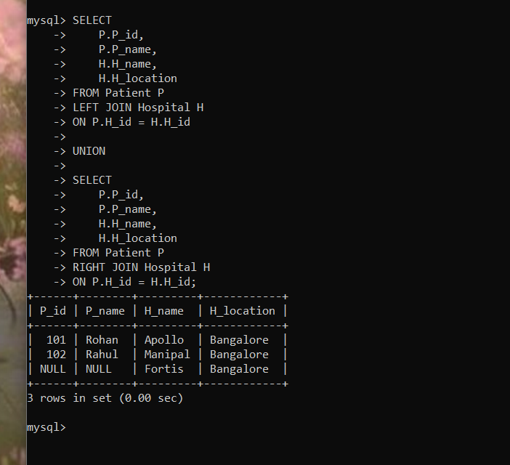

Step 5 : – FULL OUTER JOIN (using UNION)
Purpose:-
Display all patients and all hospitals, including:
- Patients who have a hospital.
- Hospitals that have patients.
- Hospitals with no patients (Fortis).
This gives the complete picture of both tables. Since every patient already belongs to a hospital, the LEFT JOIN doesn't add anything extra. The RIGHT JOIN contributes the Fortis row, and UNION removes duplicate rows.

MySQL does not support the FULL OUTER JOIN operation directly. Therefore, it is simulated by combining the results of a LEFT JOIN and a RIGHT JOIN using the UNION operator. This query displays every patient and every hospital, including hospitals without any admitted patients. In this example, Fortis Hospital appears even though no patient is currently admitted there.

A hospital management system should display all hospitals, even if some currently have no admitted patients. This helps administrators monitor hospital availability and occupancy.

the LEFT JOIN is redundant in the FULL OUTER JOIN simulation because every patient is already assigned to a hospital. However, we still include it because we're trying to reproduce the definition of a FULL OUTER JOIN, not just the current output.

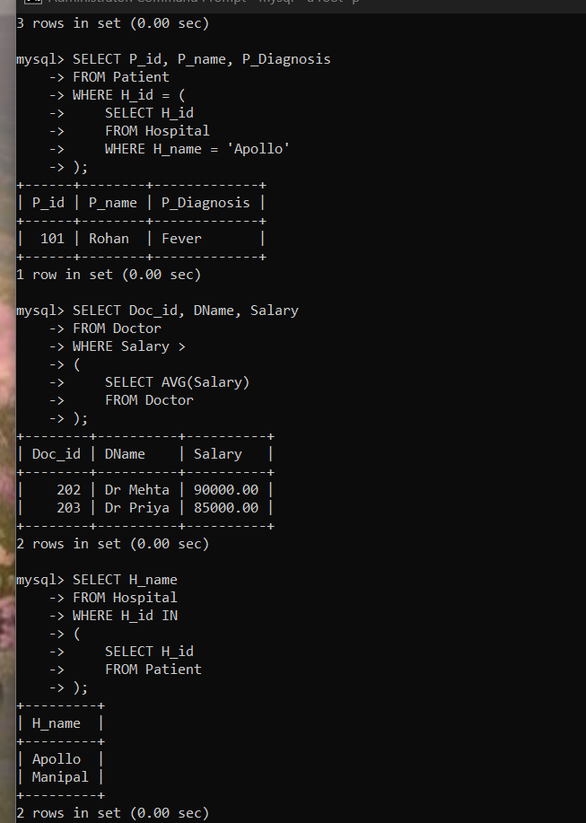

Subquery 1: Patients admitted to Apollo Hospital
The Purpose is to Find the patients admitted to Apollo Hospital without directly knowing its H_id. Hospital staff often know the hospital name, not its ID. The subquery first finds Apollo's ID, then retrieves all its patients.
Subquery 2: Doctors earning more than the average salary ; the Purpose
Is to Find experienced/high-paid doctors. Hospital management may want to identify doctors earning above the average salary.

Subquery 3: Hospitals that currently have patients
Used to Find hospitals where at least one patient is admitted.
This helps administrators identify active hospitals. (Fortis won't appear because no patient is admitted.)

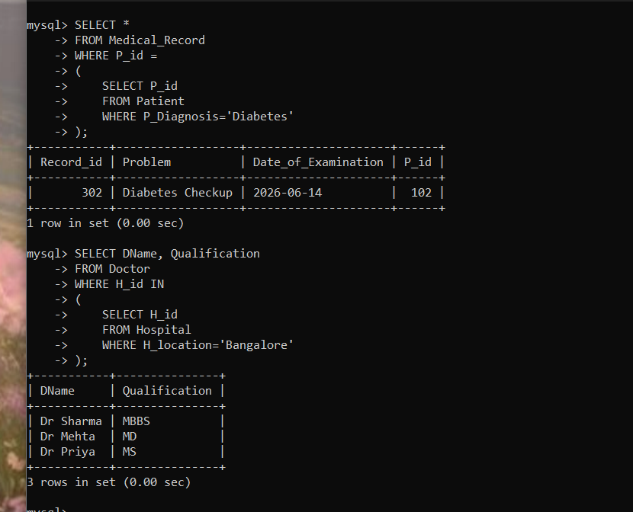

Subquery 4: Medical records of patients diagnosed with Diabetes
Doctors may want to view the medical record of patients diagnosed with Diabetes.

Subquery 5: Doctors working in hospitals located in Bangalore
Purpose is to Find doctors employed in Bangalore hospitals. Useful when administrators need a list of doctors working in a particular city.

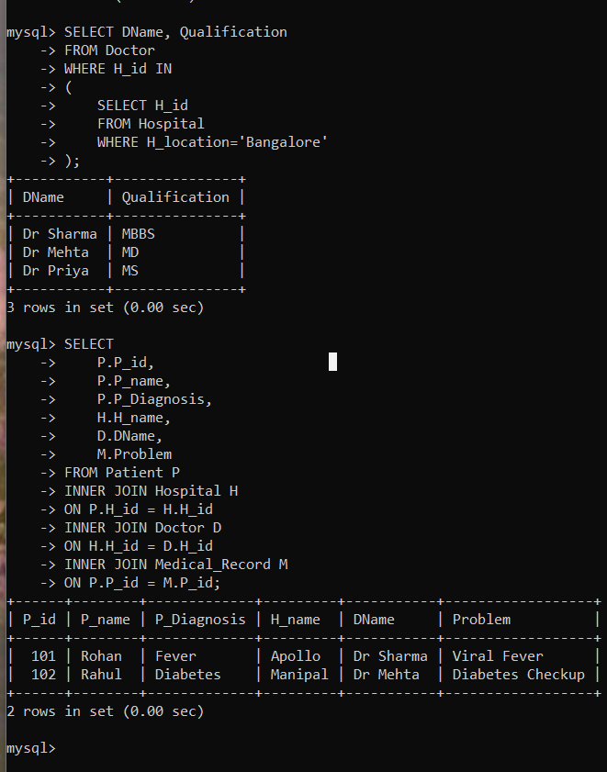

Compound SQL Query (Using All Four Tables)

- Patient Name
- Diagnosis
- Hospital Name
- Doctor working in that Hospital
- Medical Record (Problem)

This compound query combines the Patient, Hospital, Doctor, and Medical_Record tables to generate a comprehensive patient treatment report. It provides meaningful information required by hospital administrators for monitoring patient admissions, diagnosis, assigned hospital, attending doctor, and medical records. The query
demonstrates how multiple related tables can be integrated to support real-world decision-making.

Part 3 – Difference Between JOINs

JOIN | Description | Hospital Example
INNER JOIN | Returns only matching records from both tables. | Shows only patients who are admitted to a hospital. Fortis is not displayed because it has no patients.
LEFT JOIN | Returns all records from the left table and matching records from the right table. If no match exists, NULL values are displayed. | Shows all hospitals, including Fortis, with NULL for patient details because no patients are admitted there.
RIGHT JOIN | Returns all records from the right table and matching records from the left table. If no match exists, NULL values are displayed. | Displays all hospitals and their patients. Fortis appears even without any admitted patients.
FULL OUTER JOIN | Returns all records from both tables. Since MySQL does not support it directly, it is implemented using LEFT JOIN UNION RIGHT JOIN. | Displays all hospitals and all patients, including unmatched records from both tables.

Conclusion:
In this lab exercise, various SQL JOIN operations, subqueries, and a compound SQL query were implemented using the Hospital Management System database. The queries were designed based on real-world hospital requirements such as patient admission tracking, doctor information retrieval, and medical record management. This exercise demonstrated how relational databases combine data from multiple tables to generate meaningful information for decision-making while maintaining data integrity.

Self-Learning:
During this exercise, I explored the limitation that MySQL does not support the FULL OUTER JOIN operation directly. I learned to simulate it using the UNION of LEFT JOIN and RIGHT JOIN. I also understood how JOINs and subqueries are applied to solve practical business problems in a Hospital Management System rather than being used only for retrieving data.

