Course: MAI511-1 - Advanced Database Technologies

LAB Exercise – IV Normalization - reg.no- 2648544

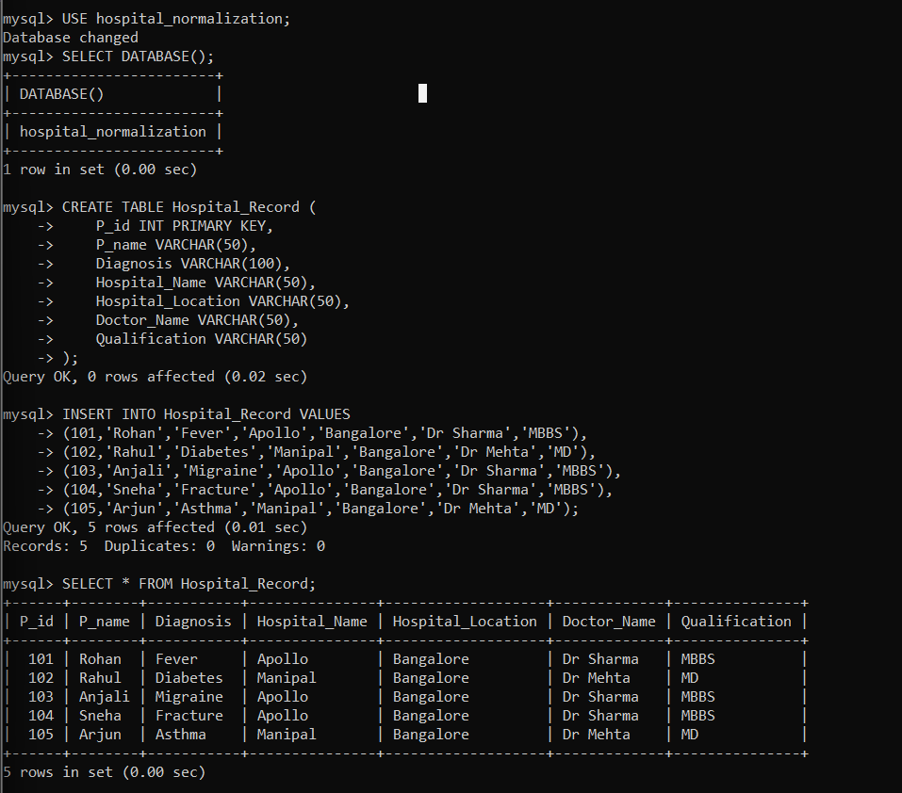
A new database named hospital_normalization was created to perform the normalization process without affecting the existing Hospital Management database. This database is used exclusively for demonstrating the conversion from the original relation to the normalized design.

The Hospital_Record table was created to represent the original database design before normalization. It stores patient, hospital, and doctor details together, resulting in redundant data and dependency issues.
------------------------------------------------------------------
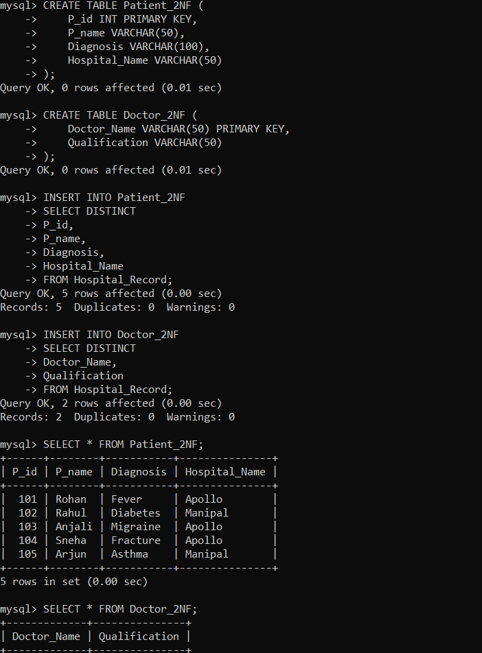
The Patient_2NF table was created to separate patient-related information from the original relation. This helps reduce redundancy by storing patient details independently.
The Doctor_2NF table was created to store doctor details separately from patient records. This removes repeated doctor information and improves data organization.
Distinct patient records were transferred from the original table into Patient_2NF. This step eliminates duplicate patient information while preserving data integrity.
Unique doctor records were inserted into the Doctor_2NF table using the SELECT DISTINCT statement. This prevents duplication of doctor information.
-------------------------------------------------------------------
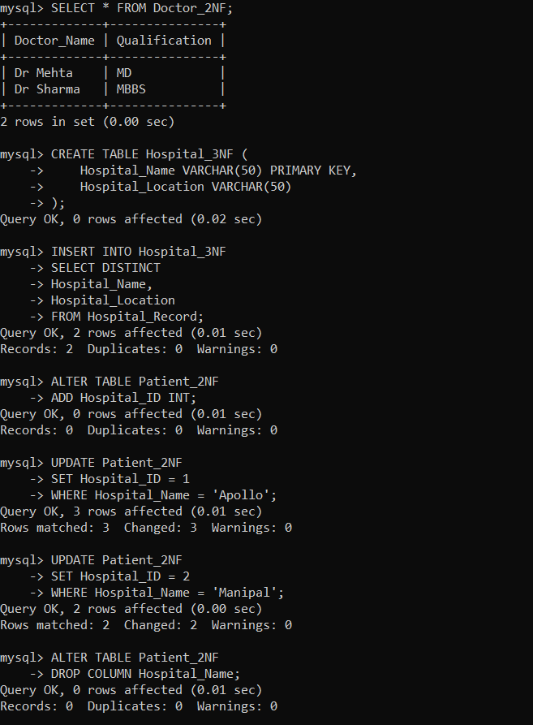
The Hospital_3NF table was created to store hospital information independently. This removes the transitive dependency between hospital name and hospital location.
Unique hospital records were inserted into the Hospital_3NF table. Each hospital is stored only once along with its location, improving consistency.
A hospital identifier was assigned to each patient record to establish a relationship with the Hospital_3NF table. This replaces repeated hospital names with a reference key.
The Hospital_Name column was removed from the Patient_2NF table after introducing the hospital identifier. This completes the removal of the transitive dependency.
----------------------------------------------------------------------------------
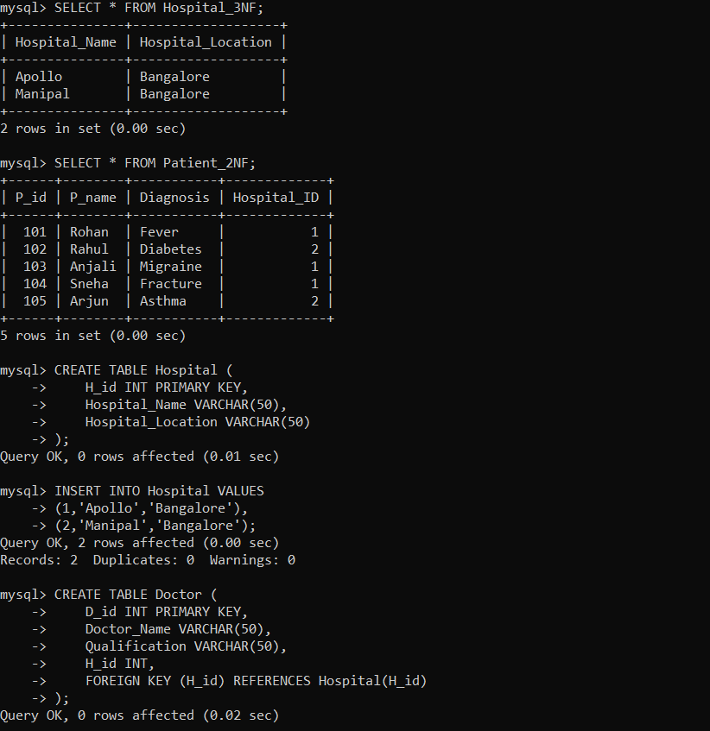
The Hospital_3NF table was displayed to verify the successful normalization of hospital information. Hospital details are now maintained independently.
The updated Patient_2NF table was displayed to verify that patient records now reference hospitals using the hospital identifier instead of repeating hospital names.
The final normalized Hospital table was created with a unique hospital ID, hospital name, and location. This table forms the foundation of the normalized database.
The normalized Doctor table was created with a foreign key linking each doctor to a hospital. This establishes a proper relationship between hospitals and doctors.
The normalized Patient table was created with a foreign key referencing the Hospital table. Patient information is now stored independently without repeating hospital details.
The Medical_Record table was created to maintain patient medical history separately. It references the Patient table using a foreign key to preserve referential integrity.
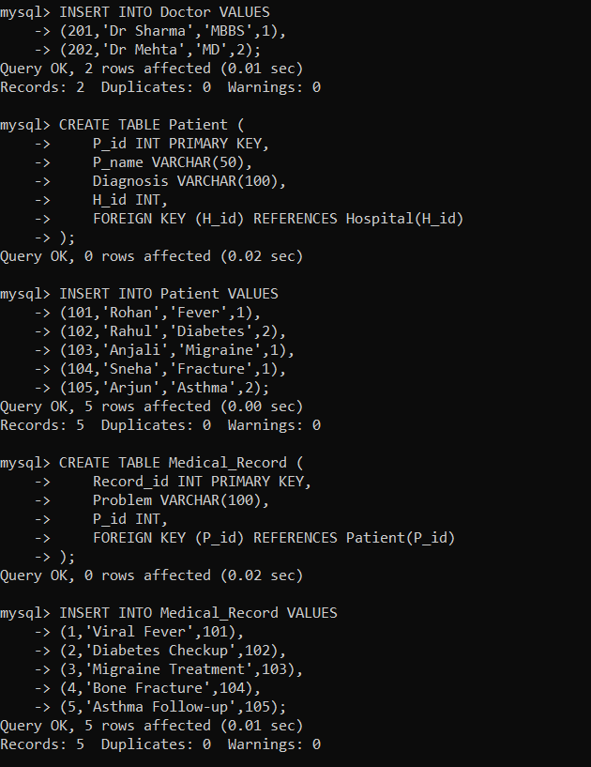
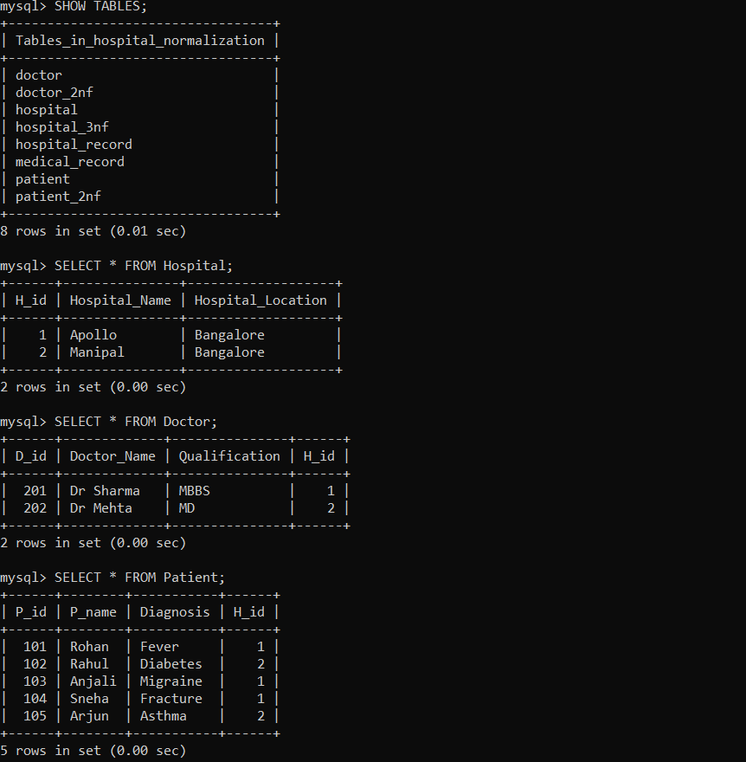
The contents of all normalized tables were displayed to verify that the data was correctly distributed according to Third Normal Form (3NF). The insert operation was performed on both the original and normalized database designs. The comparison demonstrates that the normalized design reduces redundant data insertion. The update operation was executed on both database designs. The normalized database requires updating only a single record, thereby eliminating update anomalies. The delete operation was compared between the original and normalized designs. The normalized database preserves related hospital and doctor information even after deleting patient records.

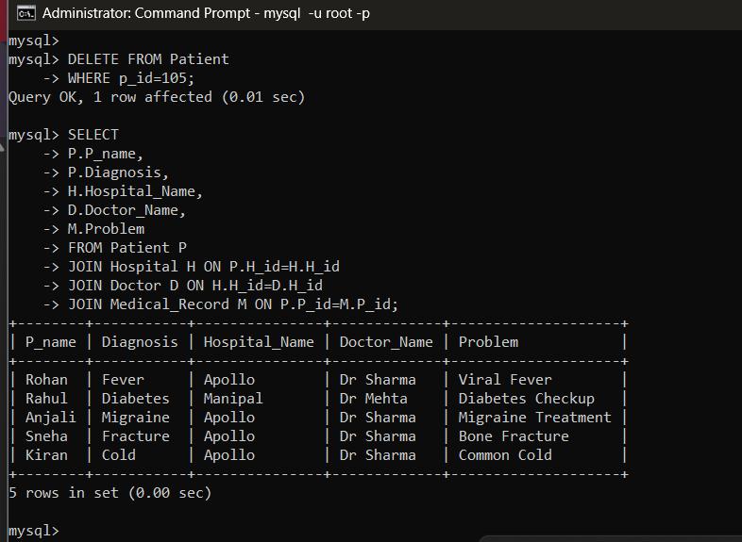
A JOIN query was executed to retrieve patient, hospital, doctor, and medical record information from multiple normalized tables. This demonstrates how normalization supports efficient data retrieval through relationships.

Efficiency Comparison Table

Parameter | Before Normalization | After Normalization
Number of tables | 1 | 4
Data redundancy | High | Low
Storage usage | High | Optimized
Update anomaly | Present | Eliminated
Insert anomaly | Present | Eliminated
Delete anomaly | Present | Eliminated
Data consistency | Low | High
Query complexity | Simple (single table) | Moderate (uses JOINs)

Conclusion:
This lab demonstrated the process of normalizing a hospital database from the original relation to Third Normal Form (3NF). By identifying functional dependencies and removing redundancy, the database design became more organized, consistent, and efficient. The comparison between the original and normalized designs showed that normalization minimizes update, insert, and delete anomalies while improving data integrity and maintainability.

Self-Learning:
Through this lab, I gained a practical understanding of the normalization process and its role in designing efficient relational databases. I learned how to identify functional dependencies, recognize redundancy and anomalies, and systematically convert a relation into 1NF, 2NF, and 3NF. I also understood that normalization improves data consistency and maintainability, although it may require JOIN operations to retrieve related information from multiple tables.

