MAI511-1 - Advanced Database Technologies
Reg.No:- 2648544
Exercise:
Simulate the Timestamp Ordering (TO) Concurrency Control Algorithm in y our
respective business domain using any language, where multiple transactions access
concurrently.
1. Schema Design (Table to simulate the data items and track transaction)
2. Insert a data item with initial values, timestamp and Insert two transactions with
logical timestamps
3. Simulate the read operation with timestamp ordering logic
4. Simulate the write operation with timestamp ordering logic
5. A brief explanation of how each TO operation is demonstrated.

Aim
To simulate the Timestamp Ordering (TO) Concurrency Control Algorithm using Python in the Hospital Management domain by demonstrating timestamp-based read and write operations.

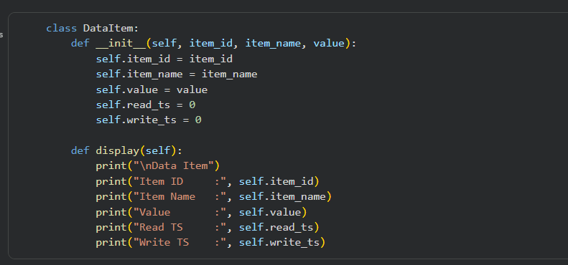We created a class called DataItem to represent a database. record.Read_TS = 0 and Write_TS = 0 because no transaction has accessed the data yet.
Timestamp Ordering always checks when the data was last read and when the data was last written. Therefore, every data item must maintain these two timestamps.
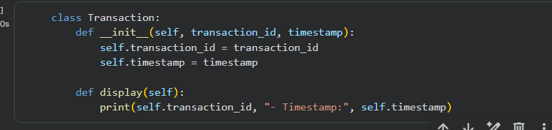
We created two transactions. Every transaction must have a logical timestamp. The timestamp decides who gets priority.
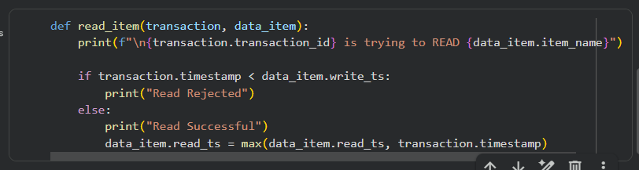
Read Operation is executed. Before allowing the read, the program checks if Transaction Timestamp<Write Timestamp; If YES, Reject; If NO, Allow read.
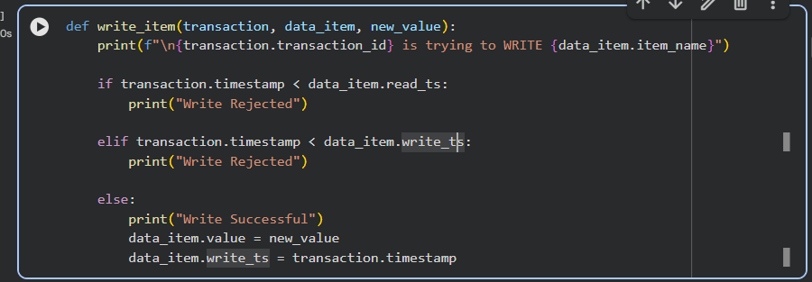
We are executing a write operation here. Before allowing write, the algorithm checks:-Condition 1:- TS(T)< Read_TS. If true, Reject. Because a newer transaction has already read this value. Allowing an older transaction to overwrite it would violate timestamp ordering.
Condition 2:- TS(T)<Write_TS . If it is true, reject. Because a newer transaction has already been written, an older transaction cannot overwrite newer data. If neither condition is true, Write succeeds.

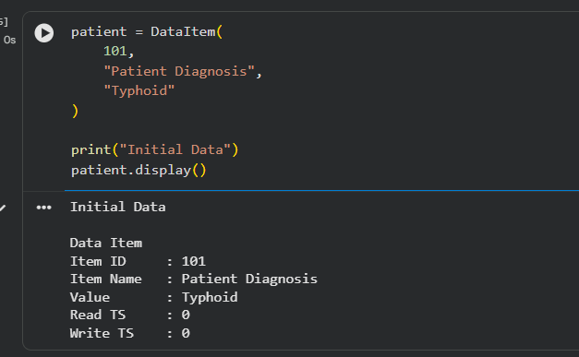
Created one database item. Inserted one data item.
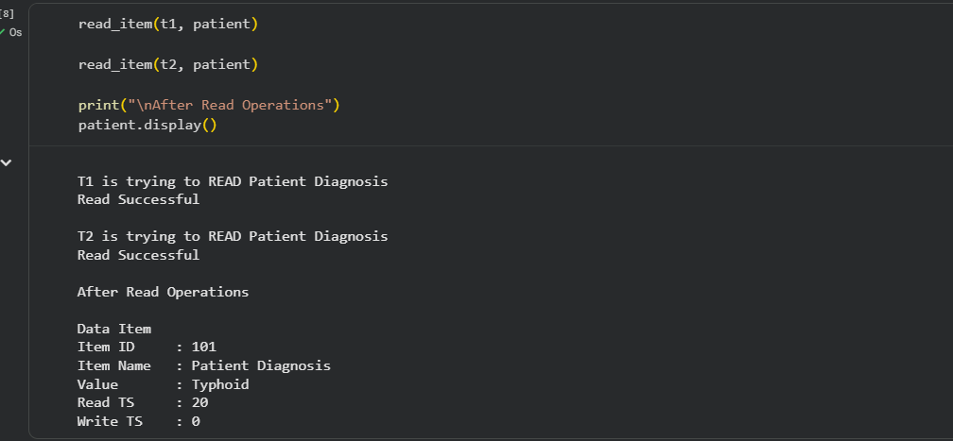
Read Simulation. T1 reads, and then T2 reads. After each successful read, Read_TS was updated.
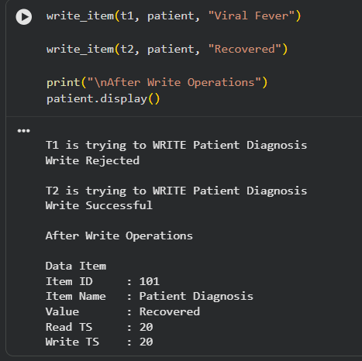
Write Simulation. T1 writes, and then T2 writes. Each write updated ‘Diagnosis ‘ and ‘Write_TS’.

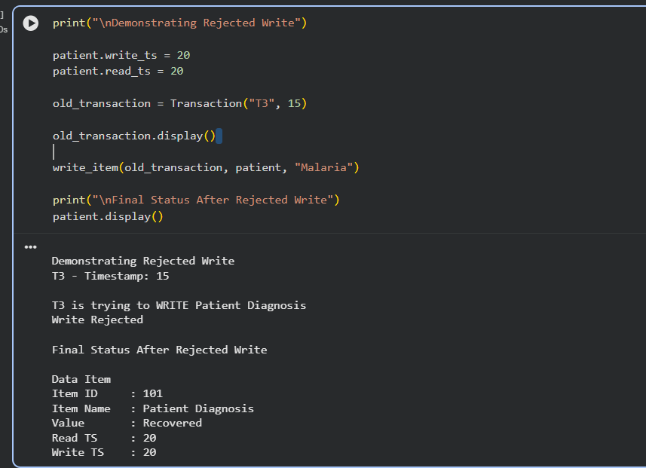
Initially, Write_TS = 20 and Now T3 Timestamp = 15. The algorithm checks 15 < 20. Since this is True, the write is rejected. If the older transaction were allowed to write, it would overwrite data written by a newer transaction, violating Timestamp Ordering. According to the Timestamp Ordering protocol, an older transaction cannot overwrite a value written by a newer transaction. Therefore, the write request is rejected.
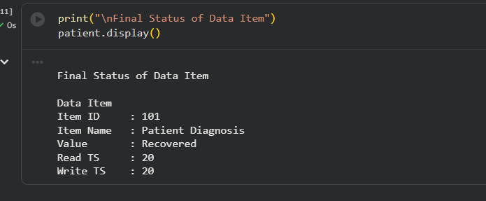
This block of code shows how the timestamps changed after all operations.

