Course: MAI511-1 - Advanced Database Technologies

LAB Exercise – V ACID Properties of Transaction - Reg.no -2648544
Using the database developed for your selected application domain, implement and demonstrate the ACID properties of a transaction by performing a suitable transaction operation.
The implementation should demonstrate:
Atomicity
Execute a transaction involving multiple SQL operations.
Demonstrate the successful execution of all operations using COMMIT.
Demonstrate failure handling using ROLLBACK.
Consistency
Ensure that the transaction maintains database integrity by applying appropriate constraints such as
primary key, foreign key, and domain constraints.
Isolation
Demonstrate how concurrent transactions are handled using appropriate transaction isolation levels.
Durability
Verify that committed transactions are permanently stored in the database even after closing and
reopening the database session.
Select a meaningful transaction scenario related to their application domain and implement the
required SQL transaction commands.

Aim
To demonstrate the ACID (Atomicity, Consistency, Isolation, and Durability) properties of transaction management using the Hospital Management System database in MySQL.
Database Used
The Hospital Management System database developed in the previous laboratory exercises was used. The database consists of the following tables:
- Hospital
- Doctor
- Patient
- Medical_Record
- Scenario

- A Hospital Management System was considered for demonstrating transaction management. During patient admission, multiple database operations such as adding patient details and creating medical records must either complete successfully together or fail together. The ACID properties ensure that the database remains accurate, consistent, and reliable even when multiple transactions are performed simultaneously or when unexpected failures occur.

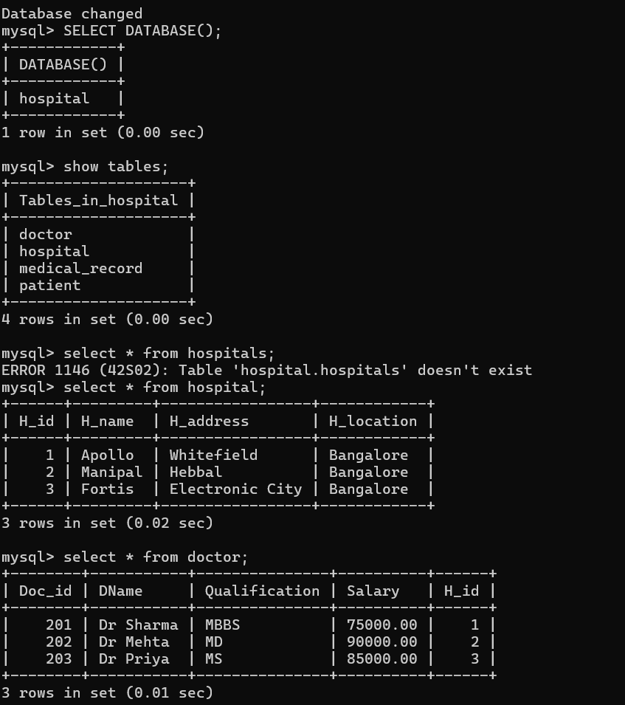
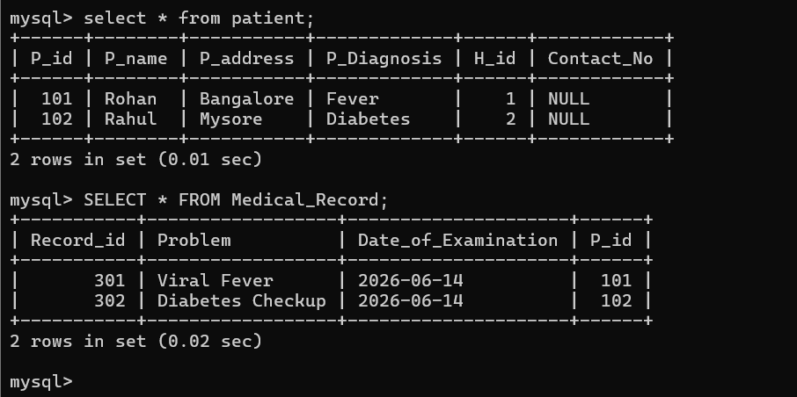
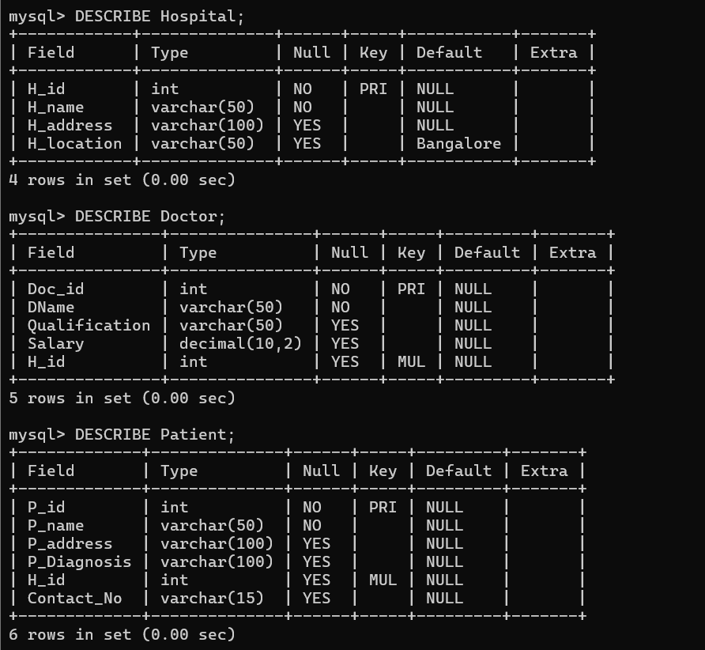
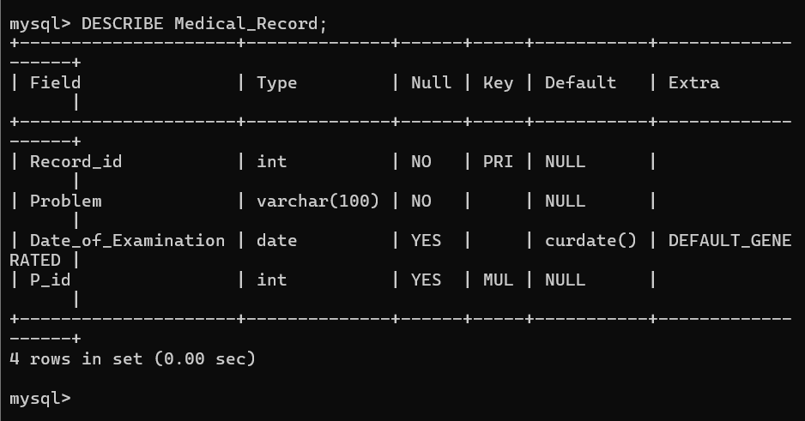
The available databases in the MySQL server were displayed. The hospital database, developed in the previous lab exercises, was selected for implementing and demonstrating the ACID properties of transactions.
The existing records in all tables were displayed before performing transaction operations. This establishes the initial database state and helps verify the effects of COMMIT and ROLLBACK during the demonstration.
----------------------------------------
PART 1: ATOMICITY
Atomicity ensures that a transaction is treated as a single unit of work. Either all operations are completed successfully, or none of them are applied to the database.
Scenario
A new patient Priya is admitted to Apollo Hospital.
The admission involves two operations:
- Insert the patient into the Patient table.
- Create the patient's Medical_Record.
If both succeed → COMMIT
If one fails → ROLLBACK

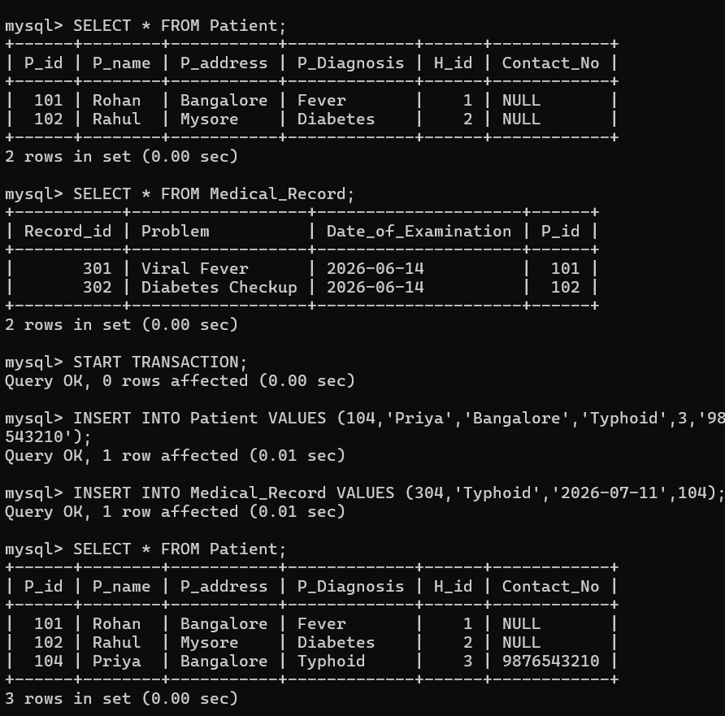
The newly inserted patient and corresponding medical record are visible within the current transaction. The changes are not yet permanently stored because the transaction has not been committed.
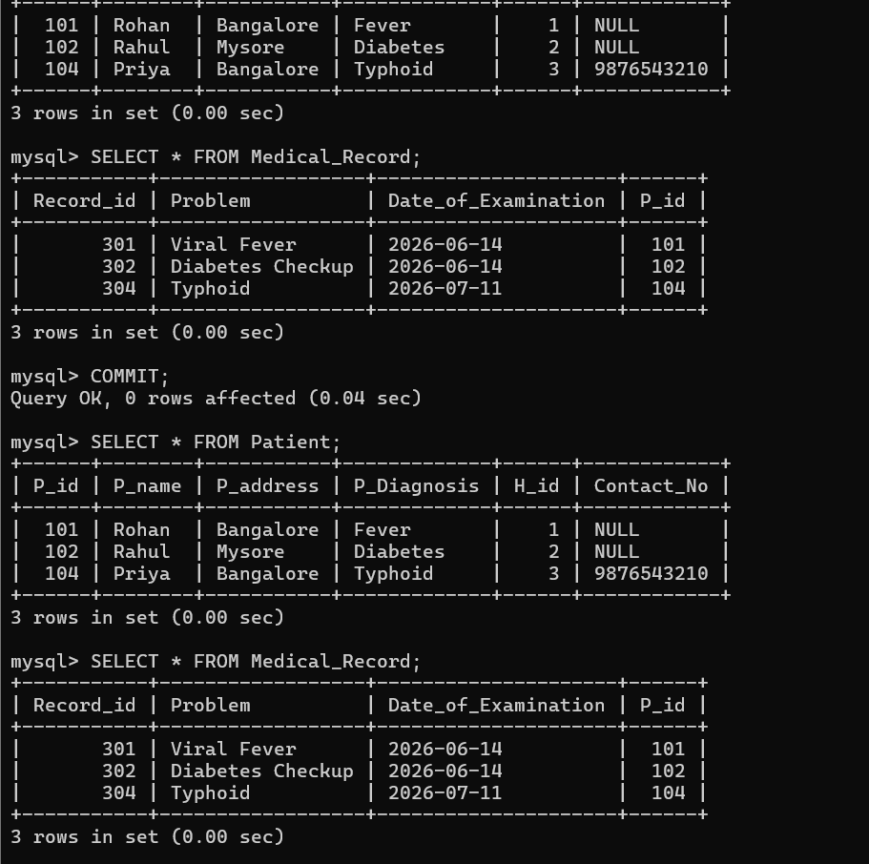
The COMMIT command permanently saved both insert operations. The new patient and medical record remain stored in the database, demonstrating the Atomicity property for a successful transaction.
Part 1(B): Atomicity using ROLLBACK
Scenario
A patient Karan is admitted to Apollo Hospital. During the admission process, incorrect details are entered. Since the transaction contains an error, the entire transaction is cancelled using ROLLBACK, ensuring that no partial data is stored.
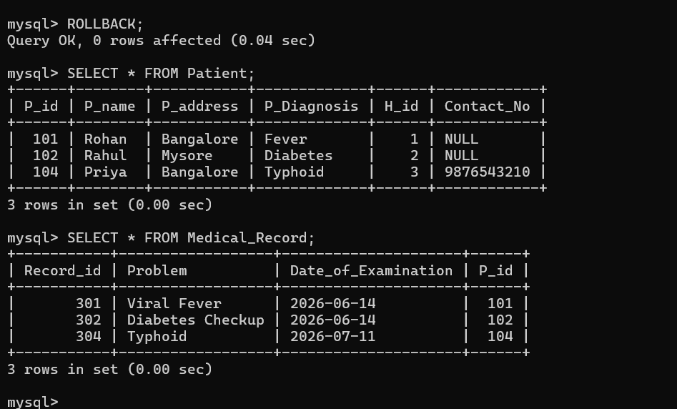

The ROLLBACK command cancelled the transaction. The newly inserted patient and medical record were removed, demonstrating that none of the transaction's operations were permanently applied.

Part 2: Consistency
Consistency ensures that every transaction takes the database from one valid state to another valid state by enforcing all integrity constraints, such as Primary Key, Foreign Key, and data type constraints.
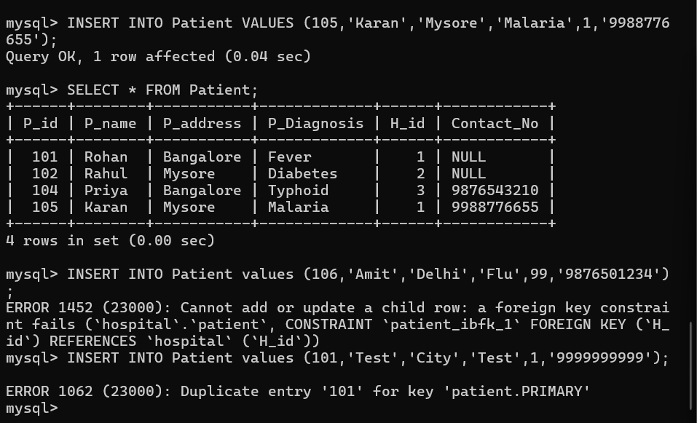
A valid patient record was inserted successfully because all constraints were satisfied. The primary key was unique, and the hospital ID referenced an existing hospital, maintaining database consistency.
Since Hospital ID 99 is not present in the Hospital table, MySQL should return a Foreign Key Constraint Error. The insertion failed because Hospital ID 99 does not exist in the Hospital table. The foreign key constraint prevented invalid data from being inserted, thereby maintaining database consistency.
Part 3: Isolation
Isolation ensures that multiple transactions executing at the same time do not interfere with each other. Each transaction behaves as if it is running independently until it is committed.
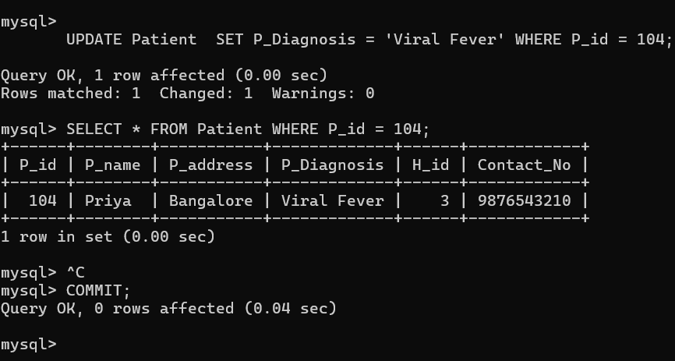
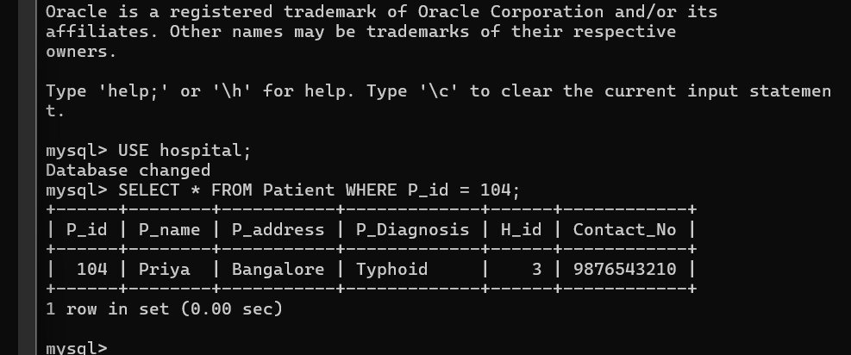
Transaction 1 updated the patient's diagnosis but did not commit the transaction. Transaction 2 continued to view the previously committed value, demonstrating that uncommitted changes are isolated from other transactions.
After the COMMIT operation, the updated diagnosis became visible to the second transaction. This demonstrates that only committed changes are shared between transactions, satisfying the Isolation property.
Window 1 updated Priya's diagnosis to Viral Fever, but did not commit.
Window 2 still saw Typhoid, because it could only see the last committed value.
This means uncommitted changes from one transaction were isolated from another transaction.
Part 4: Durability
Durability ensures that once a transaction is committed, its changes are permanently stored in the database and remain intact even if the system crashes or restarts.

Hospital Scenario
A new patient Neha is admitted to Apollo Hospital.
Once the transaction is committed, the patient record should still exist even after closing and reopening MySQL.

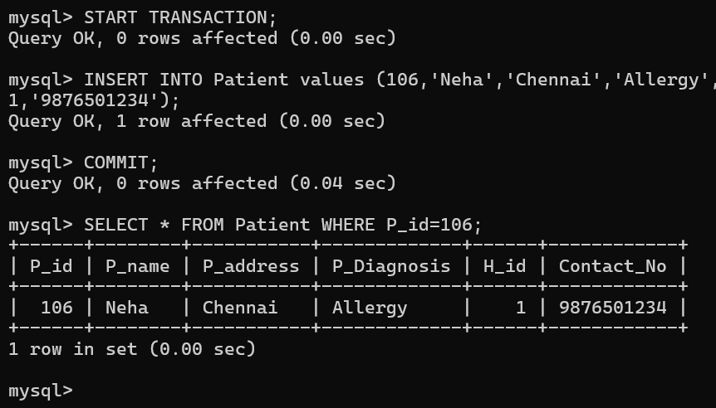
A new patient record was inserted and committed successfully. The COMMIT command permanently saved the transaction in the database.

Closes mysql , then opens it again .
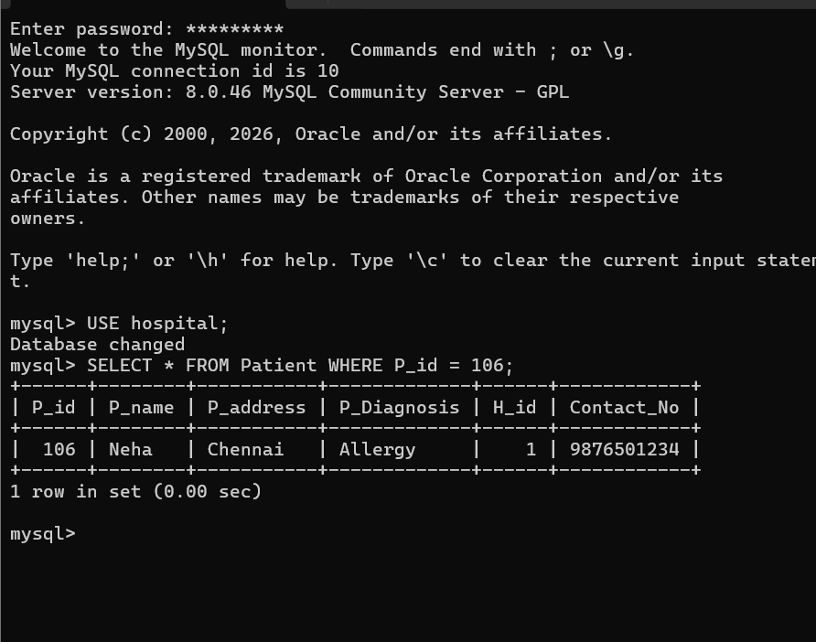

After closing and reopening the MySQL server, the committed patient record remained available in the database. This demonstrates the Durability property, which guarantees that committed transactions are permanently stored.
Conclusion
The ACID properties of transactions were successfully demonstrated using the Hospital Management database. Atomicity was verified through COMMIT and ROLLBACK operations, Consistency through integrity constraints, Isolation by executing concurrent transactions in separate MySQL sessions, and Durability by verifying that committed data remained available after restarting the MySQL client. These properties ensure reliable, accurate, and secure transaction processing in relational database systems.

Self Learning
Through this lab, I learned how transaction management ensures data reliability in a database. I gained practical experience with COMMIT, ROLLBACK, transaction isolation levels, and integrity constraints, and understood how the ACID properties work together to maintain consistency and prevent data loss in real-world applications.

