CHRIST University -Department of Computer Science

M.Sc. in Artificial Intelligence &Machine Learning (MSAIML)

Data Structures — Practical / Lab Assessment
Reg.No- 2648544
Rohan sam reji
28/09/2026

Scenario
GenoScan AI is a bioinformatics start-up building a machine-learning model that predicts gene-regulation activity from DNA sequences. Before the data is fed to the model, a feature-extraction module must locate every occurrence of short, biologically important patterns called motifs (for example, the binding site GCTAG) inside long DNA reads made up only of the characters A, C, G and T. The number and positions of these motifs become input features for the ML model.
The current prototype uses a brute-force search, which becomes very slow when millions of reads are processed. Repetitive regions such as AAAAAAAA…, which are common in real genomes, make it even worse.
You have been hired as a data-structures engineer to replace this module with an efficient, verifiable string-matching component and to justify your choice with evidence.
Expected Outcomes of the Lab
Learning Outcomes
On successful completion of this experiment, the student will be able to:
1. Implement the naïve and KMP string-matching algorithms from first principles without library support.
2. Construct and interpret the LPS (failure-function) array and explain how it avoids re-examining text
characters.
3. Analyse and empirically compare algorithms using comparison counts and execution time, and relate
observations to asymptotic complexity.
4. Handle edge cases and validate inputs in a way that suits production data pipelines.
5. Independently learn an advanced technique (hashing, heuristics or automata) and select the most
suitable algorithm for a real AI/ML pre-processing problem.
Expected Inference (sample)
On random DNA, all algorithms perform close to linearly. For highly repetitive DNA, the naïve algorithm degrades to O(n·m), whereas KMP remains linear. Hence KMP (or Aho–Corasick when many motifs are searched together) is the recommended choice for GenoScan feature-extraction module.
Program code- 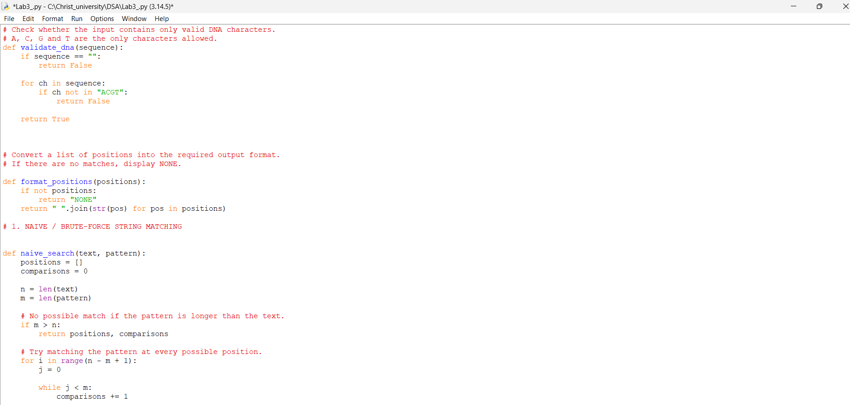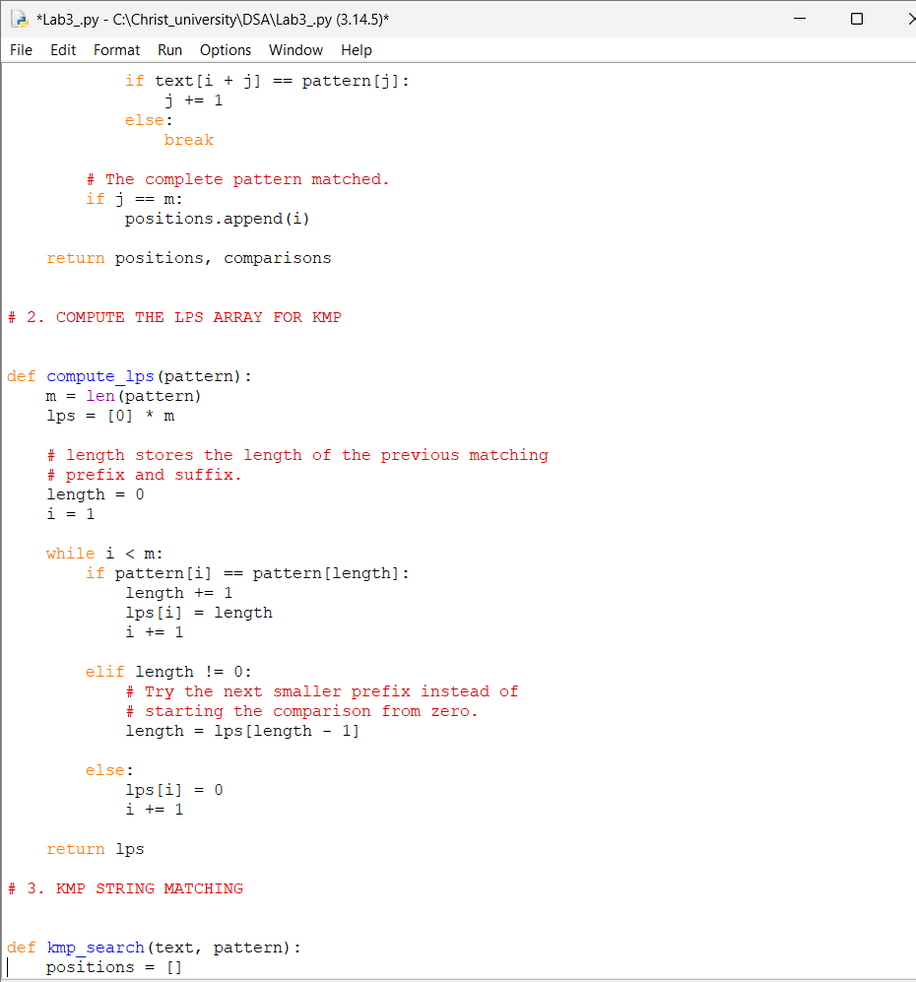
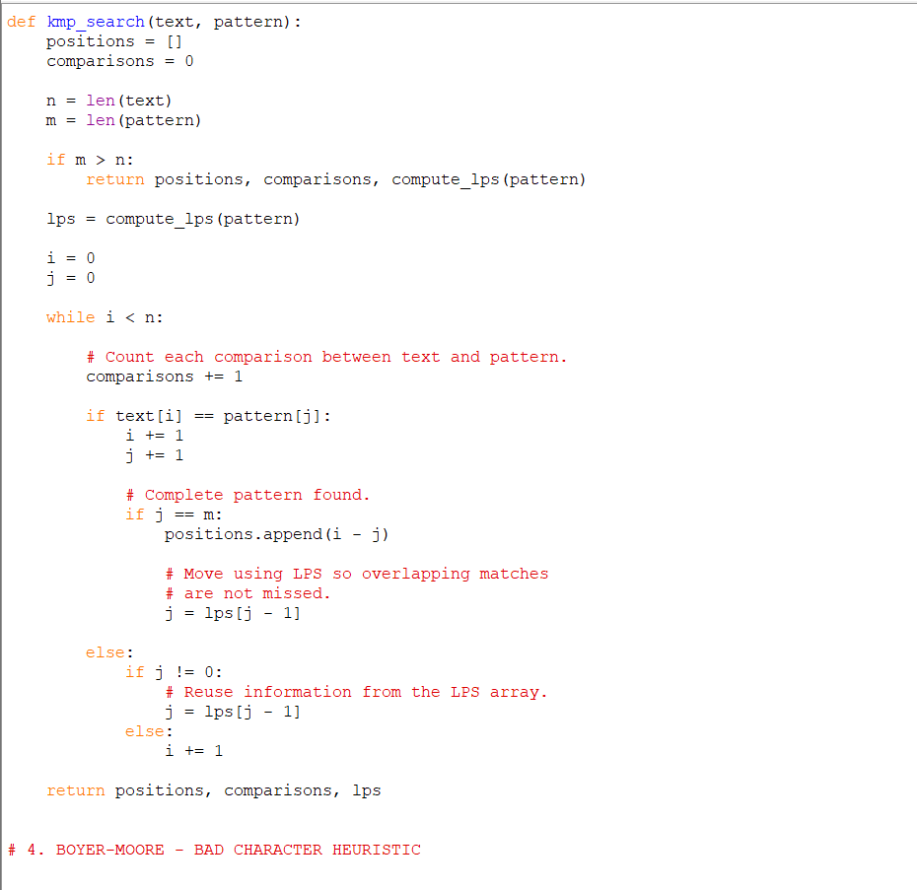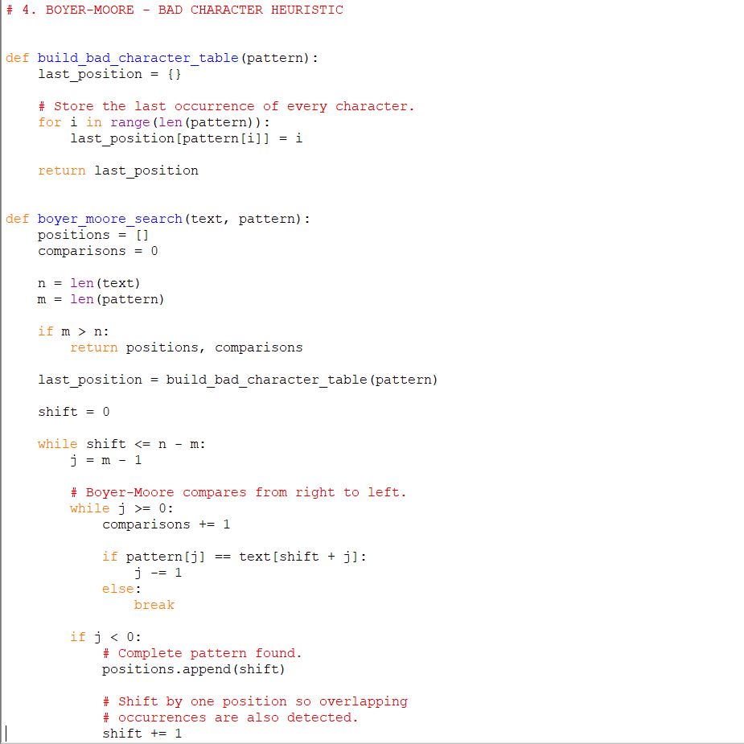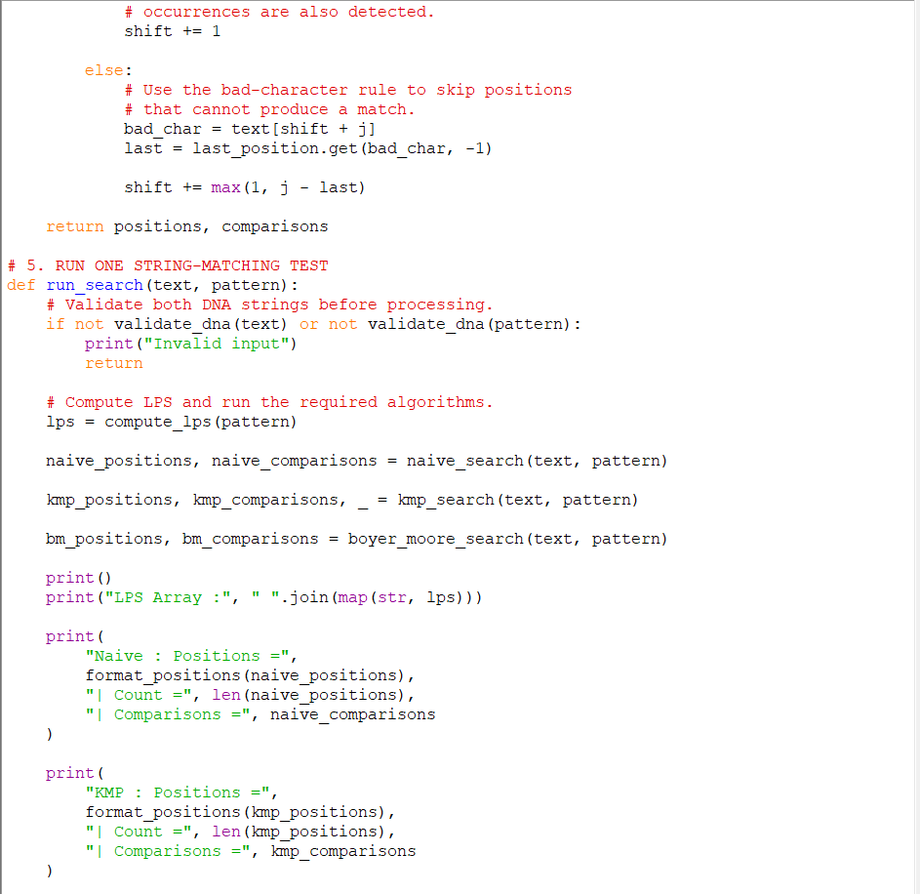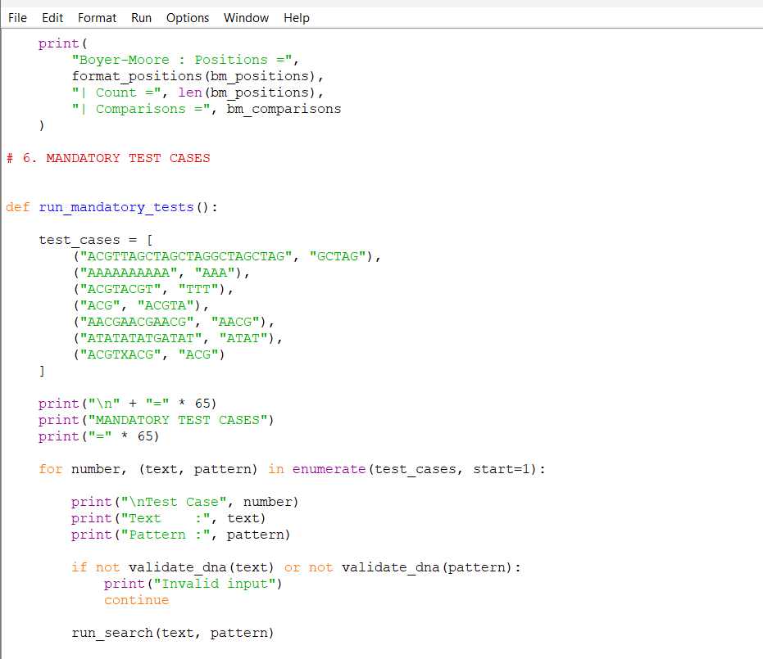

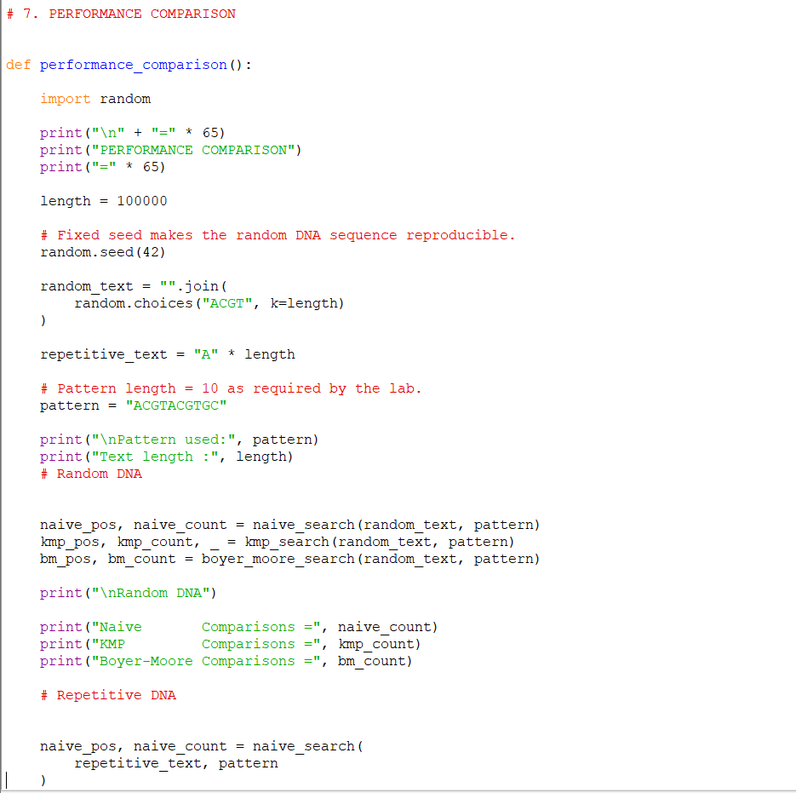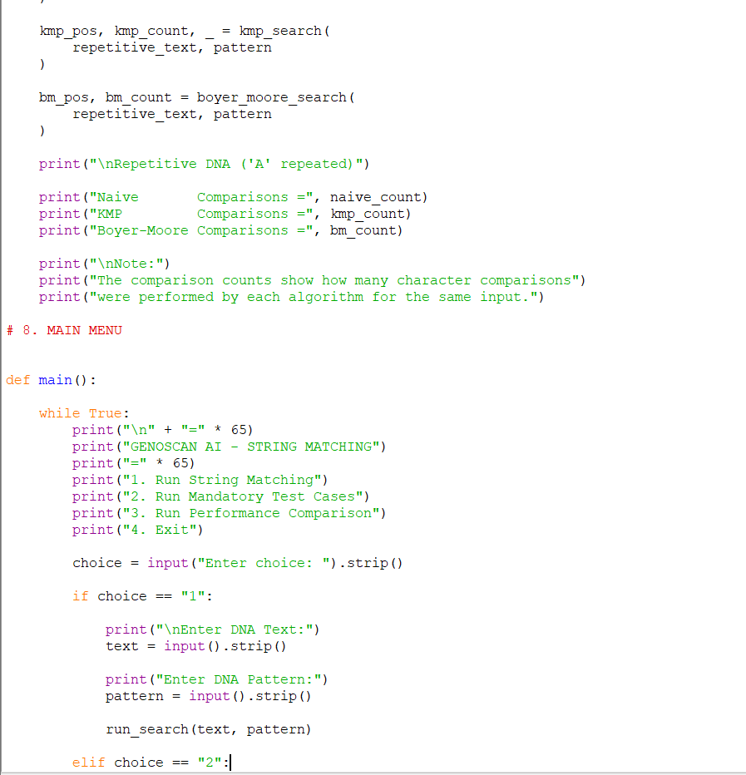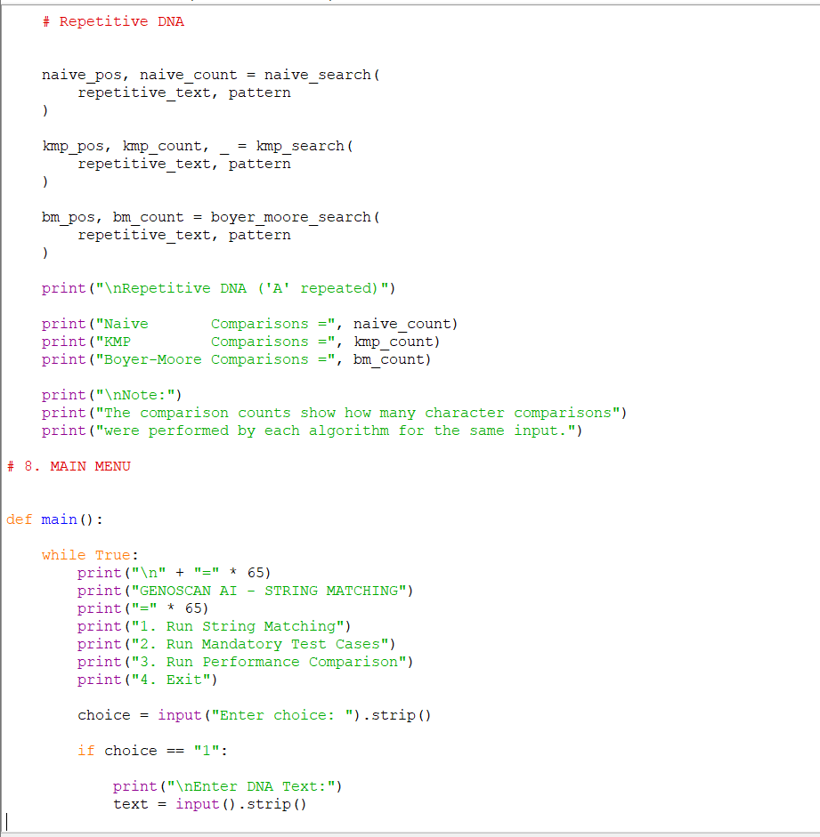-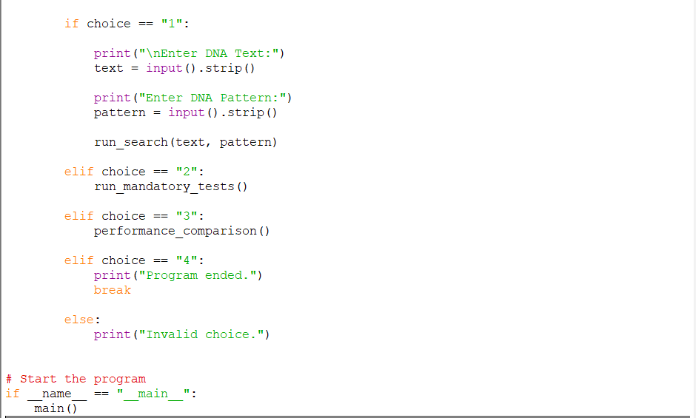

Output- The main menu provides options to run a normal string-matching operation, execute all mandatory test cases, perform the performance comparison, or exit the program.

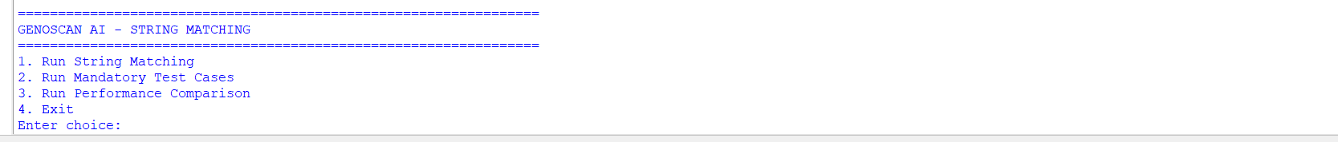

Mandatory Test Cases
Test Case | Text | Pattern | Expected/Observed Result | Purpose
1 | ACGTTAGCTAGCTAGGCTAGCTAG | GCTAG | 6 10 15 19 | Normal and overlapping matching
2 | AAAAAAAAAA | AAA | 0 1 2 3 4 5 6 7 | Overlapping/repetitive case
3 | ACGTACGT | TTT | NONE | Pattern absent
4 | ACG | ACGTA | NONE | Pattern longer than text
5 | AACGAACGAACG | AACG | 0 4 8 | Multiple occurrences
6 | ATATATATGATAT | ATAT | 0 2 4 9 | Overlapping occurrences
7 | ACGTXACG | ACG | Invalid input | Input validation

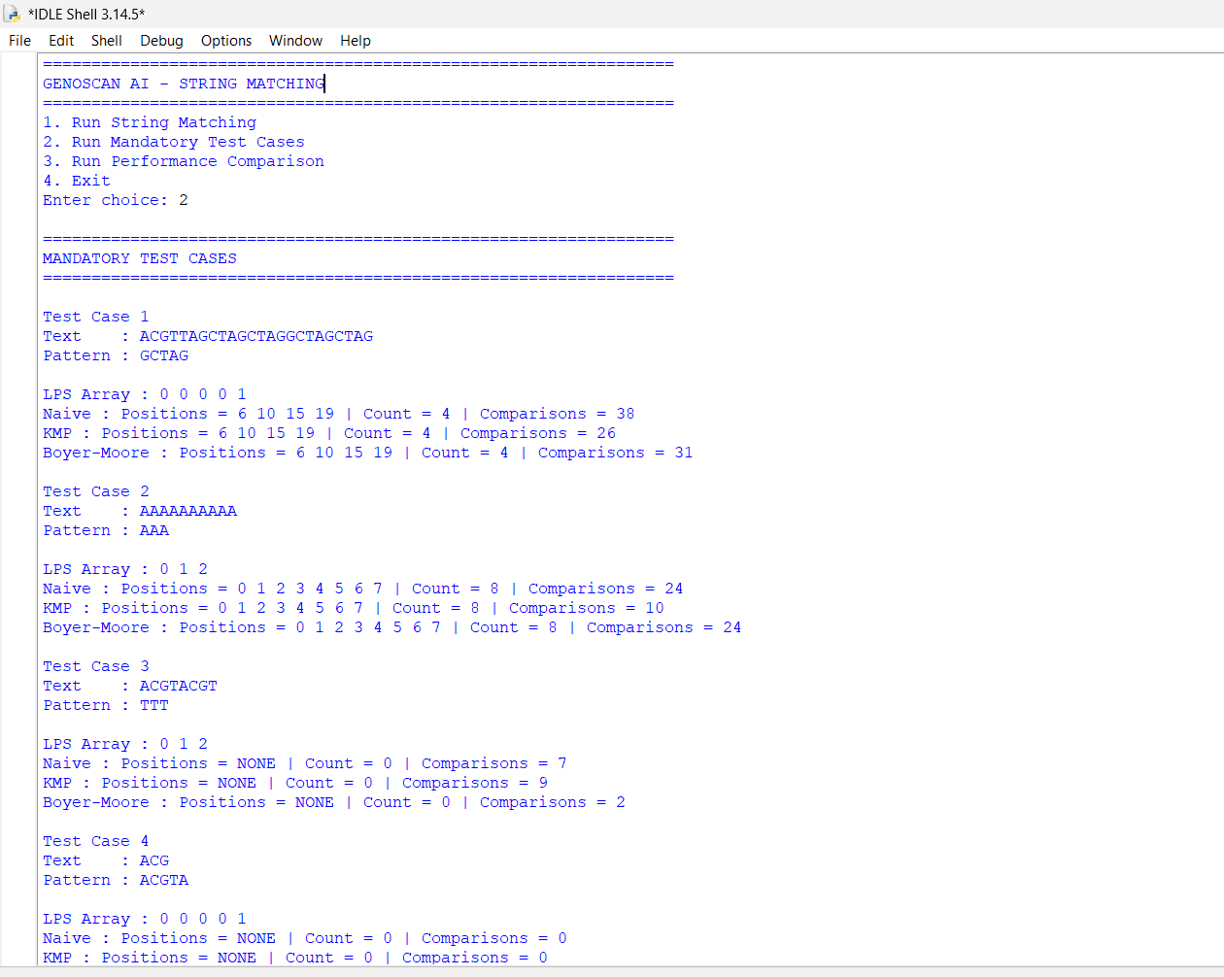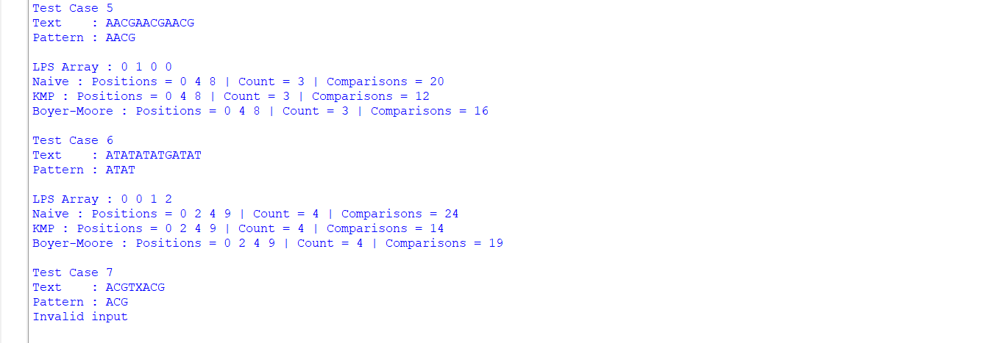

Test Cases 1 and 2 demonstrate normal and overlapping pattern matching. Test Case 1 identifies four occurrences of GCTAG, while Test Case 2 demonstrates multiple overlapping occurrences of AAA in a repetitive DNA sequence.

Test Case 3 demonstrates the situation where the pattern does not occur in the text and the program displays NONE. Test Case 4 handles the case where the pattern is longer than the text without producing an error.

Test Cases 5 and 6 demonstrate multiple and overlapping occurrences. The program correctly reports all starting positions and generates the required LPS arrays.

Test Case 7 checks input validation. The DNA sequence contains the character X, which is outside the valid DNA alphabet A, C, G and T. Therefore, the program displays Invalid input.
PERFORMANCE COMPARISON
Experimental Setup
A DNA text of length 100,000 was generated for the performance experiment. The pattern used was ACGTACGTGC, which has length 10. The program tested both a randomly generated DNA sequence and a repetitive DNA sequence containing 100,000 A characters. The number of character comparisons performed by Naïve, KMP and Boyer-Moore was recorded.

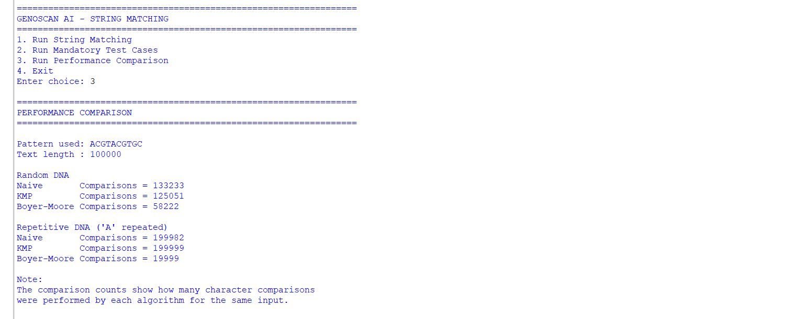

Performance Comparison

Input Type | Naïve Comparisons | KMP Comparisons | Boyer-Moore Comparisons
Random DNA (100,000) | 133,233 | 125,051 | 58,222
Repetitive DNA (100,000 A's) | 199,982 | 199,999 | 19,999

Pattern: ACGTACGTGC
Pattern length: 10
Text length: 100,000

PERFORMANCE INFERENCE
Inference
- For the random DNA input, Boyer-Moore performed 58,222 comparisons, compared with 133,233 for Naïve and 125,051 for KMP.
- For the repetitive DNA input, Boyer-Moore performed 19,999 comparisons, while Naïve and KMP performed 199,982 and 199,999 comparisons respectively, showing that comparison counts depend on the structure of the input.
The screenshot shows the comparison counts obtained for a 100,000-character random DNA sequence and a 100,000-character repetitive DNA sequence. The same pattern of length 10 was used for all three algorithms.

TIME AND SPACE COMPLEXITY
Complexity Analysis
Algorithm | Pre-processing | Best Case | Worst Case | Extra Space
Naïve | None | O(n) | O(n × m) | O(1)
KMP | O(m) | O(n) | O(n + m) | O(m)
Boyer-Moore (Bad Character) | O(m) | Depends on input | O(n × m) | O(σ)

n = length of text ,m = length of pattern ,σ = alphabet size
Naïve matching may repeatedly compare the same characters and therefore has a worst-case complexity of O(n × m). KMP preprocesses the pattern using the LPS array and searches in O(n + m). Boyer-Moore can skip positions using the bad-character heuristic, although its worst-case complexity with this heuristic is O(n × m).
The screenshot shows the program’s exit option, confirming that the GenoScan AI DNA string matching program completed its execution successfully.
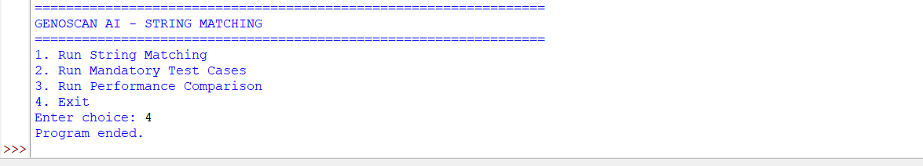

SELF-LEARNING
Boyer-Moore with Bad-Character Heuristic
As the self-learning component, I implemented the Boyer-Moore string matching algorithm using the Bad-Character Heuristic. Unlike the Naïve and KMP algorithms, Boyer-Moore compares the pattern with the text from right to left. When a mismatch occurs, the algorithm checks the last occurrence of the mismatching character in the pattern and uses this information to decide the shift. This can allow the algorithm to skip multiple positions that cannot contain a valid match.
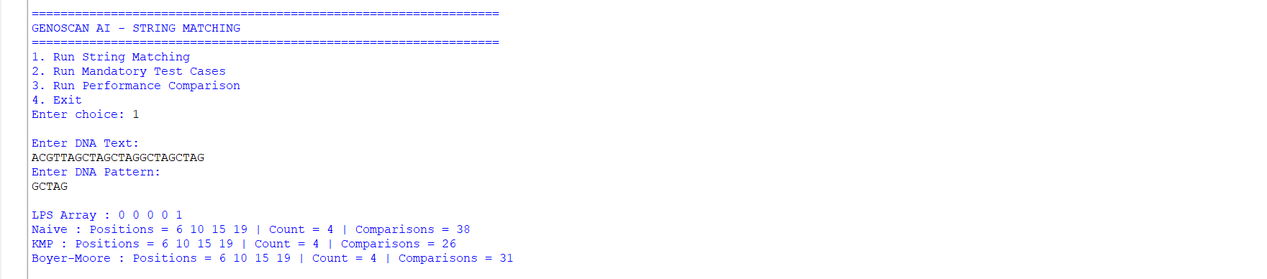
I also integrated Boyer-Moore into the same testing framework so that its matching positions and comparison counts could be compared with Naïve and KMP. This helped me understand how a heuristic-based string matching algorithm can reduce unnecessary comparisons for certain types of input.

APPLICATION IN GENOSCAN AI
String matching can be used in GenoScan AI to locate important DNA motifs before the sequence data is passed to a machine-learning model. The positions and frequency of these motifs can be converted into features for the ML model. Efficient matching becomes important when large numbers of DNA sequences need to be processed.
The lab scenario specifically describes motif positions and counts being used as input features for the ML model.

UNDERSTANDING
Through this activity, I understood how string matching algorithms can be applied to a real-world DNA sequence problem. I learned that the Naïve method checks possible positions directly, while KMP improves the search by using the LPS array to avoid unnecessary comparisons. I also understood how overlapping occurrences need to be handled carefully. Implementing Boyer-Moore as the self-learning part helped me understand how heuristic-based shifting can reduce the number of comparisons for certain inputs.
CONCLUSION
This experiment helped me implement and compare different string matching techniques using DNA sequences. The program successfully handled the seven mandatory test cases, including overlapping patterns, absent patterns, patterns longer than the text and invalid input. KMP was implemented using the LPS array, and Boyer-Moore was added as the self-learning extension. The performance experiment showed how the number of character comparisons changes depending on both the algorithm and the input structure.

