LAB QUESTION _6

Self-Balancing Binary Search Tree: Implementation and Comparison

Programme MSc Artificial Intelligence &amp; Machine Learning (MSc AIML)

Course Data Structures and Algorithms Laboratory

Lab Topic Implement a Self-Balancing Binary Search Tree and Compare
Scenario
MediQueue is a telemedicine start-up that serves patients across several cities. Every new patient
is given a numeric Patient ID at registration, and the platform must be able to insert, search and
delete patient records within milliseconds, even when millions of records are stored.
The first version of the system indexed patient records using a plain Binary Search Tree (BST). It
worked well during testing, where IDs were entered in random order. After launch, the team
observed that search times kept growing steadily. An engineer found the cause: IDs are issued by
an auto-increment counter, so records arrive in almost sorted order, and the BST degenerated into
something that behaves like a linked list.
You have been hired as a junior data engineer. Your manager has asked you to replace the index
with a self-balancing BST (AVL Tree) and to produce an evidence-based comparison that proves
the new index is worth deploying.
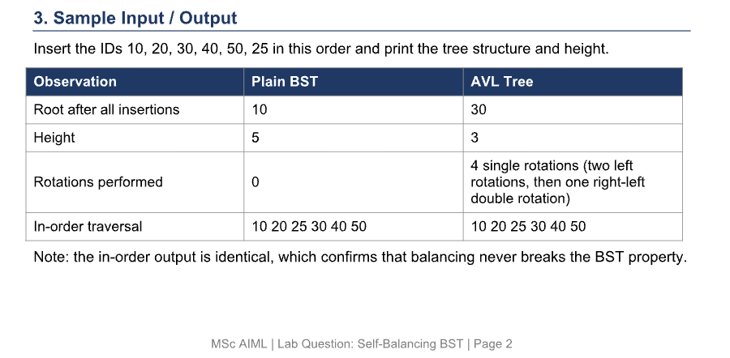

Program code & Result : -
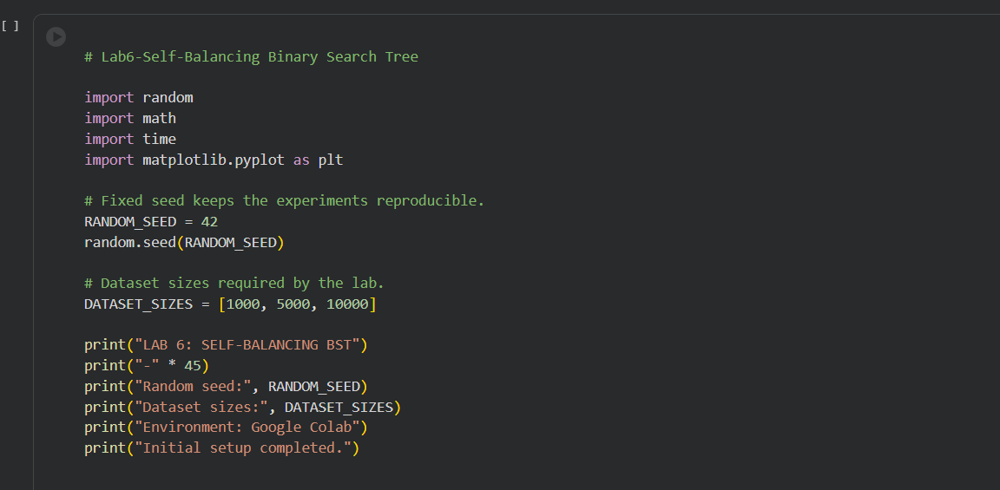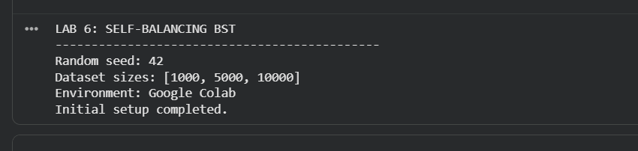
The initial setup imports the required Python modules, including random, math, time, and matplotlib.pyplot. A fixed random seed of 42 is configured to ensure reproducibility of the experiments. The dataset sizes are initialized as 1,000, 5,000, and 10,000 patient records. Google Colab is used as the execution environment.

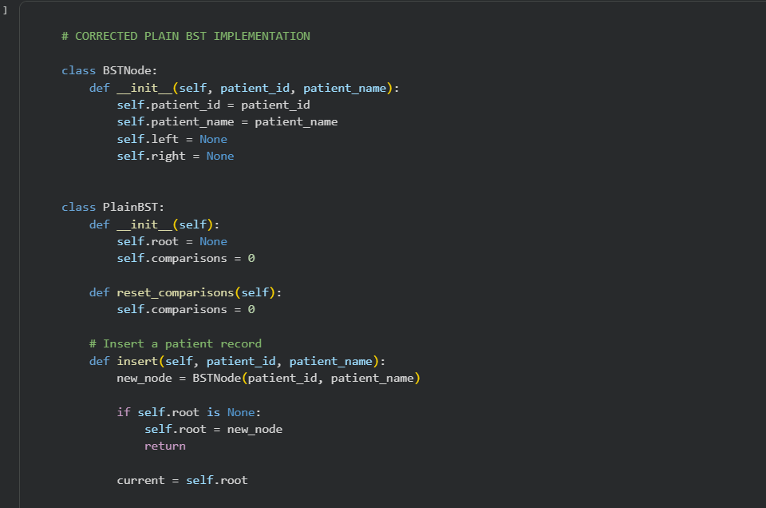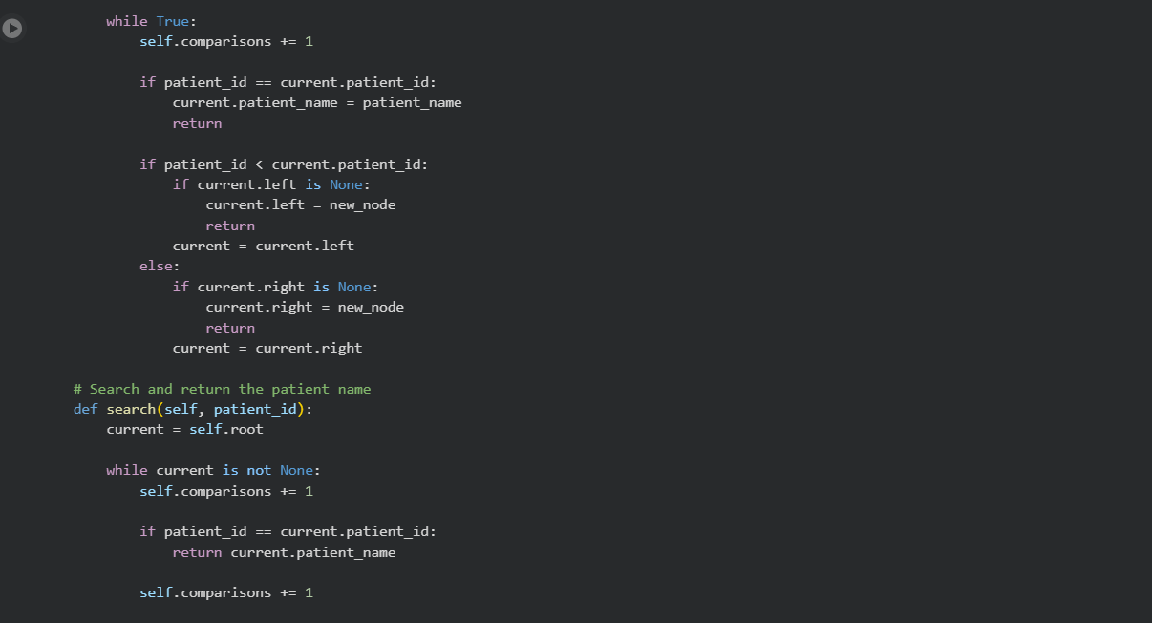
A Plain Binary Search Tree (BST) is implemented to store patient records using Patient ID as the key and Patient Name as the associated value. Each node contains references to its left and right children. The implementation supports insertion, searching, deletion, in-order traversal, height calculation, and tree display. A comparison counter is also maintained to measure search and insertion operations.
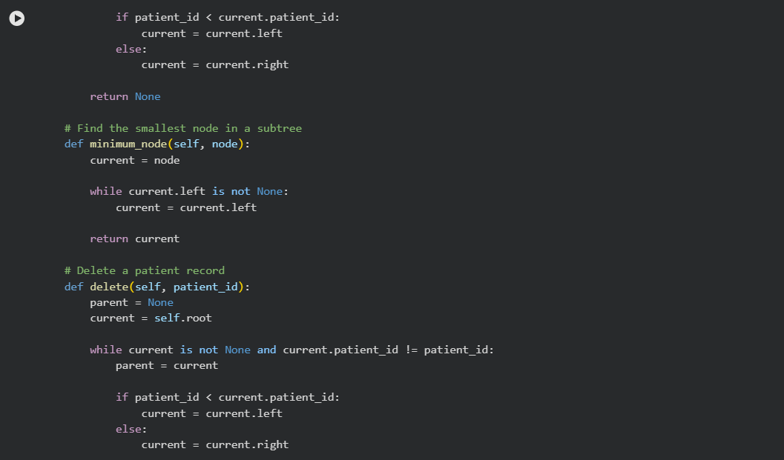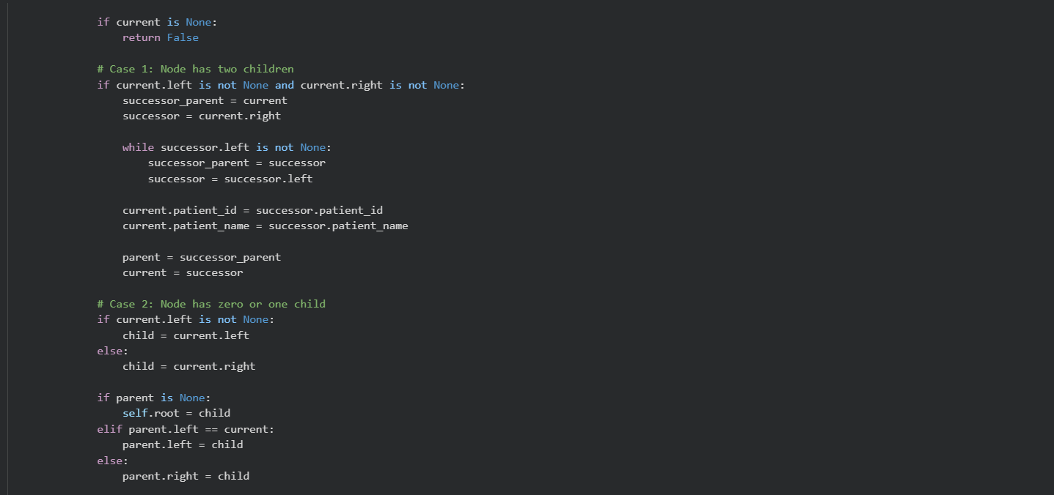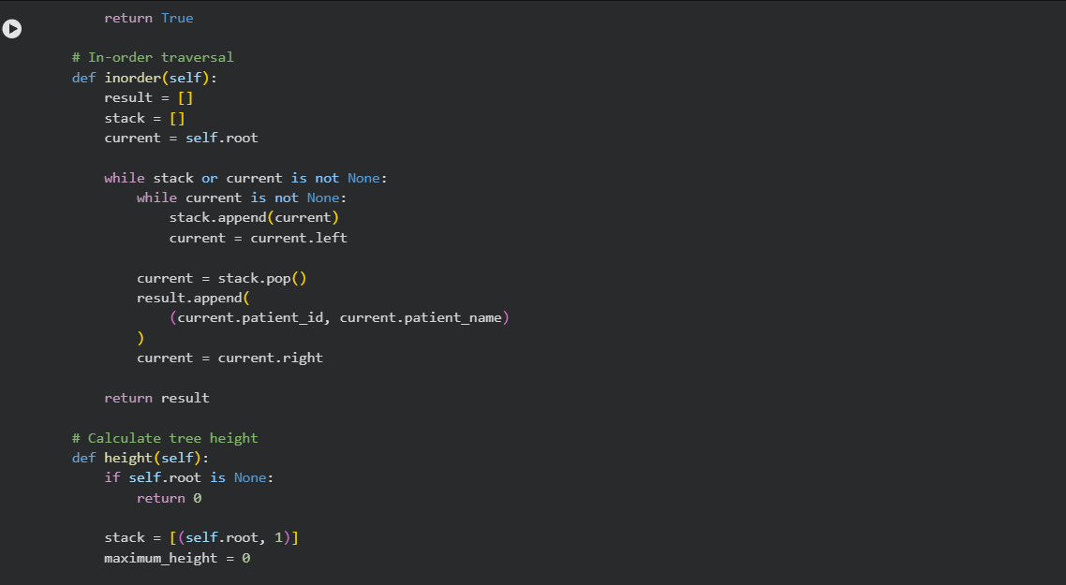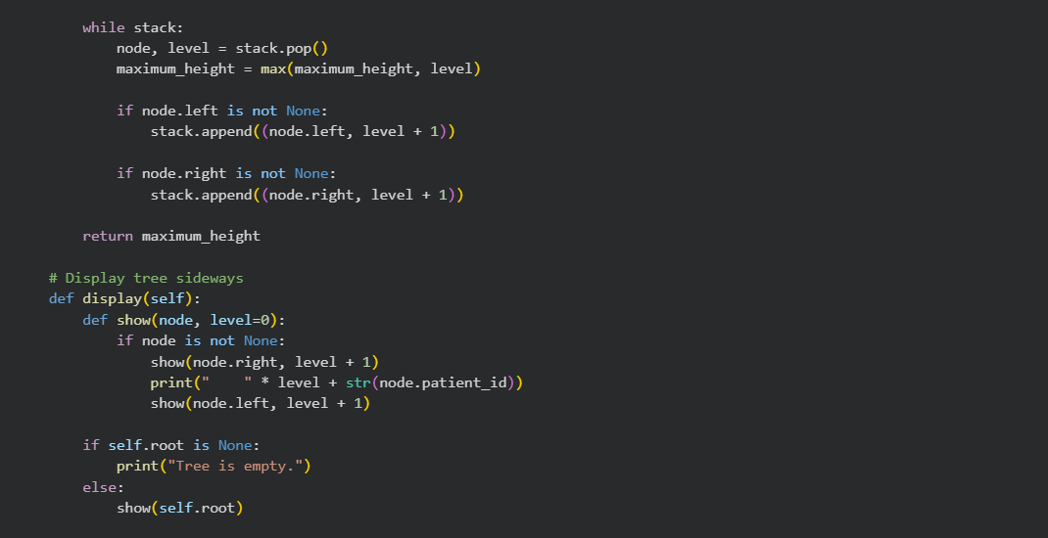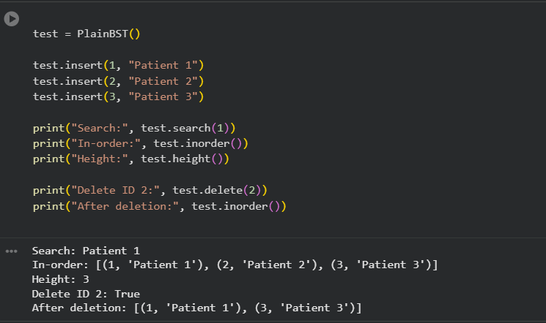
The basic operations of the Plain BST are tested using a sample set of patient records. The program performs insertion, searches for a patient, displays the in-order traversal, calculates the tree height, and deletes a record. The output demonstrates that the BST maintains records in sorted order and correctly updates its structure after deletion.
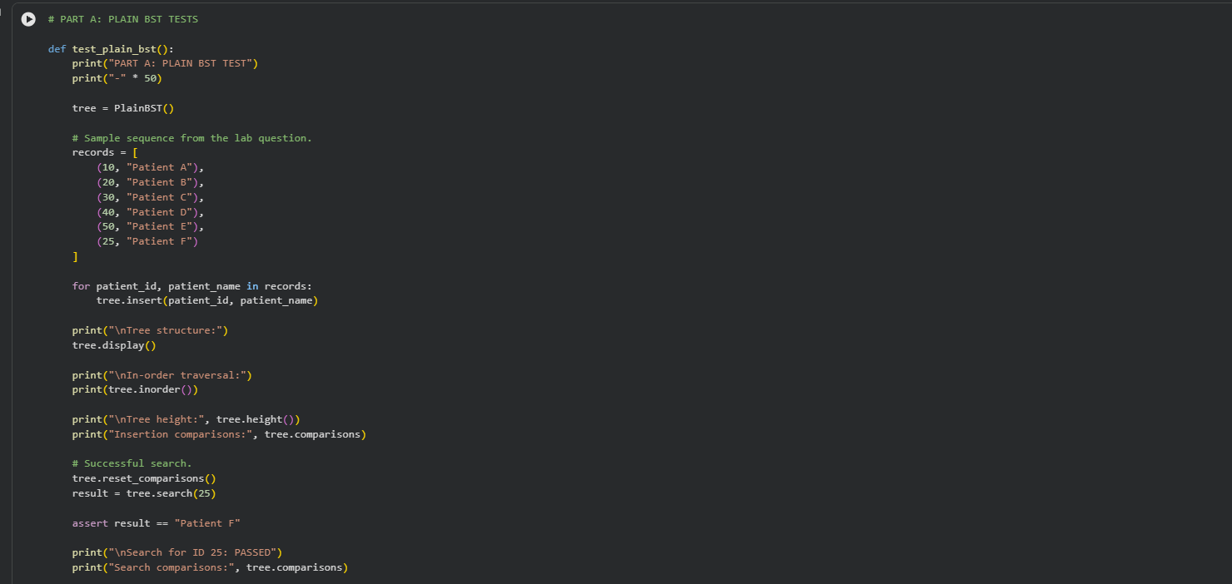A dedicated test function verifies the correctness of the Plain BST using sample Patient IDs. It checks the tree structure, in-order traversal, height, insertion comparisons, successful search, and unsuccessful search. Assertions are used to confirm that the returned results and expected tree properties are correct.
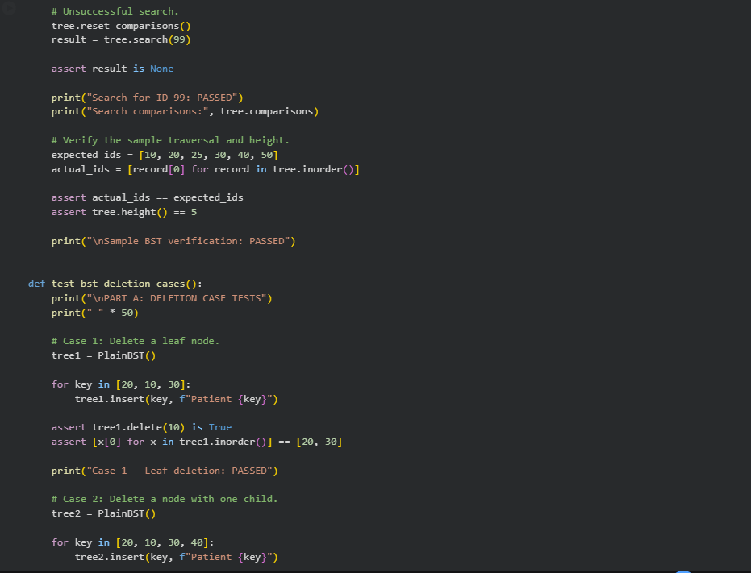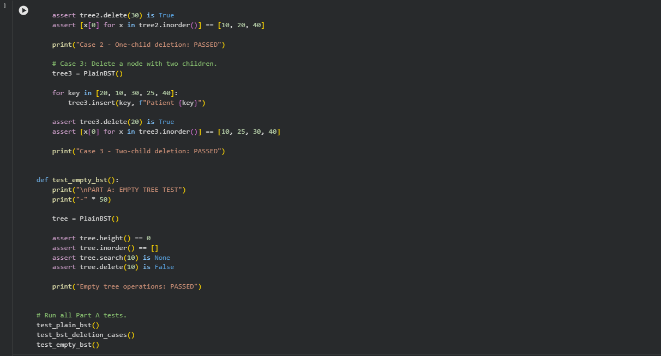
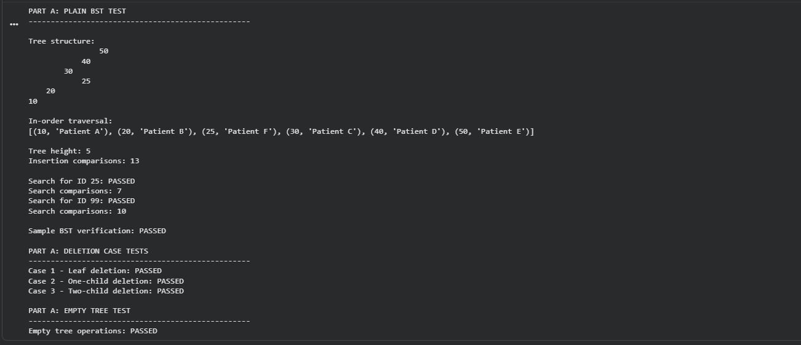 Three deletion scenarios are tested: deleting a leaf node, deleting a node with one child, and deleting a node with two children. The implementation handles each case while preserving the Binary Search Tree ordering property. All three deletion tests pass successfully.
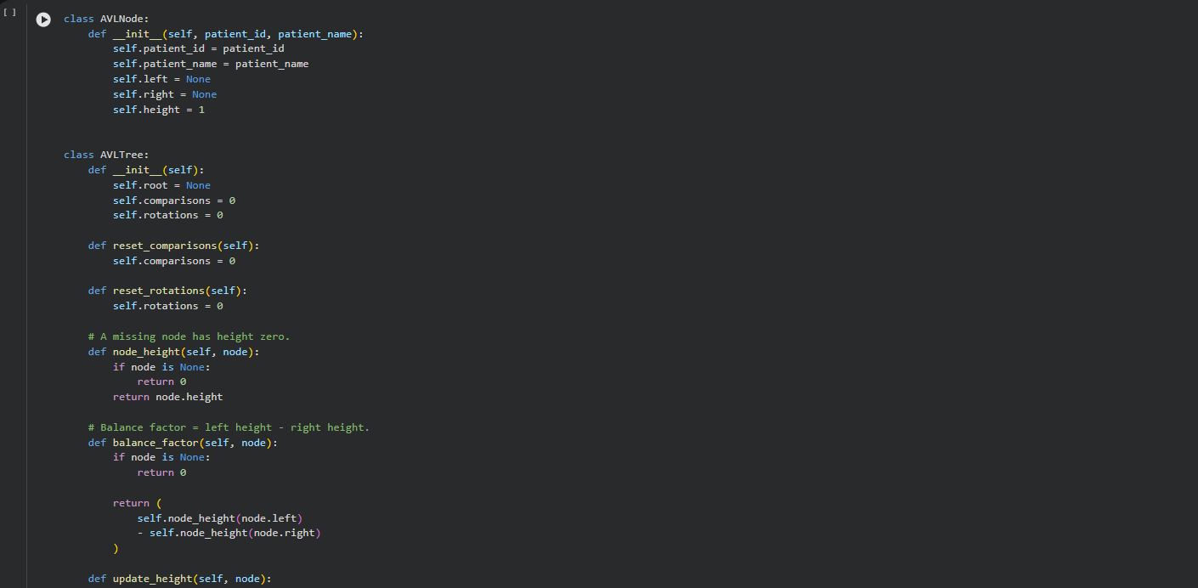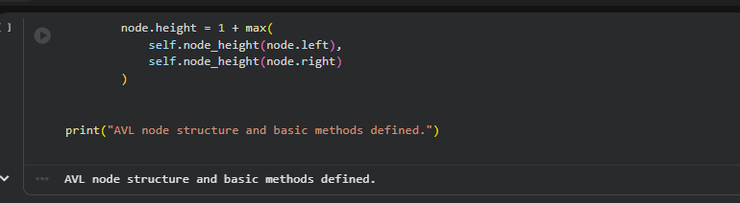 The AVL node structure is introduced with an additional height attribute alongside the Patient ID, Patient Name, and child references. Basic methods are defined to obtain node height, calculate the balance factor, and update node height. These methods provide the foundation for maintaining AVL tree balance.
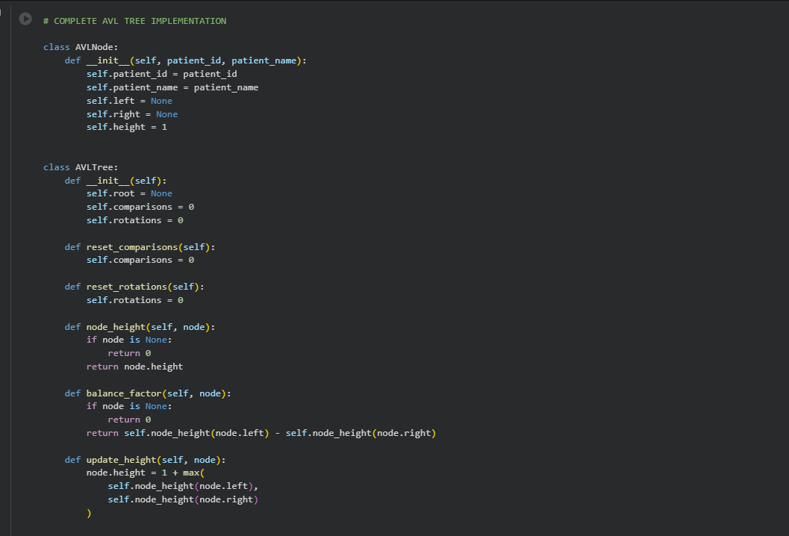
The complete AVL Tree implementation extends the ordinary BST by automatically maintaining balance after insertion and deletion. It includes left and right rotations, balance-factor calculation, rebalancing logic, searching, deletion, and in-order traversal. The implementation also tracks comparisons and rotations and includes validation methods to check the AVL balance and BST ordering properties.
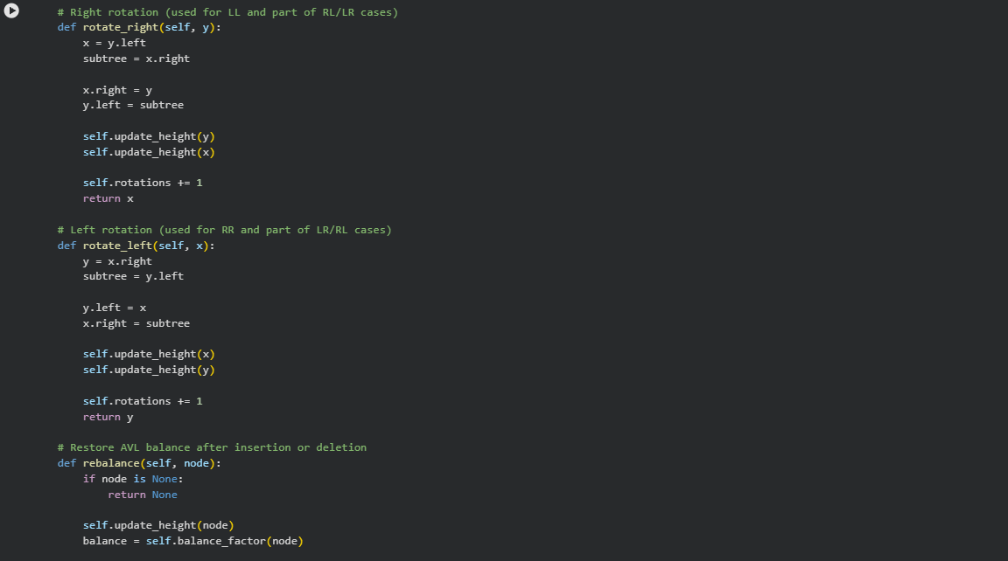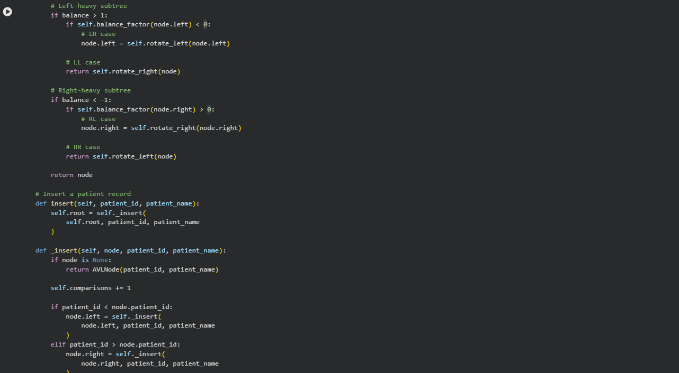 The four AVL rotation cases—LL (Left-Left), RR (Right-Right), LR (Left-Right), and RL (Right-Left)—are tested using specific insertion sequences. The tests verify that the tree restores balance and produces the expected root after rotation. All four cases pass the AVL validation checks.
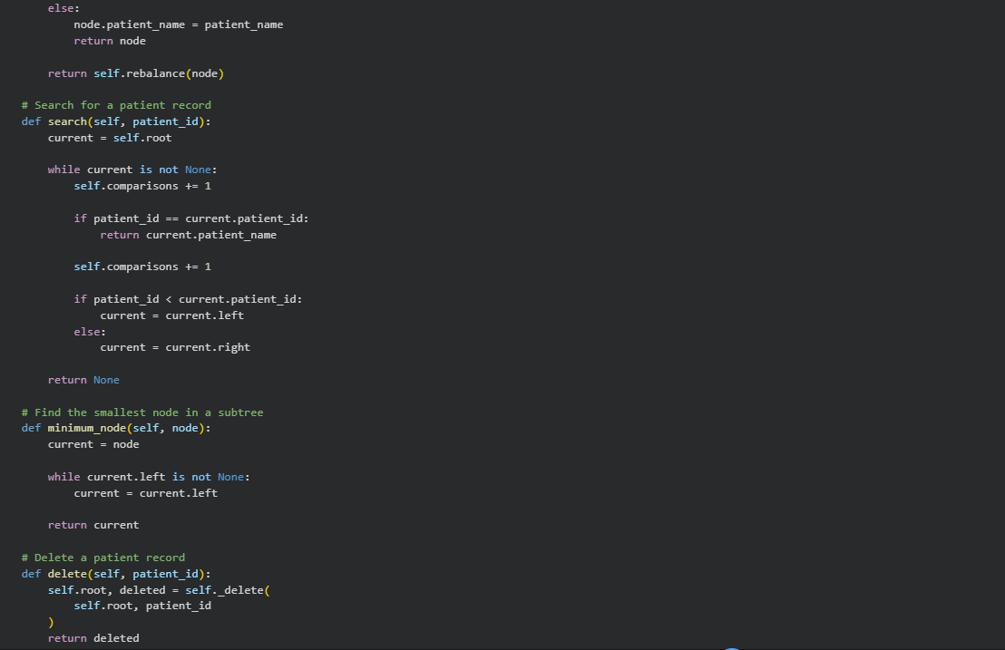
A larger AVL tree is constructed using sample Patient IDs. The program displays the balanced tree, performs in-order traversal, calculates its height, and records the number of rotations. Successful and unsuccessful searches are also tested. Deletion tests cover leaf, one-child, and two-child scenarios, while additional assertions verify that the tree remains balanced and maintains the BST property.
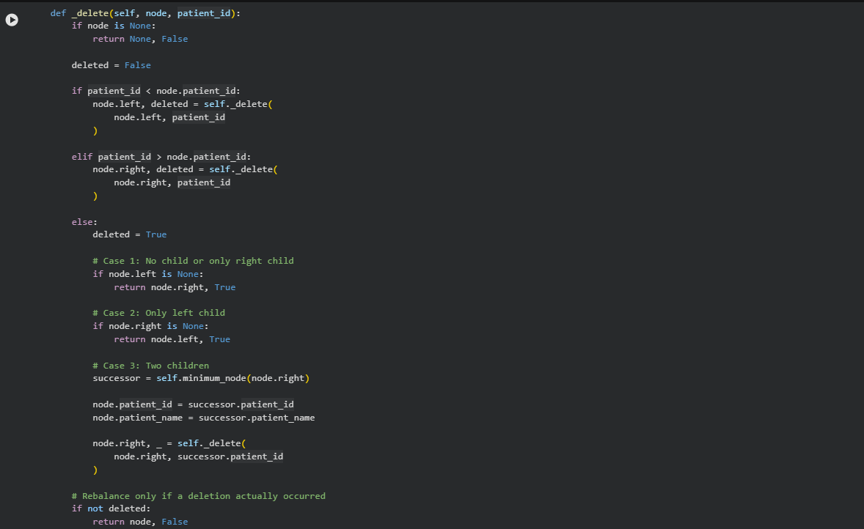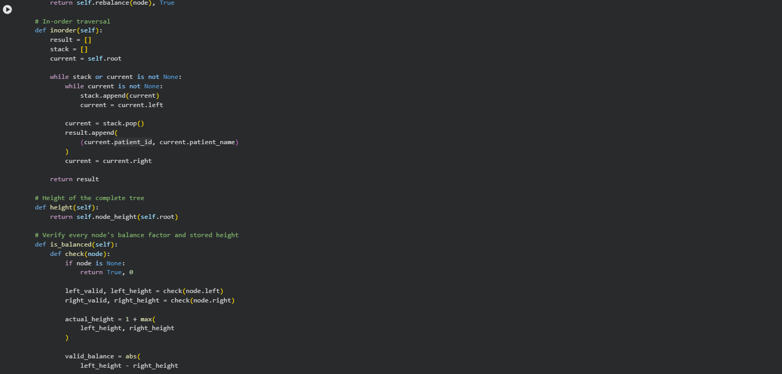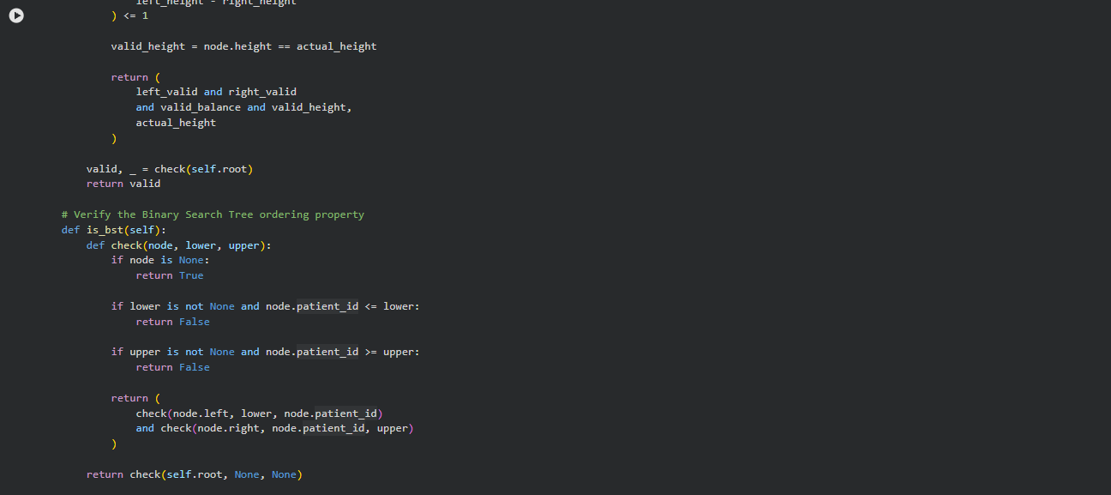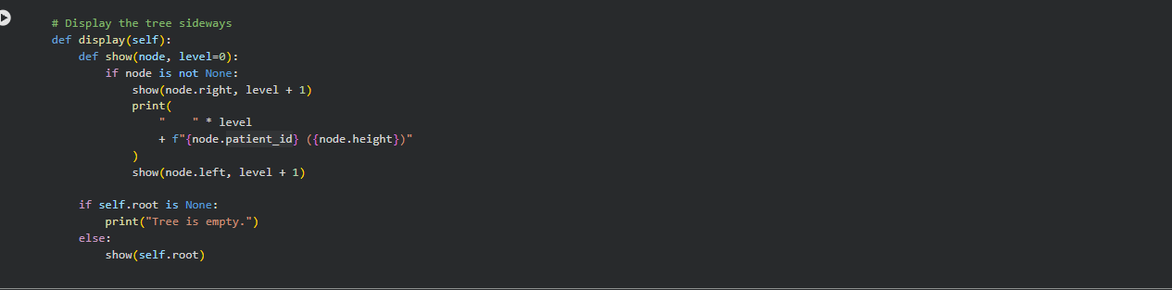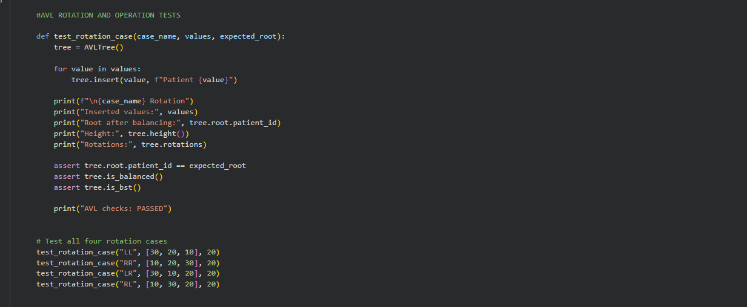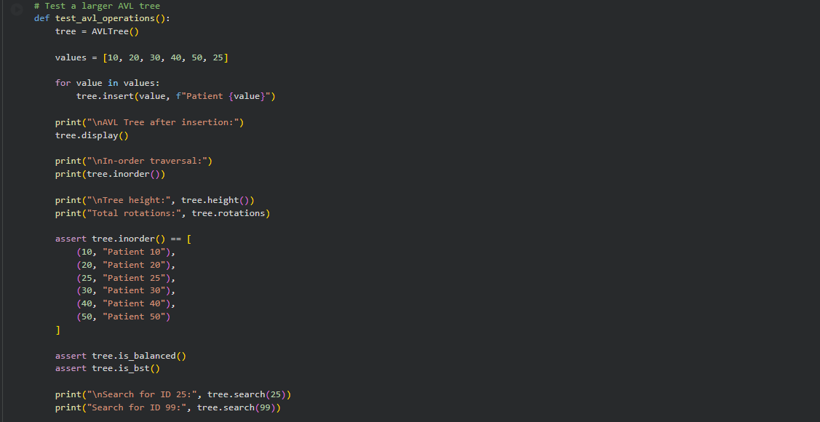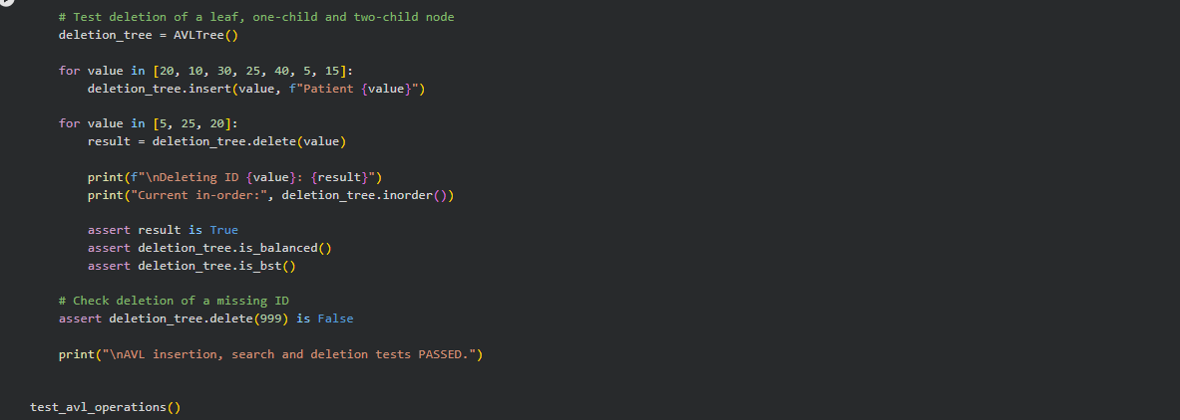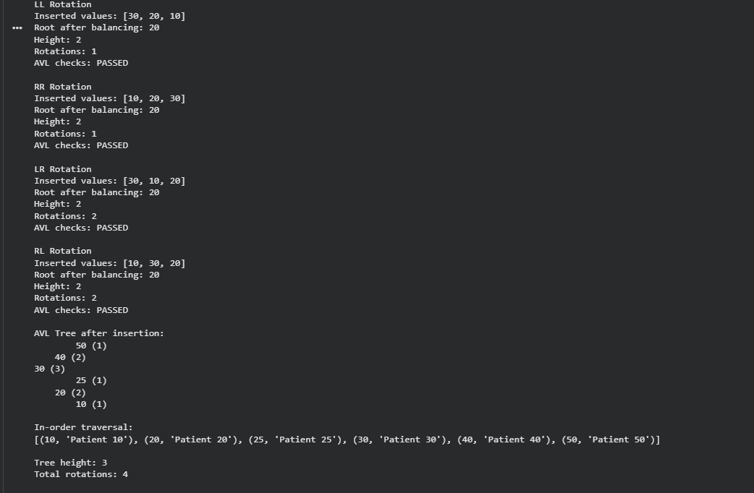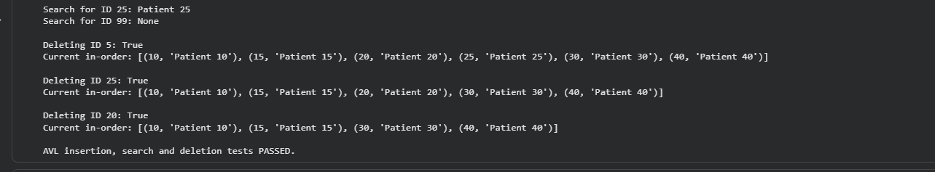
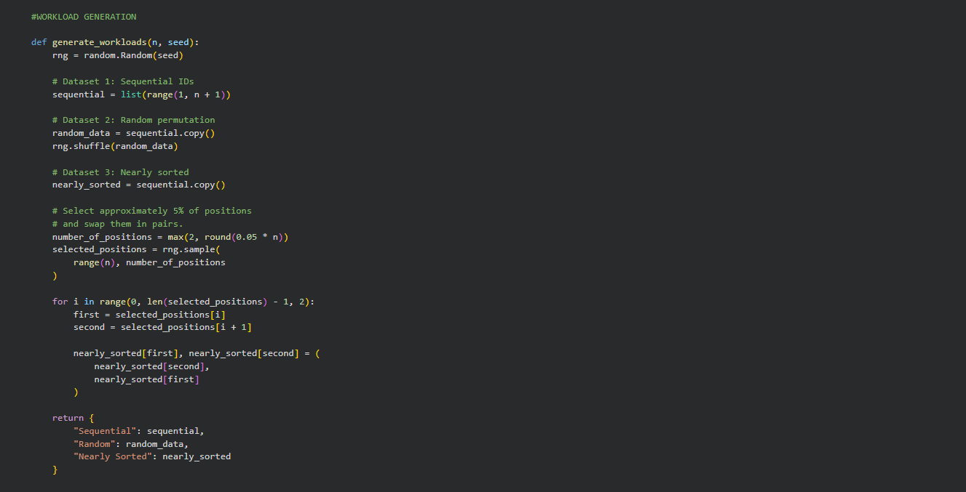 Three different insertion datasets are generated to evaluate the performance of Plain BST and AVL Tree implementations: Sequential, Random, and Nearly Sorted. The experiments use dataset sizes of 1,000, 5,000, and 10,000 records. Approximately 5% of positions are selected and swapped in the nearly sorted dataset. A fixed seed ensures that the generated workloads remain reproducible.
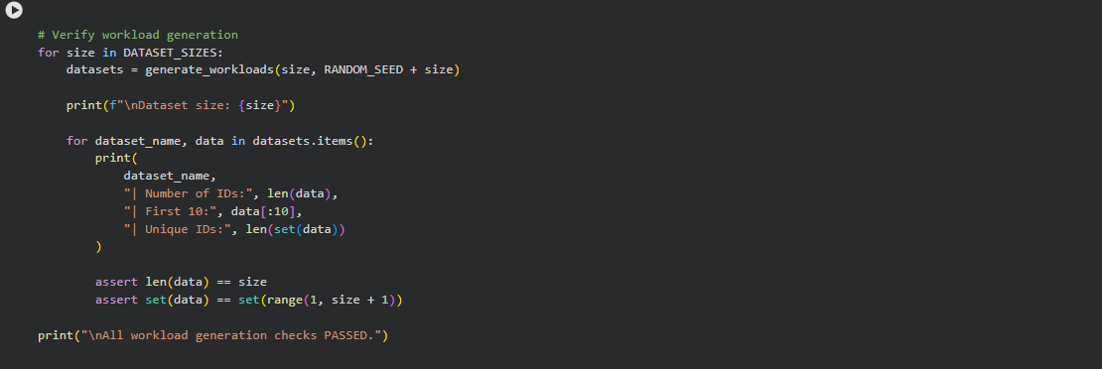 The generated datasets are checked for their expected size and uniqueness of Patient IDs. The first few values of each dataset are displayed for verification. Assertions confirm that every dataset contains exactly the required number of unique IDs, covering the complete range from 1 to N.
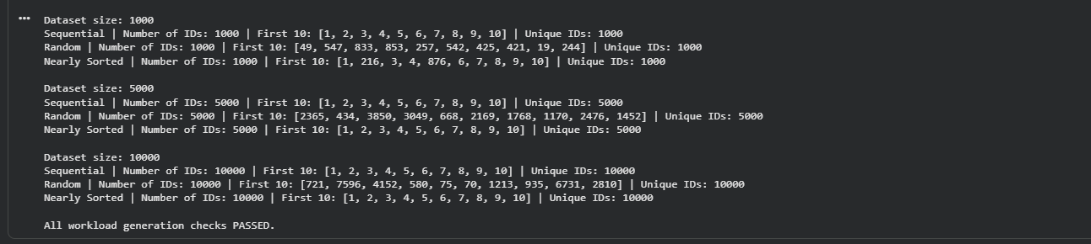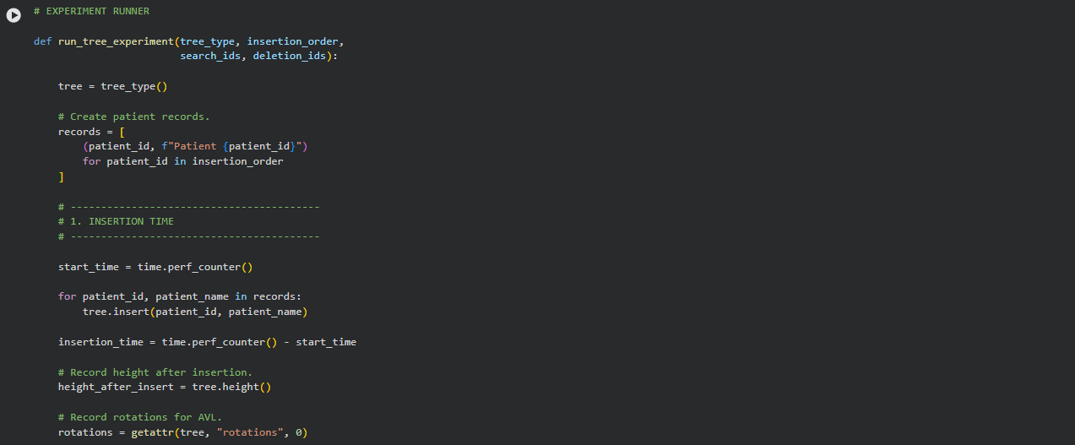
A common experiment runner is developed to evaluate both Plain BST and AVL Tree using the same workloads. It measures insertion time, tree height after insertion, average comparisons for 1,000 successful searches, and height after deleting 20% of the records. The number of rotations is also recorded for AVL trees. Validation checks are performed after deletion to ensure that the AVL tree remains valid.
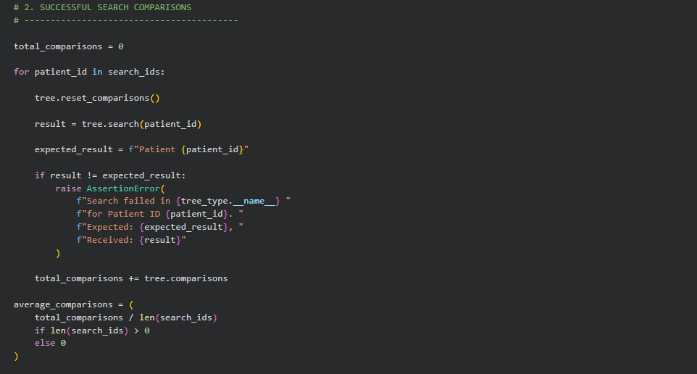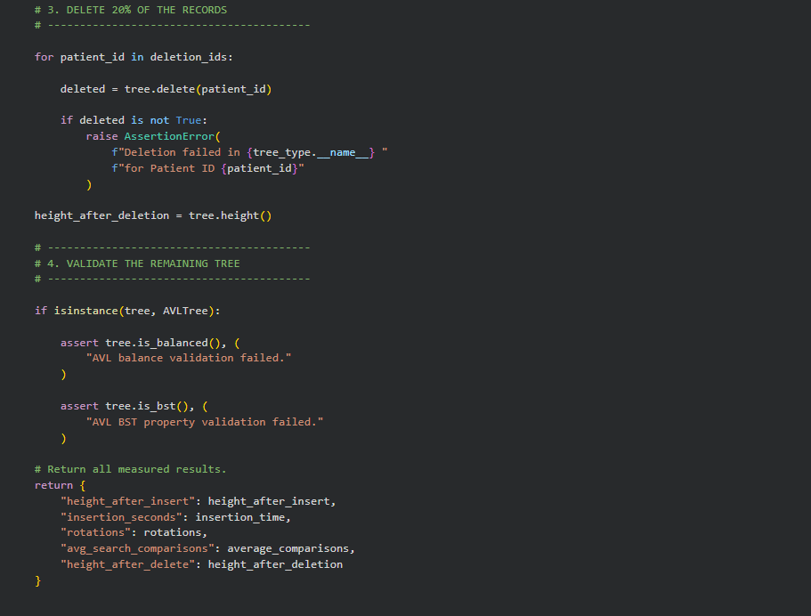
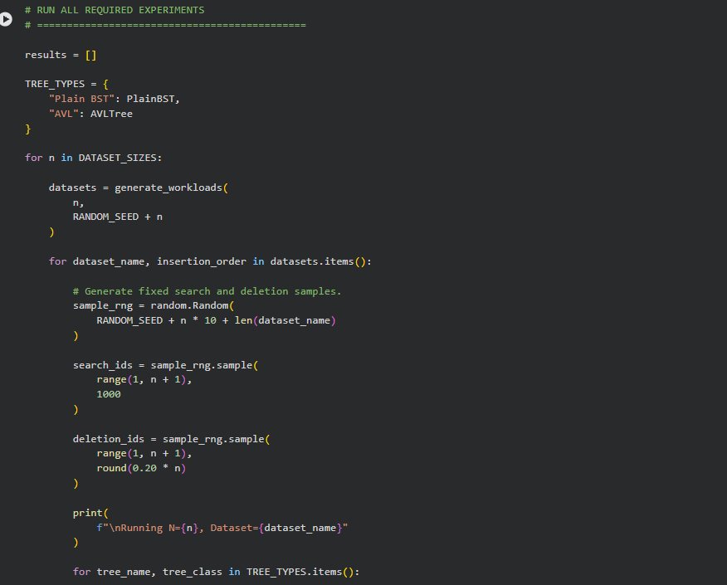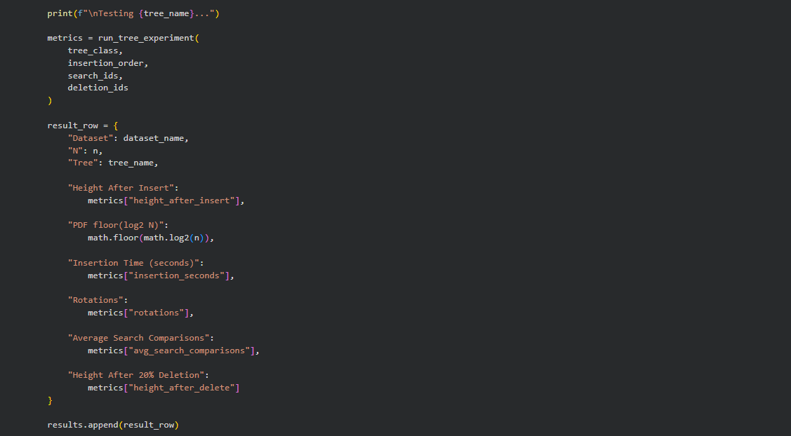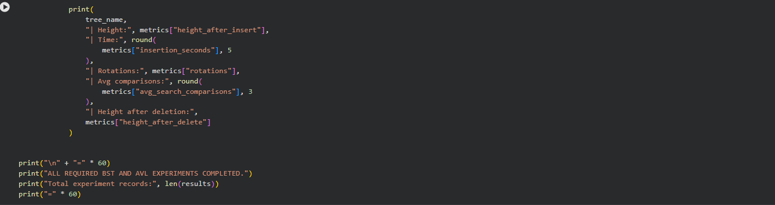
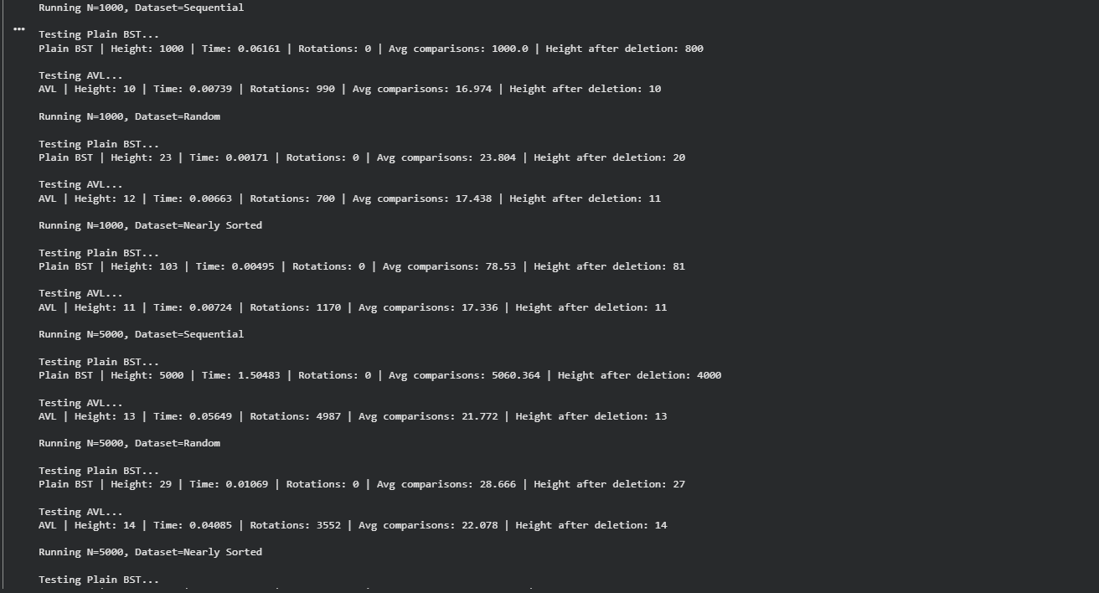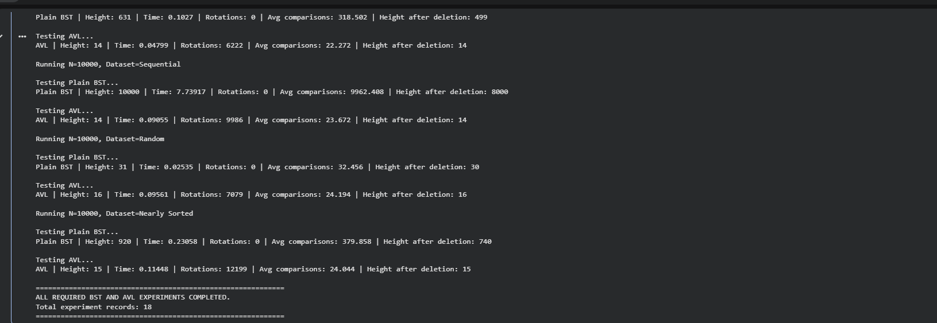
The experiment runner is executed for both tree types across all three dataset patterns and all three dataset sizes. This produces 18 experiment records in total. The output displays the measured performance metrics and confirms that all required BST and AVL experiments have been completed.
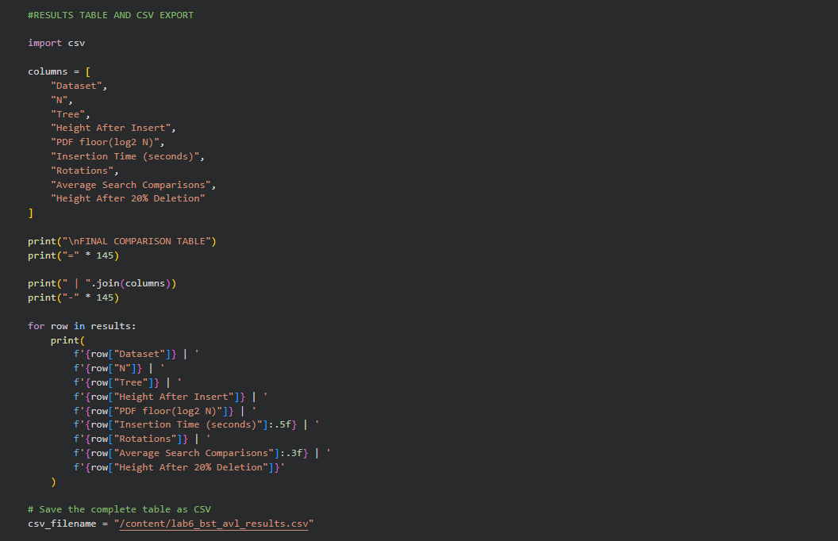
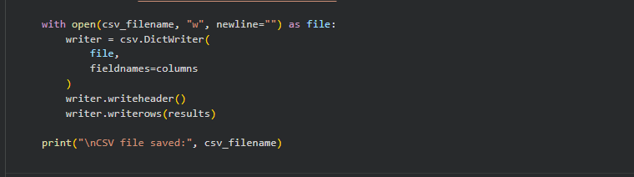 The measured results are organized into a comparison table containing the dataset type, number of records, tree type, height after insertion, theoretical minimum height specified in the lab question, insertion time, rotations, average search comparisons, and height after deleting 20% of the records. The complete results are also exported to a CSV file named lab6_bst_avl_results.csv for further analysis and documentation.
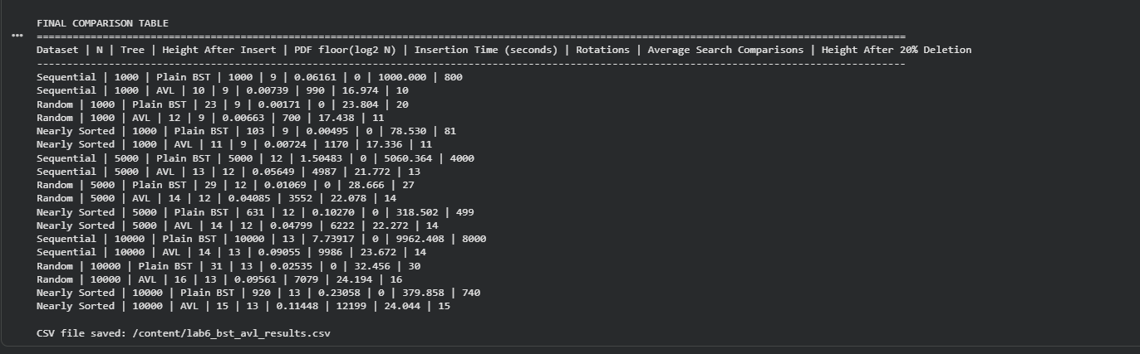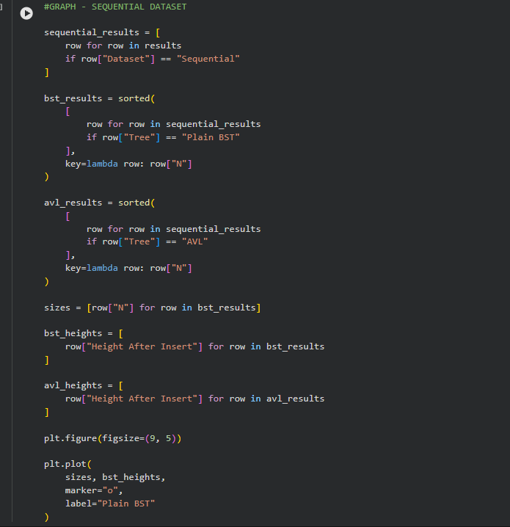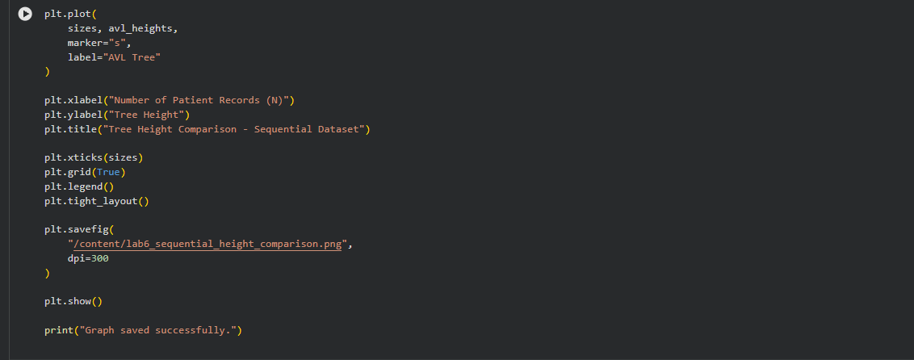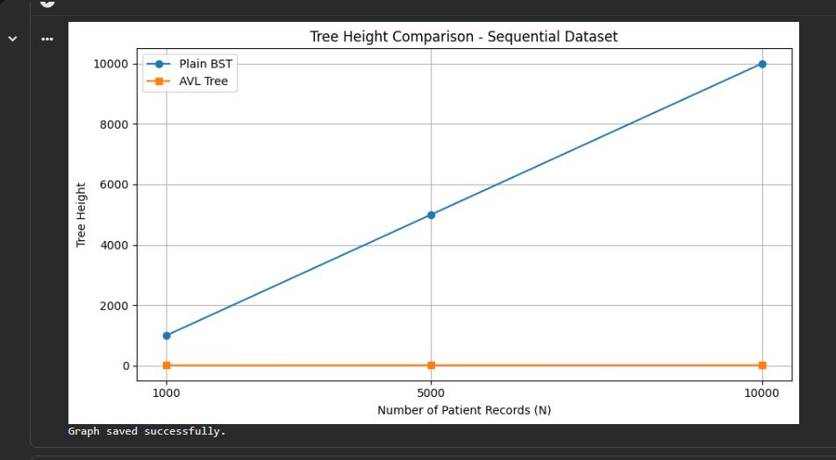
A graph is generated using the sequential dataset to compare the heights of Plain BST and AVL Tree for increasing dataset sizes. The graph uses the number of patient records on the X-axis and tree height on the Y-axis. It illustrates how sequential insertion can cause the Plain BST to become highly skewed, whereas AVL rotations maintain a much smaller tree height.
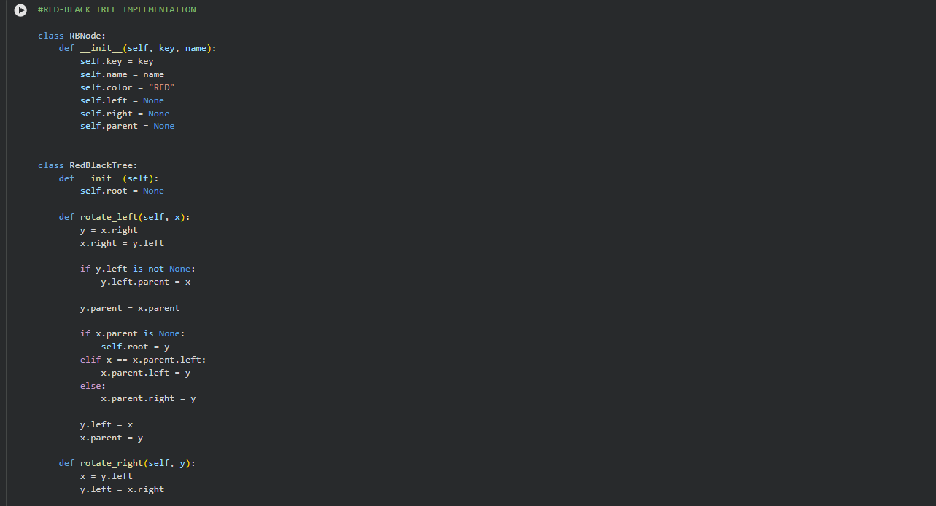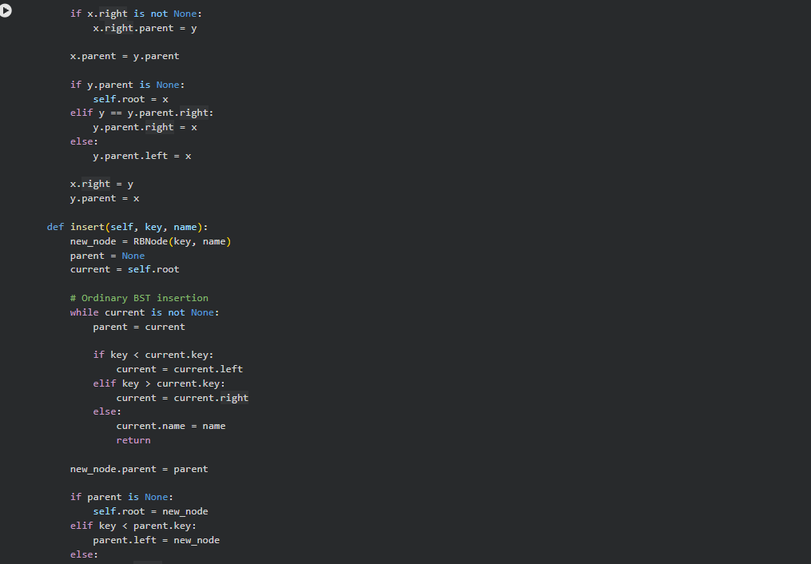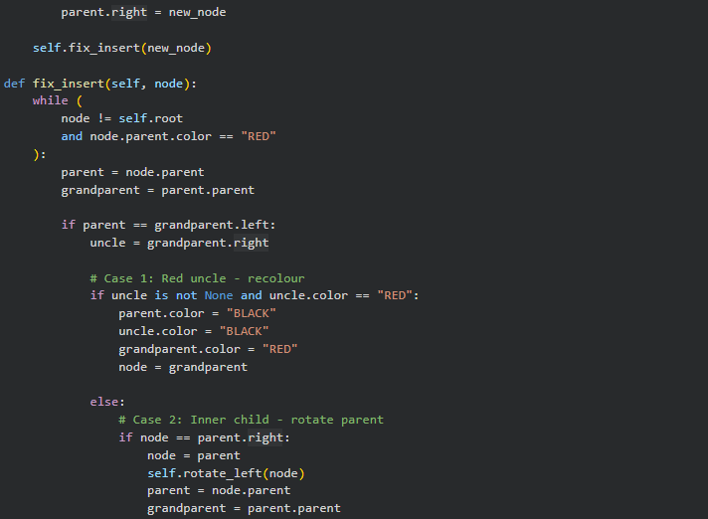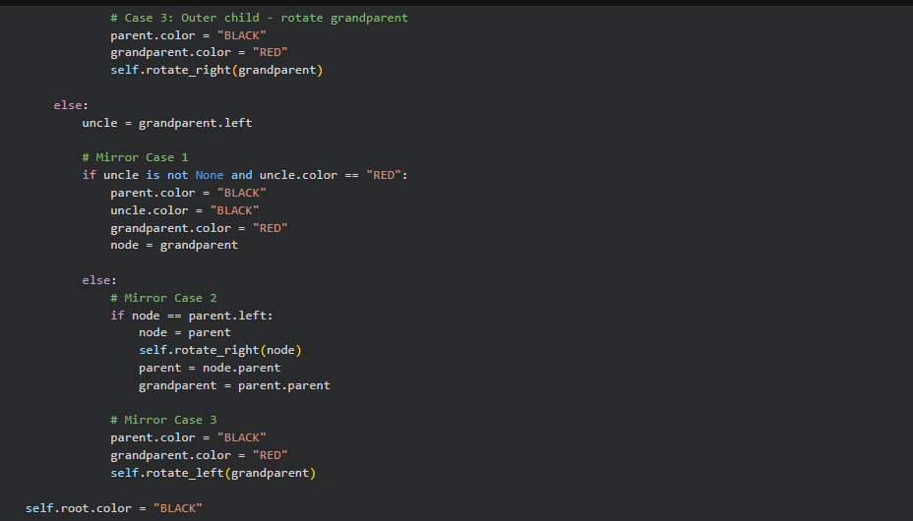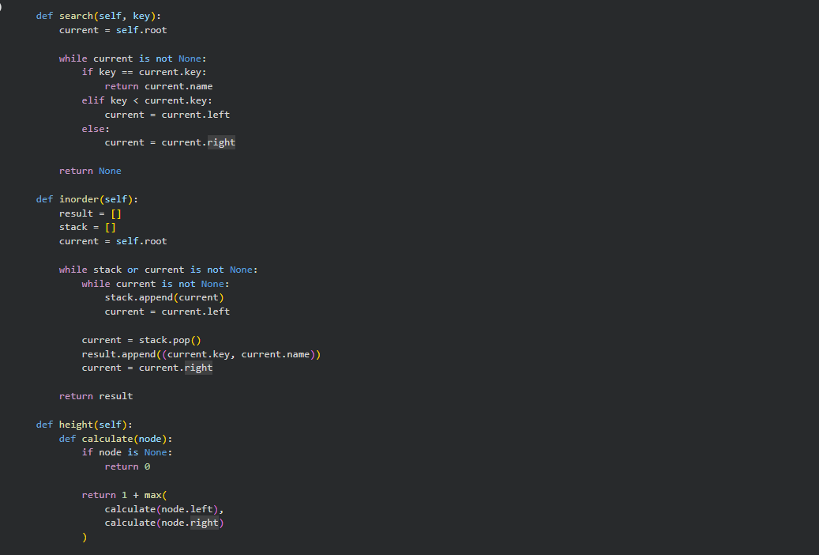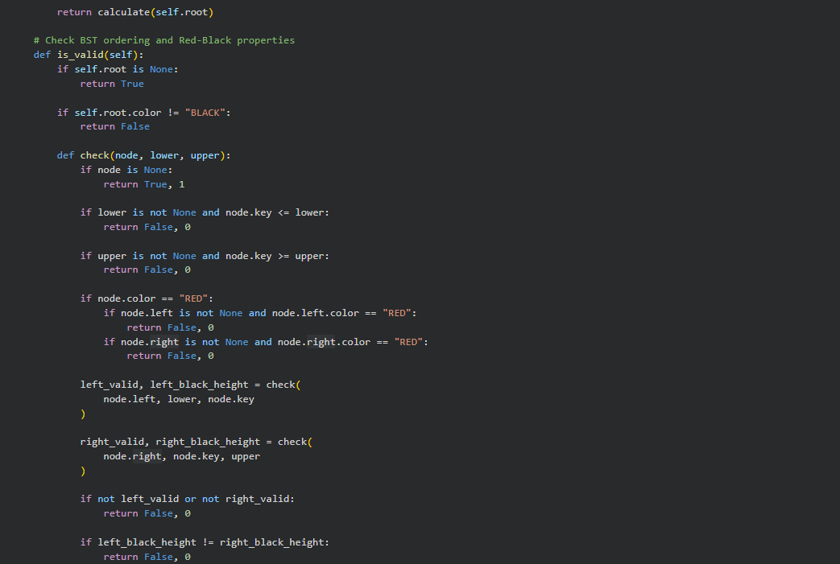
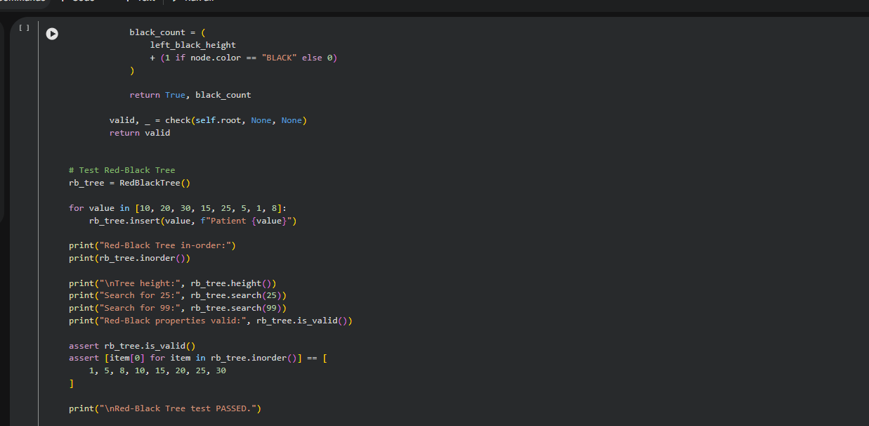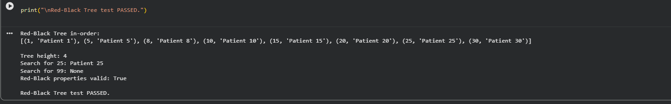 A Red-Black Tree is implemented as an additional self-learning activity. Each node stores a key, patient name, colour, and parent and child references. The implementation uses left and right rotations, recolouring, and insertion-fix operations to maintain Red-Black Tree properties. The root is maintained as black, and the implementation includes searching, in-order traversal, height calculation, and a validation method.

The Red-Black Tree is tested using a sample sequence of Patient IDs. The program displays the in-order traversal, calculates the tree height, and performs successful and unsuccessful searches. The validation function checks the BST ordering, root colour, red-node restrictions, and equal black height across paths. The test confirms that the Red-Black Tree properties are valid.

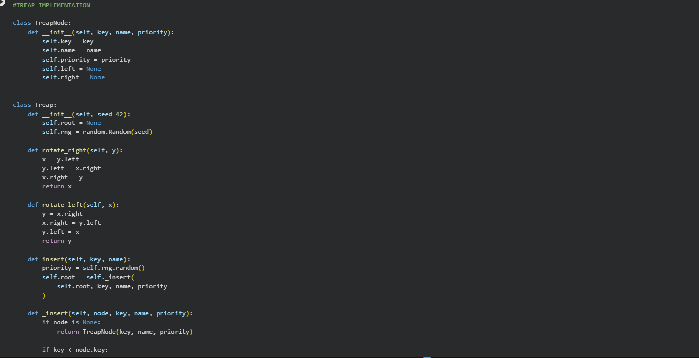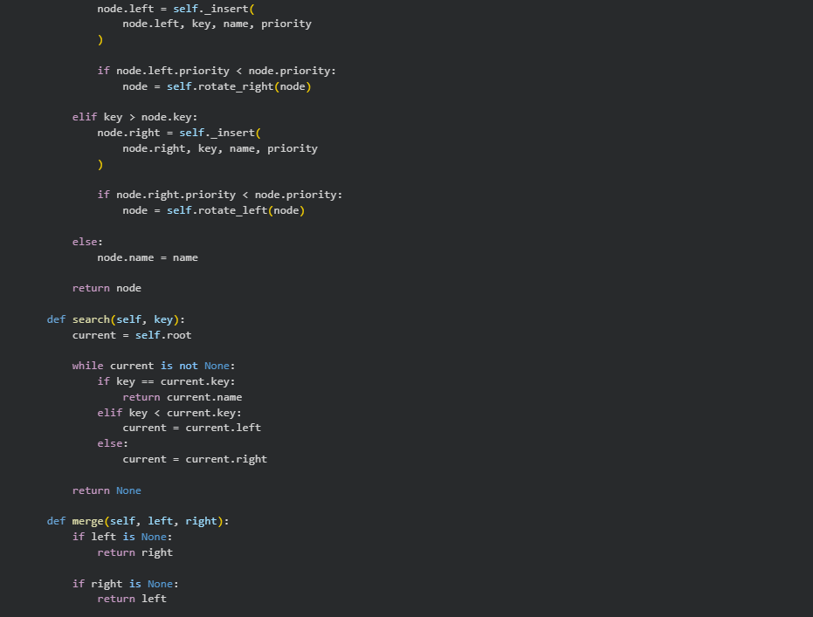
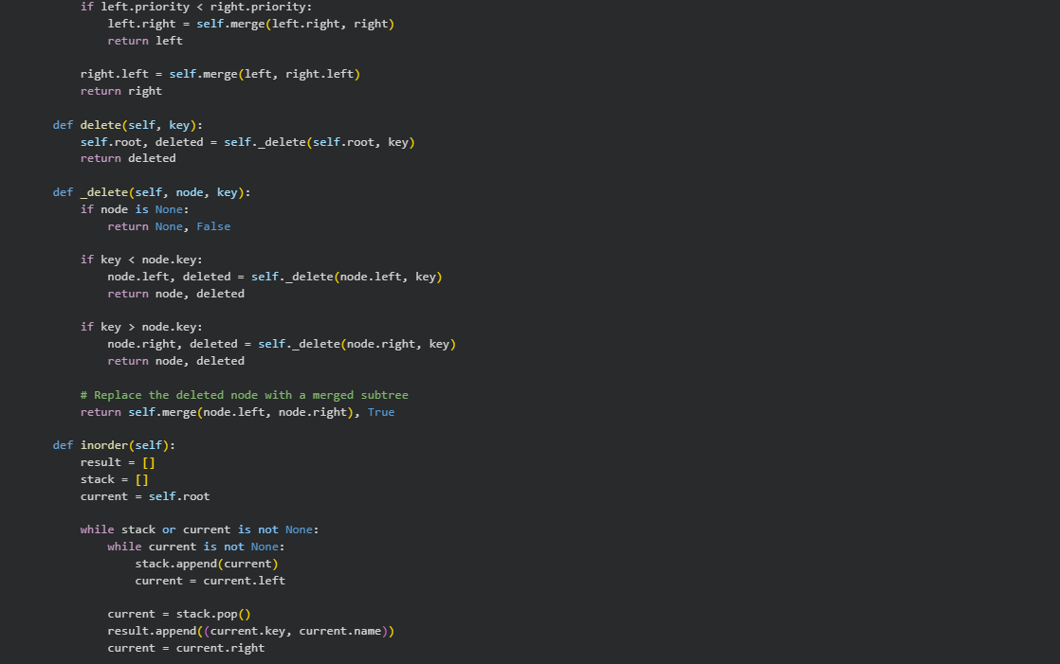
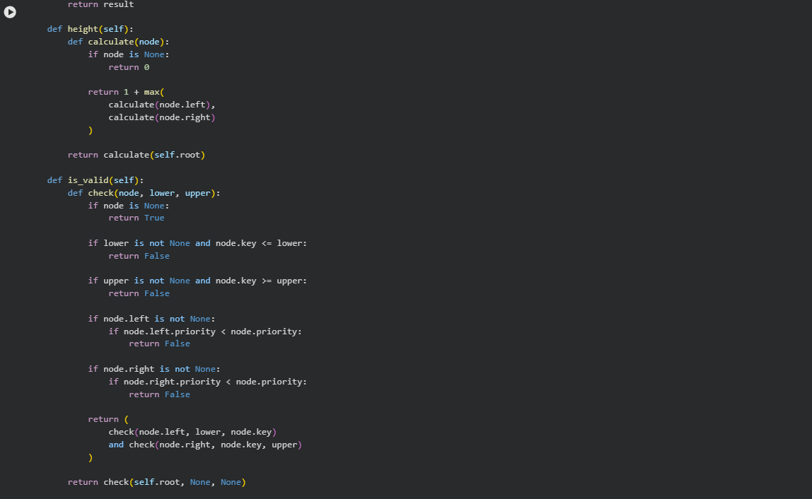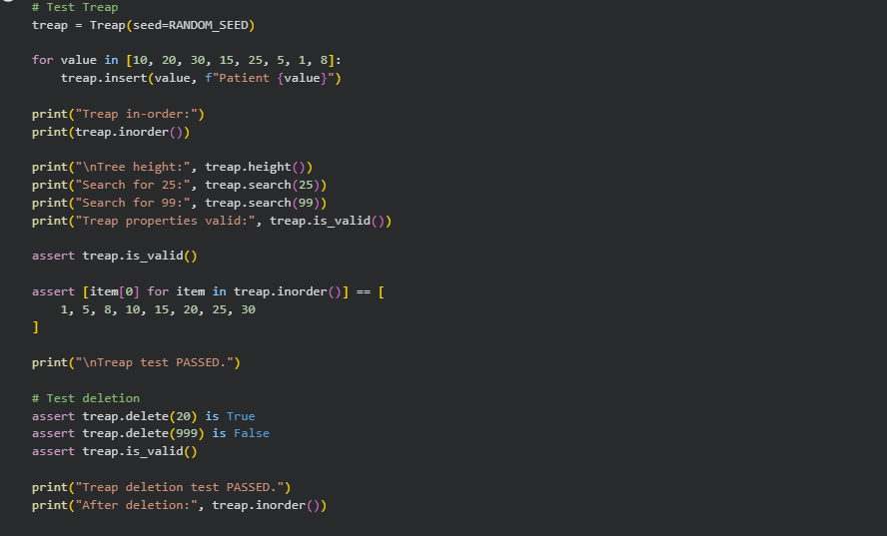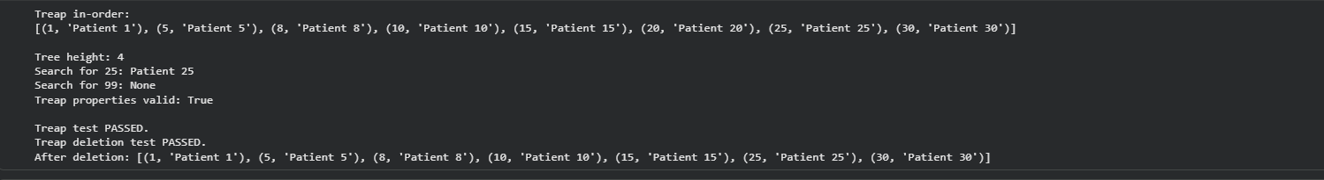 A Treap is implemented by combining the properties of a Binary Search Tree and a heap. Each node stores a key, patient name, and randomly generated priority. Insertion uses rotations to maintain the heap-priority property, while searching, deletion, merging, and in-order traversal are also implemented. A fixed random seed is used to make priority generation reproducible.

The Treap is tested using a sample set of Patient IDs. The program verifies in-order traversal, calculates tree height, and performs successful and unsuccessful searches. It also tests deletion of an existing and a non-existing record. Validation checks confirm that the BST ordering and heap-priority properties are maintained.
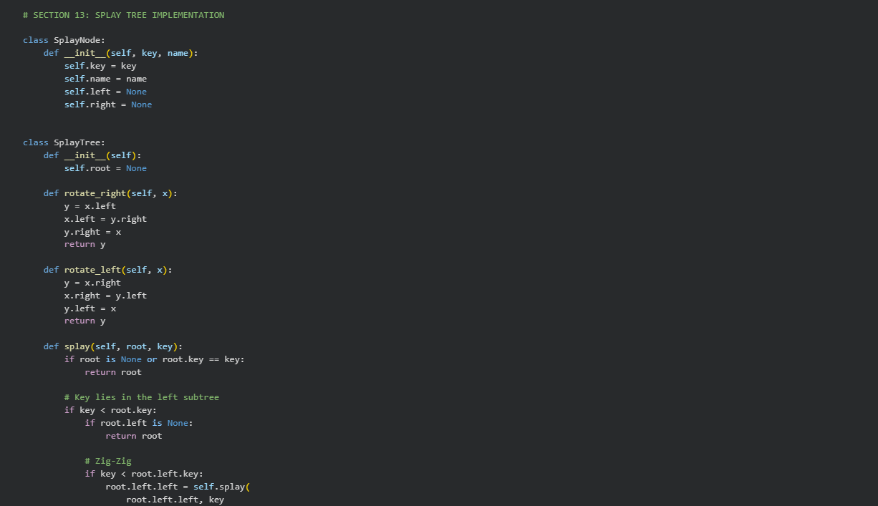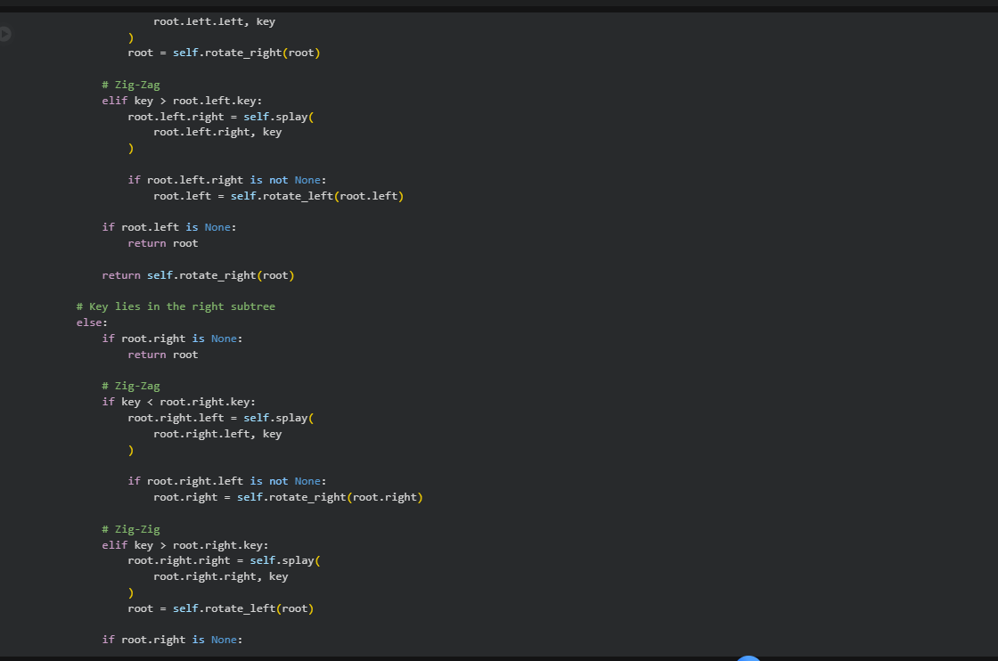
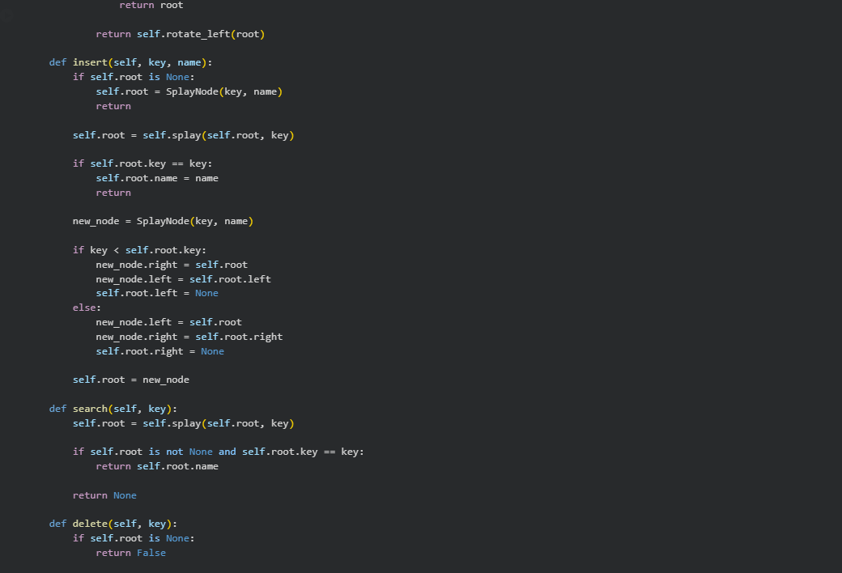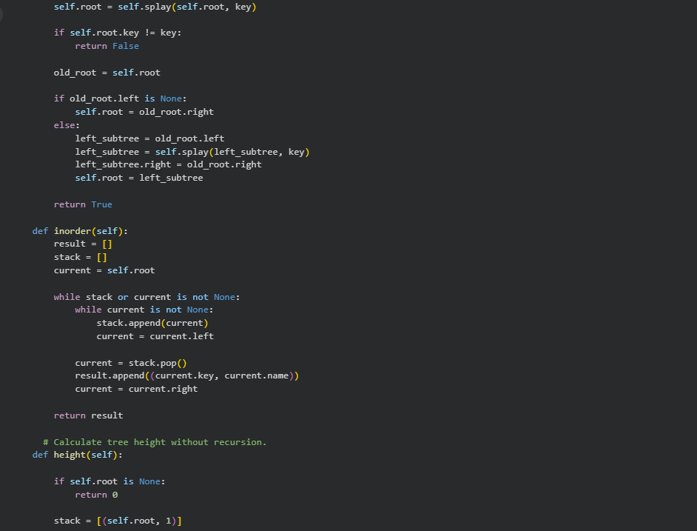
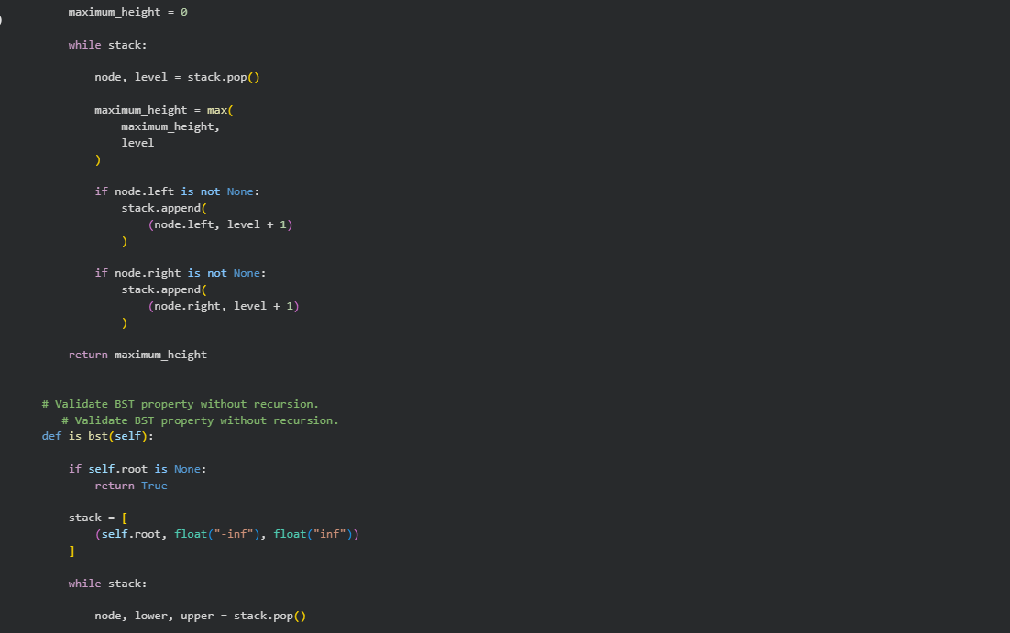
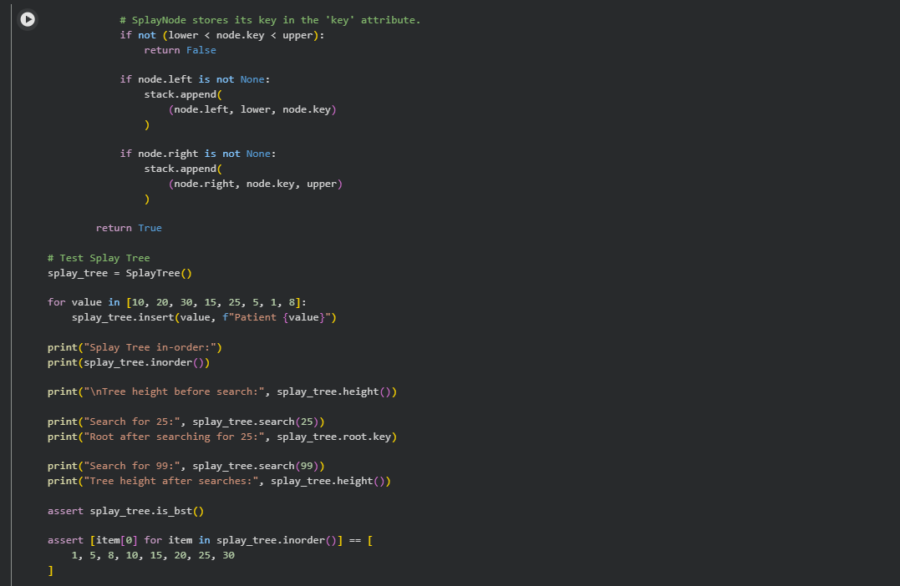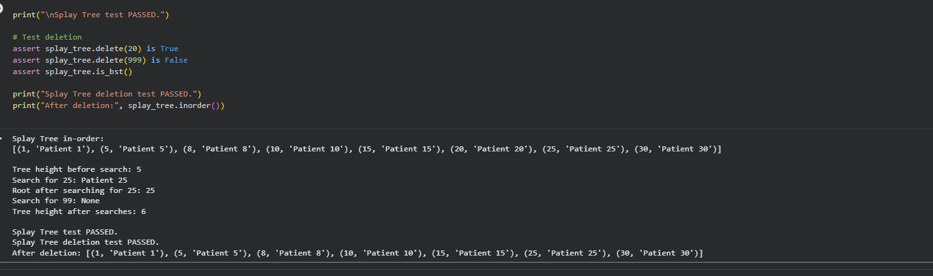 A Splay Tree is implemented as another self-learning activity. It uses rotations to move an accessed or inserted node towards the root. The implementation includes Zig-Zig and Zig-Zag operations, along with insertion, searching, deletion, in-order traversal, and height calculation. An iterative validation method is used to verify the BST ordering property.

The Splay Tree is tested using a sample set of Patient IDs. The program displays the in-order traversal and tree height before searching for a record. After a successful search for Patient ID 25, the accessed node becomes the root, demonstrating the splaying operation. An unsuccessful search and deletion tests are also performed, followed by validation of the BST property.
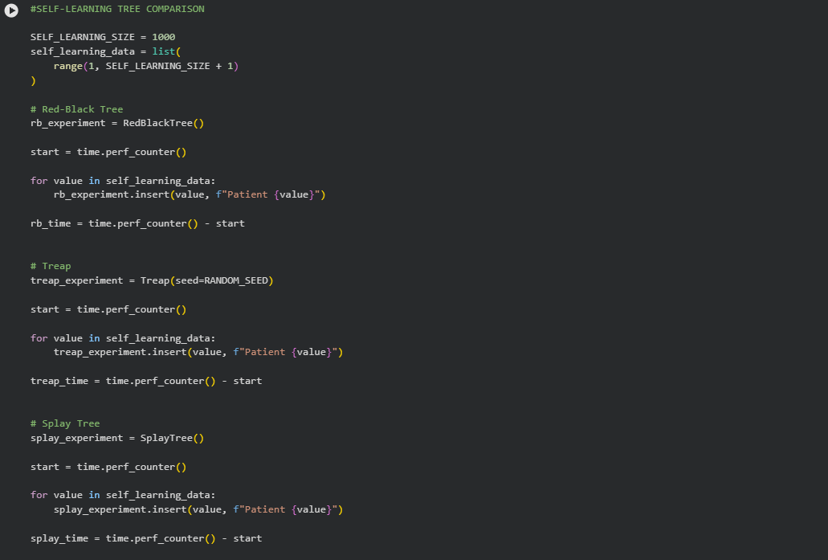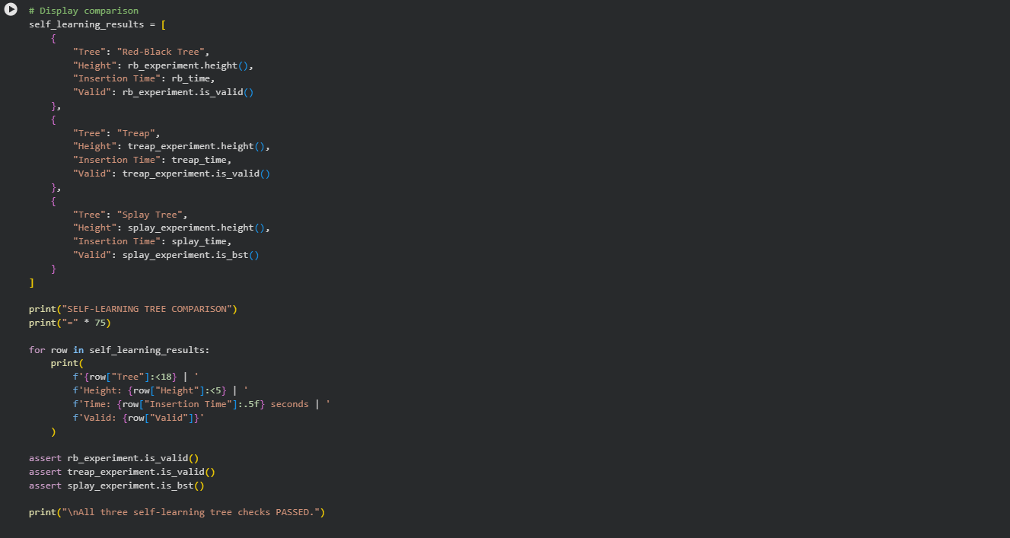
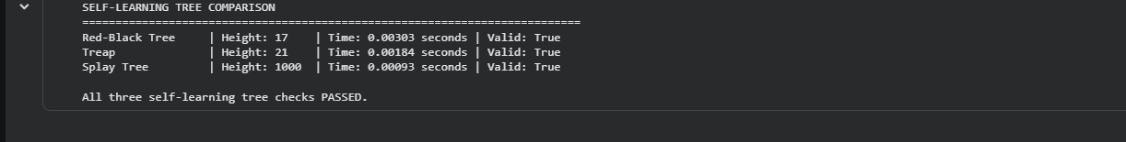
Red-Black Tree, Treap, and Splay Tree are compared using 1,000 sequential Patient IDs. The experiment measures insertion time and final tree height and checks whether each implementation satisfies its respective validation conditions. The results provide an additional comparison of different tree-organization approaches beyond the required Plain BST and AVL Tree.
The final assertions verify the validity of all three additional tree implementations. The Red-Black Tree, Treap, and Splay Tree validation checks pass successfully. This confirms that the additional implementations satisfy the properties checked by their respective validation methods.

Main experimental observation
- For sequential insertion with 10,000 records, the Plain BST reaches a height of 10,000.
- The AVL Tree reaches a height of 14 for the same dataset.
- The Plain BST therefore becomes highly skewed, while AVL rotations maintain a balanced structure.
output for 1,000 sequential records is:
Tree | Height | Insertion time | Valid
Red-Black Tree | 17 | 0.00303 s | True
Treap | 21 | 0.00184 s | True
Splay Tree | 1000 | 0.00093 s | True

Concepts
1 Binary Search Tree
A Binary Search Tree is a hierarchical data structure in which each node contains a key and references to its left and right children.
The BST property states that:
- Keys in the left subtree are smaller than the node's key.
- Keys in the right subtree are greater than the node's key.
- Both subtrees must also satisfy the BST property.
2 AVL Tree
An AVL Tree is a self-balancing Binary Search Tree. It maintains a balance factor for every node.
Balance Factor = Height of Left Subtree − Height of Right Subtree.
For a valid AVL Tree, the balance factor of every node must be -1, 0 or +1.
3 AVL Rotations
Four rotation cases are used to restore balance:
- LL – Right rotation.
- RR – Left rotation.
- LR – Left rotation followed by right rotation.
- RL – Right rotation followed by left rotation.

Dataset Generation
Three types of datasets are used:
Sequential Dataset: Patient IDs are inserted in ascending order from 1 to N. This arrangement is used to demonstrate the possibility of a skewed Plain BST.
Random Dataset: Patient IDs are shuffled into a random permutation before insertion. This evaluates tree performance under a random insertion order.
Nearly Sorted Dataset: Patient IDs are initially arranged in ascending order, with approximately 5% of positions selected and randomly swapped. This represents an input arrangement that is mostly sorted but contains some variation.
The experiment uses dataset sizes of 1,000, 5,000 and 10,000. A fixed random seed is used to make the workload generation reproducible.

Experimental Methodology
Both Plain BST and AVL Tree implementations are evaluated using the same generated datasets.
The following measurements are collected:
- Height after inserting all records.
- Theoretical minimum height using the formula specified in the lab question: floor(log₂ N).
- Time taken for insertion.
- Total AVL rotations.
- Average comparisons over 1,000 randomly selected successful searches.
- Height after randomly deleting 20% of the records.
The same search and deletion samples are used for both tree types within each dataset, ensuring a consistent comparison.
Time Complexity
Operation | Plain BST – Average | Plain BST – Worst | AVL Tree
Search | O(log N) | O(N) | O(log N)
Insertion | O(log N) | O(N) | O(log N)
Deletion | O(log N) | O(N) | O(log N)
In-order traversal | O(N) | O(N) | O(N)
Height calculation | O(N) | O(N) | O(1) using stored root height
The Plain BST can become skewed, resulting in linear worst-case time complexity. The AVL Tree maintains logarithmic height, ensuring logarithmic search, insertion and deletion.

Performance Analysis: Plain BST vs AVL Tree
The experimental results are used to identify the input arrangement that causes the greatest height in a Plain BST and to compare its search cost with the AVL Tree.
The analysis also considers the additional operations required by AVL balancing, including height updates and rotations.
Experiment: Inserted N = 1000, 5000 and 10000 keys into a plain BST and an AVL tree, using three datasets (Sequential, Random, Nearly Sorted). Recorded height, insertion time, rotations, average search comparisons, and height after deleting 20% of the keys.
Key results (N = 10,000)
Dataset | Tree | Height | Insert time (s) | Rotations | Avg search comps | Height after 20% deletion
Sequential | BST | 10000 | 9.431 | 0 | 9962.4 | 8000
Sequential | AVL | 14 | 0.095 | 9986 | 23.7 | 14
Random | BST | 31 | 0.024 | 0 | 32.5 | 30
Random | AVL | 16 | 0.091 | 7079 | 24.2 | 16
Nearly Sorted | BST | 920 | 0.873 | 0 | 379.9 | 740
Nearly Sorted | AVL | 15 | 0.271 | 12199 | 24.0 | 15
The theoretical minimum height is floor(log₂ N) = 13 for N = 10,000.
Observations
1. Plain BST depends entirely on input order. On sequential data it degenerates into a linked list: height equals N (1000, 5000, 10000), and average search cost is about N comparisons, so search is O(n). Nearly sorted data is also badly affected (height 920 at N = 10,000). Random data behaves well, with height 31, about 2.4 times log₂ N.
2. AVL height stays near-optimal on every dataset. Heights were 14 for sequential and 16 for random at N = 10,000, within 1 to 3 levels of the minimum of 13. Search cost stays at about 22 to 24 comparisons regardless of input pattern, confirming O(log n).
3. Insertion time shows the trade-off. For sequential data, AVL is about 100 times faster at N = 10,000 (0.095 s vs 9.43 s), because the BST must walk an ever-longer chain on each insert. For nearly sorted data AVL is about 3 times faster. For random data, the plain BST is about 4 times faster (0.024 s vs 0.091 s), because AVL pays for rotations and height updates that a random BST doesn’t need.
4. Rotations are the cost of balance. AVL performed roughly N rotations for sequential data (9986 for N = 10,000), about 0.7 N for random, and about 1.2 N for nearly sorted. Nearly sorted data is the most rotation-heavy case.
5. Deletion. After removing 20% of keys, the plain BST on sequential data still has height 8000, so the skew persists. AVL height is unchanged at 14, because rebalancing keeps the structure compact.
6. Scaling. From N = 1000 to 10000, sequential BST insert time grew from 0.057 s to 9.43 s (about 166 times for 10 times the data), consistent with O(n²) total cost. AVL grew from 0.007 s to 0.095 s (about 13 times), consistent with O(n log n).
Conclusion
The plain BST is fast and simple only when input is random, and it has no worst-case guarantee. AVL costs extra rotations and a small overhead on random data, but it guarantees O(log n) height, search and insertion regardless of input order, and it stays balanced after deletions. For real data, which is often sorted or partially sorted, AVL is the safer choice.

Self-Learning Activity
In addition to the required Plain BST and AVL implementations, three alternative tree structures are explored:
- Red-Black Tree: Maintains balance through colour properties, rotations and recolouring.
- Treap: Combines BST ordering with heap priority ordering.
- Splay Tree: Moves accessed nodes towards the root through splaying operations.
As part of the self-learning activity, I studied and implemented a Red-Black Tree to understand how it maintains balance during insertion. A Red-Black Tree is a self-balancing Binary Search Tree in which each node is assigned either a red or black colour. These colours follow specific rules that prevent the tree from becoming excessively unbalanced.
A Red-Black Tree follows five main properties:
- Every node is either red or black.
- The root is always black.
- All NIL (leaf) nodes are black.
- A red node cannot have a red child.
- Every path from a node to its descendant NIL nodes contains the same number of black nodes.
After insertion, violations are corrected using recolouring and rotations. These operations maintain the Red-Black properties while preserving the Binary Search Tree ordering.
A Red-Black Tree has a worst-case height of at most (2\log_2(n+1)), where (n) is the number of nodes. This provides logarithmic search, insertion and deletion performance.
Unlike an AVL Tree, which maintains a stricter balance condition using node heights and balance factors, a Red-Black Tree uses colour rules to allow comparatively flexible balancing. AVL Trees can provide shorter search paths, whereas Red-Black Trees often require less strict rebalancing.
Experimental Observation
I implemented and tested the Red-Black Tree using 1,000 sequential patient IDs. The experiment produced a tree height of 17, an insertion time of approximately 0.00303 seconds, and a successful validation result. This demonstrates that the Red-Black Tree maintained a balanced structure even when the IDs were inserted in ascending order.
For additional exploration, I also implemented Treap and Splay Trees. With the same sequential input, the Treap produced a height of 21, while the Splay Tree produced a height of 1,000 before subsequent access operations. The Splay Tree demonstrated its self-adjusting behaviour when searching for a key moved that key to the root. These observations show that different tree structures use different balancing strategies.
Conclusion
The experiment demonstrates how insertion order influences the structure and performance of a Binary Search Tree. It also shows how AVL balancing helps maintain logarithmic tree height through rotations.
The experimental comparison provides an understanding of the trade-off between the simpler structure of a Plain BST and the additional balancing operations of an AVL Tree. The self-learning activity further explores alternative tree structures and their balancing mechanisms.

GitHub – DSA Lab 6: Self-Balancing BST
https://github.com/rohansamreji-sys/Data_Structures-and-Algorithms/tree/main/Lab6_Self_Balancing_BST

