Lab Exercise 1: Application of Stack

RegNo-2648544

Scenario-Based Problem: AI-Based Web Browser History Manager
An AI-powered research assistant used by MSAIML students maintains the recently visited
research pages using a Stack. Since users generally want to return to the most recently
visited page first, the system follows the LIFO (Last In, First Out) principle.
Develop a menu-driven program to implement a Browser History Manager using Stack.
Requirements
Implement the following stack operations:
1. Visit a Page (Push)
o Add a newly visited webpage to the stack.
o Example: Google Scholar → IEEE Xplore → ResearchGate
2. Go Back (Pop)
o Remove and display the most recently visited webpage.
o If the stack is empty, display an appropriate message.
3. Current Page (Peek)
o Display the webpage currently at the top of the stack without removing it.
4. Display History
o Display all webpages currently stored in the stack.
5. Exit
o Terminate the program.
Tasks
• Implement the Stack using an array or linked list.
• Demonstrate Push, Pop, Peek, and Display operations.
• Handle Stack Overflow/Underflow where applicable.
• Explain why LIFO is suitable for maintaining browser history.
• Test the program using different sequences of operations.
Expected Learning Outcome:
Students will be able to apply the Stack data structure and LIFO principle to solve a
practical problem and explain the relevance of stack operations in an application.

Output-

Program code
# Set the maximum number of pages the stack can store
MAX_SIZE = 5

# Created an empty stack
stack = []

# Set top to -1 because the stack is initially empty
top = -1

# Function to visit a new webpage
def visit_page():
global top

# To Check if the stack is full
if top == MAX_SIZE - 1:
print("Stack Overflow! History is full.")
return

# Take the webpage name from the user
page = input("Enter webpage: ")

# Add the webpage to the top of the stack
stack.append(page)

# Move top one position up
top += 1

# Display the visited page
print("Visited:", page)

# Function to go back to the previous webpage
def go_back():
global top

# Check if the stack is empty
if top == -1:
print("Stack Underflow! No previous page.")
return

# Remove and display the top webpage
print("Removed:", stack.pop())

# Move top one position down
top -= 1

# Function to display the current webpage
def current_page():

# Check if there is no webpage in the stack
if top == -1:
print("No page is currently open.")

# Display the top webpage without removing it
else:
print("Current Page:", stack[top])

# Function to display all visited webpages
def display_history():

# Check if the stack is empty
if top == -1:
print("History is empty.")
return

# Display the history heading
print("Browser History:")

# Display pages from top to bottom
for i in range(top, -1, -1):
print(stack[i])

# Function to clear the complete browser history
def clear_history():
global top

# Remove all pages from the stack
stack.clear()

# Reset top because the stack is now empty
top = -1

# Display confirmation
print("History cleared.")

# Keep showing the menu until the user chooses Exit
while True:

# Display the available options
print("\n1. Visit Page")
print("2. Go Back")
print("3. Current Page")
print("4. Display History")
print("5. Clear History")
print("6. Exit")

# Ask the user to select an option
choice = input("Enter choice: ")

# Option 1: Visit a webpage
if choice == "1":
visit_page()

# Option 2: Go back to the previous webpage
elif choice == "2":
go_back()

# Option 3: Display the current webpage
elif choice == "3":
current_page()

# Option 4: Display browser history
elif choice == "4":
display_history()

# Option 5: Clear the browser history
elif choice == "5":
clear_history()

# Option 6: Exit the program
elif choice == "6":
print("Exiting...")
break

# Handle an invalid menu choice
else:
print("Invalid choice.")

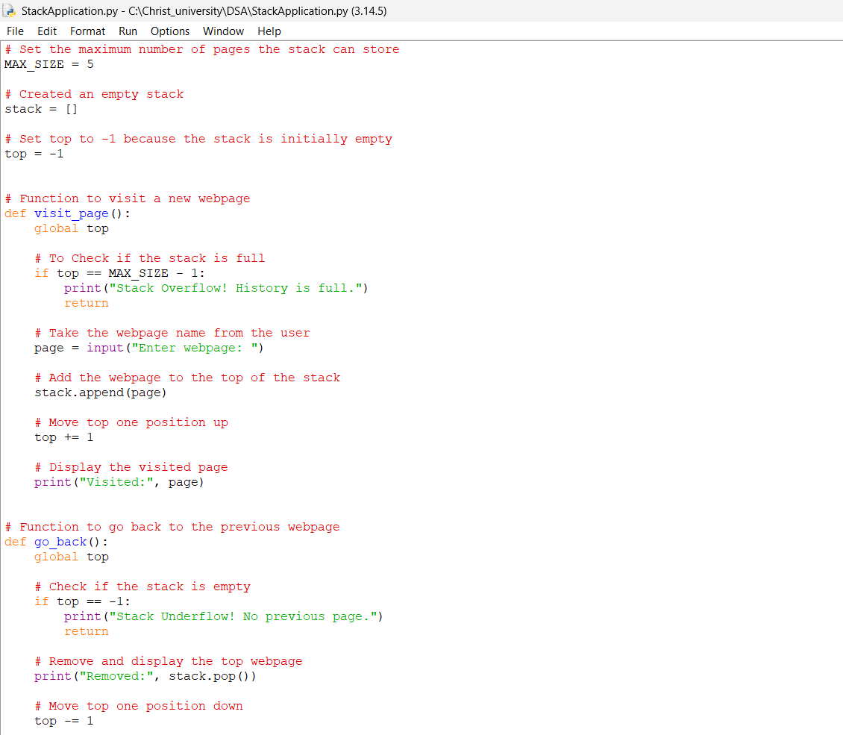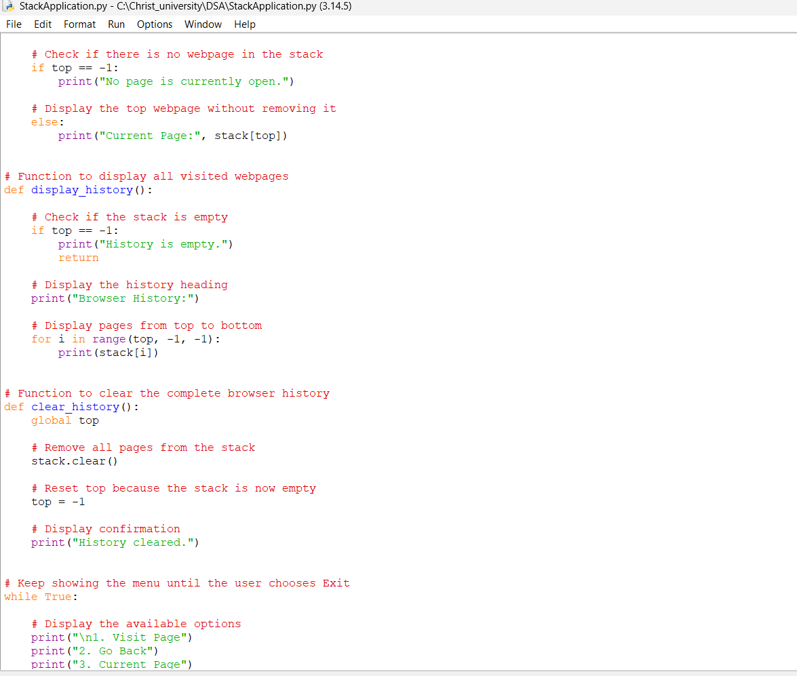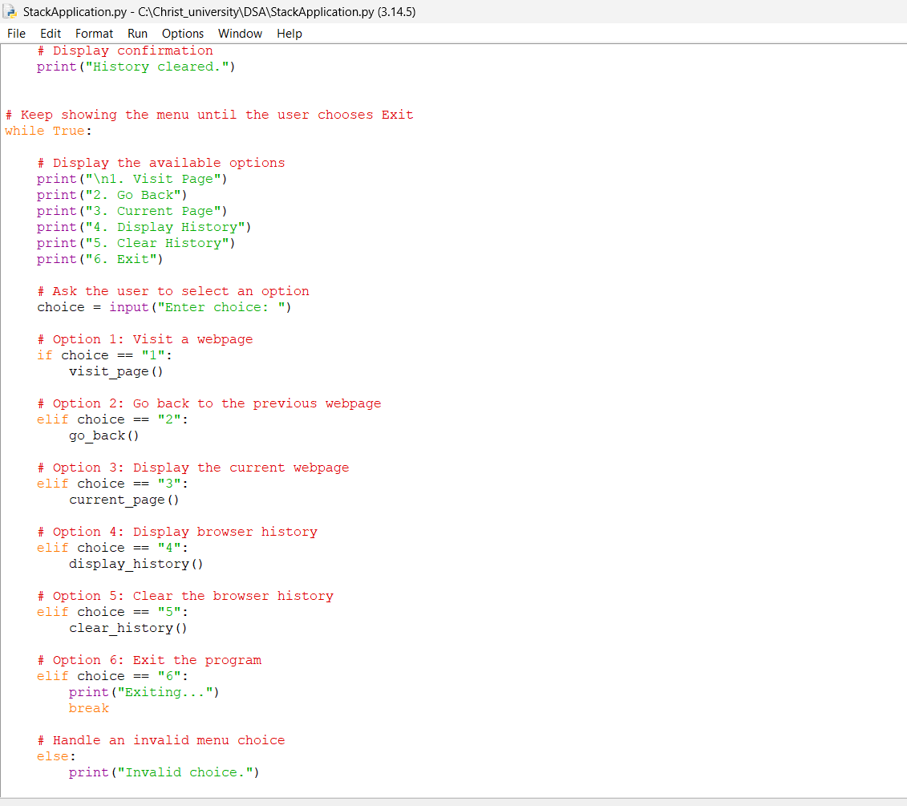

Results-
Demonstrating the operations-
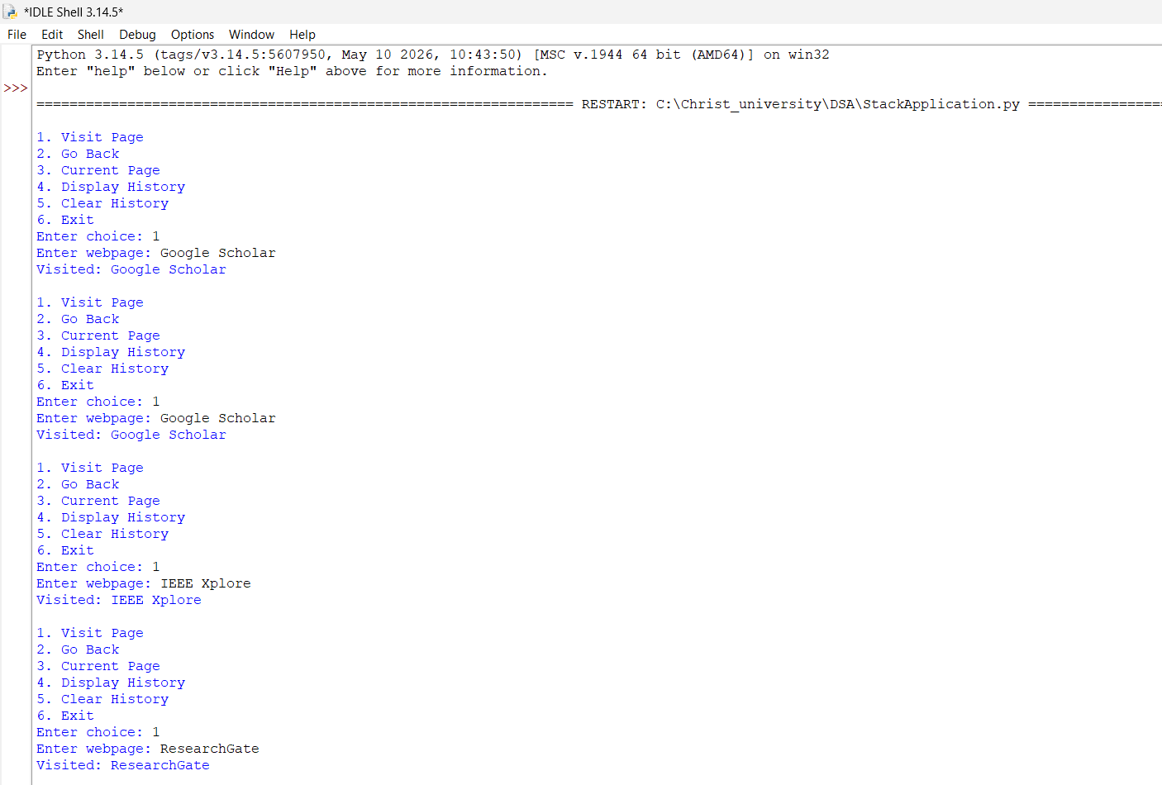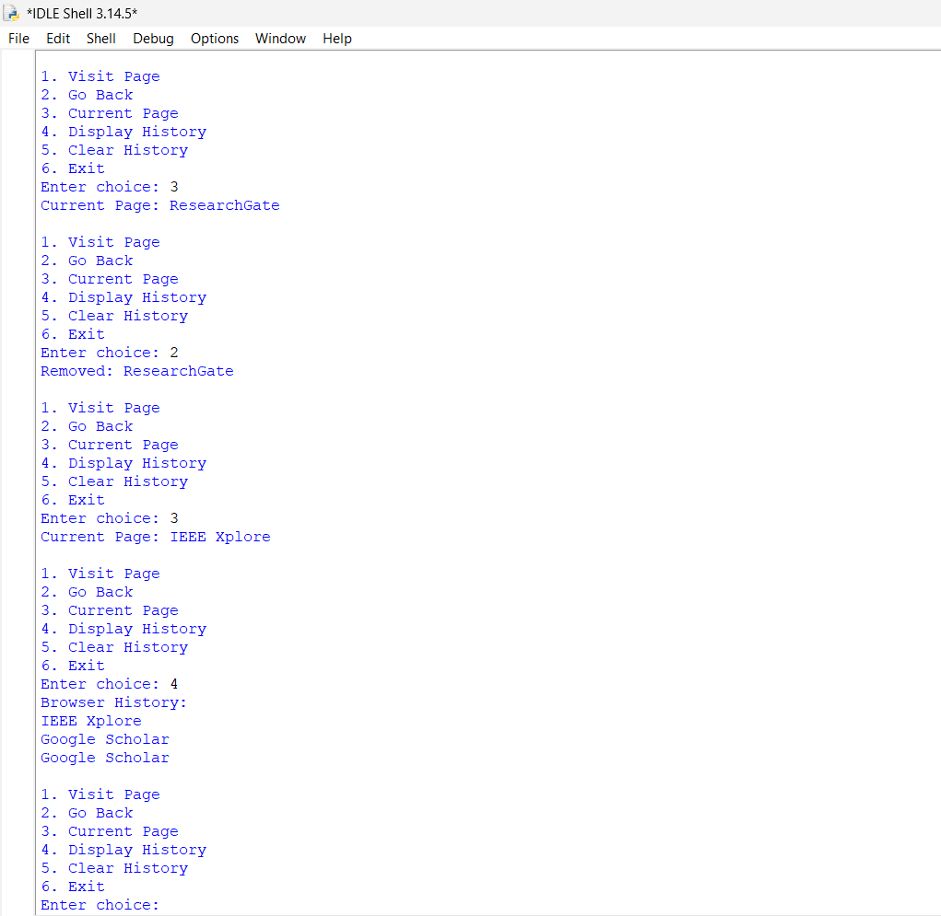
Demonstrating Stack overflow - 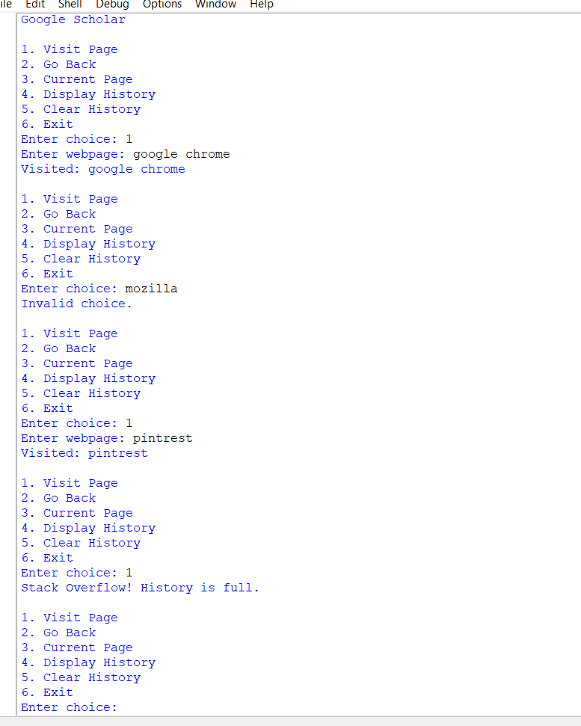
Demonstrating stack underflow & clearing history -
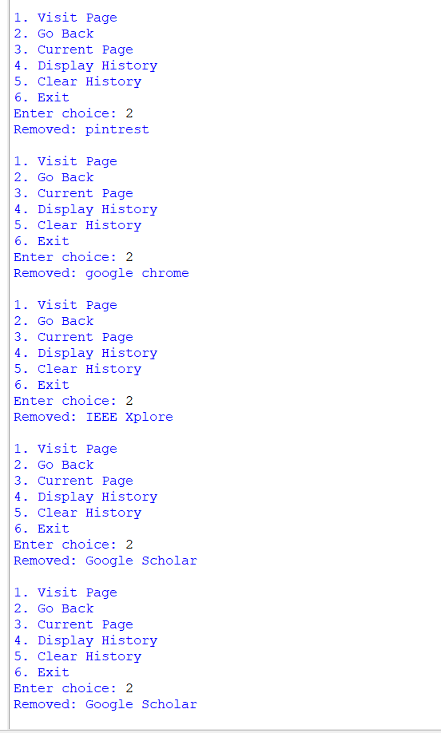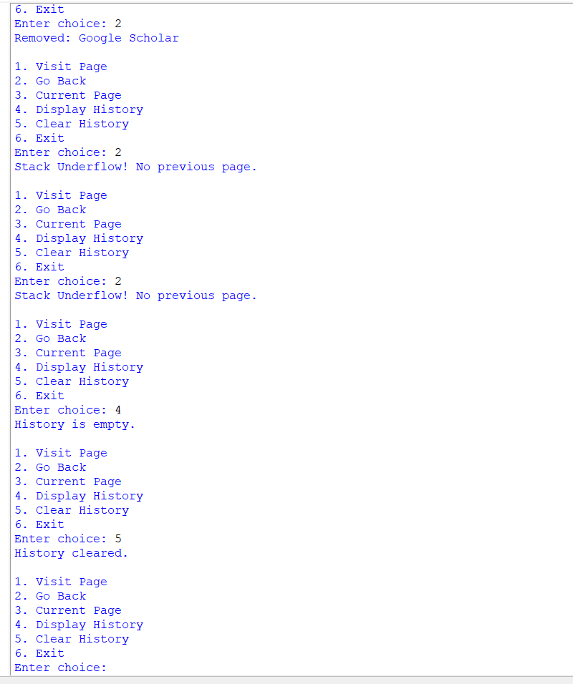
Exiting –


