M.Sc. in Artificial Intelligence and Machine Learning (MSAIML)

Course: Data Structures — Practical / Lab Assessment – 2

Experiment: Implement Queue Operations using Linked List
Student name – Rohan Sam Reji
Reg.No-2648544
Date- 24/09/26

Scenario: SmartCare Hospital OPD Token System
Problem - SmartCare Multi-Speciality Hospital runs a busy Out-Patient Department (OPD). Every morning, hundreds of patients arrive at the registration desk and receive a token. Patients must be called to the doctor strictly in the order in which they registered — first-come, first-served. The number of patients varies greatly from day to day (40 on a quiet Sunday, 400+ during a flu season), so the hospital IT team does NOT want a fixed-size array. They have asked you, as a Data Structures intern, to build the core patient-queue module using a singly linked list.
Each patient record (node) must store:
• Token Number — integer, auto-generated in increasing order (101, 102, 103 …)
• Patient Name — string
• Age — integer
• Department — string (e.g., General Medicine, Orthopaedics, ENT)
• Next — pointer/reference to the next patient in the queue
The queue must maintain two pointers, FRONT (patient to be called next) and REAR (most recently
registered patient), so that both insertion and deletion run in O(1) time.

PROGRAM CODE- 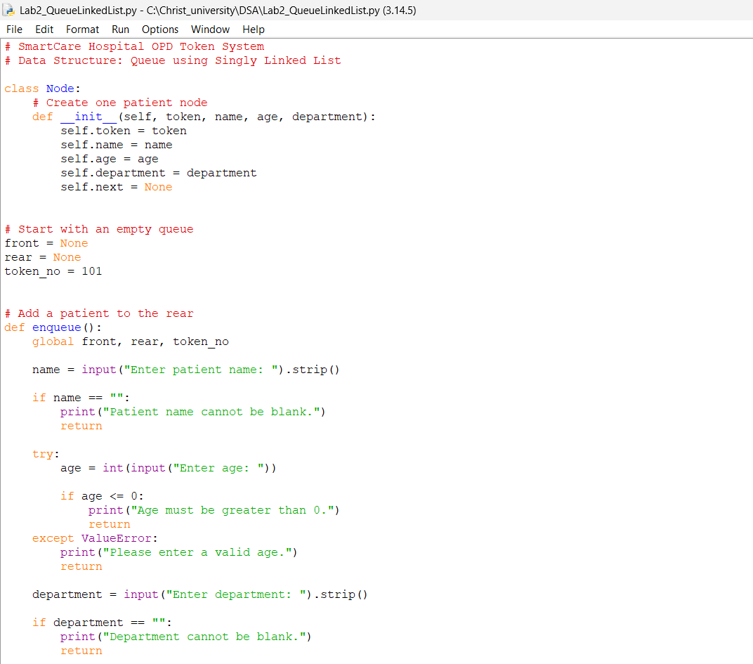

FRONT points to the patient who will be called next.
REAR points to the most recently registered patient.
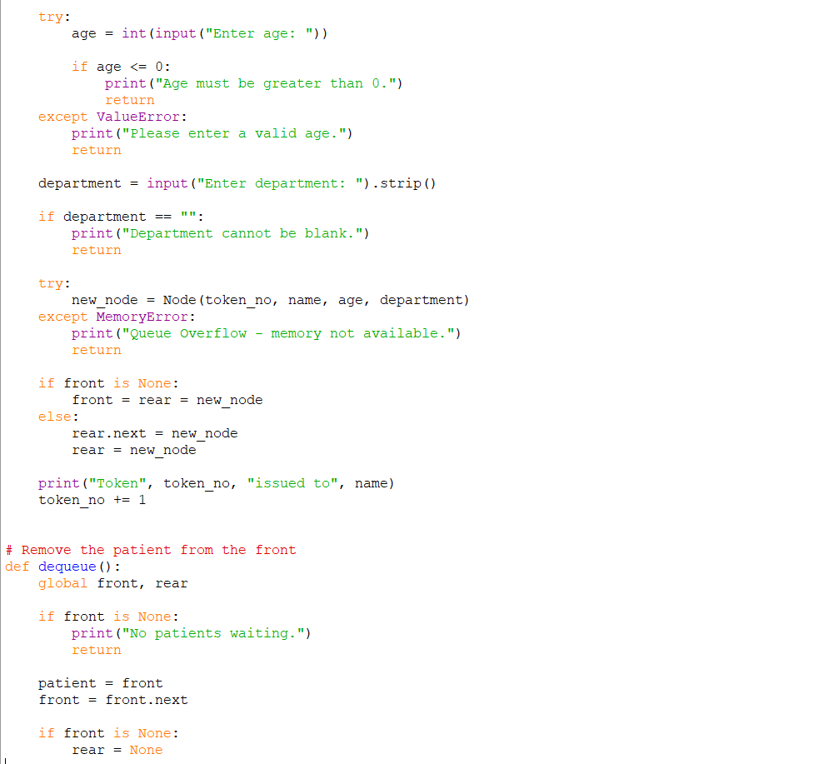

“MemoryError” is handled in case memory allocation fails.
If the queue is empty, the new node becomes both FRONT and REAR.

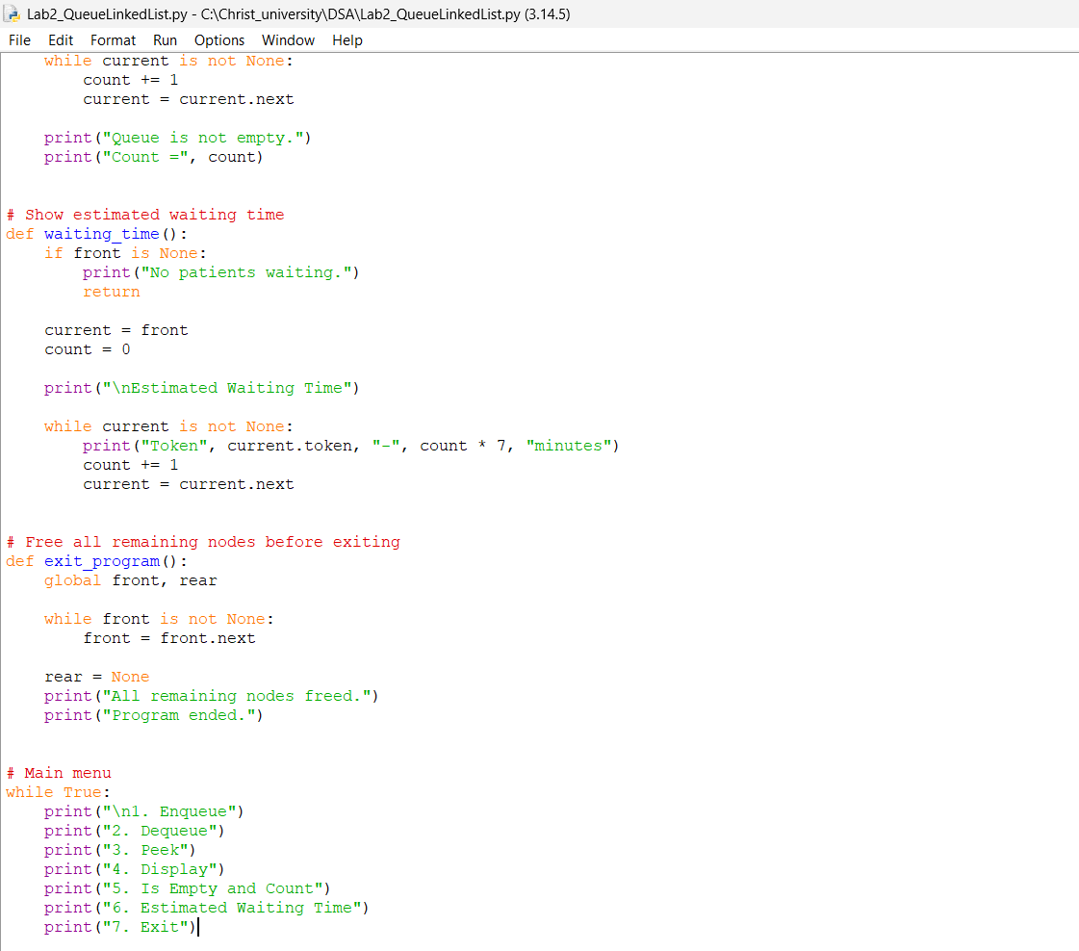A dequeue cannot be performed when the queue is empty.
The menu keeps running until the user selects Exit

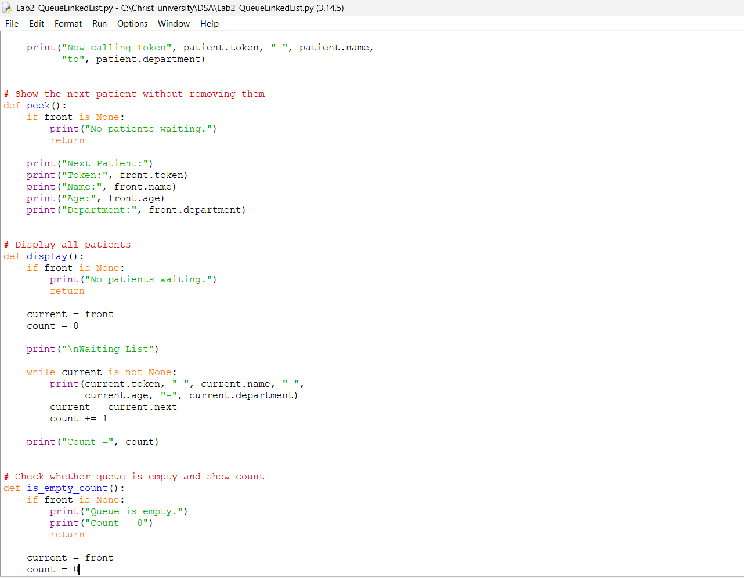Peek only views the first patient without removing them.
There is nothing to display if the queue is empty

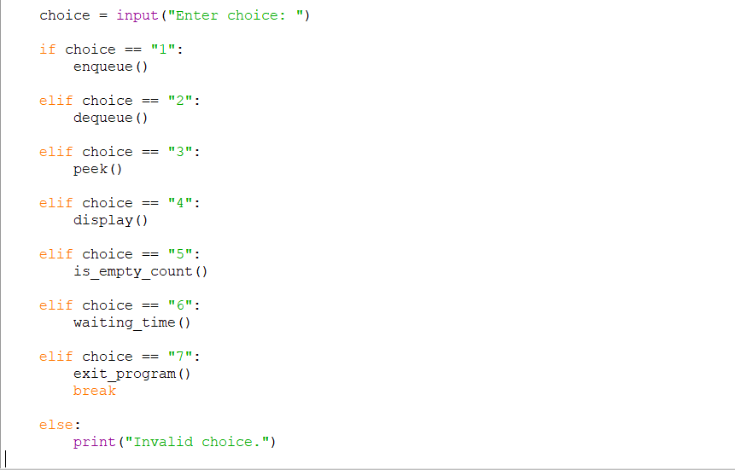

Output-
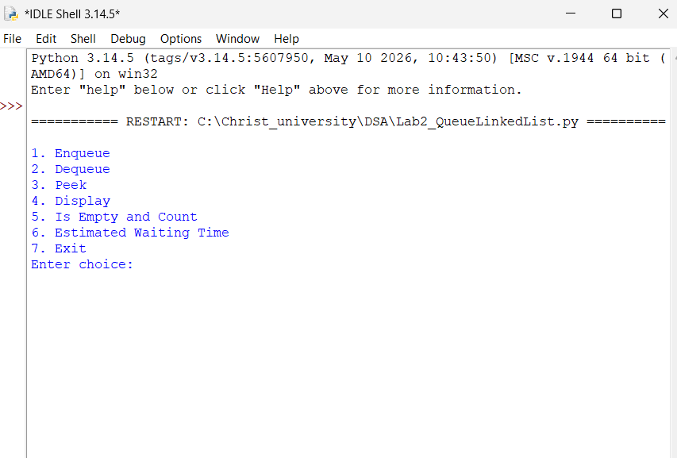

Initial program interface
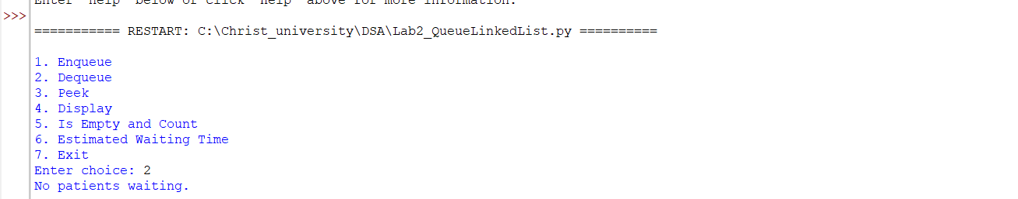

Demonstration 1: Dequeue on an Empty Queue
The program was first tested with a dequeue operation while no patients were present in the queue. The program correctly displayed “No patients waiting.” This confirms that the queue handles the underflow condition without crashing.

…………….
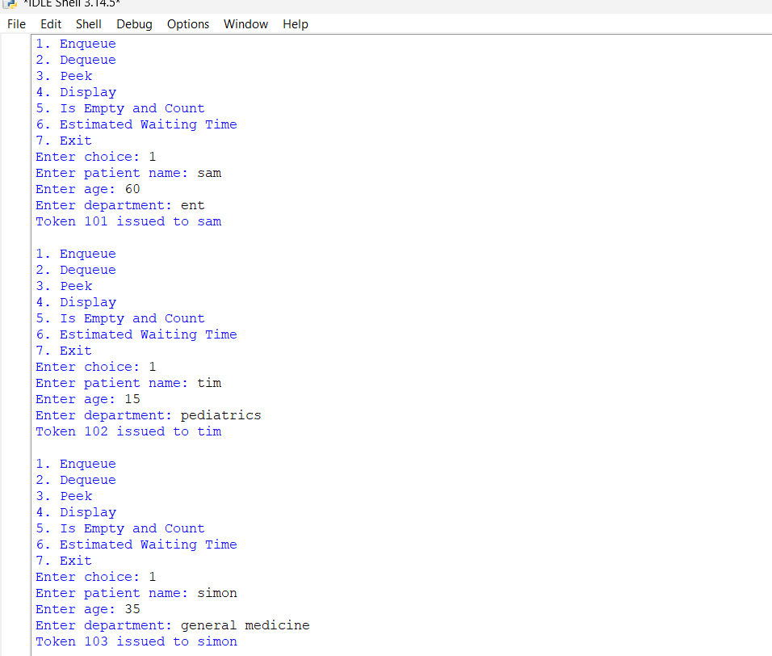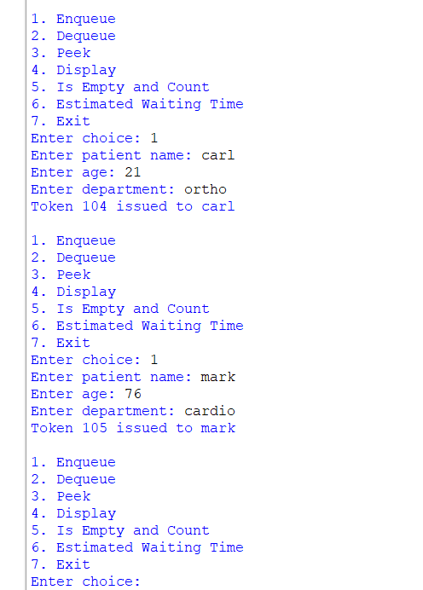
Demonstration 2: Enqueue Operation
Three patients were registered using the Enqueue operation. The program automatically generated tokens 101, 102, and 103 in increasing order. This shows that new patients are added at the rear of the queue.

………….
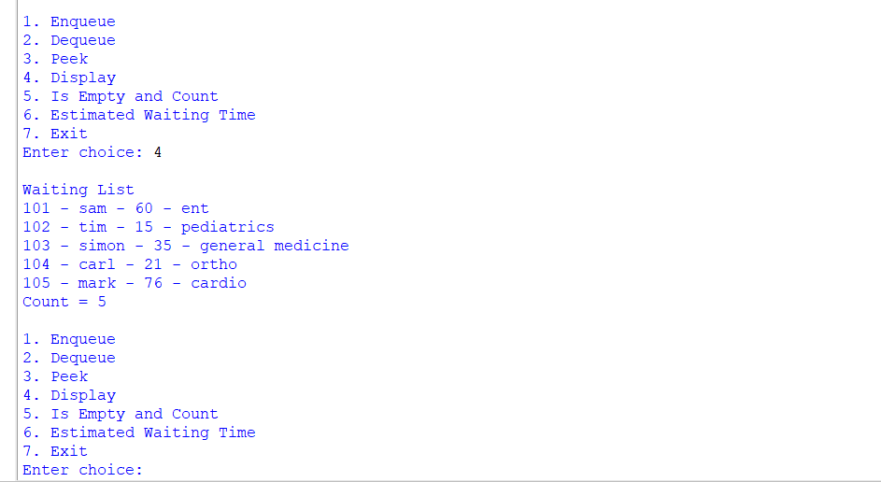
Demonstration 3: Displaying the Waiting List
The Display operation was used to view the patients currently waiting. The patients appeared in the same order in which they were registered: 101 → 102 → 103. The program also displayed the current count as 3, confirming the FIFO order of the queue.

…………
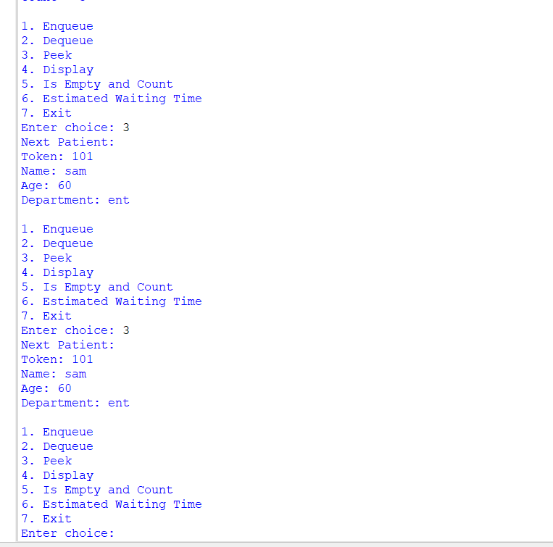
Demonstration 4: Peek / Front Operation
The Peek operation displayed the first patient , Token 101, as the next patient to be called. The patient remained in the queue because Peek only checks the FRONT node without removing it.

……
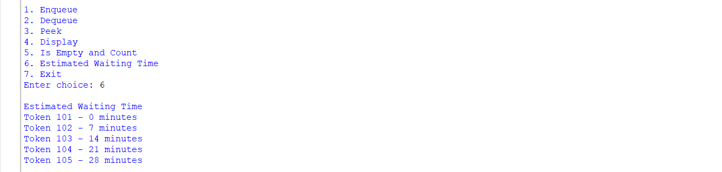
Demonstration 5 - Estimated Waiting Time – ( Extra feature added )
The Estimated Waiting Time feature was tested using the assumption of 7 minutes per consultation. The program calculates the expected waiting time based on the patient's position in the queue. This was added as a self-learning extension beyond the basic queue operations.

……
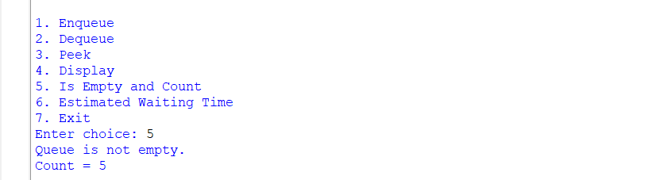 Demonstration 6- Is Empty and count
Is Empty, and count performs two checks:
- Is Empty -checks whether there are any patients in the queue. If front is None, the queue is empty. Otherwise, patients are waiting.
- Count -counts how many patients are currently waiting by traversing the linked list from the front to the end.

……….
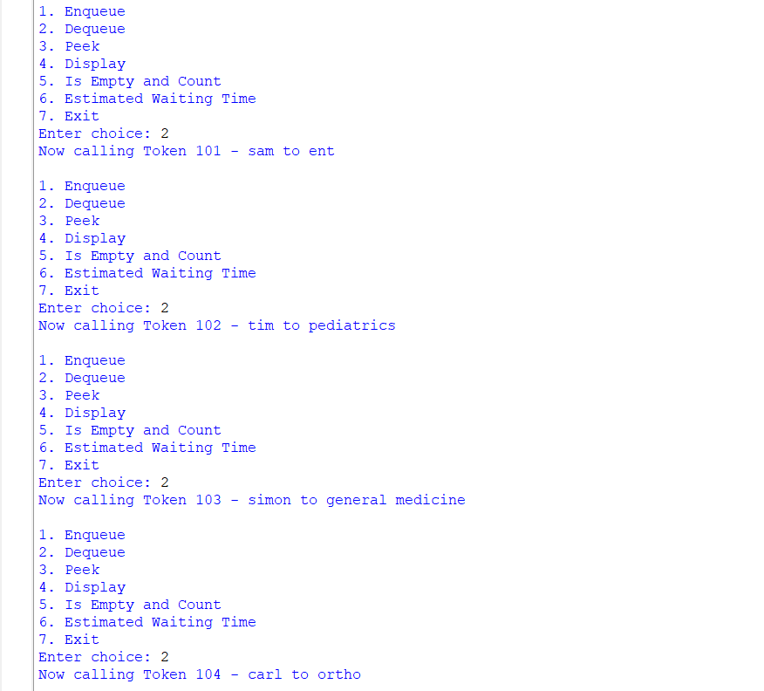 Demonstration 7 - Calling Patients
The Dequeue operation was performed to call the patients in their registration order. Patient 1 was called first, followed by patient 2 and patient 3 . This demonstrates the FIFO (First In, First Out) principle of a queue.

……….
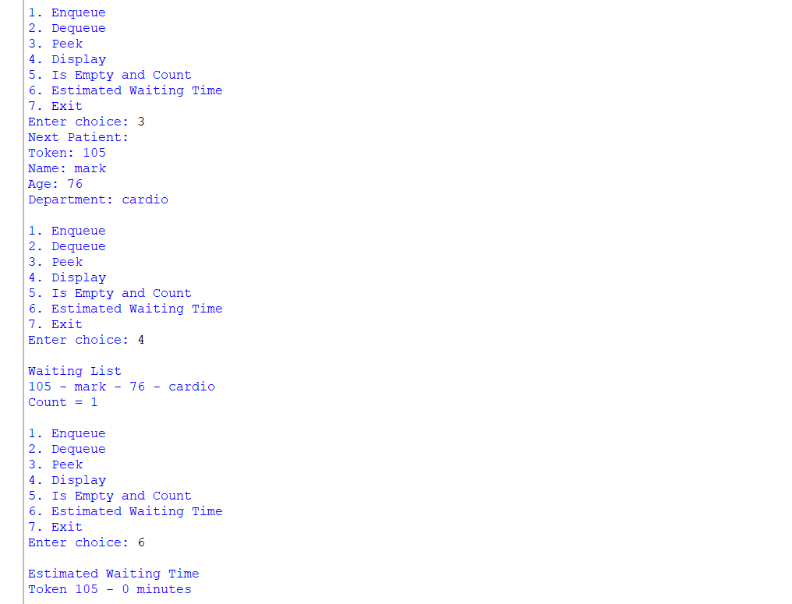 Demonstration 8 - peeking , displaying, and seeing the estimated waiting time. (showing the operations )
…………
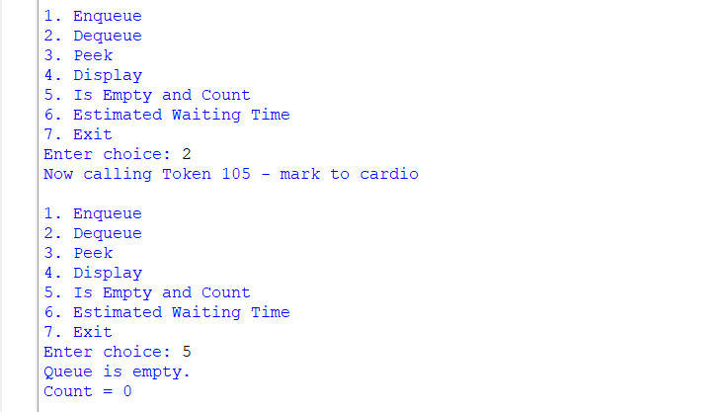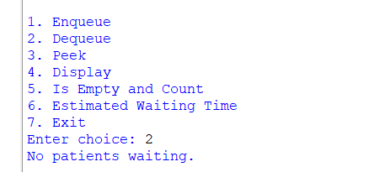
Demonstration 9 - Empty Queue After Deletion
After removing all patients, the queue became empty. The FRONT and REAR pointers were reset to None when the last patient was removed. This confirms that the single-node and empty-queue conditions were handled correctly.

………..
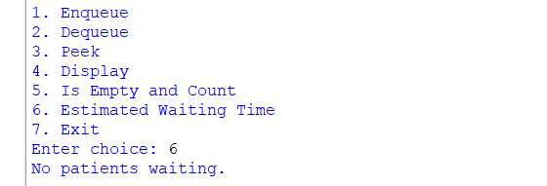
Checking the estimated waiting time while no patient remains results in – no patient waiting.
…………….
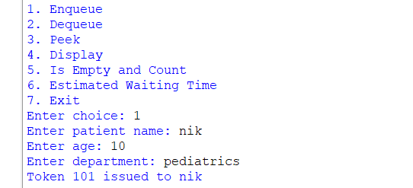
Demonstration 10 - New Patient After Emptying the Queue
After the queue became empty, Sita was registered and received Token 104. The queue worked normally again, showing that the FRONT and REAR pointers were correctly reset and reused for a new insertion.
……..

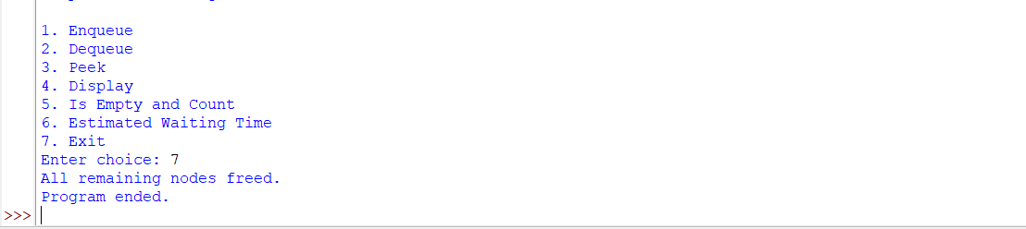exiting the program after successfully displaying /demonstrating all the operations mentioned in the activity.
Demonstration 11 - Program Exit
Finally, the Exit operation was selected. The program cleared the remaining nodes and displayed “All remaining nodes freed.” This demonstrates that the program performs proper cleanup before termination.

…………………..
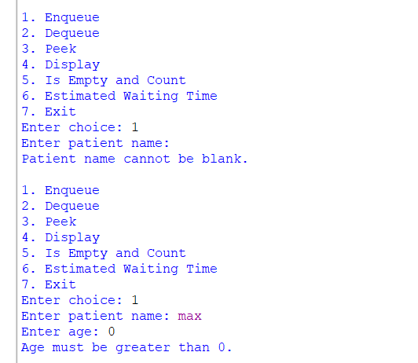
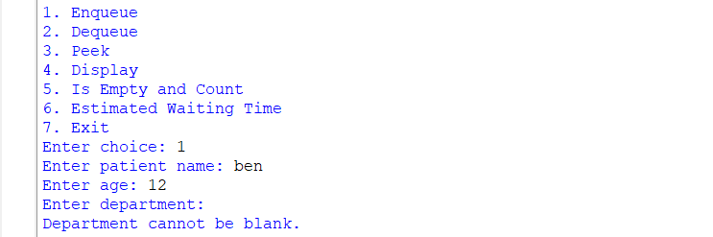
displaying invalid inputs.
……….
Extra comments - In our program, there is no fixed point where the queue becomes full.
Because we are using a singly linked list, nodes are created dynamically in memory. So, unlike an array-based queue, the queue doesn't have a fixed capacity, such as 10 or 100 patients. In our Python program, overflow would occur only if the system cannot allocate memory for a new patient node.

Boundary Conditions
The program was designed to handle important boundary and invalid-input cases so that the queue works correctly even in special situations.
Boundary Condition | Handling in the Program
Dequeue from an empty queue | Displays “No patients waiting” without attempting to remove a node.
Peek on an empty queue | Displays “No patients waiting” because there is no front patient.
First insertion | When the queue is empty, both FRONT and REAR are set to the newly created node.
Last patient dequeued | After removing the last node, FRONT becomes None and REAR is also reset to None.
Memory allocation failure | If a new node cannot be created due to insufficient memory, the program displays “Queue Overflow - memory not available.”
Blank patient name | The program rejects the input and displays “Patient name cannot be blank.”
Invalid age | Non-numeric or non-positive age values are rejected.
Invalid menu choice | The program displays “Invalid choice” and continues running.

Note: The required queue behaviour was tested during the demonstration. The memory allocation failure condition is implemented in the program, but was not intentionally triggered during testing.

Complexity Analysis
The time complexity of the main queue operations is shown below.
Operation | Time Complexity | Reason
Enqueue | O(1) | A new node is directly added using the REAR pointer.
Dequeue | O(1) | The FRONT pointer is moved to the next node.
Peek | O(1) | The front patient's information is accessed directly.
Display | O(n) | Every patient node is visited to display the queue.
Is Empty | O(1) | The program directly checks whether FRONT is None.
Count | O(n) | The linked list is traversed to count all patients.
Estimated Waiting Time | O(n) | Each patient in the queue is visited to calculate the waiting time.

Explanation
The Enqueue, Dequeue and Peek operations are efficient because the program maintains both FRONT and REAR pointers. Operations that require information about every patient, such as Display, Count and Estimated Waiting Time, require traversal of the linked list and therefore take O(n) time.

My Understanding
Through this lab, I understood how a queue follows the FIFO (First In, First Out) principle, where the patient who enters first is called first. I also understood how a singly linked list can be used to implement a queue without a fixed size.
Using FRONT and REAR pointers makes insertion and deletion efficient. The practical testing also helped me understand the importance of correctly updating these pointers, especially when the queue becomes empty. Adding the estimated waiting time feature helped me see how a basic data structure can be extended for a real-world application.
……………..
Self-Learning Feature – Estimated Waiting Time
As a self-learning extension, I implemented an Estimated Waiting Time feature in the SmartCare Hospital OPD Token System. The purpose of this feature is to give patients an approximate idea of how long they may have to wait before their consultation.
For this feature, I assumed that each patient requires approximately 7 minutes for consultation. The program calculates the estimated waiting time based on the patient's position in the queue. The first patient has a waiting time of 0 minutes, since they are next to be served. The second patient has an estimated waiting time of 7 minutes; the third, 14 minutes; and the value increases by 7 minutes for each position in the queue.
For example:
Patient Position | Estimated Waiting Time
1st | 0 minutes
2nd | 7 minutes
3rd | 14 minutes
4th | 21 minutes

This feature helped me understand how the basic FIFO queue concept can be extended to provide useful information in a real-world hospital environment. It also gave me practical experience in traversing the linked list and using the patient's position to perform a simple calculation.

Conclusion
This lab helped me understand the practical implementation of a queue using a singly linked list. I implemented the required operations such as Enqueue, Dequeue, Peek, Display, Is Empty and Count, along with input validation and boundary-condition handling.
The SmartCare Hospital OPD Token System showed how a queue can be applied to a real-world situation where patients are served according to their arrival order. I also added an estimated waiting time feature as a self-learning extension. Overall, this activity helped me connect the concepts of FIFO, linked lists, FRONT and REAR pointers, and dynamic memory allocation with a practical application.

