

Department of Computer Science

Lab Manual

of

MACHINE LEARNING

MAI412-1
Class Name: I MSAIM
MSc Artificial Intelligence and Machine Learning
2026

Prepared by: | Verified by:
Rohan Sam Reji | Dr NISHA VARGHESE
2648544

Department Overview
Department of Computer Science of CHRIST (Deemed to be University) strives to shape outstanding computer professionals with ethical and human values to reshape nation's destiny. The training imparted aims to prepare young minds for the challenging opportunities in the IT industry with a global awareness rooted in the Indian soil, nourished and supported by experts in the field.
Vision
The Department of Computer Science endeavours to imbibe the vision of the University “Excellence and Service”. The department is committed to this philosophy which pervades every aspect and functioning of the department.
Mission
“To develop IT professionals with ethical and human values”. To accomplish our mission, the department encourages students to apply their acquired knowledge and skills towards professional achievements in their career. The department also moulds the students to be socially responsible and ethically sound.
Programme Outcomes:
PO1: Disciplinary Expertise: Apply in-depth knowledge and understanding of advanced concepts in the respective discipline to innovate and solve complex scientific problems.
PO2: Critical Thinking and Problem Solving: Develop critical thinking, analytical reasoning, and problem-solving skills to address complex real-world challenges with scientific temper and objectivity.
PO3: Research Skills: Demonstrate independent research capabilities with scientific integrity and objectivity to advance scientific knowledge and technological innovation
PO4: Professional skills: Demonstrate effective science communication, sustainable technology use, and a strong commitment to professional ethics and collaborative skills to excel in academic, research, and professional roles globally.
PO5: Scientific Social Responsibility: Demonstrate awareness of environmental sustainability, cultural diversity, and inclusivity, contributing to the betterment of society.
Programme Specific Outcomes:
PSO1: Advanced Knowledge Applications: Apply advanced concepts, to design and develop intelligent systems for solving complex real-world problems.
PSO2: Critical Thinking and Optimization: Demonstrate critical thinking and analytical reasoning to provide solutions for real-world challenges.
PSO3: Research and Innovation: Conduct independent research while maintaining scientific integrity.
PSO4: Professional and Ethical Conduct: Exhibit strong ethical and professional standards ensuring fairness, accountability, and transparency to demonstrate effective communication and teamwork in academia, industry, and research settings.

PSO5: Societal and Environmental Impact: Develop sustainable solutions addressing social, economic, and environmental challenges while promoting inclusivity, cultural diversity, and responsible deployment for the benefit of society.
Programme Eligibility
• Candidates having 50% marks in any recognized university in India or Abroad recognized by UGC / AIU in any of the following UG degrees
1. Bachelor of Computer Applications
2. Bachelor degree in Science / Engineering with any of the following Computer Science / Information Technology / Computer Technology / Data Science / Mathematics with Computer Science
• Candidates writing their final year examinations March-May are eligible to apply.
Programme Objective
This programme is conceptualised and designed based on the strong commitment of the department to provide better quality education to the students. The principal objectives of this course are to:
• Heighten technological awareness
• Train future industry specialists
• Encourage effective software development
• Provide research training
• Involve students in innovative research
• Produce graduates with a two-year professional education in Computer Science with technical, professional, and communications skills.
Ethics and Human Values
1. Only proprietary or open-source software would be used for academic teaching and learning purposes.
2. Copying of programs from the internet, friends or from other sources is strictly discouraged since it impairs development of programming skills.
3. Unique Practical (Domain based) exercises ensure that the students don't get involved in code plagiarism.
4. Projects undertaken by students during the course are done in teams to improve collaborative work and synergy between team members.
5. Projects involve modularization which initiates students to take individual responsibility for common goals.
6. Passion for excellence is promoted among the students, be it in software development or project documentation.
7. Giving due credit to sources during the seminar and research assignment is promoted among the students
8. The course and its design enforce the practice of good referencing technique to improve the sense of integrity.

9. Courses involving group discussions and debates on ethical practices and human values are designed to sensitize the students in dealing with customers and members within the Organization.

Course Plan Discussion & Evaluation pattern, Introduction to ML
UNIT I - INTRODUCTION TO DATA PREPROCESSING
Getting to know your data: Data Objects and Attribute Types, Measuring Data Similarity and Dissimilarity – Data Pre-processing
INTRODUCTION TO MACHINE LEARNING
Origins of Machine Learning – Basic learning process – Machine Learning in Practice- Types of Machine Learning Algorithm
UNIT II
RULE-BASED MACHINE LEARNING
Mining Frequent Patterns, Associations and Correlations - Basic Concepts - Frequent Itemset Mining Methods – Pattern Evaluation Methods
UNIT III
ADVANCED PATTERN MINING
Pattern Mining – Pattern Mining in Multilevel, Multidimensional space – Constraint-based Frequent Pattern Mining, Mining High-Dimensional Data and Colossal Patterns
UNIT IV
SUPERVISED LEARNING I
Classification – Basic Concepts – Decision Tree Induction Bayes Classification Methods – Rule-Based Classification. Model Evaluation and Selection – Techniques to improve Classification Accuracy.
UNIT V
SUPERVISED LEARNING II
Bayesian Belief Networks – Support Vector Machines, Classification using Frequent Patterns – Lazy Learners

LIST OF PROGRAMS
MSCAIML
Sl.  no | Title of lab Experiment | Page  number | RBT | CO
1 | Data Exploration for identifying different datasets |  | L3 | CO1
2 | Preprocessing the dataset using normalization techniques |  | L3 | CO1
3 | Identify frequent itemsets using the Apriori Algorithm |  | L3 | CO2
4 | Generate FP Tree for a transaction dataset |  | L3 | CO2
5 | Explore generating multilevel association rules |  | L3 | CO3
6 | Explore multi-dimensional associations |  | L3 | CO3
7 | Demonstrate the Naïve Bayes classifier |  | L4 | CO4
8 | Construct a Decision Tree for a dataset and identify the order of attributes. |  | L3 | CO4
9 | Explore SVM Classifier |  | L3 | CO5
10 | Demonstrate Lazy Learner |  | L5 | CO5

Program Evaluation Rubrics
Completion | 3 Marks
Concept Clarity | 3 Marks
Interpretation | 2 Marks
Timely Submission | 2 Marks

General Instructions
1. The file you have to save with your name, last 3 digits of register number and program number “Aaron_101_Lab1”.
2. The implemented code you have to download and upload in the Google Class room in the given scheduled time.

Lab 1

Exploratory Data Analysis (EDA) of a Domain-Specific Dataset
Aim: To perform Exploratory Data Analysis on a domain-specific dataset (Patient Length of Stay) in order to understand its structure, quality, feature types and the relationships between variables, and to summarise the key insights that can guide further Machine Learning tasks.

Procedure and Implementation
Lab Exercise 1: Exploratory Data Analysis (EDA)
Dataset: Patient Length of Stay Prediction
This notebook is designed to satisfy all requirements mentioned in the lab sheet:
Part A: Dataset Understanding
- Domain identification
- Number of records and attributes
- Feature types
- Target variable
- Dataset significance
Part B: Data Quality Assessment
- Missing values
- Duplicate records
- Invalid/inconsistent values
- Data reliability
Part C: Feature Analysis
- Feature categorization
- Correlation analysis
- Feature importance
- Redundant features
- Feature engineering suggestions
Part D: Insight Generation
- Trends and patterns
- Relationships among variables
- Business/domain implications
- ML recommendations
# Install packages if needed
# !pip install pandas numpy matplotlib seaborn scikit-learn

import pandas as pd
import numpy as np
import matplotlib.pyplot as plt
import seaborn as sns

plt.rcParams['figure.figsize'] = (10,6)
sns.set_style('whitegrid')

Upload Dataset
from google.colab import files
import io # Import io module for in-memory file handling

uploaded = files.upload()

filename = list(uploaded.keys())[0]
# Read the content directly from the uploaded bytes object using io.StringIO
# This ensures correct parsing bypassing potential path issues or re-encoding.
df = pd.read_csv(io.StringIO(uploaded[filename].decode('utf-8')), sep=',')

df.head()
Saving LengthOfStay[1].csv to LengthOfStay[1] (2).csv
eid vdate rcount gender dialysisrenalendstage asthma irondef \
0 1 8/29/2012 0 F 0 0 0
1 2 5/26/2012 5+ F 0 0 0
2 3 9/22/2012 1 F 0 0 0
3 4 8/9/2012 0 F 0 0 0
4 5 12/20/2012 0 F 0 0 0

pneum substancedependence psychologicaldisordermajor ... glucose \
0 0 0 0 ... 192.476918
1 0 0 0 ... 94.078507
2 0 0 0 ... 130.530524
3 0 0 0 ... 163.377028
4 1 0 1 ... 94.886654

bloodureanitro creatinine bmi pulse respiration \
0 12.0 1.390722 30.432418 96 6.5
1 8.0 0.943164 28.460516 61 6.5
2 12.0 1.065750 28.843812 64 6.5
3 12.0 0.906862 27.959007 76 6.5
4 11.5 1.242854 30.258927 67 5.6

secondarydiagnosisnonicd9 discharged facid lengthofstay
0 4 9/1/2012 B 3
1 1 6/2/2012 A 7
2 2 9/25/2012 B 3
3 1 8/10/2012 A 1
4 2 12/24/2012 E 4

[5 rows x 28 columns]

Part A - Dataset Understanding
print("Shape:", df.shape)
print("\nColumns:")
print(df.columns.tolist())

print("\nData Types:")
print(df.dtypes)
Shape: (100000, 28)

Columns:
['eid', 'vdate', 'rcount', 'gender', 'dialysisrenalendstage', 'asthma', 'irondef', 'pneum', 'substancedependence', 'psychologicaldisordermajor', 'depress', 'psychother', 'fibrosisandother', 'malnutrition', 'hemo', 'hematocrit', 'neutrophils', 'sodium', 'glucose', 'bloodureanitro', 'creatinine', 'bmi', 'pulse', 'respiration', 'secondarydiagnosisnonicd9', 'discharged', 'facid', 'lengthofstay']

Data Types:
eid int64
vdate object
rcount object
gender object
dialysisrenalendstage int64
asthma int64
irondef int64
pneum int64
substancedependence int64
psychologicaldisordermajor int64
depress int64
psychother int64
fibrosisandother int64
malnutrition int64
hemo int64
hematocrit float64
neutrophils float64
sodium float64
glucose float64
bloodureanitro float64
creatinine float64
bmi float64
pulse int64
respiration float64
secondarydiagnosisnonicd9 int64
discharged object
facid object
lengthofstay int64
dtype: object

# Target variable
target = 'lengthofstay'
print("Target Variable:", target)
Target Variable: lengthofstay

Domain
Healthcare / Hospital Management
Dataset Purpose
Predict patient hospital stay duration (Length of Stay) using patient demographics,
medical conditions, laboratory measurements, and admission-related information.
Part B - Data Quality Assessment
# Missing Values
missing = df.isnull().sum()
missing[missing > 0].sort_values(ascending=False)
Series([], dtype: int64)

# Duplicate Records
duplicates = df.duplicated().sum()
print("Duplicate Records:", duplicates)
Duplicate Records: 0

# Summary Statistics
df.describe(include='all')
eid vdate rcount gender dialysisrenalendstage \
count 100000.000000 100000 100000 100000 100000.000000
unique NaN 367 6 2 NaN
top NaN 10/3/2012 0 F NaN
freq NaN 333 55031 57643 NaN
mean 50000.500000 NaN NaN NaN 0.036420
std 28867.657797 NaN NaN NaN 0.187334
min 1.000000 NaN NaN NaN 0.000000
25% 25000.750000 NaN NaN NaN 0.000000
50% 50000.500000 NaN NaN NaN 0.000000
75% 75000.250000 NaN NaN NaN 0.000000
max 100000.000000 NaN NaN NaN 1.000000

asthma irondef pneum substancedependence \
count 100000.000000 100000.000000 100000.000000 100000.000000
unique NaN NaN NaN NaN
top NaN NaN NaN NaN
freq NaN NaN NaN NaN
mean 0.035270 0.094940 0.039450 0.063060
std 0.184462 0.293134 0.194664 0.243072
min 0.000000 0.000000 0.000000 0.000000
25% 0.000000 0.000000 0.000000 0.000000
50% 0.000000 0.000000 0.000000 0.000000
75% 0.000000 0.000000 0.000000 0.000000
max 1.000000 1.000000 1.000000 1.000000

psychologicaldisordermajor ... glucose bloodureanitro \
count 100000.000000 ... 100000.000000 100000.000000
unique NaN ... NaN NaN
top NaN ... NaN NaN
freq NaN ... NaN NaN
mean 0.239040 ... 141.963384 14.097185
std 0.426499 ... 29.992996 12.952454
min 0.000000 ... -1.005927 1.000000
25% 0.000000 ... 121.682383 11.000000
50% 0.000000 ... 142.088545 12.000000
75% 0.000000 ... 162.180996 14.000000
max 1.000000 ... 271.444277 682.500000

creatinine bmi pulse respiration \
count 100000.000000 100000.000000 100000.000000 100000.000000
unique NaN NaN NaN NaN
top NaN NaN NaN NaN
freq NaN NaN NaN NaN
mean 1.099350 29.805759 73.444720 6.493768
std 0.200262 2.003769 11.644555 0.568473
min 0.219770 21.992683 21.000000 0.200000
25% 0.964720 28.454235 66.000000 6.500000
50% 1.098764 29.807516 73.000000 6.500000
75% 1.234867 31.156885 81.000000 6.500000
max 2.035202 38.935293 130.000000 10.000000

secondarydiagnosisnonicd9 discharged facid lengthofstay
count 100000.000000 100000 100000 100000.00000
unique NaN 378 5 NaN
top NaN 2/16/2012 E NaN
freq NaN 316 30755 NaN
mean 2.123310 NaN NaN 4.00103
std 2.050641 NaN NaN 2.36031
min 0.000000 NaN NaN 1.00000
25% 1.000000 NaN NaN 2.00000
50% 1.000000 NaN NaN 4.00000
75% 3.000000 NaN NaN 6.00000
max 10.000000 NaN NaN 17.00000

[11 rows x 28 columns]

# Check invalid values in binary columns
binary_cols = [col for col in df.columns if df[col].nunique() <= 2]

for col in binary_cols:
print(col, sorted(df[col].dropna().unique()))
gender ['F', 'M']
dialysisrenalendstage [np.int64(0), np.int64(1)]
asthma [np.int64(0), np.int64(1)]
irondef [np.int64(0), np.int64(1)]
pneum [np.int64(0), np.int64(1)]
substancedependence [np.int64(0), np.int64(1)]
psychologicaldisordermajor [np.int64(0), np.int64(1)]
depress [np.int64(0), np.int64(1)]
psychother [np.int64(0), np.int64(1)]
fibrosisandother [np.int64(0), np.int64(1)]
malnutrition [np.int64(0), np.int64(1)]
hemo [np.int64(0), np.int64(1)]

Suggested Data Cleaning
- Remove duplicate records.
- Handle missing values using median/mode imputation.
- Convert date columns to datetime.
- Validate binary columns (0/1).
- Standardize categorical values.
Part C - Feature Analysis
# Identify columns that should be numeric (excluding date and problematic string columns)
numeric_cols_to_convert = [
'eid', 'dialysisrenalendstage', 'asthma', 'irondef', 'pneum',
'substancedependence', 'psychologicaldisordermajor', 'depress', 'psychother',
'fibrosisandother', 'malnutrition', 'hemo', 'hematocrit', 'neutrophils',
'sodium', 'glucose', 'bloodureanitro', 'creatinine', 'bmi', 'pulse',
'respiration', 'secondarydiagnosisnonicd9', 'lengthofstay'
]

# Convert problematic 'rcount' column: replace '5+' with 5, then convert to numeric
df['rcount'] = df['rcount'].astype(str).str.replace('+', '', regex=False).replace('', np.nan)
df['rcount'] = pd.to_numeric(df['rcount'], errors='coerce')

# Convert other identified columns to numeric, coercing errors
for col in numeric_cols_to_convert:
if col in df.columns:
df[col] = pd.to_numeric(df[col], errors='coerce')

# Separate numeric columns (now that types are correct)
numeric_df = df.select_dtypes(include=np.number)

numeric_df.head()
eid rcount dialysisrenalendstage asthma irondef pneum \
0 1 0 0 0 0 0
1 2 5 0 0 0 0
2 3 1 0 0 0 0
3 4 0 0 0 0 0
4 5 0 0 0 0 1

substancedependence psychologicaldisordermajor depress psychother ... \
0 0 0 0 0 ...
1 0 0 0 0 ...
2 0 0 0 0 ...
3 0 0 0 0 ...
4 0 1 0 0 ...

neutrophils sodium glucose bloodureanitro creatinine bmi \
0 14.20 140.361132 192.476918 12.0 1.390722 30.432418
1 4.10 136.731692 94.078507 8.0 0.943164 28.460516
2 8.90 133.058514 130.530524 12.0 1.065750 28.843812
3 9.40 138.994023 163.377028 12.0 0.906862 27.959007
4 9.05 138.634836 94.886654 11.5 1.242854 30.258927

pulse respiration secondarydiagnosisnonicd9 lengthofstay
0 96 6.5 4 3
1 61 6.5 1 7
2 64 6.5 2 3
3 76 6.5 1 1
4 67 5.6 2 4

[5 rows x 24 columns]

# Correlation with target
corr_target = numeric_df.corr()[target].sort_values(ascending=False)
corr_target
lengthofstay 1.000000
rcount 0.749514
psychologicaldisordermajor 0.286724
hemo 0.217696
irondef 0.193838
psychother 0.191695
malnutrition 0.174397
dialysisrenalendstage 0.169695
bloodureanitro 0.148290
substancedependence 0.147886
pneum 0.135461
depress 0.121408
asthma 0.082005
fibrosisandother 0.062131
pulse 0.006683
secondarydiagnosisnonicd9 0.006540
eid 0.001543
bmi 0.000132
glucose -0.003447
sodium -0.003546
creatinine -0.004026
neutrophils -0.010658
respiration -0.022291
hematocrit -0.064016
Name: lengthofstay, dtype: float64

# Correlation Heatmap
plt.figure(figsize=(14,10))
sns.heatmap(numeric_df.corr(), cmap='coolwarm')
plt.title('Correlation Heatmap')
plt.show()
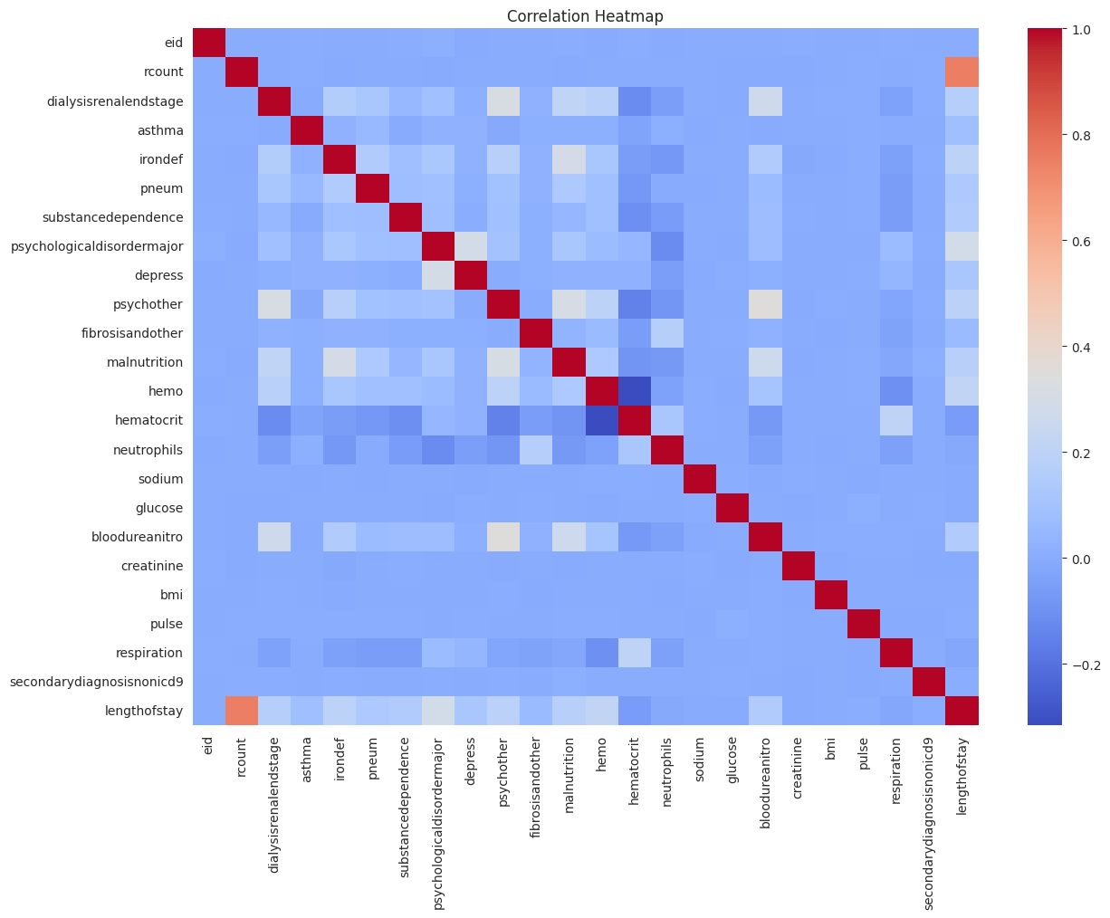

# Target Distribution
sns.histplot(df[target], bins=10, kde=True)
plt.title('Length of Stay Distribution')
plt.show()
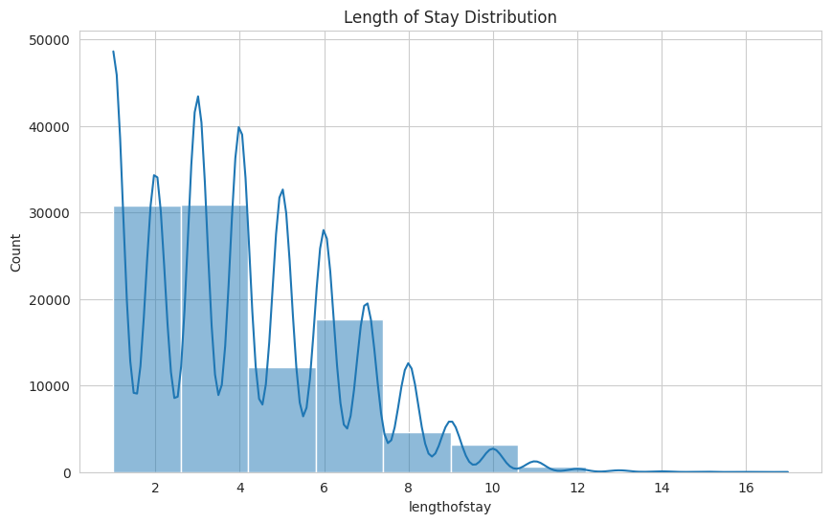

# Numerical Feature Distributions
numeric_df.hist(figsize=(16,14))
plt.tight_layout()
plt.show()
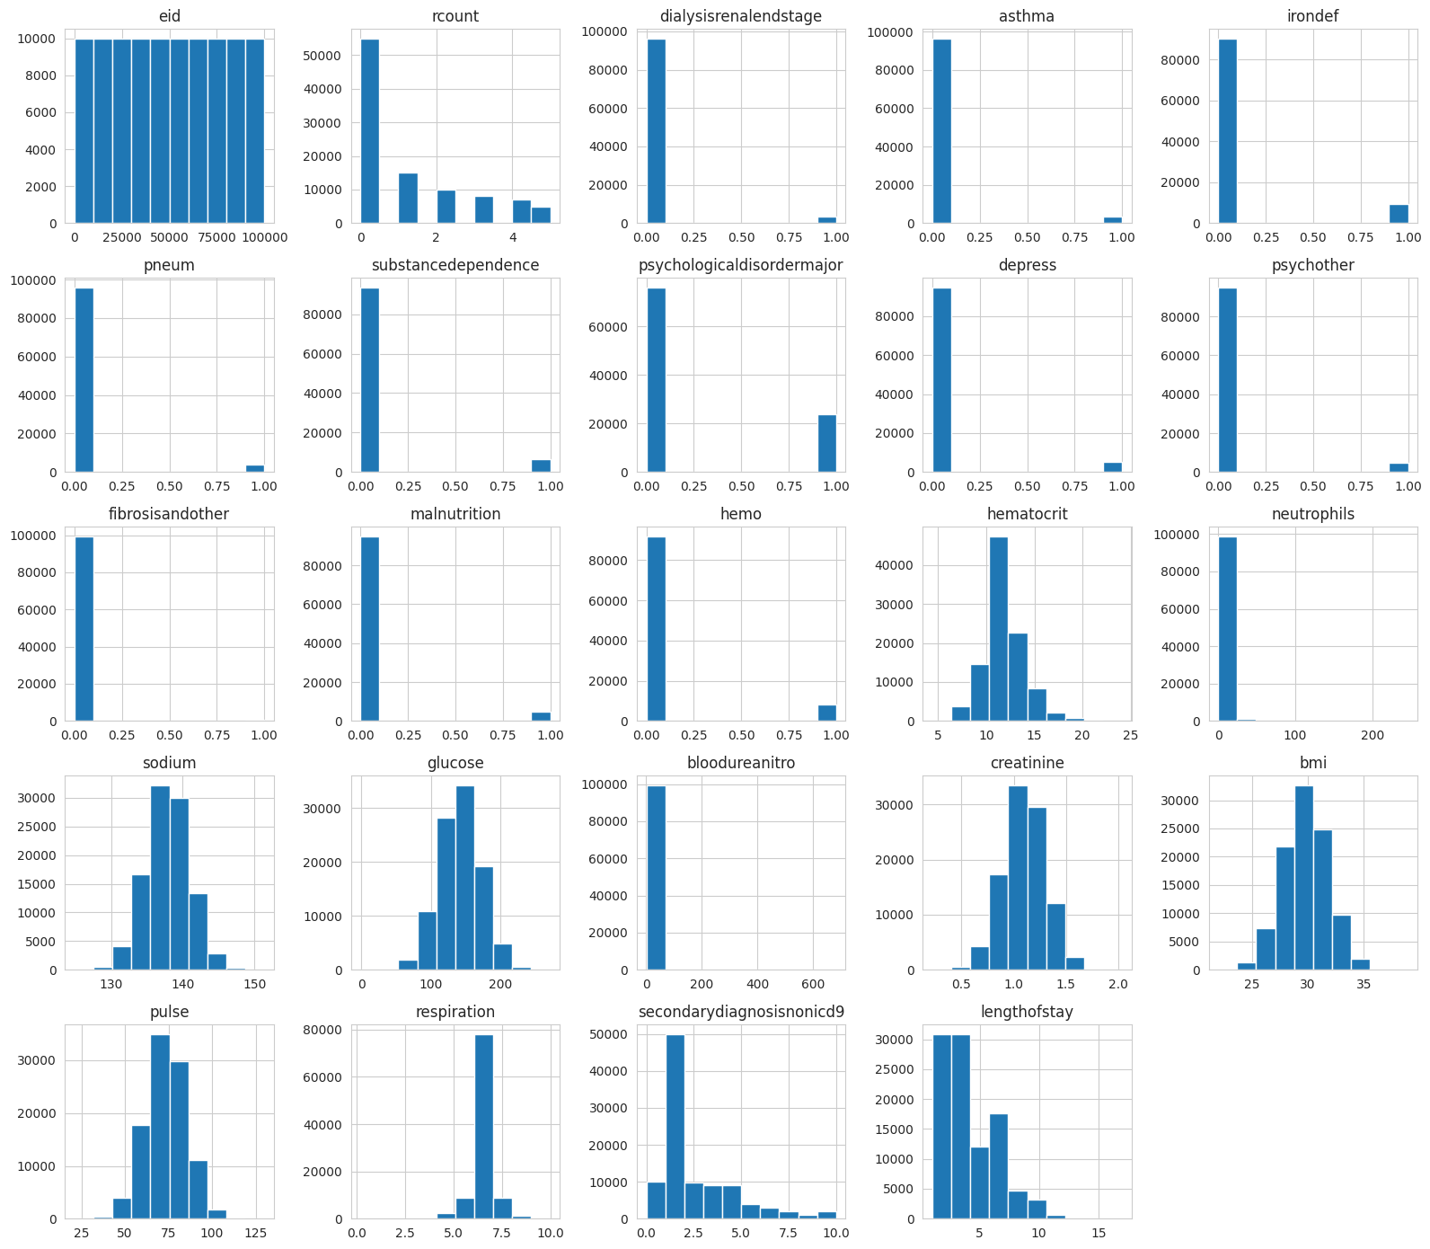

# Feature Importance using Random Forest
from sklearn.ensemble import RandomForestRegressor
from sklearn.preprocessing import LabelEncoder

data = df.copy()

for col in data.select_dtypes(include='object').columns:
data[col] = LabelEncoder().fit_transform(data[col].astype(str))

X = data.drop(columns=[target])
y = data[target]

model = RandomForestRegressor(random_state=42)
model.fit(X, y)

importance = pd.DataFrame({
'Feature': X.columns,
'Importance': model.feature_importances_
}).sort_values('Importance', ascending=False)

importance.head(15)
Feature Importance
2 rcount 0.564830
26 facid 0.151887
15 hematocrit 0.044455
23 respiration 0.028308
21 bmi 0.025465
20 creatinine 0.024935
18 glucose 0.024581
17 sodium 0.024073
22 pulse 0.022685
14 hemo 0.021484
19 bloodureanitro 0.017417
16 neutrophils 0.014088
9 psychologicaldisordermajor 0.006065
0 eid 0.004904
4 dialysisrenalendstage 0.004142

# Top Features Plot
top15 = importance.head(15)

sns.barplot(data=top15, x='Importance', y='Feature')
plt.title('Top 15 Important Features')
plt.show()
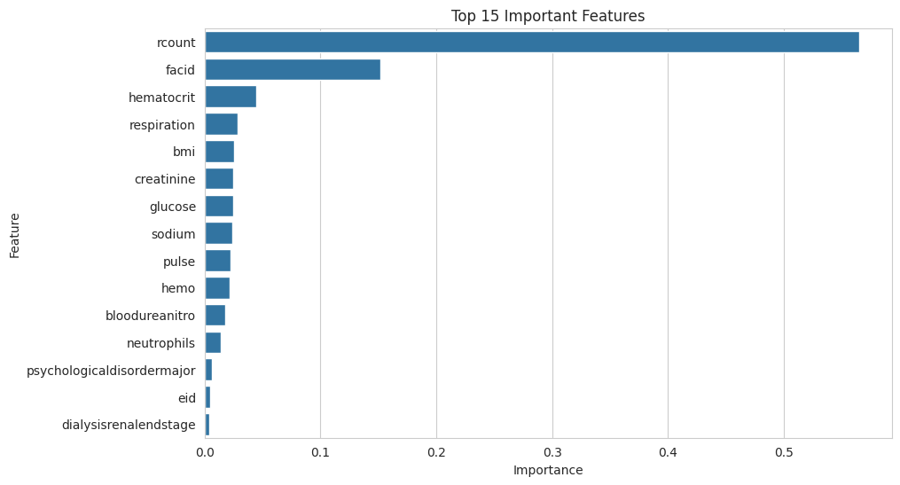

Feature Categorization
Numerical Features
- hemo
- hematocrit
- neutrophils
- sodium
- glucose
- bloodureanitro
- creatinine
- bmi
- pulse
- respiration
- lengthofstay
Categorical Features
- gender
- rcount
- facid
Binary Features
- dialysisrenalendstage
- asthma
- irondef
- pneum
- substancedependence
- psychologicaldisordermajor
- depress
- psychother
- fibrosisandother
- malnutrition
Date Features
- vdate
- discharged
Part D - Insight Generation
print('Average Length of Stay:', round(df['lengthofstay'].mean(),2))
print('Median Length of Stay:', round(df['lengthofstay'].median(),2))
Average Length of Stay: 4.0
Median Length of Stay: 4.0

Report Template
#### Key Findings
1. Dataset belongs to healthcare/hospital management.
2. Target variable is Length of Stay.
3. Laboratory measurements and diagnosis-related variables influence LOS.
4. Correlation and feature importance identify influential predictors.
5. Data quality assessment highlights missing values and duplicates.
#### Trends and Patterns
- Longer stays may be associated with severe conditions.
- Certain laboratory values may correlate with LOS.
- Readmission count and comorbidities may affect hospitalization duration.
#### Domain Implications
- Better resource allocation.
- Bed occupancy forecasting.
- Early risk identification.
- Improved discharge planning.
#### Recommended ML Tasks
1. Length of Stay Prediction (Regression)
2. Stay Category Prediction (Classification)
3. Readmission Risk Prediction
4. Patient Risk Stratification

Inference: The Length of Stay dataset contains 100,000 hospital admission records across 28 attributes, with no missing values and no duplicate records, indicating a clean and reliable dataset. The correlation heatmap and feature importance analysis (Random Forest) show that readmission count (rcount), facility ID and a few clinical measurements such as hematocrit, respiration and BMI have the strongest influence on the length of stay. Most binary comorbidity flags (asthma, dialysis, substance dependence, etc.) have a weaker but still positive relationship with the target. The distribution of the target variable is fairly symmetric around a mean and median of 4 days.

Conclusion: This experiment successfully demonstrated Exploratory Data Analysis on a healthcare dataset. Dataset understanding, data quality assessment, feature categorisation and correlation/feature-importance analysis were carried out, and the insights generated (key predictors of Length of Stay, absence of missing/duplicate data, and feature types) confirm that the dataset is well suited for building regression or classification models to predict patient length of stay.

Lab 2

Preprocessing the Dataset using Normalization Techniques
Aim: To preprocess the Patient Length of Stay dataset by handling missing values and duplicates, and to apply Min-Max and Z-Score normalization on the numerical clinical features, comparing their effect on the data distribution.

Procedure and Implementation
Lab Exercise 1: Exploratory Data Analysis (EDA)
Dataset: Patient Length of Stay Prediction
This notebook is designed to satisfy all requirements mentioned in the lab sheet:
Part A: Dataset Understanding
- Domain identification
- Number of records and attributes
- Feature types
- Target variable
- Dataset significance
Part B: Data Quality Assessment
- Missing values
- Duplicate records
- Invalid/inconsistent values
- Data reliability
Part C: Feature Analysis
- Feature categorization
- Correlation analysis
- Feature importance
- Redundant features
- Feature engineering suggestions
Part D: Insight Generation
- Trends and patterns
- Relationships among variables
- Business/domain implications
- ML recommendations
# Install packages if needed
# !pip install pandas numpy matplotlib seaborn scikit-learn

import pandas as pd
import numpy as np
import matplotlib.pyplot as plt
import seaborn as sns

plt.rcParams['figure.figsize'] = (10,6)
sns.set_style('whitegrid')

Upload Dataset
from google.colab import files
import io # Import io module for in-memory file handling

uploaded = files.upload()

filename = list(uploaded.keys())[0]
# Read the content directly from the uploaded bytes object using io.StringIO
# This ensures correct parsing bypassing potential path issues or re-encoding.
df = pd.read_csv(io.StringIO(uploaded[filename].decode('utf-8')), sep=',')

df.head()
Saving LengthOfStay[1].csv to LengthOfStay[1] (2).csv
eid vdate rcount gender dialysisrenalendstage asthma irondef \
0 1 8/29/2012 0 F 0 0 0
1 2 5/26/2012 5+ F 0 0 0
2 3 9/22/2012 1 F 0 0 0
3 4 8/9/2012 0 F 0 0 0
4 5 12/20/2012 0 F 0 0 0

pneum substancedependence psychologicaldisordermajor ... glucose \
0 0 0 0 ... 192.476918
1 0 0 0 ... 94.078507
2 0 0 0 ... 130.530524
3 0 0 0 ... 163.377028
4 1 0 1 ... 94.886654

bloodureanitro creatinine bmi pulse respiration \
0 12.0 1.390722 30.432418 96 6.5
1 8.0 0.943164 28.460516 61 6.5
2 12.0 1.065750 28.843812 64 6.5
3 12.0 0.906862 27.959007 76 6.5
4 11.5 1.242854 30.258927 67 5.6

secondarydiagnosisnonicd9 discharged facid lengthofstay
0 4 9/1/2012 B 3
1 1 6/2/2012 A 7
2 2 9/25/2012 B 3
3 1 8/10/2012 A 1
4 2 12/24/2012 E 4

[5 rows x 28 columns]

Part A - Dataset Understanding
print("Shape:", df.shape)
print("\nColumns:")
print(df.columns.tolist())

print("\nData Types:")
print(df.dtypes)
Shape: (100000, 28)

Columns:
['eid', 'vdate', 'rcount', 'gender', 'dialysisrenalendstage', 'asthma', 'irondef', 'pneum', 'substancedependence', 'psychologicaldisordermajor', 'depress', 'psychother', 'fibrosisandother', 'malnutrition', 'hemo', 'hematocrit', 'neutrophils', 'sodium', 'glucose', 'bloodureanitro', 'creatinine', 'bmi', 'pulse', 'respiration', 'secondarydiagnosisnonicd9', 'discharged', 'facid', 'lengthofstay']

Data Types:
eid int64
vdate object
rcount object
gender object
dialysisrenalendstage int64
asthma int64
irondef int64
pneum int64
substancedependence int64
psychologicaldisordermajor int64
depress int64
psychother int64
fibrosisandother int64
malnutrition int64
hemo int64
hematocrit float64
neutrophils float64
sodium float64
glucose float64
bloodureanitro float64
creatinine float64
bmi float64
pulse int64
respiration float64
secondarydiagnosisnonicd9 int64
discharged object
facid object
lengthofstay int64
dtype: object

# Target variable
target = 'lengthofstay'
print("Target Variable:", target)
Target Variable: lengthofstay

Domain
Healthcare / Hospital Management
Dataset Purpose
Predict patient hospital stay duration (Length of Stay) using patient demographics,
medical conditions, laboratory measurements, and admission-related information.
Part B - Data Quality Assessment
# Missing Values
missing = df.isnull().sum()
missing[missing > 0].sort_values(ascending=False)
Series([], dtype: int64)

# Duplicate Records
duplicates = df.duplicated().sum()
print("Duplicate Records:", duplicates)
Duplicate Records: 0

# Summary Statistics
df.describe(include='all')
eid vdate rcount gender dialysisrenalendstage \
count 100000.000000 100000 100000 100000 100000.000000
unique NaN 367 6 2 NaN
top NaN 10/3/2012 0 F NaN
freq NaN 333 55031 57643 NaN
mean 50000.500000 NaN NaN NaN 0.036420
std 28867.657797 NaN NaN NaN 0.187334
min 1.000000 NaN NaN NaN 0.000000
25% 25000.750000 NaN NaN NaN 0.000000
50% 50000.500000 NaN NaN NaN 0.000000
75% 75000.250000 NaN NaN NaN 0.000000
max 100000.000000 NaN NaN NaN 1.000000

asthma irondef pneum substancedependence \
count 100000.000000 100000.000000 100000.000000 100000.000000
unique NaN NaN NaN NaN
top NaN NaN NaN NaN
freq NaN NaN NaN NaN
mean 0.035270 0.094940 0.039450 0.063060
std 0.184462 0.293134 0.194664 0.243072
min 0.000000 0.000000 0.000000 0.000000
25% 0.000000 0.000000 0.000000 0.000000
50% 0.000000 0.000000 0.000000 0.000000
75% 0.000000 0.000000 0.000000 0.000000
max 1.000000 1.000000 1.000000 1.000000

psychologicaldisordermajor ... glucose bloodureanitro \
count 100000.000000 ... 100000.000000 100000.000000
unique NaN ... NaN NaN
top NaN ... NaN NaN
freq NaN ... NaN NaN
mean 0.239040 ... 141.963384 14.097185
std 0.426499 ... 29.992996 12.952454
min 0.000000 ... -1.005927 1.000000
25% 0.000000 ... 121.682383 11.000000
50% 0.000000 ... 142.088545 12.000000
75% 0.000000 ... 162.180996 14.000000
max 1.000000 ... 271.444277 682.500000

creatinine bmi pulse respiration \
count 100000.000000 100000.000000 100000.000000 100000.000000
unique NaN NaN NaN NaN
top NaN NaN NaN NaN
freq NaN NaN NaN NaN
mean 1.099350 29.805759 73.444720 6.493768
std 0.200262 2.003769 11.644555 0.568473
min 0.219770 21.992683 21.000000 0.200000
25% 0.964720 28.454235 66.000000 6.500000
50% 1.098764 29.807516 73.000000 6.500000
75% 1.234867 31.156885 81.000000 6.500000
max 2.035202 38.935293 130.000000 10.000000

secondarydiagnosisnonicd9 discharged facid lengthofstay
count 100000.000000 100000 100000 100000.00000
unique NaN 378 5 NaN
top NaN 2/16/2012 E NaN
freq NaN 316 30755 NaN
mean 2.123310 NaN NaN 4.00103
std 2.050641 NaN NaN 2.36031
min 0.000000 NaN NaN 1.00000
25% 1.000000 NaN NaN 2.00000
50% 1.000000 NaN NaN 4.00000
75% 3.000000 NaN NaN 6.00000
max 10.000000 NaN NaN 17.00000

[11 rows x 28 columns]

# Check invalid values in binary columns
binary_cols = [col for col in df.columns if df[col].nunique() <= 2]

for col in binary_cols:
print(col, sorted(df[col].dropna().unique()))
gender ['F', 'M']
dialysisrenalendstage [np.int64(0), np.int64(1)]
asthma [np.int64(0), np.int64(1)]
irondef [np.int64(0), np.int64(1)]
pneum [np.int64(0), np.int64(1)]
substancedependence [np.int64(0), np.int64(1)]
psychologicaldisordermajor [np.int64(0), np.int64(1)]
depress [np.int64(0), np.int64(1)]
psychother [np.int64(0), np.int64(1)]
fibrosisandother [np.int64(0), np.int64(1)]
malnutrition [np.int64(0), np.int64(1)]
hemo [np.int64(0), np.int64(1)]

Suggested Data Cleaning
- Remove duplicate records.
- Handle missing values using median/mode imputation.
- Convert date columns to datetime.
- Validate binary columns (0/1).
- Standardize categorical values.
Part C - Feature Analysis
# Identify columns that should be numeric (excluding date and problematic string columns)
numeric_cols_to_convert = [
'eid', 'dialysisrenalendstage', 'asthma', 'irondef', 'pneum',
'substancedependence', 'psychologicaldisordermajor', 'depress', 'psychother',
'fibrosisandother', 'malnutrition', 'hemo', 'hematocrit', 'neutrophils',
'sodium', 'glucose', 'bloodureanitro', 'creatinine', 'bmi', 'pulse',
'respiration', 'secondarydiagnosisnonicd9', 'lengthofstay'
]

# Convert problematic 'rcount' column: replace '5+' with 5, then convert to numeric
df['rcount'] = df['rcount'].astype(str).str.replace('+', '', regex=False).replace('', np.nan)
df['rcount'] = pd.to_numeric(df['rcount'], errors='coerce')

# Convert other identified columns to numeric, coercing errors
for col in numeric_cols_to_convert:
if col in df.columns:
df[col] = pd.to_numeric(df[col], errors='coerce')

# Separate numeric columns (now that types are correct)
numeric_df = df.select_dtypes(include=np.number)

numeric_df.head()
eid rcount dialysisrenalendstage asthma irondef pneum \
0 1 0 0 0 0 0
1 2 5 0 0 0 0
2 3 1 0 0 0 0
3 4 0 0 0 0 0
4 5 0 0 0 0 1

substancedependence psychologicaldisordermajor depress psychother ... \
0 0 0 0 0 ...
1 0 0 0 0 ...
2 0 0 0 0 ...
3 0 0 0 0 ...
4 0 1 0 0 ...

neutrophils sodium glucose bloodureanitro creatinine bmi \
0 14.20 140.361132 192.476918 12.0 1.390722 30.432418
1 4.10 136.731692 94.078507 8.0 0.943164 28.460516
2 8.90 133.058514 130.530524 12.0 1.065750 28.843812
3 9.40 138.994023 163.377028 12.0 0.906862 27.959007
4 9.05 138.634836 94.886654 11.5 1.242854 30.258927

pulse respiration secondarydiagnosisnonicd9 lengthofstay
0 96 6.5 4 3
1 61 6.5 1 7
2 64 6.5 2 3
3 76 6.5 1 1
4 67 5.6 2 4

[5 rows x 24 columns]

# Correlation with target
corr_target = numeric_df.corr()[target].sort_values(ascending=False)
corr_target
lengthofstay 1.000000
rcount 0.749514
psychologicaldisordermajor 0.286724
hemo 0.217696
irondef 0.193838
psychother 0.191695
malnutrition 0.174397
dialysisrenalendstage 0.169695
bloodureanitro 0.148290
substancedependence 0.147886
pneum 0.135461
depress 0.121408
asthma 0.082005
fibrosisandother 0.062131
pulse 0.006683
secondarydiagnosisnonicd9 0.006540
eid 0.001543
bmi 0.000132
glucose -0.003447
sodium -0.003546
creatinine -0.004026
neutrophils -0.010658
respiration -0.022291
hematocrit -0.064016
Name: lengthofstay, dtype: float64

# Correlation Heatmap
plt.figure(figsize=(14,10))
sns.heatmap(numeric_df.corr(), cmap='coolwarm')
plt.title('Correlation Heatmap')
plt.show()

# Target Distribution
sns.histplot(df[target], bins=10, kde=True)
plt.title('Length of Stay Distribution')
plt.show()

# Numerical Feature Distributions
numeric_df.hist(figsize=(16,14))
plt.tight_layout()
plt.show()

# Feature Importance using Random Forest
from sklearn.ensemble import RandomForestRegressor
from sklearn.preprocessing import LabelEncoder

data = df.copy()

for col in data.select_dtypes(include='object').columns:
data[col] = LabelEncoder().fit_transform(data[col].astype(str))

X = data.drop(columns=[target])
y = data[target]

model = RandomForestRegressor(random_state=42)
model.fit(X, y)

importance = pd.DataFrame({
'Feature': X.columns,
'Importance': model.feature_importances_
}).sort_values('Importance', ascending=False)

importance.head(15)
Feature Importance
2 rcount 0.564830
26 facid 0.151887
15 hematocrit 0.044455
23 respiration 0.028308
21 bmi 0.025465
20 creatinine 0.024935
18 glucose 0.024581
17 sodium 0.024073
22 pulse 0.022685
14 hemo 0.021484
19 bloodureanitro 0.017417
16 neutrophils 0.014088
9 psychologicaldisordermajor 0.006065
0 eid 0.004904
4 dialysisrenalendstage 0.004142

# Top Features Plot
top15 = importance.head(15)

sns.barplot(data=top15, x='Importance', y='Feature')
plt.title('Top 15 Important Features')
plt.show()

Feature Categorization
Numerical Features
- hemo
- hematocrit
- neutrophils
- sodium
- glucose
- bloodureanitro
- creatinine
- bmi
- pulse
- respiration
- lengthofstay
Categorical Features
- gender
- rcount
- facid
Binary Features
- dialysisrenalendstage
- asthma
- irondef
- pneum
- substancedependence
- psychologicaldisordermajor
- depress
- psychother
- fibrosisandother
- malnutrition
Date Features
- vdate
- discharged
Part D - Insight Generation
print('Average Length of Stay:', round(df['lengthofstay'].mean(),2))
print('Median Length of Stay:', round(df['lengthofstay'].median(),2))
Average Length of Stay: 4.0
Median Length of Stay: 4.0

Report Template
#### Key Findings
1. Dataset belongs to healthcare/hospital management.
2. Target variable is Length of Stay.
3. Laboratory measurements and diagnosis-related variables influence LOS.
4. Correlation and feature importance identify influential predictors.
5. Data quality assessment highlights missing values and duplicates.
#### Trends and Patterns
- Longer stays may be associated with severe conditions.
- Certain laboratory values may correlate with LOS.
- Readmission count and comorbidities may affect hospitalization duration.
#### Domain Implications
- Better resource allocation.
- Bed occupancy forecasting.
- Early risk identification.
- Improved discharge planning.
#### Recommended ML Tasks
1. Length of Stay Prediction (Regression)
2. Stay Category Prediction (Classification)
3. Readmission Risk Prediction
4. Patient Risk Stratification
# ============================================
# LAB EXERCISE 2
# Patient Length of Stay Prediction
# Preprocessing using Normalization Techniques
# ============================================

# -------------------------------
# Import Libraries
# -------------------------------

import pandas as pd
import numpy as np
import matplotlib.pyplot as plt
import seaborn as sns

from google.colab import files
from sklearn.preprocessing import MinMaxScaler, StandardScaler

plt.style.use('ggplot')

# -------------------------------
# Upload Dataset
# -------------------------------

uploaded = files.upload()

filename = list(uploaded.keys())[0]

# Read CSV
df = pd.read_csv(filename)

print("Dataset Loaded Successfully!")

# -------------------------------
# Dataset Understanding
# -------------------------------

print("\nFirst 5 Rows")
display(df.head())

print("\nShape of Dataset")
print(df.shape)

print("\nDataset Information")
df.info()

print("\nSummary Statistics")
display(df.describe())

print("\nColumn Names")
print(df.columns.tolist())

# -------------------------------
# Numerical & Categorical Columns
# -------------------------------

numeric_cols = df.select_dtypes(include=np.number).columns.tolist()
categorical_cols = df.select_dtypes(exclude=np.number).columns.tolist()

print("\nNumerical Columns:")
print(numeric_cols)

print("\nCategorical Columns:")
print(categorical_cols)

# -------------------------------
# Missing Values
# -------------------------------

print("\nMissing Values")
display(df.isnull().sum())

# Fill missing numerical values with median

for col in numeric_cols:
df[col].fillna(df[col].median(), inplace=True)

# -------------------------------
# Duplicate Records
# -------------------------------

print("\nDuplicate Records:", df.duplicated().sum())

df.drop_duplicates(inplace=True)

print("Shape after removing duplicates:", df.shape)

# -------------------------------
# Features for Normalization
# -------------------------------

features = [
'hemo',
'hematocrit',
'neutrophils',
'sodium',
'glucose',
'bloodureanitro',
'creatinine',
'bmi',
'pulse',
'respiration'
]

# -------------------------------
# ORIGINAL DATA
# -------------------------------

print("\nOriginal Feature Values")
display(df[features].head())

# -------------------------------
# Box Plot Before Normalization
# -------------------------------

plt.figure(figsize=(12,6))
sns.boxplot(data=df[features])
plt.xticks(rotation=45)
plt.title("Before Normalization")
plt.show()

# -------------------------------
# Histogram Before Normalization
# -------------------------------

df[features].hist(figsize=(15,10), bins=20)
plt.suptitle("Histogram Before Normalization")
plt.tight_layout()
plt.show()

# -------------------------------
# Line Graph Before Normalization
# -------------------------------

df[features].head(50).plot(figsize=(12,6))
plt.title("Original Feature Values")
plt.show()

# -------------------------------
# Min-Max Normalization
# -------------------------------

minmax_scaler = MinMaxScaler()

minmax_scaled = minmax_scaler.fit_transform(df[features])

minmax_df = pd.DataFrame(minmax_scaled, columns=features)

print("\nMin-Max Normalized Data")
display(minmax_df.head())

# -------------------------------
# Box Plot After Min-Max
# -------------------------------

plt.figure(figsize=(12,6))
sns.boxplot(data=minmax_df)
plt.xticks(rotation=45)
plt.title("After Min-Max Normalization")
plt.show()

# -------------------------------
# Line Graph After Min-Max
# -------------------------------

minmax_df.head(50).plot(figsize=(12,6))
plt.title("Line Graph After Min-Max Normalization")
plt.show()

# -------------------------------
# Z-Score Normalization
# -------------------------------

standard_scaler = StandardScaler()

zscore_scaled = standard_scaler.fit_transform(df[features])

zscore_df = pd.DataFrame(zscore_scaled, columns=features)

print("\nZ-Score Normalized Data")
display(zscore_df.head())

# -------------------------------
# Box Plot After Z-Score
# -------------------------------

plt.figure(figsize=(12,6))
sns.boxplot(data=zscore_df)
plt.xticks(rotation=45)
plt.title("After Z-Score Normalization")
plt.show()

# -------------------------------
# Histogram After Z-Score
# -------------------------------

zscore_df.hist(figsize=(15,10), bins=20)
plt.suptitle("Histogram After Z-Score Normalization")
plt.tight_layout()
plt.show()

# -------------------------------
# Line Graph After Z-Score
# -------------------------------

zscore_df.head(50).plot(figsize=(12,6))
plt.title("Line Graph After Z-Score Normalization")
plt.show()

# -------------------------------
# Compare Original and Normalized Data
# -------------------------------

comparison = pd.DataFrame({
"Original Mean": df[features].mean(),
"Min-Max Mean": minmax_df.mean(),
"Z-Score Mean": zscore_df.mean()
})

print("\nComparison Table")
display(comparison)

# -------------------------------
# Check Mean & Standard Deviation
# -------------------------------

print("\nMean after Z-Score")
print(zscore_df.mean())

print("\nStandard Deviation after Z-Score")
print(zscore_df.std())

# -------------------------------
# Final Conclusion
# -------------------------------

print("""
======================================================
CONCLUSION
======================================================

1. Min-Max Normalization scales data between 0 and 1.
2. Z-Score Normalization transforms data to Mean = 0 and Standard Deviation = 1.
3. Healthcare data contains measurements with different scales.
4. Z-Score Normalization is generally more suitable for Patient Length of Stay datasets because it handles varying feature scales effectively.
5. Normalization improves the performance of many Machine Learning algorithms.

======================================================
""")
Saving LengthOfStay.csv.zip to LengthOfStay.csv.zip
Dataset Loaded Successfully!

First 5 Rows
eid vdate rcount gender dialysisrenalendstage asthma irondef \
0 1 8/29/2012 0 F 0 0 0
1 2 5/26/2012 5+ F 0 0 0
2 3 9/22/2012 1 F 0 0 0
3 4 8/9/2012 0 F 0 0 0
4 5 12/20/2012 0 F 0 0 0

pneum substancedependence psychologicaldisordermajor ... glucose \
0 0 0 0 ... 192.476918
1 0 0 0 ... 94.078507
2 0 0 0 ... 130.530524
3 0 0 0 ... 163.377028
4 1 0 1 ... 94.886654

bloodureanitro creatinine bmi pulse respiration \
0 12.0 1.390722 30.432418 96 6.5
1 8.0 0.943164 28.460516 61 6.5
2 12.0 1.065750 28.843812 64 6.5
3 12.0 0.906862 27.959007 76 6.5
4 11.5 1.242854 30.258927 67 5.6

secondarydiagnosisnonicd9 discharged facid lengthofstay
0 4 9/1/2012 B 3
1 1 6/2/2012 A 7
2 2 9/25/2012 B 3
3 1 8/10/2012 A 1
4 2 12/24/2012 E 4

[5 rows x 28 columns]
Shape of Dataset
(100000, 28)

Dataset Information
<class 'pandas.core.frame.DataFrame'>
RangeIndex: 100000 entries, 0 to 99999
Data columns (total 28 columns):
# Column Non-Null Count Dtype
--- ------ -------------- -----
0 eid 100000 non-null int64
1 vdate 100000 non-null object
2 rcount 100000 non-null object
3 gender 100000 non-null object
4 dialysisrenalendstage 100000 non-null int64
5 asthma 100000 non-null int64
6 irondef 100000 non-null int64
7 pneum 100000 non-null int64
8 substancedependence 100000 non-null int64
9 psychologicaldisordermajor 100000 non-null int64
10 depress 100000 non-null int64
11 psychother 100000 non-null int64
12 fibrosisandother 100000 non-null int64
13 malnutrition 100000 non-null int64
14 hemo 100000 non-null int64
15 hematocrit 100000 non-null float64
16 neutrophils 100000 non-null float64
17 sodium 100000 non-null float64
18 glucose 100000 non-null float64
19 bloodureanitro 100000 non-null float64
20 creatinine 100000 non-null float64
21 bmi 100000 non-null float64
22 pulse 100000 non-null int64
23 respiration 100000 non-null float64
24 secondarydiagnosisnonicd9 100000 non-null int64
25 discharged 100000 non-null object
26 facid 100000 non-null object
27 lengthofstay 100000 non-null int64
dtypes: float64(8), int64(15), object(5)
memory usage: 21.4+ MB

Summary Statistics
eid dialysisrenalendstage asthma irondef \
count 100000.000000 100000.000000 100000.000000 100000.000000
mean 50000.500000 0.036420 0.035270 0.094940
std 28867.657797 0.187334 0.184462 0.293134
min 1.000000 0.000000 0.000000 0.000000
25% 25000.750000 0.000000 0.000000 0.000000
50% 50000.500000 0.000000 0.000000 0.000000
75% 75000.250000 0.000000 0.000000 0.000000
max 100000.000000 1.000000 1.000000 1.000000

pneum substancedependence psychologicaldisordermajor \
count 100000.000000 100000.000000 100000.000000
mean 0.039450 0.063060 0.239040
std 0.194664 0.243072 0.426499
min 0.000000 0.000000 0.000000
25% 0.000000 0.000000 0.000000
50% 0.000000 0.000000 0.000000
75% 0.000000 0.000000 0.000000
max 1.000000 1.000000 1.000000

depress psychother fibrosisandother ... neutrophils \
count 100000.000000 100000.000000 100000.000000 ... 100000.000000
mean 0.051660 0.049390 0.004790 ... 10.177455
std 0.221341 0.216682 0.069044 ... 5.353131
min 0.000000 0.000000 0.000000 ... 0.100000
25% 0.000000 0.000000 0.000000 ... 7.700000
50% 0.000000 0.000000 0.000000 ... 9.400000
75% 0.000000 0.000000 0.000000 ... 11.500000
max 1.000000 1.000000 1.000000 ... 245.900000

sodium glucose bloodureanitro creatinine \
count 100000.000000 100000.000000 100000.000000 100000.000000
mean 137.891397 141.963384 14.097185 1.099350
std 2.999669 29.992996 12.952454 0.200262
min 124.912632 -1.005927 1.000000 0.219770
25% 135.871062 121.682383 11.000000 0.964720
50% 137.887151 142.088545 12.000000 1.098764
75% 139.912885 162.180996 14.000000 1.234867
max 151.387283 271.444277 682.500000 2.035202

bmi pulse respiration secondarydiagnosisnonicd9 \
count 100000.000000 100000.000000 100000.000000 100000.000000
mean 29.805759 73.444720 6.493768 2.123310
std 2.003769 11.644555 0.568473 2.050641
min 21.992683 21.000000 0.200000 0.000000
25% 28.454235 66.000000 6.500000 1.000000
50% 29.807516 73.000000 6.500000 1.000000
75% 31.156885 81.000000 6.500000 3.000000
max 38.935293 130.000000 10.000000 10.000000

lengthofstay
count 100000.00000
mean 4.00103
std 2.36031
min 1.00000
25% 2.00000
50% 4.00000
75% 6.00000
max 17.00000

[8 rows x 23 columns]
Column Names
['eid', 'vdate', 'rcount', 'gender', 'dialysisrenalendstage', 'asthma', 'irondef', 'pneum', 'substancedependence', 'psychologicaldisordermajor', 'depress', 'psychother', 'fibrosisandother', 'malnutrition', 'hemo', 'hematocrit', 'neutrophils', 'sodium', 'glucose', 'bloodureanitro', 'creatinine', 'bmi', 'pulse', 'respiration', 'secondarydiagnosisnonicd9', 'discharged', 'facid', 'lengthofstay']

Numerical Columns:
['eid', 'dialysisrenalendstage', 'asthma', 'irondef', 'pneum', 'substancedependence', 'psychologicaldisordermajor', 'depress', 'psychother', 'fibrosisandother', 'malnutrition', 'hemo', 'hematocrit', 'neutrophils', 'sodium', 'glucose', 'bloodureanitro', 'creatinine', 'bmi', 'pulse', 'respiration', 'secondarydiagnosisnonicd9', 'lengthofstay']

Categorical Columns:
['vdate', 'rcount', 'gender', 'discharged', 'facid']

Missing Values
eid 0
vdate 0
rcount 0
gender 0
dialysisrenalendstage 0
asthma 0
irondef 0
pneum 0
substancedependence 0
psychologicaldisordermajor 0
depress 0
psychother 0
fibrosisandother 0
malnutrition 0
hemo 0
hematocrit 0
neutrophils 0
sodium 0
glucose 0
bloodureanitro 0
creatinine 0
bmi 0
pulse 0
respiration 0
secondarydiagnosisnonicd9 0
discharged 0
facid 0
lengthofstay 0
dtype: int64
Duplicate Records: 0
The behavior will change in pandas 3.0. This inplace method will never work because the intermediate object on which we are setting values always behaves as a copy.

For example, when doing 'df[col].method(value, inplace=True)', try using 'df.method({col: value}, inplace=True)' or df[col] = df[col].method(value) instead, to perform the operation inplace on the original object.

df[col].fillna(df[col].median(), inplace=True)
Shape after removing duplicates: (100000, 28)

Original Feature Values
hemo hematocrit neutrophils sodium glucose bloodureanitro \
0 0 11.5 14.20 140.361132 192.476918 12.0
1 0 9.0 4.10 136.731692 94.078507 8.0
2 0 8.4 8.90 133.058514 130.530524 12.0
3 0 11.9 9.40 138.994023 163.377028 12.0
4 0 9.1 9.05 138.634836 94.886654 11.5

creatinine bmi pulse respiration
0 1.390722 30.432418 96 6.5
1 0.943164 28.460516 61 6.5
2 1.065750 28.843812 64 6.5
3 0.906862 27.959007 76 6.5
4 1.242854 30.258927 67 5.6
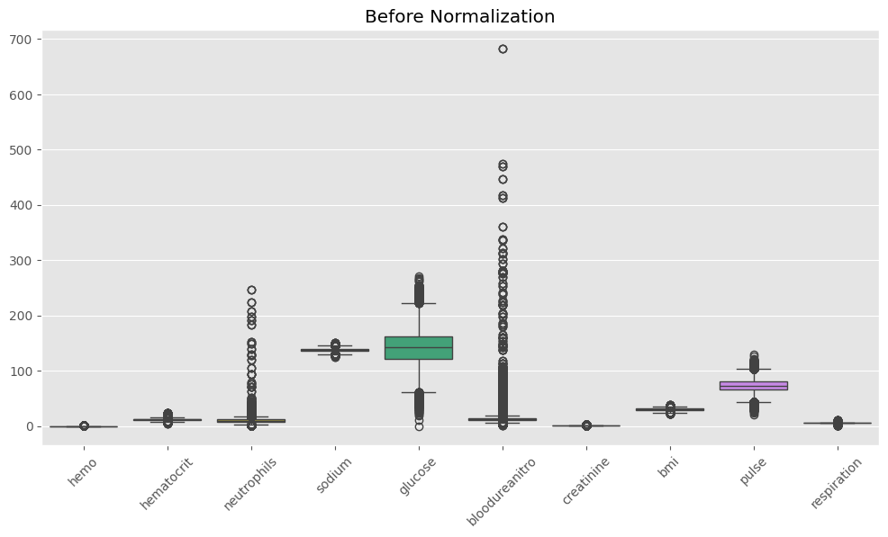
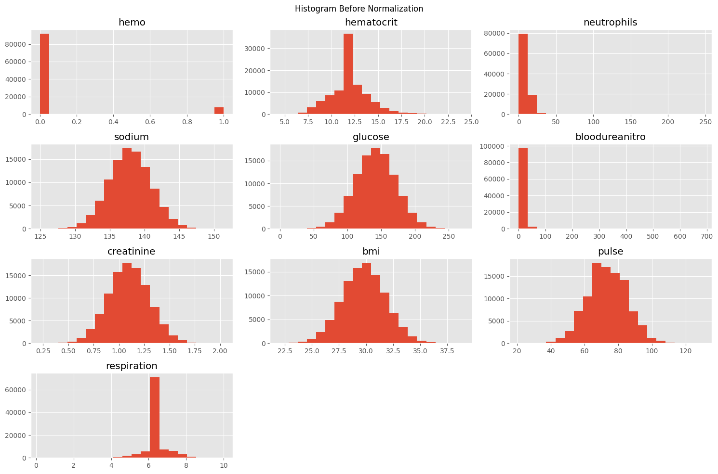
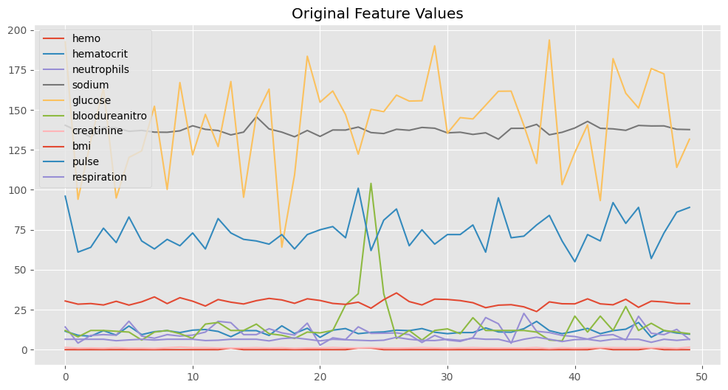
Min-Max Normalized Data
hemo hematocrit neutrophils sodium glucose bloodureanitro \
0 0.0 0.360406 0.057364 0.583520 0.710159 0.016141
1 0.0 0.233503 0.016273 0.446429 0.348997 0.010271
2 0.0 0.203046 0.035801 0.307686 0.482791 0.016141
3 0.0 0.380711 0.037836 0.531882 0.603350 0.016141
4 0.0 0.238579 0.036412 0.518315 0.351964 0.015407

creatinine bmi pulse respiration
0 0.644999 0.498137 0.688073 0.642857
1 0.398470 0.381750 0.366972 0.642857
2 0.465994 0.404373 0.394495 0.642857
3 0.378473 0.352149 0.504587 0.642857
4 0.563549 0.487897 0.422018 0.551020
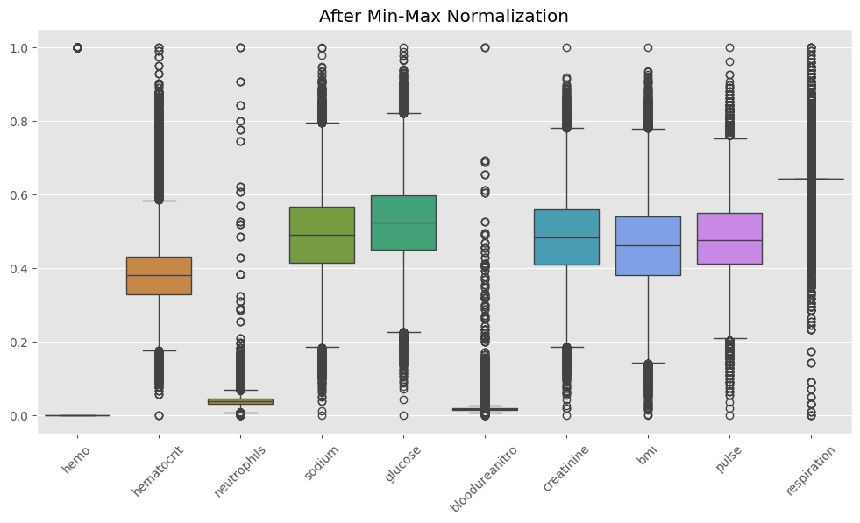
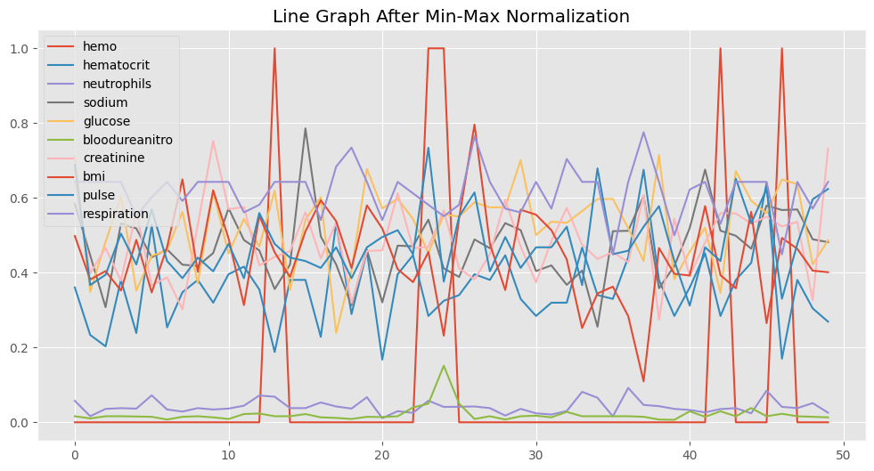
Z-Score Normalized Data
hemo hematocrit neutrophils sodium glucose bloodureanitro \
0 -0.294884 -0.234247 0.751441 0.823340 1.684186 -0.161915
1 -0.294884 -1.464694 -1.135314 -0.386613 -1.596543 -0.470738
2 -0.294884 -1.760001 -0.238638 -1.611147 -0.381186 -0.161915
3 -0.294884 -0.037375 -0.145235 0.367584 0.713958 -0.161915
4 -0.294884 -1.415476 -0.210617 0.247842 -1.569599 -0.200518

creatinine bmi pulse respiration
0 1.454965 0.312741 1.936991 0.010963
1 -0.779911 -0.671360 -1.068721 0.010963
2 -0.167779 -0.480071 -0.811089 0.010963
3 -0.961187 -0.921644 0.219441 0.010963
4 0.716587 0.226159 -0.553456 -1.572234
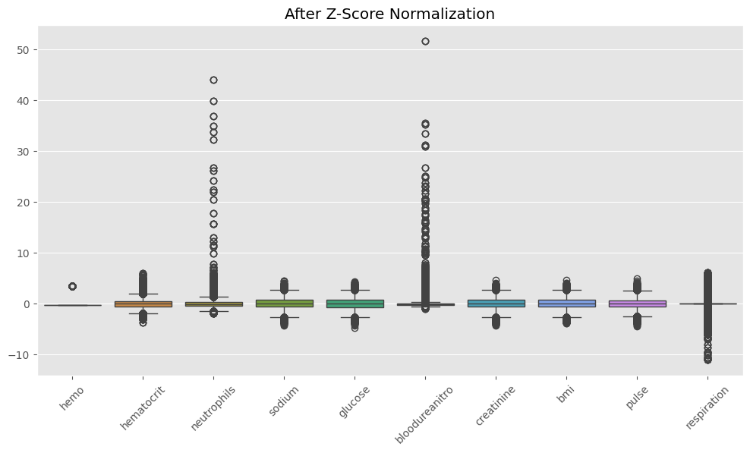
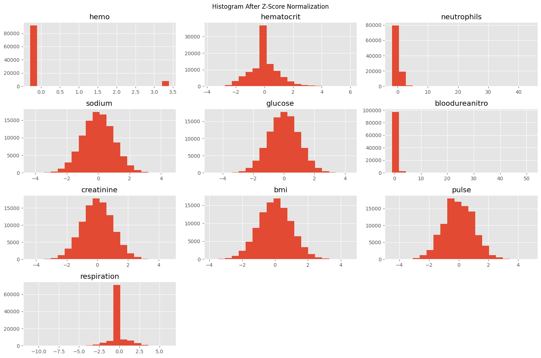
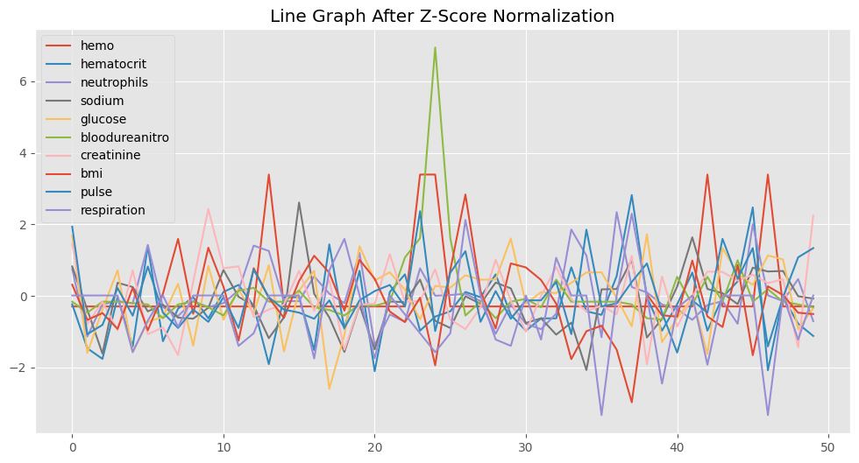
Comparison Table
Original Mean Min-Max Mean Z-Score Mean
hemo 0.080000 0.080000 -4.973799e-17
hematocrit 11.975939 0.384565 -5.821477e-16
neutrophils 10.177455 0.040999 1.620037e-16
sodium 137.891397 0.490234 -6.056950e-15
glucose 141.963384 0.524754 5.812950e-16
bloodureanitro 14.097185 0.019218 -2.870593e-17
creatinine 1.099350 0.484502 9.450218e-16
bmi 29.805759 0.461150 -1.329354e-15
pulse 73.444720 0.481144 -3.281286e-16
respiration 6.493768 0.642221 2.281411e-15
Mean after Z-Score
hemo -4.973799e-17
hematocrit -5.821477e-16
neutrophils 1.620037e-16
sodium -6.056950e-15
glucose 5.812950e-16
bloodureanitro -2.870593e-17
creatinine 9.450218e-16
bmi -1.329354e-15
pulse -3.281286e-16
respiration 2.281411e-15
dtype: float64

Standard Deviation after Z-Score
hemo 1.000005
hematocrit 1.000005
neutrophils 1.000005
sodium 1.000005
glucose 1.000005
bloodureanitro 1.000005
creatinine 1.000005
bmi 1.000005
pulse 1.000005
respiration 1.000005
dtype: float64

======================================================
CONCLUSION
======================================================

1. Min-Max Normalization scales data between 0 and 1.
2. Z-Score Normalization transforms data to Mean = 0 and Standard Deviation = 1.
3. Healthcare data contains measurements with different scales.
4. Z-Score Normalization is generally more suitable for Patient Length of Stay datasets because it handles varying feature scales effectively.
5. Normalization improves the performance of many Machine Learning algorithms.

======================================================

Inference: Before normalization, the clinical features (hemoglobin, hematocrit, neutrophils, sodium, glucose, blood urea nitrogen, creatinine, BMI, pulse and respiration) were on very different scales, which is clearly visible in the box plots and histograms. Min-Max Normalization rescaled every feature to the [0, 1] range while preserving the shape of the original distribution, whereas Z-Score Normalization transformed the features to a mean of 0 and a standard deviation of 1, centring the data and making it more suitable for distance-based or gradient-based algorithms.

Conclusion: This experiment showed that normalization is an essential preprocessing step when features are measured on different scales, as is the case with the healthcare dataset used here. Z-Score Normalization was found to be generally more suitable for this dataset because it standardises varying clinical scales while remaining less sensitive to outliers than Min-Max scaling, which improves the reliability of downstream Machine Learning models.

Lab 3

Frequent Itemset Mining using the Apriori Algorithm
Aim: To identify frequent itemsets and generate useful recommendations by applying the Apriori Algorithm on transactional datasets — a hospital pharmacy medicine dataset and a library book-borrowing dataset.

Procedure and Implementation
# ==========================================
# Question 1
# Hospital Pharmacy Analysis using Apriori
# ==========================================

import pandas as pd
from itertools import combinations

# Transactions
transactions = [
['Paracetamol','Vitamin C','Cough Syrup'],
['Paracetamol','Antibiotic','Vitamin C'],
['Antibiotic','Vitamin C','Pain Reliever'],
['Paracetamol','Vitamin C','Pain Reliever'],
['Paracetamol','Antibiotic','Vitamin C'],
['Vitamin C','Cough Syrup']
]

min_support = 3

# -----------------------
# Candidate 1 Itemsets
# -----------------------

C1 = {}

for transaction in transactions:
for item in transaction:
C1[item] = C1.get(item,0)+1

print("\nCandidate Itemsets C1")
print(pd.DataFrame(C1.items(),columns=['Medicine','Support Count']))

# Frequent 1-itemsets

L1 = {k:v for k,v in C1.items() if v>=min_support}

print("\nFrequent Itemsets L1")
print(pd.DataFrame(L1.items(),columns=['Medicine','Support Count']))

# -----------------------
# Candidate 2 Itemsets
# -----------------------

C2={}

for transaction in transactions:
for pair in combinations(sorted(transaction),2):
C2[pair]=C2.get(pair,0)+1

print("\nCandidate Itemsets C2")
print(pd.DataFrame(C2.items(),columns=['Itemset','Support Count']))

L2={k:v for k,v in C2.items() if v>=min_support}

print("\nFrequent Itemsets L2")
print(pd.DataFrame(L2.items(),columns=['Itemset','Support Count']))

# -----------------------
# Candidate 3 Itemsets
# -----------------------

C3={}

for transaction in transactions:
for triple in combinations(sorted(transaction),3):
C3[triple]=C3.get(triple,0)+1

print("\nCandidate Itemsets C3")
print(pd.DataFrame(C3.items(),columns=['Itemset','Support Count']))

L3={k:v for k,v in C3.items() if v>=min_support}

print("\nFrequent Itemsets L3")
print(pd.DataFrame(L3.items(),columns=['Itemset','Support Count']))

print("\n================================")
print("Medicine Stock Recommendation")
print("================================")

for item in L2:
print(item)
Candidate Itemsets C1
Medicine Support Count
0 Paracetamol 4
1 Vitamin C 6
2 Cough Syrup 2
3 Antibiotic 3
4 Pain Reliever 2

Frequent Itemsets L1
Medicine Support Count
0 Paracetamol 4
1 Vitamin C 6
2 Antibiotic 3

Candidate Itemsets C2
Itemset Support Count
0 (Cough Syrup, Paracetamol) 1
1 (Cough Syrup, Vitamin C) 2
2 (Paracetamol, Vitamin C) 4
3 (Antibiotic, Paracetamol) 2
4 (Antibiotic, Vitamin C) 3
5 (Antibiotic, Pain Reliever) 1
6 (Pain Reliever, Vitamin C) 2
7 (Pain Reliever, Paracetamol) 1

Frequent Itemsets L2
Itemset Support Count
0 (Paracetamol, Vitamin C) 4
1 (Antibiotic, Vitamin C) 3

Candidate Itemsets C3
Itemset Support Count
0 (Cough Syrup, Paracetamol, Vitamin C) 1
1 (Antibiotic, Paracetamol, Vitamin C) 2
2 (Antibiotic, Pain Reliever, Vitamin C) 1
3 (Pain Reliever, Paracetamol, Vitamin C) 1

Frequent Itemsets L3
Empty DataFrame
Columns: [Itemset, Support Count]
Index: []

================================
Medicine Stock Recommendation
================================
('Paracetamol', 'Vitamin C')
('Antibiotic', 'Vitamin C')

# ==========================================
# Question 2
# Library Borrowing Analysis
# ==========================================

import pandas as pd
from itertools import combinations

transactions = [
['Data Structures','Python Programming','DBMS'],
['Data Structures','Operating Systems'],
['Python Programming','DBMS','Machine Learning'],
['Data Structures','Python Programming','Machine Learning'],
['Data Structures','Python Programming','DBMS'],
['Python Programming','DBMS']
]

min_support=3

# C1

C1={}

for t in transactions:
for item in t:
C1[item]=C1.get(item,0)+1

print("\nCandidate Itemsets C1")
print(pd.DataFrame(C1.items(),columns=['Book','Support Count']))

L1={k:v for k,v in C1.items() if v>=min_support}

print("\nFrequent Itemsets L1")
print(pd.DataFrame(L1.items(),columns=['Book','Support Count']))

# C2

C2={}

for t in transactions:
for pair in combinations(sorted(t),2):
C2[pair]=C2.get(pair,0)+1

print("\nCandidate Itemsets C2")
print(pd.DataFrame(C2.items(),columns=['Itemset','Support Count']))

L2={k:v for k,v in C2.items() if v>=min_support}

print("\nFrequent Itemsets L2")
print(pd.DataFrame(L2.items(),columns=['Itemset','Support Count']))

# C3

C3={}

for t in transactions:
for triple in combinations(sorted(t),3):
C3[triple]=C3.get(triple,0)+1

print("\nCandidate Itemsets C3")
print(pd.DataFrame(C3.items(),columns=['Itemset','Support Count']))

L3={k:v for k,v in C3.items() if v>=min_support}

print("\nFrequent Itemsets L3")
print(pd.DataFrame(L3.items(),columns=['Itemset','Support Count']))

print("\nRecommended Books Together")

for item in L2:
print(item)
Candidate Itemsets C1
Book Support Count
0 Data Structures 4
1 Python Programming 5
2 DBMS 4
3 Operating Systems 1
4 Machine Learning 2

Frequent Itemsets L1
Book Support Count
0 Data Structures 4
1 Python Programming 5
2 DBMS 4

Candidate Itemsets C2
Itemset Support Count
0 (DBMS, Data Structures) 2
1 (DBMS, Python Programming) 4
2 (Data Structures, Python Programming) 3
3 (Data Structures, Operating Systems) 1
4 (DBMS, Machine Learning) 1
5 (Machine Learning, Python Programming) 2
6 (Data Structures, Machine Learning) 1

Frequent Itemsets L2
Itemset Support Count
0 (DBMS, Python Programming) 4
1 (Data Structures, Python Programming) 3

Candidate Itemsets C3
Itemset Support Count
0 (DBMS, Data Structures, Python Programming) 2
1 (DBMS, Machine Learning, Python Programming) 1
2 (Data Structures, Machine Learning, Python Pro... 1

Frequent Itemsets L3
Empty DataFrame
Columns: [Itemset, Support Count]
Index: []

Recommended Books Together
('DBMS', 'Python Programming')
('Data Structures', 'Python Programming')

Inference: For the hospital pharmacy dataset, the itemsets {Paracetamol, Vitamin C} and {Antibiotic, Vitamin C} were found to be frequent at a minimum support count of 3, showing that Vitamin C is commonly prescribed alongside Paracetamol and Antibiotics. For the library dataset, {DBMS, Python Programming} and {Data Structures, Python Programming} were the frequent itemsets, indicating that students who borrow Python Programming books frequently also borrow DBMS or Data Structures books. In both cases no frequent 3-itemset was found at the chosen minimum support, showing that triple combinations occurred too rarely to be considered frequent.

Conclusion: The Apriori Algorithm was implemented step-by-step (candidate generation followed by pruning) for two different domains. The results demonstrate how the algorithm systematically eliminates infrequent candidates at each level, and the final frequent 2-itemsets were used to generate simple, practical recommendations — medicine stock recommendations for the pharmacy and book-pairing recommendations for the library.

Lab 4

Generating an FP-Tree for a Transaction Dataset
Aim: To construct a Frequent Pattern Tree (FP-Tree) for given transactional datasets without candidate generation, by building a frequency table, ordering transactions by descending frequency and inserting them into a shared prefix tree.

Procedure and Implementation
Lab Exercise 4 - FP Tree
from collections import Counter

def frequency_table(transactions):
f=Counter()
for t in transactions: f.update(t)
return f

def filter_sort_transactions(transactions,freq,minsup):
order=sorted([i for i,c in freq.items() if c>=minsup], key=lambda x:(-freq[x],x))
om={k:i for i,k in enumerate(order)}
out=[]
for t in transactions:
items=[i for i in t if freq[i]>=minsup]
items.sort(key=lambda x:om[x])
out.append(items)
return out

def build_tree(transactions):
tree={}
for t in transactions:
node=tree
for item in t:
if item not in node:
node[item]={"count":0,"children":{}}
node[item]["count"]+=1
node=node[item]["children"]
return tree

def show(tree,ind=""):
for k,v in tree.items():
print(ind+"|--",k,"("+str(v["count"])+")")
show(v["children"],ind+" ")

def run(title,transactions,minsup):
print("="*40);print(title);print("="*40)
print("\nTransactions")
for i,t in enumerate(transactions,1): print(f"T{i}: {t}")
freq=frequency_table(transactions)
print("\nFrequency Table")
for k,v in freq.items(): print(k,":",v)
ft=filter_sort_transactions(transactions,freq,minsup)
print("\nSorted Transactions")
for i,t in enumerate(ft,1): print(f"T{i}: {t}")
tree=build_tree(ft)
print("\nFP Tree")
print("ROOT")
show(tree)
movie=[["Action","Comedy","Thriller"],["Action","Drama","Thriller"],["Comedy","Thriller","Romance"],["Action","Comedy","Thriller"],["Action","Comedy","Drama"]]
smart=[["Smart Light","Smart TV","Air Conditioner"],["Smart Light","Smart Speaker","Air Conditioner"],["Smart TV","Air Conditioner","Smart Speaker"],["Smart Light","Smart TV","Air Conditioner"],["Smart Light","Air Conditioner","Smart Speaker"]]
run("Scenario 1",movie,3)
print()
run("Scenario 2",smart,3)
========================================
Scenario 1
========================================

Transactions
T1: ['Action', 'Comedy', 'Thriller']
T2: ['Action', 'Drama', 'Thriller']
T3: ['Comedy', 'Thriller', 'Romance']
T4: ['Action', 'Comedy', 'Thriller']
T5: ['Action', 'Comedy', 'Drama']

Frequency Table
Action : 4
Comedy : 4
Thriller : 4
Drama : 2
Romance : 1

Sorted Transactions
T1: ['Action', 'Comedy', 'Thriller']
T2: ['Action', 'Thriller']
T3: ['Comedy', 'Thriller']
T4: ['Action', 'Comedy', 'Thriller']
T5: ['Action', 'Comedy']

FP Tree
ROOT
|-- Action (4)
|-- Comedy (3)
|-- Thriller (2)
|-- Thriller (1)
|-- Comedy (1)
|-- Thriller (1)

========================================
Scenario 2
========================================

Transactions
T1: ['Smart Light', 'Smart TV', 'Air Conditioner']
T2: ['Smart Light', 'Smart Speaker', 'Air Conditioner']
T3: ['Smart TV', 'Air Conditioner', 'Smart Speaker']
T4: ['Smart Light', 'Smart TV', 'Air Conditioner']
T5: ['Smart Light', 'Air Conditioner', 'Smart Speaker']

Frequency Table
Smart Light : 4
Smart TV : 3
Air Conditioner : 5
Smart Speaker : 3

Sorted Transactions
T1: ['Air Conditioner', 'Smart Light', 'Smart TV']
T2: ['Air Conditioner', 'Smart Light', 'Smart Speaker']
T3: ['Air Conditioner', 'Smart Speaker', 'Smart TV']
T4: ['Air Conditioner', 'Smart Light', 'Smart TV']
T5: ['Air Conditioner', 'Smart Light', 'Smart Speaker']

FP Tree
ROOT
|-- Air Conditioner (5)
|-- Smart Light (4)
|-- Smart TV (2)
|-- Smart Speaker (2)
|-- Smart Speaker (1)
|-- Smart TV (1)

Inference: In the movie-genre scenario, Action, Comedy and Thriller were the most frequent items (each appearing 4 times), so the tree built a shared path headed by Action, with Comedy and Thriller branching underneath it, reflecting how frequently these genres occur together. In the smart-home scenario, Air Conditioner was the most frequent item (5/5 transactions) and therefore formed the root branch of the tree, with Smart Light, Smart TV and Smart Speaker forming shared sub-paths beneath it.

Conclusion: The FP-Growth approach was shown to compactly represent all the frequency information of the transactions in a single tree, avoiding the repeated database scans and candidate generation that Apriori requires. Items that co-occur frequently share common prefix paths in the tree, which directly reveals the strongest itemset associations without needing to enumerate candidate itemsets explicitly.

Lab 5

Association Rule Mining and OLAP Operations on a Multidimensional Dataset
Aim: To generate multidimensional association rules and perform OLAP operations (Roll-up, Drill-down, Slice, Dice, Pivot and a 3D OLAP Cuboid) on categorised attributes of the Patient Length of Stay dataset.

Procedure and Implementation
# LAB EXERCISE 5
# Association Rule Mining and OLAP Operations

# Install mlxtend (Run only once in Colab)
!pip install mlxtend

# Import Libraries
import pandas as pd
import numpy as np

import matplotlib.pyplot as plt
from mpl_toolkits.mplot3d import Axes3D

from google.colab import files

from mlxtend.preprocessing import TransactionEncoder
from mlxtend.frequent_patterns import apriori, association_rules

# Upload Dataset
uploaded = files.upload()

# Read Dataset
df = pd.read_csv(next(iter(uploaded)))

# Display first 5 rows
df.head()
Saving LengthOfStay.csv to LengthOfStay.csv
eid vdate rcount gender dialysisrenalendstage asthma irondef \
0 1 8/29/2012 0 F 0 0 0
1 2 5/26/2012 5+ F 0 0 0
2 3 9/22/2012 1 F 0 0 0
3 4 8/9/2012 0 F 0 0 0
4 5 12/20/2012 0 F 0 0 0

pneum substancedependence psychologicaldisordermajor ... glucose \
0 0 0 0 ... 192.476918
1 0 0 0 ... 94.078507
2 0 0 0 ... 130.530524
3 0 0 0 ... 163.377028
4 1 0 1 ... 94.886654

bloodureanitro creatinine bmi pulse respiration \
0 12.0 1.390722 30.432418 96 6.5
1 8.0 0.943164 28.460516 61 6.5
2 12.0 1.065750 28.843812 64 6.5
3 12.0 0.906862 27.959007 76 6.5
4 11.5 1.242854 30.258927 67 5.6

secondarydiagnosisnonicd9 discharged facid lengthofstay
0 4 9/1/2012 B 3
1 1 6/2/2012 A 7
2 2 9/25/2012 B 3
3 1 8/10/2012 A 1
4 2 12/24/2012 E 4

[5 rows x 28 columns]

# Dataset Shape
print("Dataset Shape:")
print(df.shape)

# Column Names
print("\nColumn Names:")
print(df.columns.tolist())

# Dataset Information
print("\nDataset Information:")
df.info()

# Missing Values
print("\nMissing Values:")
print(df.isnull().sum())
Dataset Shape:
(100000, 28)

Column Names:
['eid', 'vdate', 'rcount', 'gender', 'dialysisrenalendstage', 'asthma', 'irondef', 'pneum', 'substancedependence', 'psychologicaldisordermajor', 'depress', 'psychother', 'fibrosisandother', 'malnutrition', 'hemo', 'hematocrit', 'neutrophils', 'sodium', 'glucose', 'bloodureanitro', 'creatinine', 'bmi', 'pulse', 'respiration', 'secondarydiagnosisnonicd9', 'discharged', 'facid', 'lengthofstay']

Dataset Information:
<class 'pandas.core.frame.DataFrame'>
RangeIndex: 100000 entries, 0 to 99999
Data columns (total 28 columns):
# Column Non-Null Count Dtype
--- ------ -------------- -----
0 eid 100000 non-null int64
1 vdate 100000 non-null object
2 rcount 100000 non-null object
3 gender 100000 non-null object
4 dialysisrenalendstage 100000 non-null int64
5 asthma 100000 non-null int64
6 irondef 100000 non-null int64
7 pneum 100000 non-null int64
8 substancedependence 100000 non-null int64
9 psychologicaldisordermajor 100000 non-null int64
10 depress 100000 non-null int64
11 psychother 100000 non-null int64
12 fibrosisandother 100000 non-null int64
13 malnutrition 100000 non-null int64
14 hemo 100000 non-null int64
15 hematocrit 100000 non-null float64
16 neutrophils 100000 non-null float64
17 sodium 100000 non-null float64
18 glucose 100000 non-null float64
19 bloodureanitro 100000 non-null float64
20 creatinine 100000 non-null float64
21 bmi 100000 non-null float64
22 pulse 100000 non-null int64
23 respiration 100000 non-null float64
24 secondarydiagnosisnonicd9 100000 non-null int64
25 discharged 100000 non-null object
26 facid 100000 non-null object
27 lengthofstay 100000 non-null int64
dtypes: float64(8), int64(15), object(5)
memory usage: 21.4+ MB

Missing Values:
eid 0
vdate 0
rcount 0
gender 0
dialysisrenalendstage 0
asthma 0
irondef 0
pneum 0
substancedependence 0
psychologicaldisordermajor 0
depress 0
psychother 0
fibrosisandother 0
malnutrition 0
hemo 0
hematocrit 0
neutrophils 0
sodium 0
glucose 0
bloodureanitro 0
creatinine 0
bmi 0
pulse 0
respiration 0
secondarydiagnosisnonicd9 0
discharged 0
facid 0
lengthofstay 0
dtype: int64

# Create Categories for Numerical Attributes

# BMI Category
df["BMI_Category"] = pd.cut(
df["bmi"],
bins=[0, 18.5, 25, 100],
labels=["Underweight", "Normal", "Overweight"]
)

# Glucose Category
df["Glucose_Category"] = pd.cut(
df["glucose"],
bins=[0, 140, 200, 1000],
labels=["Normal", "High", "Very High"]
)

# Length of Stay Category
df["Stay_Category"] = pd.cut(
df["lengthofstay"],
bins=[0, 3, 7, 100],
labels=["Short Stay", "Medium Stay", "Long Stay"]
)

# Create Multidimensional Dataset
multi_df = df[[
"gender",
"BMI_Category",
"Glucose_Category",
"Stay_Category",
"discharged"
]]

print("Multidimensional Dataset")

multi_df.head()
Multidimensional Dataset
gender BMI_Category Glucose_Category Stay_Category discharged
0 F Overweight High Short Stay 9/1/2012
1 F Overweight Normal Medium Stay 6/2/2012
2 F Overweight Normal Short Stay 9/25/2012
3 F Overweight High Short Stay 8/10/2012
4 F Overweight Normal Medium Stay 12/24/2012

# One-Hot Encoding

# Convert each row into a transaction
transactions = multi_df.astype(str).values.tolist()

# Apply One-Hot Encoding
te = TransactionEncoder()
te_array = te.fit(transactions).transform(transactions)

# Create Encoded DataFrame
encoded_df = pd.DataFrame(te_array, columns=te.columns_)

print("One-Hot Encoded Dataset")
encoded_df.head()
One-Hot Encoded Dataset
1/1/2013 1/10/2012 1/10/2013 1/11/2012 1/11/2013 1/12/2012 1/12/2013 \
0 False False False False False False False
1 False False False False False False False
2 False False False False False False False
3 False False False False False False False
4 False False False False False False False

1/13/2012 1/13/2013 1/14/2012 ... F High Long Stay M \
0 False False False ... True True False False
1 False False False ... True False False False
2 False False False ... True False False False
3 False False False ... True True False False
4 False False False ... True False False False

Medium Stay Normal Overweight Short Stay Very High nan
0 False False True True False False
1 True True True False False False
2 False True True True False False
3 False False True True False False
4 True True True False False False

[5 rows x 388 columns]

# Apriori Algorithm

frequent_itemsets = apriori(
encoded_df,
min_support=0.10,
use_colnames=True
)

print("Frequent Itemsets")
frequent_itemsets
Frequent Itemsets
support itemsets
0 0.57643 (F)
1 0.50054 (High)
2 0.42357 (M)
3 0.44563 (Medium Stay)
4 0.47736 (Normal)
5 0.99194 (Overweight)
6 0.46872 (Short Stay)
7 0.28879 (F, High)
8 0.24626 (Medium Stay, F)
9 0.27458 (F, Normal)
10 0.57166 (Overweight, F)
11 0.28563 (Short Stay, F)
12 0.21175 (M, High)
13 0.22191 (Medium Stay, High)
14 0.49647 (Overweight, High)
15 0.23769 (Short Stay, High)
16 0.19937 (Medium Stay, M)
17 0.20278 (M, Normal)
18 0.42028 (Overweight, M)
19 0.18309 (Short Stay, M)
20 0.21284 (Medium Stay, Normal)
21 0.44158 (Overweight, Medium Stay)
22 0.46930 (Overweight, Normal)
23 0.22284 (Short Stay, Normal)
24 0.46564 (Overweight, Short Stay)
25 0.12267 (Medium Stay, F, High)
26 0.28630 (Overweight, F, High)
27 0.14497 (Short Stay, F, High)
28 0.11726 (Medium Stay, F, Normal)
29 0.24396 (Overweight, Medium Stay, F)
30 0.26981 (Overweight, F, Normal)
31 0.13540 (Short Stay, F, Normal)
32 0.28368 (Overweight, Short Stay, F)
33 0.21017 (Overweight, M, High)
34 0.22005 (Overweight, Medium Stay, High)
35 0.23598 (Overweight, Short Stay, High)
36 0.19762 (Overweight, Medium Stay, M)
37 0.19949 (Overweight, M, Normal)
38 0.18196 (Overweight, Short Stay, M)
39 0.20879 (Overweight, Medium Stay, Normal)
40 0.21976 (Overweight, Short Stay, Normal)
41 0.12157 (Overweight, Medium Stay, F, High)
42 0.14386 (Overweight, Short Stay, F, High)
43 0.11496 (Overweight, Medium Stay, F, Normal)
44 0.13345 (Overweight, Short Stay, F, Normal)

# Association Rules

rules = association_rules(
frequent_itemsets,
metric="confidence",
min_threshold=0.60
)

# Display Important Columns
rules = rules[[
"antecedents",
"consequents",
"support",
"confidence",
"lift"
]]

print("Association Rules")
rules
Association Rules
antecedents consequents support confidence \
0 (F) (Overweight) 0.57166 0.991725
1 (Short Stay) (F) 0.28563 0.609383
2 (High) (Overweight) 0.49647 0.991869
3 (M) (Overweight) 0.42028 0.992233
4 (Medium Stay) (Overweight) 0.44158 0.990912
5 (Normal) (Overweight) 0.46930 0.983115
6 (Short Stay) (Overweight) 0.46564 0.993429
7 (F, High) (Overweight) 0.28630 0.991378
8 (Short Stay, High) (F) 0.14497 0.609912
9 (Medium Stay, F) (Overweight) 0.24396 0.990660
10 (F, Normal) (Overweight) 0.26981 0.982628
11 (Short Stay, Normal) (F) 0.13540 0.607611
12 (Overweight, Short Stay) (F) 0.28368 0.609226
13 (Short Stay, F) (Overweight) 0.28368 0.993173
14 (Short Stay) (Overweight, F) 0.28368 0.605223
15 (M, High) (Overweight) 0.21017 0.992538
16 (Medium Stay, High) (Overweight) 0.22005 0.991618
17 (Short Stay, High) (Overweight) 0.23598 0.992806
18 (Medium Stay, M) (Overweight) 0.19762 0.991222
19 (M, Normal) (Overweight) 0.19949 0.983776
20 (Short Stay, M) (Overweight) 0.18196 0.993828
21 (Medium Stay, Normal) (Overweight) 0.20879 0.980972
22 (Short Stay, Normal) (Overweight) 0.21976 0.986178
23 (Medium Stay, F, High) (Overweight) 0.12157 0.991033
24 (Overweight, Short Stay, High) (F) 0.14386 0.609628
25 (Short Stay, F, High) (Overweight) 0.14386 0.992343
26 (Short Stay, High) (Overweight, F) 0.14386 0.605242
27 (Medium Stay, F, Normal) (Overweight) 0.11496 0.980385
28 (Overweight, Short Stay, Normal) (F) 0.13345 0.607253
29 (Short Stay, F, Normal) (Overweight) 0.13345 0.985598

lift
0 0.999783
1 1.057167
2 0.999928
3 1.000295
4 0.998963
5 0.991104
6 1.001501
7 0.999433
8 1.058085
9 0.998710
10 0.990612
11 1.054093
12 1.056895
13 1.001243
14 1.058711
15 1.000603
16 0.999676
17 1.000873
18 0.999277
19 0.991769
20 1.001904
21 0.988942
22 0.994192
23 0.999085
24 1.057592
25 1.000407
26 1.058745
27 0.988352
28 1.053473
29 0.993607

# Display Frequent Itemsets

print("\nFrequent Itemsets")
display(frequent_itemsets)

# Display Association Rules

print("\nAssociation Rules")
display(rules)
Frequent Itemsets
support itemsets
0 0.57643 (F)
1 0.50054 (High)
2 0.42357 (M)
3 0.44563 (Medium Stay)
4 0.47736 (Normal)
5 0.99194 (Overweight)
6 0.46872 (Short Stay)
7 0.28879 (F, High)
8 0.24626 (Medium Stay, F)
9 0.27458 (F, Normal)
10 0.57166 (Overweight, F)
11 0.28563 (Short Stay, F)
12 0.21175 (M, High)
13 0.22191 (Medium Stay, High)
14 0.49647 (Overweight, High)
15 0.23769 (Short Stay, High)
16 0.19937 (Medium Stay, M)
17 0.20278 (M, Normal)
18 0.42028 (Overweight, M)
19 0.18309 (Short Stay, M)
20 0.21284 (Medium Stay, Normal)
21 0.44158 (Overweight, Medium Stay)
22 0.46930 (Overweight, Normal)
23 0.22284 (Short Stay, Normal)
24 0.46564 (Overweight, Short Stay)
25 0.12267 (Medium Stay, F, High)
26 0.28630 (Overweight, F, High)
27 0.14497 (Short Stay, F, High)
28 0.11726 (Medium Stay, F, Normal)
29 0.24396 (Overweight, Medium Stay, F)
30 0.26981 (Overweight, F, Normal)
31 0.13540 (Short Stay, F, Normal)
32 0.28368 (Overweight, Short Stay, F)
33 0.21017 (Overweight, M, High)
34 0.22005 (Overweight, Medium Stay, High)
35 0.23598 (Overweight, Short Stay, High)
36 0.19762 (Overweight, Medium Stay, M)
37 0.19949 (Overweight, M, Normal)
38 0.18196 (Overweight, Short Stay, M)
39 0.20879 (Overweight, Medium Stay, Normal)
40 0.21976 (Overweight, Short Stay, Normal)
41 0.12157 (Overweight, Medium Stay, F, High)
42 0.14386 (Overweight, Short Stay, F, High)
43 0.11496 (Overweight, Medium Stay, F, Normal)
44 0.13345 (Overweight, Short Stay, F, Normal)
Association Rules
antecedents consequents support confidence \
0 (F) (Overweight) 0.57166 0.991725
1 (Short Stay) (F) 0.28563 0.609383
2 (High) (Overweight) 0.49647 0.991869
3 (M) (Overweight) 0.42028 0.992233
4 (Medium Stay) (Overweight) 0.44158 0.990912
5 (Normal) (Overweight) 0.46930 0.983115
6 (Short Stay) (Overweight) 0.46564 0.993429
7 (F, High) (Overweight) 0.28630 0.991378
8 (Short Stay, High) (F) 0.14497 0.609912
9 (Medium Stay, F) (Overweight) 0.24396 0.990660
10 (F, Normal) (Overweight) 0.26981 0.982628
11 (Short Stay, Normal) (F) 0.13540 0.607611
12 (Overweight, Short Stay) (F) 0.28368 0.609226
13 (Short Stay, F) (Overweight) 0.28368 0.993173
14 (Short Stay) (Overweight, F) 0.28368 0.605223
15 (M, High) (Overweight) 0.21017 0.992538
16 (Medium Stay, High) (Overweight) 0.22005 0.991618
17 (Short Stay, High) (Overweight) 0.23598 0.992806
18 (Medium Stay, M) (Overweight) 0.19762 0.991222
19 (M, Normal) (Overweight) 0.19949 0.983776
20 (Short Stay, M) (Overweight) 0.18196 0.993828
21 (Medium Stay, Normal) (Overweight) 0.20879 0.980972
22 (Short Stay, Normal) (Overweight) 0.21976 0.986178
23 (Medium Stay, F, High) (Overweight) 0.12157 0.991033
24 (Overweight, Short Stay, High) (F) 0.14386 0.609628
25 (Short Stay, F, High) (Overweight) 0.14386 0.992343
26 (Short Stay, High) (Overweight, F) 0.14386 0.605242
27 (Medium Stay, F, Normal) (Overweight) 0.11496 0.980385
28 (Overweight, Short Stay, Normal) (F) 0.13345 0.607253
29 (Short Stay, F, Normal) (Overweight) 0.13345 0.985598

lift
0 0.999783
1 1.057167
2 0.999928
3 1.000295
4 0.998963
5 0.991104
6 1.001501
7 0.999433
8 1.058085
9 0.998710
10 0.990612
11 1.054093
12 1.056895
13 1.001243
14 1.058711
15 1.000603
16 0.999676
17 1.000873
18 0.999277
19 0.991769
20 1.001904
21 0.988942
22 0.994192
23 0.999085
24 1.057592
25 1.000407
26 1.058745
27 0.988352
28 1.053473
29 0.993607

# 3D OLAP Cuboid

olap_data = multi_df.groupby(["gender", "Stay_Category"]).size().reset_index(name="Count")

# Convert categories to numbers
x = olap_data["gender"].astype("category").cat.codes
y = olap_data["Stay_Category"].astype("category").cat.codes
z = np.zeros(len(olap_data))

dx = np.ones(len(olap_data))*0.4
dy = np.ones(len(olap_data))*0.4
dz = olap_data["Count"]

fig = plt.figure(figsize=(10,7))
ax = fig.add_subplot(111, projection='3d')

ax.bar3d(x, y, z, dx, dy, dz)

ax.set_xlabel("Gender")
ax.set_ylabel("Stay Category")
ax.set_zlabel("Patient Count")
ax.set_title("3D OLAP Cuboid")

plt.show()
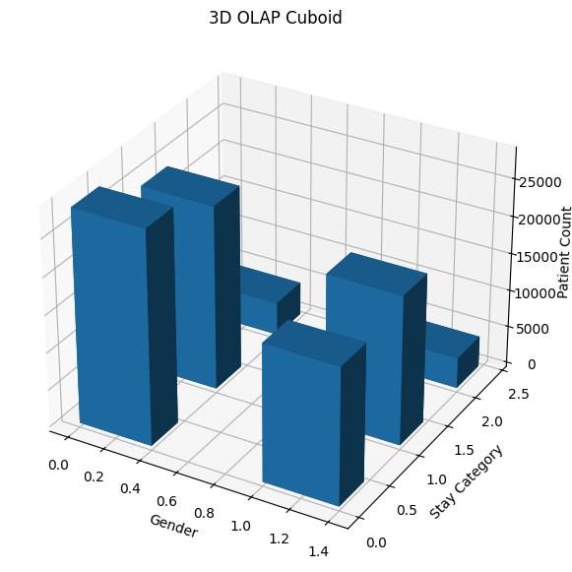

# Roll-Up

rollup = multi_df.groupby("gender").size().reset_index(name="Patient Count")

print("Roll-Up")
display(rollup)
Roll-Up
gender Patient Count
0 F 57643
1 M 42357

# Drill-Down

drilldown = multi_df.groupby(
["gender","Stay_Category"]
).size().reset_index(name="Patient Count")

print("Drill-Down")

display(drilldown)
Drill-Down
gender Stay_Category Patient Count
0 F Short Stay 28563
1 F Medium Stay 24626
2 F Long Stay 4454
3 M Short Stay 18309
4 M Medium Stay 19937
5 M Long Stay 4111

# Slice

slice_data = multi_df[
multi_df["gender"]=="Male"
]

print("Slice (Male Patients)")

slice_data.head()
Slice (Male Patients)
Empty DataFrame
Columns: [gender, BMI_Category, Glucose_Category, Stay_Category, discharged]
Index: []

# Dice

dice = multi_df[
(multi_df["gender"]=="Male") &
(multi_df["Glucose_Category"]=="High") &
(multi_df["Stay_Category"]=="Long Stay")
]

print("Dice")

dice.head()
Dice
Empty DataFrame
Columns: [gender, BMI_Category, Glucose_Category, Stay_Category, discharged]
Index: []

# Pivot

pivot = pd.pivot_table(
multi_df,
index="gender",
columns="Stay_Category",
aggfunc="size",
fill_value=0
)

print("Pivot Table")

display(pivot)
Pivot Table
Stay_Category Short Stay Medium Stay Long Stay
gender
F 28563 24626 4454
M 18309 19937 4111

# Interpretation

print("INTERPRETATION")
print("- Frequent itemsets show the combinations of patient characteristics that occur frequently.")
print("- Association rules indicate relationships using Support, Confidence and Lift.")
print("- Roll-Up provides summarized information.")
print("- Drill-Down provides detailed information.")
print("- Slice filters one dimension.")
print("- Dice filters multiple dimensions.")
print("- Pivot rearranges data for better analysis.")
print("- The 3D OLAP Cuboid helps visualize multidimensional patient data.")
INTERPRETATION
- Frequent itemsets show the combinations of patient characteristics that occur frequently.
- Association rules indicate relationships using Support, Confidence and Lift.
- Roll-Up provides summarized information.
- Drill-Down provides detailed information.
- Slice filters one dimension.
- Dice filters multiple dimensions.
- Pivot rearranges data for better analysis.
- The 3D OLAP Cuboid helps visualize multidimensional patient data.

Inference: INTERPRETATION
- Frequent itemsets show the combinations of patient characteristics that occur frequently.
- Association rules indicate relationships using Support, Confidence and Lift.
- Roll-Up provides summarized information.
- Drill-Down provides detailed information.
- Slice filters one dimension.
- Dice filters multiple dimensions.
- Pivot rearranges data for better analysis.
- The 3D OLAP Cuboid helps visualize multidimensional patient data.

Conclusion: This experiment showed how a single patient dataset can be viewed from multiple dimensions (gender, BMI category, glucose category and stay category) using classical OLAP operations, and how the same categorical data can be mined for association rules. Together, Roll-up/Drill-down/Slice/Dice/Pivot and Association Rule Mining provide complementary summarised and detailed views that are valuable for hospital-resource decision-making.

Lab 6

Advanced Pattern Mining — Pattern Fusion and Colossal Patterns
Aim: To identify frequent itemsets using the Apriori Algorithm on a hospital pharmacy transaction dataset and to perform Pattern Fusion in order to merge overlapping frequent itemsets into larger, colossal patterns.

Procedure and Implementation
#lab 6

!pip install mlxtend

import pandas as pd
from mlxtend.preprocessing import TransactionEncoder
from mlxtend.frequent_patterns import apriori

transactions = [
["Paracetamol","Vitamin C","Antibiotic"],
["Paracetamol","Vitamin C","Pain Reliever"],
["Paracetamol","Vitamin C","Antibiotic","Pain Reliever"],
["Paracetamol","Vitamin C","Antibiotic"],
["Vitamin C","Pain Reliever","Antacid"],
["Paracetamol","Vitamin C","ORS"],
["Paracetamol","Antibiotic","Pain Reliever"],
["Paracetamol","Vitamin C","Antibiotic","ORS"],
["Vitamin C","Pain Reliever","Calcium"],
["Paracetamol","Vitamin C","Antibiotic"],

["Paracetamol","Vitamin C","Antibiotic","Pain Reliever"],
["Paracetamol","Vitamin C","Multivitamin"],
["Vitamin C","Antibiotic","Pain Reliever"],
["Paracetamol","Vitamin C","Antibiotic","Antacid"],
["Paracetamol","Vitamin C","Pain Reliever"],
["Vitamin C","ORS","Calcium"],
["Paracetamol","Vitamin C","Antibiotic","Pain Reliever"],
["Paracetamol","Vitamin C","Antibiotic"],
["Paracetamol","Pain Reliever","Antacid"],
["Paracetamol","Vitamin C","Antibiotic","Calcium"],

["Vitamin C","Pain Reliever","Multivitamin"],
["Paracetamol","Vitamin C","ORS"],
["Paracetamol","Vitamin C","Antibiotic","Pain Reliever"],
["Paracetamol","Vitamin C","Antibiotic"],
["Paracetamol","Vitamin C","Pain Reliever"],
["Vitamin C","Antibiotic","ORS"],
["Paracetamol","Vitamin C","Antibiotic","Pain Reliever"],
["Paracetamol","Vitamin C","Antacid","Cough Syrup"],
["Vitamin C","Pain Reliever","Calcium","Cough Syrup"],
["Paracetamol","Vitamin C","Antibiotic","Pain Reliever","Cough Syrup"]
]

df = pd.DataFrame({
"Transaction_ID": [f"T{i+1}" for i in range(len(transactions))],
"Medicines": transactions
})

display(df)
Transaction_ID Medicines
0 T1 [Paracetamol, Vitamin C, Antibiotic]
1 T2 [Paracetamol, Vitamin C, Pain Reliever]
2 T3 [Paracetamol, Vitamin C, Antibiotic, Pain Reli...
3 T4 [Paracetamol, Vitamin C, Antibiotic]
4 T5 [Vitamin C, Pain Reliever, Antacid]
5 T6 [Paracetamol, Vitamin C, ORS]
6 T7 [Paracetamol, Antibiotic, Pain Reliever]
7 T8 [Paracetamol, Vitamin C, Antibiotic, ORS]
8 T9 [Vitamin C, Pain Reliever, Calcium]
9 T10 [Paracetamol, Vitamin C, Antibiotic]
10 T11 [Paracetamol, Vitamin C, Antibiotic, Pain Reli...
11 T12 [Paracetamol, Vitamin C, Multivitamin]
12 T13 [Vitamin C, Antibiotic, Pain Reliever]
13 T14 [Paracetamol, Vitamin C, Antibiotic, Antacid]
14 T15 [Paracetamol, Vitamin C, Pain Reliever]
15 T16 [Vitamin C, ORS, Calcium]
16 T17 [Paracetamol, Vitamin C, Antibiotic, Pain Reli...
17 T18 [Paracetamol, Vitamin C, Antibiotic]
18 T19 [Paracetamol, Pain Reliever, Antacid]
19 T20 [Paracetamol, Vitamin C, Antibiotic, Calcium]
20 T21 [Vitamin C, Pain Reliever, Multivitamin]
21 T22 [Paracetamol, Vitamin C, ORS]
22 T23 [Paracetamol, Vitamin C, Antibiotic, Pain Reli...
23 T24 [Paracetamol, Vitamin C, Antibiotic]
24 T25 [Paracetamol, Vitamin C, Pain Reliever]
25 T26 [Vitamin C, Antibiotic, ORS]
26 T27 [Paracetamol, Vitamin C, Antibiotic, Pain Reli...
27 T28 [Paracetamol, Vitamin C, Antacid, Cough Syrup]
28 T29 [Vitamin C, Pain Reliever, Calcium, Cough Syrup]
29 T30 [Paracetamol, Vitamin C, Antibiotic, Pain Reli...

num_transactions = len(transactions)

unique_items = sorted(set(item for transaction in transactions for item in transaction))

print("Domain Selected :", "Hospital Pharmacy Medicine Analysis")
print("Number of Transactions :", num_transactions)
print("Number of Unique Items :", len(unique_items))

print("\nUnique Medicines")

for item in unique_items:
print(item)
Domain Selected : Hospital Pharmacy Medicine Analysis
Number of Transactions : 30
Number of Unique Items : 9

Unique Medicines
Antacid
Antibiotic
Calcium
Cough Syrup
Multivitamin
ORS
Pain Reliever
Paracetamol
Vitamin C

te = TransactionEncoder()
te_array = te.fit(transactions).transform(transactions)

transaction_df = pd.DataFrame(te_array, columns=te.columns_)

display(transaction_df.head())

frequent_itemsets = apriori(
transaction_df,
min_support=0.30,
use_colnames=True
)

frequent_itemsets["Support Count"] = (
frequent_itemsets["support"] * len(transactions)
).astype(int)

frequent_itemsets = frequent_itemsets.sort_values(
by="support",
ascending=False
)

print("Minimum Support : 30%")
print("\nFrequent Itemsets")

display(frequent_itemsets)
Antacid Antibiotic Calcium Cough Syrup Multivitamin ORS \
0 False True False False False False
1 False False False False False False
2 False True False False False False
3 False True False False False False
4 True False False False False False

Pain Reliever Paracetamol Vitamin C
0 False True True
1 True True True
2 True True True
3 False True True
4 True False True
Minimum Support : 30%

Frequent Itemsets
support itemsets Support Count
3 0.933333 (Vitamin C) 28
2 0.766667 (Paracetamol) 23
8 0.700000 (Paracetamol, Vitamin C) 21
0 0.566667 (Antibiotic) 17
1 0.533333 (Pain Reliever) 16
5 0.533333 (Antibiotic, Vitamin C) 16
4 0.500000 (Paracetamol, Antibiotic) 15
9 0.466667 (Paracetamol, Antibiotic, Vitamin C) 14
7 0.466667 (Pain Reliever, Vitamin C) 14
6 0.366667 (Paracetamol, Pain Reliever) 11
10 0.300000 (Paracetamol, Pain Reliever, Vitamin C) 9

fused_patterns = []

itemsets = frequent_itemsets["itemsets"].tolist()

for i in range(len(itemsets)):
for j in range(i + 1, len(itemsets)):
common = itemsets[i].intersection(itemsets[j])

if len(common) >= 1:
merged = itemsets[i].union(itemsets[j])

if merged not in fused_patterns:
fused_patterns.append(merged)

fusion_df = pd.DataFrame({
"Fused Pattern": [", ".join(sorted(pattern)) for pattern in fused_patterns],
"Number of Items": [len(pattern) for pattern in fused_patterns]
})

print("Pattern Fusion")

display(fusion_df)
Pattern Fusion
Fused Pattern Number of Items
0 Paracetamol, Vitamin C 2
1 Antibiotic, Vitamin C 2
2 Antibiotic, Paracetamol, Vitamin C 3
3 Pain Reliever, Vitamin C 2
4 Pain Reliever, Paracetamol, Vitamin C 3
5 Antibiotic, Paracetamol 2
6 Pain Reliever, Paracetamol 2
7 Antibiotic, Pain Reliever, Vitamin C 3
8 Antibiotic, Pain Reliever, Paracetamol, Vitamin C 4
9 Antibiotic, Pain Reliever, Paracetamol 3

largest_size = max(len(pattern) for pattern in fused_patterns)

colossal_patterns = [
pattern
for pattern in fused_patterns
if len(pattern) == largest_size
]

support_values = []

for pattern in colossal_patterns:

count = sum(
pattern.issubset(set(transaction))
for transaction in transactions
)

support_values.append(count)

colossal_df = pd.DataFrame({
"Colossal Pattern":[", ".join(sorted(pattern)) for pattern in colossal_patterns],
"Support Count":support_values,
"Number of Items":[largest_size]*len(colossal_patterns)
})

print("Colossal Patterns")

display(colossal_df)
Colossal Patterns
Colossal Pattern Support Count \
0 Antibiotic, Pain Reliever, Paracetamol, Vitamin C 6

Number of Items
0 4

highest_support = frequent_itemsets.iloc[0]

print("TASK 5 ANALYSIS\n")

print("Pattern with Highest Support")
print(highest_support["itemsets"])
print("Support Count :", highest_support["Support Count"])

print("\nLargest Colossal Pattern")

for pattern in colossal_patterns:
print(pattern)

print("\nNumber of Fusion Operations :", len(fused_patterns))

print("\nFrequent Itemsets Before Fusion :", len(frequent_itemsets))

print("Patterns After Fusion :", len(fused_patterns))

print("\nPattern Fusion reduces redundancy by merging frequent patterns that share common items into larger meaningful patterns instead of storing many overlapping patterns.")
TASK 5 ANALYSIS

Pattern with Highest Support
frozenset({'Vitamin C'})
Support Count : 28

Largest Colossal Pattern
frozenset({'Pain Reliever', 'Antibiotic', 'Vitamin C', 'Paracetamol'})

Number of Fusion Operations : 10

Frequent Itemsets Before Fusion : 11
Patterns After Fusion : 10

Pattern Fusion reduces redundancy by merging frequent patterns that share common items into larger meaningful patterns instead of storing many overlapping patterns.

Interpretation
In this experiment, a custom hospital pharmacy transaction dataset containing 30 transactions and 10 unique medicines was created. The Apriori algorithm was applied with a minimum support of 30% to identify frequent medicine combinations. The generated frequent itemsets showed which medicines were commonly prescribed together. Pattern Fusion was then performed to merge compatible frequent itemsets into larger patterns, reducing the number of overlapping patterns while preserving meaningful associations. The largest fused pattern was identified as the colossal pattern, representing the maximum number of frequently occurring medicines in a single pattern. Overall, the experiment demonstrated how Pattern Fusion can simplify frequent pattern mining by reducing redundancy and producing larger, more informative patterns.
In the first block, I imported the required Python libraries and created my own hospital pharmacy transaction dataset. The dataset consists of 30 transactions, where each transaction contains a list of medicines prescribed together. I then converted the dataset into a DataFrame and displayed it to verify that the data was created correctly.
in 2nd block, I analyzed the created dataset by finding the total number of transactions and the number of unique medicines. I also displayed the selected domain and the list of unique medicines to get a clear understanding of the dataset before performing pattern mining.
in 3rd block, I converted the transaction dataset into a binary format using TransactionEncoder, which is required for the Apriori algorithm. I then applied the Apriori algorithm with a minimum support of 30% to generate all frequent itemsets and displayed their corresponding support counts.
in 4th block, I performed Pattern Fusion by comparing the frequent itemsets and merging those that shared common items. This process created larger frequent patterns while reducing the number of overlapping patterns, making the results easier to analyze.
in 5th block, I identified the largest fused frequent patterns, known as colossal patterns. I also calculated their support count and displayed the number of items present in each colossal pattern to determine the most significant pattern in the dataset.
in 6th block, I analyzed the overall results by identifying the pattern with the highest support, the largest colossal pattern, and the total number of fusion operations performed. I also compared the number of frequent itemsets before and after Pattern Fusion to understand how the technique helps reduce redundancy and simplifies pattern analysis.

Inference: In this experiment, a custom hospital pharmacy transaction dataset containing 30 transactions and 9 unique medicines was created. The Apriori algorithm was applied with a minimum support of 30% to identify frequent medicine combinations. The generated frequent itemsets showed which medicines were commonly prescribed together. Pattern Fusion was then performed to merge compatible frequent itemsets into larger patterns, reducing the number of overlapping patterns while preserving meaningful associations. The largest fused pattern was identified as the colossal pattern, representing the maximum number of frequently occurring medicines in a single pattern.

Conclusion: Overall, the experiment demonstrated how Pattern Fusion can simplify frequent pattern mining by reducing redundancy and producing larger, more informative patterns. {Antibiotic, Pain Reliever, Paracetamol, Vitamin C} emerged as the colossal pattern with a support count of 6, showing that this combination represents the most significant grouping of medicines prescribed together in the dataset.

Lab 7

Constructing a Decision Tree and Identifying the Order of Attributes
Aim: To construct a Decision Tree for a Student Performance dataset and identify the order in which attributes are selected as the root node by the ID3 (Information Gain), C4.5 (Gain Ratio) and CART (Gini Index) attribute-selection measures.

Procedure and Implementation
import pandas as pd

data = {
"Attendance": ["High","High","Medium","Low","Low","Medium","High","Medium","High","Low","Medium","High"],
"Assignment": ["Yes","Yes","Yes","No","No","Yes","No","No","Yes","Yes","No","Yes"],
"Study Hours": ["High","Medium","High","Low","Medium","Medium","High","Low","Medium","Low","Medium","High"],
"Previous Grade": ["Good","Good","Average","Poor","Poor","Average","Good","Poor","Average","Poor","Average","Good"],
"Result": ["Pass","Pass","Pass","Fail","Fail","Pass","Pass","Fail","Pass","Fail","Fail","Pass"]
}

df = pd.DataFrame(data)

display(df)
Attendance Assignment Study Hours Previous Grade Result
0 High Yes High Good Pass
1 High Yes Medium Good Pass
2 Medium Yes High Average Pass
3 Low No Low Poor Fail
4 Low No Medium Poor Fail
5 Medium Yes Medium Average Pass
6 High No High Good Pass
7 Medium No Low Poor Fail
8 High Yes Medium Average Pass
9 Low Yes Low Poor Fail
10 Medium No Medium Average Fail
11 High Yes High Good Pass

predictor_attributes = list(df.columns[:-1])

target_attribute = df.columns[-1]

print("Predictor Attributes")
print(predictor_attributes)

print("\nTarget Attribute")
print(target_attribute)

print("\nTotal Records")
print(len(df))

print("\nTarget Classes")
print(df[target_attribute].unique())

print("\nNumber of Target Classes")
print(df[target_attribute].nunique())
Predictor Attributes
['Attendance', 'Assignment', 'Study Hours', 'Previous Grade']

Target Attribute
Result

Total Records
12

Target Classes
['Pass' 'Fail']

Number of Target Classes
2

#Entropy calculation

from math import log2

def entropy(column):
values = column.value_counts(normalize=True)
return -sum(p * log2(p) for p in values)

dataset_entropy = entropy(df["Result"])

print("Entropy of Dataset")
print(round(dataset_entropy,4))
Entropy of Dataset
0.9799

def attribute_entropy(attribute):

total = len(df)

ent = 0

for value in df[attribute].unique():

subset = df[df[attribute] == value]

weight = len(subset) / total

ent += weight * entropy(subset["Result"])

return ent

entropy_table = pd.DataFrame({
"Attribute": predictor_attributes,
"Entropy": [round(attribute_entropy(col),4) for col in predictor_attributes]
})

display(entropy_table)
Attribute Entropy
0 Attendance 0.3333
1 Assignment 0.6459
2 Study Hours 0.4046
3 Previous Grade 0.2704

#INTERMEDIATE ENTROPY CALCULATIONS
print("INTERMEDIATE ENTROPY CALCULATIONS\n")

for attribute in predictor_attributes:

print("Attribute :", attribute)

weighted_entropy = 0

for value in df[attribute].unique():

subset = df[df[attribute] == value]

total = len(subset)

pass_count = len(subset[subset["Result"] == "Pass"])
fail_count = len(subset[subset["Result"] == "Fail"])

p_pass = pass_count / total if total else 0
p_fail = fail_count / total if total else 0

ent = 0

if p_pass > 0:
ent -= p_pass * log2(p_pass)

if p_fail > 0:
ent -= p_fail * log2(p_fail)

weight = total / len(df)

weighted_entropy += weight * ent

print(f"\n{value}")
print(f"Pass : {pass_count}")
print(f"Fail : {fail_count}")
print(f"P(Pass) = {round(p_pass,3)}")
print(f"P(Fail) = {round(p_fail,3)}")
print(f"Entropy = {round(ent,4)}")
print(f"Weighted Entropy = {round(weight*ent,4)}")

print("\nFinal Weighted Entropy =", round(weighted_entropy,4))
INTERMEDIATE ENTROPY CALCULATIONS

Attribute : Attendance

High
Pass : 5
Fail : 0
P(Pass) = 1.0
P(Fail) = 0.0
Entropy = 0.0
Weighted Entropy = 0.0

Medium
Pass : 2
Fail : 2
P(Pass) = 0.5
P(Fail) = 0.5
Entropy = 1.0
Weighted Entropy = 0.3333

Low
Pass : 0
Fail : 3
P(Pass) = 0.0
P(Fail) = 1.0
Entropy = 0.0
Weighted Entropy = 0.0

Final Weighted Entropy = 0.3333
Attribute : Assignment

Yes
Pass : 6
Fail : 1
P(Pass) = 0.857
P(Fail) = 0.143
Entropy = 0.5917
Weighted Entropy = 0.3451

No
Pass : 1
Fail : 4
P(Pass) = 0.2
P(Fail) = 0.8
Entropy = 0.7219
Weighted Entropy = 0.3008

Final Weighted Entropy = 0.6459
Attribute : Study Hours

High
Pass : 4
Fail : 0
P(Pass) = 1.0
P(Fail) = 0.0
Entropy = 0.0
Weighted Entropy = 0.0

Medium
Pass : 3
Fail : 2
P(Pass) = 0.6
P(Fail) = 0.4
Entropy = 0.971
Weighted Entropy = 0.4046

Low
Pass : 0
Fail : 3
P(Pass) = 0.0
P(Fail) = 1.0
Entropy = 0.0
Weighted Entropy = 0.0

Final Weighted Entropy = 0.4046
Attribute : Previous Grade

Good
Pass : 4
Fail : 0
P(Pass) = 1.0
P(Fail) = 0.0
Entropy = 0.0
Weighted Entropy = 0.0

Average
Pass : 3
Fail : 1
P(Pass) = 0.75
P(Fail) = 0.25
Entropy = 0.8113
Weighted Entropy = 0.2704

Poor
Pass : 0
Fail : 4
P(Pass) = 0.0
P(Fail) = 1.0
Entropy = 0.0
Weighted Entropy = 0.0

Final Weighted Entropy = 0.2704

#information gain
entropy_table["Information Gain"] = round(
dataset_entropy - entropy_table["Entropy"],4
)

display(entropy_table)

best_id3 = entropy_table.sort_values(
by="Information Gain",
ascending=False
).iloc[0]

print("Root Node using ID3")

print(best_id3["Attribute"])
Attribute Entropy Information Gain
0 Attendance 0.3333 0.6466
1 Assignment 0.6459 0.3340
2 Study Hours 0.4046 0.5753
3 Previous Grade 0.2704 0.7095
Root Node using ID3
Previous Grade

#Gain ratio(c4.5)
def split_info(attribute):

values = df[attribute].value_counts(normalize=True)

return -sum(p * log2(p) for p in values)

entropy_table["Split Information"] = [
round(split_info(col),4)
for col in predictor_attributes
]

entropy_table["Gain Ratio"] = round(
entropy_table["Information Gain"] /
entropy_table["Split Information"],
4
)

display(entropy_table)

best_c45 = entropy_table.sort_values(
by="Gain Ratio",
ascending=False
).iloc[0]

print("Root Node using C4.5")

print(best_c45["Attribute"])
Attribute Entropy Information Gain Split Information Gain Ratio
0 Attendance 0.3333 0.6466 1.5546 0.4159
1 Assignment 0.6459 0.3340 0.9799 0.3409
2 Study Hours 0.4046 0.5753 1.5546 0.3701
3 Previous Grade 0.2704 0.7095 1.5850 0.4476
Root Node using C4.5
Previous Grade

#Gini Index(CART)

def gini(attribute):

total = len(df)

gini_value = 0

for value in df[attribute].unique():

subset = df[df[attribute] == value]

weight = len(subset) / total

probs = subset["Result"].value_counts(normalize=True)

g = 1 - sum(p**2 for p in probs)

gini_value += weight * g

return gini_value

entropy_table["Gini Index"] = [
round(gini(col),4)
for col in predictor_attributes
]

display(entropy_table)

best_cart = entropy_table.sort_values(
by="Gini Index"
).iloc[0]

print("Root Node using CART")

print(best_cart["Attribute"])
Attribute Entropy Information Gain Split Information Gain Ratio \
0 Attendance 0.3333 0.6466 1.5546 0.4159
1 Assignment 0.6459 0.3340 0.9799 0.3409
2 Study Hours 0.4046 0.5753 1.5546 0.3701
3 Previous Grade 0.2704 0.7095 1.5850 0.4476

Gini Index
0 0.1667
1 0.2762
2 0.2000
3 0.1250
Root Node using CART
Previous Grade

#comparative analysis

print(f"ID3 Root Node : {best_id3['Attribute']}")
print(f"C4.5 Root Node : {best_c45['Attribute']}")
print(f"CART Root Node : {best_cart['Attribute']}")

print("\nExplanation")

if best_id3["Attribute"] == best_c45["Attribute"] == best_cart["Attribute"]:
print("All three algorithms selected the same root node because it provides the best split according to their respective measures.")
else:
print("The algorithms selected different root nodes because each uses a different attribute selection measure.")

print("\nAttribute Selection Measures")

print("ID3 -> Information Gain")
print("C4.5 -> Gain Ratio")
print("CART -> Gini Index")
ID3 Root Node : Previous Grade
C4.5 Root Node : Previous Grade
CART Root Node : Previous Grade

Explanation
All three algorithms selected the same root node because it provides the best split according to their respective measures.

Attribute Selection Measures
ID3 -> Information Gain
C4.5 -> Gain Ratio
CART -> Gini Index

#justification
print("ID3 JUSTIFICATION")
print(f"{best_id3['Attribute']} is selected because it has the highest Information Gain ({best_id3['Information Gain']}).")
print("Higher Information Gain means greater reduction in uncertainty.\n")

print("C4.5 JUSTIFICATION")
print(f"{best_c45['Attribute']} is selected because it has the highest Gain Ratio ({best_c45['Gain Ratio']}).")
print("Gain Ratio removes the bias of Information Gain towards attributes with many values.\n")

print("CART JUSTIFICATION")
print(f"{best_cart['Attribute']} is selected because it has the lowest Gini Index ({best_cart['Gini Index']}).")
print("Lower Gini Index indicates better class purity after splitting.")
ID3 JUSTIFICATION
Previous Grade is selected because it has the highest Information Gain (0.7095).
Higher Information Gain means greater reduction in uncertainty.

C4.5 JUSTIFICATION
Previous Grade is selected because it has the highest Gain Ratio (0.4476).
Gain Ratio removes the bias of Information Gain towards attributes with many values.

CART JUSTIFICATION
Previous Grade is selected because it has the lowest Gini Index (0.125).
Lower Gini Index indicates better class purity after splitting.

#comparative analysis
comparison = pd.DataFrame({
"Algorithm":["ID3","C4.5","CART"],
"Root Node":[
best_id3["Attribute"],
best_c45["Attribute"],
best_cart["Attribute"]
]
})

display(comparison)
Algorithm Root Node
0 ID3 Previous Grade
1 C4.5 Previous Grade
2 CART Previous Grade

#strength and limitation
comparison_table = pd.DataFrame({

"Measure":[
"Information Gain",
"Gain Ratio",
"Gini Index"
],

"Strength":[
"Easy to understand and reduces entropy effectively.",
"Removes the bias of Information Gain.",
"Fast and computationally efficient."
],

"Limitation":[
"Can favor attributes with many unique values.",
"Requires additional Split Information calculation.",
"Does not measure information content like entropy."
]

})

display(comparison_table)
Measure Strength \
0 Information Gain Easy to understand and reduces entropy effecti...
1 Gain Ratio Removes the bias of Information Gain.
2 Gini Index Fast and computationally efficient.

Limitation
0 Can favor attributes with many unique values.
1 Requires additional Split Information calculat...
2 Does not measure information content like entr...

#construction of decision tree
from sklearn.preprocessing import LabelEncoder
from sklearn.tree import DecisionTreeClassifier
from sklearn.tree import plot_tree

import matplotlib.pyplot as plt

encoded_df = df.copy()

encoders = {}

for col in encoded_df.columns:

encoder = LabelEncoder()

encoded_df[col] = encoder.fit_transform(encoded_df[col])

encoders[col] = encoder

X = encoded_df.drop("Result", axis=1)

y = encoded_df["Result"]

criteria = {
"ID3 (Entropy)":"entropy",
"C4.5 (Entropy)":"entropy",
"CART (Gini)":"gini"
}

for title, criterion in criteria.items():

model = DecisionTreeClassifier(
criterion=criterion,
random_state=42
)

model.fit(X,y)

plt.figure(figsize=(8,5))

plot_tree(
model,
feature_names=X.columns,
class_names=encoders["Result"].classes_,
filled=True
)

plt.title(title)

plt.show()
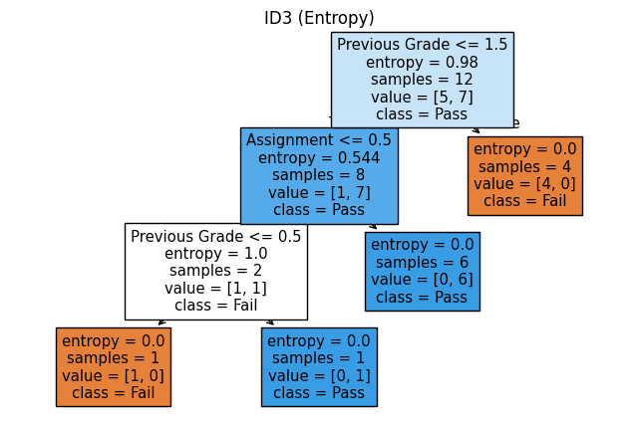
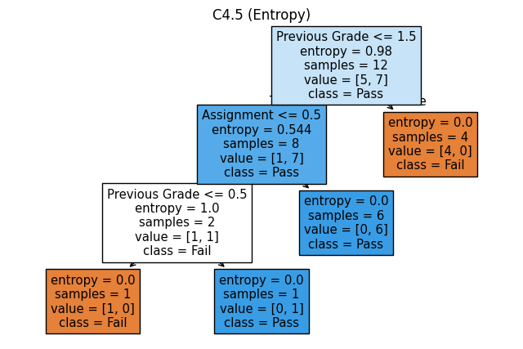
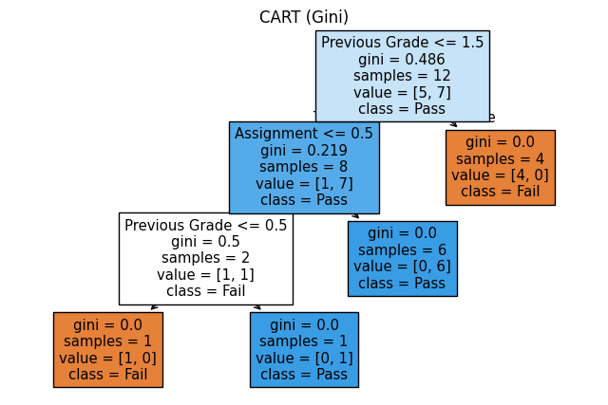

#decision tree comparison

print("DECISION TREE COMPARISON")

print("ID3")
print("- Uses Information Gain")
print("- Uses Entropy for splitting")

print("\nC4.5")
print("- Uses Gain Ratio")
print("- Improves upon ID3 by reducing attribute bias")

print("\nCART")
print("- Uses Gini Index")
print("- Produces binary decision trees")

print("\nObservation")

print("ID3 and C4.5 are entropy-based algorithms, whereas CART uses Gini Index.")
print("CART generally creates binary splits, while ID3 and C4.5 may create multiple branches.")
DECISION TREE COMPARISON
ID3
- Uses Information Gain
- Uses Entropy for splitting

C4.5
- Uses Gain Ratio
- Improves upon ID3 by reducing attribute bias

CART
- Uses Gini Index
- Produces binary decision trees

Observation
ID3 and C4.5 are entropy-based algorithms, whereas CART uses Gini Index.
CART generally creates binary splits, while ID3 and C4.5 may create multiple branches.

#final observation

print("FINAL OBSERVATIONS")

print(f"Dataset Entropy : {round(dataset_entropy,4)}")

print(f"\nBest Attribute using ID3 : {best_id3['Attribute']}")
print(f"Best Attribute using C4.5 : {best_c45['Attribute']}")
print(f"Best Attribute using CART : {best_cart['Attribute']}")

print("\nOverall Summary")

print("- Information Gain measures reduction in entropy.")
print("- Gain Ratio improves Information Gain by reducing bias.")
print("- Gini Index measures node impurity.")
print("- Decision Trees use these measures to choose the best root node.")
print("- Different algorithms may choose different attributes depending on their splitting criterion.")

print("\nNote")

print("Scikit-learn does not provide native implementations of ID3 and C4.5.")
print("Therefore, entropy-based decision trees are used to demonstrate these algorithms, while CART is implemented using the Gini criterion.")
FINAL OBSERVATIONS
Dataset Entropy : 0.9799

Best Attribute using ID3 : Previous Grade
Best Attribute using C4.5 : Previous Grade
Best Attribute using CART : Previous Grade

Overall Summary
- Information Gain measures reduction in entropy.
- Gain Ratio improves Information Gain by reducing bias.
- Gini Index measures node impurity.
- Decision Trees use these measures to choose the best root node.
- Different algorithms may choose different attributes depending on their splitting criterion.

Note
Scikit-learn does not provide native implementations of ID3 and C4.5.
Therefore, entropy-based decision trees are used to demonstrate these algorithms, while CART is implemented using the Gini criterion.

Learning Outcome:
From this experiment, I learned how Decision Tree algorithms select the best attribute for splitting a dataset using different attribute selection measures. I also understood how to calculate Entropy, Information Gain, Gain Ratio and Gini Index and how each measure influences the choice of the root node. I also learned to implement decision tree algorithms in Python, visualise the generated trees and compare the performance of ID3, C4.5 and CART.

Inference: From this experiment, I learned how Decision Tree algorithms select the best attribute for splitting a dataset using different attribute selection measures. I also understood how to calculate Entropy, Information Gain, Gain Ratio and Gini Index and how each measure influences the choice of the root node. All three algorithms (ID3, C4.5 and CART) selected 'Previous Grade' as the root node, since it produced the highest Information Gain (0.7095), the highest Gain Ratio (0.4476) and the lowest Gini Index (0.125) among the four predictor attributes.

Conclusion: I also learned to implement decision tree algorithms in Python, visualise the generated trees and compare the performance of ID3, C4.5 and CART. Although the three measures are computed differently, they agreed on the same root node for this dataset, showing that 'Previous Grade' is the strongest predictor of a student's Pass/Fail result. In general, ID3 and C4.5 are entropy-based and may produce multi-way splits, while CART uses the Gini Index and always produces binary splits.

Lab 8

Demonstrating the Naive Bayes Classifier
Aim: To demonstrate the Gaussian Naive Bayes Classifier by training it on the Hospital Length of Stay dataset to classify patients into Short Stay, Medium Stay and Long Stay categories, and to evaluate its performance using standard classification metrics.

Procedure and Implementation
# Lab Exercise 8: Naive Bayes Classification

from google.colab import files

uploaded = files.upload()

import pandas as pd
import numpy as np

# Visualization
import matplotlib.pyplot as plt
import seaborn as sns

# Data preprocessing
from sklearn.preprocessing import LabelEncoder

# Train-Test Split
from sklearn.model_selection import train_test_split

# Naive Bayes Classifier
from sklearn.naive_bayes import GaussianNB

# Evaluation Metrics
from sklearn.metrics import (
accuracy_score,
precision_score,
recall_score,
f1_score,
confusion_matrix,
classification_report
)

# Ignore warnings
import warnings
warnings.filterwarnings("ignore")

print("All libraries imported successfully!")
Saving LengthOfStay.csv to LengthOfStay (2).csv
All libraries imported successfully!

# Loading the dataset
df = pd.read_csv("LengthOfStay.csv")

# Display first 5 rows
print("First 5 Rows of the Dataset")
display(df.head())

# Dataset Shape
print("\nDataset Shape:")
print(df.shape)

# Column Names
print("\nColumn Names:")
print(df.columns.tolist())

# Dataset Information
print("\nDataset Information:")
df.info()

# Missing Values
print("\nMissing Values:")
display(df.isnull().sum())
First 5 Rows of the Dataset
eid vdate rcount gender dialysisrenalendstage asthma irondef \
0 1 8/29/2012 0 F 0 0 0
1 2 5/26/2012 5+ F 0 0 0
2 3 9/22/2012 1 F 0 0 0
3 4 8/9/2012 0 F 0 0 0
4 5 12/20/2012 0 F 0 0 0

pneum substancedependence psychologicaldisordermajor ... glucose \
0 0 0 0 ... 192.476918
1 0 0 0 ... 94.078507
2 0 0 0 ... 130.530524
3 0 0 0 ... 163.377028
4 1 0 1 ... 94.886654

bloodureanitro creatinine bmi pulse respiration \
0 12.0 1.390722 30.432418 96 6.5
1 8.0 0.943164 28.460516 61 6.5
2 12.0 1.065750 28.843812 64 6.5
3 12.0 0.906862 27.959007 76 6.5
4 11.5 1.242854 30.258927 67 5.6

secondarydiagnosisnonicd9 discharged facid lengthofstay
0 4 9/1/2012 B 3
1 1 6/2/2012 A 7
2 2 9/25/2012 B 3
3 1 8/10/2012 A 1
4 2 12/24/2012 E 4

[5 rows x 28 columns]
Dataset Shape:
(100000, 28)

Column Names:
['eid', 'vdate', 'rcount', 'gender', 'dialysisrenalendstage', 'asthma', 'irondef', 'pneum', 'substancedependence', 'psychologicaldisordermajor', 'depress', 'psychother', 'fibrosisandother', 'malnutrition', 'hemo', 'hematocrit', 'neutrophils', 'sodium', 'glucose', 'bloodureanitro', 'creatinine', 'bmi', 'pulse', 'respiration', 'secondarydiagnosisnonicd9', 'discharged', 'facid', 'lengthofstay']

Dataset Information:
<class 'pandas.core.frame.DataFrame'>
RangeIndex: 100000 entries, 0 to 99999
Data columns (total 28 columns):
# Column Non-Null Count Dtype
--- ------ -------------- -----
0 eid 100000 non-null int64
1 vdate 100000 non-null object
2 rcount 100000 non-null object
3 gender 100000 non-null object
4 dialysisrenalendstage 100000 non-null int64
5 asthma 100000 non-null int64
6 irondef 100000 non-null int64
7 pneum 100000 non-null int64
8 substancedependence 100000 non-null int64
9 psychologicaldisordermajor 100000 non-null int64
10 depress 100000 non-null int64
11 psychother 100000 non-null int64
12 fibrosisandother 100000 non-null int64
13 malnutrition 100000 non-null int64
14 hemo 100000 non-null int64
15 hematocrit 100000 non-null float64
16 neutrophils 100000 non-null float64
17 sodium 100000 non-null float64
18 glucose 100000 non-null float64
19 bloodureanitro 100000 non-null float64
20 creatinine 100000 non-null float64
21 bmi 100000 non-null float64
22 pulse 100000 non-null int64
23 respiration 100000 non-null float64
24 secondarydiagnosisnonicd9 100000 non-null int64
25 discharged 100000 non-null object
26 facid 100000 non-null object
27 lengthofstay 100000 non-null int64
dtypes: float64(8), int64(15), object(5)
memory usage: 21.4+ MB

Missing Values:
eid 0
vdate 0
rcount 0
gender 0
dialysisrenalendstage 0
asthma 0
irondef 0
pneum 0
substancedependence 0
psychologicaldisordermajor 0
depress 0
psychother 0
fibrosisandother 0
malnutrition 0
hemo 0
hematocrit 0
neutrophils 0
sodium 0
glucose 0
bloodureanitro 0
creatinine 0
bmi 0
pulse 0
respiration 0
secondarydiagnosisnonicd9 0
discharged 0
facid 0
lengthofstay 0
dtype: int64

# Data Preprocessing

# Remove duplicate records
df = df.drop_duplicates()

# Replace missing values (if any)
df.fillna(df.median(numeric_only=True), inplace=True)

# Convert 'rcount' to numeric, handling '5+'
df['rcount'] = df['rcount'].replace('5+', 5).astype(int)

# Select important features
features = [
"rcount",
"psychologicaldisordermajor",
"hematocrit",
"respiration",
"bloodureanitro",
"hemo",
"sodium",
"bmi",
"glucose",
"creatinine"
]

# Create target classes from Length of Stay
def classify_los(days):
if days <= 3:
return "Short Stay"
elif days <= 7:
return "Medium Stay"
else:
return "Long Stay"

df["LOS_Class"] = df["lengthofstay"].apply(classify_los)

# Encode target labels
label_encoder = LabelEncoder()
df["LOS_Class"] = label_encoder.fit_transform(df["LOS_Class"])

# Features and Target
X = df[features]
y = df["LOS_Class"]

print("Feature Matrix Shape:", X.shape)
print("Target Shape:", y.shape)

print("\nTarget Classes:")
print(label_encoder.classes_)
Feature Matrix Shape: (100000, 10)
Target Shape: (100000,)

Target Classes:
['Long Stay' 'Medium Stay' 'Short Stay']

#Data Visualization

plt.figure(figsize=(6,4))
sns.countplot(x=df["LOS_Class"])
plt.title("Distribution of Length of Stay Classes")
plt.xlabel("LOS Class")
plt.ylabel("Count")
plt.show()

plt.figure(figsize=(10,8))
sns.heatmap(
X.corr(),
annot=True,
cmap="coolwarm",
fmt=".2f"
)
plt.title("Feature Correlation Heatmap")
plt.show()

plt.figure(figsize=(7,5))
sns.histplot(df["lengthofstay"], bins=20, kde=True)
plt.title("Length of Stay Distribution")
plt.show()
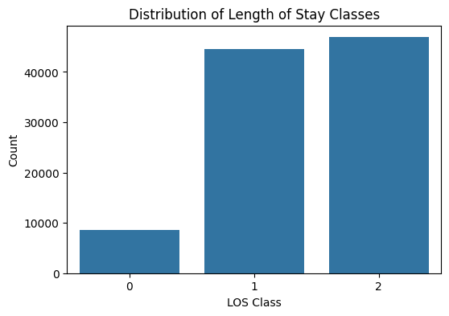
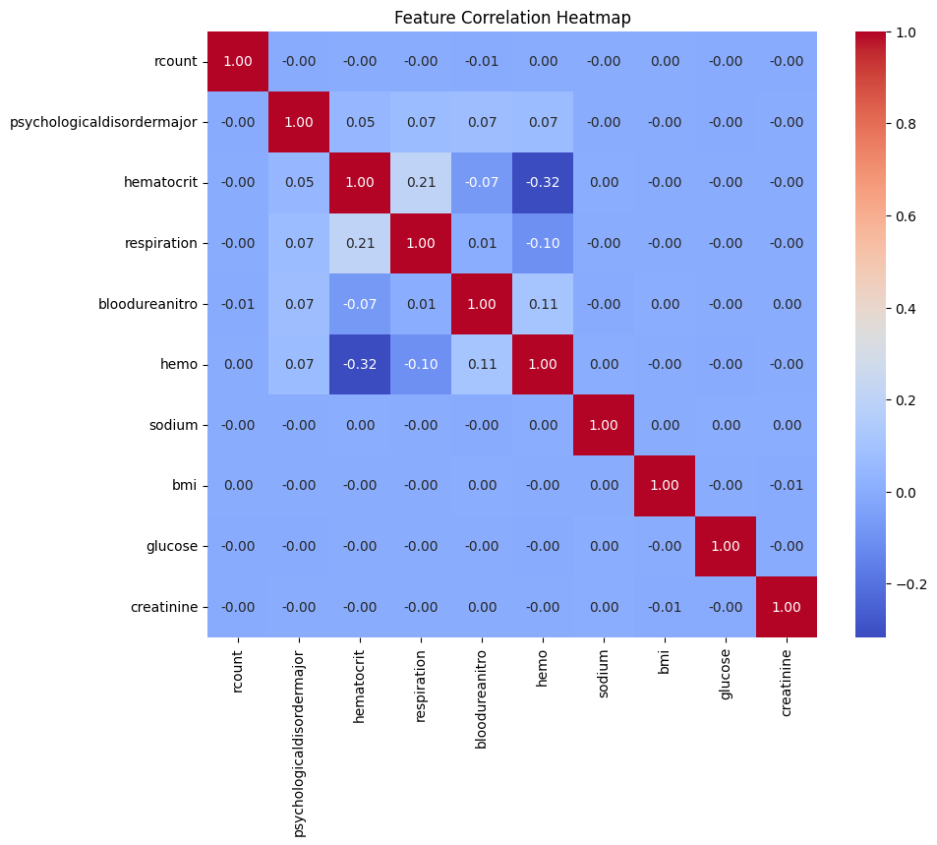
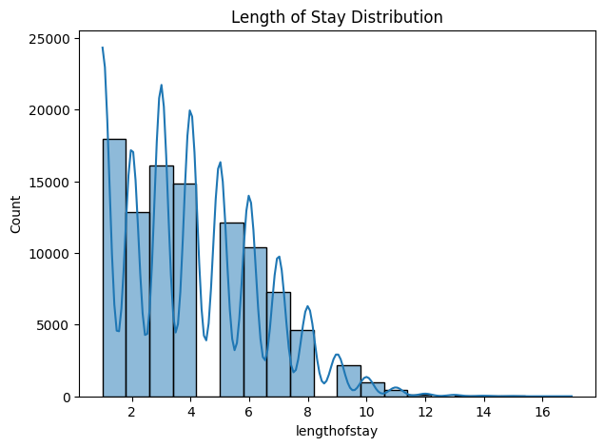

# Train-Test Split

X_train, X_test, y_train, y_test = train_test_split(
X,
y,
test_size=0.20,
random_state=42,
stratify=y
)

print("Training Samples :", X_train.shape[0])
print("Testing Samples :", X_test.shape[0])
Training Samples : 80000
Testing Samples : 20000

#Train Naive Bayes Model

model = GaussianNB()

model.fit(X_train, y_train)

print("Naive Bayes Model Trained Successfully!")
Naive Bayes Model Trained Successfully!

# Prediction
y_pred = model.predict(X_test)

print("Predicted Class Labels")
print(y_pred[:20])
Predicted Class Labels
[2 2 1 1 1 1 2 2 1 2 2 0 2 2 1 2 2 2 2 2]

# Evaluation Metrics
accuracy = accuracy_score(y_test, y_pred)

precision = precision_score(
y_test,
y_pred,
average="weighted"
)

recall = recall_score(
y_test,
y_pred,
average="weighted"
)

f1 = f1_score(
y_test,
y_pred,
average="weighted"
)

print("Accuracy :", accuracy)

print("Precision :", precision)

print("Recall :", recall)

print("F1 Score :", f1)

print("\nClassification Report\n")

print(classification_report(y_test, y_pred))
Accuracy : 0.79175
Precision : 0.7877262065556521
Recall : 0.79175
F1 Score : 0.779705235214608

Classification Report

precision recall f1-score support

0 0.73 0.31 0.43 1713
1 0.79 0.74 0.76 8913
2 0.80 0.93 0.86 9374

accuracy 0.79 20000
macro avg 0.77 0.66 0.68 20000
weighted avg 0.79 0.79 0.78 20000

# Confusion Matrix

cm = confusion_matrix(y_test, y_pred)

plt.figure(figsize=(6,5))

sns.heatmap(
cm,
annot=True,
cmap="Blues",
fmt="d",
xticklabels=label_encoder.classes_,
yticklabels=label_encoder.classes_
)

plt.xlabel("Predicted")

plt.ylabel("Actual")

plt.title("Confusion Matrix")

plt.show()
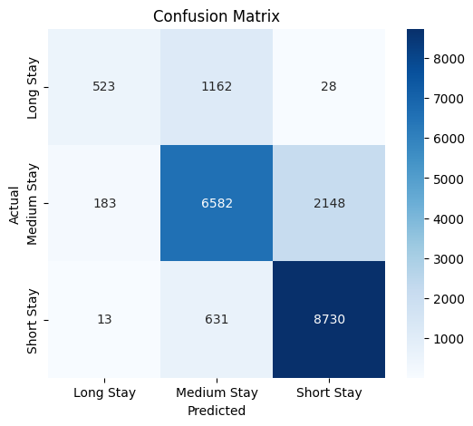

#Predict New Patient

new_patient = pd.DataFrame([[
1,
0,
40,
18,
15,
13.5,
140,
24,
100,
1.0
]], columns=features)

prediction = model.predict(new_patient)

predicted_class = label_encoder.inverse_transform(prediction)

print("Predicted Class for New Patient :")

print(predicted_class[0])
Predicted Class for New Patient :
Long Stay

Interpretation
The Naive Bayes Classification algorithm was successfully implemented using the Hospital Length of Stay dataset. After preprocessing the data, the dataset was divided into training and testing sets. The Gaussian Naive Bayes classifier was trained and used to predict the Length of Stay category of unseen patients. The model's performance was evaluated using Accuracy, Precision, Recall, F1-Score, Classification Report and Confusion Matrix. The results demonstrate that Naive Bayes can effectively classify patient stay duration into different categories while providing fast and computationally efficient predictions.
Conclusion
This experiment successfully demonstrated the implementation of the Naive Bayes Classification algorithm on the Hospital Length of Stay dataset. The model was trained, evaluated and used to classify new patient records into Short Stay, Medium Stay or Long Stay categories. Various evaluation metrics confirmed the performance of the classifier, making it suitable for classification-based healthcare applications.
Self Learning
Through this experiment, I learned how to implement the Gaussian Naive Bayes Classification algorithm using Python. I understood the importance of preprocessing data, converting numerical targets into categorical classes, splitting data into training and testing sets, evaluating classification models using multiple performance metrics and interpreting the Confusion Matrix. I also learned how Naive Bayes uses probability to classify unseen instances efficiently.

Inference: The Naive Bayes Classification algorithm was successfully implemented using the Hospital Length of Stay dataset. After preprocessing the data, the dataset was divided into training and testing sets. The Gaussian Naive Bayes classifier was trained and used to predict the Length of Stay category of unseen patients. The model's performance was evaluated using Accuracy, Precision, Recall, F1-Score, Classification Report and Confusion Matrix, achieving an overall accuracy of about 79.2%. The results demonstrate that Naive Bayes can effectively classify patient stay duration into different categories while providing fast and computationally efficient predictions.

Conclusion: This experiment successfully demonstrated the implementation of the Naive Bayes Classification algorithm on the Hospital Length of Stay dataset. The model was trained, evaluated and used to classify new patient records into Short Stay, Medium Stay or Long Stay categories. Various evaluation metrics confirmed the performance of the classifier, making it suitable for classification-based healthcare applications. Through this experiment I also learned the importance of preprocessing data, converting numerical targets into categorical classes, splitting data into training and testing sets, and interpreting the Confusion Matrix.

Lab 9

Exploring the SVM Classifier
Aim: To explore the Support Vector Machine (SVM) Classifier for binary classification of a synthetic hospital patient-risk dataset (High Risk / Low Risk), and to study the effect of the regularisation parameter C on the performance of a Linear SVM.

Procedure and Implementation
# Lab Exercise 9 - SVM Binary Classification

import pandas as pd
import numpy as np

import matplotlib.pyplot as plt
import seaborn as sns

# Dataset generation
from sklearn.datasets import make_classification

# Preprocessing
from sklearn.model_selection import train_test_split
from sklearn.preprocessing import StandardScaler

# SVM
from sklearn.svm import SVC

# Evaluation
from sklearn.metrics import (
accuracy_score,
precision_score,
recall_score,
f1_score,
confusion_matrix,
classification_report
)

# Ignore unnecessary warnings
import warnings
warnings.filterwarnings("ignore")

print(" All libraries imported successfully!")
All libraries imported successfully!

# Create Synthetic Hospital Patient Dataset

X, y = make_classification(
n_samples=1000,
n_features=7,
n_informative=5,
n_redundant=1,
n_repeated=0,
n_classes=2,
n_clusters_per_class=2,
class_sep=1.2,
flip_y=0.05,
weights=[0.50, 0.50],
random_state=42
)

# Meaningful feature names
feature_names = [
"age",
"bmi",
"heart_rate",
"glucose",
"blood_pressure",
"respiration_rate",
"severity_score"
]

# Create DataFrame
df = pd.DataFrame(X, columns=feature_names)

# Add binary target
df["high_risk"] = y

# Display first 10 records
print("First 10 Records:")
display(df.head(10))

# Display shape
print("\nDataset Shape:")
print(df.shape)
First 10 Records:
age bmi heart_rate glucose blood_pressure respiration_rate \
0 -0.574083 -1.249251 1.200104 0.852324 -1.809790 -2.304518
1 -1.547802 -1.077559 -1.073578 -2.954809 -0.741240 -2.521960
2 0.716589 0.685211 0.929165 2.442694 -2.009040 -2.011523
3 0.337956 3.432119 -1.852753 0.872259 0.813594 0.046883
4 1.636740 -1.541791 2.630308 1.970351 0.141282 0.040710
5 -0.972765 -1.691382 2.229284 4.394856 -1.234377 3.155307
6 -0.147340 0.595707 -0.032173 0.432640 0.565162 -1.737483
7 0.034375 1.909535 0.469832 4.119703 -3.026211 -1.554116
8 0.223281 0.574244 1.343290 -1.010304 0.679851 -2.256357
9 -0.220538 1.683269 2.026025 -0.393815 1.078860 -1.223234

severity_score high_risk
0 -0.142766 0
1 1.462148 1
2 -1.767841 0
3 -4.208159 1
4 -0.611210 1
5 0.085907 1
6 -3.933403 1
7 -2.725239 0
8 0.904504 0
9 2.408718 0
Dataset Shape:
(1000, 8)

#Dataset Information

print("Dataset Shape:")
print(df.shape)

print("\nData Types:")
print(df.dtypes)

print("\nDataset Information:")
df.info()

print("\nDescriptive Statistics:")
display(df.describe())

print("\nClass Distribution:")
print(df["high_risk"].value_counts())
Dataset Shape:
(1000, 8)

Data Types:
age float64
bmi float64
heart_rate float64
glucose float64
blood_pressure float64
respiration_rate float64
severity_score float64
high_risk int64
dtype: object

Dataset Information:
<class 'pandas.core.frame.DataFrame'>
RangeIndex: 1000 entries, 0 to 999
Data columns (total 8 columns):
# Column Non-Null Count Dtype
--- ------ -------------- -----
0 age 1000 non-null float64
1 bmi 1000 non-null float64
2 heart_rate 1000 non-null float64
3 glucose 1000 non-null float64
4 blood_pressure 1000 non-null float64
5 respiration_rate 1000 non-null float64
6 severity_score 1000 non-null float64
7 high_risk 1000 non-null int64
dtypes: float64(7), int64(1)
memory usage: 62.6 KB

Descriptive Statistics:
age bmi heart_rate glucose blood_pressure \
count 1000.000000 1000.000000 1000.000000 1000.000000 1000.000000
mean -0.038916 0.569059 0.599845 -0.129934 0.580472
std 1.007514 1.601325 1.722766 2.527313 1.688125
min -2.899514 -3.689284 -4.141477 -7.678079 -4.861168
25% -0.684881 -0.645880 -0.701585 -1.903681 -0.520833
50% -0.038242 0.725408 0.626671 -0.372049 0.750886
75% 0.623924 1.647875 1.731734 1.666714 1.716947
max 3.098299 6.236793 5.808412 6.426613 5.266061

respiration_rate severity_score high_risk
count 1000.000000 1000.000000 1000.00000
mean -0.592447 -0.011035 0.51000
std 1.631213 1.748538 0.50015
min -4.458034 -6.014203 0.00000
25% -1.694526 -1.293807 0.00000
50% -0.940346 0.064898 1.00000
75% 0.121632 1.257479 1.00000
max 5.885693 4.805669 1.00000
Class Distribution:
high_risk
1 510
0 490
Name: count, dtype: int64

# Save Dataset

df.to_csv("Hospital_SVM_Binary_Classification.csv", index=False)

print(" Dataset saved successfully!")

# Verify the file
import os

print("\nFiles in current directory:")
print(os.listdir())
Dataset saved successfully!

Files in current directory:
['.config', 'Hospital_SVM_Binary_Classification.csv', 'sample_data']

# Check Missing Values and Duplicates

print("Missing Values:")
display(df.isnull().sum())

print("\nTotal Missing Values:")
print(df.isnull().sum().sum())

print("\nNumber of Duplicate Records:")
print(df.duplicated().sum())
Missing Values:
age 0
bmi 0
heart_rate 0
glucose 0
blood_pressure 0
respiration_rate 0
severity_score 0
high_risk 0
dtype: int64
Total Missing Values:
0

Number of Duplicate Records:
0

# Data Preprocessing

# Remove duplicate records
df = df.drop_duplicates()

# Separate independent variables and target
X = df.drop("high_risk", axis=1)
y = df["high_risk"]

print("Independent Variables (X):")
display(X.head())

print("\nTarget Variable (y):")
display(y.head())

print("\nX Shape:", X.shape)
print("y Shape:", y.shape)
Independent Variables (X):
age bmi heart_rate glucose blood_pressure respiration_rate \
0 -0.574083 -1.249251 1.200104 0.852324 -1.809790 -2.304518
1 -1.547802 -1.077559 -1.073578 -2.954809 -0.741240 -2.521960
2 0.716589 0.685211 0.929165 2.442694 -2.009040 -2.011523
3 0.337956 3.432119 -1.852753 0.872259 0.813594 0.046883
4 1.636740 -1.541791 2.630308 1.970351 0.141282 0.040710

severity_score
0 -0.142766
1 1.462148
2 -1.767841
3 -4.208159
4 -0.611210
Target Variable (y):
0 0
1 1
2 0
3 1
4 1
Name: high_risk, dtype: int64
X Shape: (1000, 7)
y Shape: (1000,)

# Class Distribution

plt.figure(figsize=(6, 4))

sns.countplot(
x=df["high_risk"]
)

plt.title("Class Distribution")
plt.xlabel("Risk Class")
plt.ylabel("Number of Patients")

plt.xticks(
[0, 1],
["Low Risk (0)", "High Risk (1)"]
)

plt.show()
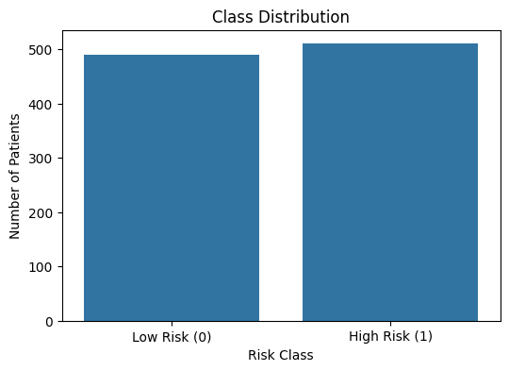

# Scatter Plot

plt.figure(figsize=(8, 6))

sns.scatterplot(
data=df,
x="severity_score",
y="glucose",
hue="high_risk",
palette="Set1",
alpha=0.7
)

plt.title("Severity Score vs Glucose by Risk Class")
plt.xlabel("Severity Score")
plt.ylabel("Glucose")
plt.legend(
title="Risk Class",
labels=["Low Risk", "High Risk"]
)

plt.show()
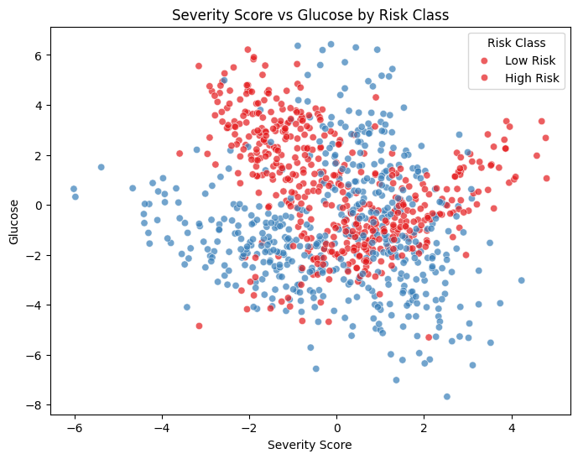

# Pair Plot

selected_features = [
"age",
"bmi",
"glucose",
"severity_score",
"high_risk"
]

sns.pairplot(
df[selected_features],
hue="high_risk",
palette="Set1"
)

plt.show()
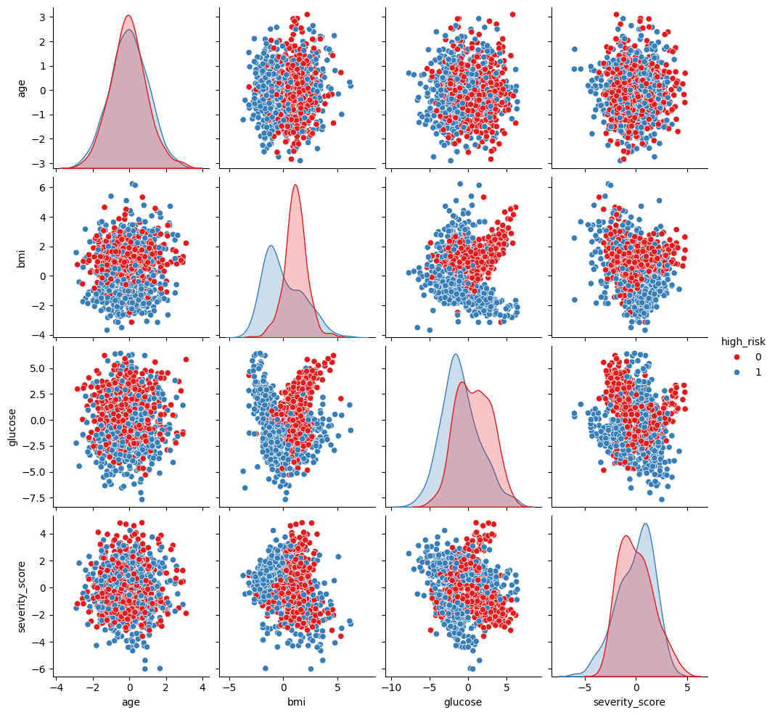

# Correlation Heatmap

plt.figure(figsize=(10, 7))

sns.heatmap(
df.corr(),
annot=True,
cmap="coolwarm",
fmt=".2f"
)

plt.title("Correlation Heatmap")
plt.show()
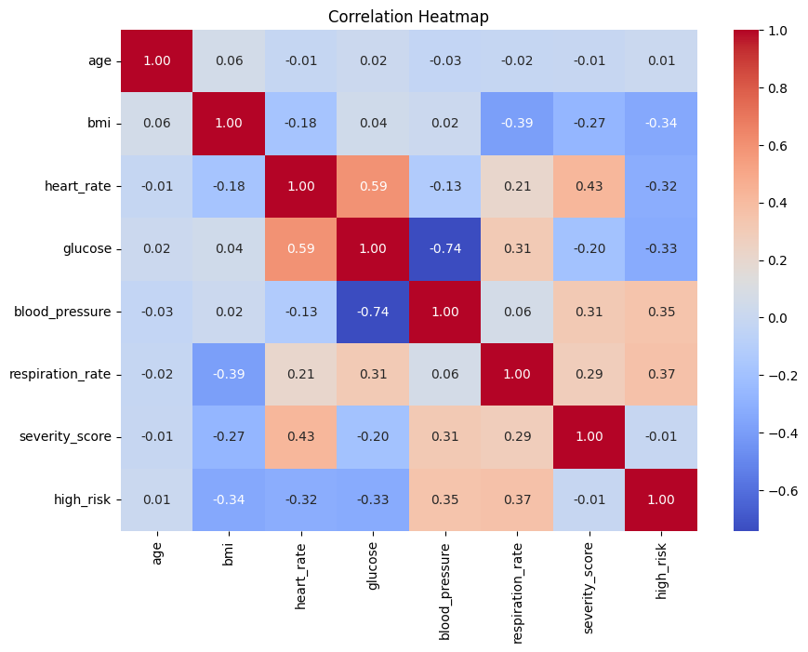

# Train-Test Split

X_train, X_test, y_train, y_test = train_test_split(
X,
y,
test_size=0.20,
random_state=42,
stratify=y
)

print("Training Samples:", X_train.shape[0])
print("Testing Samples :", X_test.shape[0])

print("\nTraining Class Distribution:")
print(y_train.value_counts())

print("\nTesting Class Distribution:")
print(y_test.value_counts())
Training Samples: 800
Testing Samples : 200

Training Class Distribution:
high_risk
1 408
0 392
Name: count, dtype: int64

Testing Class Distribution:
high_risk
1 102
0 98
Name: count, dtype: int64

# Feature Scaling

scaler = StandardScaler()

X_train_scaled = scaler.fit_transform(X_train)

X_test_scaled = scaler.transform(X_test)

print("Feature scaling completed successfully!")

print("\nFirst 5 scaled training records:")
display(pd.DataFrame(
X_train_scaled,
columns=feature_names
).head())
Feature scaling completed successfully!

First 5 scaled training records:
age bmi heart_rate glucose blood_pressure respiration_rate \
0 0.215738 -1.494209 -0.141764 0.097555 0.092491 1.767263
1 -1.152761 0.091704 -0.185543 0.987211 -1.739881 -0.990420
2 -0.666084 -1.367065 0.860383 0.433195 -0.295751 0.442590
3 -1.676247 -1.262864 1.016175 1.293241 -0.511721 1.540031
4 1.661221 0.824672 -1.446954 -1.412338 0.838946 -0.789472

severity_score
0 0.356123
1 -1.354543
2 0.376425
3 -0.162990
4 -0.280659

# Linear SVM

linear_svm = SVC(
kernel="linear",
C=1.0
)

linear_svm.fit(
X_train_scaled,
y_train
)

print("Linear SVM trained successfully!")

# Predictions
y_pred_linear = linear_svm.predict(X_test_scaled)

print("Predictions generated successfully!")
Linear SVM trained successfully!
Predictions generated successfully!

# Linear SVM Evaluation

accuracy_linear = accuracy_score(y_test, y_pred_linear)

precision_linear = precision_score(
y_test,
y_pred_linear
)

recall_linear = recall_score(
y_test,
y_pred_linear
)

f1_linear = f1_score(
y_test,
y_pred_linear
)

print("Linear SVM Performance")
print("----------------------")

print("Accuracy :", round(accuracy_linear, 4))
print("Precision:", round(precision_linear, 4))
print("Recall :", round(recall_linear, 4))
print("F1 Score :", round(f1_linear, 4))

print("\nClassification Report:")
print(classification_report(y_test, y_pred_linear))
Linear SVM Performance
----------------------
Accuracy : 0.82
Precision: 0.7845
Recall : 0.8922
F1 Score : 0.8349

Classification Report:
precision recall f1-score support

0 0.87 0.74 0.80 98
1 0.78 0.89 0.83 102

accuracy 0.82 200
macro avg 0.83 0.82 0.82 200
weighted avg 0.83 0.82 0.82 200

# Confusion Matrix

cm_linear = confusion_matrix(
y_test,
y_pred_linear
)

plt.figure(figsize=(6, 5))

sns.heatmap(
cm_linear,
annot=True,
fmt="d",
cmap="Blues",
xticklabels=["Low Risk", "High Risk"],
yticklabels=["Low Risk", "High Risk"]
)

plt.xlabel("Predicted Class")
plt.ylabel("Actual Class")
plt.title("Linear SVM Confusion Matrix")

plt.show()
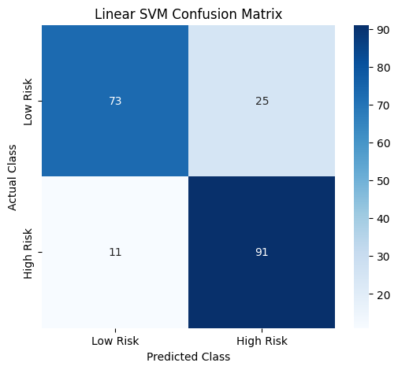

# SVM Decision Boundary and Support Vectors

# Select two features for visualization
visual_features = ["severity_score", "glucose"]

X_visual = df[visual_features]
y_visual = df["high_risk"]

# Scale the two features
visual_scaler = StandardScaler()

X_visual_scaled = visual_scaler.fit_transform(X_visual)

# Train a separate 2D Linear SVM
svm_2d = SVC(
kernel="linear",
C=1.0
)

svm_2d.fit(
X_visual_scaled,
y_visual
)

# Create grid
x_min = X_visual_scaled[:, 0].min() - 1
x_max = X_visual_scaled[:, 0].max() + 1

y_min = X_visual_scaled[:, 1].min() - 1
y_max = X_visual_scaled[:, 1].max() + 1

xx, yy = np.meshgrid(
np.linspace(x_min, x_max, 500),
np.linspace(y_min, y_max, 500)
)

grid = np.c_[xx.ravel(), yy.ravel()]

Z = svm_2d.predict(grid)

Z = Z.reshape(xx.shape)

# Plot decision regions
plt.figure(figsize=(10, 7))

plt.contourf(
xx,
yy,
Z,
alpha=0.2,
cmap="coolwarm"
)

# Plot observations
plt.scatter(
X_visual_scaled[y_visual == 0, 0],
X_visual_scaled[y_visual == 0, 1],
label="Low Risk",
alpha=0.6
)

plt.scatter(
X_visual_scaled[y_visual == 1, 0],
X_visual_scaled[y_visual == 1, 1],
label="High Risk",
alpha=0.6
)

# Highlight support vectors
plt.scatter(
svm_2d.support_vectors_[:, 0],
svm_2d.support_vectors_[:, 1],
s=100,
facecolors="none",
edgecolors="black",
linewidths=1.5,
label="Support Vectors"
)

plt.xlabel("Severity Score (Scaled)")
plt.ylabel("Glucose (Scaled)")
plt.title("Linear SVM Decision Boundary and Support Vectors")

plt.legend()
plt.show()

print("Number of Support Vectors:",
len(svm_2d.support_vectors_))
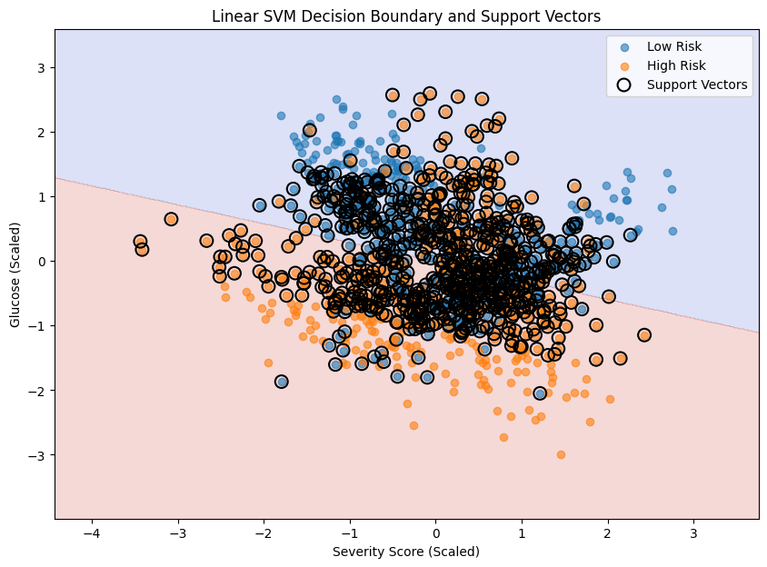
Number of Support Vectors: 769

# Effect of C

C_values = [0.01, 1, 100]

results = []

for c_value in C_values:

svm_model = SVC(
kernel="linear",
C=c_value
)

svm_model.fit(
X_train_scaled,
y_train
)

predictions = svm_model.predict(
X_test_scaled
)

results.append({
"C": c_value,
"Accuracy": accuracy_score(y_test, predictions),
"Precision": precision_score(y_test, predictions),
"Recall": recall_score(y_test, predictions),
"F1 Score": f1_score(y_test, predictions)
})

results_df = pd.DataFrame(results)

display(results_df)
C Accuracy Precision Recall F1 Score
0 0.01 0.835 0.780488 0.941176 0.853333
1 1.00 0.820 0.784483 0.892157 0.834862
2 100.00 0.820 0.784483 0.892157 0.834862

# C Value Performance Comparison

plt.figure(figsize=(8, 5))

plt.plot(
results_df["C"],
results_df["Accuracy"],
marker="o",
label="Accuracy"
)

plt.plot(
results_df["C"],
results_df["F1 Score"],
marker="o",
label="F1 Score"
)

plt.xscale("log")

plt.xlabel("C Value")
plt.ylabel("Score")

plt.title("Effect of C on Linear SVM Performance")

plt.legend()

plt.show()
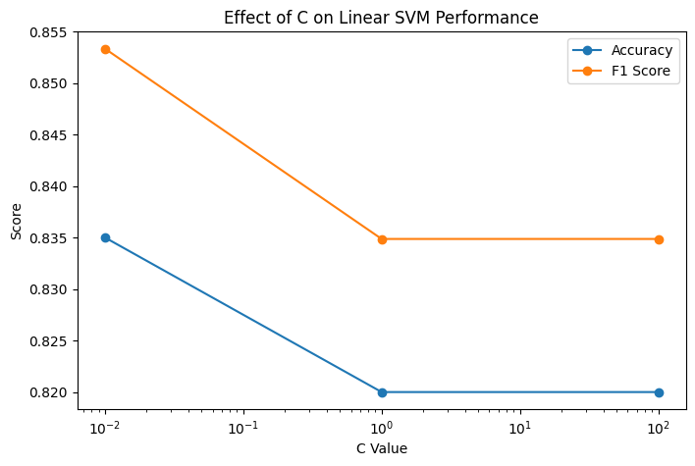

# Select Best C

best_row = results_df.loc[
results_df["F1 Score"].idxmax()
]

best_C = best_row["C"]

print("Best C Value:", best_C)

print("\nBest Model Performance:")
display(best_row)
Best C Value: 0.01

Best Model Performance:
C 0.010000
Accuracy 0.835000
Precision 0.780488
Recall 0.941176
F1 Score 0.853333
Name: 0, dtype: float64

# Final SVM Model

final_svm = SVC(
kernel="linear",
C=best_C
)

final_svm.fit(
X_train_scaled,
y_train
)

final_predictions = final_svm.predict(
X_test_scaled
)

print("Final SVM model trained successfully!")
Final SVM model trained successfully!

#Final Model Evaluation

final_accuracy = accuracy_score(
y_test,
final_predictions
)

final_precision = precision_score(
y_test,
final_predictions
)

final_recall = recall_score(
y_test,
final_predictions
)

final_f1 = f1_score(
y_test,
final_predictions
)

print("FINAL SVM PERFORMANCE")
print("=====================")

print("Accuracy :", round(final_accuracy, 4))
print("Precision:", round(final_precision, 4))
print("Recall :", round(final_recall, 4))
print("F1 Score :", round(final_f1, 4))

print("\nClassification Report:")
print(
classification_report(
y_test,
final_predictions,
target_names=["Low Risk", "High Risk"]
)
)
FINAL SVM PERFORMANCE
=====================
Accuracy : 0.835
Precision: 0.7805
Recall : 0.9412
F1 Score : 0.8533

Classification Report:
precision recall f1-score support

Low Risk 0.92 0.72 0.81 98
High Risk 0.78 0.94 0.85 102

accuracy 0.83 200
macro avg 0.85 0.83 0.83 200
weighted avg 0.85 0.83 0.83 200

# Final Confusion Matrix

final_cm = confusion_matrix(
y_test,
final_predictions
)

plt.figure(figsize=(6, 5))

sns.heatmap(
final_cm,
annot=True,
fmt="d",
cmap="Blues",
xticklabels=["Low Risk", "High Risk"],
yticklabels=["Low Risk", "High Risk"]
)

plt.xlabel("Predicted Class")
plt.ylabel("Actual Class")

plt.title("Final SVM Confusion Matrix")

plt.show()
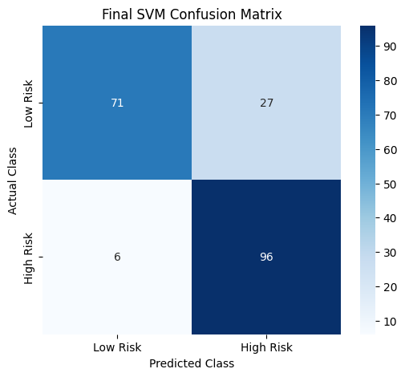

# Block 23 : Support Vector Analysis

print("Number of Support Vectors:")
print(final_svm.n_support_)

print("\nTotal Support Vectors:")
print(final_svm.n_support_.sum())
Number of Support Vectors:
[235 236]

Total Support Vectors:
471

Inference: The Linear SVM trained on the scaled patient features achieved an accuracy of about 82% with the default C = 1.0. Testing different values of C (0.01, 1 and 100) showed that a smaller C value (0.01) produced the best F1-Score (0.853) by allowing a wider margin and a small amount of misclassification, whereas larger C values did not improve performance further. The decision-boundary plot on the two most informative features (severity score and glucose) shows a clear linear separation between the two risk classes, supported by a large number of support vectors close to the margin.

Conclusion: This experiment demonstrated how a Linear SVM can be used for binary healthcare risk classification and how the C hyperparameter controls the trade-off between margin width and classification error. Using the best C value (0.01) selected via F1-Score comparison, the final SVM model achieved an accuracy of 83.5%, a recall of 94.1% and an F1-Score of 0.853, showing that SVM is an effective and reliable classifier for this type of binary risk-prediction task.

