AI Usage DISCLOSURE FORM

1. Team Details
Team Name: _______IntelliForge________
Project / Product Name: _________IntelliSight___________
Organization / Institution (if any): __________RVCE__________
Submission Date: _________8/5/2026______________

2. AI Usage Declaration
Did your team use any Artificial Intelligence (AI) in developing this project? Yes / No
____________Yes________________

3. Purpose of AI Usage ( Brief Details)
Idea generation / brainstorming: Used for refining project flow and cognitive assessment concepts.
Code generation or assistance: AI-assisted support was used for backend structuring, API planning, and development guidance.
UI / UX design: AI-assisted wireframe and interface planning were used during the design phase.
Content creation: AI-assisted support was used for documentation, reports, and project descriptions.
Data analysis: AI is used within the application to analyze gameplay behavior patterns and generate cognitive insights.
Testing / debugging: AI-assisted debugging and issue resolution were used during development.
Other: OpenClaw AI orchestration was integrated for cognitive reasoning and report generation.

4. Feature Origin Classification ( Please add/delete based on the number of the feature)
1. Feature Name: AI Cognitive Analysis Pipeline
2. Self-Generated/AI-Generated/Both : Both
3. Description ( include AI tools/platform Used, prompt used , Output Summary, Modification)
The IntelliSight platform integrates OpenClaw as the primary AI orchestration layer. OpenClaw coordinates cognitive reasoning, report generation, provider fallback handling, and structured insight generation based on gameplay interaction data.
AI Tools / Platforms Used:
- OpenClaw
- OpenAI (reasoning support)
- Anthropic Claude (report generation support)
- Google Gemini (fallback support)
- Prompt Used:
Structured prompts were used to analyze behavioral metrics such as memory, attention, logic, response time, and interaction consistency.
- Output Summary:
The AI generates cognitive insight summaries, strengths, weaknesses, and educational recommendations based on backend-generated metrics.
- Modification:
All outputs are reviewed, structured, and integrated into deterministic backend logic. AI does not independently calculate scores or diagnose children.

1. Feature Name AI-Assisted Development Support
2. Self-Generated/AI-Generated/Both ____Both_______________
3. Description (include AI tools/platform Used, prompt used , Output Summary, Modification)
Description
AI-assisted tools were used during development for:
- project planning
- backend architecture guidance
- API structuring
- documentation generation
- debugging assistance
The final implementation and integration were customized and modified by the development team.

…

5. Ethical & Compliance Confirmation
AI usage complies with guidelines and policies. Yes
No proprietary or copyrighted data misused. I Agree

6. Declaration & Sign-Off
Name of Team Representative: D Rohan Samuel
Role: Frontend Developer
Signature:
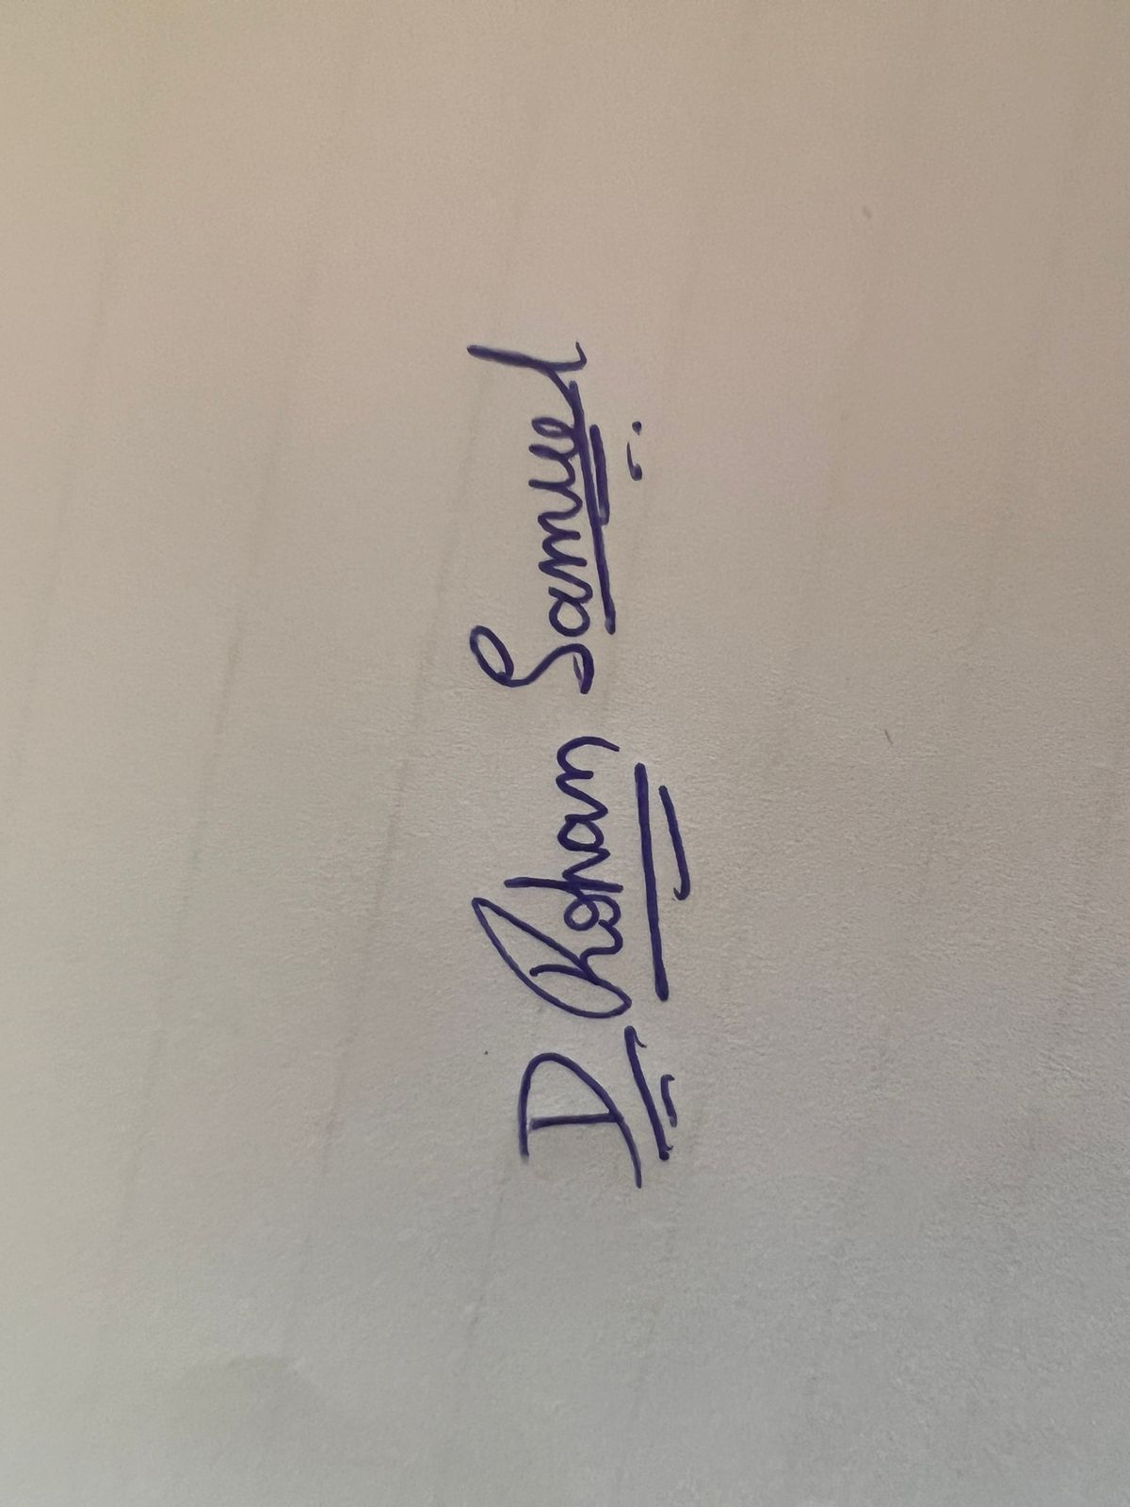
Date: 8/5/2026

