🌾 STANDARD OPERATING PROCEDURE (SOP)
Sugar Module & Sugar Desk Trading ERP System
Document Ref: SOP-SM-2026-V1 | Effective Date: August 27, 2026 | Company: Rajendra Narahari Lokhande
Document ID | Version | Scope | Platform
SOP-SM-2026-V1 | 1.0 (Production) | Sugar Trading & Accounting | Frappe v16 + Sugar Desk

1. System Roles & Responsibilities
System Role | Designation | Operational Responsibilities
Trade Operator | Data Entry / Procurement | Records Sugar Purchase lots (F9) and verifies mill contract inwarding.
Dispatch Manager | Logistics & Sales | Issues Dispatch Entries (F8), verifies available lot stock, assigns vehicle numbers and brokers.
Accounts Executive | Finance & Cash Flow | Processes Supplier Payments (F5) and Customer/Broker Receipts (F6).
Finance Head / Auditor | Audit & Controls | Reconciles Day Book (F10), monitors Broker Receivables (O) & Supplier Payables (S).
System Administrator | IT & Server Operations | Maintains bench server uptime, port management (fix_bench.sh), and Frappe database.

2. Standard Operating Procedures (Step-by-Step)

SOP-01: Sugar Purchase Lot Inwarding (Shortcut: F9 / P)
1. Press F9 or P from Gateway to open Sugar Purchase Voucher.
2. Confirm Voucher Date.
3. In Supplier (Sugar Mill) field, type the Mill Name and select from typeahead dropdown.
4. Select Sugar Grade Item (e.g. M-30, S-30, SS-30).
5. Enter Purchase Qty (Quintals) and Purchase Rate (Rs/Qtl). Total Lot Amount is calculated automatically.
6. Enter contract terms or Sauda reference in Narration.
7. Press Enter on Narration or click Save & Accept Voucher.
8. System Result: Creates Sugar Purchase record and initializes available_qty_quintal equal to purchase quantity.

SOP-02: Sugar Sales Dispatch & Lot Allocation (Shortcut: F8 / D)
1. Press F8 or D to open Dispatch Entry Voucher.
2. In Source Sugar Purchase field, search available lots. Note the live stock tag (e.g. [Stock: 3,800 Qtl]).
3. Selecting a lot automatically loads the Sugar Mill, Grade, and displays the Live Stock Banner.
4. Select Customer Party (Buyer) and Broker Name.
5. Enter Vehicle Number (e.g. MH19CZ1234).
6. Enter Dispatch Qty (Quintals) and Sales Rate (Rs/Qtl). Total Amount and Balance Due are auto-computed.
7. Press Enter on Narration to submit.
8. System Result: Generates Dispatch Entry and automatically reduces available_qty_quintal in the source Sugar Purchase lot.

SOP-03: Supplier Disbursement / Purchase Payment (Shortcut: F5 / Y)
1. Press F5 or Y to open Purchase Payment Voucher.
2. Select the specific Sugar Purchase lot being disbursed.
3. Automatically populates Mill Name, Grade, and Total Purchase Value.
4. Select Bank/Cash Account, Payment Mode (RTGS/NEFT/Cheque/UPI), and enter Bank UTR / Reference No.
5. Confirm or adjust Paid Amount (Rs) and press Enter to save.
6. System Result: Reduces outstanding balance payable to the sugar mill.

SOP-04: Customer / Broker Receipt Collection (Shortcut: F6 / R)
1. Press F6 or R to open Broker Party Payment (Receipt).
2. Select the Dispatch Entry voucher against which the collection is received.
3. System auto-fills Customer Party, Broker, and remaining balance due.
4. Select receiving Bank Account, Payment Mode, and enter UTR / Reference Number.
5. Enter Received Amount and submit voucher.
6. System Result: Reduces buyer balance due and clears broker receivables ledger.

SOP-05: Outstanding Receivables & Payables Financial Control
1. Broker Receivables Report (Shortcut: O): Press O or navigate to /register/broker-outstanding. Review KPI cards (Outstanding Due, Billed, Collected, Pending). Click Print for a branded statement of account, or CSV to export.
2. Supplier Payables Report (Shortcut: S): Press S or navigate to /register/supplier-outstanding. View all unpaid purchase lots grouped by Sugar Mill. Click Print or CSV on any mill group.

SOP-06: Daily Audit & Day Book Reconciliation (Shortcut: F10)
1. Press F10 to open Day Book.
2. Press F2 to filter transactions for a specific trading day.
3. Press F4 to filter by voucher type (Purchases, Dispatches, Payments, Receipts).
4. Reconcile total debits and credits with bank book.
5. Press F7 or click Print Day Book for signed compliance copies, or click Export CSV.

SOP-07: Record Inspection & Uneditable Read-Only Verification
1. From any Register (Purchases 'L', Dispatches 'K', Payments 'Y', Receipts 'R'), double-click any row.
2. Record opens in View Mode with badge: 'View Mode (Uneditable / Submitted) - Voucher ID'.
3. All form controls are locked (readonly) with zero dropdowns or popups.
4. Use Print Voucher to print a single document, or press Esc to return to the register table.

SOP-08: Interoperability & Navigation with ERPNext
1. Switching to ERPNext Desk: Click getMyErp on top navigation bar to go to /desk/rajendra-narahari-lokhande.
2. Returning to Sugar Desk: Inside ERPNext, click Sugar Desk button on top navbar or press Alt+S.

SOP-09: Server Recovery & Health Check
1. Clean all ports and restart bench in single command: ./fix_bench.sh --start
2. Restore permissions if needed: chown -R frappe:frappe /home/frappe/frappe-bench-v16/

3. Visual Interface Reference Guides
SOP Guide 1: Sugar Desk Gateway Command Dashboard with KPI Cards & Fast Navigation
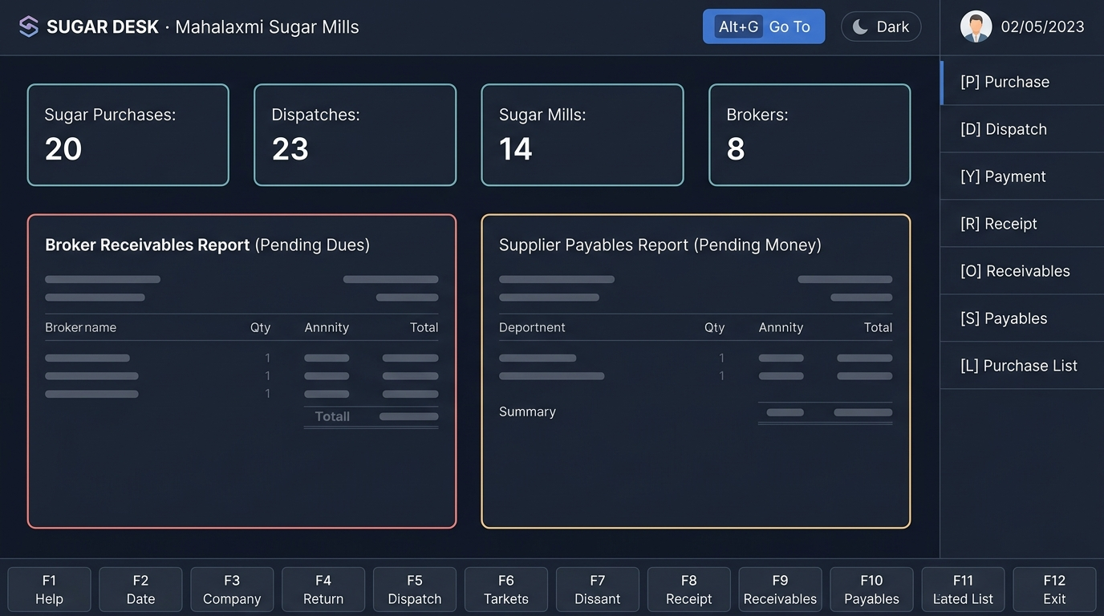

SOP Guide 2: Dispatch Entry (F8) with Live Source Purchase Lot Stock Allocation
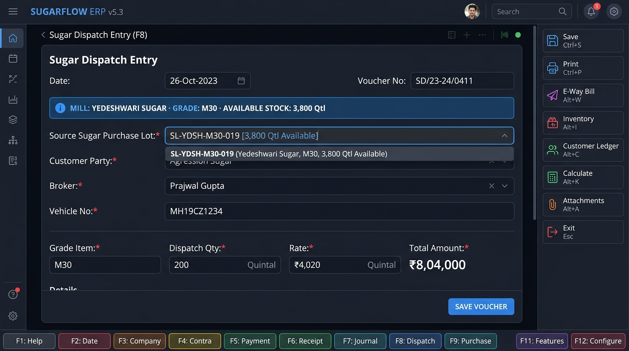

SOP Guide 3: Broker Outstanding Receivables Report (O) with Individual Broker Print/Export
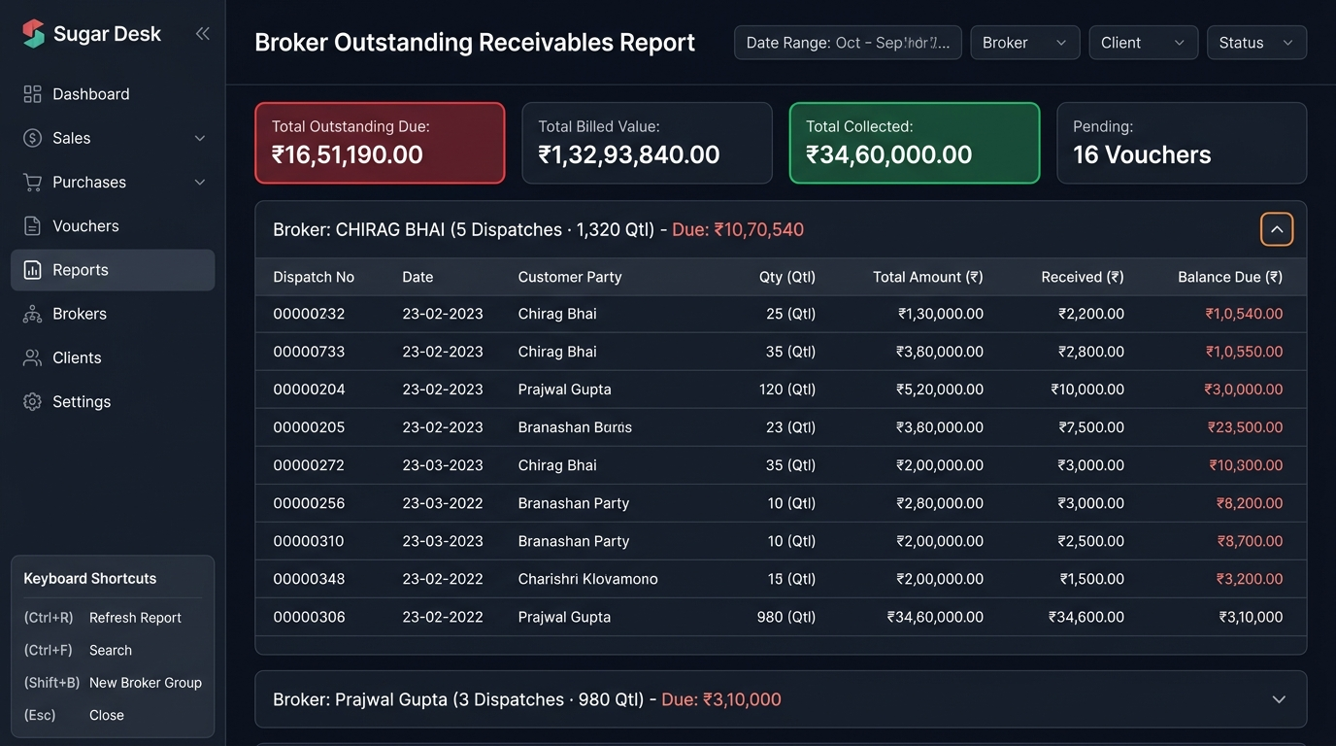

4. Master Keyboard Shortcut Reference
Key | Procedure / Action | Scope
Alt+G / Ctrl+K | Tally 'Go To' Command Search Palette | Universal
F9 / P | Sugar Purchase Voucher Entry | Universal / Gateway
F8 / D | Dispatch Entry Voucher | Universal / Gateway
F5 / Y | Purchase Payment (Supplier) | Universal / Gateway
F6 / R | Broker Party Payment (Receipt) | Universal / Gateway
F4 | Contra Voucher / Bank Transfer | Universal / Gateway
L | Sugar Purchases Register | Gateway / Registers
K | Dispatch Entries Register | Gateway / Registers
U | Sugar Mills / Suppliers List | Gateway / Registers
B | Sugar Brokers Directory | Gateway / Registers
C | Customer Parties Directory | Gateway / Registers
O | Broker Receivables Outstanding Report | Universal / Gateway
S | Supplier Payables Outstanding Report | Universal / Gateway
F10 | Day Book & Audit Register | Universal
F7 | Print Day Book / Register | Registers / Day Book
E | Export to CSV Spreadsheet | Registers / Day Book
Esc | Return to Gateway / Register | Universal

5. SOP Approval & Sign-Off Matrix
Approver Role | Name | Signature | Date
Prepared By: ERP Lead | Rajendra Narahari Lokhande | [Approved / Signed] | 27-Aug-2026
Reviewed By: Operations Manager | Rajendra Narahari Lokhande | [Approved / Signed] | 27-Aug-2026
Approved By: Director / Proprietor | Rajendra Narahari Lokhande | [Approved / Signed] | 27-Aug-2026

