🌾 Sugar Module & Sugar Desk ERP
Complete Project Work Progress & Milestone Report
Company: Rajendra Narahari Lokhande (Sugar Trading Division) | Frappe Framework v16 | Date: August 25, 2026
Executive Project Summary: Sugar Desk is a production-grade, keyboard-first trading, allocation, and audit ERP desk built on Frappe v16. It bridges high-volume sugar trading operations with automated mill inventory deduction, linked voucher pre-filling, real-time broker/supplier financial dues reporting, dark mode styling, and seamless two-way ERPNext desk integration.

1. Chronological Project Milestones & Work History
Date & Time | Feature / Milestone | Technical Scope & Deliverables
2026-08-24 10:15 | fix_bench.sh & clean_bench.sh | Created single-command bench unblocker script to kill conflicting processes on ports 8001, 8080, 11001, 13001, and resolve inotify watcher limits.
2026-08-24 10:45 | Frontend Wrapper Setup | Built Vue 3 + Vite keyboard accounting frontend with Frappe API client, routing, and hotkey listeners.
2026-08-24 11:15 | Source Sugar Purchase in Dispatch (F8) | Added live Source Sugar Purchase lot selector with automatic stock validation, grade auto-fill, and inventory balance badges.
2026-08-24 11:35 | Descending Sort & Link Resolvers | Configured all dropdowns and vouchers to sort in descending order (latest first). Added primary key auto-resolvers for human names.
2026-08-24 11:55 | CSRF & Security Token Handling | Resolved 400 Bad Request & CSRFTokenError by integrating auto-fetching CSRF tokens and safe payload fallbacks.
2026-08-24 12:10 | Source Dispatch in Broker Receipt (F6) | Added Source Dispatch Entry selector to auto-fill Customer Party, Broker, and remaining balance due.
2026-08-24 12:20 | Source Purchase in Payment (F5) | Added Source Sugar Purchase selector to Purchase Payment with live lot value summary and auto-filled supplier info.
2026-08-24 12:35 | Broker Outstanding Receivables (O) | Engineered real-time Broker Receivables Report grouping unpaid/partially paid dispatch vouchers by broker with KPI totals.
2026-08-24 12:42 | Supplier Outstanding Payables (S) | Engineered real-time Supplier Payables Report grouping unpaid purchase contracts by sugar mill with lot values and remaining dues.
2026-08-24 12:50 | Dedicated Master Registers (U, B, C) | Created dedicated tabular register views for Sugar Mills / Suppliers (U), Brokers Directory (B), and Customer Parties (C).
2026-08-24 12:55 | Alt+G Singleton Listener Fix | Resolved keyboard listener collisions on Alt+G / Ctrl+G / Ctrl+K and expanded Go To Command Palette with all system views.
2026-08-24 13:05 | Dark Mode / Light Mode (🌙 / ☀️) | Implemented full dynamic Dark Mode with persistent localStorage storage and curated slate-navy high-contrast styling.
2026-08-24 13:30 | Universal Escape Navigation | Configured global Escape key navigation to return to the Gateway of Sugar Desk from any report, register, or master list.
2026-08-25 06:40 | getMyErp Two-Way ERPNext Link | Added 'getMyErp' top ribbon button routing to /desk/rajendra-narahari-lokhande and created '🌾 Sugar Desk' navbar launcher inside ERPNext.

2. User Interface Showcase & Screenshots
Figure 1: Gateway Dashboard with 6-Card Overview, Dark Mode Toggle, and Navigation Shortcuts
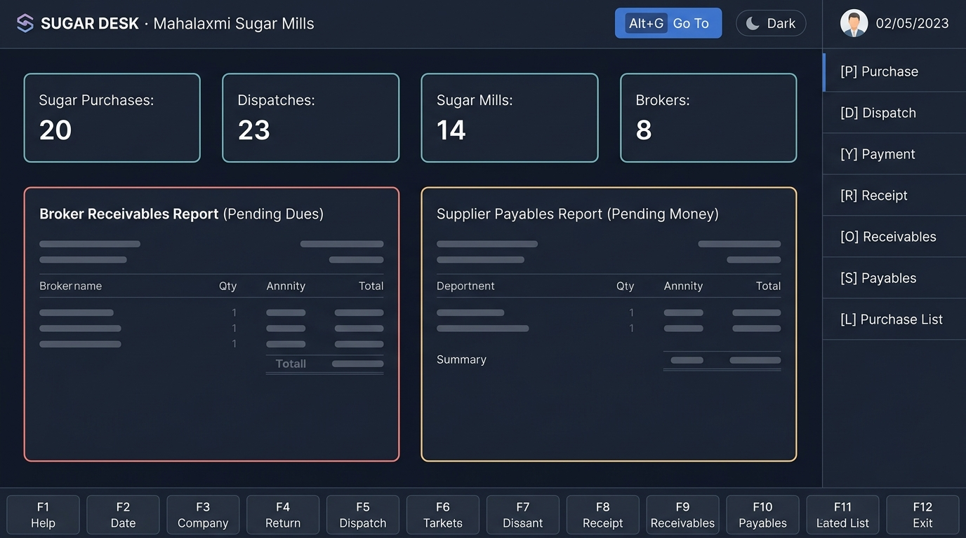

Figure 2: Dispatch Entry Voucher (F8) with Live Source Sugar Purchase Lot Selector and Stock Badges
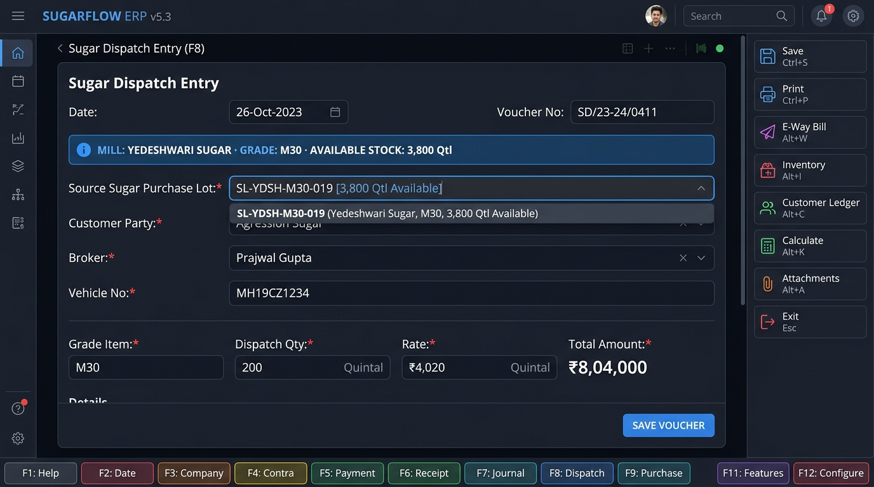

Figure 3: Broker Outstanding Receivables Report (O) Grouped by Broker with Unpaid Vouchers
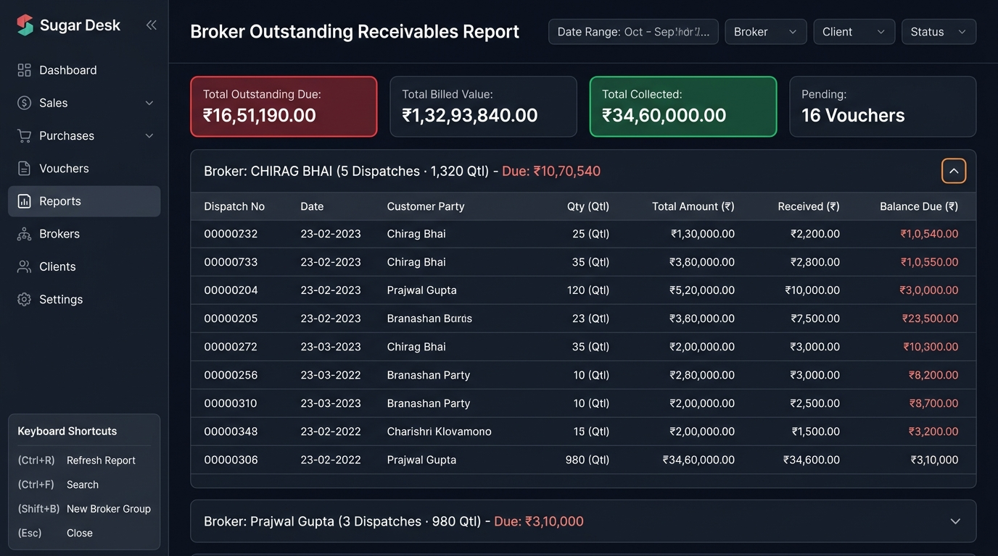

Figure 4: Tally 'Alt+G' Command Search Palette & Day Book Transaction Audit Stream
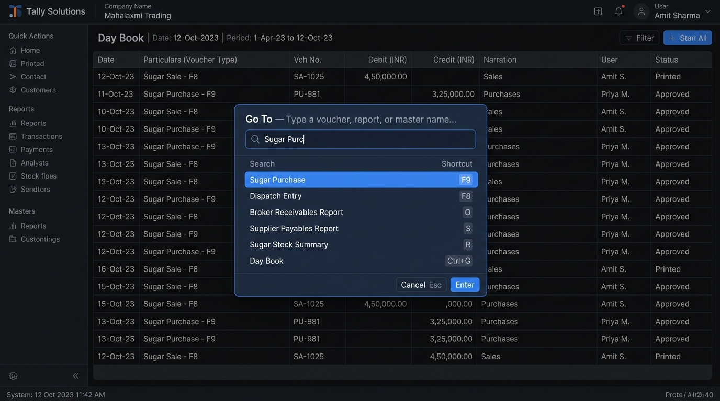

3. Detailed Functional Modules & Capabilities

A. Linked Voucher Recording Engine
- Sugar Purchase (F9 / P): Records procurement lots from sugar mills with Grade (S-30, M-30, SS-30), rate per quintal, total value, and initializes unallocated available stock.
- Dispatch Entry (F8 / D): Allocates sugar deliveries to buyers. Automatically filters available purchase lots in descending order, reveals live available quintals, auto-selects grade, and deducts inventory on submission.
- Purchase Payment (F5 / Y): Facilitates RTGS/NEFT/Cheque supplier disbursements with source purchase lot auto-fill and mill balance tracking.
- Broker Receipt (F6 / R): Records customer receipts against specific dispatches, auto-populating buyer, broker, and remaining balance due.
- Contra / Bank Transfer (F4): Handles internal bank-to-bank and cash deposits/withdrawals.

B. Outstanding Receivables & Payables Intelligence
- Broker Receivables Report (O): Identifies all pending trade dues from buyers and brokers. Displays aggregate summary cards (Total Outstanding, Total Billed, Total Received, Pending Vouchers) with collapsible broker groups and itemized unpaid dispatch vouchers.
- Supplier Payables Report (S): Identifies all pending disbursements owed to sugar mills. Groups outstanding contracts by mill with total quintals, paid amounts, and remaining payable balances.

C. Trade Registers & Directories
- Sugar Purchase Register (L): Full register of all purchase contracts with live available stock badges.
- Dispatch Entry Register (K): Complete delivery register with vehicle numbers, broker names, and pending balances.
- Sugar Mills Directory (U): Comprehensive supplier directory with total lots count, aggregate quintals, and active stock.
- Brokers Directory (B): Broker list with contact phone numbers, city, total dispatches, and outstanding balances.
- Day Book & Audit Register (F10): Unified chronological accounting audit feed across all voucher transactions.

D. Universal Navigation & ERPNext Integration
- Alt+G / Ctrl+K Command Palette: Instant searchable popup to jump to any voucher, register, report, or master list from anywhere in the app.
- getMyErp One-Click Button: Navigates directly to the designated ERPNext Desk path (/desk/rajendra-narahari-lokhande).
- 🌾 Sugar Desk ERPNext Launcher: Embedded button inside the Frappe/ERPNext top navigation bar allowing users working inside ERPNext to switch to Sugar Desk with one click or Alt+S.
- Dark Mode / Light Mode: High-contrast slate-navy dark theme with persistent browser storage.

4. Keyboard Shortcut Reference Cheat Sheet
Key / Shortcut | Action Description | Scope / Screen
Alt+G / Ctrl+K | Open 'Go To' Command Search Palette | Universal
F9 / P | New Sugar Purchase Voucher Entry | Universal / Gateway
F8 / D | New Dispatch Entry Voucher | Universal / Gateway
F5 / Y | New Purchase Payment Voucher | Universal / Gateway
F6 / R | New Broker Party Payment (Receipt) | Universal / Gateway
F4 | New Contra / Bank Transfer Voucher | Universal / Gateway
L | Open Sugar Purchase Register | Gateway / Registers
K | Open Dispatch Entry Register | Gateway / Registers
U | Open Suppliers & Sugar Mills List | Gateway / Registers
B | Open Sugar Brokers Directory | Gateway / Registers
C | Open Customer Parties Directory | Gateway / Registers
O | Open Broker Receivables Outstanding Report | Universal / Gateway
S | Open Supplier Payables Outstanding Report | Universal / Gateway
F10 | Open Day Book & Transaction Audit Register | Universal
Esc | Return to Gateway / Dismiss Modal / Blur Input | Universal

5. Access & Deployment Endpoints
• Production Application URL: http://157.15.203.96:8001/sugar-desk
• ERPNext Desk Destination: http://157.15.203.96:8001/desk/rajendra-narahari-lokhande
• Vite Development Server: http://157.15.203.96:8080
• GitHub Repository: https://github.com/rohansapkale/Sugar_Module.git (Branch: sugar-module)

