Assignment 4(DIP)

Author : Rohan Shah (M.tech AI) SR. No. : 19243

1)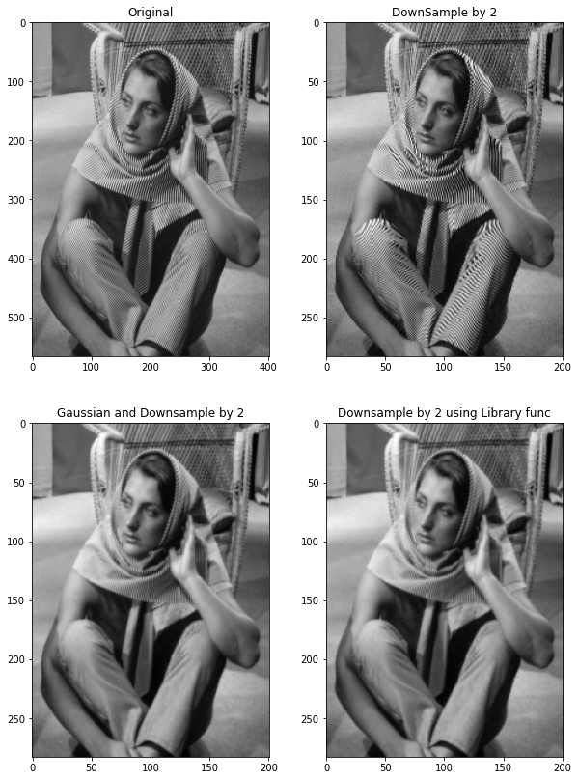

As seen in image while doing downsampling by taking every other column and row we get ringing artifact in image. So mitigate this artifact we do spatial domain Gaussian Low Pass Filter before downsampling the image. We can take different sigma and filter size and find best value.(Here 5*5 and sigma=1). Now comparing with cv2 library function it gives same result as Gaussian+Downsample.

2)first-order edge detector has too many point that detect edges while in second-order gradient-based edge detectors has few but accurate points.

Sobel Operator output:

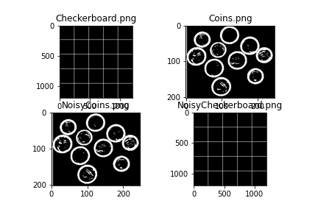

Prewitt operator output:

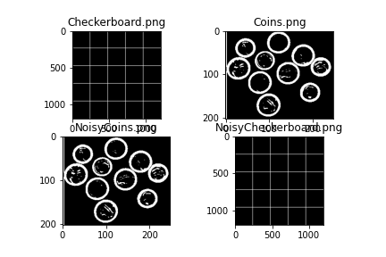

Laplacian

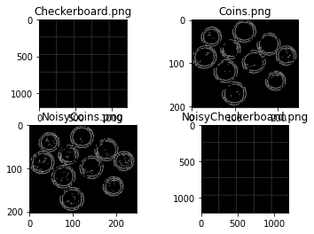

3)(a)Corner detection is dependent on threshold values as if threshold is to high then detect very less corners. So experimenting at different values, at 0.01 gives good corner detection.

Threshold = 0.01* max(corner_response)

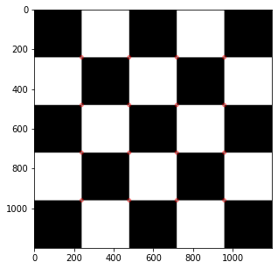T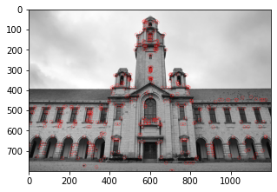

Threshold =0.6 * max(corner_resposnse)

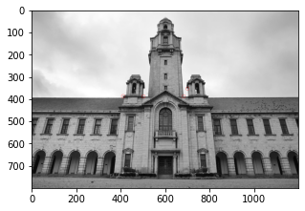

Threshold = 0.2*max(corner_response)

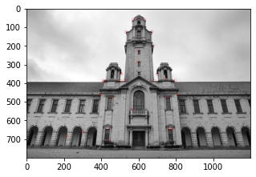

(b)After Rotating images detection is still good.(90 degree)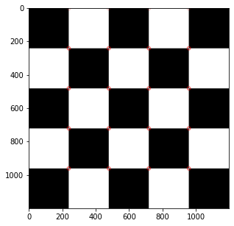(30 degree)

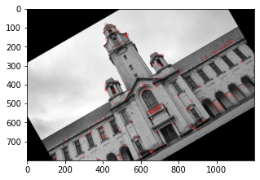

Scale:

Scale by 2

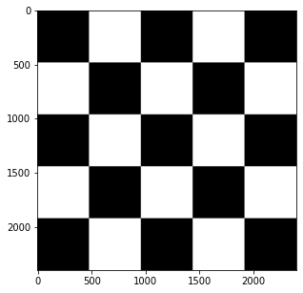

Scale by 3

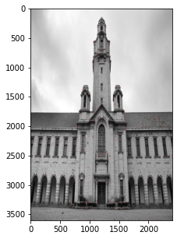

After adding noise:

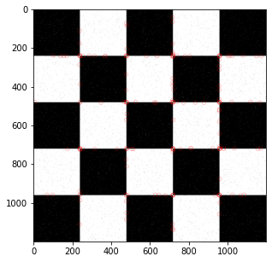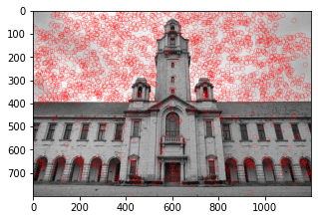

So Harris corner detection is rotation invariant but not invariant to scale and adding noise.